QUESTION-5
5. Write a C program for generalization of the Caesar cipher, known as the affine Caesar cipher, has the
following form: For each plaintext letter p, substitute the ciphertext letter C: C = E([a, b], p) = (ap + b)
mod 26 A basic requirement of any encryption algorithm is that it be one-to-one. That is, if p q, then
E(k, p) E(k, q). Otherwise, decryption is impossible, because more than one plaintext character maps into
the same ciphertext character. The affine Caesar cipher is not one-to-one for all values of a. For example,
for a = 2 and b = 3, then E([a, b], 0) = E([a, b], 13) = 3.
a. Are there any limitations on the value of b?
b. Determine which values of a are not allowed.

Aim
To write a C program to implement the Affine Caesar cipher using the formula C = (ap + b) mod 26.
Procedure
- Read the plaintext and values of a and b.
- Convert each letter into a number from 0 to 25.
- Check whether gcd(a,26) = 1.
- Apply C = (a*p+b) mod 26.
- Convert the calculated values into letters.
- Display the resulting ciphertext.
Code
C
#include <stdio.h>
#include <ctype.h>

int gcd(int a, int b) {
while (b != 0) {
int temp = b;
b = a % b;
a = temp;
}
return a;
}

int main() {
char text[100], cipher[100];
int a, b, i, p;

printf("Enter plaintext: ");
fgets(text, sizeof(text), stdin);

printf("Enter a: ");
scanf("%d", &a);

printf("Enter b: ");
scanf("%d", &b);

if (gcd(a, 26) != 1) {
printf("Invalid value of a.\n");
return 0;
}

for (i = 0; text[i] != '\0'; i++) {
if (isalpha(text[i])) {
p = toupper(text[i]) - 'A';
cipher[i] = (a * p + b) % 26 + 'A';
} else {
cipher[i] = text[i];
}
}

cipher[i] = '\0';

printf("Ciphertext: %s", cipher);

return 0;
}
Sample Input
Enter plaintext: HELLO
Enter a: 5
Enter b: 8
Sample Output
Ciphertext: RCLLA
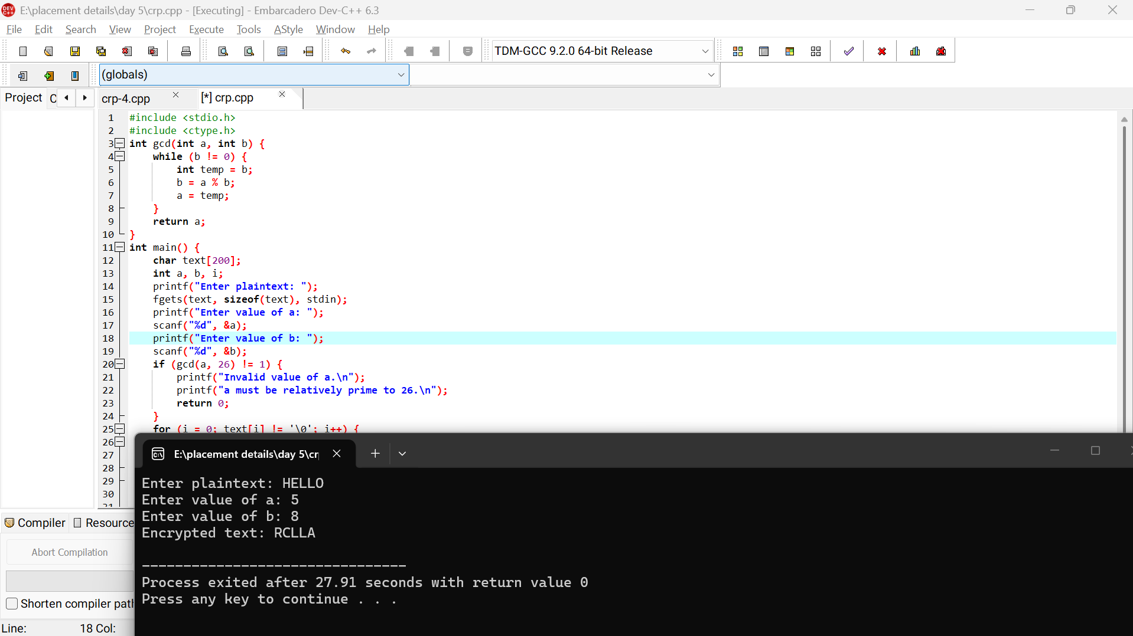
Result
Thus, the Affine Caesar cipher was successfully implemented.

