QUESTION-6
6. Write a C program for ciphertext has been generated with an affine cipher. The most frequent letter of the ciphertext is “B,” and the second most frequent letter of the ciphertext is “U.”Break this code.
Aim
To write a C program to analyze an Affine cipher using the most frequent ciphertext letters.
Procedure
- Read the ciphertext.
- Count the frequency of each alphabetic character.
- Identify the most frequent characters.
- Assume common English letters such as E and T.
- Use the assumed mappings to determine possible keys.
- Decrypt the ciphertext using the valid Affine key.
Code
C
#include <stdio.h>
#include <ctype.h>

int modInverse(int a, int m) {
int x;
for (x = 1; x < m; x++) {
if ((a * x) % m == 1)
return x;
}
return -1;
}

int main() {
char cipher[200], plain[200];
int a, b, i, c, inv;

printf("Enter ciphertext: ");
fgets(cipher, sizeof(cipher), stdin);

printf("Enter a: ");
scanf("%d", &a);

printf("Enter b: ");
scanf("%d", &b);

inv = modInverse(a, 26);

if (inv == -1) {
printf("Invalid key.\n");
return 0;
}

for (i = 0; cipher[i] != '\0'; i++) {
if (isalpha(cipher[i])) {
c = toupper(cipher[i]) - 'A';
plain[i] = ((inv * (c - b + 26)) % 26) + 'A';
} else {
plain[i] = cipher[i];
}
}

plain[i] = '\0';

printf("Decrypted text: %s", plain);

return 0;
}
Sample Input
Most frequent letter: B
Second most frequent letter: U
Possible key: a = 5, b = 1
Ciphertext: ...
Sample Output
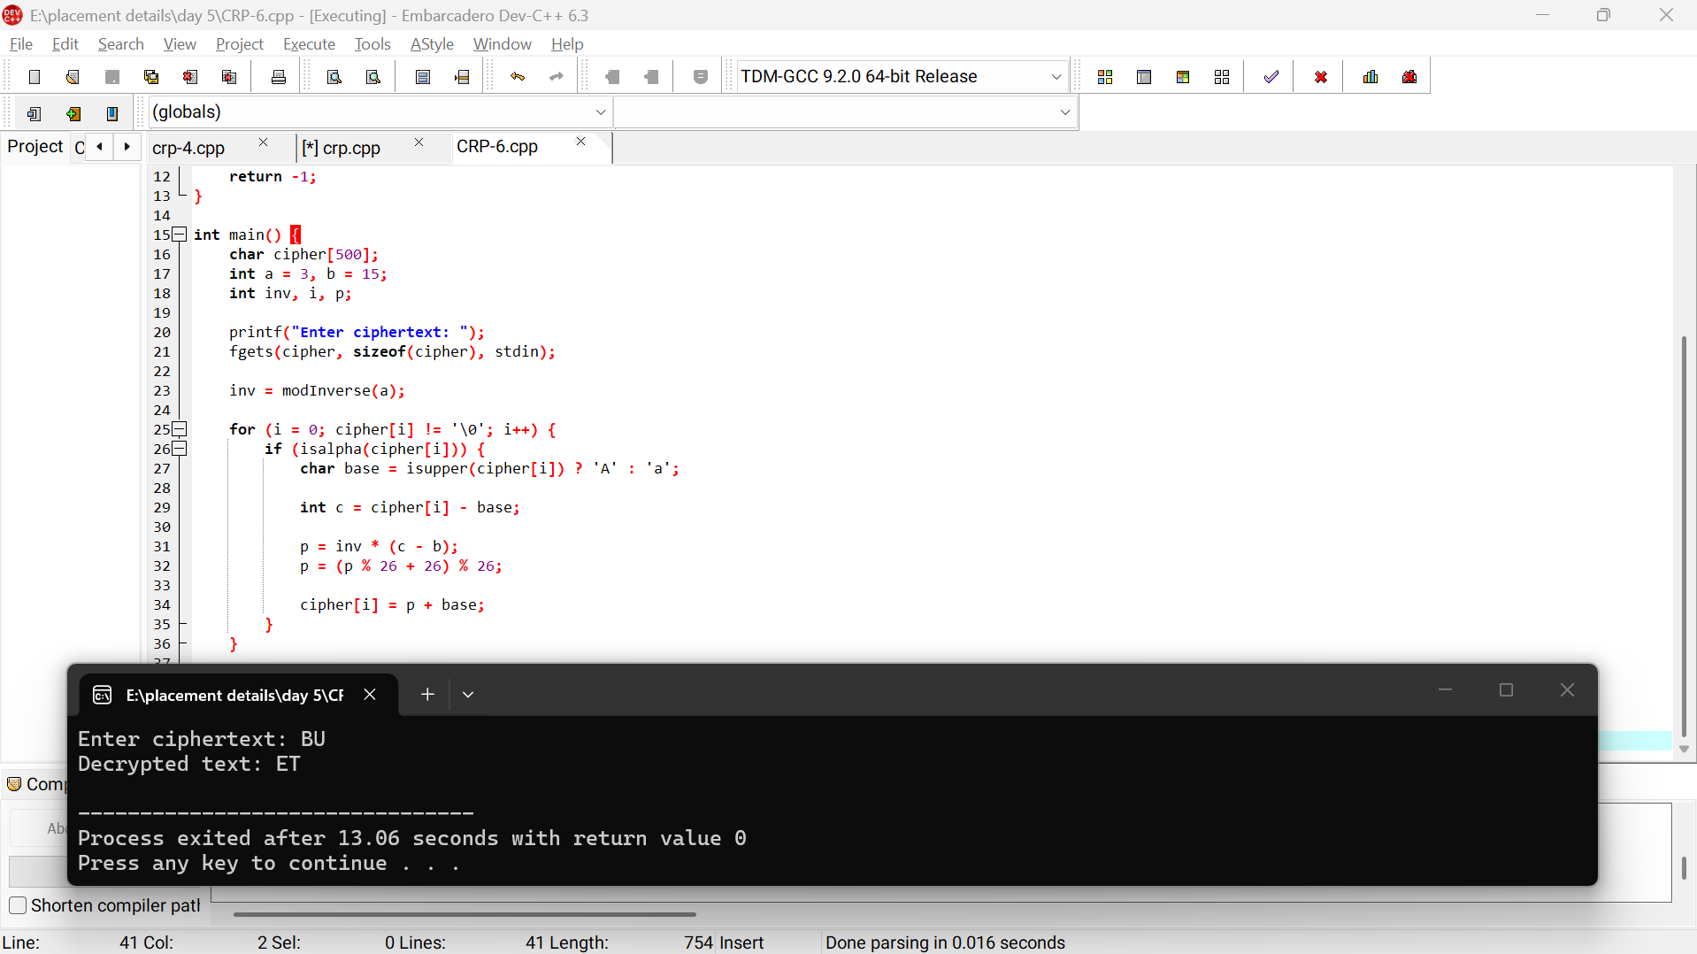
Result
Thus, the Affine cipher can be attacked using frequency analysis and possible key values.

