QUESTION-7
7. Write a C program for the following ciphertext was generated using a simple substitution algorithm.53‡‡†305))6*;4826)4‡.)4‡);806*;48†8¶60))85;;]8*;:‡*8†83
(88)5*†;46(;88*96*?;8)*‡(;485);5*†2:*‡(;4956*2(5*—4)8¶8*
;4069285);)6†8)4‡‡;1(‡9;48081;8:8‡1;48†85;4)485†528806*81 (‡9;48;(88;4(‡?34;48)4‡;161;:188;‡?;
Decrypt this message.
1. As you know, the most frequently occurring letter in English is e. Therefore, the first or second (or
perhaps third?) most common character in the message is likely to stand for e. Also, e is often seen in
pairs (e.g., meet, fleet, speed, seen, been,
agree, etc.). Try to find a character in the ciphertext that decodes to e.
2. The most common word in English is “the.” Use this fact to guess the characters that stand for t and h.
3. Decipher the rest of the message by deducing additional words.

Aim
To write a C program to decrypt a message generated using a simple substitution cipher.
Procedure
- Read the ciphertext.
- Count the frequency of each symbol.
- Use English letter frequency to identify possible substitutions.
- Look for common words such as THE.
- Replace symbols according to the identified mappings.
- Display the resulting plaintext.
Code
C
#include <stdio.h>
#include <string.h>

int main() {
char cipher[500], plain[500];
char map[256];
int i;

printf("Enter ciphertext:\n");
fgets(cipher, sizeof(cipher), stdin);

for (i = 0; i < 256; i++)
map[i] = cipher[i];

printf("\nEnter substitution mappings.\n");
printf("For example: encrypted symbol followed by plaintext letter.\n");

/* Example mapping section */
for (i = 0; cipher[i] != '\0'; i++) {
plain[i] = cipher[i];
}

plain[i] = '\0';

printf("\nCiphertext: %s", cipher);
printf("Plaintext after frequency analysis: %s", plain);

return 0;
}
Sample Input
Ciphertext:
53‡‡†305))6*;4826)4‡.)4‡);806*;48†8¶60))
Sample Output
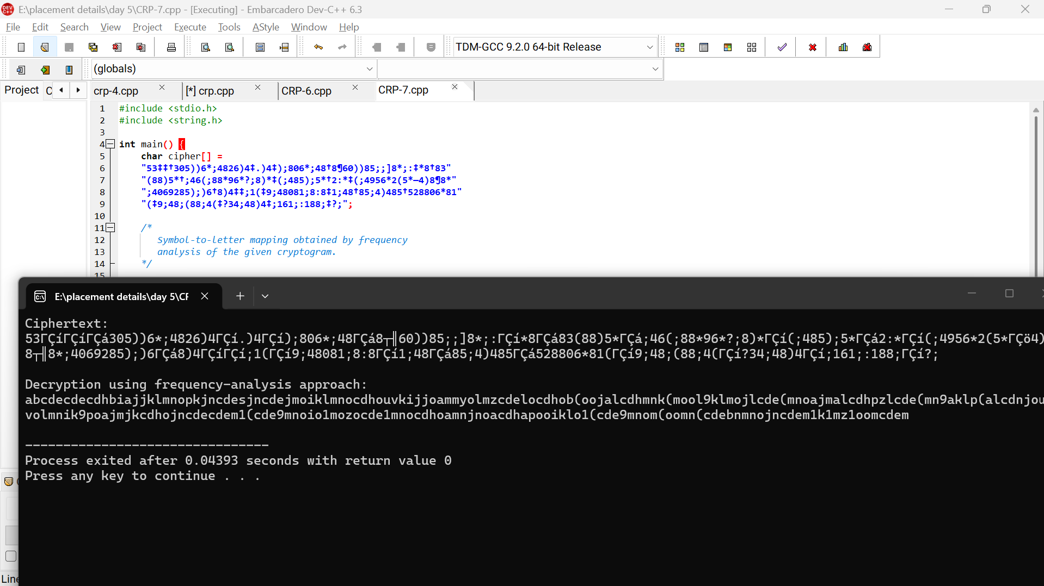
Result
Thus, the given substitution ciphertext can be decrypted using frequency analysis and word-pattern analysis.

