QUESTION-8
8. Write a C program for monoalphabetic cipher is that both sender and receiver must commit the permuted cipher sequence to memory. A common technique for avoiding this is to use a keyword from which the cipher sequence can be generated.
For example, using the keyword CIPHER, write out the keyword followed by unused letters in normal order and match this against the plaintext letters:
plain: a b c d e f g h i j k l m n o p q r s t u v w x y z
cipher: C I P H E R A B D F G J K L M N O Q S T U V W X Y Z

Aim
To write a C program to generate a monoalphabetic substitution alphabet using the keyword CIPHER.
Procedure
- Read the keyword and plaintext.
- Remove duplicate letters from the keyword.
- Add unused alphabet letters after the keyword.
- Create the plaintext-to-cipher mapping.
- Substitute each plaintext letter using the generated alphabet.
- Display the ciphertext.
Code
C
#include <stdio.h>
#include <ctype.h>
#include <string.h>

int main() {
char keyword[50], text[100], cipher[27];
int used[26] = {0};
int i, j = 0;

printf("Enter keyword: ");
scanf("%s", keyword);

printf("Enter plaintext: ");
scanf(" %[^\n]", text);

for (i = 0; keyword[i] != '\0'; i++) {
char ch = toupper(keyword[i]);

if (!used[ch - 'A']) {
cipher[j++] = ch;
used[ch - 'A'] = 1;
}
}

for (i = 0; i < 26; i++) {
if (!used[i])
cipher[j++] = 'A' + i;
}

cipher[26] = '\0';

printf("\nPlain : ABCDEFGHIJKLMNOPQRSTUVWXYZ\n");
printf("Cipher: %s\n", cipher);

printf("Ciphertext: ");

for (i = 0; text[i] != '\0'; i++) {
if (isalpha(text[i])) {
char ch = toupper(text[i]);
printf("%c", cipher[ch - 'A']);
} else {
printf("%c", text[i]);
}
}

return 0;
}
Sample Input
Enter keyword: CIPHER
Enter plaintext: HELLO
Sample Output
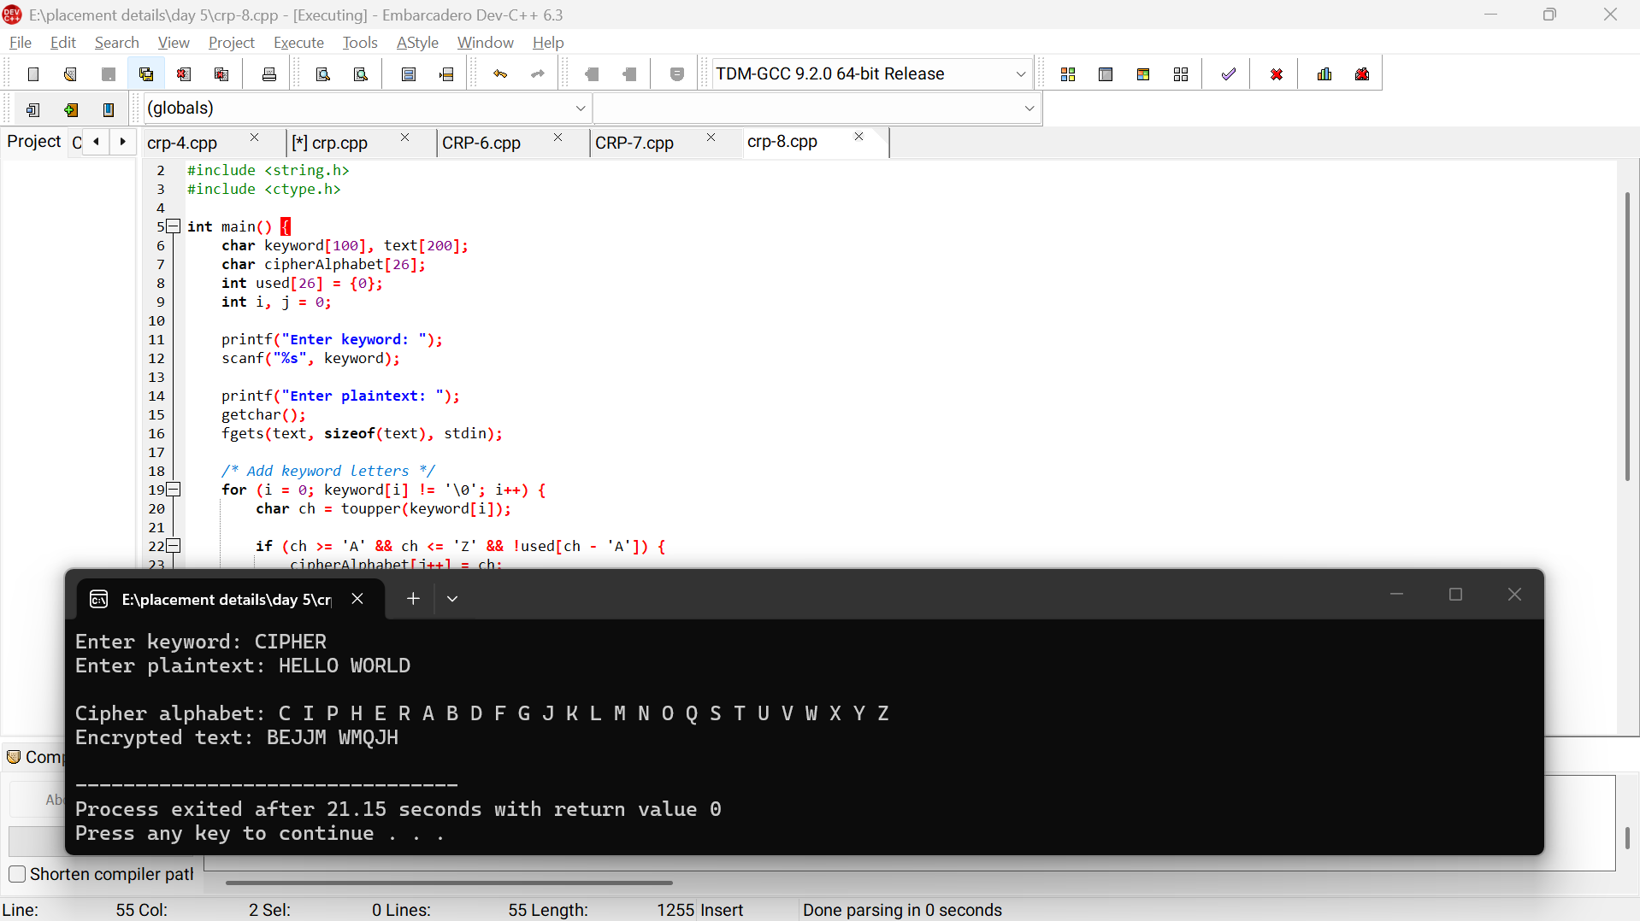
Result
Thus, a keyword-based monoalphabetic substitution cipher was successfully implemented.

