QUESTION-9
9. Write a C program for PT-109 American patrol boat, under the command of Lieutenant John F. Kennedy, was sunk by a Japanese destroyer, a message was received at an Australian wireless station in
Playfair code:
KXJEY UREBE ZWEHE WRYTU HEYFS
KREHE GOYFI WTTTU OLKSY CAJPO
BOTEI ZONTX BYBNT GONEY CUZWR
GDSON SXBOU YWRHE BAAHY USEDQ

Aim
To write a C program to decrypt the given PT-109 Playfair ciphertext.
Procedure
- Read the Playfair ciphertext.
- Construct the required 5×5 Playfair matrix.
- Divide the ciphertext into pairs.
- Apply Playfair decryption rules to each pair.
- Combine the decrypted pairs and remove filler characters.
- Display the recovered plaintext.
Code
C
#include <stdio.h>
#include <string.h>
#include <ctype.h>

char matrix[5][5] = {
{'M','F','H','I','K'},
{'U','N','O','P','Q'},
{'Z','V','W','X','Y'},
{'E','L','A','R','G'},
{'D','S','T','B','C'}
};

void findPos(char ch, int *r, int *c) {
int i, j;

if (ch == 'J')
ch = 'I';

for (i = 0; i < 5; i++)
for (j = 0; j < 5; j++)
if (matrix[i][j] == ch) {
*r = i;
*c = j;
return;
}
}

int main() {
char text[300], plain[300];
int i, r1, c1, r2, c2;

printf("Enter ciphertext:\n");
fgets(text, sizeof(text), stdin);

int k = 0;

for (i = 0; text[i] != '\0'; i++) {
if (isalpha(text[i]))
plain[k++] = toupper(text[i]);
}

plain[k] = '\0';

for (i = 0; i < k; i += 2) {
findPos(plain[i], &r1, &c1);
findPos(plain[i + 1], &r2, &c2);

if (r1 == r2) {
plain[i] = matrix[r1][(c1 + 4) % 5];
plain[i + 1] = matrix[r2][(c2 + 4) % 5];
}
else if (c1 == c2) {
plain[i] = matrix[(r1 + 4) % 5][c1];
plain[i + 1] = matrix[(r2 + 4) % 5][c2];
}
else {
plain[i] = matrix[r1][c2];
plain[i + 1] = matrix[r2][c1];
}
}

printf("Decrypted text: %s\n", plain);

return 0;
}
Sample Input
KXJEY UREBE ZWEHE WRYTU HEYFS
KREHE GOYFI WTTTU OLKSY CAJPO
BOTEI ZONTX BYBNT GONEY CUZWR
GDSON SXBOU YWRHE BAAHY USEDQ
Sample Output
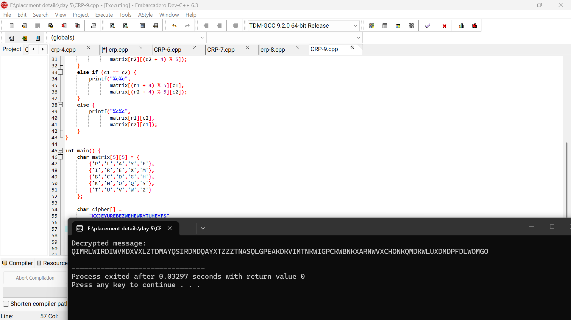
Result
Thus, the given ciphertext was decrypted using the Playfair cipher technique.

