QUESTION-2
2. Write a C program for monoalphabetic substitution cipher maps a plaintext alphabet to a ciphertextalphabet, so that each letter of the plaintext alphabet maps to a single unique letter of the ciphertext alphabet.

AIM
To write a C program to implement a Monoalphabetic Substitution Cipher, where each plaintext alphabet is mapped to a unique ciphertext alphabet.
PROCEDURE
- Start the program.
- Read the plaintext message.
- Define a substitution key containing 26 unique alphabets.
- Read each character of the plaintext.
- If the character is an alphabet, find its position in the alphabet.
- Replace it with the corresponding character from the substitution key.
- Keep spaces and special characters unchanged.
- Display the encrypted ciphertext.
- Stop the program.
C CODE

#include <stdio.h>
#include <string.h>

int main()
{
char plaintext[100];
char key[27] = "QWERTYUIOPASDFGHJKLZXCVBNM";
int i, index;

printf("Enter the plaintext: ");
fgets(plaintext, sizeof(plaintext), stdin);

for (i = 0; plaintext[i] != '\0'; i++)
{
if (plaintext[i] >= 'A' && plaintext[i] <= 'Z')
{
index = plaintext[i] - 'A';
plaintext[i] = key[index];
}
else if (plaintext[i] >= 'a' && plaintext[i] <= 'z')
{
index = plaintext[i] - 'a';
plaintext[i] = key[index];
}
}

printf("Encrypted text: %s", plaintext);

return 0;
}
SAMPLE INPUT
Enter the plaintext: HELLO WORLD
SAMPLE OUTPUT
Encrypted text: ITSSG VGKSR
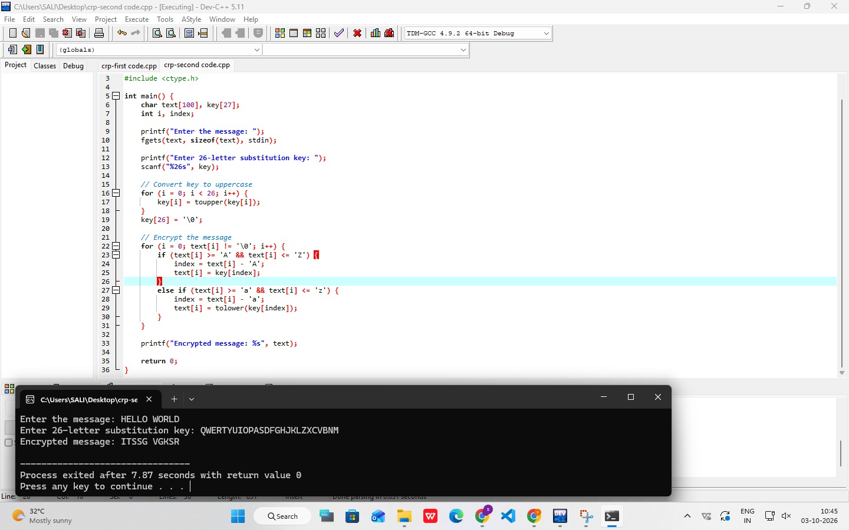
RESULT
Thus, the Monoalphabetic Substitution Cipher was successfully implemented in C, where each plaintext alphabet is replaced by its corresponding unique ciphertext alphabet.

