**RASA-ANAKAGE**

Outlook Category

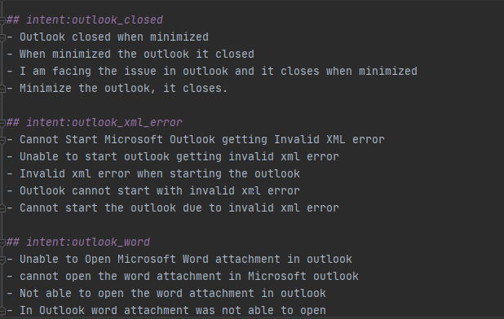

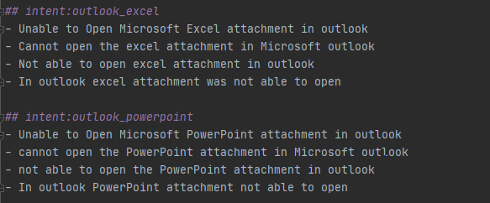

Printer Category

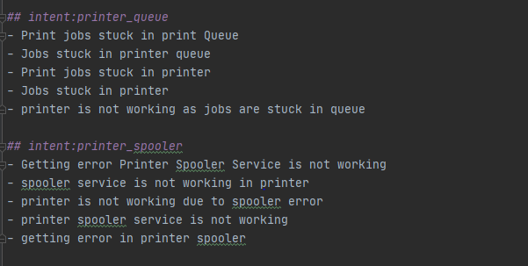

System issue

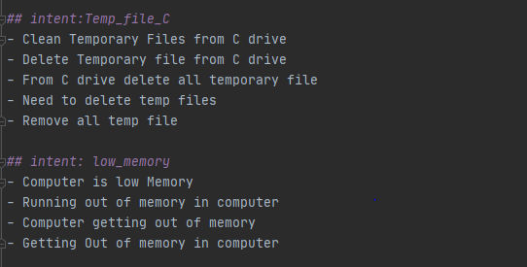

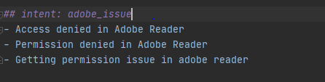

System Slow

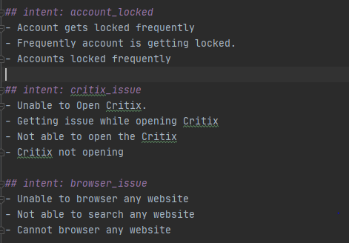

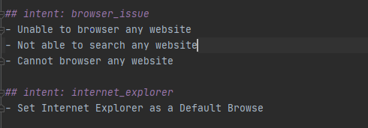

RASA Shell

Outlook category

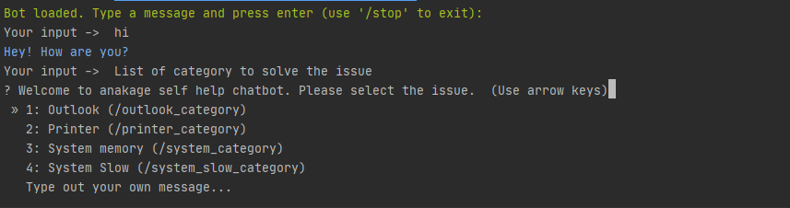

Sub-Category Outlook

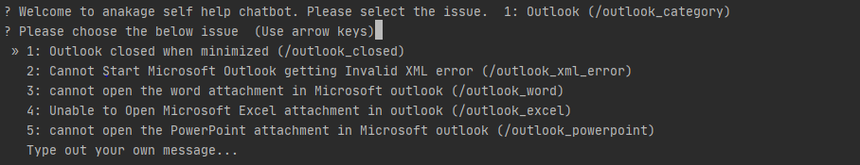

Solution for outlook issue:



**Store the Conversation in MongoDB**

Install the MongoDB

Download: <https://www.mongodb.com/download-center>

Create the folder in ‘C drive’ to store data

* Add the MongoDB configuration in rasa **endpoints.yml**

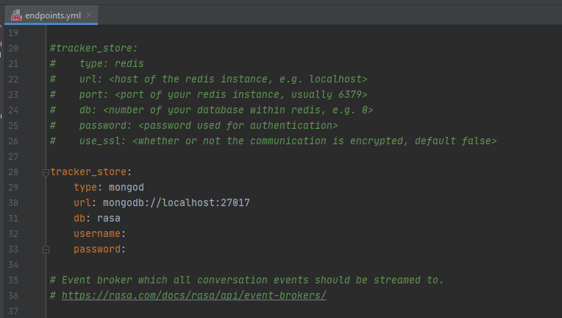

* C:\Program Files\MongoDB\Server\4.2\bin
* mongod.exe --dbpath "C:\rasa"

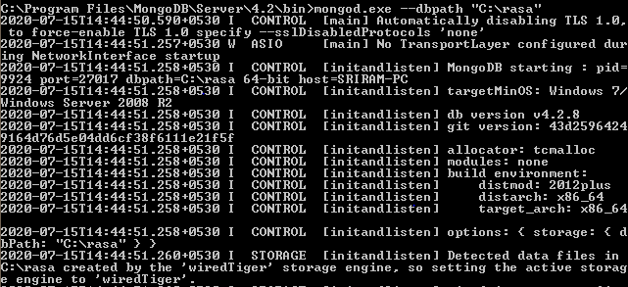

* mongo.exe
* use rasa
* db.conversations.find().pretty()
* check the collections in MongoDB