**SLACK-RASA CHATBOT**

Slack is a collaboration hub that can replace email to help you and your team to work together seamlessly. It’s designed to support the way in which people naturally work together, so that you can collaborate with people online as efficiently as you do face-to-face.

**Prerequisites:**

1. Working RASA Chatbot on your local machine.
2. Ngrok Software to be downloaded on your local machine. It’s used for local RASA Chatbot and Slack for exchanging the message over a secure link

Download: <https://ngrok.com/download>

1. Good Internet Connection.

**Steps:**

1. **Creating Slack App**

Before creating a slack app, you need to create a slack workplace by using your email id

Link: <https://slack.com/create#email>

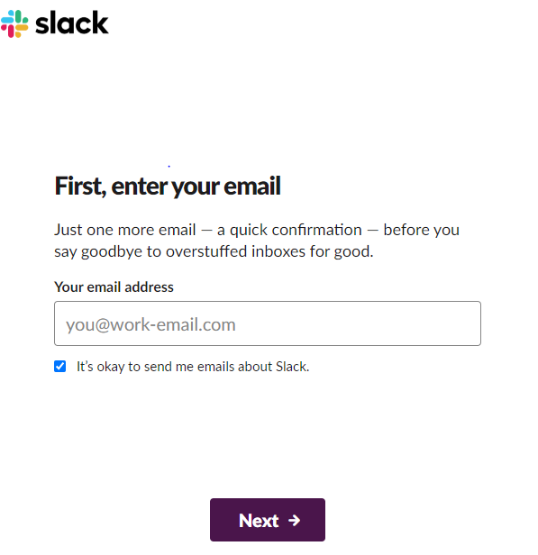

Once the workspace is created, then create a new app within the workspace.

Link: <https://api.slack.com/apps>

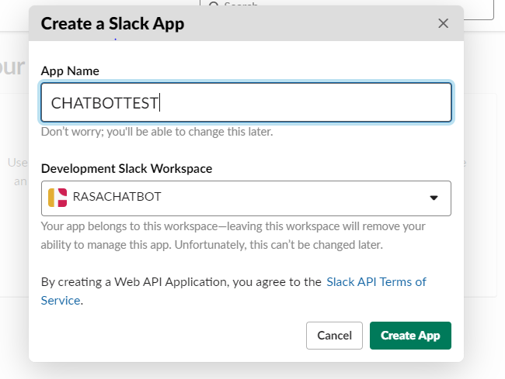

It will be directed to the **Basic information section** and you should scroll down to reach the **Display Information**. Here you have the option of filling the name, description, a photo and a background color for your bot (Optional).

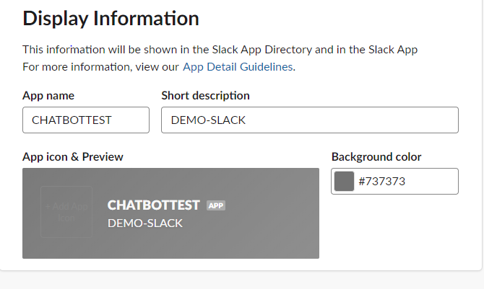

Once you have filled the above attributes, the **Save Changes** option should get activated. You should click it to confirm the changes.

1. **Authorization and Permission for your BOT**

* Add the permissions for your bot so that it can read and write text messages with anyone who wants to interact with your bot.
* Navigate to **OAuth & Permissions** tab on the left side menu of the page and scroll down to **Scope**section
* Drop down to the **Bot Token Scopes.**

Add **chat:write, im:read, im:write, im:history and mpim:history**

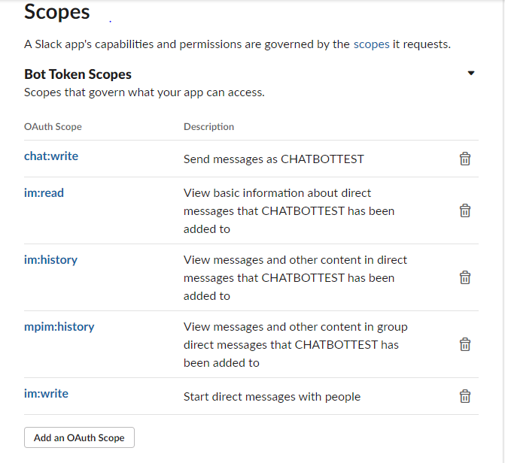

* Now, scroll up and click **Install App** option to install the app on slack with these permissions.
* A pop up window would appear notifying that your bot is asking for permissions on your workspace. Go ahead and click **Allow**

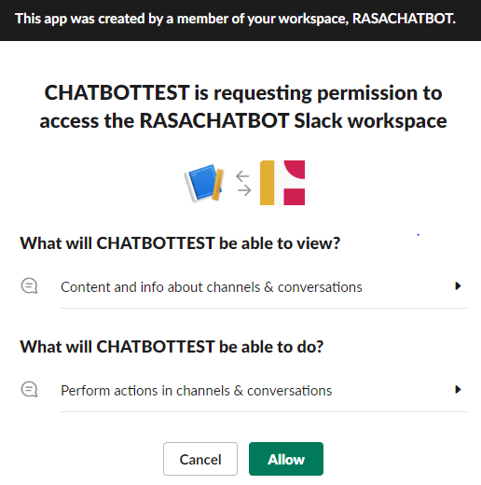

* After installing the app with the permissions, you have will receive the key to connect your slack bot with your RASA bot.

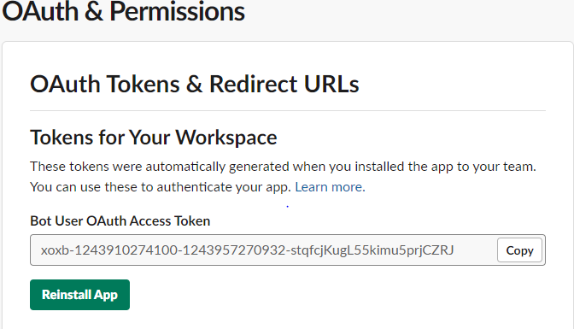

1. **Setting up credentials.yml page**

The next step is to copy the above bot token and paste in the credentials.yml page of your RASA project.

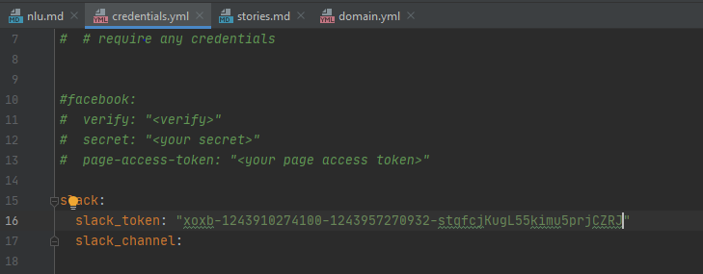

1. **Running scripts for actions, ngrok and shell**

* **Run actions server**

Ensure to uncomment the action_endpoint tag in the endpoints.yml page of your project.

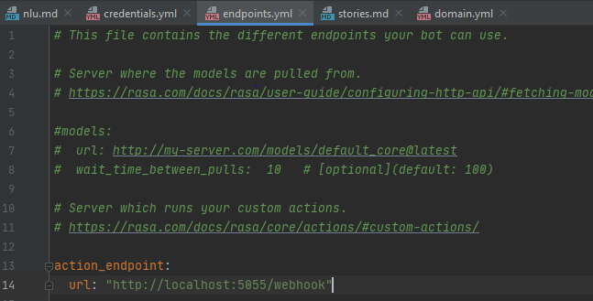

Start the RASA action server on your local machine command: **rasa run actions**

* **Run RASA Shell**

**rasa run --port 5002 --connector slack --credentials credentials.yml --endpoints endpoints.yml --log-file out.log --cors * --enable-api –debug**

* **Start ngrok on the 5002 port of localhost**

The next job is start ngrok on port 5002 by opening a command prompt and typing the command **ngrok http 5002**

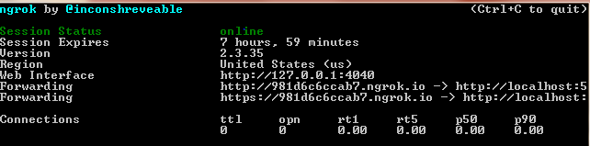

Copy the second forwarding URL: [**https://981d6c6ccab7.ngrok.io**](https://981d6c6ccab7.ngrok.io)and append **webhooks/slack/webhook** to get something like below

<https://981d6c6ccab7.ngrok.io>/webhooks/slack/webhook

1. **Final Configuration of slack**

You need to first go to the **Event Subscription** section from the left hand side menu options and then toggle **the Enable Events switch** on the page to ensure it is **ON**.

Copy the ngrok URL and paste it. We get it as **Verified**.

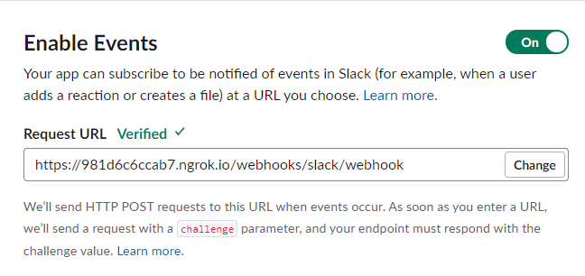

In the same page, go to **Subscribe to bot events** and add the following 2 events: **message.im and message.mpim**

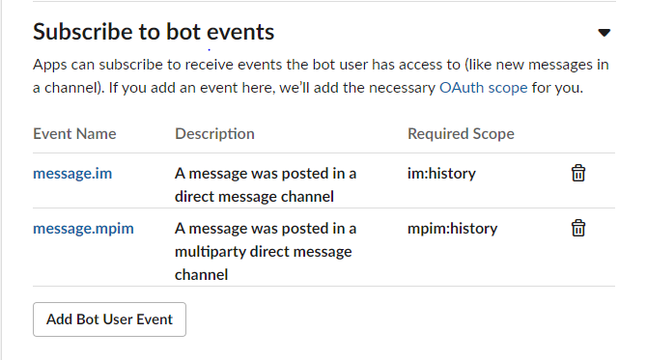

Adding these events will prompt you **to save the changes** and **reinstall the app**. Go ahead and reinstall the app and that’s it!

To start chatting with your bot, go to [**https://slack.com/intl/en-in/**](https://slack.com/intl/en-in/)and **click Launch Slack** to go to your workspace.

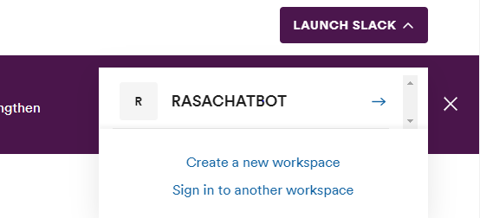

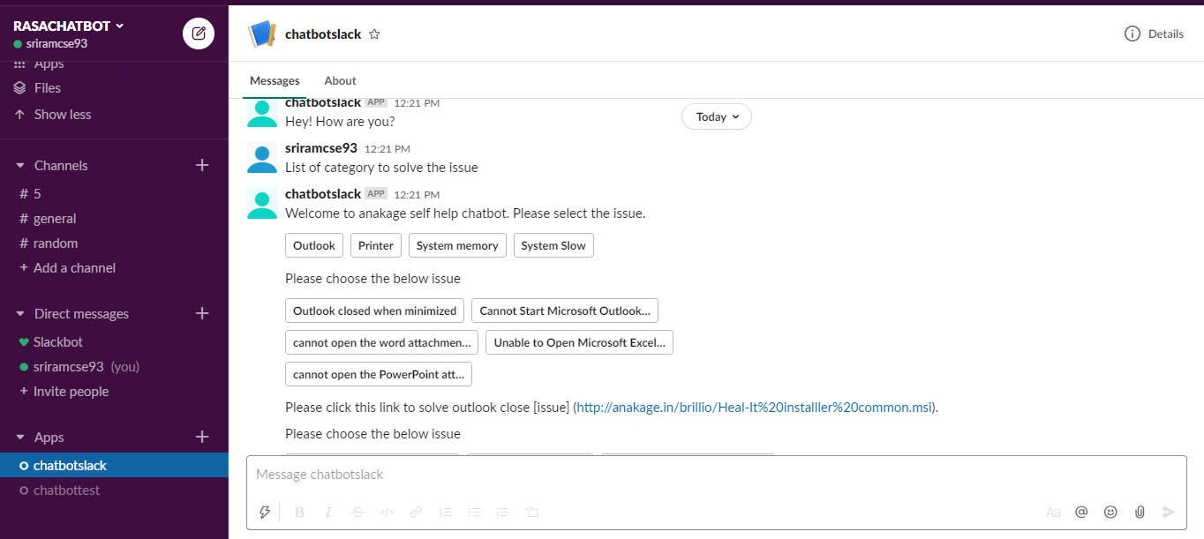

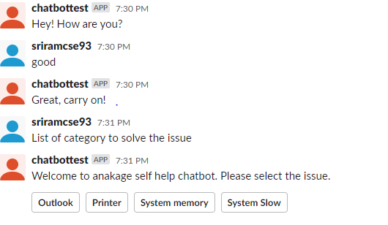

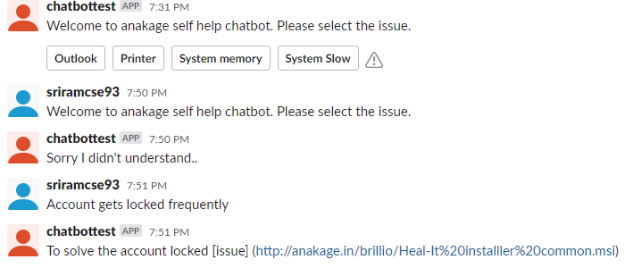

**Reference Link:** <https://medium.com/analytics-vidhya/integrating-your-rasa-chat-bot-with-slack-c18bffc6018b>

**Issue 1:**

RASA payload buttons not working in Slack API

**Error:**

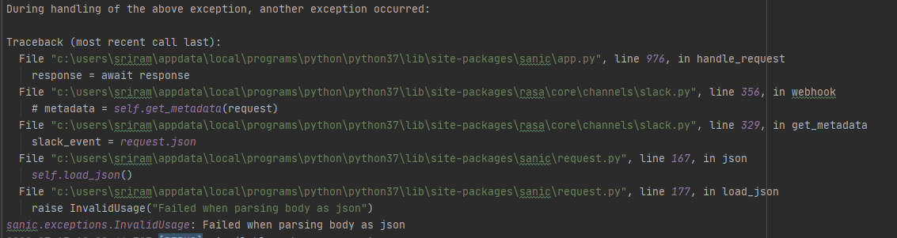

**Solution:**

Need to update the connector in slack.py

C:\Users\SRIRAM\AppData\Local\Programs\Python\Python37\Lib\site-packages\rasa\core\channels\slack.py

**Line: 356**

Update the below code and restart the rasa run.

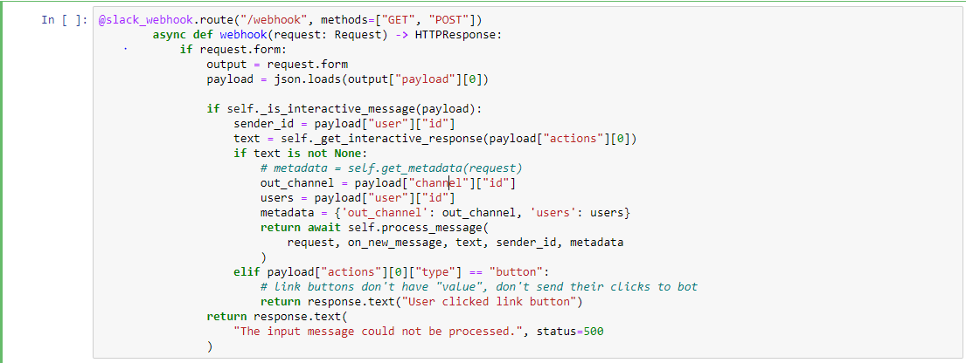

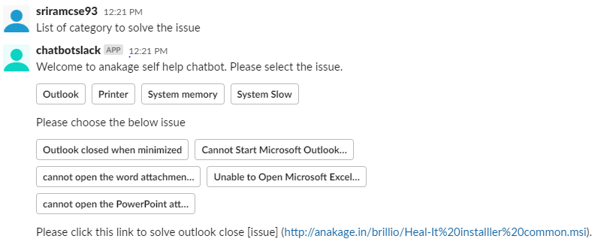

**Reference Link:** <https://github.com/RasaHQ/rasa/issues/5704>