1. Category of Anakage

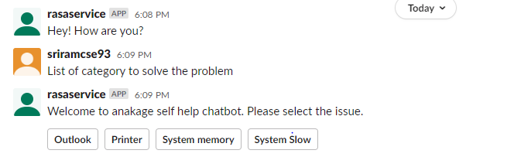

1. Outlook Sub Category

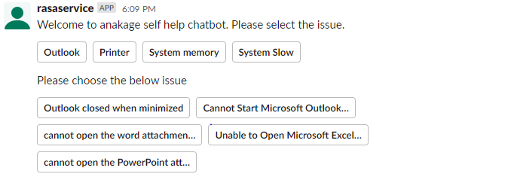

1. Solution for Outlook Closed when minimized

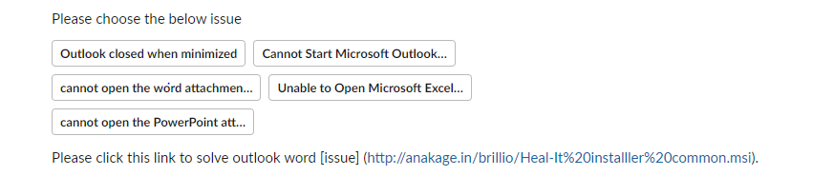

1. Printer Sub Category



1. Solution for Printer jobs stuck



1. System memory Sub Category

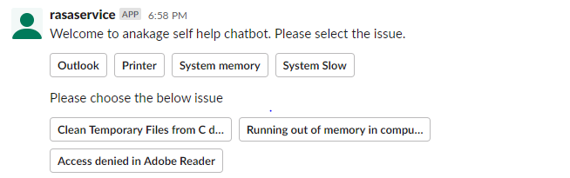

1. Solutions for Access denied

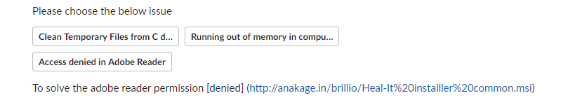

1. System Slow Sub Category

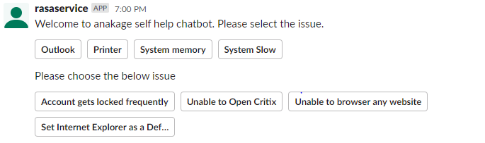

1. Solution for Account gets locked

