Tunable MEMS Comb Drive DC Capacitor

Sriram Ganapati Bhagwat, Venkata Sri Harshini Boorela, Avyukt Sharma, Kai Tan, Qiuyi Wu  
*Instructor:* Dr. Marco Colangelo, *Teaching Assistant:* Mr. Onurcan Kaya

***Tunable MEMS Comb Drive DC Capacitor***

[1] Abstract

**This research describes a 2.4 GHz MEMS comb-structured variable dc capacitor with a capacitance tuning range of 300% while avoiding undesired coupling through the springs. This innovative varactor is made up of two comb structures that are both fixed to the substrate and moveable, suspended on mechanical springs. The mechanical mechanism is decoupled from the DC capacitor in this new design, allowing for a separate optimum design.**

# INTRODUCTION

T

unable MEMS Comb Drive DC Capacitor is a microelectromechanical system (MEMS) device that utilizes a comb-drive actuator mechanism to dynamically change its capacitance. This tunability allows for precise control of electrical signals in various applications, including: 1. RF circuits: Tuning filters, oscillators, and other RF components. 2. Optical modulators: Modulating the intensity of light in optical communication systems. 3. Sensors: Detecting pressure, strain, and other physical parameters.

The Components which are used are as follows:

1. Comb fingers: Interdigitated electrodes on both fixed and movable plates.
2. Actuation mechanism: Comb-drive structure powered by DC voltage.
3. Capacitance plates: The electrodes that form the capacitor.
4. Springs: Suspend the movable plate and provide restoring force.

The working principle Tunable MEMS Comb Drive DC Capacitor :

Applying a DC voltage across the comb fingers creates an electrostatic force that attracts the shifting plate to the stationary plate.

The movement of the movable plate changes the overlap area between the capacitor plates, thus changing the capacitance.

The springs provide a restoring force that opposes the electrostatic force, resulting in a stable position for the movable plate at a specific DC voltage.

## **What is the device?**

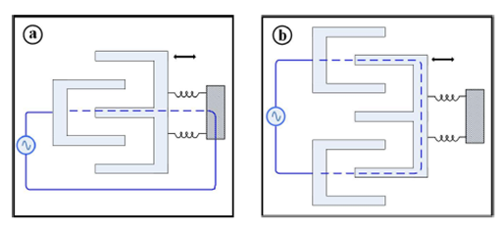

Figure 1:Comb capacitor

A comb varactor is composed of two interdigit comb structures Figure 1, one is fastened to the substrate, while the other is held in place by mechanical springs that allow it to move toward the anchored comb. The variable capacitance is located between these two combs, and the mechanical spring links them electrically. The mechanical spring modifies the varactor circuit by adding serial resistance and serial inductance, reducing the quality factor and resonance frequency.

Yet another concept. There are three comb-like structures. The first two combs are permanently attached to the substrate, while the third (movable comb) is held in place by mechanical springs. Because the capacitance is from one anchored comb to the mobile comb and back to the second anchored comb, the contact to the movable comb is capacitive, mechanical spring and the dc capacitor are totally separated.

# Motivation / Advantages:

High tuning range: Comb-drive actuators can achieve a large change in capacitance.

Low power consumption: DC operation requires minimal power compared to other tunable capacitor technologies.

Compact size: MEMS technology allows for miniaturization of the device.

High Q-factor: Low losses in the device enable efficient signal processing.

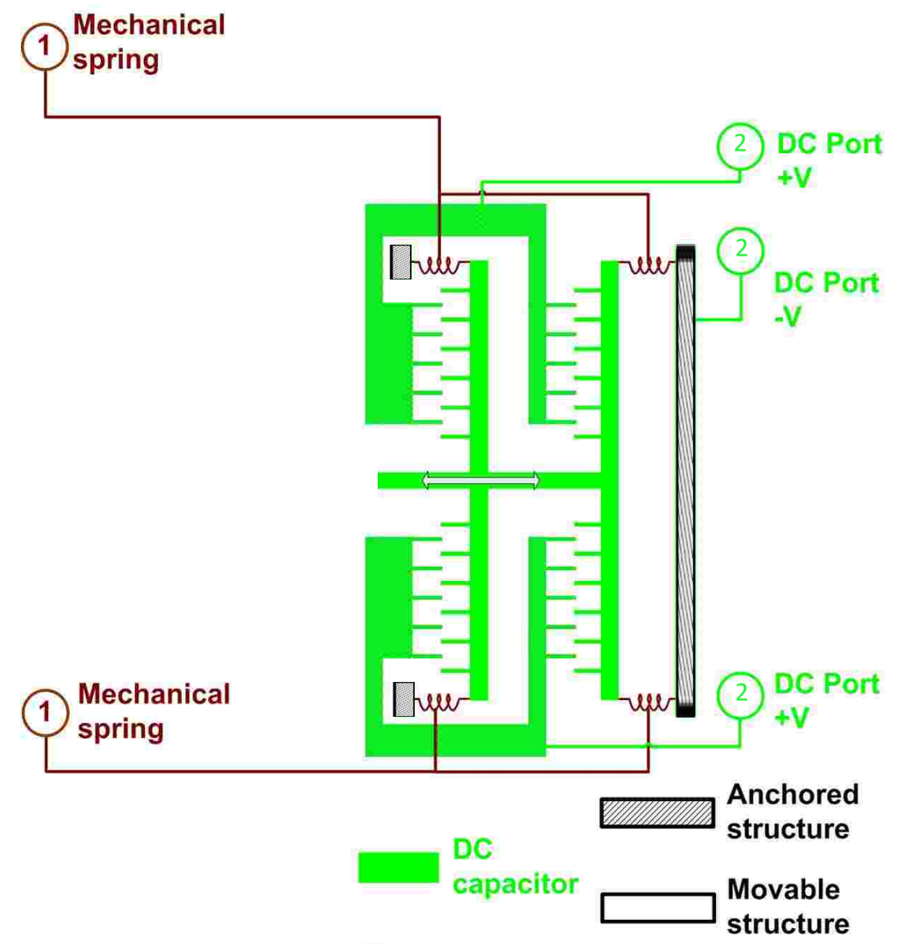

Figure 2 : A schematic view of Tunable MEMS Comb Drive DC Capacitor

DC part consists of multiple comb-like structures and mechanical springs(Figure 2). Half of the combs are anchored to the substrate, as well as the other half are mechanically held springs. Analyzing the net force for the voltage is, the effective spring constant is a negative constant, which means the increase in gap will cause the decrease in force [1]. Therefore, the system is always stable and there is no spring softening/hardening.

Multiple comb-like structures increase the total capacitor value, resulting in larger net force and better robustness. There are some major factors: moving part of RF capacitor, serial resistance, and serial inductance of the mechanical springs, etc.

## **what is the problem that the device is intended to solve?**

There are several signal integrity difficulties in wireless communications, such as reflection and impedance mismatch, which resulted in significant signal loss, which are becoming increasingly vital as both industries (wireless communications and MEMS) improvements. Signal loss happens when an impedance mismatch prevents the supplied signal from being fully received by the receiver during the transmission session. As a result, an impedance matching network, also known as a tuner, is required to reduce any signal loss caused by impedance mismatch between the sending and receiving antennas, as well as the accompanying components.

# Device Specifications

Tunable capacitors, with focus on certain IoT applications. [1]

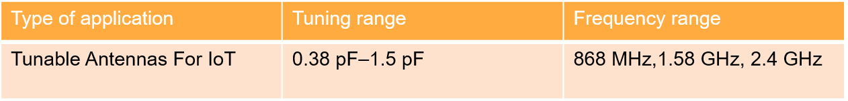

Figure 3

Our device targets on IoT applications with the tuning range as 0.38pF to 1.5pF and the frequency till 2.4GHz

## **Applications for Tunable Antennas in IoT devices has many advantages as follows:**

1. Multi-band and Multi-protocol Devices
2. Enhanced Coverage and Signal Strength
3. Reduced Power Consumption
4. Improved Security
5. MEMS capacitors have a high Q factor
6. Compact size
7. **Multi-band and Multi-protocol Devices:**

Tunable antennas enable IoT devices to operate across multiple frequency bands and protocols, such as cellular, Wi-Fi, Bluetooth and even more. This eliminates the need for multiple antennas and simplifies device design.

For Example: Nowadays smart devices can switch between cellular and Wi-Fi networks depending on availability and cost.

1. **Enhanced Coverage and Signal Strength:**

Tunable antennas can be adjusted to optimize their radiation pattern and improve signal strength in challenging environments. This can be particularly beneficial in areas with weak signal reception or complex signal propagation paths.

Examples: Smart agricultural sensors can adjust their antenna parameters to ensure reliable communication even in remote areas.

1. **Reduced Power Consumption:**

Tunable antennas can be fine-tuned to operate at the minimum required power level for a specific communication scenario. This can significantly reduce the power consumption of the device, extending its battery life.

Examples: Low-power wireless sensor networks can extend their lifespan by adjusting their antenna parameters to optimize communication efficiency. Wearable devices can conserve battery power by dynamically adapting their antenna performance to changing environments.

1. **Improved Security:**

Tunable antennas can be used to implement frequency hopping techniques, making it more difficult for unauthorized devices to intercept communications.

Examples: Industrial control systems can utilize frequency hopping to enhance security and prevent unauthorized access to critical data. Wireless medical devices can employ tunable antennas for secure communication of sensitive patient information.

1. **MEMS capacitors have a high Q factor: which Indicates the device with low losses.**

The Q factor is a crucial factor for tunable capacitors since it quantifies the antenna's bandwidth.

1. **Compact size:**

As you may be aware, mems devices are extremely tiny and small in comparison to other devices.

## **Antenna tuning:**

Antenna tuning is the process of adjusting the impedance of an antenna to match the impedance of the radio transmitter or receiver that it is connected to. This is important for maximizing the efficiency of the antenna and preventing damage to the radio.

Now the Tuning range is given by:

Tuning range = (Cmax – Cmin / Cmax )* 100 = 294.736%

So, our Tuning range is calculated as shown here, which is around 300%

Our target for ΔC is as follows ;

ΔC = Cmax – Cmin = 1.5pF – 0.38pF = 1.12pF

## **Quality factor:**

The quality factor (Q factor) of a tunable MEMS comb drive DC capacitor is an important characteristic showing the device's performance and efficiency. It essentially measures how well the capacitor stores and releases electrical energy, with a higher Q factor signifying less energy loss and better performance.

The quality factor is given by

Here, fc is the center frequency

For example, in our case if we consider for 4G applications fc is 2.325GHz corresponds to a range of f1 = 2.3GHz to f2 = 2.4GHz. and here we get the Qfactor ≈ 5 : 1

## **Impedance of Capacitor :**

The impedance of a capacitor is given by the formula:

**Z= 44.204 Ω**

Here we consider frequency as 2.4GHz and the capacitance C = 1.5pF

Therefore, the **series equivalent resistance** for this capacitor is approximately **44.2 Ω**.

Our target for impedance is 50 Ω so we get the C Equivalent value as 1.33pF

When using transmitters, antenna tuners are quite crucial. Typically, resistive loads with a fixed value of **50 ohms** or less are reactance-free and is suited to receive power from transmitters. However, depending on the frequency and other factors, the feedline and antenna's impedance may change.

**Similarly calculating for equivalent C and Z values for the complete range shown in this Table A:** Figure 4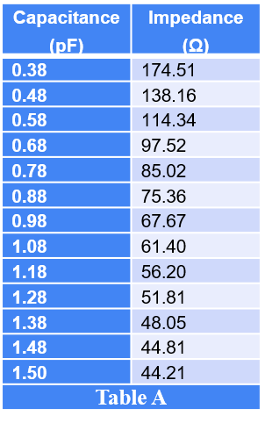

Figure 4

Here, Zc is the capacitive impedance, C is the capacitive capacitance, and f is the frequency.

## **Capacitive Reactance:**

Here, Xc is the Capacitive Reactance.

Here Depending on the frequency, inductive or capacitive reactance has various dominating values.

When the capacitance is increased, the capacitive reactance drops, and therefore the impedance reduces.

When capacitance is reduced, capacitive reactance rises, and so impedance rises.

As a result, we employ the impedance "Z" for high frequencies.

We now know that capacitive reactance varies along with the frequency, but resistance does not.

Now we can say as impedance-Z will vary when frequency vary. As seen by the graph (Figure 5)

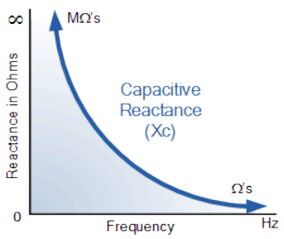

Figure 5 : Capacitive Reactance and Frequency Relationship

## **The Comb Drive Equation:**

The Comb Drive Equation illustrates the connection between the electrostatic force produced by a comb-drive actuator and a variety of factors. Figure 6

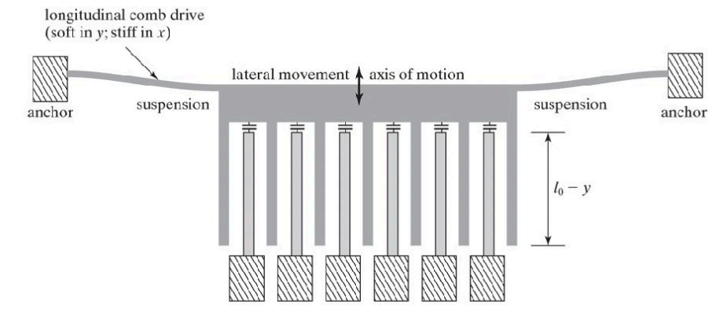

Figure 6

How does a Comb drive work? you may ask,

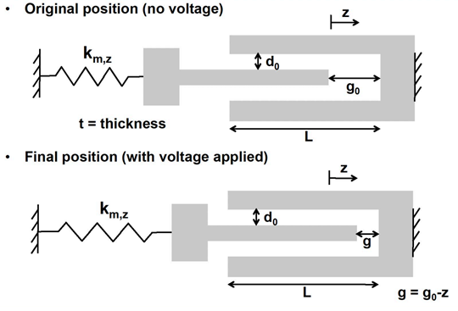

Figure 7

A comb drive, as seen above(Figure 7), generates motion by using electrostatic forces. It is made up of two sets of interdigitated comb-shaped electrodes: a fixed comb and a moveable comb.

When we apply voltage across it the comb moves, and the displacement is given by z

And the formula for displacement is as given below

here:

* ε 🡪 per-mittivity of the dielectric material between the plates ( F / m )
* g 🡪 gap between fingers (in m)
* g0 🡪 Initial distance/gap between the finger(m)
* V 🡪 DC-voltage applied (F)
* k 🡪 spring constant (Hz)

## **Sensitivity:**

The sensitivity of a Tunable MEMS Comb Drive DC Capacitor refers to the change in capacitance per unit change when voltage is applied across the capacitor.

It is typically expressed in units of femtofarads per volt.

Figure 7

Sz is given as

Where d0 initial Gap distance between the fixed and movable combs as shown here.

## **Mechanical Spring :**

The mechanical spring constant (k) is a crucial parameter in Tunable MEMS Comb Drive DC Capacitors, as it determines the relationship between the applied force (F) and the resulting displacement of the movable plate shown in Figure 7

* The movable comb is attached to a spring that provides a restoring force, opposing the electrostatic force.
* This spring force helps to control the motion of the movable comb and prevents it from collapsing onto the fixed comb.

The mechanical spring-constant k is given as:

Where E🡪 Young’s modulus and

We have I = (wt3)/12 .

And for n Fixed- guided beams the k is updated as shown here.

Note : Our structure uses fixed-guided beam as mechanical spring

The Number of fingers in our comb structure is also calculated using the following equation.

We can use the following formula to calculate the gap between the fingers (g) ( Figure 7)

here:

* ε 🡪 per-mittivity of the dielectric material between the plates ( F / m )
* A🡪 is area of one capacitor plate (m2)
* g 🡪 gap between the fingers (m)
* C 🡪 Capacitor capacitance (F)
* F 🡪 frequency (Hz)

## **Role of Spring Constant in Tunable MEMS Comb Drive DC Capacitors:**

1. Tuning Range: The spring constant directly influences the tuning range of the capacitor. A higher spring constant limits the displacement of the movable plate, restricting the capacitance change and consequently the tuning range. Conversely, a lower spring constant allows for larger displacements and a wider tuning range, but at the expense of reduced stability and controllability.
2. Resonant Frequency: The spring constant, along with the mass of the movable plate, determines the resonant frequency of the MEMS structure. This resonance frequency can be problematic if it falls within the operating frequency range of the capacitor, as it can lead to unwanted vibrations and instability.
3. Linearity: The ideal spring behavior for a tunable MEMS capacitor is linear, where the force is directly proportional to the displacement. However, real MEMS structures exhibit some non-linearity due to factors like fabrication imperfections and stress variations. The spring constant should be designed to minimize this non-linearity for optimal performance.

## **Pull-in Voltage :**

The pull-in voltage nothing but the maximum DC voltage that can be applied before the movable comb structure collapses onto the fixed comb structure.

This collapse occurs due to the electrostatic attraction between the combs increasing with voltage, eventually overcoming the restoring forces of the spring supporting the movable comb.

The Formula for the pull in Voltage is shown, Figure 8

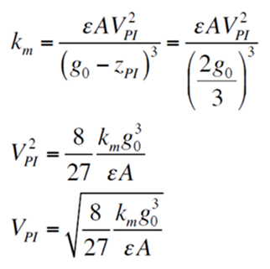

Figure 8

Pull in happens when the net spring constant goes to zero (Figure 10)

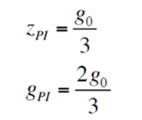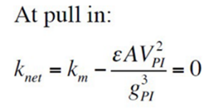

Figure 10

Figure 9

1. The gap at which pull in occurs is always 2/3 of the initial gap Figure 9
2. The voltage at which pull in occurs depends on the characteristics of the system which is the

− initial gap g0

− Stiffness of the mechanical spring

− Area and material used inside capacitor Figure 9

## **Electrostatic force :**

The electrostatic force between the fixed and movable combs is given as in Figure 11

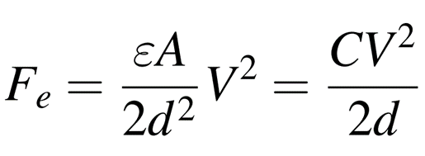

Figure 11

This force Fe is generated by the attractive electrostatic interaction between the charged comb fingers and is responsible for the movement of the movable comb.

## **Reliability**

Tunable capacitor performance can alter over time, especially if they are put in a hostile environment. Tunable dc capacitors are considered more dependable than MEMS switches’. This is since, unlike MEMS switches, the adjustable capacitor plates do not come into contact, and there is no dielectric layer between the capacitor plates, hence no dielectric layer charging occurs. Dielectric layer charging is a significant issue in MEMS-based devices [2]. This implies that the capacitor's dielectric charging has no influence on the pull-in voltage, which is a major concern with MEMS-based switches. Similarly, MEMS tunable capacitors do not require hermetically sealing since humidity does not affect charging or surface-contact issues [3] [4].

## **Noise :**

Noise in tunable MEMS comb drive DC capacitors refers to unwanted electrical fluctuations that can degrade the performance and accuracy of the device. These fluctuations can arise from various sources, impacting the capacitor's capacitance, leakage current, and overall functionality.

Here are some of the noises in tunable MEMS comb drive DC capacitors:

* **Thermal Noise.**
* **Shot Noise.**
* **Flicker Noise (1/f Noise).**
* **Mechanical Noise.**
* **Substrate Noise.**

## **Future work:**

We plan to simulate dynamic analysis towards the finals as well – **how fast can we move this capacitor**

## **Mathematical computations (approx. values)**

The values that are required for the Fabrication Process are listed below.

1. Cmin = 0.38pF
2. Cmax = 1.5pF
3. F =2.4GHz
4. Tuning range= 294.736%
5. ΔC =1.12pF
6. L =200 μm length (assume)
7. w =20 μm width (assume)
8. T =3 μm thickness (assume)
9. g0 ≈5.54 μm
10. g ≈0.0236 μm
11. k ≈ 0.2 N/m
12. Nc = 44
13. ε0 ≈ 8.854 x 10-12 (C2N-1m2)
14. z ≈ 5.126*10-9 m
15. Vp =0.054407V
16. Z ≈ 174.51 Ω Impedance @C=0.38pF so when

**z= 50 Ω @C = 1.33pF**,

1. Fe = 3.384476 fFV-1 (femtofarads per volt)
2. Qfactor = 5:1
3. E = 160GPa 🡪Here E 🡪 Youngs modulus

# Device Simulations

## **Impedance & Capacitance relationship**

# Fabrication Process

In this part of the report, we will go through the fabrication process of our MEMS system. This includes all the details, for example mask pattern, choice of etchant, and cleaning process. The cross section of the device along with masks will also be shown as steps proceed.

1. Start with a Silicon wafer.



1. RCA clean
2. LPCVD, deposit a 3 microns of oxide layer as sacrificial layer.

Si

1. Photolithography, spin coat 4 microns of positive photoresist and expose with mask 1. (To create space to anchors)

Si

Mask 1 (UV light shines through blue area):

1. BOE etch through oxide layer.
2. Use piranha to remove photoresist and perform RCA clean.

Si

1. Deposit 2 microns of polysilicon on top of oxide layer. (Anchor thickness will be 4microns)

Si

1. Photolithography, spin coat 4 microns of positive photoresist and expose with mask 2.

Si

Mask 2 (UV light shines through blue area):

Note: The below picture shows a general pattern of mask 2 (finger = 4)

Si

1. Dry-etch polysilicon using reactive-ion etching.
2. Use piranha to remove photoresist and perform RCA clean.

Si

1. Used buffered HF to remove sacrificial layer.

Si

1. RCA clean.
2. Rinse and dry to critical point.

# Packaging

This part of the report will discuss some key steps of packaging starting with chip dicing. A brief explanation on which dicing technique we choose, and its advantages will be reported. Then we will quickly walk through how to combine fabrication process with chip dicing in our case and move on to packaging type and package dimensions.

## Blade Dicing

Blade dicing is water involved, and dicing generates heat due to friction between the cutting blade and the semiconductor material. Water is used as a coolant to dissipate this heat and prevent overheating of both the blade and the semiconductor wafer. Cooling is crucial to maintain the integrity of the semiconductor devices and prevent damage to the sensitive electronic components.

Water also acts as a lubricant during the dicing process. It reduces friction between the cutting blade and the semiconductor material, which helps in achieving a smoother and more precise cut. This is important for preventing damage to the delicate structures of the semiconductor devices.

Since blade dicing is chosen and water is involved, now we must consider when to apply blade dicing along with fabrication process. Thes best way to implement blade dicing is to cut the chip before releasing the device which is step 11 “Used buffered HF to remove sacrificial layer”. In this case, cutting the chip before removing sacrificial layer will not cause the device to break down.

## Package dimensions

For our device, ceramic packaging is selected simply because ceramics can be hermetically sealed, providing a barrier against moisture and other contaminants. This is important for protecting MEMS devices, as exposure to humidity or impurities can degrade device performance. Package dimensions must be big enough to make sure the chip fits in, after reviewing device dimensions which previously calculated, package dimensions have been proposed as below.

|  |  |
| --- | --- |
|  | mm |
| a | 0.6 |
| b | 1.2 |
| c | >1.2 |
| d | >1.2 |
| e | 1 |
| f | 0.8 |
| g | 0.5 |

# Conclusion

Because of their improved performance, MEMS tunable capacitors have surpassed CMOS tunable capacitors in the RF industry. This study provides an overview of electrostatically driven tunable capacitors. Different designs have been researched, and their impact on tunable capacitor performance enhancement has been studied. Furthermore, several applications of adjustable capacitors and their effect on application performance have been summarized. Due to the great performance of tunable capacitors in these frequency ranges, significant future research on high frequency ranges, terahertz (THz), and 5G ranges is predicted.

Significant work on MEMS-based electrostatically adjustable capacitors has been published during the last two decades. To enhance tuning range, quality factor, and linearity, several out-of-plane and in-plane designs using parallel-plate, lateral comb drive systems, and a mix of both topologies have been documented utilizing various materials and manufacturing procedures. Some of them also focused on enhancing the dependability of tunable capacitors, however the reliability is usually excellent owing to the device's non-contact nature. The kind of actuation, manufacturing of fab process, and design factors, such as plate gaps and dimensions, all have a significant impact on the performance of tunable capacitors.

Pending/future activity :

Device structure:

* Separation of actuator and capacitor

Mathematical computations:

* Device size values
* Formulating equations

Dynamic modeling:

* Device response time
* State equations

# References

|  |  |
| --- | --- |
| [1] | T. Z. L. G. O. L. a. Y. N. E. David, "High tuning range MEMS capacitor for microwave applications," *2009 IEEE International Conference on Microwaves, Communications, Antennas and Electronics Systems,* pp. 1-4, 2019. |
| [2] | F. a. M. I. Y. Khan, "RF MEMS electrostatically actuated tunable capacitors and their applications: A Review," *Journal of Micromechanics and Microengineering,* vol. 32, p. 013002, 2021. |
| [3] | V. S. W, "5-GHz band highly linear VCO IC with a novel resonant circuit 2007 Topical Meeting on Silicon Monolithic Integrated Circuits in RF," *Capacitive RF MEMS switch dielectric charging and reliability: a critical review with recommendations J. Micromech. Microeng.,* vol. 074001, p. 22, 2012. |
| [4] | R. G. M, "RF MEMS: Theory, Design, and Technology," *RF MEMS: theory, design, and technology,* 2004. |

1.