Tunable MEMS Comb Drive Capacitor

Sriram Ganapati Bhagwat   
*Instructor:* Dr. Marco Colangelo

[1] Abstract

**This research describes a MEMS comb structured variable capacitor at 20GHz that features a wide capacitance tuning range of 200% while avoiding undesired coupling through the springs. This innovative varactor is made up of two comb structures that are both fixed to the substrate and moveable, suspended on mechanical springs. With this unique design, mechanical mechanism the RF capacitor and mechanical mechanism may be designed independently for best results.**

# INTRODUCTION

T

unable MEMS Comb Drive Capacitor is a microelectromechanical system (MEMS) device that utilizes a comb-drive actuator mechanism to dynamically change its capacitance. This tunability allows for precise control of electrical signals in various applications, including: 1. RF circuits: Tuning filters, oscillators, and other RF components. 2. Optical modulators: Modulating the intensity of light in optical communication systems. 3. Sensors: Detecting pressure, strain, and other physical parameters.

The Components which are used are as follows:

1. Comb fingers: Interdigitated electrodes on both fixed and movable plates.
2. Actuation mechanism: Comb-drive structure powered by DC voltage.
3. Capacitance plates: The electrodes that form the capacitor.
4. Springs: Suspend the movable plate and provide restoring force.

The working principle Tunable MEMS Comb Drive Capacitor:

Applying a DC voltage across the comb fingers creates an electrostatic force that attracts the shifting plate to the stationary plate.

The movement of the movable plate changes the overlap area between the capacitor plates, thus changing the capacitance.

The springs provide a restoring force that opposes the electrostatic force, resulting in a stable position for the movable plate at a specific DC voltage.

**What is the device?**

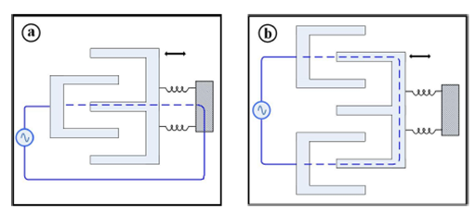

Figure 1:Comb capacitor

A comb varactor is composed of two interdigit comb structures Figure 1, one is fastened to the substrate, while the other is held in place by mechanical springs that allow it to move toward the anchored comb. The variable capacitance is located between these two combs, and the mechanical spring links them electrically. The mechanical spring modifies the varactor circuit by adding serial resistance and serial inductance, reducing the quality factor and resonance frequency.

Yet another concept. There are three comb-like structures. The first two combs are permanently attached to the substrate, while the third (movable comb) is held in place by mechanical springs. Because the capacitance is from one anchored comb to the mobile comb and back to the second anchored comb, the contact to the movable comb is capacitive, mechanical spring and the dc capacitor are totally separated.

# Motivation / Advantages:

High tuning range: Comb-drive actuators can achieve a large change in capacitance.

Low power consumption: DC operation requires minimal power compared to other tunable capacitor technologies.

Compact size: MEMS technology allows for miniaturization of the device.

High Q-factor: Low losses in the device enable efficient signal processing. 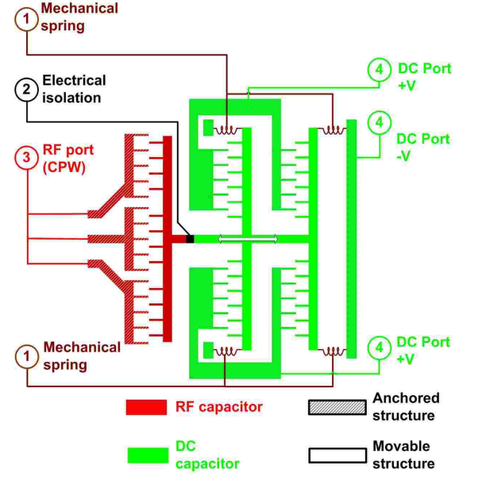

Figure 2: A schematic view of Tunable MEMS Comb Drive Capacitor

DC part consists of multiple comb-like structures and mechanical springs(Figure 2). Half of the combs are anchored to the substrate, as well as the other half are mechanically held springs. Analyzing the net force for the voltage is, the effective spring constant is a negative constant, which means the increase in gap will cause the decrease in force [1]. Therefore, the system is always stable and there is no spring softening/hardening.

Multiple comb-like structures increase the total capacitor value, resulting in larger net force and better robustness. There are some major factors: moving part of RF capacitor, serial resistance, and serial inductance of the mechanical springs, etc.

## **what is the problem that the device is intended to solve?**

There are several signal integrity difficulties in wireless communications, such as reflection and impedance mismatch, which resulted in significant signal loss, which are becoming increasingly vital as both industries (wireless communications and MEMS) improvements. Signal loss happens when an impedance mismatch prevents the supplied signal from being fully received by the receiver during the transmission session. As a result, an impedance matching network, also known as a tuner, is required to reduce any signal loss caused by impedance mismatch between the sending and receiving antennas, as well as the accompanying components.

# Device Specifications

Tunable capacitors, with focus on certain IoT applications. [1]

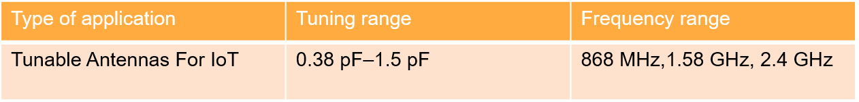

Figure 3

Our device targets on IoT applications and for microwave application with the tuning range as 0.38pF to 1.5pF and the frequency till 2.4GHz for the DC part and with combined RF we can go up to 20GHz.The more details on frequency , Q and operating voltage is shown in the below table.

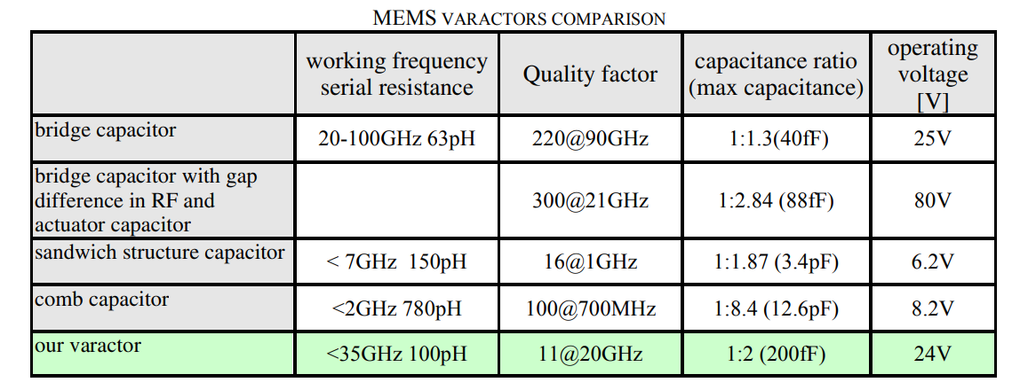

## **Applications for Tunable Antennas in IoT devices has many advantages as follows:**

1. Multi-band and Multi-protocol Devices
2. Enhanced Coverage and Signal Strength
3. Reduced Power Consumption
4. Improved Security
5. MEMS capacitors have a high Q factor
6. Compact size

## **Antenna tuning:**

Antenna tuning is the process of adjusting the impedance of an antenna to match the impedance of the radio transmitter or receiver that it is connected to. This is important for maximizing the efficiency of the antenna and preventing damage to the radio.

Now the Tuning range is given by:

Tuning range = (Cmax – Cmin / Cmax )* 100 = 294.736%

So, our Tuning range is calculated as shown here, which is around 300%

Our target for ΔC is as follows ;

ΔC = Cmax – Cmin = 1.5pF – 0.38pF = 1.12pF

## **Quality factor:**

The quality factor (Q factor) of a tunable MEMS comb drive DC capacitor is an important characteristic showing the device's performance and efficiency. It essentially measures how well the capacitor stores and releases electrical energy, with a higher Q factor signifying less energy loss and better performance.

The quality factor is given by

Here, fc is the center frequency

For example, in our case if we consider for 4G applications fc is 2.325GHz corresponds to a range of f1 = 2.3GHz to f2 = 2.4GHz. and here we get the Qfactor ≈ 5 : 1

## **Impedance of Capacitor :**

The impedance of a capacitor is given by the formula:

**Z= 44.204 Ω**

Here we consider frequency as 2.4GHz and the capacitance C = 1.5pF

Therefore, the **series equivalent resistance** for this capacitor is approximately **44.2 Ω**.

## **The Comb Drive Equation:**

The Comb Drive Equation illustrates the connection between the electrostatic force produced by a comb-drive actuator and a variety of factors. Figure 6

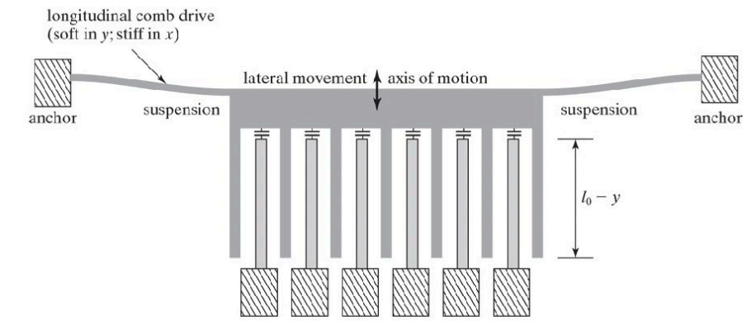

Figure 4

How does a Comb drive work? you may ask,

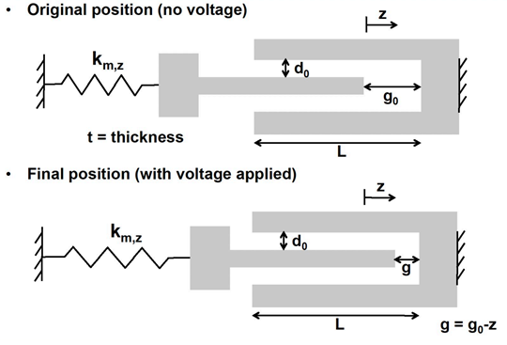

Figure 5

A comb drive, as seen above(Figure 7), generates motion by using electrostatic forces. It is made up of two sets of interdigitated comb-shaped electrodes: a fixed comb and a moveable comb.

When we apply voltage across it the comb moves, and the displacement is given by z

And the formula for displacement is as given below

here:

* ε 🡪 per-mittivity of the dielectric material between the plates ( F / m )
* g 🡪 gap between fingers (in m)
* g0 🡪 Initial distance/gap between the finger(m)
* V 🡪 DC-voltage applied (F)
* k 🡪 spring constant (Hz)

## **Reliability**

Tunable capacitor performance can alter over time, especially if they are put in a hostile environment. Tunable dc capacitors are considered more dependable than MEMS switches. This is since, unlike MEMS switches, the adjustable capacitor plates do not come into contact, and there is no dielectric layer between the capacitor plates, hence no dielectric layer charging occurs. Dielectric layer charging is a significant issue in MEMS-based devices [2]. This implies that the capacitor's dielectric charging has no influence on the pull-in voltage, which is a major concern with MEMS-based switches. Similarly, MEMS tunable capacitors do not require hermetically sealing since humidity does not affect charging or surface-contact issues [3] [4].

# Fabrication Process

In this part of the report, we will go through the fabrication process of our MEMS system. This includes all the details, for example mask pattern, choice of etchant, and cleaning process. The cross section of the device along with masks will also be shown as steps proceed.

1. Start with a Silicon wafer.



**Note:**

**We will do the fabrication part for the top layer first which is for Low resistivity silicon shown below:**

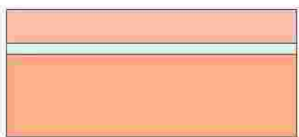

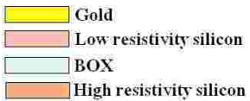

1. RCA clean
2. LPCVD, deposit a 3 microns of oxide layer as sacrificial layer.

Si Low resistivity

1. Photolithography, spin coat 4 microns of positive photoresist and expose with mask 1. (To create space to anchors)

Si Low resistivity

Mask 1 (UV light shines through blue area):

Si Low resistivity

1. BOE etch through oxide layer.
2. Use piranha to remove photoresist and perform RCA clean.

Si Low resistivity

1. Deposit 2 microns of polysilicon on top of oxide layer. (Anchor thickness will be 4microns)

Si Low resistivity

1. Photolithography, spin coat 4 microns of positive photoresist and expose with mask 2.

Si Low resistivity

Mask 2 (UV light shines through blue area):

Note: The below picture shows a general pattern of mask 2 (for comb structures, colored area blocks light)

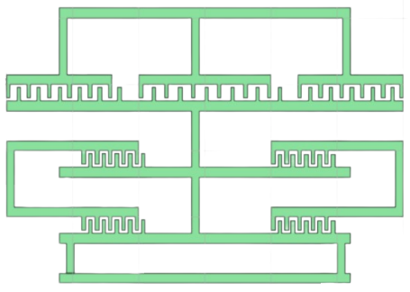

Si Low resistivity

1. Dry-etch polysilicon using reactive-ion etching.
2. Use piranha to remove photoresist and perform RCA clean.

Si Low resistivity

1. Used buffered HF to remove sacrificial layer.

Si Low resistivity

1. RCA clean.
2. Rinse and dry to critical point.
3. Now Flip the wafer and etch the below part

Si High resistivity

BOX

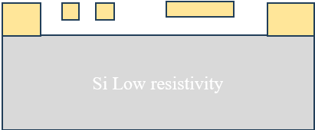

1. Now do Photolithography, spin coat 4 microns of negative photoresist and expose with the mask 3 shown below.(colored area blocks light)
2. Etch the high resistivity layer

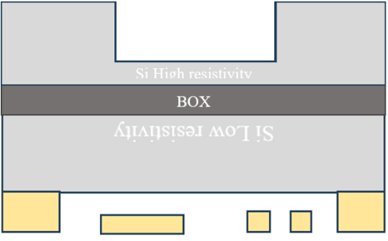

1. Now again etch the layer using the mask below(colored area blocks light)

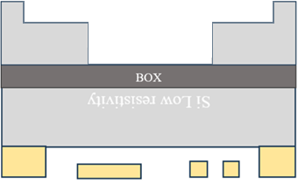

End of fabrication process.

# Device Variations for High tuning range MEMS capacitor

Now, create the device's mask using phidl (python coding), and align each mask with the others as indicated below figure 8 and transform into a file for gds.

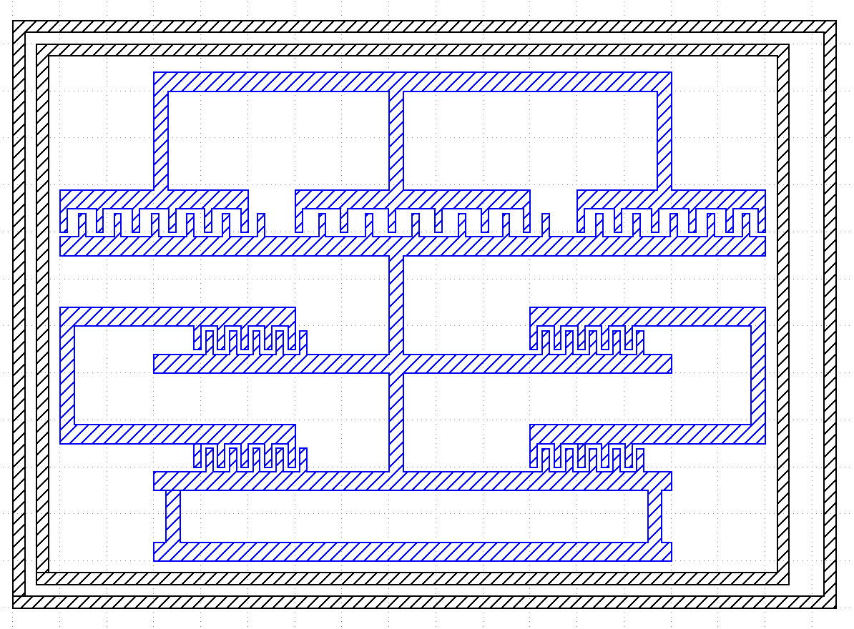

Figure 6

[Click here](https://github.com/sriramgb/Micro_nano_My_project) to get the code and GDS files

# Layout Top View for High tuning range MEMS capacitor

Now adjust the comb length and width properties, and the top view of all the devices is shown below.

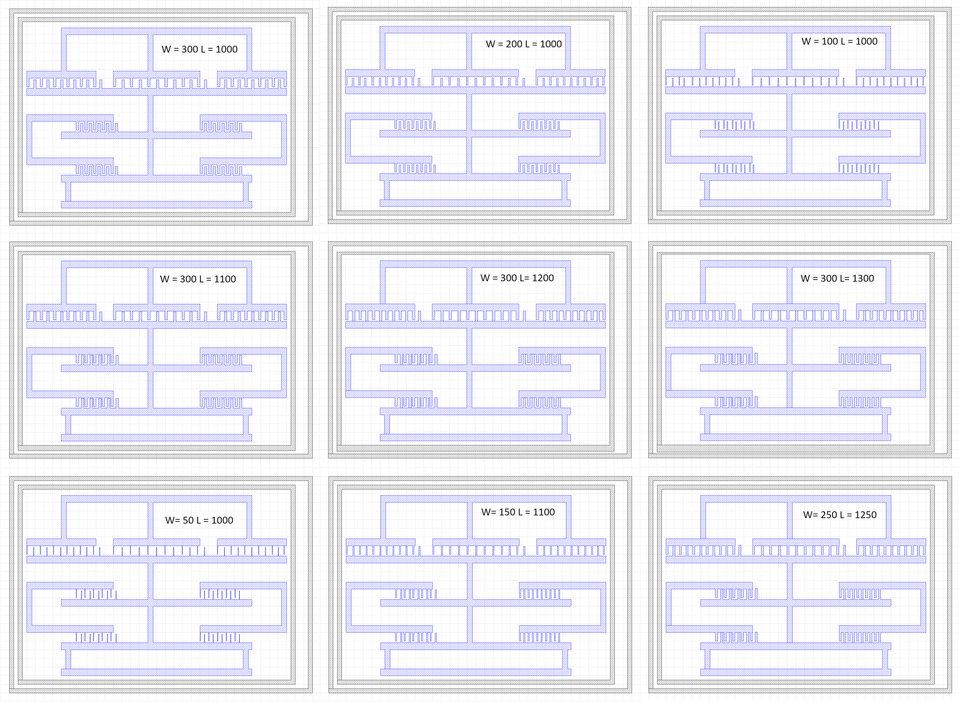

Figure 7

Three masks are displayed beside/below the above image. If all three masks are integrated, figure 9 is produced.

Mask 1

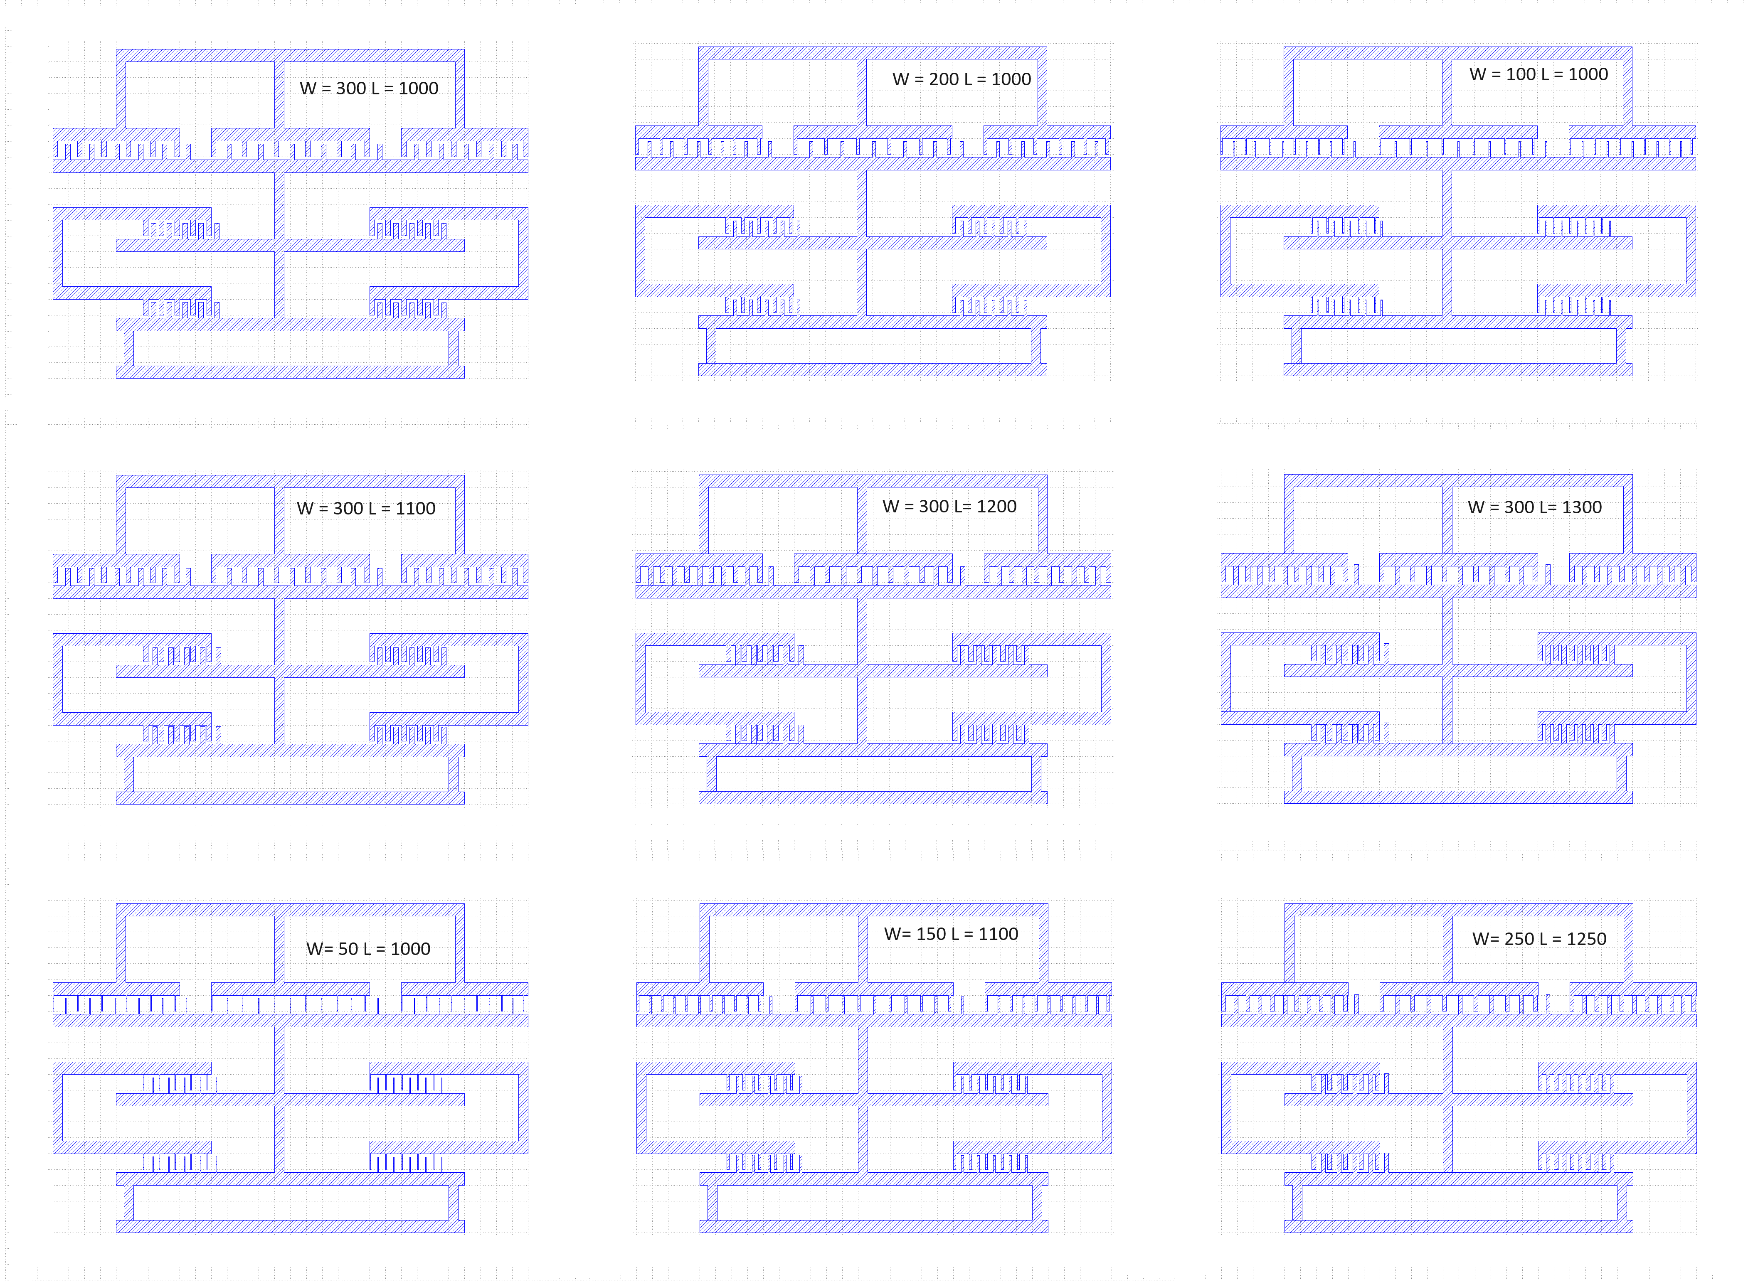

Mask 2

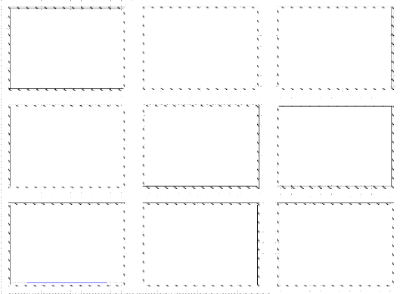

Mask 3

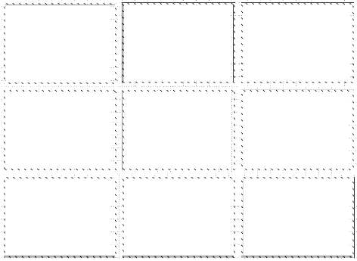

# Test Structures for High tuning range MEMS capacitor

**1) Step-resolution**

The pg.litho_steps() function creates lithographic test structure that is useful for measuring resolution of photoresist or electron-beam resists. It provides both positive-tone and negative-tone resolution tests.

import phidl.geometry as pg

from phidl import quickplot as qp

D = pg.litho_steps(

line_widths = [1,2,4,8,16],

line_spacing = 10,

height = 100,

layer = 0

)

qp(D) # quickplot the geometry

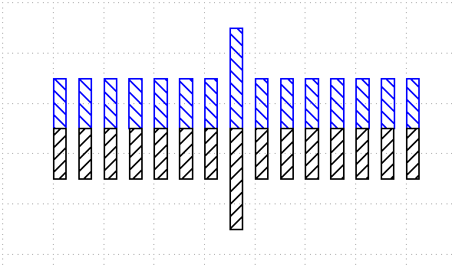

Figure 8

**2) Calipers (inter-layer alignment)**

The pg.litho_calipers() function is used to detect offsets in multilayer fabrication. It creates a two sets of notches on different layers. When an fabrication error/offset occurs, it is easy to detect how much the offset is because both center-notches are no longer aligned.

import phidl.geometry as pg

from phidl import quickplot as qp

D = pg.litho_calipers(

notch_size = [1,5],

notch_spacing = 2,

num_notches = 7,

offset_per_notch = 0.1,

row_spacing = 0,

layer1 = 1,

layer2 = 2)

qp(D) # quickplot the geometry

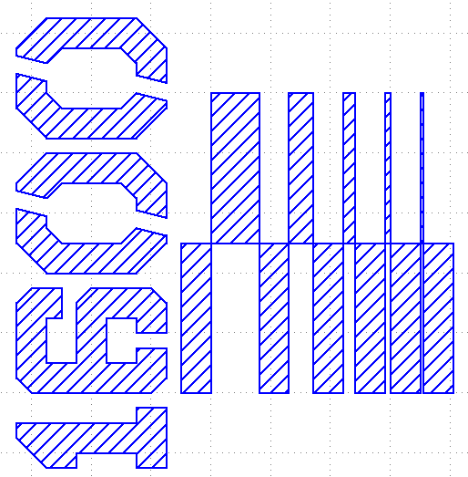

Figure 9

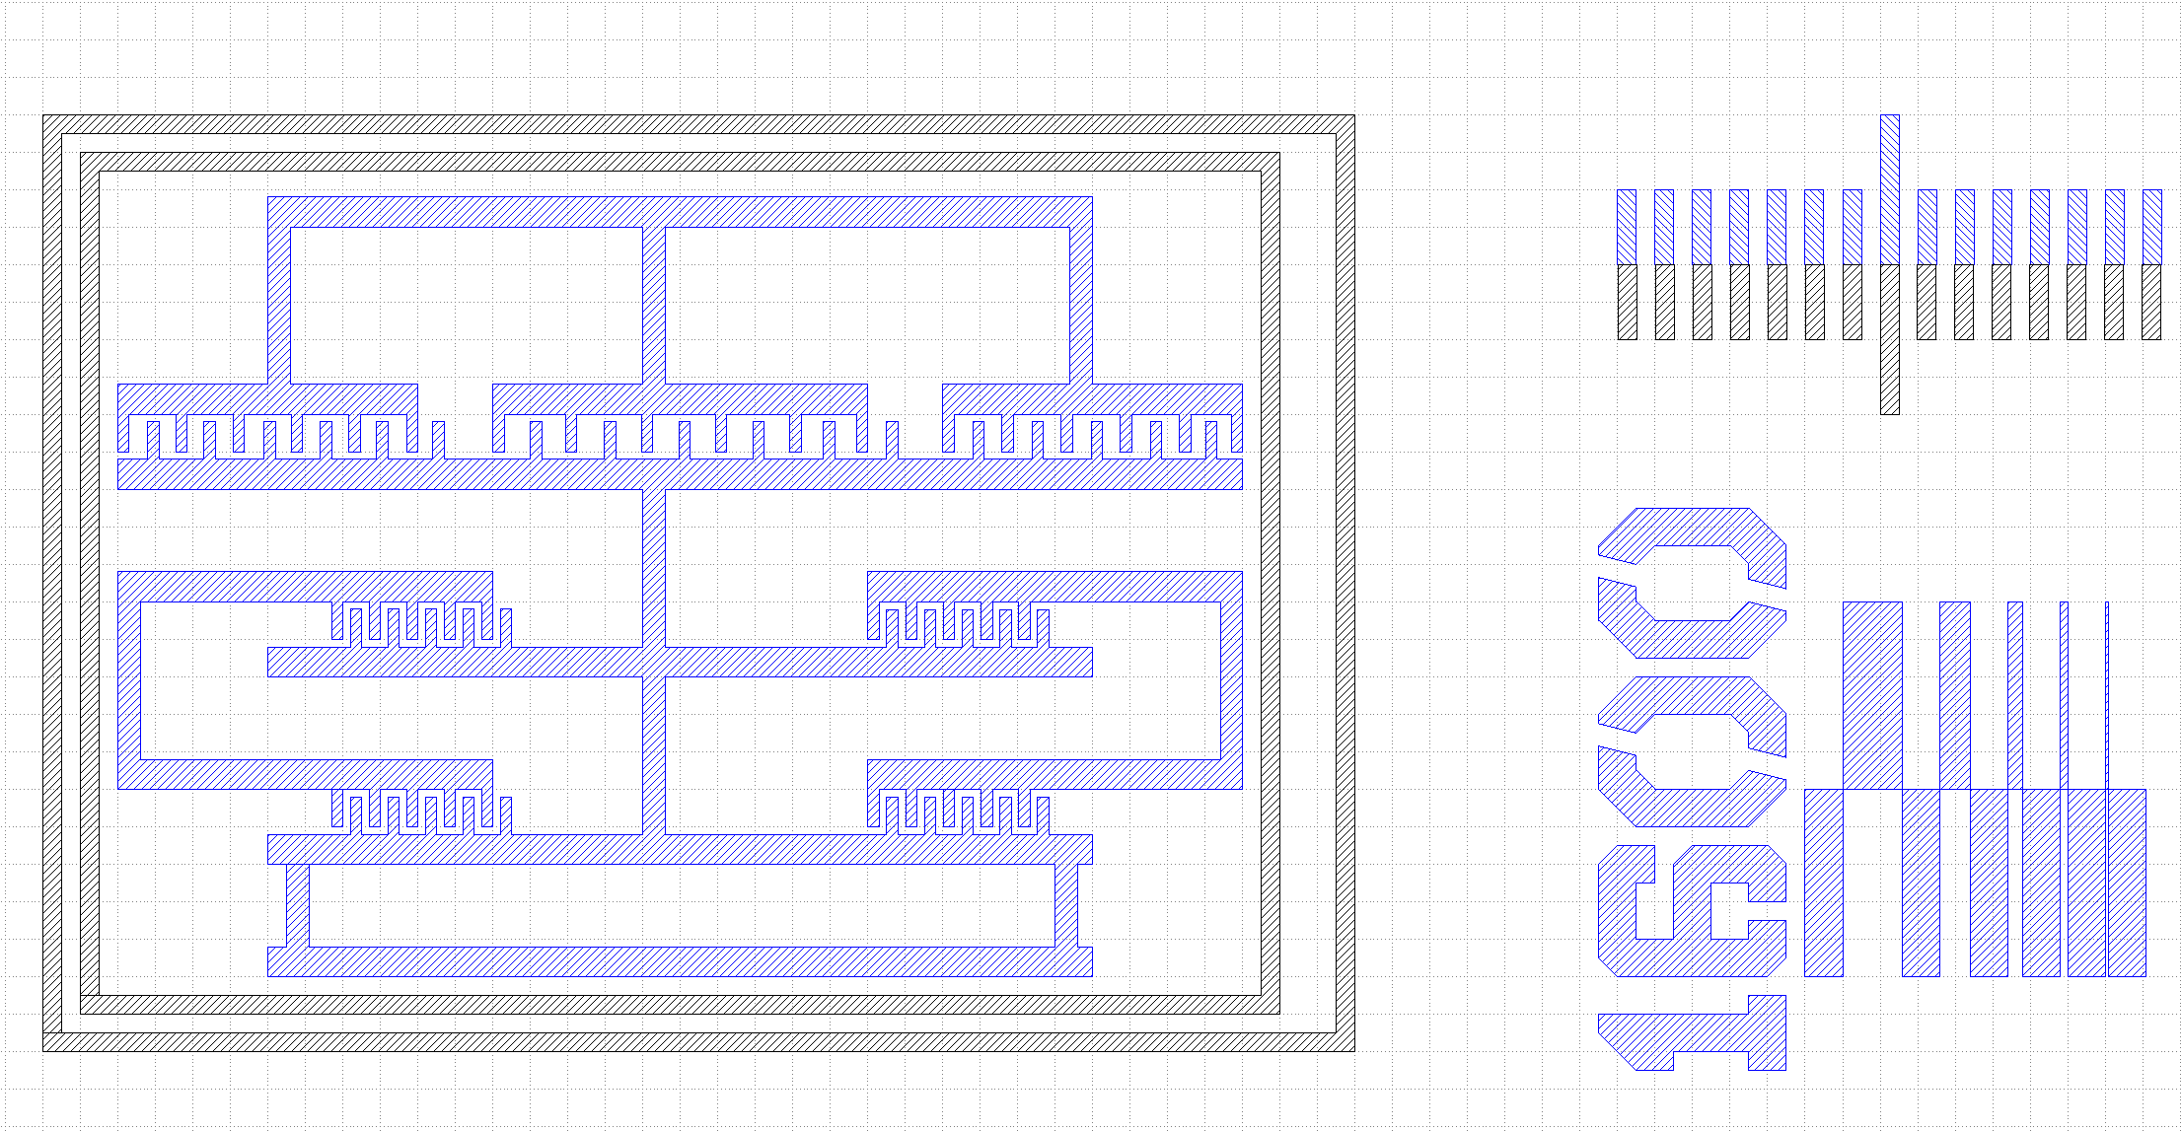

Figure 10

**Note:** Here we test the Low resistivity silicon and high resistivity Silicon using the below device which we done similar in Lab 6.

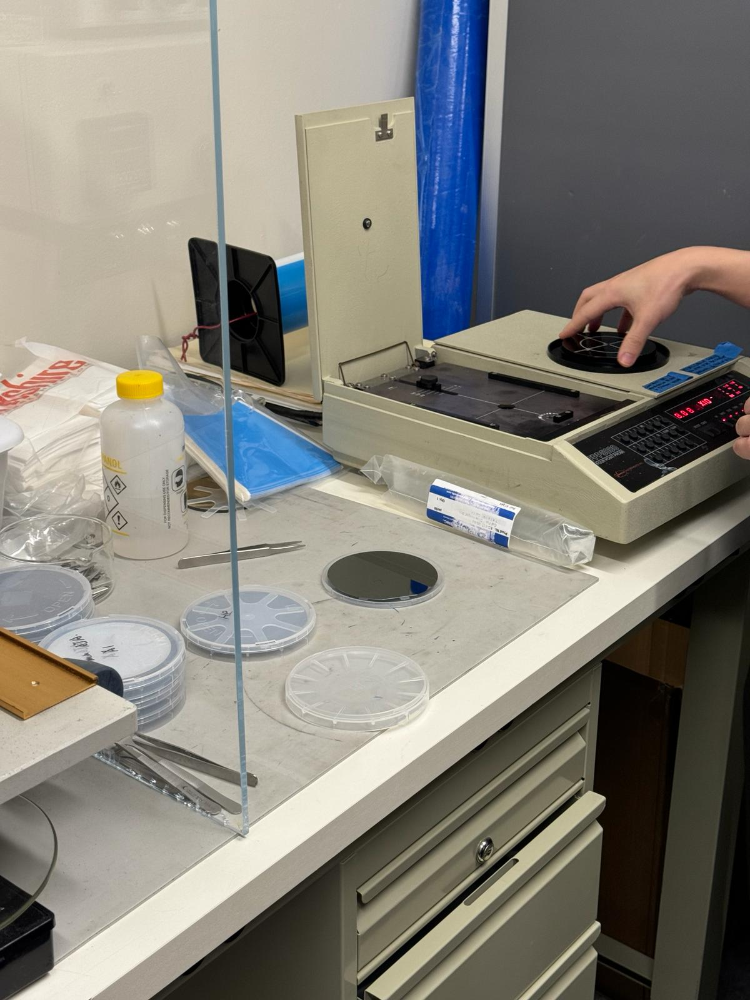

Figure 11

# References

|  |  |
| --- | --- |
| [1] | T. Z. L. G. O. L. a. Y. N. E. David, "High tuning range MEMS capacitor for microwave applications," *2009 IEEE International Conference on Microwaves, Communications, Antennas and Electronics Systems,* pp. 1-4, 2019. |
| [2] | F. a. M. I. Y. Khan, "RF MEMS electrostatically actuated tunable capacitors and their applications: A Review," *Journal of Micromechanics and Microengineering,* vol. 32, p. 013002, 2021. |
| [3] | V. S. W, "5-GHz band highly linear VCO IC with a novel resonant circuit 2007 Topical Meeting on Silicon Monolithic Integrated Circuits in RF," *Capacitive RF MEMS switch dielectric charging and reliability: a critical review with recommendations J. Micromech. Microeng.,* vol. 074001, p. 22, 2012. |
| [4] | R. G. M, "RF MEMS: Theory, Design, and Technology," *RF MEMS: theory, design, and technology,* 2004. |

1.