**SMART PARKING USING INTERNET OF THING (IOT)**

*The rapid urbanization and growing vehicle population have led to an increasing demand for efficient and intelligent parking management solutions. Traditional parking systems often result in congestion, wasted time, and environmental pollution. In response to these challenges, this paper presents a comprehensive Smart Parking System (SPS) empowered by the Internet of Things (IoT) technology.

*The proposed IoT-based Smart Parking System leverages a network of sensors and communication devices to monitor and manage parking spaces in real-time. These sensors are strategically deployed in parking areas, and they continuously collect data related to parking space occupancy and availability. This data is then transmitted to a central cloud-based platform for analysis and dissemination.

**Key components of the system include**:

**Sensor Network**: Low-cost, energy-efficient sensors are employed to detect the presence or absence of vehicles in parking spaces. These sensors communicate wirelessly with the central platform.

**Data Processing and Analysis**: The cloud-based platform processes the data received from the sensors in real-time. Machine learning algorithms are employed to predict parking space availability and optimize resource allocation.

**User Interface:** An intuitive mobile application and web portal provide users with real-time information about available parking spaces, navigation to the nearest available spot, and the ability to make reservations.

**Notifications and Alerts**: Users can receive notifications and alerts through the mobile app, reducing the time spent searching for parking spaces and minimizing frustration.

**Payment Integration**: The system offers seamless payment integration, allowing users to pay for parking digitally, reducing the need for physical payment methods.

**Environmental Benefits**: By optimizing parking space allocation and reducing the time spent searching for parking, the system contributes to reduced traffic congestion and lower carbon emissions.

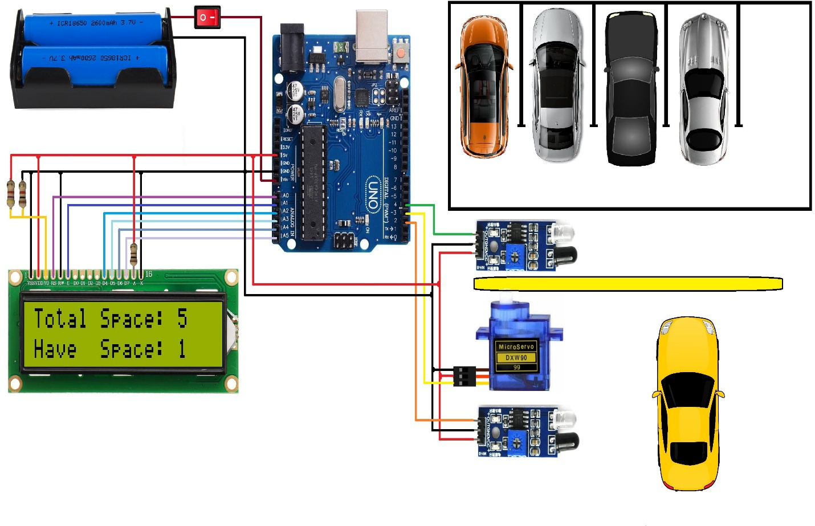The IoT-based Smart Parking System presented in this paper offers a scalable and efficient solution to alleviate the parking challenges faced in urban areas. Through real-time monitoring, predictive analytics, and user-friendly interfaces, the system not only enhances the overall parking experience but also contributes to a more sustainable and environmentally friendly urban environment. As cities continue to grow, such IoT-enabled solutions are crucial in ensuring efficient resource utilization and improving the quality of life for urban residents.