Assessment 1: find out the Sales that has

5000 cpi , 3 percentage discounts, 20 rewards offers

4000 cpi , 8 percentage discounts, 19 rewards offers

**Answer :** using the multiple regression model we here predict the sales

Equation 1 : 128.43512778*5000 + 5913.51964731 * 3 + -4902.54602054 * 20 + 264780.07095467084 = sales = 826645

Equation 2 : 128.43512778 * 4000 + 5913.51964731 * 8 + -4902.54602054 * 19 = sales = 467900

Assessment 2:  the bank details of customer – need to predict the how we can offer loan to customer based on the cybill score, Age, insurance, debit card , cards.

Accuracy score for the model is : 71%

Confusion matrix is [86, 45],

[28, 95]

Here The Truepositive(TP) : 83

True Negatvie(TN) : 45

False Positive(FP) : 28

False Negative(FN) : 95

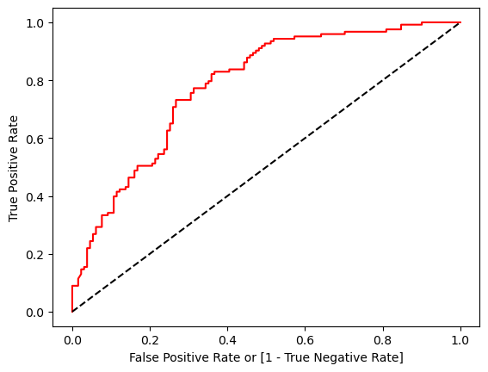

Roc Curve is Positive side It is a good model

**Assessment 3:**

**Model 1 :** Knn model

Accuracy: 44.36%

The model accuracy is very low in knn

**Model 2: Decision Tree**

Accuracy :0.54%

The Decision tree model accuracy is also low

**Model 3 : Svm**

Accuracy: 0.54

In the svm the accuracy score is low also but when we remove the any it accuracy score only drop

**Model 4: Random forest**

Accuracy : 0.51%

In the random forest also the accuracy score is low

**Model 5: Kmeans**

The Clusters have been divided into three clusters so compared to other model we can’t say it is good model or not because it doesn’t clearly classifies.