A PROJECT REPORT ON

GRID GUARD
SOLAR MONITORING

A Full-Stack Real-Time Solar Telemetry and Grid Monitoring Platform

Submitted in partial fulfilment of the requirements for the course
Full-Stack Web Development

Academic Year 2025–2026

SUBMITTED BY

S. No | Student Name | Roll Number | Batch
1 | Sri Ram Kanuri | 2520040072 | 08
2 | Deepak Sai Kumar Reddy Challa | 2520040041 | 08

UNDER THE GUIDANCE OF

Dr. Karumuri Sri Rama Murthy, Asst. Professor,

Department of CSE,

Department of Electronics and Communication Engineering

Academic Year 2025–2026

Abstract
Grid Guard is a full-stack web platform that monitors solar photovoltaic (PV) installa-tions in real time. Live electrical telemetry—DC/AC power, bus voltage, current, module temperature, irradiance, and grid frequency—is continuously ingested and presented on a responsive operator dashboard.
- Real-time monitoring: One-second telemetry refreshes rendered on a React + TypeScript single-page application.
- Alerting: Threshold-based safety notifications for over-voltage, over-temperature, and frequency drift.
- Persistence: Time-stamped readings stored in PostgreSQL 18 and streamed live through Firebase Realtime Database.
- Administration: A role-based admin console for managing members, nodes, alerts, and audit logs.
- Deployment: Three-tier stack with a Vite frontend, FastAPI backend, and Post-greSQL persistence layer.
The result is a production-style reference implementation of a modern full-stack IoT dashboard that demonstrates real-time streaming, authentication, role-based access control, and responsive UI design.
Keywords: Solar Monitoring, Real-Time Dashboard, React, TypeScript, FastAPI, Post-greSQL, Firebase, WebSockets, Telemetry.

Contents

Abstract 1
- Introduction 7
  - Overview 7
  - Motivation 7
  - Scope of the Project 7
  - Organisation of the Report 8
- Problem Description 9
  - Current State of Solar Monitoring 9
  - Key Challenges 9
  - Functional Requirements 10
  - Non-Functional Requirements 10
- Technologies Used 11
  - Overview of the Stack 11
  - Front-End Technologies 11
    - React 19 + TypeScript 11
    - Vite 12
    - Tailwind CSS 12
    - React Router 12
    - Firebase SDK (Web) 12
  - Back-End / Middleware Technologies 12
    - FastAPI 12
    - Uvicorn 12
    - SQLAlchemy 12
    - Python smtplib 13
    - pyotp 13
  - Database Technologies 13
    - PostgreSQL 18 13
    - Firebase Realtime Database 13
    - Why Two Databases? 13
- System Architecture 14
  - High-Level Architecture 14
  - Component Descriptions 14
    - Solar Sensor Node 14
    - FastAPI Backend 15
    - PostgreSQL Database 15
    - Firebase Realtime Database 15
    - React SPA 15
  - Data Flow 15
  - Design Decisions 16
- Implementation Details 17
  - Project Structure 17
  - Backend Implementation 17
    - Application Bootstrap 17
    - Telemetry Worker 18
    - REST Endpoints 19
    - Email Dispatch 19
    - Threshold-Based Alerting 20
  - Front-End Implementation 20
    - Component Hierarchy 20
    - Real-Time Telemetry Hook 21
    - Alert Service 21
  - Database Design 22
    - Entity Overview 22
    - Selected Table Definitions 22
    - Table Catalogue 24
  - Authentication and MFA 24
- Output Screens 25
  - Public Landing Page 25
  - Login Screen 25
  - Member Dashboard 26
  - Grid Monitoring 26
  - Energy Analytics 27
  - Alerts Console 27
  - Admin Dashboard 28
  - Member Management 28
  - Audit Log 29
  - System Health 29
- Future Enhancements and Conclusion 30
  - Future Enhancements 30
  - Conclusion 30

List of Figures

  - High-level Grid Guard architecture. 14

  - Simplified entity-relationship overview 22

  - Public landing page with live telemetry pill. 25
  - Operator login with three authentication modes. 25
  - Primary member dashboard. 26
  - Grid monitoring and stability view 26
  - Solar energy performance page. 27
  - Alerts and fault-detection view 27
  - Administrative control dashboard. 28
  - Member access directory 28
  - Immutable audit ledger 29
  - System health monitor 29

List of Tables
  - Functional requirements of the Grid Guard system. 10
  - Summary of technology stack. 11
  - Key architectural decisions. 16
  - Principal REST endpoints. 19
  - Database tables and their roles. 24

Chapter 1

Introduction

Overview
The rapid global shift toward renewable energy has made solar photovoltaic (PV) installa-tions one of the fastest-growing sources of electrical generation. A modern solar installa-tion is not a single device but a distributed system: PV arrays, string inverters, combiner boxes, grid-tie switchgear, battery storage, and environmental sensors all produce contin-uous streams of electrical and thermal data. Managing that data—capturing it, storing it, visualising it, and reacting to it—has become a core engineering challenge.
Grid Guard addresses that challenge with a full-stack web application that streams live telemetry from solar nodes to a browser-based control console. It provides operators with a clear, glanceable view of every parameter that matters and raises alerts the moment a value crosses a safety threshold.

Motivation
Traditional solar monitoring systems suffer from three recurring problems:

    - Closed, vendor-locked hardware. Commercial SCADA systems require proprietary gateways and expensive licences.
    - Stale polling. Legacy dashboards refresh every 30–60 seconds, hiding transient faults such as over-voltage spikes or inverter trips.
    - Poor operator experience. Engineering-grade tools are text-heavy and unusable on the tablets and phones field technicians actually carry.
Grid Guard was designed to address all three: open standards, sub-second data propa-gation, and an interface built mobile-first with Tailwind CSS.

Scope of the Project
This report covers the design, architecture, and implementation of the Grid Guard system. The features documented here include:

- Real-time telemetry display (power, voltage, current, temperature, irradiance, fre-quency).
- Historical trending and analytics views.

- Threshold-based alerts and notifications via email.

- A role-based administrative console.

- Audit logging and operator presence tracking.

Predictive or machine-learning features are outside the scope of this document.

Organisation of the Report
Chapter 2 describes the problem being solved. Chapter 3 lists the technology stack. Chap-ter 4 presents the architecture. Chapter 5 walks through implementation details. Chapter 6 shows the output screens. Chapter 7 discusses future enhancements and concludes.

Chapter 2

Problem Description

Current State of Solar Monitoring
A typical small-to-medium solar installation (5 kW to 500 kW) relies on one of two moni-toring approaches:
    - Inverter-vendor portals. Each inverter manufacturer offers a proprietary cloud portal. Data is only visible once every 5–15 minutes, and multiple vendors cannot be aggregated.
    - Manual / spreadsheet logging. Smaller installations often rely on technicians walk-ing to a wall-mounted display and recording values by hand.
Both approaches fail to provide the sub-second visibility needed to catch inverter trips, transient over-voltage conditions, or PV string disconnections.

Key Challenges
The design of Grid Guard had to address the following technical challenges.

- High-Frequency Data Ingestion
Solar telemetry is time-series data. A single node can emit one frame per second, each frame containing six or more numeric fields. Over a month, a three-node installation produces over seven million data points. The storage and retrieval layer must handle this write rate gracefully.

- Real-Time Propagation to the UI
Operators expect the dashboard to reflect the current state of the physical system. A polling model (client asks the server every 𝑁 seconds) introduces latency and does not scale with many concurrent operators. A push-based model is required.

- Responsive, Operator-Friendly UI
Field engineers use tablets; office operators use desktops; supervisors use phones. The same data must be readable and actionable on all three.

- Safety Alerting
Threshold breaches must be surfaced immediately—on-screen and by email—so a technician can act before equipment is damaged.

- Access Control
Not every operator should be able to decommission a node or delete an alert. The platform must enforce role separation between member and administrator.

Functional Requirements

Table 2.1: Functional requirements of the Grid Guard system.

ID Requirement

FR-01 The system shall display live solar telemetry (power, voltage, current, temperature, irradi-ance, frequency) with a refresh interval of one second.
FR-02 The system shall persist every telemetry frame into a relational database for historical querying.
FR-03 The system shall raise an alert when any monitored parameter crosses a configurable threshold.
FR-04 The system shall dispatch email notifications for CRITICAL alerts to all active operators. FR-05 The system shall provide an administrative console for member, node, and alert management. FR-06 The system shall record an immutable audit trail of every administrative action.
FR-07 The system shall support email OTP and TOTP-based two-factor authentication. FR-08 The dashboard shall be usable on viewports from 320 px to 1920 px.

Non-Functional Requirements
    - Latency: Telemetry frame visible on UI within 500 ms of node emission.

    - Availability: 99.5% uptime target.

    - Scalability: Support at least 50 concurrent operators and 20 nodes on a single-instance deployment.
    - Security: Passwords hashed; sensitive data never logged; OTPs time-bound and single-use.
    - Maintainability: Clear separation between frontend, backend, and data layers.

Chapter 3

Technologies Used

Overview of the Stack
Grid Guard is a three-tier application: a single-page frontend, a Python REST backend, and a dual-store data layer (PostgreSQL for history, Firebase Realtime Database for live streaming). Table 3.1 summarises the stack.
Table 3.1: Summary of technology stack.

Layer | Technology | Purpose
Frontend | React 19 + TypeScript | Component-driven SPA with static typing
Bundler | Vite 8 | Fast ESM dev server and production build
Styling | Tailwind CSS v4 | Utility-first responsive styling
Routing | React Router v7 | Client-side routing and route guards
Icons | Lucide React | Consistent icon set
Charts | Custom SVG / Chart primitives | Trend visualisation
Auth SDK | Firebase Auth | Session handling and OTP flows
Backend | FastAPI (Python 3.11+) | Async REST API and background workers
Server | Uvicorn (ASGI) | ASGI production server
Validation | Pydantic v2 | Request/response schema validation
ORM | SQLAlchemy 2.0 | Declarative models and sessions
Email | Python smtplib | Transactional email via Gmail SMTP
MFA | pyotp | RFC 6238 TOTP generation and verification
Primary DB | PostgreSQL 18 | Relational persistence of users, nodes, readings,
 |  | alerts
Live DB | Firebase Realtime Database | Sub-second fan-out of telemetry to clients
Cache | In-memory Python dict | OTP store, live telemetry snapshot

Front-End Technologies

React 19 + TypeScript
React provides the component model and virtual-DOM reconciliation needed for a dashboard that re-renders on every telemetry tick. TypeScript enforces shape contracts on the telemetry

payloads, which reduces the risk of a malformed reading propagating through the UI.

Vite
Vite serves as the development server (native ESM, near-instant HMR) and the production bundler (Rollup-based). The project uses Vite’s PostCSS pipeline to compile Tailwind.

Tailwind CSS
Tailwind’s utility classes make responsive design explicit at the markup level. The project uses a mobile-first breakpoint strategy (sm:, md:, lg:, xl:) and a custom dark palette appropriate for control-room environments.

React Router
Client-side routing with nested layouts. Admin routes are wrapped in an AdminRoute guard that redirects unauthenticated or non-admin users.

Firebase SDK (Web)
Firebase Auth handles session tokens; Firebase Realtime Database is used exclusively for the live telemetry stream and presence heartbeat.

Back-End / Middleware Technologies

FastAPI
FastAPI provides the REST surface. Its decorator-based routing, Pydantic validation, and async-first design make it a natural fit for an IoT backend.

Uvicorn
ASGI server used to run the FastAPI app in production and development.

SQLAlchemy
Declarative ORM used to define the thirteen PostgreSQL tables, manage sessions, and provide relationship loading.

    - Python smtplib
Standard-library SMTP client used to dispatch OTP emails, alert notifications, and admin broadcasts through Gmail’s TLS relay.

pyotp
Implements RFC 6238 TOTP. Used for generating provisioning URIs, rendering QR codes, and verifying six-digit codes with a one-step clock window.

Database Technologies

PostgreSQL 18
The primary persistence layer. Chosen for its support of JSONB (used for flexible telemetry metadata), INET (used for session IP tracking), and native UUID types. The schema is described in detail in Chapter 5.

Firebase Realtime Database
A document-style JSON tree with WebSocket fan-out. Every telemetry frame is written to
/telemetry/GG-NODE-01 and every connected client receives the update in the same tick. This eliminates the need for the frontend to poll and lets a single write propagate to many tabs, devices, and operators.

Why Two Databases?
      - PostgreSQL is optimised for query, aggregate, and join workloads (e.g. “average power over the last 24 hours”).
      - Firebase RTDB is optimised for push, fan-out, and ephemeral workloads (e.g. “send this reading to every open dashboard”).
Using both lets each store do what it is best at.

Chapter 4

System Architecture

High-Level Architecture
Grid Guard follows a classic three-tier architecture with an additional real-time fan-out path.
Solar Sensor HTTP / JSON
Node
FastAPI Backend
spawns
PostgreSQL 18
WS push
React SPA
^{REST} (Dashboard)
Telemetry write Firebase
Worker Thread Realtime DB
Data Layer
Figure 4.1: High-level Grid Guard architecture.

Component Descriptions

Solar Sensor Node
Represents a physical or simulated edge device (ESP32, STM32, Raspberry Pi, or a software emulator) that emits a telemetry frame roughly once per second. Each frame contains six core parameters:
      - DC power (W)
      - AC power (W)
      - Bus voltage (V)
      - Current (A)
      - Module temperature (°C)
      - Irradiance (W/m2)

Frames are posted to POST /api/telemetry.

FastAPI Backend
The backend has two responsibilities:

- Serve the REST endpoints (/api/users, /api/nodes, /api/alerts, /api/telemetry,
/api/auth/*, /api/admin/*).

- Run a background telemetry worker thread that maintains an in-memory snapshot of the most recent reading and periodically persists aggregated rows.

PostgreSQL Database
Stores the durable entities: users, sessions, nodes, sensors, sensor readings, grid telemetry, energy analytics, battery analytics, alerts, audit logs, and presence.

Firebase Realtime Database
Stores a single hot path: /telemetry/<nodeId>. Every write fans out to subscribed clients over a WebSocket.

React SPA
The operator console. It renders eight member pages and eight admin pages, all under a shared layout with header, navigation, and a persistent connection to Firebase RTDB.

Data Flow
- The sensor node posts a telemetry frame.

- FastAPI validates the payload with Pydantic and updates the in-memory snapshot.

- A background worker pushes the snapshot to Firebase RTDB and, at a lower frequency, persists a row into PostgreSQL.
- Firebase fans out the update to every connected browser tab.

- The React SPA re-renders the affected widgets.

- If a threshold is crossed, an alert is written to PostgreSQL and a notification email is dispatched via SMTP.

Design Decisions

Table 4.1: Key architectural decisions.

Decision Rationale

Dual-store (PG + RTDB) History needs SQL; live stream needs push semantics. Splitting
lets each store optimise for its workload.
Background worker thread Decouples HTTP request handling from the 1 Hz write loop, pre-venting request latency spikes.
In-memory telemetry snapshot Serves /api/telemetry/live in microseconds without touching
the database.
JWT-free session model Simple session tokens stored server-side; avoids the complexity of
a JWT lifecycle.
Tailwind utility-first Eliminates stylesheet drift; every layout decision is visible at the
markup level.
FastAPI + Uvicorn Async by default, native Pydantic validation, minimal boilerplate.

Chapter 5

Implementation Details

Project Structure

1
grid -guard -solar- monitoring/
|-- backend/
| |-- app.py
| |-- database.py
|-- src/
| |-- components/
| |-- pages/
| |-- pages/admin/
| |-- services/
| |-- firebase/
| |-- types/
|-- ml-server/
|-- public/
|-- index.html
|-- package.json
|-- requirements.txt
|-- vite.config.ts
|-- tsconfig.json
|-- .env
# FastAPI app, routes, background workers
# SQLAlchemy models + session factory # React + TypeScript frontend
# Reusable UI primitives # Member pages
# Admin console pages
# API clients, telemetry, alerts
# Firebase config , auth, RTDB helpers # Shared TypeScript types
# (Not used in this report)

2

3

4

5

6

7

8

9

10

11

12

13

14

15

16

17

18

19

Listing 5.1: Repository layout.

Backend Implementation

Application Bootstrap
FastAPI’s lifespan handler initialises the database and starts three background threads.

1
@asynccontextmanager
async def lifespan(app: FastAPI): initialize_database_data()
threading.Thread(target=telemetry_background_worker , daemon=True)
.start()
threading.Thread(target=autonomous_ml_evaluator_24h , daemon=True)
.start()

2

3

4

5

6
threading.Thread(target=queue_dispatcher_worker , daemon=True). start()
yield

app = FastAPI(title="Grid Guard Solar Monitoring API", lifespan= lifespan)

7

8

9

Listing 5.2: Lifespan handler.

Telemetry Worker
The worker produces a new frame every second, updates the in-memory cache, and period-ically persists to PostgreSQL.
1 def | telemetry_background_worker():
2 | tick = 0
3 | energy_acc = 45.2
4 | while True:
5 | tick += 1
6 | t = tick * 0.1
7 | bus_voltage = round (230.4 + math.sin(t*0.7)*0.6 , | 1)
8 | power_kw = round (4.82 + math.sin(t*0.5)*0.15 , 2)
9 | energy_acc = round( energy_acc + power_kw /3600.0 , | 3)
10 | reading = {
11 | "nodeId": "GG-NODE -01 ",
12 | " voltage": bus_voltage ,
13 | "power": power_kw ,
14 | "energy": energy_acc ,
15 | "status": "ONLINE",
16 | }
17 | latest_telemetry_cache.update( reading)
18
19 | if tick % 2 == 0:
20 | db = SessionLocal()
21 | db.add( SensorReading(
22 | node_id=primary_node.id,
23 | power_kw=power_kw ,
24 | voltage_v=bus_voltage ,
25 | energy_kwh=energy_acc ,
26 | ))
27 | db.commit()
28 | db.close()
29
30
time.sleep (1.0)

Listing 5.3: Telemetry worker loop (condensed).

REST Endpoints
Table 5.1 lists the primary endpoints.

Table 5.1: Principal REST endpoints.

Method | Path | Purpose
GET | /api/health | Service and DB health check
GET | /api/telemetry/live | Latest telemetry frame
POST | /api/telemetry | Ingest a new reading
GET | /api/telemetry/history | Recent readings (paginated)
GET | /api/users | List operators
POST | /api/users | Create or update an operator
POST | /api/auth/send-otp | Dispatch OTP email
POST | /api/auth/verify-otp | Verify OTP and open session
POST | /api/auth/mfa/generate | Generate TOTP secret
POST | /api/auth/mfa/activate | Activate TOTP for account
GET | /api/nodes | List solar nodes
POST | /api/nodes | Provision a node
GET | /api/alerts | List alerts
POST | /api/alerts | Raise an alert
POST | /api/alerts/{id}/resolve | Resolve an alert
GET | /api/audit-logs | Retrieve audit trail
POST | /api/admin/send-email | Broadcast email

Email Dispatch

1
def send_smtp_email(to_addrs , subject , text_content , html_content= None):
msg = MIMEMultipart(" alternative") msg[" Subject"] = Header(subject , "utf-8") msg["From"] = Header(smtp_from , "utf-8") msg["To"] = ", ".join( to_addrs)
msg.attach( MIMEText(text_content , "plain", "utf-8")) if html_content:
msg.attach( MIMEText(html_content , "html", "utf-8"))

server = smtplib.SMTP(smtp_host , smtp_port , timeout=8) server. starttls(); server.login(smtp_user , smtp_pass) server. sendmail(smtp_user , to_addrs , msg. as_string()) server.quit()

2

3

4

5

6

7

8

9

10

11

12

13

Listing 5.4: SMTP dispatch helper.

Threshold-Based Alerting
When a telemetry frame breaches a configured threshold, an alert row is written and CRITICAL alerts trigger an email broadcast.
if module_temp > 60.0: db.add(Alert(
node_id=primary_node.id, alert_type=" temperature", severity=" CRITICAL", title=" Inverter Overheating",
message=f"Module temperature { module_temp} C exceeds 60 C limit",
value=module_temp , threshold=60.0 , status="ACTIVE",
))
db.commit()
notify_operators( subject="Over- temperature alert", body="...")
1

2

3

4

5

6

7

8

9

10

11

12

Listing 5.5: Threshold check inside the worker.

Front-End Implementation

Component Hierarchy

1
<BrowserRouter >
<AuthProvider >
<Routes >
<Route path="/" element={<HomePage/>}/>
<Route path="/ login" element={<LoginPage/>}/>
<Route path="/ register" element={<RegisterPage/>}/>
<Route element={<MemberLayout/>}>
</Route >
<Route element={<AdminRoute/>}>
<Route element={<AdminLayout/>}>
<Route path="/ admin/ dashboard"
/>}/>
<Route path="/ admin/ members"
<Route path="/ admin/nodes"
element={<AdminDashboard
element={<AdminMembers/>}/>
element={<AdminNodes/>}/>

2

3

4

5

6

7

8 | <Route | path="/ dashboard" | element={<Dashboard/>}/>
9 | <Route | path="/ energy" | element={<Energy/>}/>
10 | <Route | path="/ grid" | element={<GridMonitoring/>}/>
11 | <Route | path="/ alerts" | element={<Alerts/>}/>
12 | <Route | path="/ analytics" | element={<Analytics/>}/>
13 | <Route | path="/ profile" | element={<Profile/>}/>
14 | <Route | path="/ settings" | element={<Settings/>}/>
15

16

17

18

19

20

21
<Route path="/ admin/alerts"
<Route path="/ admin/emails"
<Route path="/ admin/audit"
element={<AdminAlerts/>}/>
element={<AdminEmails/>}/> element={<AdminAuditLogs
/>}/>
<Route path="/ admin/system" element={<AdminSystemHealth
/>}/>
</Route >
</Route >
</Routes >
</AuthProvider >
</ BrowserRouter >

22

23

24

25

26

27

28

29

Listing 5.6: Top-level React routing tree.

Real-Time Telemetry Hook
A custom hook subscribes to the Firebase RTDB telemetry path and streams the snapshot into React state.

1
export function useTelemetry(nodeId: string) {
const [reading , setReading] = useState <TelemetryFrame | null >( null)
;

useEffect(() => {
const ref = rtdbRef(realtimeDb , ‘/ telemetry/${nodeId}‘); const unsub = onValue(ref, (snap) => {
const data = snap.val();
if (data) setReading(data);
});
return () => unsub();
}, [nodeId]);

return reading;
}

2

3

4

5

6

7

8

9

10

11

12

13

14

Listing 5.7: Custom useTelemetry hook.

Alert Service

1
export const alertService = {
createAlert: async (data: Omit<Alert, "id">) => { const id = await rtdbService. createAlert(data); if (data. severity === " CRITICAL") {
await apiClient. sendTelegramAlert({ message: data.message ,
severity: " CRITICAL",

2

3

4

5

6

7

8
node_id: data.nodeId ,
});
}
return id;
},
};

9

10

11

12

13

Listing 5.8: Alert creation with side-effect.

Database Design

Entity Overview

user sessions
sensors
sensor readings
grid telemetry
alerts
audit logs
solar nodes
presence
users
Figure 5.1: Simplified entity-relationship overview.

Selected Table Definitions

1
class User(Base):
tablename = "users"
id = Column(UUID( as_uuid=True), primary_key=True , default=uuid.uuid4 )
email = Column(String(255), unique=True , nullable=False) name = Column(String(150))
role = Column(String(30), default="member") is_active = Column(Boolean , default=True) mfa_secret = Column(String(128))
mfa_enabled = Column(Boolean , default=False) created_at = Column( DateTime( timezone=True)) last_login_at = Column( DateTime( timezone=True))

class SensorReading(Base):
tablename = " sensor_readings"

2

3

4

5

6

7

8

9

10

11

12

13

14

15 id = Column(BigInteger , primary_key=True ,
autoincrement=True)
16 |  | node_id |  | = | Column(UUID( as_uuid=True),
17 |  |  |  |  | ForeignKey(" solar_nodes.id", ondelete="
 |  |  |  |  | CASCADE"))
18 |  | timestamp |  | = | Column( DateTime( timezone=True))
19 |  | power_kw |  | = | Column(Float)
20 |  | voltage_v |  | = | Column(Float)
21 |  | current_a |  | = | Column(Float)
22 |  | temperature_c |  | = | Column(Float)
23 |  | irradiance_w_m2 |  | = | Column(Float)
24 |  | frequency_hz |  | = | Column(Float)
25 |  | energy_kwh |  | = | Column(Float)
26 |  | status |  | = | Column(String(50))
27
28 clas  29 |  | s Alert(Base):  tablename = |  | "al | erts"
30 id = Column(BigInteger , primary_key=True , autoincrement
=True)
31 | node_id |  | = | Column(UUID( as_uuid=True), ForeignKey(" solar_nodes
 | .id"))
32 | alert_type |  | = | Column(String(100))
33 | severity |  | = | Column(String(30))
34 | message |  | = | Column(Text)
35 | value |  | = | Column(Float)
36 | threshold |  | = | Column(Float)
37 | status |  | = | Column(String(30), default="ACTIVE")
38 | created_at |  | = | Column( DateTime( timezone=True))
 |  |  |  | Listing 5.9: Core SQLAlchemy models.

Table Catalogue

Table 5.2: Database tables and their roles.

Table Role

users Operator and administrator accounts user sessions Active and historical login sessions presence Real-time online/offline heartbeat solar nodes Physical or virtual solar installations
sensors Individual measurement devices inside a node
sensor readings Time-series of all telemetry frames
grid telemetry Grid-side voltage, current, frequency records energy analytics Aggregated generation metrics over a window battery analytics State-of-charge and battery health records alerts Raised threshold-breach events
audit logs Immutable trail of administrative actions
system status Rolling health snapshots of the platform

Authentication and MFA
Grid Guard supports three authentication paths:

- Password login — bcrypt-hashed credentials verified against the users table.
- Email OTP — a six-digit numeric code is generated server-side, emailed via SMTP, and stored in an in-memory dictionary with a five-minute expiry and a five-attempt cap.
- TOTP MFA — after scanning a QR code provisioned by pyotp, operators enter a six-digit rolling code that is validated with a ±30-second window.
Session tokens are generated with secrets.token hex(12) and recorded in user sessions
along with IP address and user agent.

Chapter 6

Output Screens
This chapter presents the principal screens of the Grid Guard platform. Each screenshot has been captured at a 1440 × 900 viewport and reproduced here at reduced scale.

Public Landing Page

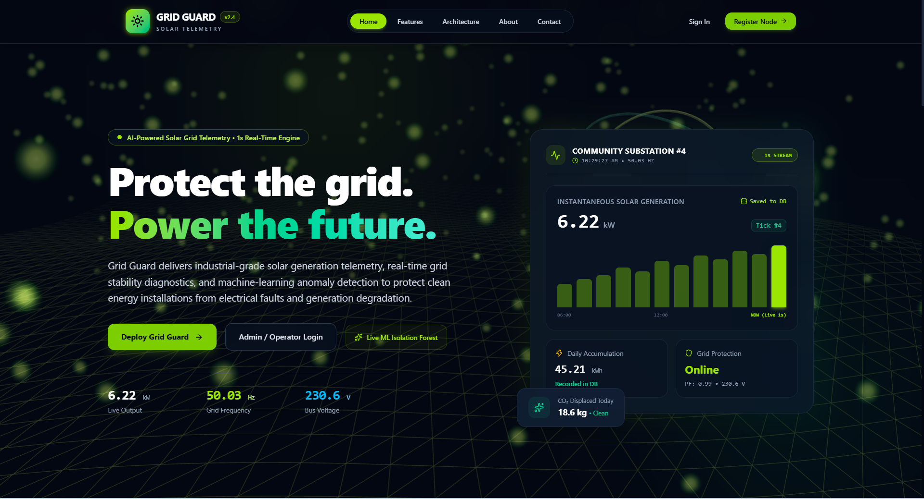
Figure 6.1: Public landing page with live telemetry pill.

Login Screen

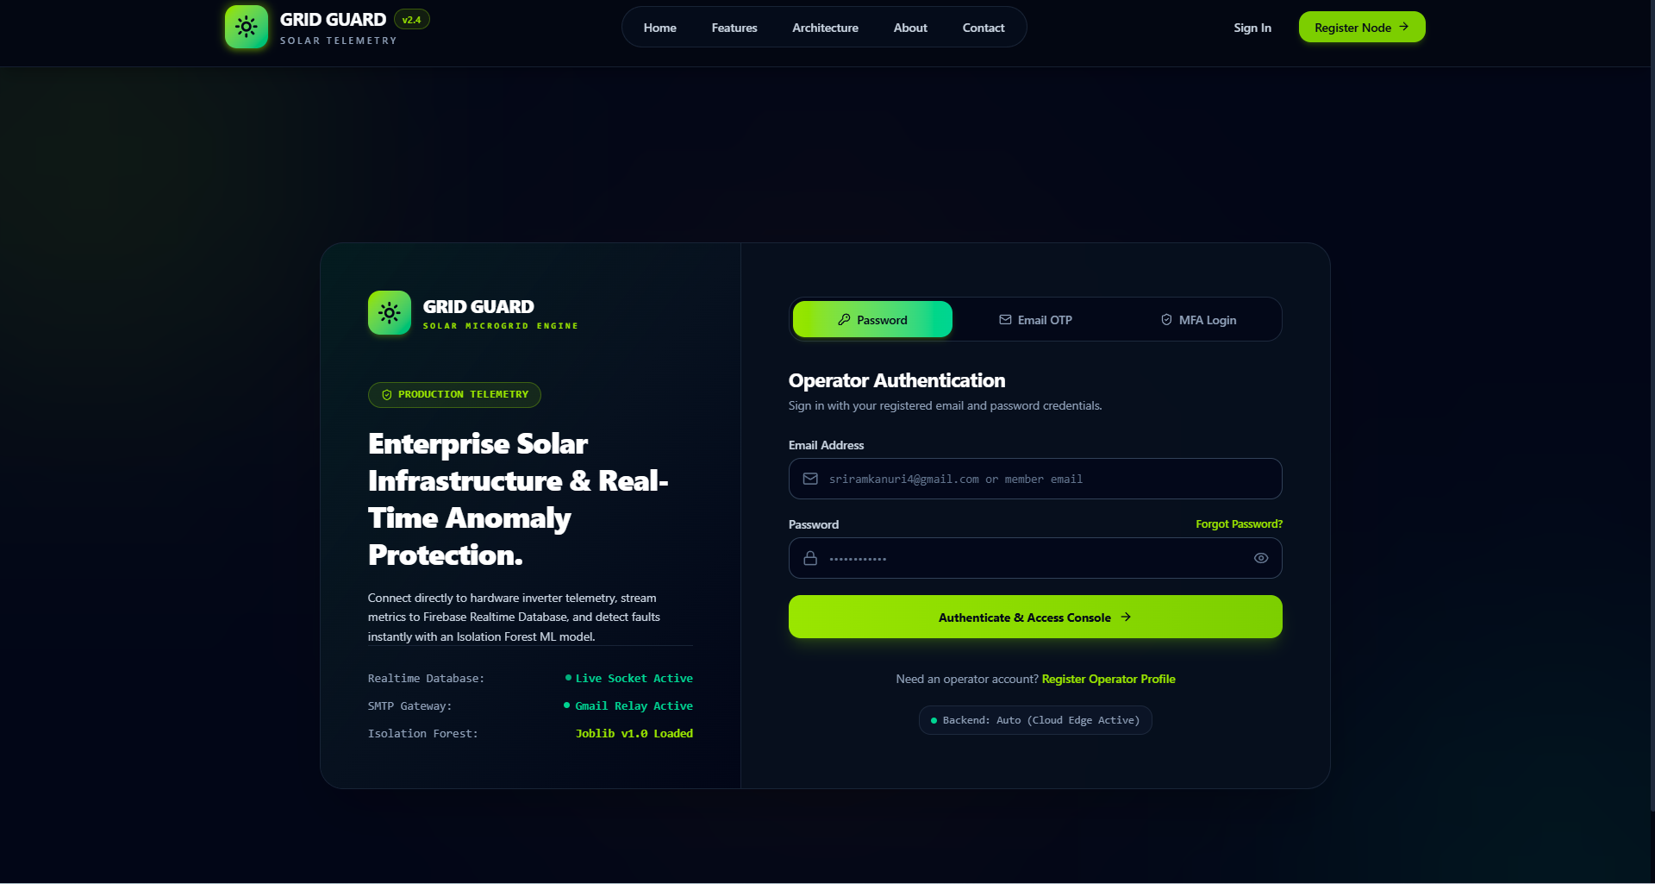
Figure 6.2: Operator login with three authentication modes.

Member Dashboard

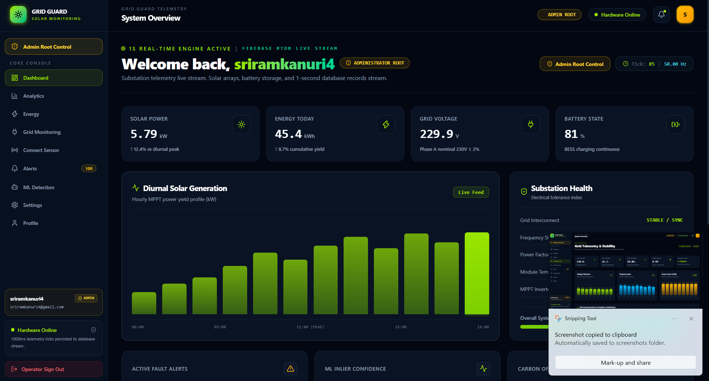
Figure 6.3: Primary member dashboard.

Grid Monitoring

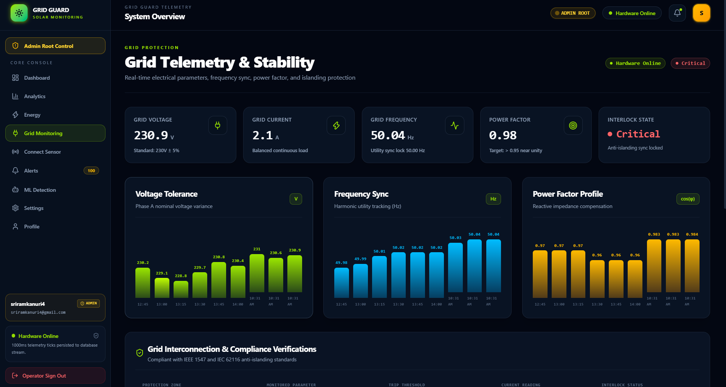
Figure 6.4: Grid monitoring and stability view.

Energy Analytics

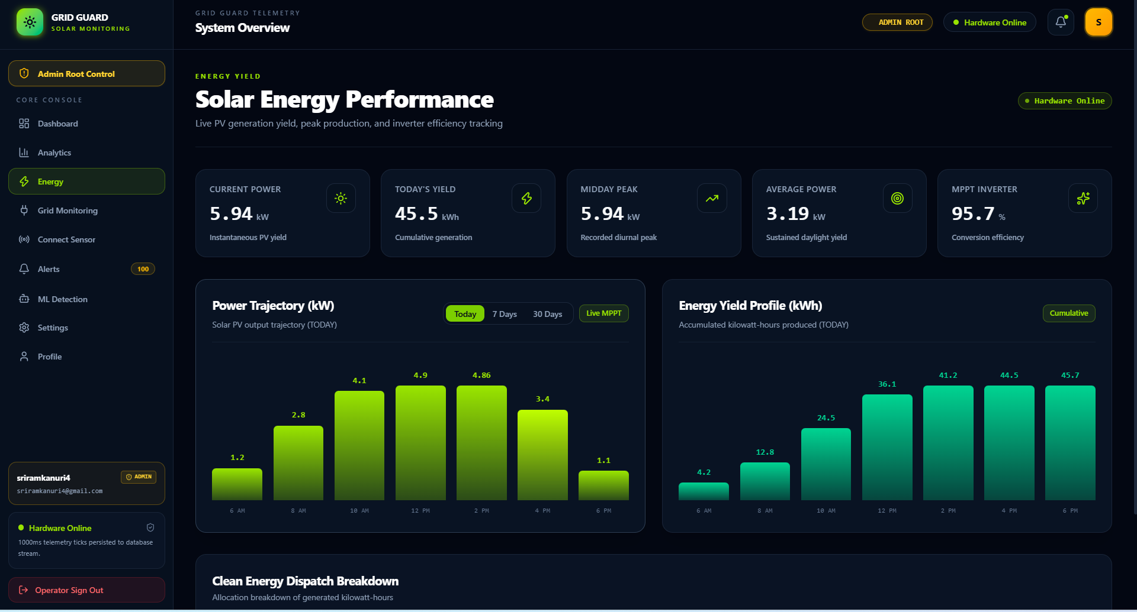
Figure 6.5: Solar energy performance page.

Alerts Console

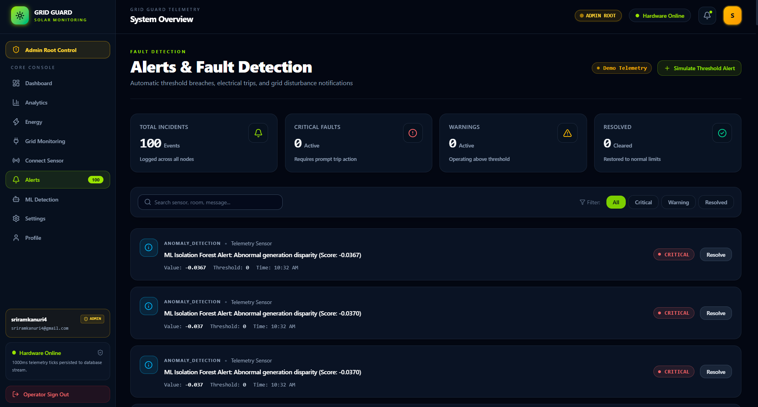
Figure 6.6: Alerts and fault-detection view.

Admin Dashboard

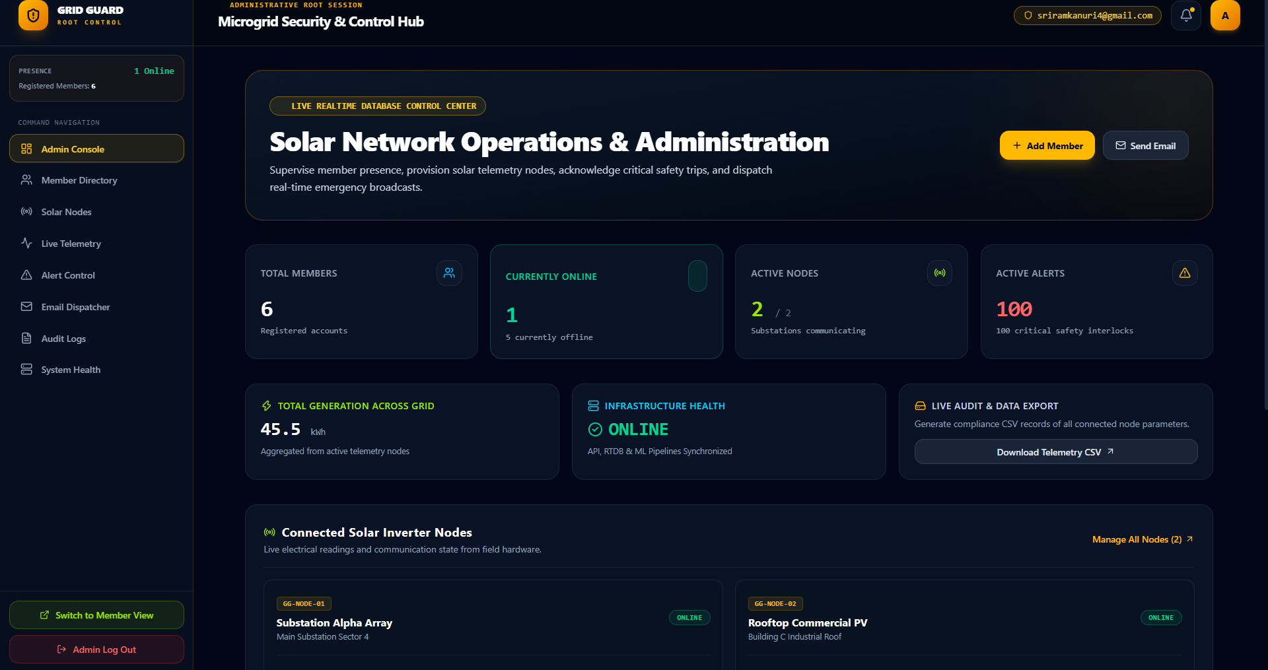
Figure 6.7: Administrative control dashboard.

Member Management

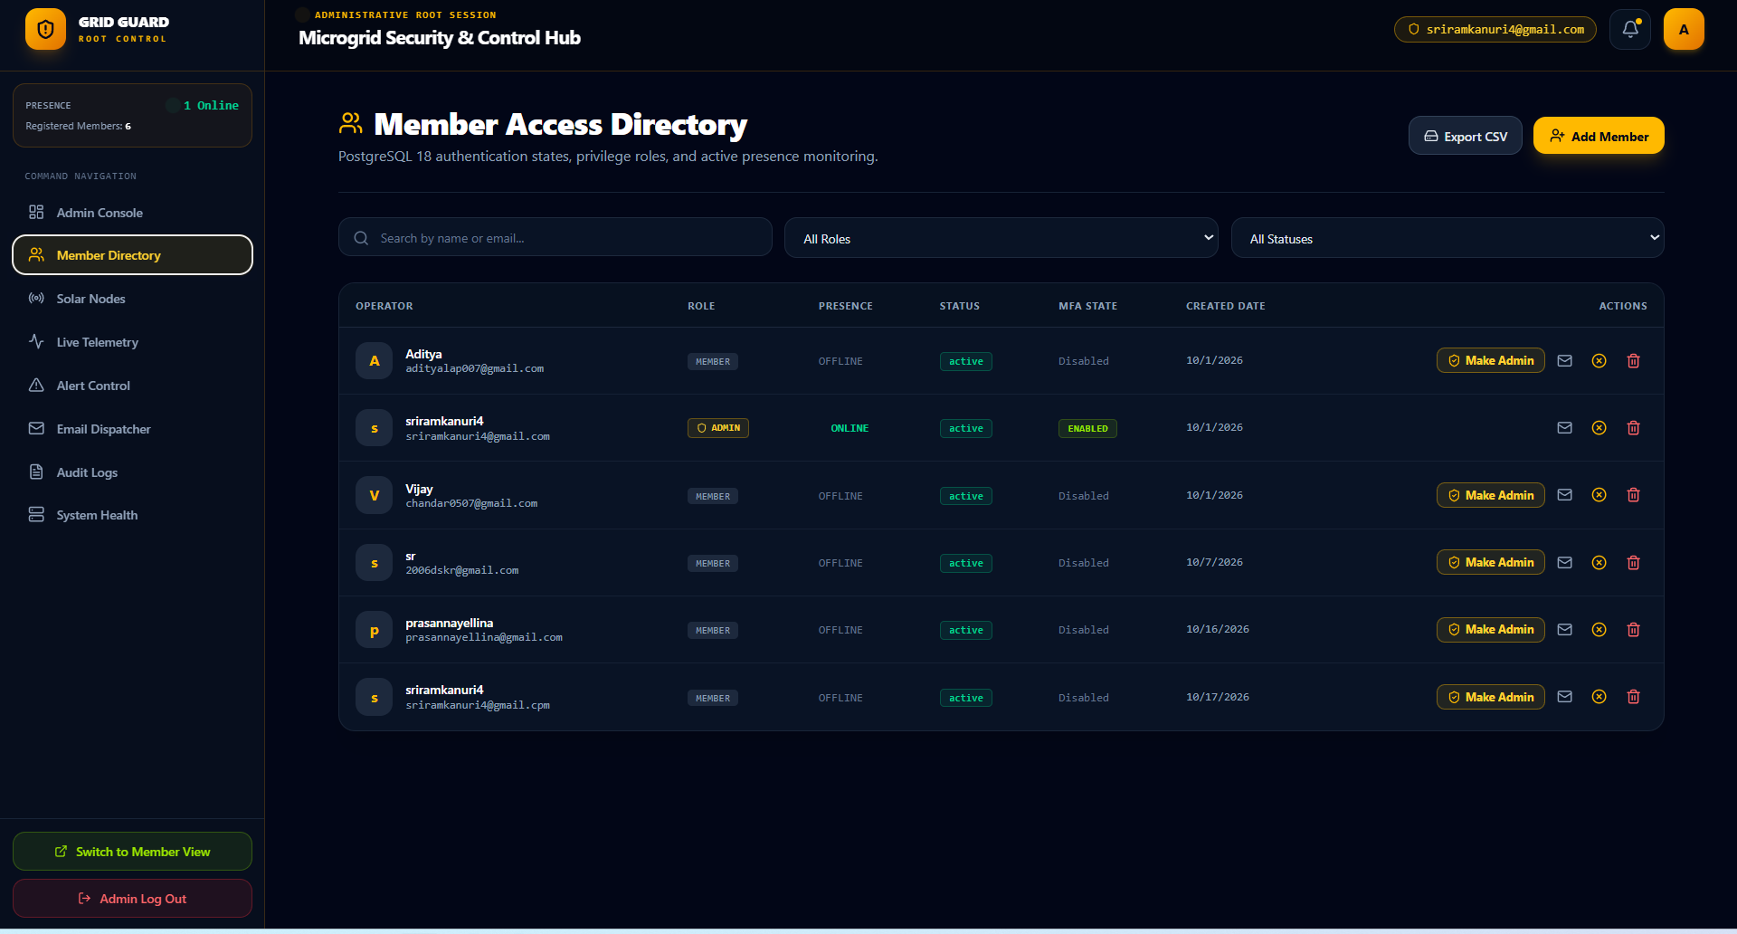
Figure 6.8: Member access directory.

Audit Log

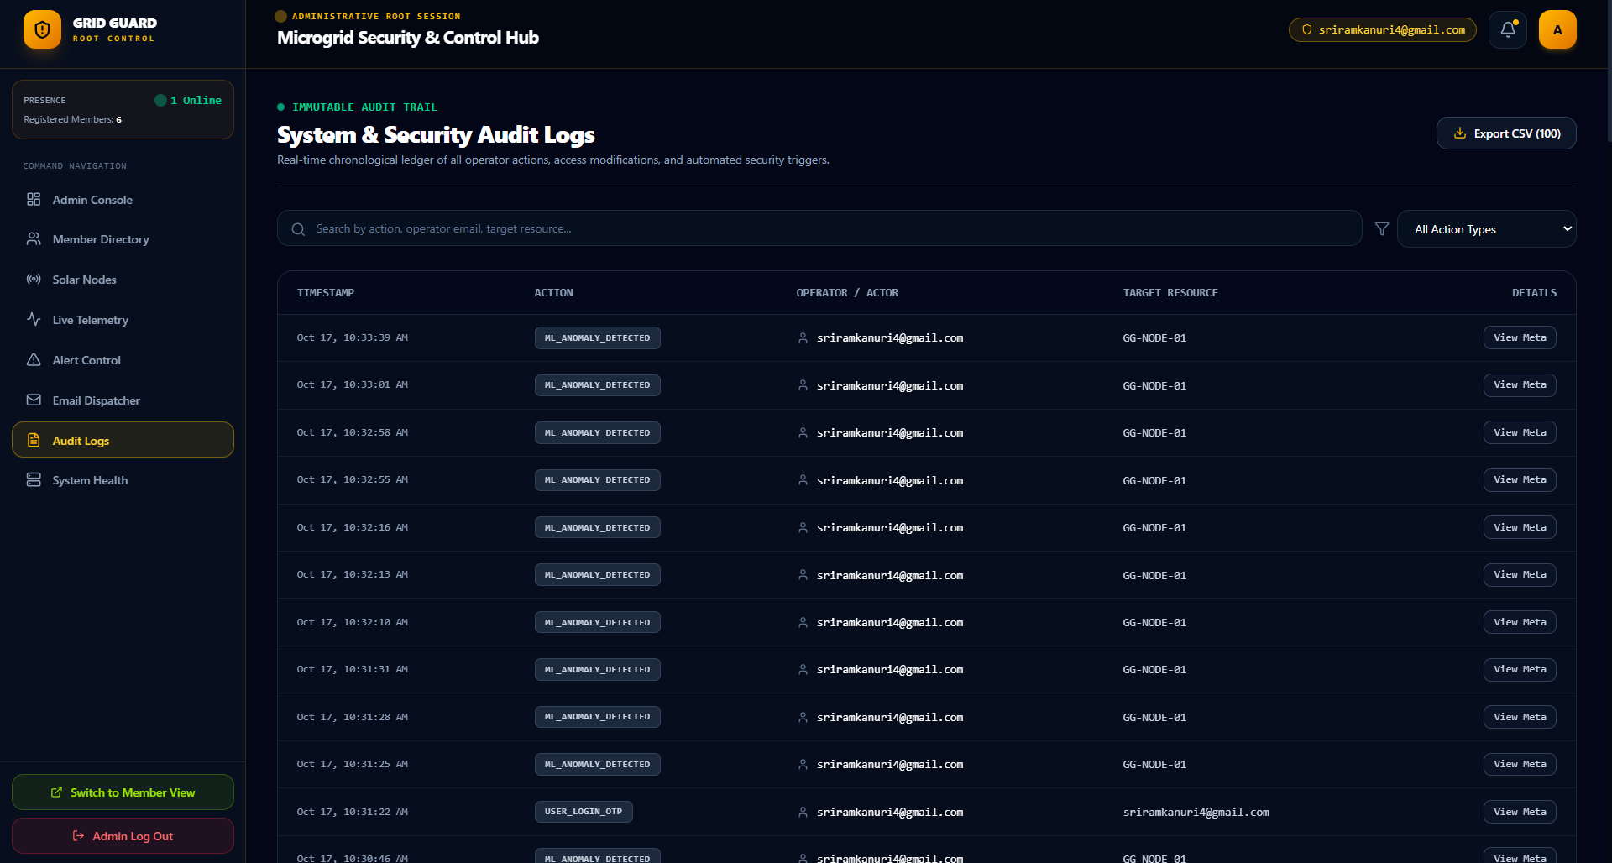
Figure 6.9: Immutable audit ledger.

System Health

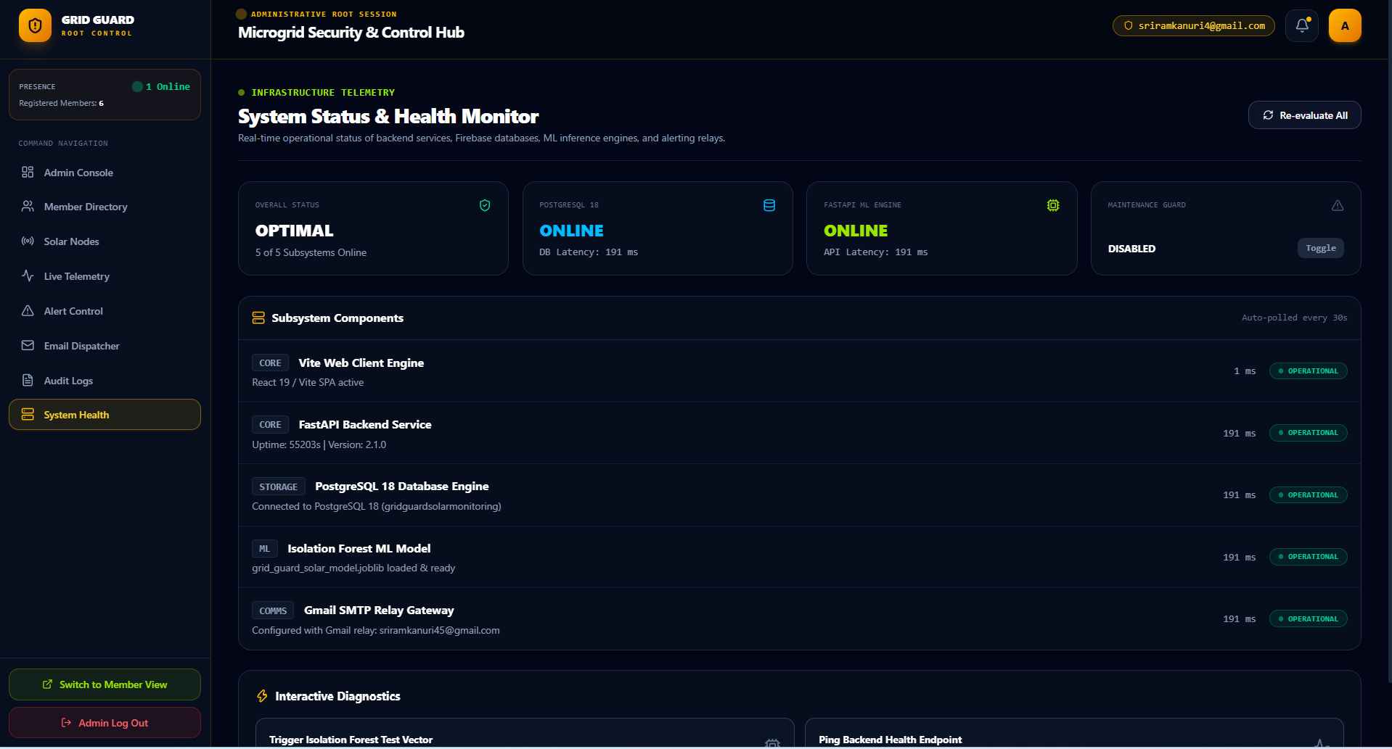
Figure 6.10: System health monitor.

Chapter 7

Future Enhancements and Conclusion

Future Enhancements
    - Modbus / MQTT native ingest. Add first-class protocol adapters so physical inverters can publish directly without an intermediary HTTP bridge.
    - Mobile application. A React Native or Flutter companion app for field engineers, reusing the same REST and RTDB contracts.
    - Multi-tenant support. Introduce an organisation entity so a single deployment can host multiple independent sites with strict data isolation.
    - Automated report generation. A weekly PDF/email summary of generation, down-time, and alert counts, dispatched to site owners.
    - Role expansion. Add a viewer role (read-only) and an engineer role (can resolve alerts but not provision nodes).
    - Containerised deployment. Package the frontend, backend, and database in Docker Compose or Kubernetes for reproducible deployment.
    - Grafana / Prometheus integration. Expose Prometheus metrics from FastAPI and provide a Grafana dashboard for infrastructure observability.
    - Offline-tolerant edge caching. Allow the node to buffer readings locally and replay them once connectivity is restored.
    - Two-way control. Enable operators to remotely trip or re-arm an inverter through an authenticated control channel, with an immutable audit trail.
    - Internationalisation. Extract user-facing strings into a locale bundle so the console can be shipped in regional languages.

Conclusion
Grid Guard demonstrates that a modern full-stack web application can deliver real-time solar telemetry with the polish of a commercial control-room product. The system combines a React 19 + TypeScript single-page frontend, a FastAPI + PostgreSQL backend, and a

Firebase Realtime Database fan-out path to achieve sub-second data propagation from a solar node to every connected operator.
The project exercises a broad range of full-stack skills: REST API design, ORM modelling, asynchronous background workers, transactional email, time-based one-time passwords, role-based access control, responsive UI design with Tailwind, and three-tier deployment. Each layer is a self-contained concern with a clean interface to the next, which keeps the codebase maintainable and makes future extensions—native MQTT ingest, mobile clients, multi-tenancy—straightforward to add.
Beyond the technology, the project is a study in operator experience: the interface prioritises glanceable KPIs, consistent colour semantics, and clear action paths for acknowl-edging or resolving an alert. In a domain where seconds matter, that emphasis on clarity is what turns a telemetry feed into a usable monitoring tool.

