Version 0.1
For ASD Review / NASK Preview
16 February 2012

Invoicing Process

Invoicing Process: Activity Diagrams

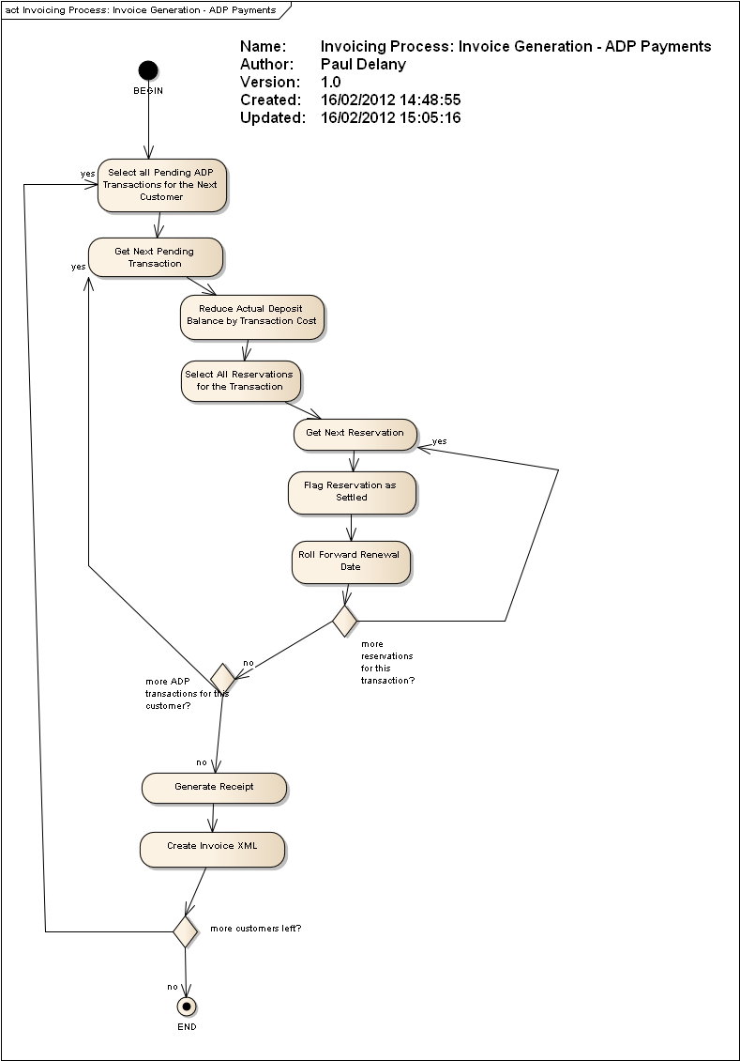
Figure 1 : Invoicing Process: Invoice Generation - ADP Payments

Invoicing Process: Use Cases

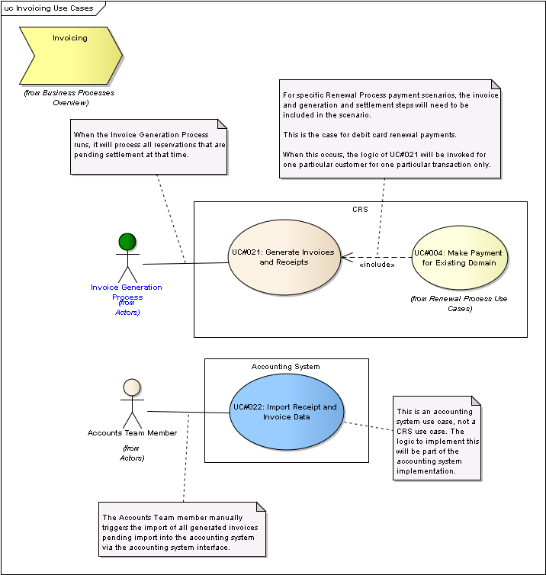
Figure 2 : Invoicing Use Cases

UC#021: Generate Invoices and Receipts
public UseCase:
The actor triggers the system to generate the receipts and invoices for IEDR services (e.g., registrations, renewals and transfers) paid for using deposit accounts (ADP payments), credit cards and debit cards based on the pending unsettled reservations.
While credit card and debit card payments can, in theory, be included on the same invoice, in practice they will be separate because debit card payment invoice generation will take place at the point the transaction is initiated by the customer, not when the batch invoice generation process runs, so they will end up being separate from credit card payment invoices as a result.
The receipt will be generated for the associated set of reservations. The invoice is then generated for the associated receipt.
The invoice will be an XML document, and this will be considered as the canonical invoice copy. A 'printable' format of the invoice (e.g., PDF) is also produced from the XML invoice. Registrars will then have access to the invoice.
Appropriate DSM events will be triggered during processing.
When triggered as part of a batch run:
For each customer it will
- first select all ADP transactions / reservations for the customer, if any, that are ready and pending settlement and generate a single invoice / receipt as a result, updating actual and available deposit accounts as it goes
- then select all pending card payment transactions / reservations for the customer, if any, ready and pending settlement and generate a single invoice / receipt as a result, requesting settlement from RealEx as it proceeds (and only including successfully settled transactions on the invoice).
When triggered for a specific transaction:
For the customer it will
- select the transaction and associated reservations for the customer and attempt to settle the transaction and associated reservations, generating the invoice / receipt pair

Scenarios
UC021-SC01: Registrar ADP Payments Invoice {Basic Path}. A registrar with some reserved but unsettled ADP reservations exists.
1. The actor identifies the customer to be invoiced for any pending ADP transactions. The system selects all ADP transactions (that is, transactions which are associated with ADP reservations) which have all associated ADP reservations flagged as reserved but not settled.
2. The system creates the invoice object, generating the next unique, sequential invoice number.
3. The system records that processing of the next invoice has begun. [This is to allow detection of failure mid-processing.]
4. FOR EACH TRANSACTION:
5. The system flags the transaction has having started settlement.
6. The system reduces the actual deposit balance by the transaction cost.
7. FOR EACH RESERVATION associated with the transaction:
8. The system flags the reservation as having its settlement started.
9. DSM EVENT: Payment(period). The domain is the domain associated with the reservation. The period is the duration of the reservation. This will result in the update of the renewal date.
10. The system flags the reservation as being settled and set the settlement timestamp to the current timestamp.
11. END FOR EACH RESERVATION.
12. The system associates the transaction with the invoice.
13. The system flags the transaction has having ended settlement.
14. END FOR EACH TRANSACTION.
15. The system creates the receipt object.
16. The system writes the invoice XML to the invoice XML output directory's date-named subfolder (e.g., <invoiceXMLOutputRootDir>/2012-02-16/ ). [See example]. The format of the XML filename is <invoicenumber>.xml.
17. The PDF version of the invoice is generated from the invoice XML and placed in the invoice PDF output directory. The format of the PDF filename is <invoicenumber.pdf>.
18. The system records that the generation of the invoice is complete.

UC021-SC02: Registrar Credit Card Payments Invoice {Basic Path}. A registrar with some unsettled credit card reservations which are ready for settlement exists.
1. The actor identifies the customer to be invoiced for any pending credit card transactions. The system selects all credit card transactions (that is, transactions which are associated with credit card reservations) which have all associated credit card reservations flagged as ready for settlement but not settled.
2. The system creates the invoice object, generating the next unique, sequential invoice number.
3. The system records that processing of the next invoice has begun.
4. FOR EACH TRANSACTION:
5. The system flags the transaction has having started settlement.
6. The system requests settlement of the pre-authorised RealEx credit card transaction. RealEx responds with success.
7. FOR EACH RESERVATION associated with the transaction:
8. The system flags the reservation as having its settlement started.
9. DSM EVENT: Payment(period). The domain is the domain associated with the reservation. The period is the duration of the reservation. This will result in the update of the renewal date.
10. The system flags the reservation as being settled and set the settlement timestamp to the current timestamp.
11. END FOR EACH RESERVATION.
12. The system associates the transaction with the invoice.
13. The system flags the transaction has having ended settlement.
14. END FOR EACH TRANSACTION.
15. The system creates the receipt object.
16. The system writes the invoice XML to the invoice XML output directory's date-named subfolder (e.g., <invoiceXMLOutputRootDir>/2012-02-16/ ). [See example]. The format of the XML filename is <invoicenumber>.xml.
17. The PDF version of the invoice is generated from the invoice XML and placed in the invoice PDF output directory. The format of the PDF filename is <invoicenumber.pdf>.
18. The system records that the generation of the invoice is complete.

UC021-SC03: Registrar Debit Card - REDUNDANT {Basic Path}. Debit card payment method is not available to Registrars.

UC021-SC04: Direct Credit Card Payments Invoice {Basic Path}. A direct customer with some unsettled credit card reservations which are ready for settlement exists.
1. The actor identifies the customer to be invoiced for any pending credit card transactions. The system selects all credit card transactions (that is, transactions which are associated with credit card reservations) which have all associated credit card reservations flagged as ready for settlement but not settled.
2. The system creates the invoice object, generating the next unique, sequential invoice number.
3. The system records that processing of the next invoice has begun.
4. FOR EACH TRANSACTION:
5. The system flags the transaction has having started settlement.
6. The system requests settlement of the pre-authorised RealEx credit card transaction. RealEx responds with success.
7. FOR EACH RESERVATION associated with the transaction:
8. The system flags the reservation as having its settlement started.
9. DSM EVENT: Payment(period). The domain is the domain associated with the reservation. The period is the duration of the reservation. This will result in the update of the renewal date.
10. The system flags the reservation as being settled and set the settlement timestamp to the current timestamp.
11. END FOR EACH RESERVATION.
12. The system associates the transaction with the invoice.
13. The system flags the transaction has having ended settlement.
14. END FOR EACH TRANSACTION.
15. The system creates the receipt object.
16. The system writes the invoice XML to the invoice XML output directory's date-named subfolder (e.g., <invoiceXMLOutputRootDir>/2012-02-16/ ). [See example]. The format of the XML filename is <invoicenumber>.xml.
17. The PDF version of the invoice is generated from the invoice XML and placed in the invoice PDF output directory. The format of the PDF filename is <invoicenumber.pdf>.
18. The system records that the generation of the invoice is complete.

UC021-SC05: Direct Debit Card Payments Invoice {Basic Path}. A direct customer with some unsettled debit card reservations which are ready for settlement exists.
Note: As no pre-authorisation exists for debit cards the debit card details are supplied by the actor for this scenario.
1. The actor identifies the debit card transaction to be processed. The system creates the invoice object, generating the next unique, sequential invoice number.
2. The system flags the transaction has having started settlement.
3. The system requests settlement of the debit card transaction via RealEx. RealEx responds with success.
4. FOR EACH RESERVATION associated with the transaction:
5. The system flags the reservation as having its settlement started.
6. DSM EVENT: Payment(period). The domain is the domain associated with the reservation. The period is the duration of the reservation. This will result in the update of the renewal date.
7. The system flags the reservation as being settled and set the settlement timestamp to the current timestamp.
8. END FOR EACH RESERVATION.
9. The system creates the invoice object with the next unique, sequential invoice number and flags it as having begun settlement.
10. The system associates the transaction with the invoice.
11. The system flags the transaction has having ended settlement.
12. The system creates the receipt object.
13. The system writes the invoice XML to the invoice XML output directory's date-named subfolder (e.g., <invoiceXMLOutputRootDir>/2012-02-16/ ). [See example]. The format of the XML filename is <invoicenumber>.xml.
14. The PDF version of the invoice is generated from the invoice XML and placed in the invoice PDF output directory. The format of the PDF filename is <invoicenumber.pdf>.
15. The system records that the generation of the invoice is complete.

Invoice XML for ADP Payments
public Object:
<!-- Formal schema TBD. General structure here for discussion and review. -->
<invoice invoiceNumber="INV123456" invoiceDate="2012-02-16" currency="EUR">
<account>
<name>Irish Domains</name>
<address>123 Some Place,Somewhere</address>
<county>Dublin</county>
<country>Ireland</country>
<accountNo>12343</accountNo>
<billC>EA1-IEDR</billC>
</account>
<iedr>
<name>IE Domain Registry</name>
<address>Harbour Square, 4th Floor, Dun Laoghaire</address>
<county>Co. Dublin</county>
<country>Ireland</country>
<email>accounts@iedr.ie</email>
</iedr>
<totalExVAT>20.00</totalExVAT>
<totalVAT>4.60</totalVAT>
<totalIncVAT>24.60</totalIncVAT>
<transactions>
<transaction id="1234" method="ADP"> <!-- id is the internal id of the transaction -->
<!-- Item corresponds to a reservation. -->
<item reservationID="1234">
<product id="123">
<!-- from Product table. Prices can change over time. -->
<productName>1 Year Reseller Registration Rate</productName>
<productDurationYears>1</productDurationYears>
</product>
<domain>
<domainName>example1.ie</domainName>
</domain>
<cost>10.00</cost>
<VATRateID>3</VATRateID>
<VATCode>A</VATCode>
<VATRate>23</VATRate>
<VATAmount>2.30</VATAmount>
<total>12.30</total>
</item>
<item reservationID="1235">
<product id="123">
<productName>1 Year Reseller Registration Rate</productName>
<productDurationYears>1</productDurationYears>
</product>
<domain>
<domainName>example2.ie</domainName>
</domain>
<cost>10.00</cost>
<VATRateID>3</VATRateID>
<VATCode>A</VATCode>
<VATRate>23</VATRate>
<VATAmount>2.30</VATAmount>
<total>12.30</total>
</item>
</transaction>
<transaction id="7894">
<!-- Item corresponds to a reservation. -->
<item reservationID="1236">
<product id="123">
<!-- from Product table. Prices can change over time. -->
<productName>1 Year Reseller Registration Rate</productName>
<productDurationYears>1</productDurationYears>
</product>
<domain>
<domainName>example3.ie</domainName>
</domain>
<cost>10.00</cost>
<VATRateID>3</VATRateID>
<VATCode>A</VATCode>
<VATRate>23</VATRate>
<VATAmount>2.30</VATAmount>
<total>12.30</total>
</item>
</transaction>
</transactions>
</invoice>

UC#022: Import Receipt and Invoice Data
public UseCase:
This is not a CRS use case - it is part of the TBC new accounting system. It is included here for informational purposes only but outside of development scope.
The actor imports receipt and invoice data generated by CRS which have not yet been imported into the Accounting System.
Each invoice/receipt to be imported already includes base price, VAT amounts, VAT rate codes, accounting system Person details, the payment type used (PIA vs. ADP), and all other detail required by the Accounting System.
For each invoice/receipt the import process will perform a recalculation of the VAT amounts based on the invoice data. Any discrepancy found between the amount presented in the invoice and the amount recalculated by the accounting system will be considered an exception (i.e., it should never be the case) and the import of that invoice will not proceed. An indication of this failure will also be made to IEDR accounts personnel.

Scenarios
Basic Path {Basic Path}.

Accounts Team Member
public Actor:
A member of the IEDR Accounts Team.

Invoice Generation Process
public «internal worker» Actor:
The internal process responsible for generating receipts and invoices that result from pending reservations.

REQ#0014: Invoices are issued when domains are paid for.
«Political» Requirement:
Invoices are no longer issued in arrears of the renewal date / transfer date / new registration date.

REQ#0016: The 30 day billing cycle is replaced with a 29 day renewal cycle.
«Political» Requirement:
30 day 'billing cycle' credit terms will be eliminated for all transactions (renewals, new registrations and transfers) to be replaced by a 29 day 'renewal cycle', i.e., 29 days from the renewal date until the deletion date (1+14+14=29).

REQ#0024: Product pricing rates can change over time.
«Assumption» Requirement:
Pricing tables implemented to future proof against arbitrary rate changes.

REQ#0032: CRS must generate invoices.
«Functional» Requirement:
CRS will be the prime generator of Invoices. Invoice data will be transferred over to the G/L system.

REQ#0043: Deposit accounts must be maintained in CRS.
«Constraint» Requirement:
Deposit accounts will be maintained in CRS and should match the G/L.

REQ#0073: History records must be recorded.
«Functional» Requirement:
History must be recorded as per the status quo CRS-API approach.

REQ#0074: Receipts must have an auto incremented ID value.
«Functional» Requirement:
Receipts should be created as per the CRS-API approach with the exception of the introduction of a &ldquo;id&rdquo; value within the Receipts database table. It is proposed that we introduce an integer auto_increment receipt id value, which will allow for multiple payments per domain at any time. This would allow a registrar to renew a domain as many times as they like at any time, without causing duplicate receipt errors as would arise with the status quo table structure.

REQ#0087: Reports must be able to distinguish the method of payment used for an invoice (ADP/PIA).
«Constraint» Requirement:
Rationale: Finance require reports to be run based on the distinction between them. The current implementation encodes this information in the Receipt Order ID.
The payment method used to pay an invoice and the associated set of domain status updates must be recorded for reporting purposes.
- by domain update we mean whether the domain went from NRP to Active etc. Approach will be to include domain state at payment and any other necessary detail.

REQ#0101: New registrations and transfers must be settled before the ticket is completed on CRS.
«Political» Requirement:

REQ#0118: Processing of payment must complete before a newly registered domain's renewal date is rolled forward.
«Political» Requirement:

REQ#0164: Domain names must not be truncated when displayed on a printable invoice.
«Constraint» Requirement:
Rationale
Domain names, though they may be long, should be fully identifiable on invoices.

REQ#0165: Data to be included in invoice XML.
«Constraint» Requirement:
The invoice XML must include:
- Invoice number (as generated by CRS)
- Account Number (which is the Bill-C Nic on the Account, if Registrar)
- Customer Name (Bill-C Name)
- Customer Address (Bill-C Address)
- Invoice Date - *The date the invoice is generated*
- Applied VAT Rate Code - From the VAT Rate code table
- Applied VAT Rate - The VAT rate corresponding to the rate code, at the invoice date
- Details for each line item (see below)
- Total Value (ex VAT) - the sum of all line item Ex. VAT values
- VAT total - the sum of all line item VAT values
- Total inc. VAT - the sum of all line items inc. VAT
- Payment method (ADP / PIA) - the payment method used to pay the invoice, which will be known
The details for each line item must include:
- domain name - must not be truncated
- domain holder name
- product / unit cost ex. VAT
- reservation ID - if applicable
- VAT amount
- cost inc. VAT
- transaction type (renewal, registration, transfer)
- domain registration date
- domain renewal date
- domain transfer date - if applicable
- The date of the transaction
- The time of the transaction
The invoice XML could include other data fields which may be useful for diagnostic / issue resolution purposes.

REQ#0166: The CRS receipt and invoice generation process schedule will be configurable.
«Usability» Requirement:
IEDR Accounts will determine the schedule for this process to run.

REQ#0167: The Accounting System import of invoice data will occur when IEDR Accounts team manually trigger it.
«Functional» Requirement:
The Accounting System import of receipt / invoice data will occur when IEDR Accounts team manually trigger it.

REQ#0178: Separate invoices / receipts will be generated for ADP and CC payments.
«Functional» Requirement:
The set of reservations pertaining to ADP payments will be processed separately from CC payment reservations.

REQ#0179: The invoice import to the accounting system must create new debtor's ledgers if necessary.
«Functional» Requirement:
[detail]

REQ#0181: Transaction costs and VAT should be calculated at one time only for any transaction.
«Soln. Idea» Requirement:

REQ#0182: Registration transaction costs calculated when the associated reservation is created.
«Legal» Requirement:

REQ#0183: Transfer transaction costs calculated when transfer request is made.
«Legal» Requirement:
For transfers, the transaction costs including VAT if applicable, are calculated when the registration request is made.
This is true regardless of:
Channel (API vs. NRC)
Customer (Direct vs. Registrant)
Payment method (ADP, Credit Card, Debit Card)

REQ#0184: Renewal transaction costs calculated at point in time of payment.
«Legal» Requirement:
For renewals, the transaction costs including VAT if applicable, are calculated when the renewal payment is made.
This is true regardless of:
Channel (API vs. NRC)
Customer (Direct vs. Registrant)
Payment method (ADP, Credit Card, Debit Card)

REQ#0190: Separate invoices will be generated for ADP payments and card payments. Debit and credit card payments can (but will not) appear on the same invoice.
«Assumption» Requirement:
Debit card transactions will generate an invoice straight away - so will not appear with cc transactions on same invoice.

REQ#0214: Renewal payments cannot be made against GIBO domains that have not yet been Post-registration Audited.
«Constraint» Requirement:

REQ#0215: Payments cannot be made against domains in voluntary NRP.
«Constraint» Requirement:

REQ#0232: WIPO disputed domains can be renewed.
«Assumption» Requirement:

REQ#0233: The period of time to advance the renewal date for autorenewed / renew once domains is always one year.
«Assumption» Requirement:

REQ#0234: If a customer makes an advance renewal payment on a domain with renewal mode 'once' (R), the domain becomes not autorenewed thereafter.
«Functional» Requirement:
Source: AB

REQ#0236: WIPO disputed domains cannot be renewed by the customer.
«Functional» Requirement:

REQ#0239: Charity / Non-billable domains cannot have renewal payments made for them. They will have the renewal date rolled forward by 1 year when due unless placed into voluntary NRP.
«Functional» Requirement:

REQ#0250: Internal system process logging should be available and configurable.
«Functional» Requirement:
Some logging for all scheduled processes (anything whose schedule is configured):
Scheduled DNScheck runs
IE BEO / NRP clear-downs
Finance re-checks (GIBO)
Invoice settlements
Basically, any batch-type processing that is run by a 'system' actor.
Ideally, the verbosity of the logging could be configurable too. (ERROR, WARNING, DEBUG, INFO)

REQ#0253: Reservations are only settled at the point the associated invoice is generated.
«Functional» Requirement:

REQ#0261: If a renewal payment is attempted for a domain in voluntary NRP then the domain should be automatically removed from voluntary NRP before the payment is processed immediately afterwards.
«Functional» Requirement:

REQ#0262: WIPO disupted domains can be renewed by the customer, or autorenewed if appropriate, but if entering involuntary NRP the domain will go no further than being suspended, without being deleted.
«Functional» Requirement:
This is so that:
a) the customer does not get a free lunch
b) the customer does not lose ownership of the domain while the dispute is ongoing

REQ#0267: Charities and other non-billable domains never appear on invoices.
«Constraint» Requirement:

REQ#0268: For registrations, renewals and transfers, the renewal date of a domain is only rolled forward when the invoice is generated, as this is considered settlement.
«Functional» Requirement:

REQ#0269: All settled reservations must reference the associated invoice generated when they were settled.
«Constraint» Requirement:

REQ#0274: All rollforward of renewal dates is supported by an irreversible, settled receipt (whether by credit card, deduction from deposit account, debit card etc).
«Constraint» Requirement:

REQ#0275: Roll-forward of renewal dates must only take place after a settlement.
«Functional» Requirement:
No changes to renewal dates are permitted during a financial *reservation*. If, for any reason, a financially settle transaction is reversed or voided, then the renewal dates MUST be rolled back to the original state.

REQ#0276: All financial transactions must give value to the customer; that is, they all must roll forward the renewal date.
«Policy» Requirement:
All financial transactions must give &lsquo;value&rsquo; to the customer, measured by rolling forward the renewal dates, by the appropriate number of years. (Note :- There are *no* financial transactions at the Registry which fail to impact the renewal dates).

REQ#0277: All financial transactions must generate an e-mail confirmation to be sent to the customer BillC and to IEDR Accounts mailing list.
«Functional» Requirement:
All financial transactions must generate an e-mail confirmation - to be sent to the customer BillC and to IEDR Accounts mailing list.

REQ#0278: All receipts from customers must result in rolled-forward renewal dates.
«Constraint» Requirement:

REQ#0279: All receipts from customers must be recorded in the CRS system.
«Functional» Requirement:

REQ#0280: All receipts from customers must be passed correctly to the accounting system.
«Functional» Requirement:
All receipts from customers are passed correctly to the ABM accounting system.

REQ#0286: All credit card receipts must be routed through Realex.
«Functional» Requirement:
*All* credit card receipts must be routed through Realex.
To ensure that credit card transactions via the API and the NRC are only processed by a reputable processor (currently Realex) and are complete and accurate.

REQ#0287: Transaction IDs or Order IDs must be provided to Realex, in respect of all reservations and settlements - sufficient to allow matching to IEDR transaction IDs (and reconciliation where differences arise).
«Functional» Requirement:
Transaction IDs or Order IDs must be provided to Realex, in respect of all reservations and settlements - sufficient to allow matching to IEDR transaction IDs (and reconciliation where differences arise).
To ensure that credit card transactions via the API and the NRC are only processed by a reputable processor (currently Realex) and are complete and accurate.

REQ#0288: Settlements via Realex must be matched by a contemporaneously generated invoice.
«Functional» Requirement:
Settlements via Realex *must* be matched by a contemporaneously generated invoice, XML'd to the customer, and XML'd to the ABM folder on the network
To ensure that credit card transactions via the API and the NRC are only processed by a reputable processor (currently Realex) and are complete and accurate.

REQ#0289: Only valid domains can be selected for payment by customers.
«Functional» Requirement:
Only valid domains can be selected for payment by customers.

REQ#0290: Only billable domains can be selected for payment by customers.
«Functional» Requirement:

REQ#0291: Charity/IEDR owned domains should not be billed. Their renewal dates should be rolled forward by 1 year at a time by an automated process, in advance of the Renewal Date +1 (to avoid entering the NRP process).
«Functional» Requirement:
Charity/IEDR owned domains should not be billed &ndash; their renewal dates should be rolled forward by an automated process, in advance of the RenDt +1 (to avoid entering the NRP process).

REQ#0292: Every financial settlement must result in an invoice, which must be sent to the customer.
«Functional» Requirement:
Every financial settlement must result in an invoice, which must be XML&rsquo;d to the customer.

REQ#0294: Invoice numbering must be unique. No breaks in sequence. No duplicate invoice numbers
«Functional» Requirement:
Invoice numbering must be unique. No breaks in sequence. No duplicate invoice numbers

REQ#0295: All invoices must be uploaded to the accounting system's GL and debtors Ledger's. None can be omitted.
«Functional» Requirement:
All XML invoices must be ‘sent’ to the ABM folder for upload to the ABM GL and debtors Ledger's. None can be omitted.

REQ#0299: Separate invoices must be generated in respect of Registrar deposit account receipts and credit card receipts.
«Constraint» Requirement:

REQ#0301: Separate invoices must be generated for direct receipts (credit and debit cards).
«Functional» Requirement:
Separate invoices must be generated for Direct receipts (combined credit cards and debit cards).

REQ#0302: It can be assumed that there is no timing dependency between the import of invoices to the accounting system and the import of DOA transaction data into the accounting system.
«Assumption» Requirement:

REQ#0017: Month-end batch processing procedures are replaced by real-time transaction processing.
«Purpose» Requirement:
Invoices and receipts are generated at the same time, on receipt of payment. As such, there are no month-end batch processing procedures.

REQ#0031: Existing VISION accounting package to be replaced.
«Assumption» Requirement:
The accounting package will be replaced. The new system will interact with CRS.

REQ#0084: VAT rate changes must be accommodated in a controlled manner.
«Sup/Maint» Requirement:
There will be a mechanism to allow changes in VAT rates on specified dates to be affected.
Rationale
VAT rates can change and so the system needs to accommodate this in a controlled manner. As such, applicable VAT rates will have periods of validity.
Potential Implementation
The VAT Rate table would consist of the following:
- ID - Primary Key
- Category - The VAT Category (has values such as 'A', 'B', etc.). Every VAT charge applicable to a transaction is associated with a particular category. Different categories may have different rates.
- From date - The date from which (inclusively) the VAT rate applies to the category.
- Rate - The rate.
NOTE: It must be ensured that no inserts / updates / deletes ever affect existing transaction details.
[Potentially, the invoice XML can contain a copy of the VAT table record used at the time. Reservation table may also do this as double-check.]

REQ#0112: Accounts team must be emailed for all receipts.
«Functional» Requirement:
This is currently the status quo, and needs to persist.
These emails function as double-checks in revenue assurance.

REQ#0058: CRS must be primary source for financial data
«Constraint» Requirement:
Data will flow from CRS to G/L only, not the other way.
G/L can perform double-check on calculation and does exception report.

REQ#0033: The flow of invoice data from CRS to G/L system can be controlled by IEDR Finance.
«Usability» Requirement:
The CRS will perform invoicing. The G/L will accept invoice data from CRS.
There will be some form of invoice batch run initiated by IEDR Finance.

REQ#0108: Invoices delivered from CRS and G/L must match in form and content.
«Functional» Requirement:
Invoices delivered from CRS and G/L must match in form and content.
There will be a 'softcopy format' of an invoice (for example, a PDF) that is available to Registrars and the G/L system.
The softcopy document format needs to be the same in every respect. It is an issue if even the format alone changes.
Potential solution
Approach may be to generate softcopy one time from XML via XSLT and store. Both CRS and G/L would deliver this softcopy when necessary to the registrar.

REQ#0052: CRS must be the source of sequence numbers.
«Constraint» Requirement:
Sequence numbers used, such as Invoice numbers, will be generated by CRS, and not from an external source, such as the external G/L system, as CRS is a real-time system, and such dependencies cause technical and usability issues (delays).

REQ#0120: There must be a direct correspondance between invoices and receipts.
«Constraint» Requirement:
Every receipt will correspond to an invoice, and an invoice will correctly tally with all associated receipts.

REQ#0035: Invoice data transfer from CRS to G/L system will be XML.
«Constraint» Requirement:
This is an implementation constraint. XML (as opposed to CSV or other) allows greater flexibility in terms of data transformation and future proofing.

REQ#0103: Invoices sent to registrars and accounting system.
«Functional» Requirement:
When invoices are generated, they must be available to both Registrars for re-download and the accounting system to email via CRS.
Note: The timing of the availability of the invoice in the accounting system depends on the timing of the import of data from CRS to the accounting system.

REQ#0109: Invoice sequencing must be complete.
«Functional» Requirement:
Invoice sequencing must be complete and without gaps when imported into the G/L system. Therefore, it must be complete in the CRS system also, as CRS will be the source of invoice data.

REQ#0034: There will be a clear delineation between accounting months when importing invoices into G/L.
«Constraint» Requirement:
As such there must be a clear point in the sequence of invoices where the run of invoices prior to the point are from the previous month and the run following the point belong to the current month.
One potential solution approach is for the CRS system to generate the primary invoice data in XML format and store it in date formatted folders, which can then be accessed by the G/L system.

REQ#0047: G/L system must import financial data as-is.
«Constraint» Requirement:
The system must not re-calculate independently. This must be the case even if CRS were to calculate VAT incorrectly.

REQ#0063: The system must implement the Domain State Machine model.
«Constraint» Requirement:
Proposed Implementation Approach
The specification of the business events and actions affecting the lifecycle of a domain as a formal state machine aids overall clarity and identification of edge cases which need to be addressed. Implementing the logic as a state machine has the additional benefit of future-proofing the system, to some extent, against changes in business rules and requirements without needing to make modifications to code and deploying full revisions of components.
To that end, one recommended approach to implementing the DSM logic is as follows:
States
Implement states as a DSM State Table, with one row per state, and the unique ID ('state number') being the primary reference. In addition, the table should include one field for each of the five parameters (Domain Holder Type, Renewal Type etc.) as shown in the DSM Specification. These fields are not intended to be referenced anywhere in code, but would greatly assist understanding the meaning of states, as well as debugging efforts.
It should be noted from the DSM Spec 'States' tab that the ID numbers are not sequential. This is because infeasible and redundant states have been removed. However, it is recommended that the state numbers are maintained as is, and not altered. This is to avoid confusion when cross-referencing from the specification to the implementation.
Events
The set of events that the DSM responds to is enumerated in a DSM Event table, and uniquely identified.
Actions
The set of actions that the DSM are caused by a transition is enumerated in a DSM Action table.
Transitions
The full set of transitions in the DSM are contained in a DSM Transition table. Each record of this table will reference the current state, an event, next state, and a sequence of actions.
Execution Model
When a business process responsible for one or more events in the DSM is executing, it will find all domains currently in a state that is a current state for any transition initiated by the event. Then, for each domain, it will select and execute the actions associated with the transition to the next state, and then update the domain to be in the next state of the transition.

REQ#0104: Invoice sequencing must be controlled within CRS.
«Functional» Requirement:
Invoice sequencing must be controlled within CRS.
No duplicates/no missing numbers.

REQ#0088: The history of domain states for a domain must be recorded.
«Functional» Requirement:
The current status quo of recording the full domain record history is also to be maintained. The recording of domain state could be part of this full record.
This will greatly assist issue diagnosis and resolution, both in terms of system debugging and customer issue resolution.

REQ#0127: VAT must be applied to invoice line items, not to subtotal.
«Legal» Requirement:
Given that VAT is used in reservation calculation per line item it must be likewise calculated when invoicing, otherwise discrepancies could occur between the two.

REQ#0045: PI Invoices will reside solely in G/L.
«Assumption» Requirement:
PI invoices are out-of-scope for BPR.

REQ#0110: Invoice discrepancies handled in G/L.
«Assumption» Requirement:
In cases where CRS and G/L differ on the details of an invoice, it will be handled as an exception by the G/L somehow.

REQ#0050: A discrepancy in an invoice received by th G/L system from CRS will not prevent processing of the batch.
«Usability» Requirement:
When batch processing invoices between CRS and the G/L, discrepancies in one item will not interfere with the processing of other unrelated items.

REQ#0116: An invoice must be imported into G/L system exactly once.
«Constraint» Requirement:
There will be a structured directory system used to deposit the invoice XML as it is generated. The structure will be:
<invoice_root>/<YYYYMMDD>/NEW
<invoice_root>/<YYYYMMDD>/ARCHIVE
Generated XML will be deposited in the appropriate /NEW directory.
The process that imports invoices to the G/L system will move them from the NEW to the ARCHIVE directory.
The <invoice_root> path should be configurable as a system environment variable. See REQ#100.

REQ#0140: Payment of renewal fees must be permitted for a domain in WIPO arbitration.
«Functional» Requirement:
Payment of renewal fees should be permitted for a domain in WIPO arbitration (and the renewal date rolled forward, in the normal way).
However, registrant would be separately advised (see IEDR web site) that there will be no refunds, in the event that the WIPO decision is negative for him.

Invoicing Process: Logical Entities

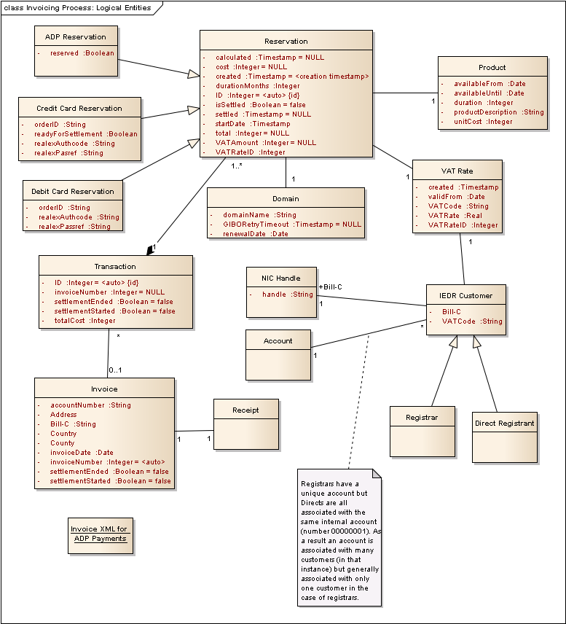
Figure 3 : Invoicing Process: Logical Entities

Business Entity Logical Model::Account
public Class:

Custom Properties

Business Entity Logical Model::ADP Reservation
public Class
Extends: Reservation. :
A reservation made against a deposit account.

Custom Properties

Business Entity Logical Model::ADP Reservation Attributes
Attribute | Type | Notes
reserved | private :  Boolean | False if the reservation is not ready to be settled, and has no impact on available ADP balance. If true, and not yet settled, then it is ready to be settled and will have an impact on available balance until that time.

Business Entity Logical Model::Credit Card Reservation
public Class
Extends: Reservation. :
A reservation made using a credit card.

Custom Properties

Business Entity Logical Model::Credit Card Reservation Attributes
Attribute | Type | Notes
orderID | private :  String | See RealEx API documentation.Max. length 40.
readyForSettlement | private :  Boolean | If true, and not yet settled, then this is ready to be included in the next invoice run for settlement.
realexAuthcode | private :  String | See RealEx API documentation.Max. length 10.
realexPasref | private :  String | See RealEx API documentation.Max. length 50.

Business Entity Logical Model::Debit Card Reservation
public Class
Extends: Reservation. :
A reservation made using a debit card.

Custom Properties

Business Entity Logical Model::Debit Card Reservation Attributes
Attribute | Type | Notes
orderID | private :  String | See RealEx API documentation.Max. length 40.
realexAuthcode | private :  String | See RealEx API documentation.Max. length 10.
realexPassref | private :  String | See RealEx API documentation.Max. length 50.

Business Entity Logical Model::Direct Registrant
public Class
Extends: IEDR Customer. :
A customer that registers domains on their own behalf.

Custom Properties

Business Entity Logical Model::Domain
public Class:
A .ie domain.

Custom Properties

Business Entity Logical Model::Domain Attributes
Attribute | Type | Notes
domainName | private :  String
GIBORetryTimeout | private :  Timestamp | The timestamp when a financially-failed GIBO registered domain's retry period expires.  Initial Value: NULL;
renewalDate | private :  Date | The renewal date.

Business Entity Logical Model::IEDR Customer
public Class:
Represents a customer who registers domains from the IEDR. Either a direct registrant or a registrar.

Custom Properties

Business Entity Logical Model::IEDR Customer Attributes
Attribute | Type | Notes
Bill-C | private :
VATCode | private :  String | The VAT Code applicable to the registrant.

Business Entity Logical Model::Invoice
public Class:

Custom Properties

Business Entity Logical Model::Invoice Attributes
Attribute | Type | Notes
accountNumber | private :  String | The account number associated with the customer.
Address | private :
Bill-C | private :  String | The Bill-C nic handle associated with the customer.
Country | private :
County | private :
invoiceDate | private :  Date | The date the invoice is generated.
invoiceNumber | private :  Integer | The unique sequence number of this invoice.  Initial Value: <auto>;
settlementEnded | private :  Boolean | Flag to indicate that settlement of the invoice has completed successfully.  Initial Value: false;
settlementStarted | private :  Boolean | A flag to indicate that settlement of the invoice has started. This is for detecting failure during generation of an invoice.  Initial Value: false;

Business Entity Logical Model::NIC Handle
public Class:

Custom Properties

Business Entity Logical Model::NIC Handle Attributes
Attribute | Type | Notes
handle | private :  String

Business Entity Logical Model::Product
public Class:
A product that customers can purchase (e.g., 1 year domain registration, 2-year domain registration etc.)

Custom Properties

Business Entity Logical Model::Product Attributes
Attribute | Type | Notes
availableFrom | private :  Date | The date that the product becomes available. The product is available to customers from and including this date.
availableUntil | private :  Date | The last date that the product is available. The product is available for purchase until and inclusive of this date.
duration | private :  Integer | Number of years of domain registration for the product.
productDescription | private :  String | Description of the product.
unitCost | private :  Integer | The cost of the product, ex. VAT.

Business Entity Logical Model::Receipt
public Class:

Custom Properties

Business Entity Logical Model::Registrar
public Class
Extends: IEDR Customer. :

Custom Properties

Business Entity Logical Model::Reservation
public Class:
An entity that maintains all necessary information regarding a reservation for a transaction.

Custom Properties

Business Entity Logical Model::Reservation Attributes
Attribute | Type | Notes
calculated | private :  Timestamp | The timestamp at which the vatAmount and total attributes are calculated, based on the cost (derived from the associated product) and the vatRate. This must only occur once in the lifetime of the entity.  Initial Value: NULL;
cost | private :  Integer | The base cost of the reservation, ex VAT, derived from the associated product cost.  Initial Value: NULL;
created | private :  Timestamp | The initial creation timestamp of the reservation.  Initial Value: <creation timestamp>;
durationMonths | private :  Integer | The number of months to roll the renewal date of the domain forward by when the reservation is settled.
ID | private :  Integer | A globally unique ID for the reservation.  Initial Value: <auto>;
isSettled | private :  Boolean | True if the reservation has been settled, false otherwise.  Initial Value: false;
settled | private :  Timestamp | The date and time at which the reservation was settled.  Initial Value: NULL;
startDate | private :  Timestamp | This is the date and time that marks the beginning of the period of time from which the customer derives value for the transaction. Used for revenue recognition accounting purposes.
total | private :  Integer | The total cost inclusive of any applicable VAT.  Initial Value: NULL;
VATAmount | private :  Integer | The amount of applicable VAT.  Initial Value: NULL;
VATRateID | private :  Integer | The ID of the VAT Rate used to perform the calculation of VAT Amount.

Business Entity Logical Model::Transaction
public Class:
Represents a single payment transaction by a customer.

Custom Properties

Business Entity Logical Model::Transaction Attributes
Attribute | Type | Notes
ID | private :  Integer | UID for the transaction.  Initial Value: <auto>;
invoiceNumber | private :  Integer | References the associated invoice on which it appears.  Initial Value: NULL;
settlementEnded | private :  Boolean | This is a flag set when all actions associated with successfully settling the transaction have completed.  Initial Value: false;
settlementStarted | private :  Boolean | A flag set to indicate that settlement of the transaction was started. This is to allow for detection of failed transaction settlement.  Initial Value: false;
totalCost | private :  Integer | The total cost, inclusive of VAT, of all the associated reservations.

Business Entity Logical Model::VAT Rate
public Class:
This represents the valid VAT rate for a particular VAT rate code starting from a particular date in time. It is valid unless and until it is superceded by a VAT rate for the same code at a future point in time.

Custom Properties

Business Entity Logical Model::VAT Rate Attributes
Attribute | Type | Notes
created | private :  Timestamp | The timestamp when the VAT Rate entity was created. This is for data integrity validation. VAT Rates should never be updated or deleted. Only inserted.
validFrom | private :  Date | The date that the VAT rate for the VAT code comes into effect.
VATCode | private :  String | Alphabetic code for the VAT Rate.
VATRate | private :  Real | The VAT rate itself (e.g., 0.23).
VATRateID | private :  Integer | A unique ID for each VAT Rate. This is required to be referenced by other entities for data integrity validation.

