FINAL
Version 1.0
15 Feb 2012

Registration Process

This package defines the use cases, activities and events of the Registration process.

Registration Process: Activity Diagrams

This shows the general sequence of events for registration using ADP payments.

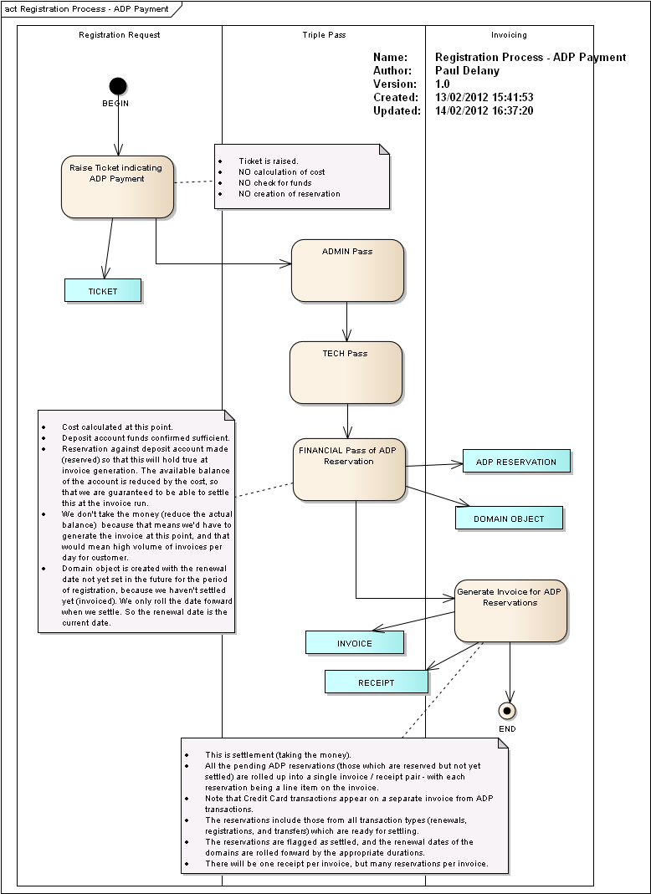
Figure 1 : Registration Process - ADP Payment

This shows the general sequence of events for registration using credit card payments.

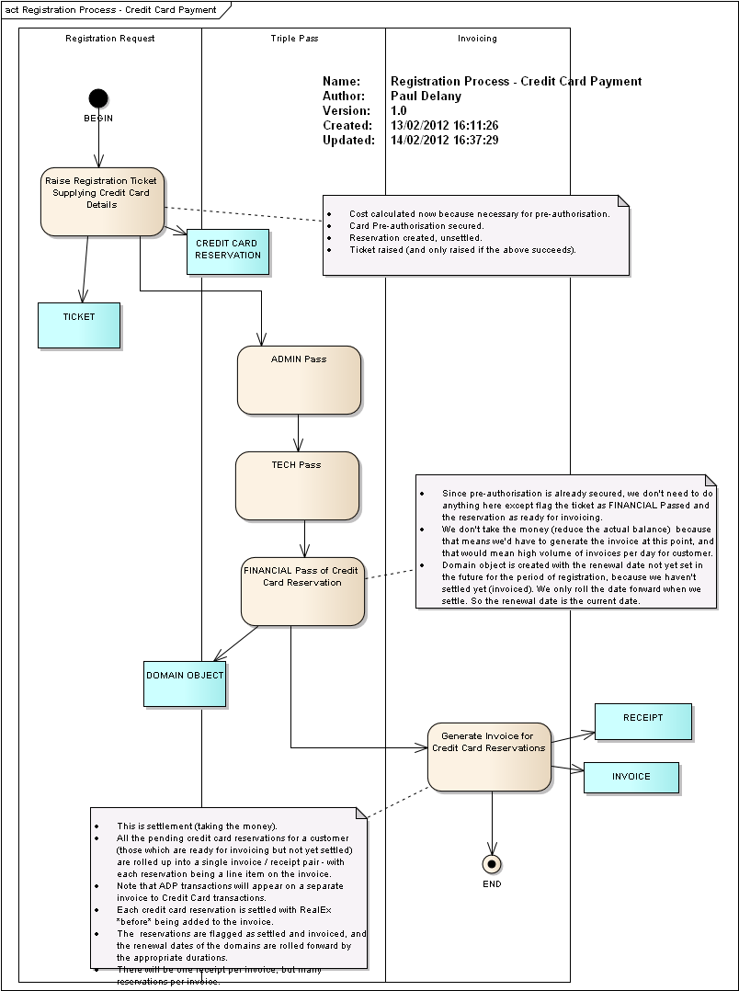
Figure 2 : Registration Process - Credit Card Payment

Registration Process: Use Cases

This package defines the use cases of the Registration process.

The set of use cases relating to domain registration.

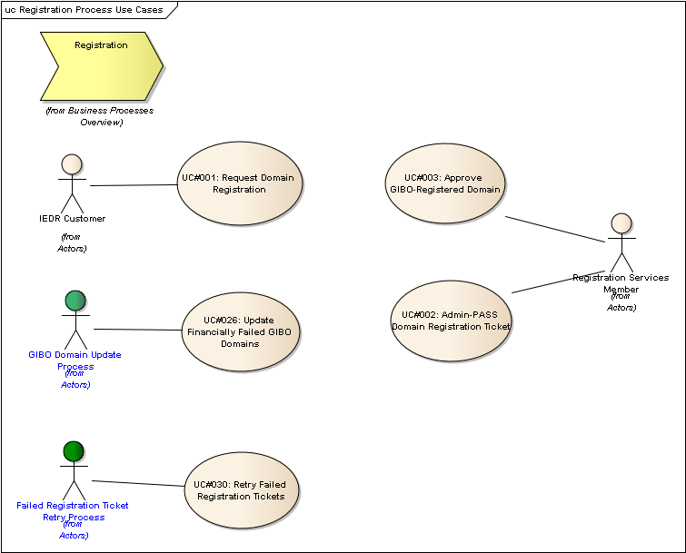
Figure 3 : Registration Process Use Cases

UC#001: Request Domain Registration
Type: public UseCase
Status: Proposed. Version 1.0. Phase 1.0.
Package: Registration Process: Use Cases
Details: Created on 19/12/2011 14:28:44. Modified on 14/02/2012 17:12:28. Author: Paul Delany

The actor initiates the sequence of events to ultimately register a domain that is not already registered. The domain may not be created on completion of the use case, but rather the registration request (ticket) is created which will be further processed.
GIBO registration is an exception to this - the domain is created first, without any corresponding registration ticket, and thereafter the registration details are reviewed by Registration Services, and then financial aspects are processed.

Scenarios
UC001-SC01: Registrar Basic {Basic Path}. A registrar attempts to register a domain via the CRS-API.
Details
Registrar / Direct: Registrar
Payment Method: ADP
NRC / API: API
Regular Registration / GIBO: Regular
Payment Success: Success
Billable Domain / Charity Domain: Billable
Customer is VAT Exempt?: No
1. The actor issues a domain:create command via the API for domain example.ie, for a 1 year period, supplying 2 valid nameserver details, a domain holder class of Natural Person and category Personal Name, a valid ADMIN-C Nic handle, and a valid TECH-C Nic.
2. The system validates that the domain is not already registered, that no registration ticket for the domain exists in the system, that all mandatory details are supplied and correct.
3. The registration ticket is created in the system. The expiry date for the ticket is set to be 27 days from the current date.
4. The system responds with success code, the ticket number, the creation date of the ticket, and expiry date of the ticket. [See EX003: Registration API response.].

UC001-SC02: Direct Basic {Basic Path}. A direct registrant attempts to register a valid unregistered billable domain via NRC using a credit card.
Details
Registrar / Direct: Direct
Payment Method: Credit Card
NRC / API: NRC
Regular Registration / GIBO: Regular
Authorisation Success: Success
Billable Domain / Charity Domain: Billable
Customer is VAT Exempt?: Yes
1. The actor submits a domain registration request via NRC for domain example.ie, for a 1 year period, supplying 2 valid nameserver details, a domain holder class of Natural Person and category Personal Name, a valid admin-c nic handle, and a valid tech-c admin handle. [It is assumed that if the actor has logged into the system then the Nic handle used for logging in is the Bill-C to be associated with the registration.] The actor also supplies valid credit card details.
2. The system validates that the domain is not already registered, that no registration ticket for the domain exists in the system, that all mandatory details are supplied and correct.
3. The system calculates the value of the transaction. [See EX004: VAT Exempt Cost Calculation.]
4. The system requests authorisation (not settlement) of the credit card for the transaction via the RealEx API. Settlement is not requested from RealEx at this time; only the authorisation of the transaction. [See RealAuth XML Definitions Guide v2.1, Section 3]
5. RealEx responds with a valid authorisation. [See RealAuth XML Definitions Guide v2.1, Section 3]
6. The system creates the corresponding credit card reservation. The reservation has its duration set to 1 year (this is so that when it is settled the renewal date will be rolled forward by the appropriate period). The credit card reservation is flagged as not ready for settlement (because the associated ticket has not yet been ADMIN / TECH passed). [See Reservation in logical model.]
7. The system creates the registration ticket. The ticket must be associated with the credit card reservation.
8. The system responds by indicating the success of the operation.

UC001-SC03: Registrar Credit Card {Basic Path}.
Details
Registrar / Direct: Registrar
Payment Method: Credit Card
NRC / API: NRC
Regular Registration / GIBO: Regular
Authorisation Success: Success
Billable Domain / Charity Domain: Billable
Customer is VAT Exempt?: No
1. The actor submits a domain registration request via NRC for domain example.ie, for a 1 year period, supplying 2 valid nameserver details, a domain holder class of Natural Person and category Personal Name, a valid admin-c nic handle, and a valid tech-c admin handle (the default tech-c nic). The actor also supplies valid credit card details.
2. The system validates that the domain is not already registered, that no registration ticket for the domain exists in the system, that all mandatory details are supplied and correct.
3. The system calculates the value of the transaction. [See EX002: Regular VAT calculation.]
4. The system requests authorisation (not settlement) of the credit card for the transaction via the RealEx API. Settlement is not requested from RealEx at this time; only the authorisation of the transaction. [See RealAuth XML Definitions Guide v2.1, Section 3]
5. RealEx responds with a valid authorisation. [See RealAuth XML Definitions Guide v2.1, Section 3]
6. The system creates the corresponding credit card reservation. The reservation has its duration set to 1 year (this is so that when it is settled the renewal date will be rolled forward by the appropriate period).The credit card reservation is flagged as not ready for settlement (because the associated ticket has not yet been ADMIN / TECH passed). [See Reservation logical model]
7. The system creates the registration ticket. The ticket is associated with the credit card reservation.
8. The system responds by indicating the success of the operation.

UC001-SC04: Direct Registrant Debit Card - REDUNDANT {Basic Path}.
Details
Registrar / Direct: Direct
Payment Method: Visa Debit Card
NRC / API: NRC
Regular Registration / GIBO: Regular
Authorisation Success: Success
Billable Domain / Charity Domain: Billable
Customer is VAT Exempt?: No
No Debit Card payments permitted for Registrations.

UC001-SC05: Registrar Charity Reg {Basic Path}.
Details
Registrar / Direct: Registrar
Payment Method: n/a (charity registrations don't require payment)
NRC / API: API
Regular Registration / GIBO: Regular
Authorisation Success: n/a - no payment required for charities
Billable Domain / Charity Domain: Charity
Customer is VAT Exempt?: No
1. The actor issues a domain:create command via the API for domain example.ie, for a 1 year period,supplying 2 valid nameserver details, a domain holder class of Natural Person and category Personal Name, a valid admin-c nic handle, and a valid tech-c admin handle (the default tech-c nic). The charity CHY code is also supplied. [EX005: API domain:create Charity Registration]
2. The system validates that the domain is not already registered, that no registration ticket for the domain exists in the system, that all mandatory details are supplied and correct. The CHY code format is validated also.
3. The registration ticket is created in the system, which includes the CHY code supplied. The expiry date for the ticket is set to be the ticket expiry limit number of days (currently 27) from the current date.
4. The system responds with success code, the ticket number, the creation date of the ticket, and expiry date of the ticket. [See EX003: Registration API response.].

UC001-SC06: Registrar Debit Card - REDUNDANT {Basic Path}.
Details
Registrar / Direct: Registrar
Payment Method: Visa Debit Card
NRC / API: NRC
Regular Registration / GIBO: Regular
Authorisation Success: Success
Billable Domain / Charity Domain: Billable
Customer is VAT Exempt?: Yes
Debit Cards not permitted for Registrations as pre-authorisation not possible.

UC001-SC07: Direct Charity Reg {Basic Path}.
Details
Registrar / Direct: Direct
Payment Method: n/a (not required for charity registrations)
NRC / API: NRC
Regular Registration / GIBO: Regular
Authorisation Success: Success
Billable Domain / Charity Domain: Charity
Customer is VAT Exempt?: No
1. The actor submits a domain registration request via NRC for domain example.ie, for a 1 year period, supplying 2 valid nameserver details, a domain holder class of Sole Trader and category of Personal Trading Name, a valid admin-c nic handle, and a valid tech-c admin handle. [The Bill-C is assumed to be the actor's log-in Nic.] The actor also supplies a CHY code.
2. The system validates that the domain is not already registered, that no registration ticket for the domain exists in the system, that all mandatory details are supplied and correct. The CHY code format is validated also.
3. The system creates the registration ticket. The ticket must include the CHY code.
4. The system creates the reservation with zero cost. [See EX002: Regular VAT calculation]
5. The system responds by indicating the success of the operation.

UC001-SC08: GIBO Basic {Alternate}.
Details
Registrar / Direct: Registrar
Payment Method: ADP
NRC / API: API
Regular Registration / GIBO: GIBO
Authorisation Success: Success
Billable Domain / Charity Domain: Billable
Customer is VAT Exempt?: Yes
1. The actor issues the domain:autocreate command via the API for domain example.ie, supplying 2 valid nameserver details, a domain holder class and category permitted by the specified restrictions, a valid admin-c nic handle, and a valid tech-c admin handle. [See EX007: domain:autocreate GIBO Registration request]
2. The system validates that the domain is not already registered, that no registration ticket for the domain exists in the system, that all mandatory details are supplied and correct.
3. DSM EVENT: CreateGIBODomain(D=<current date>+1 year). This results in the creation of the domain object
4. The system responds with success code. [See EX008: domain:autocreate success response].

UC001-SC09: CC Authorisation fails - REDUNDANT {Exception}.
Details
Registrar / Direct: Registrar
Payment Method: Credit Card
NRC / API: API
Regular Registration / GIBO: Regular
Authorisation Success: Fail
Billable Domain / Charity Domain: Billable
Customer is VAT Exempt?: Yes
No card payments via API for registrations or transfers, due to resulting impact on API.

UC001-SC10: Debit Card Auth Fails - REDUNDANT {Exception}.
Details
Registrar / Direct: Direct
Payment Method: Visa Debit Card
NRC / API: NRC
Regular Registration / GIBO: Regular
Authorisation Success: Fail
Billable Domain / Charity Domain: Bill
Customer is VAT Exempt?: No
No debit card payments for registrations as pre-authorisation not possible.

UC001-SC11: Deposit Account Doesn't Exist - REDUNDANT {Exception}.
Details
Registrar / Direct: Registrar
Payment Method: ADP
NRC / API: API
Regular Registration / GIBO: Regular
Authorisation Success: Fail - due to no deposit account
Billable Domain / Charity Domain: Billable
Customer is VAT Exempt?: No
This scenario is redundant as the creation of the reservation for ADP payments is done at the point of Triple-passing the ticket, not at point of raising the ticket.
The outcome in this case is the same as for SC01.

UC001-SC12: GIBO via Credit Card - REDUNDANT {Alternate}. Details
Registrar / Direct: Registrar
Payment Method: Credit Card
NRC / API: API
Regular Registration / GIBO: GIBO
Authorisation Success: Success
Billable Domain / Charity Domain: Billable
Customer is VAT Exempt?: No
GIBO Registration via Credit Card is not permitted. Only the ADP payment method is valid for GIBO registration. This scenario is infeasible.

Tagged Values
- API = Y.

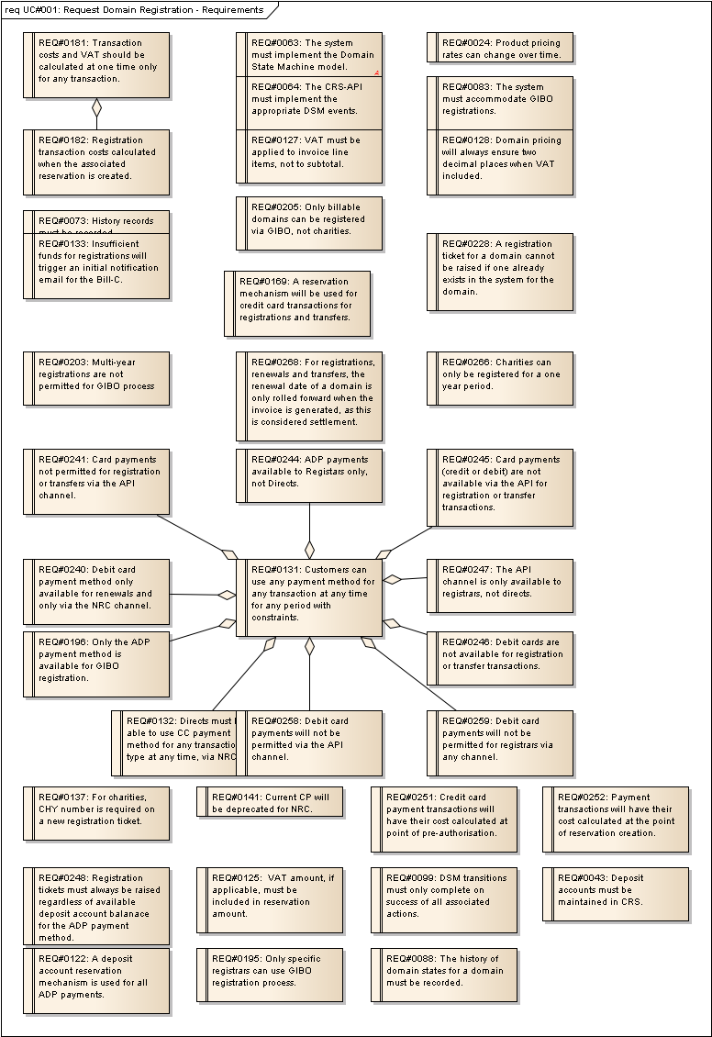
Figure 4 : UC#001: Request Domain Registration - Requirements

EX001: API domain:create using ADP
Type: public Entity
Status: Proposed. Version 1.0. Phase 1.0.
Package: Registration Process: Use Cases
Details: Created on 24/01/2012 16:34:24. Modified on 13/02/2012 11:39:47. Author: Paul Delany

<ieapi xmlns="http://www.domainregistry.ie/ieapi-1.3" xmlns:xsi="http://www.w3.org/2001/XMLSchema-instance" xsi:schemaLocation="http://www.domainregistry.ie/ieapi-1.3 ieapi-1.3.xsd">
<command>
<create>
<domain:create xmlns:domain="http://www.domainregistry.ie/ieapi-domain-1.3" xsi:schemaLocation="http://www.domainregistry.ie/ieapi-domain-1.3 ieapi-domain-1.3.xsd">
<domain:name>example.ie</domain:name>
<domain:period unit="y">1</domain:period>
<domain:ns>
<domain:nsName>ns1.example.ie</domain:nsName>
<domain:nsAddr>192.1.2.3</domain:nsAddr>
</domain:ns>
<domain:ns>
<domain:nsName>ns1.example2.ie</domain:nsName>
</domain:ns>
<domain:holder class="Natural Person">
<domain:holderName category="Personal Name">John Doe</domain:holderName>
<domain:holderRemarks/>
</domain:holder>
<domain:contact type="admin">XXX123-IEDR</domain:contact>
<domain:contact type="tech">XXX124-IEDR</domain:contact>
</domain:create>
</create>
</command>
</ieapi>

EX002: Regular VAT calculation
Type: public Entity
Status: Proposed. Version 1.0. Phase 1.0.
Package: Registration Process: Use Cases
Details: Created on 24/01/2012 16:39:05. Modified on 24/01/2012 16:56:38. Author: Paul Delany

Customer VAT Code: 'A'
Current VAT Rate 'A': 23%
1 Year Domain Registration Cost Ex. VAT: EUR 10.00
Calculation:
VAT Amount: 10.00 * 0.23 = 2.30
Total Cost: 10.00 + 2.30 = 12.30

EX003: Registration API response
Type: public Entity
Status: Proposed. Version 1.0. Phase 1.0.
Package: Registration Process: Use Cases
Details: Created on 24/01/2012 16:40:38. Modified on 13/02/2012 11:40:06. Author: Paul Delany

Ex. Response XML:
<ieapi xmlns="http://www.domainregistry.ie/ieapi-1.3" xmlns:xsi="http://www.w3.org/2001/XMLSchema-instance" xsi:schemaLocation="http://www.domainregistry.ie/ieapi-1.3 ieapi-1.3.xsd">
<response>
<result code="1000">
<msg>Command completed successfully</msg>
</result>
<resData>
<domain:appData xmlns:domain="http://www.domainregistry.ie/ieapi-domain-1.3" xsi:schemaLocation="http://www.domainregistry.ie/ieapi-domain-1.2 ieapi-domain-1.2.xsd">
<domain:name>example.ie</domain:name>
<domain:appNumber>75057</domain:appNumber>
<domain:appDate>2006-07-01T14:00:00.0Z</domain:appDate>
<domain:exDate>2006-08-01T14:00:00.0Z</domain:exDate>
</domain:appData>
</resData>
</response>
</ieapi>

EX004: VAT Exempt cost calculation
Type: public Entity
Status: Proposed. Version 1.0. Phase 1.0.
Package: Registration Process: Use Cases
Details: Created on 24/01/2012 16:44:03. Modified on 24/01/2012 16:56:44. Author: Paul Delany

Ex. Transaction Cost Calculation:
Customer VAT Code: 'B' (note: in this example, 'B' is a VAT Exempt code.)
Current VAT Rate 'B': 0%
1 Year Domain Registration Cost Ex. VAT: EUR 10.00
Calculation:
VAT Amount: 10.00 * 0.00 = 0.00
Total Cost: 10.00 + 0.00 = 10.00

EX005: API domain:create Charity Registration
Type: public Entity
Status: Proposed. Version 1.0. Phase 1.0.
Package: Registration Process: Use Cases
Details: Created on 24/01/2012 16:49:13. Modified on 13/02/2012 11:40:27. Author: Paul Delany

Ex. Request XML:
<ieapi xmlns="http://www.domainregistry.ie/ieapi-1.3" xmlns:xsi="http://www.w3.org/2001/XMLSchema-instance" xsi:schemaLocation="http://www.domainregistry.ie/ieapi-1.3 ieapi-1.3.xsd">
<command>
<create>
<domain:create xmlns:domain="http://www.domainregistry.ie/ieapi-domain-1.3" xsi:schemaLocation="http://www.domainregistry.ie/ieapi-domain-1.3 ieapi-domain-1.3.xsd">
<domain:name>example.ie</domain:name>
<domain:period unit="y">1</domain:period>
<domain:ns>
<domain:nsName>ns1.example.ie</domain:nsName>
<domain:nsAddr>192.1.2.3</domain:nsAddr>
</domain:ns>
<domain:ns>
<domain:nsName>ns1.example2.ie</domain:nsName>
</domain:ns>
<domain:holder class="Natural Person">
<domain:holderName category="Personal Name">John Doe</domain:holderName>
<domain:holderRemarks/>
</domain:holder>
<domain:contact type="admin">XXX123-IEDR</domain:contact>
<domain:contact type="tech">XXX124-IEDR</domain:contact>
<domain:chy>XYZ123</domain:chy>
</domain:create>
</create>
</command>
</ieapi>

EX006: 2-year cost calculation
Type: public Entity
Status: Proposed. Version 1.0. Phase 1.0.
Package: Registration Process: Use Cases
Details: Created on 24/01/2012 16:55:43. Modified on 24/01/2012 16:56:00. Author: Paul Delany

Ex. Transaction Cost Calculation:
Customer VAT Code: 'B' (note: in this example, 'B' is a VAT Exempt code.
Current VAT Rate 'B': 0%
2 Year Domain Registration Cost Ex. VAT: EUR 20.00
Calculation:
VAT Amount: 20.00 * 0.00 = 0.00
Total Cost: 20.00 + 0.00 = 20.00

EX007: domain:autocreate GIBO Registration request
Type: public Entity
Status: Proposed. Version 1.0. Phase 1.0.
Package: Registration Process: Use Cases
Details: Created on 24/01/2012 16:57:26. Modified on 13/02/2012 11:40:55. Author: Paul Delany

Ex. XML Request
<?xml version="1.0" encoding="UTF-8" standalone="no"?>
<ieapi xmlns="http://www.domainregistry.ie/ieapi-1.3" xmlns:xsi="http://www.w3.org/2001/XMLSchema-instance" xsi:schemaLocation="http://www.domainregistry.ie/ieapi-1.3 ieapi-1.3.xsd">
<command>
<create>
<domain:autocreate xmlns:domain="http://www.domainregistry.ie/ieapi-domain-1.3" xsi:schemaLocation="http://www.domainregistry.ie/ieapi-domain-1.3 ieapi-domain-1.3.xsd">
<domain:name>example.ie</domain:name>
<domain:ns>
<domain:nsName>ns1.example.ie</domain:nsName>
<domain:nsAddr>192.1.2.3</domain:nsAddr>
</domain:ns>
<domain:ns>
<domain:nsName>ns1.example2.ie</domain:nsName>
</domain:ns>
<domain:holder class="Natural Person">
<domain:holderName category="Personal Name">John Doe</domain:holderName>
<domain:holderRemarks />
</domain:holder>
<domain:contact type="admin">XXX123-IEDR</domain:contact>
<domain:contact type="tech">XXX124-IEDR</domain:contact>
</domain:autocreate>
</create>
</command>
</ieapi>

EX008: domain:autocreate success response
Type: public Entity
Status: Proposed. Version 1.0. Phase 1.0.
Package: Registration Process: Use Cases
Details: Created on 24/01/2012 16:59:03. Modified on 13/02/2012 11:41:15. Author: Paul Delany

Ex. Response XML:
<?xml version="1.0" encoding="UTF-8" standalone="no"?>
<ieapi xmlns="http://www.domainregistry.ie/ieapi-1.3" xmlns:xsi="http://www.w3.org/2001/XMLSchema-instance" xsi:schemaLocation="http://www.domainregistry.ie/ieapi-1.3 ieapi-1.3.xsd">
<response>
<result code="1000">
<msg>Command completed successfully</msg>
</result>
<resData>
<domain:creData xmlns:domain="http://www.domainregistry.ie/ieapi-domain-1.3" xsi:schemaLocation="http://www.domainregistry.ie/ieapi-domain-1.3 ieapi-domain-1.3.xsd">
<domain:name>example.ie</domain:name>
<domain:creDate>2006-07-01</domain:creDate>
<domain:exDate>2007-07-01</domain:exDate>
</domain:creData>
</resData>
</response>
</ieapi>

UC#002: Admin-PASS Domain Registration Ticket
Type: public UseCase
Status: Proposed. Version 1.0. Phase 1.0.
Package: Registration Process: Use Cases
Details: Created on 19/12/2011 14:31:22. Modified on 14/02/2012 17:14:53. Author: Paul Delany

The actor reviews a domain registration ticket for compliance with IEDR domain registration policy and procedures, a.k.a., 'admin-passing' the domain.
Successfully passing the admin review will automatically trigger the technical and financial checks and, if successful, will result in the domain object being created.

Scenarios
UC002-SC01: Registrar Happy Path {Basic Path}.
Details
Registrar / Direct: Registrar
Payment Method: ADP
Admin Review: Success
DNS Check: Success
Financial Processing: Success
Billable / Charity: Billable
VAT Exempt?: No
1. The actor checks that the registration ticket request details conform to IEDR policy, and that all necessary supporting documentation has been received.
2. The actor sets the admin status of the ticket to PASSED.
3. The system performs the DNS check on the nameserver details supplied with the ticket and confirms they are valid.
4. The system sets the tech-status of the ticket to PASSED.
5. The system performs the financial checks on the ticket:
6. The value of the registration is calculated and the reservation created, initially flagged as not ready for settlement (unreserved). The reservation has its duration set to the registration period of the ticket (this is so that when it is settled the renewal date will be rolled forward by the appropriate period).
7. It is confirmed that the registrar's deposit account has sufficient available funds - the reservation is flagged as ready for settlement (reserved). [At this point, the reservation will affect the available deposit account balance.]
8. The financial status of the ticket is PASSED.
9. DSM EVENT: CreateBillableDomainRegistrar(D=<current date>). This creates the domain object.
10. The ticket is closed.
[Settlement of the reservation, advancing the renewal date of the domain take place at a later point when the invoice run is performed.]

UC002-SC02: Direct Happy Path {Basic Path}.
Details
Registrar / Direct: Direct
Payment Method: Credit Card
Admin Review: Success
DNS Check: Success
Financial Processing: Success
Billable / Charity: Billable
VAT Exempt?: Yes
1. The actor checks that the registration ticket request details conform to IEDR policy, and that all necessary supporting documentation has been received.
2. The actor sets the admin status of the ticket to PASSED.
3. The system performs the DNS check on the nameserver details supplied with the ticket and confirms they are valid.
4. The system sets the tech-status of the ticket to PASSED.
5. The system performs the financial checks on the ticket:
6. The reservation is updated to indicate that it is ready for settlement (at the next invoicing run).
7. The financial status of the ticket is PASSED.
8. DSM EVENT: CreateBillableDomainDirect(D=<current date>). This creates the domain.
9. The ticked is closed.
[Settlement of the reservation / card transaction take place at a later point when the invoice run is performed.]

UC002-SC03: Direct registrant via Debit Card - REDUNDANT {Basic Path}.
Details
Registrar / Direct: Direct
Payment Method: Debit Card
Admin Review: Success
DNS Check: Success
Financial Processing: Success
Billable / Charity: Billable
VAT Exempt?: No
Debit card payment not permitted for registrations as pre-authorisation not possible.

UC002-SC04: Charity Registration {Basic Path}.
Details
Registrar / Direct: Registrar
Payment Method: n/a (charity)
Admin Review: Success
DNS Check: Success
Financial Processing: n/a (charity)
Billable / Charity: Charity
VAT Exempt?: No
1. The actor checks that the registration ticket request details conform to IEDR policy, and that all necessary supporting documentation has been received, and that they CHY corresponds to a verified charity organisation.
2. The actor sets the admin status of the ticket to PASSED.
3. The system performs the DNS check on the nameserver details supplied with the ticket and confirms they are valid.
4. The system sets the tech-status of the ticket to PASSED.
5. The system sets the financial status of the ticket to PASSED, as charities require no financial checks.
6. DSM EVENT: CreateCharityDomainRegistrar(D=<current date> + 1 year). This creates the domain object.
7. The ticked is closed,

UC002-SC05: DNS Check Failure {Basic Path}.
Details
Registrar / Direct: Registrar
Payment Method: ADP
Admin Review: Success
DNS Check: Fail
Financial Processing: n/a
Billable / Charity: Billable
VAT Exempt?: Yes
1. The actor checks that the registration ticket request details conform to IEDR policy, and that all necessary supporting documentation has been received.
2. The actor sets the admin status of the ticket to PASSED.
3. The system performs the DNS check on the nameserver details supplied with the ticket and the check fails.
4. A notification email for the associated Tech-C is or queued for delivery.
5. The system sets the tech-status of the ticket to STALLED.

UC002-SC06: Insufficient available Deposit Funds {Basic Path}.
Details
Registrar / Direct: Registrar
Payment Method: ADP
Admin Review: Success
DNS Check: Success
Financial Processing: Fails
Billable / Charity: Billable
VAT Exempt?: No
1. The actor checks that the registration ticket request details conform to IEDR policy, and that all necessary supporting documentation has been received.
2. The actor sets the admin status of the ticket to PASSED.
3. The system performs the DNS check on the nameserver details supplied with the ticket and confirms they are valid.
4. The system sets the tech-status of the ticket to PASSED.
5. The system performs the financial checks on the ticket:
6. The value of the registration is calculated, and an associated reservation is created, flagged as unreserved. The reservation has its duration set to the registration period of the ticket (this is so that when it is settled the renewal date will be rolled forward by the appropriate period).
7. It is confirmed that the registrar's ADP account has insufficient available funds.
8. The financial status of the ticket is STALLED.

UC002-SC07: Admin-Failure {Exception}.
Details
Registrar / Direct: Registrar
Payment Method: ADP
Admin Review: Admin Failure
DNS Check: n/a
Financial Processing: n/a
Billable / Charity: Billable
VAT Exempt?: No
1. The actor checks that the registration ticket request details conform to IEDR policy, and that all necessary supporting documentation has been received, but confirms that the claim to the domain is not in line with IEDR Policy.
2. The actor sets the admin status of the ticket to STALLED.

UC002-SC08: CC Settlement Failure - REDUNDANT {Exception}.
Details
Registrar / Direct: Direct
Payment Method: Credit Card
Admin Review: Success
DNS Check: Success
Financial Processing: Fail
Billable / Charity: Billable
VAT Exempt?: No
Redundant because settlement of credit card payments occurs at the invoice run. [See Invoicing Process.]

UC002-SC09: Debit Card Settlement Failure - REDUNDANT {Exception}.
Details
Registrar / Direct: Direct
Payment Method: Debit Card
Admin Review: Success
DNS Check: Success
Financial Processing: Fails
Billable / Charity: Billable
VAT Exempt?: No
No Debit Card payments available for Registrations.

Tagged Values
- API = N.

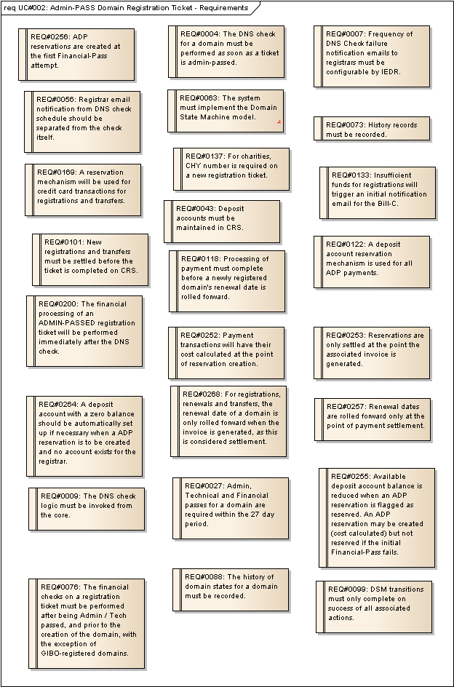
Figure 5 : UC#002: Admin-PASS Domain Registration Ticket - Requirements

UC#030: Retry Failed Registration Tickets
Type: public UseCase
Status: Proposed. Version 1.0. Phase 1.0.
Package: Registration Process: Use Cases
Details: Created on 23/01/2012 12:05:42. Modified on 14/02/2012 17:17:48. Author: Paul Delany

The actor retries the financial / technical checks on registration tickets which have previously failed at these points.
The use case involves the actor processing failed registration tickets, however each scenario relates to a single selected ticket (i.e., a registration ticket that is ADMIN-Passed and either TECH-stalled OR FINANCIAL-stalled.

Scenarios
UC030-SC01: Tech-stalled Succeeds ADP Payment {Basic Path}.
Details
FIN-Failed: No
TECH-Failed:Yes
Payment Method: ADP
Fin. Process Succeeds?: Yes
DNS Check Passes?: Yes
Registrant: Registrar
Billable / Charity: Billable
1. The actor selects a registration ticket that is admin-passed but tech-stalled.
2. The actor initiates the DNS check process for the details associated with the ticket. The system performs the check and confirms that the DNS details are valid, and flags the ticket as TECH-PASSED.
3. The actor initiates the financial processing of the ticket.
4. The system obtains the payment method (ADP) and payment details (cost, VAT etc.) from the ADP reservation associated with the ticket.
5. The system checks to see if the available funds in the ADP account are sufficient, and confirms that they are.
6. The available balance of the deposit account is reduced by the total cost of the reservation and the reservation is flagged as having been reserved, and ready for inclusion on an invoice.
7. The ticket is flagged as FINANCIAL-PASSED.
8. DSM EVENT: CreateBillableDomainRegistrar(D=<current date>). This creates the domain object in the system.
9. The ticket is closed.

UC030-SC02: Tech-Stalled Retry Fails {Basic Path}.
Details
FIN-Failed: No
TECH-Failed: Yes
Payment Method: ADP
Fin. Process Succeeds?: Yes
DNS Check Passes?: No
Registrant: Registrar
Billable / Charity: Billable
1. The actor selects a registration ticket that is admin-passed, but tech-stalled.
2. The actor initiates the DNS check process for the details associated with the ticket. The system performs the check which reports that there is an issue with the DNS configuration supplied.

UC030-SC03: Financially-stalled Succeeds Credit Card Payment - REDUNDANT {Basic Path}.
Details
FIN-Failed: Yes
TECH-Failed: No
Payment Method: Credit Card
Fin. Process Succeeds?: Yes
DNS Check Passes?: Yes
Registrant: Registrar
Billable / Charity: Billable
Redundant because credit card settlement will take place at invoice generation, not triple-pass. (See Invoice Process.) There will be no financially stalled registration tickets which have credit card payment methods.

UC030-SC04: Tech-Stalled Passes Fails Debit Card Processing - REDUNDANT {Basic Path}.
Details
FIN-Failed:No
TECH-Failed:Yes
Payment Method: Debit Card
Fin. Process Succeeds?: No
DNS Check Passes?: Yes
Registrant: Registrar
Billable / Charity: Billable
No debit card payments for registration.

UC030-SC05: Direct Charity Registration Passes DNS Check {Alternate}.
Details
FIN-Failed:No
TECH-Failed:Yes
Payment Method: n/a
Fin. Process Succeeds?: n/a
DNS Check Passes?: Yes
Registrant: Registrar
Billable / Charity: Charity
1. The actor selects a registration ticket that is admin-passed but tech-stalled.
2. The actor initiates the DNS check process for the details associated with the ticket. The system performs the check and confirms that the DNS details are valid, and flags the ticket as TECH-PASSED.
3. The actor initiates the financial processing of the ticket.
4. The system determines that it is a charity registration and so does not require payment.
5. The ticket is flagged as FINANCIAL-PASSED.
6. DSM EVENT: CreateCharityDomainDirect(D=<current date> + 1 year). This creates the domain object. The Renewal Date is also set to be one year from the current date.
7. The ticket is closed.

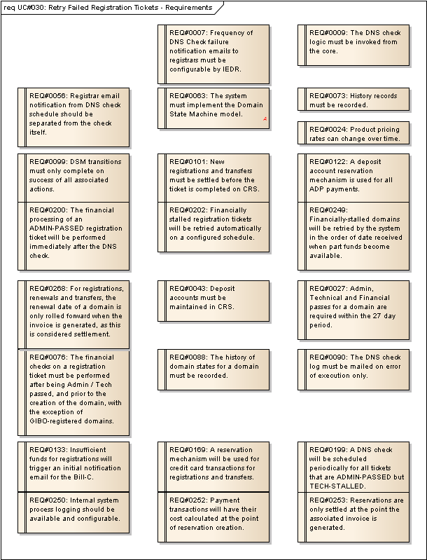
Figure 6 : UC#030: Retry Failed Registration Tickets - Requirements

UC#003: Approve GIBO-Registered Domain
Type: public UseCase
Status: Proposed. Version 1.0. Phase 1.0.
Package: Registration Process: Use Cases
Details: Created on 05/01/2012 16:02:37. Modified on 14/02/2012 17:19:19. Author: Paul Delany

The actor reviews a GIBO-registered domain which has not yet been Post-registration Audited by registration services.
If the review is successful, then the financial payment is processed with respect to the domain.
If the review is not successful, then the domain is scheduled for immediate deletion.
If the review is successful but payment processing is not initially successful, then the payment processing will be automatically retried for a defined period. If not successful within that period, then the domain is scheduled for deletion.

Scenarios
UC003-SC01: Happy Path {Basic Path}. Detail
Payment Method: ADP
Admin Review: Success
Financial Processing: Success
WIPO Disputed: N
1. The actor reviews the details of the domain for compliance with IEDR policy, and confirms all is correct.
2. The actor sets the domain status to Active [Note: this is the interface label - not the DSM NRP status. Only DSM events can trigger DSM state change.].
3. The system processes financials:
4. The system calculates the cost of the transaction and creates the associated reservation, flagged as not reserved. The reservation has its duration set to ZERO. This is because, for GIBO, the renewal date is initially set to +1 year from the current date when it is created, and does not need to be rolled forward when payment is settled.
5. The system verifies that there is sufficient available funds in the deposit account.
6. The system updates the reservation and flags it as reserved, ready for invoicing. At the same time, the available balance of the deposit account is reduced by the total cost of the reservation.
7. DSM EVENT: GIBOAuthorisation. This will set the DSM status of the domain to Active.

UC003-SC02: Financials Fail {Exception}. Detail
Payment Method: ADP
Admin Review: Success
Financial Processing: Fail
WIPO Disputed: N
1. The actor reviews the details of the domain for compliance with IEDR policy, and confirms all is correct.
2. The actor sets the domain status to Active.
3. The system processes financials:
4. The system calculates the cost of the transaction and creates an associated ADP reservation, flagged as unreserved. The reservation has its duration set to zero.
5. The system verifies that there is sufficient available funds in the deposit account, but finds that there are insufficient funds.
6. DSM EVENT: GIBOPaymentFailure. This will set the DSM status of the domain to Transaction Failed, for financial processing retry after a period of time. The retry period timeout deadline is also set as a result of this.

UC003-SC03: Admin-Review Fail {Exception}. Detail
Payment Method: ADP
Admin Review: Fail
Financial Processing: n/a
WIPO Disputed: N
1. The actor reviews the details of the domain for compliance with IEDR policy, but determines that the registration details are not valid.
2. The actor sets the domain status to Delete [Note: this is the interface label - not the DSM NRP status. Only DSM events can trigger DSM state change.].
3. DSM EVENT: GIBOAdminFailure. This will flag the domain for deletion by the Domain Deletion Process.

UC003-SC04: WIPO Disputed {Exception}. Detail
Payment Method: ADP
Admin Review: n/a
Financial Processing: n/a
WIPO Disputed: Y
The actor can review the domain details, but can neither Admin-PASS the domain nor schedule it for deletion, as it is in WIPO dispute.

UC003-SC05: Credit Card - REDUNDANT {Basic Path}. Detail
Payment Method: Credit Card
Admin Review: Success
Financial Processing: Success
WIPO Disputed: N
Only ADP for GIBO registration.

UC003-SC06: Debit Card Failure - REDUNDANT {Exception}. Detail
Payment Method: Debit Card
Admin Review: Success
Financial Processing: Fail
WIPO Disputed: Y
ADP is the only permitted payment method for GIBO, so this scenario is infeasible.

Tagged Values
- API = N.

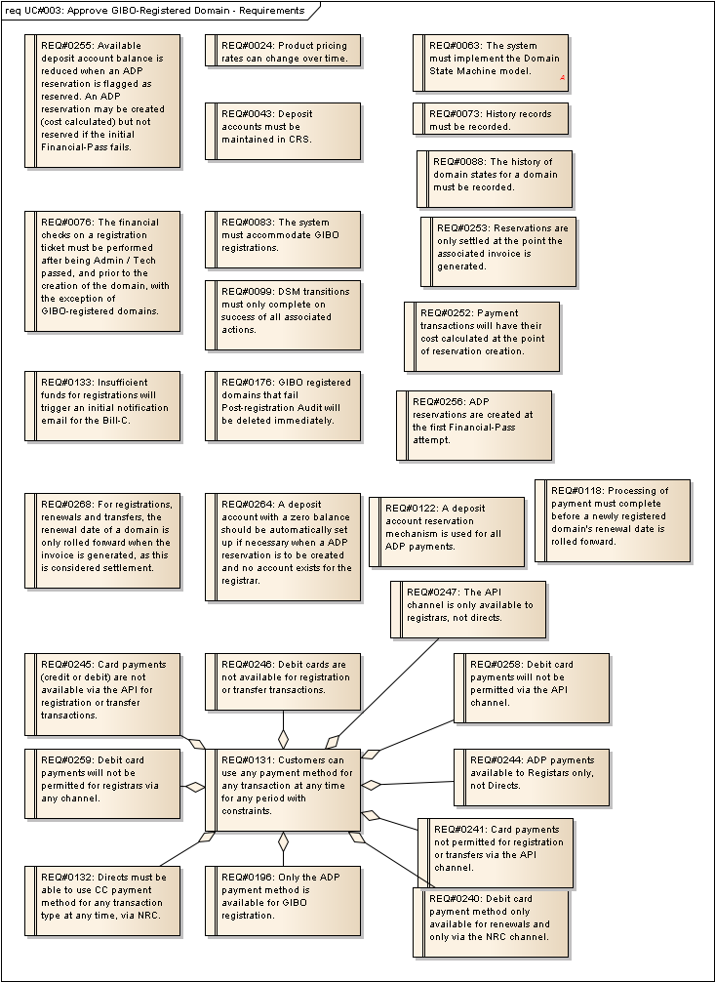
Figure 7 : UC#003: Approve GIBO-Registered Domain - Requirements

UC#026: Update Financially Failed GIBO Domains
Type: public UseCase
Status: Proposed. Version 1.0. Phase 1.0.
Package: Registration Process: Use Cases
Details: Created on 16/01/2012 17:09:24. Modified on 14/02/2012 16:19:57. Author: Paul Delany

The actor checks to see if there are any GIBO domains which have previously failed financial checks and either triggers their deletion (if the retry period has expired) or retries the payment transaction.

Scenarios
UC026-SC01: Retry Succeeds {Basic Path}. Details
Payment Method: ADP
WIPO Dispute: N
Retry Period Expired: N
Retry Succeeds: Y
1. The actor confirms that the payment retry period has not yet expired.
2. The actor determines the transaction cost from the reservation associated with the domain.
3. The actor checks the available balance of the associated deposit account and confirms there is sufficient available balance to cover the transaction cost.
4. The actor updates the reservation as being reserved, ready for invoicing. This will affect the available balance of the deposit account.
5. DSM EVENT: Payment(Period=0). This sets the NRP DSM status of the domain to Active. The date does not need to be rolled forward as it is already 1 year in advance automatically for GIBO registered domains when created.

UC026-SC02: Retry Succeeds - Credit Card - REDUNDANT {Basic Path}. Details
Payment Method: Credit Card
WIPO Dispute: N
Retry Period Expired: N
Retry Succeeds: Y
Credit Card payment is not an option for GIBO registration so this scenario is infeasible.

UC026-SC03: Retry Period Expired {Basic Path}. Details
Payment Method: ADP
WIPO Dispute: N
Retry Period Expired: Y
Retry Succeeds: N
1. The actor confirms that the payment retry period has expired.
2. DSM EVENT: GIBOPaymentRetryTimeout. This flags the domain for deletion.

UC026-SC04: Retry Fails {Basic Path}. Details
Payment Method: ADP
WIPO Dispute: N
Retry Period Expired: N
Retry Succeeds: N
1. The actor confirms that the payment retry period has not yet expired.
2. The actor determines the transaction cost from the reservation associated with the domain.
3. The actor checks the available balance of the associated deposit account and confirms there is insufficient available balance to cover the transaction cost.

UC026-SC05: WIPO Disputed {Exception}. Details
Payment Method: ADP
WIPO Dispute: Y
Retry Period Expired: N
Retry Succeeds: N
As the domain is in WIPO dispute no action is taken by the actor.
[Note: This will have the effect that any such domain will in fact be published to the zone file for the duration of the WIPO dispute - despite not having been charged. This may be a very unlikely situation, but clarification is required as to whether GIBO registered domains can ever be put into WIPO dispute prior to full authorisation and payment, or should it be mandated that in order for a domain to be placed into WIPO dispute the RS review / payment taken must happen first.]

Tagged Values
- API = N.

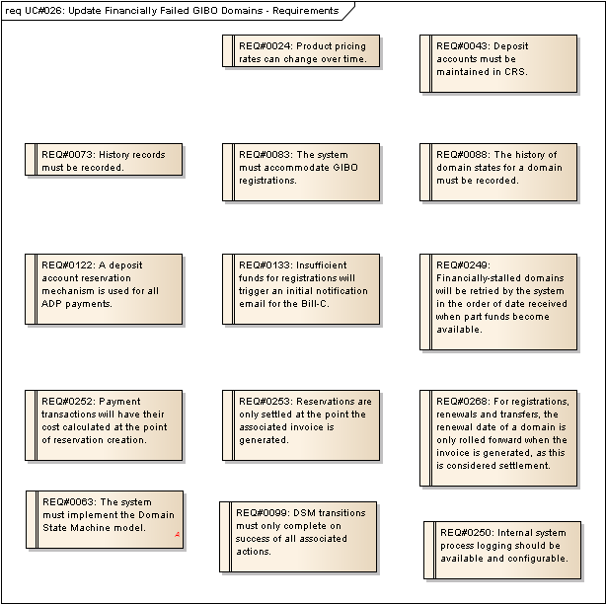
Figure 8 : UC#026: Update Financially Failed GIBO Domains - Requirements

Registration Process: Logical Entities

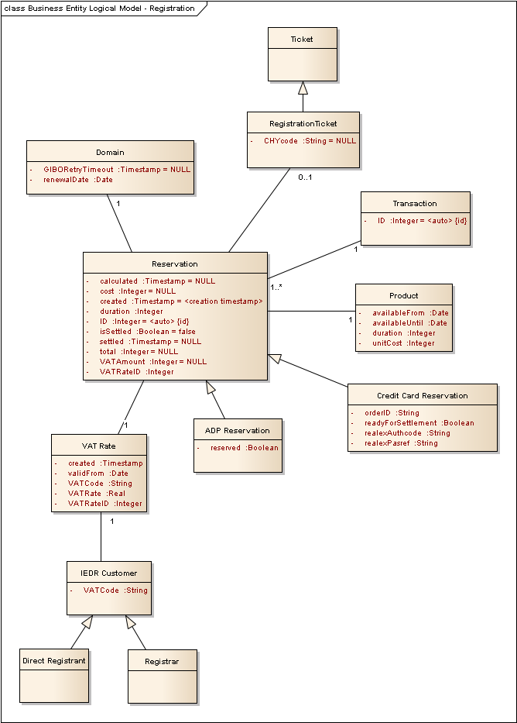
Figure 9 : Business Entity Logical Model - Registration

Reservation
Type: public Class
Status: Proposed. Version 1.0. Phase 1.0.
Package: Business Entity Logical Model
Details: Created on 19/01/2012 15:09:31. Modified on 14/02/2012 17:08:12. Author: Paul Delany

An entity that maintains all necessary information regarding a reservation for a transaction.

Custom Properties

Reservation Attributes
Attribute | Type | Notes
calculated | private :  Timestamp | The timestamp at which the vatAmount and total attributes are calculated, based on the cost (derived from the associated product) and the vatRate. This must only occur once in the lifetime of the entity.  Initial Value: NULL;
cost | private :  Integer | The base cost of the reservation, ex VAT, derived from the associated product cost.  Initial Value: NULL;
created | private :  Timestamp | The initial creation timestamp of the reservation.  Initial Value: <creation timestamp>;
duration | private :  Integer | The number of years to roll the renewal date of the domain forward by when the reservation is settled.
ID | private :  Integer | A globally unique ID for the reservation.  Initial Value: <auto>;
isSettled | private :  Boolean | True if the reservation has been settled, false otherwise.  Initial Value: false;
settled | private :  Timestamp | The date and time at which the reservation was settled.  Initial Value: NULL;
total | private :  Integer | The total cost inclusive of any applicable VAT.  Initial Value: NULL;
VATAmount | private :  Integer | The amount of applicable VAT.  Initial Value: NULL;
VATRateID | private :  Integer | The ID of the VAT Rate used to perform the calculation of VAT Amount.

Domain
Type: public Class
Status: Proposed. Version 1.0. Phase 1.0.
Package: Business Entity Logical Model
Details: Created on 19/01/2012 15:09:54. Modified on 01/02/2012 14:47:58. Author: Paul Delany

A .ie domain.

Custom Properties

Domain Attributes
Attribute | Type | Notes
GIBORetryTimeout | private :  Timestamp | The timestamp when a financially-failed GIBO registered domain's retry period expires.  Initial Value: NULL;
renewalDate | private :  Date | The renewal date.

Ticket
Type: public Class
Status: Proposed. Version 1.0. Phase 1.0.
Package: Business Entity Logical Model
Details: Created on 19/01/2012 15:10:07. Modified on 24/01/2012 15:40:30. Author: Paul Delany

A registration services ticket.

Custom Properties

IEDR Customer
Type: public Class
Status: Proposed. Version 1.0. Phase 1.0.
Package: Business Entity Logical Model
Details: Created on 20/01/2012 15:02:31. Modified on 14/02/2012 15:03:07. Author: Paul Delany

Represents a customer who registers domains from the IEDR. Either a direct registrant or a registrar.

Custom Properties

IEDR Customer Attributes
Attribute | Type | Notes
VATCode | private :  String | The VAT Code applicable to the registrant.

Direct Registrant
Type: public Class
Extends: IEDR Customer.
Status: Proposed. Version 1.0. Phase 1.0.
Package: Business Entity Logical Model
Details: Created on 20/01/2012 15:02:47. Modified on 24/01/2012 15:43:56. Author: Paul Delany

A customer that registers domains on their own behalf.

Custom Properties

Registrar
Type: public Class
Extends: IEDR Customer.
Status: Proposed. Version 1.0. Phase 1.0.
Package: Business Entity Logical Model
Details: Created on 20/01/2012 15:02:55. Modified on 20/01/2012 15:03:59. Author: Paul Delany

Custom Properties

ADP Reservation
Type: public Class
Extends: Reservation.
Status: Proposed. Version 1.0. Phase 1.0.
Package: Business Entity Logical Model
Details: Created on 20/01/2012 15:04:55. Modified on 01/02/2012 14:47:58. Author: Paul Delany

A reservation made against a deposit account.

Custom Properties

ADP Reservation Attributes
Attribute | Type | Notes
reserved | private :  Boolean | False if the reservation is not ready to be settled, and has no impact on available ADP balance. If true, and not yet settled, then it is ready to be settled and will have an impact on available balance until that time.

Credit Card Reservation
Type: public Class
Extends: Reservation.
Status: Proposed. Version 1.0. Phase 1.0.
Package: Business Entity Logical Model
Details: Created on 20/01/2012 15:05:09. Modified on 01/02/2012 14:47:58. Author: Paul Delany

A reservation made using a credit card.

Custom Properties

Credit Card Reservation Attributes
Attribute | Type | Notes
orderID | private :  String | See RealEx API documentation.Max. length 40.
readyForSettlement | private :  Boolean | If true, and not yet settled, then this is ready to be included in the next invoice run for settlement.
realexAuthcode | private :  String | See RealEx API documentation.Max. length 10.
realexPasref | private :  String | See RealEx API documentation.Max. length 50.

RegistrationTicket
Type: public Class
Extends: Ticket.
Status: Proposed. Version 1.0. Phase 1.0.
Package: Business Entity Logical Model
Details: Created on 20/01/2012 15:12:16. Modified on 01/02/2012 14:47:58. Author: Paul Delany

A ticket pertaining to domain registration requests.

Custom Properties

RegistrationTicket Attributes
Attribute | Type | Notes
CHYcode | private :  String | A charity registration code.  Initial Value: NULL;

Product
Type: public Class
Status: Proposed. Version 1.0. Phase 1.0.
Package: Business Entity Logical Model
Details: Created on 20/01/2012 15:51:33. Modified on 02/02/2012 11:33:07. Author: Paul Delany

A product that customers can purchase (e.g., 1 year domain registration, 2-year domain registration etc.)

Custom Properties

Product Attributes
Attribute | Type | Notes
availableFrom | private :  Date | The date that the product becomes available. The product is available to customers from and including this date.
availableUntil | private :  Date | The last date that the product is available. The product is available for purchase until and inclusive of this date.
duration | private :  Integer | Number of years of domain registration for the product.
unitCost | private :  Integer | The cost of the product, ex. VAT.

VAT Rate
Type: public Class
Status: Proposed. Version 1.0. Phase 1.0.
Package: Business Entity Logical Model
Details: Created on 24/01/2012 15:48:13. Modified on 06/02/2012 15:18:51. Author: Paul Delany

This represents the valid VAT rate for a particular VAT rate code starting from a particular date in time. It is valid unless and until it is superceded by a VAT rate for the same code at a future point in time.

Custom Properties

VAT Rate Attributes
Attribute | Type | Notes
created | private :  Timestamp | The timestamp when the VAT Rate entity was created. This is for data integrity validation. VAT Rates should never be updated or deleted. Only inserted.
validFrom | private :  Date | The date that the VAT rate for the VAT code comes into effect.
VATCode | private :  String | Alphabetic code for the VAT Rate.
VATRate | private :  Real | The VAT rate itself (e.g., 0.23).
VATRateID | private :  Integer | A unique ID for each VAT Rate. This is required to be referenced by other entities for data integrity validation.

Transaction
Type: public Class
Status: Proposed. Version 1.0. Phase 1.0.
Package: Business Entity Logical Model
Details: Created on 01/02/2012 14:47:58. Modified on 01/02/2012 14:50:06. Author: Paul Delany

Represents a single payment transaction by a customer.

Custom Properties

Transaction Attributes
Attribute | Type | Notes
ID | private :  Integer | UID for the transaction.  Initial Value: <auto>;

Registration Process: DSM Aspects

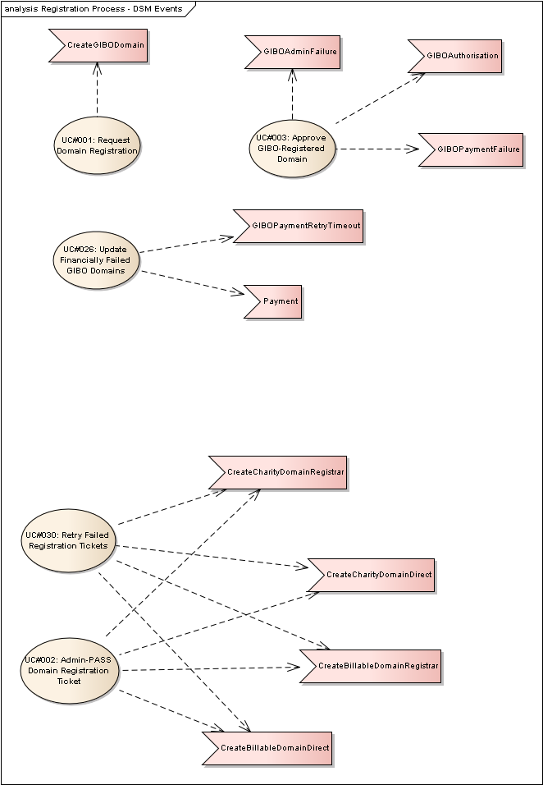
Figure 10 : Registration Process - DSM Events

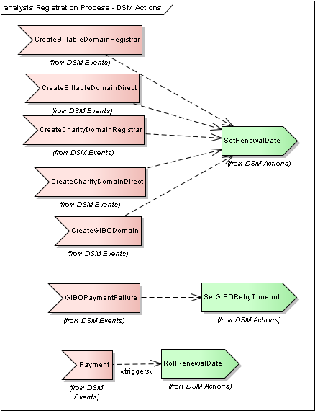
Figure 11 : Registration Process - DSM Actions

SetRenewalDate
Type: public Event
Status: Proposed. Version 1.0. Phase 1.0.
Package: DSM Actions
Details: Created on 24/01/2012 12:57:07. Modified on 24/01/2012 14:40:03. Author: Paul Delany

Params:
D:Date - the renewal date to set.
Action which sets the domain's renewal date to be D.

CreateBillableDomainRegistrar
Type: public Event
Status: Proposed. Version 1.0. Phase 1.0.
Package: DSM Events
Details: Created on 19/12/2011 10:36:08. Modified on 24/01/2012 14:39:46. Author: Paul Delany

Params:
D:Date - the initial renewal date.
Triggered when a new billable domain is to be created for a Registrar.

CreateBillableDomainDirect
Type: public Event
Status: Proposed. Version 1.0. Phase 1.0.
Package: DSM Events
Details: Created on 05/01/2012 17:09:51. Modified on 24/01/2012 14:39:40. Author: Paul Delany

Params:
D:Date - the initial renewal date.
Triggered when a new billable domain is to be created for a Direct Registrant.

CreateCharityDomainRegistrar
Type: public Event
Status: Proposed. Version 1.0. Phase 1.0.
Package: DSM Events
Details: Created on 05/01/2012 17:10:04. Modified on 24/01/2012 14:39:36. Author: Paul Delany

Params:
D:Date - the initial renewal date.
Triggered when a new charity domain is to be created for a Registrar.

CreateCharityDomainDirect
Type: public Event
Status: Proposed. Version 1.0. Phase 1.0.
Package: DSM Events
Details: Created on 05/01/2012 17:10:35. Modified on 24/01/2012 14:39:17. Author: Paul Delany

Params:
D:Date - the initial renewal date.
Triggered when a new charity domain is to be created for a Direct registrant.

CreateGIBODomain
Type: public Event
Status: Proposed. Version 1.0. Phase 1.0.
Package: DSM Events
Details: Created on 05/01/2012 17:20:39. Modified on 24/01/2012 14:39:29. Author: Paul Delany

Params:
D:Date - the initial renewal date.
A DSM Event that is triggered when a domain registered via the GIBO process is created. It results in a new domain object with D as the renewal date.

SetGIBORetryTimeout
Type: public Event
Status: Proposed. Version 1.0. Phase 1.0.
Package: DSM Actions
Details: Created on 24/01/2012 15:13:45. Modified on 24/01/2012 15:22:24. Author: Paul Delany

Params:
None.
Sets the GIBO retry timeout to be: current timestamp + 24 hours.

GIBOPaymentFailure
Type: public Event
Status: Proposed. Version 1.0. Phase 1.0.
Package: DSM Events
Details: Created on 05/01/2012 16:09:18. Modified on 24/01/2012 12:54:15. Author: Paul Delany

Triggered when the first payment processing is attempted for GIBO registered domain and processing fails.

RollRenewalDate
Type: public Event
Status: Proposed. Version 1.0. Phase 1.0.
Package: DSM Actions
Details: Created on 06/02/2012 15:49:49. Modified on 06/02/2012 15:51:11. Author: Paul Delany

Params:
P: INT
Action which advances the domain's current renewal date by exactly P years.

Payment
Type: public Event
Status: Proposed. Version 1.0. Phase 1.0.
Package: DSM Events
Details: Created on 04/01/2012 12:34:34. Modified on 02/02/2012 11:47:35. Author: Paul Delany

Params:
Period: INT - number of years registration being paid for.
Triggered when payment for a domain is successfully completed (settled).

Registration Process: Open Issues

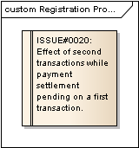
Figure 12 : Registration Process: Open Issues

ISSUE#0020: Effect of second transactions while payment settlement pending on a first transaction.
Type: «Functional» Issue
Status: Proposed. Version 1.0. Phase 1.0.; Priority: Medium; Difficulty: Medium
Package: Registration Process: Open Issues
Details: Created on 14/02/2012 11:37:28. Modified on 14/02/2012 16:40:36. Author: Paul Delany

1) Registration Process - ADP/Credit Card
As there is a gap in the time that the domain is created and the payment
actually being settled, I am wondering what will happen if/when a domain
is transferred to another account during this time (or other actions
such as voluntary NRP). Does the domain locking procedure still stand
(not mentioned in the use cases) and is a domain allowed to be entered
into NRP during this window?
2) Same issue with Renewal process - ADP/Credit Card, if funds are
reserved in the morning and not settled until that evening.
The objective of BPR is to allow customers to transact on their domains at any time. Prima facie, this means elimination of the current "locked" mechanism. However the point is still valid - given the elapsed time difference between reservation and settlement.
For new registrations, triple passed but not yet settled - we could allow a new ticket to be created e.g. a new transfer request, however a warning flag would be attached, to prevent, say, admin pass of the new ticket, until *after* the settlement had been completed).
For renewals, reserved not yet settled - we would obviously allow a further payment/MYR request, no problem. We could also allow a new ticket to be created e.g. a new transfer request, however a warning flag would be attached, to prevent, say, admin pass of the new ticket, until *after* the settlement had been completed).
In all cases, a voluntary NRP will be allowed at any time - however, it will not stop the settlement process (hereinafter referred to as "the unstoppable settlement juggernaut").

