DRAFT for ASD Review 24 Jan 2012
- Updated with missing examples 25 Jan 2012

Registration Process

This package defines the use cases, activities and events of the Registration process.

Registration Process: Use Cases

This package defines the use cases of the Registration process.

The set of use cases relating to domain registration.

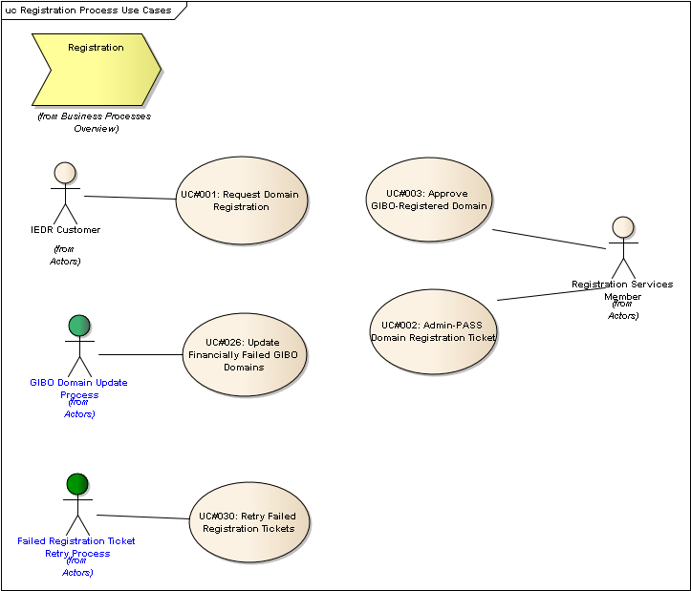
Figure 1 : Registration Process Use Cases

UC#001: Request Domain Registration
Type: public UseCase
Status: Proposed. Version 1.0. Phase 1.0.
Package: Registration Process: Use Cases
Details: Created on 19/12/2011 14:28:44. Modified on 24/01/2012 17:04:15. Author: Paul Delany

The actor initiates the sequence of events to ultimately register a domain that is not already registered. The domain may not be created on completion of the use case, but rather the registration request (ticket) is created which will be further processed.
GIBO registration is an exception to this - the domain is created first, without any corresponding registration ticket, and thereafter the registration details are reviewed by Registration Services, and then financial aspects are processed.

Scenarios
SC01: Registrar Basic {Basic Path}. A registrar attempts to register a domain via the CRS-API.
Details
Registrar / Direct: Registrar
Payment Method: ADP
NRC / API: API
Regular Registration / GIBO: Regular
Payment Success: Success
Billable Domain / Charity Domain: Billable
Customer is VAT Exempt?: No
1. The actor issues a domain:create command via the API for domain example.ie, for a 1 year period, supplying 2 valid nameserver details, a domain holder class of Natural Person and category Personal Name, a valid ADMIN-C Nic handle, and a valid TECH-C Nic. The XML also indicates that the Deposit Account (ADP) method is to be used for payment. [See EX001: API domain:create using ADP]
2. The system validates that the domain is not already registered, that all mandatory details are supplied and correct, and that an ADP account exists for the registrar
3. The registration ticket is created in the system. The expiry date for the ticket is set to be 27 days from the current date.
4. The value of the transaction is calculated. [See EX002: Regular VAT calculation.]
5. An ADP reservation is created an associated with the ticket.
6. The system responds with success code, the ticket number, the creation date of the ticket, and expiry date of the ticket. [See EX003: Registration API response.].

SC02: Direct Basic {Basic Path}. A direct registrant attempts to register a valid unregistered billable domain via NRC using a credit card.
Details
Registrar / Direct: Direct
Payment Method: Credit Card
NRC / API: NRC
Regular Registration / GIBO: Regular
Authorisation Success: Success
Billable Domain / Charity Domain: Billable
Customer is VAT Exempt?: Yes
1. The actor submits a domain registration request via NRC for domain example.ie, for a 1 year period, supplying 2 valid nameserver details, a domain holder class of Natural Person and category Personal Name, a valid admin-c nic handle, a valid bill-c nic handle and a valid tech-c admin handle. The actor also supplies valid credit card details.
2. The system validates that the domain is not already registered, that all mandatory details are supplied and correct.
3. The system calculates the value of the transaction. [See EX004: VAT Exempt Cost Calculation.]
4. The system requests authorisation (not settlement) of the credit card for the transaction via the RealEx API. Settlement is not requested from RealEx at this time; only the authorisation of the transaction. [See RealAuth XML Definitions Guide v2.1, Section 3]
5. RealEx responds with a valid authorisation. [See RealAuth XML Definitions Guide v2.1, Section 3]
6. The system creates the corresponding credit card reservation. The credit card reservation is flagged as not ready for settlement (because the associated ticket has not yet been ADMIN / TECH passed). [See Reservation in logical model.]
7. The system creates the registration ticket. The ticket must be associated with the credit card reservation.
8. The system responds by indicating the success of the operation.

SC03: Registrar Credit Card {Basic Path}.
Details
Registrar / Direct: Registrar
Payment Method: Credit Card
NRC / API: NRC
Regular Registration / GIBO: Regular
Authorisation Success: Success
Billable Domain / Charity Domain: Billable
Customer is VAT Exempt?: No
1. The actor submits a domain registration request via NRC for domain example.ie, for a 1 year period, supplying 2 valid nameserver details, a domain holder class of Natural Person and category Personal Name, a valid admin-c nic handle, a valid bill-c nic handle and a valid tech-c admin handle. The actor also supplies valid credit card details.
2. The system validates that the domain is not already registered, that all mandatory details are supplied and correct.
3. The system calculates the value of the transaction. [See EX002: Regular VAT calculation.]
4. The system requests authorisation (not settlement) of the credit card for the transaction via the RealEx API. Settlement is not requested from RealEx at this time; only the authorisation of the transaction. [See RealAuth XML Definitions Guide v2.1, Section 3]
5. RealEx responds with a valid authorisation. [See RealAuth XML Definitions Guide v2.1, Section 3]
6. The system creates the corresponding credit card reservation. The credit card reservation is flagged as not ready for settlement (because the associated ticket has not yet been ADMIN / TECH passed). [See Reservation logical model]
7. The system creates the registration ticket. The ticket is associated with the credit card reservation.
8. The system responds by indicating the success of the operation.

SC04: Direct Registrant Debit Card {Basic Path}.
Details
Registrar / Direct: Direct
Payment Method: Visa Debit Card
NRC / API: NRC
Regular Registration / GIBO: Regular
Authorisation Success: Success
Billable Domain / Charity Domain: Billable
Customer is VAT Exempt?: No
1. The actor submits a domain registration request via NRC for domain example.ie, for a 1 year period, supplying 2 valid nameserver details, a domain holder class of Natural Person and category Personal Name, a valid admin-c nic handle, a valid bill-c nic handle and a valid tech-c admin handle. The actor also supplies valid VISA debit card details.
2. The system validates that the domain is not already registered, that all mandatory details are supplied and correct.
3. The system calculates the value of the transaction. [ EX002: Regular VAT calculation.]
4. The system requests authorisation (not settlement) of the debit card for the transaction via the RealEx API. Settlement is not requested from RealEx at this time; only the authorisation of the transaction. [See RealAuth XML Definitions Guide v2.1, Section 3]
5. RealEx responds with a valid authorisation. [See RealAuth XML Definitions Guide v2.1, Section 3]
6. The system creates the corresponding debit card reservation. The debit card reservation is flagged as not ready for settlement (because the associated ticket has not yet been ADMIN / TECH passed). [See reservation logical model]
7. The system creates the registration ticket. The ticket is associated with the credit card reservation.
8. The system responds by indicating the success of the operation.
[Query for AB: should debit card payments be invoiced separately from credit card payments?]

SC05: Registrar Charity Reg {Basic Path}.
Details
Registrar / Direct: Registrar
Payment Method: n/a (charity registrations don't require payment)
NRC / API: API
Regular Registration / GIBO: Regular
Authorisation Success: n/a - no payment required for charities
Billable Domain / Charity Domain: Charity
Customer is VAT Exempt?: No
1. The actor issues a domain:create command via the API for domain example.ie, for a 1 year period, supplying 2 valid nameserver details, a domain holder class of Natural Person and category Personal Name, a valid ADMIN-C Nic handle, and a valid TECH-C Nic. The charity CHY code is also supplied. [EX005: API domain:create Charity Registration]
2. The system validates that the domain is not already registered, that all mandatory details are supplied and correct.
3. The registration ticket is created in the system, which includes the CHY code supplied. The expiry date for the ticket is set to be 27 days from the current date.
4. A reservation is created in the system and indicates a zero cost. This is to ensure that the registration shows up on an invoice, regardless of having no cost associated.
5. The system responds with success code, the ticket number, the creation date of the ticket, and expiry date of the ticket. [See EX003: Registration API response.].

SC06: Registrar Debit Card {Basic Path}.
Details
Registrar / Direct: Registrar
Payment Method: Visa Debit Card
NRC / API: NRC
Regular Registration / GIBO: Regular
Authorisation Success: Success
Billable Domain / Charity Domain: Billable
Customer is VAT Exempt?: Yes
1. The actor submits a domain registration request via NRC for domain example.ie, for a 2 year period, supplying 2 valid nameserver details, a domain holder class of Natural Person and category Personal Name, a valid admin-c nic handle, a valid bill-c nic handle and a valid tech-c admin handle. The actor also supplies valid VISA debit card details.
2. The system validates that the domain is not already registered, that all mandatory details are supplied and correct.
3. The system calculates the value of the transaction. [ EX006: 2-year cost calculation]
4. The system requests authorisation (not settlement) of the debit card for the transaction via the RealEx API. Settlement is not requested from RealEx at this time; only the authorisation of the transaction. [See RealAuth XML Definitions Guide v2.1, Section 3]
5. RealEx responds with a valid authorisation. [See RealAuth XML Definitions Guide v2.1, Section 3]
6. The system creates the corresponding debit card reservation. The debit card reservation is flagged as not ready for settlement (because the associated ticket has not yet been ADMIN / TECH passed). [See reservation logical model]
7. The system creates the registration ticket. The ticket must reference the credit card reservation.
8. The system responds by indicating the success of the operation.

SC07: Direct Charity Reg {Basic Path}.
Details
Registrar / Direct: Direct
Payment Method: n/a (not required for charity registrations)
NRC / API: NRC
Regular Registration / GIBO: Regular
Authorisation Success: Success
Billable Domain / Charity Domain: Charity
Customer is VAT Exempt?: No
1. The actor submits a domain registration request via NRC for domain example.ie, for a 2 year period, supplying 2 valid nameserver details, a domain holder class of Natural Person and category Personal Name, a valid admin-c nic handle, a valid bill-c nic handle and a valid tech-c admin handle. The actor also supplies a CHY code.
2. The system validates that the domain is not already registered, that all mandatory details are supplied and correct.
3. The system creates the registration ticket. The ticket must include the CHY code.
4. The system creates the reservation with zero cost. [See EX002: Regular VAT calculation]
5. The system responds by indicating the success of the operation.

SC08: GIBO Basic {Alternate}.
Details
Registrar / Direct: Registrar
Payment Method: ADP
NRC / API: API
Regular Registration / GIBO: GIBO
Authorisation Success: Success
Billable Domain / Charity Domain: Billable
Customer is VAT Exempt?: Yes
1. The actor issues the domain:autocreate command via the API for domain example.ie, for a 1 year period, supplying 2 valid nameserver details, a domain holder class of Natural Person and category Personal Name, a valid ADMIN-C Nic handle, and a valid TECH-C Nic. The XML also indicates that the Deposit Account (ADP) method is to be used for payment. [See EX007: domain:autocreate GIBO Registration request]
2. The system validates that the domain is not already registered, that all mandatory details are supplied and correct, and that an ADP account exists for the registrar.
3. The value of the transaction is calculated. [See EX004: VAT Exempt cost calculation]
4. A reservation is created in the system indicating that the ADP payment method is to be used, and the calculated cost recorded.
5. DSM EVENT: CreateGIBODomain(D=<current date>+1 year). This results in the creation of the domain object. The domain is associated with the reservation
6. The system responds with success code. [See EX008: domain:autocreate success response].

SC09: CC Authorisation fails {Exception}.
Details
Registrar / Direct: Registrar
Payment Method: Credit Card
NRC / API: API
Regular Registration / GIBO: Regular
Authorisation Success: Fail
Billable Domain / Charity Domain: Billable
Customer is VAT Exempt?: Yes
1. The actor issues a domain:create command via the API for domain example.ie, for a 1 year period, supplying 2 valid nameserver details, a domain holder class of Natural Person and category Personal Name, a valid ADMIN-C Nic handle, and a valid TECH-C Nic. The XML also includes the credit card details to be used for payment. [See Request XML below]
2. The system validates that the domain is not already registered, that all mandatory details are supplied and correct.
3. The system calculates the value of the transaction [See: EX004: VAT Exempt cost calculation]
4. The system seeks authorisation (not settlement) from RealEx via the RealEx API.
5. The RealEx API responds with an authorisation failure response [See RealAuth XML Definitions Guide v2.1, Section 3]
6. The system responds with failure status information. [See Response XML below]
Ex. Request XML:
<ieapi xmlns="http://www.domainregistry.ie/ieapi-1.2" xmlns:xsi="http://www.w3.org/2001/XMLSchema-instance" xsi:schemaLocation="http://www.domainregistry.ie/ieapi-1.2 ieapi-1.2.xsd">
<command>
<create>
<domain:create xmlns:domain="http://www.domainregistry.ie/ieapi-domain-1.2" xsi:schemaLocation="http://www.domainregistry.ie/ieapi-domain-1.2 ieapi-domain-1.2.xsd">
<domain:name>example.ie</domain:name>
<domain:period unit="y">1</domain:period>
<domain:ns>
<domain:nsName>ns1.example.ie</domain:nsName>
<domain:nsAddr>192.1.2.3</domain:nsAddr>
</domain:ns>
<domain:ns>
<domain:nsName>ns1.example2.ie</domain:nsName>
</domain:ns>
<domain:holder class="Natural Person">
<domain:holderName category="Personal Name">John Doe</domain:holderName>
<domain:holderRemarks/>
</domain:holder>
<domain:contact type="admin">XXX123-IEDR</domain:contact>
<domain:contact type="tech">XXX124-IEDR</domain:contact>
<domain:paymentMethod type="creditCard" test="false">
<domain:cardHolder>John Doe<domain:cardHolder>
<domain:cardNumber>12341234123412<domain:cardNumber>
<domain:expiryDate>2010-01<domain:expiryDate>
<domain:cardType>VISA<domain:cardType>
</domain:paymentMethod>
</domain:create>
</create>
</command>
</ieapi>
Ex. Response XML:
<ieapi xmlns="http://www.domainregistry.ie/ieapi-1.2" xmlns:xsi="http://www.w3.org/2001/XMLSchema-instance" xsi:schemaLocation="http://www.domainregistry.ie/ieapi-1.2 ieapi-1.2.xsd">
<response>
<result code="2201">
<msg>Authorization error</msg>
</result>
</response>
</ieapi>

SC10: Debit Card Auth Fails {Exception}.
Details
Registrar / Direct: Direct
Payment Method: Visa Debit Card
NRC / API: NRC
Regular Registration / GIBO: Regular
Authorisation Success: Fail
Billable Domain / Charity Domain: Bill
Customer is VAT Exempt?: No
1. The actor submits a domain registration request via NRC for domain example.ie, for a 1 year period, supplying 2 valid nameserver details, a domain holder class of Natural Person and category Personal Name, a valid admin-c nic handle, a valid bill-c nic handle and a valid tech-c admin handle. The actor also supplies valid debit card details.
2. The system validates that the domain is not already registered, that all mandatory details are supplied and correct.
3. The system calculates the value of the transaction. [ refer to EX002: Regular VAT calculation]
4. The system requests authorisation (not settlement) of the debit card for the transaction via the RealEx API. Settlement is not requested from RealEx at this time; only the authorisation of the transaction. [See RealAuth XML Definitions Guide v2.1, Section 3]
5. RealEx responds with a failed authorisation. [See RealAuth XML Definitions Guide v2.1, Section 3]
6. The system responds by indicating the authorisation failure of the operation.

SC11: Deposit Account Doesn't Exist {Exception}.
Details
Registrar / Direct: Registrar
Payment Method: ADP
NRC / API: API
Regular Registration / GIBO: Regular
Authorisation Success: Fail - due to no deposit account
Billable Domain / Charity Domain: Billable
Customer is VAT Exempt?: No
1. The actor issues a domain:create command via the API for domain example.ie, for a 1 year period, supplying 2 valid nameserver details, a domain holder class of Natural Person and category Personal Name, a valid ADMIN-C Nic handle, and a valid TECH-C Nic. The XML also indicates that the Deposit Account (ADP) method is to be used for payment.[See EX001: API domain:create using ADP]
2. The system validates that the domain is not already registered, that all mandatory details are supplied and correct.
3. The system determines that no ADP account has been set up for the registrar.
4. The system responds with the failure status. [See Response XML below].
Ex. Response XML:
<ieapi xmlns="http://www.domainregistry.ie/ieapi-1.2" xmlns:xsi="http://www.w3.org/2001/XMLSchema-instance" xsi:schemaLocation="http://www.domainregistry.ie/ieapi-1.2 ieapi-1.2.xsd">
<response>
<result code="812
<msg>Payment type not allowed</msg>
</result>
</response>
</ieapi>

SC12: GIBO via Credit Card {Alternate}. Details
Registrar / Direct: Registrar
Payment Method: Credit Card
NRC / API: API
Regular Registration / GIBO: GIBO
Authorisation Success: Success
Billable Domain / Charity Domain: Billable
Customer is VAT Exempt?: No
1. The actor issues the domain:autocreate command via the API for domain example.ie, for a 1 year period, supplying 2 valid nameserver details, a domain holder class of Natural Person and category Personal Name, a valid ADMIN-C Nic handle, and a valid TECH-C Nic. The XML also indicates that that credit card is the intended payment method, and the credit card details are supplied. [See request XML]
2. The system validates that the domain is not already registered, that all mandatory details are supplied and correct.
3. The system calculates the value of the transaction. [See EX002: Regular VAT calculation]
4. The system requests authorisation (not settlement) of the credit card for the transaction via the RealEx API. Settlement is not requested from RealEx at this time; only the authorisation of the transaction. [See RealAuth XML Definitions Guide v2.1, Section 3]
5. RealEx responds with a valid authorisation. [See RealAuth XML Definitions Guide v2.1, Section 3]
6. The system creates the corresponding credit card reservation. The credit card reservation is flagged as not ready for settlement (because the associated ticket has not yet been ADMIN / TECH passed). [See Reservation logical model]
7. DSM EVENT: CreateGIBODomain(D=<current date> + 1 year). This results in the creation of the domain object.
8. The domain is associated with the reservation.
9. The system responds with success code. [See EX008: domain:autocreate success response].
Ex. XML Request
<?xml version="1.0" encoding="UTF-8" standalone="no"?>
<ieapi xmlns="http://www.domainregistry.ie/ieapi-1.2" xmlns:xsi="http://www.w3.org/2001/XMLSchema-instance" xsi:schemaLocation="http://www.domainregistry.ie/ieapi-1.2 ieapi-1.2.xsd">
<command>
<create>
<domain:autocreate xmlns:domain="http://www.domainregistry.ie/ieapi-domain-1.2" xsi:schemaLocation="http://www.domainregistry.ie/ieapi-domain-1.2ieapi-domain-1.2.xsd">
<domain:name>example.ie</domain:name>
<domain:period unit="y">1</domain:period>
<domain:ns>
<domain:nsName>ns1.example.ie</domain:nsName>
<domain:nsAddr>192.1.2.3</domain:nsAddr>
</domain:ns>
<domain:ns>
<domain:nsName>ns1.example2.ie</domain:nsName>
</domain:ns>
<domain:holder class="Natural Person">
<domain:holderName category="Personal Name">John Doe</domain:holderName>
<domain:holderRemarks />
</domain:holder>
<domain:contact type="admin">XXX123-IEDR</domain:contact>
<domain:contact type="tech">XXX124-IEDR</domain:contact>
<domain:paymentMethod type="creditCard" test="false">
<domain:cardHolder>John Doe<domain:cardHolder>
<domain:cardNumber>12341234123412<domain:cardNumber>
<domain:expiryDate>2010-01<domain:expiryDate>
<domain:cardType>VISA<domain:cardType>
</domain:paymentMethod>
</domain:autocreate>
</create>
</command>
</ieapi>

Tagged Values
- API = Y.

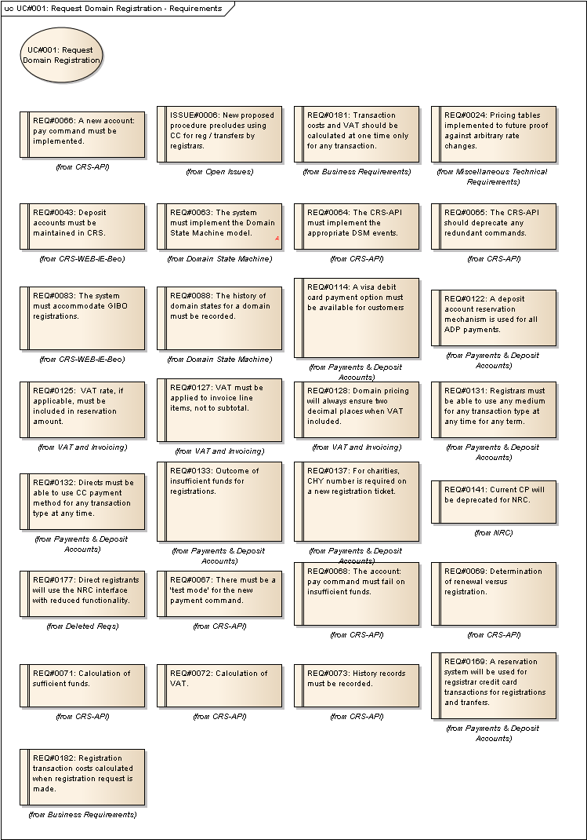
Figure 2 : UC#001: Request Domain Registration - Requirements

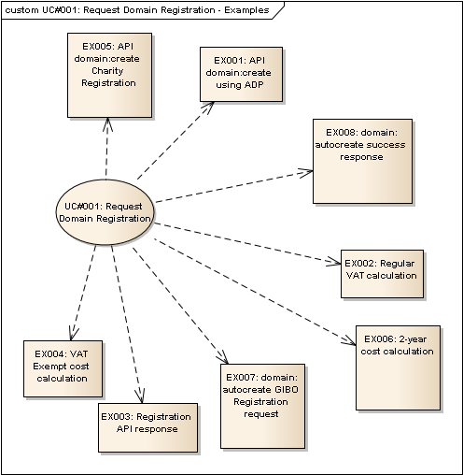
Figure 3 : UC#001: Request Domain Registration - Examples

EX001: API domain:create using ADP
Type: public Entity
Status: Proposed. Version 1.0. Phase 1.0.
Package: Registration Process: Use Cases
Details: Created on 24/01/2012 16:34:24. Modified on 24/01/2012 16:37:42. Author: Paul Delany

<ieapi xmlns="http://www.domainregistry.ie/ieapi-1.2" xmlns:xsi="http://www.w3.org/2001/XMLSchema-instance" xsi:schemaLocation="http://www.domainregistry.ie/ieapi-1.2 ieapi-1.2.xsd">
<command>
<create>
<domain:create xmlns:domain="http://www.domainregistry.ie/ieapi-domain-1.2" xsi:schemaLocation="http://www.domainregistry.ie/ieapi-domain-1.2 ieapi-domain-1.2.xsd">
<domain:name>example.ie</domain:name>
<domain:period unit="y">1</domain:period>
<domain:ns>
<domain:nsName>ns1.example.ie</domain:nsName>
<domain:nsAddr>192.1.2.3</domain:nsAddr>
</domain:ns>
<domain:ns>
<domain:nsName>ns1.example2.ie</domain:nsName>
</domain:ns>
<domain:holder class="Natural Person">
<domain:holderName category="Personal Name">John Doe</domain:holderName>
<domain:holderRemarks/>
</domain:holder>
<domain:contact type="admin">XXX123-IEDR</domain:contact>
<domain:contact type="tech">XXX124-IEDR</domain:contact>
<domain:paymentMethod type="depositAccount" test="false">
</domain:paymentMethod>
</domain:create>
</create>
</command>
</ieapi>

EX002: Regular VAT calculation
Type: public Entity
Status: Proposed. Version 1.0. Phase 1.0.
Package: Registration Process: Use Cases
Details: Created on 24/01/2012 16:39:05. Modified on 24/01/2012 16:56:38. Author: Paul Delany

Customer VAT Code: 'A'
Current VAT Rate 'A': 23%
1 Year Domain Registration Cost Ex. VAT: EUR 10.00
Calculation:
VAT Amount: 10.00 * 0.23 = 2.30
Total Cost: 10.00 + 2.30 = 12.30

EX003: Registration API response
Type: public Entity
Status: Proposed. Version 1.0. Phase 1.0.
Package: Registration Process: Use Cases
Details: Created on 24/01/2012 16:40:38. Modified on 24/01/2012 16:56:40. Author: Paul Delany

Ex. Response XML:
<ieapi xmlns="http://www.domainregistry.ie/ieapi-1.2" xmlns:xsi="http://www.w3.org/2001/XMLSchema-instance" xsi:schemaLocation="http://www.domainregistry.ie/ieapi-1.2 ieapi-1.2.xsd">
<response>
<result code="1000">
<msg>Command completed successfully</msg>
</result>
<resData>
<domain:appData xmlns:domain="http://www.domainregistry.ie/ieapi-domain-1.2" xsi:schemaLocation="http://www.domainregistry.ie/ieapi-domain-1.2 ieapi-domain-1.2.xsd">
<domain:name>example.ie</domain:name>
<domain:appNumber>75057</domain:appNumber>
<domain:appDate>2006-07-01T14:00:00.0Z</domain:appDate>
<domain:exDate>2006-08-01T14:00:00.0Z</domain:exDate>
</domain:appData>
</resData>
</response>
</ieapi>

EX004: VAT Exempt cost calculation
Type: public Entity
Status: Proposed. Version 1.0. Phase 1.0.
Package: Registration Process: Use Cases
Details: Created on 24/01/2012 16:44:03. Modified on 24/01/2012 16:56:44. Author: Paul Delany

Ex. Transaction Cost Calculation:
Customer VAT Code: 'B' (note: in this example, 'B' is a VAT Exempt code.)
Current VAT Rate 'B': 0%
1 Year Domain Registration Cost Ex. VAT: EUR 10.00
Calculation:
VAT Amount: 10.00 * 0.00 = 0.00
Total Cost: 10.00 + 0.00 = 10.00

EX005: API domain:create Charity Registration
Type: public Entity
Status: Proposed. Version 1.0. Phase 1.0.
Package: Registration Process: Use Cases
Details: Created on 24/01/2012 16:49:13. Modified on 24/01/2012 16:49:42. Author: Paul Delany

Ex. Request XML:
<ieapi xmlns="http://www.domainregistry.ie/ieapi-1.2" xmlns:xsi="http://www.w3.org/2001/XMLSchema-instance" xsi:schemaLocation="http://www.domainregistry.ie/ieapi-1.2 ieapi-1.2.xsd">
<command>
<create>
<domain:create xmlns:domain="http://www.domainregistry.ie/ieapi-domain-1.2" xsi:schemaLocation="http://www.domainregistry.ie/ieapi-domain-1.2 ieapi-domain-1.2.xsd">
<domain:name>example.ie</domain:name>
<domain:period unit="y">1</domain:period>
<domain:ns>
<domain:nsName>ns1.example.ie</domain:nsName>
<domain:nsAddr>192.1.2.3</domain:nsAddr>
</domain:ns>
<domain:ns>
<domain:nsName>ns1.example2.ie</domain:nsName>
</domain:ns>
<domain:holder class="Natural Person">
<domain:holderName category="Personal Name">John Doe</domain:holderName>
<domain:holderRemarks/>
</domain:holder>
<domain:contact type="admin">XXX123-IEDR</domain:contact>
<domain:contact type="tech">XXX124-IEDR</domain:contact>
<domain:chy>XYZ123</domain:chy>
</domain:create>
</create>
</command>
</ieapi>

EX006: 2-year cost calculation
Type: public Entity
Status: Proposed. Version 1.0. Phase 1.0.
Package: Registration Process: Use Cases
Details: Created on 24/01/2012 16:55:43. Modified on 24/01/2012 16:56:00. Author: Paul Delany

Ex. Transaction Cost Calculation:
Customer VAT Code: 'B' (note: in this example, 'B' is a VAT Exempt code.
Current VAT Rate 'B': 0%
2 Year Domain Registration Cost Ex. VAT: EUR 20.00
Calculation:
VAT Amount: 20.00 * 0.00 = 0.00
Total Cost: 20.00 + 0.00 = 20.00

EX007: domain:autocreate GIBO Registration request
Type: public Entity
Status: Proposed. Version 1.0. Phase 1.0.
Package: Registration Process: Use Cases
Details: Created on 24/01/2012 16:57:26. Modified on 24/01/2012 16:57:49. Author: Paul Delany

Ex. XML Request
<?xml version="1.0" encoding="UTF-8" standalone="no"?>
<ieapi xmlns="http://www.domainregistry.ie/ieapi-1.2" xmlns:xsi="http://www.w3.org/2001/XMLSchema-instance" xsi:schemaLocation="http://www.domainregistry.ie/ieapi-1.2 ieapi-1.2.xsd">
<command>
<create>
<domain:autocreate xmlns:domain="http://www.domainregistry.ie/ieapi-domain-1.2" xsi:schemaLocation="http://www.domainregistry.ie/ieapi-domain-1.2ieapi-domain-1.2.xsd">
<domain:name>example.ie</domain:name>
<domain:period unit="y">1</domain:period>
<domain:ns>
<domain:nsName>ns1.example.ie</domain:nsName>
<domain:nsAddr>192.1.2.3</domain:nsAddr>
</domain:ns>
<domain:ns>
<domain:nsName>ns1.example2.ie</domain:nsName>
</domain:ns>
<domain:holder class="Natural Person">
<domain:holderName category="Personal Name">John Doe</domain:holderName>
<domain:holderRemarks />
</domain:holder>
<domain:contact type="admin">XXX123-IEDR</domain:contact>
<domain:contact type="tech">XXX124-IEDR</domain:contact>
<domain:paymentMethod type="depositAccount" test="false">
</domain:paymentMethod>
</domain:autocreate>
</create>
</command>
</ieapi>

EX008: domain:autocreate success response
Type: public Entity
Status: Proposed. Version 1.0. Phase 1.0.
Package: Registration Process: Use Cases
Details: Created on 24/01/2012 16:59:03. Modified on 24/01/2012 16:59:29. Author: Paul Delany

Ex. Response XML:
<?xml version="1.0" encoding="UTF-8" standalone="no"?>
<ieapi xmlns="http://www.domainregistry.ie/ieapi-1.2" xmlns:xsi="http://www.w3.org/2001/XMLSchema-instance" xsi:schemaLocation="http://www.domainregistry.ie/ieapi-1.2 ieapi-1.2.xsd">
<response>
<result code="1000">
<msg>Command completed successfully</msg>
</result>
<resData>
<domain:creData xmlns:domain="http://www.domainregistry.ie/ieapi-domain-1.2" xsi:schemaLocation="http://www.domainregistry.ie/ieapi-domain-1.2 ieapi-domain-1.2.xsd">
<domain:name>example.ie</domain:name>
<domain:creDate>2006-07-01</domain:creDate>
<domain:exDate>2007-07-01</domain:exDate>
</domain:creData>
</resData>
</response>
</ieapi>

UC#002: Admin-PASS Domain Registration Ticket
Type: public UseCase
Status: Proposed. Version 1.0. Phase 1.0.
Package: Registration Process: Use Cases
Details: Created on 19/12/2011 14:31:22. Modified on 24/01/2012 17:05:40. Author: Paul Delany

The actor reviews a domain registration ticket for compliance with IEDR domain registration policy and procedures, a.k.a., 'admin-passing' the domain.
Successfully passing the admin review will automatically trigger the technical and financial checks and, if successful, will result in the domain object being created.

Scenarios
SC01: Registrar Happy Path {Basic Path}.
Details
Registrar / Direct: Registrar
Payment Method: ADP
Admin Review: Success
DNS Check: Success
Financial Processing: Success
Billable / Charity: Billable
VAT Exempt?: No
1. The actor checks that the registration ticket request details conform to IEDR policy, and that all necessary supporting documentation has been received.
2. The actor sets the admin status of the ticket to PASSED.
3. The system performs the DNS check on the nameserver details supplied with the ticket and confirms they are valid.
4. The system sets the tech-status of the ticket to PASSED.
5. The system performs the financial checks on the ticket:
6. The value of the registration is obtained from the associated reservation.
7. It is confirmed that the registrar's ADP account has sufficient available funds.
8. The system updates the reservation and flags it as placed against the ADP account, ready to be invoiced. At the same time, the actual balance of the deposit account is reduced by the total cost of the reservation.
9. The financial status of the ticket is PASSED.
10. The system sends an email to the registrar notifying them of the reservation details.
11. DSM EVENT: CreateBillableDomainRegistrar. This creates the domain object.
12. The system removes the registration ticket.

SC02: Direct Happy Path {Basic Path}.
Details
Registrar / Direct: Direct
Payment Method: Credit Card
Admin Review: Success
DNS Check: Success
Financial Processing: Success
Billable / Charity: Billable
VAT Exempt?: Yes
1. The actor checks that the registration ticket request details conform to IEDR policy, and that all necessary supporting documentation has been received.
2. The actor sets the admin status of the ticket to PASSED.
3. The system performs the DNS check on the nameserver details supplied with the ticket and confirms they are valid.
4. The system sets the tech-status of the ticket to PASSED.
5. The system performs the financial checks on the ticket:
6. The RealEx credit card authorisation reference is obtained from the existing credit card reservation associated with the ticket.
7. The system requests settlement of the transaction via the RealEx API, which responds with success.
8. The reservation is updated to indicate that it has been settled and can be included on a subsequent invoice.
9. The financial status of the ticket is PASSED.
10. The system sends an email to the direct registrant notifying them of the settlement details.
11. DSM EVENT: CreateBillableDomainDirect. This creates the domain.
12. The system removes the registration ticket.

SC03: Direct registrant via Debit Card {Basic Path}.
Details
Registrar / Direct: Direct
Payment Method: Debit Card
Admin Review: Success
DNS Check: Success
Financial Processing: Success
Billable / Charity: Billable
VAT Exempt?: No
1. The actor checks that the registration ticket request details conform to IEDR policy, and that all necessary supporting documentation has been received.
2. The actor sets the admin status of the ticket to PASSED.
3. The system performs the DNS check on the nameserver details supplied with the ticket and confirms they are valid.
4. The system sets the tech-status of the ticket to PASSED.
5. The system performs the financial checks on the ticket:
6. The RealEx debit card authorisation reference is obtained from the existing debit card reservation associated with the ticket.
7. The system requests settlement of the transaction via the RealEx API, which responds with success.
8. The reservation is updated to indicate that it has been settled and can be included on a subsequent invoice.
9. The financial status of the ticket is PASSED.
10. The system sends an email to the direct registrant notifying them of the settlement details.
11. DSM EVENT: CreateBillableDomainDirect. This creates the domain.
12. The system removes the registration ticket.

SC04: Charity Registration {Basic Path}.
Details
Registrar / Direct: Registrar
Payment Method: n/a (charity)
Admin Review: Success
DNS Check: Success
Financial Processing: n/a (charity)
Billable / Charity: Charity
VAT Exempt?: No
1. The actor checks that the registration ticket request details conform to IEDR policy, and that all necessary supporting documentation has been received, and that they CHY corresponds to a verified charity organisation.
2. The actor sets the admin status of the ticket to PASSED.
3. The system performs the DNS check on the nameserver details supplied with the ticket and confirms they are valid.
4. The system sets the tech-status of the ticket to PASSED.
5. The system updates the reservation for a zero amount against the ADP account, and indicates that it can appear on an invoice. [Assumption: Charity registrations appear on invoices regardless of having no cost.]
6. The financial status of the ticket is PASSED. [The system does not send an email to the registrar notifying them of the reservation details, as no payment to be taken.]
7. DSM EVENT: CreateCharityDomainRegistrar. This creates the domain object.
8. The system removes the registration ticket.

SC05: DNS Check Failure {Basic Path}.
Details
Registrar / Direct: Registrar
Payment Method: ADP
Admin Review: Success
DNS Check: Fail
Financial Processing: n/a
Billable / Charity: Billable
VAT Exempt?: Yes
1. The actor checks that the registration ticket request details conform to IEDR policy, and that all necessary supporting documentation has been received.
2. The actor sets the admin status of the ticket to PASSED.
3. The system performs the DNS check on the nameserver details supplied with the ticket and the check fails.
4. A notification email for the associated Bill-C is sent (or queued for delivery).
5. The system sets the tech-status of the ticket to FAILED.

SC06: Insufficient available Deposit Funds {Basic Path}.
Details
Registrar / Direct: Registrar
Payment Method: ADP
Admin Review: Success
DNS Check: Success
Financial Processing: Fails
Billable / Charity: Billable
VAT Exempt?: No
1. The actor checks that the registration ticket request details conform to IEDR policy, and that all necessary supporting documentation has been received.
2. The actor sets the admin status of the ticket to PASSED.
3. The system performs the DNS check on the nameserver details supplied with the ticket and confirms they are valid.
4. The system sets the tech-status of the ticket to PASSED.
5. The system performs the financial checks on the ticket:
6. The value of the registration is obtained from the associated reservation.
7. It is confirmed that the registrar's ADP account has insufficient available funds.
8. The financial status of the ticket is FAILED.

SC07: Admin-Failure {Exception}.
Details
Registrar / Direct: Registrar
Payment Method: ADP
Admin Review: Admin Failure
DNS Check: n/a
Financial Processing: n/a
Billable / Charity: Billable
VAT Exempt?: No
1. The actor checks that the registration ticket request details conform to IEDR policy, and that all necessary supporting documentation has been received, but confirms that the claim to the domain is not in line with IEDR Policy.
2. The actor sets the admin status of the ticket to STALLED.

SC08: CC Settlement Failure {Exception}.
Details
Registrar / Direct: Direct
Payment Method: Credit Card
Admin Review: Success
DNS Check: Success
Financial Processing: Fail
Billable / Charity: Billable
VAT Exempt?: No
1. The actor checks that the registration ticket request details conform to IEDR policy, and that all necessary supporting documentation has been received.
2. The actor sets the admin status of the ticket to PASSED.
3. The system performs the DNS check on the nameserver details supplied with the ticket and confirms they are valid.
4. The system sets the tech-status of the ticket to PASSED.
5. The system performs the financial checks on the ticket:
6. The RealEx credit card authorisation reference is obtained from the existing credit card reservation associated with the ticket.
7. The system requests settlement of the transaction via the RealEx API, which responds with failure.
8. The financial status of the ticket is FAILED.

SC09: Debit Card Settlement Failure {Exception}.
Details
Registrar / Direct: Direct
Payment Method: Debit Card
Admin Review: Success
DNS Check: Success
Financial Processing: Fails
Billable / Charity: Billable
VAT Exempt?: No
1. The actor checks that the registration ticket request details conform to IEDR policy, and that all necessary supporting documentation has been received.
2. The actor sets the admin status of the ticket to PASSED.
3. The system performs the DNS check on the nameserver details supplied with the ticket and confirms they are valid.
4. The system sets the tech-status of the ticket to PASSED.
5. The system performs the financial checks on the ticket:
6. The RealEx debit card authorisation reference is obtained from the existing credit card reservation associated with the ticket.
7. The system requests settlement of the transaction via the RealEx API, which responds with failure.
8. The financial status of the ticket is FAILED.

Tagged Values
- API = N.

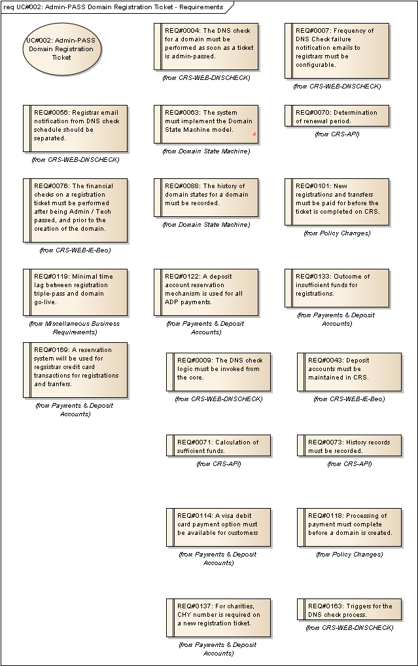
Figure 4 : UC#002: Admin-PASS Domain Registration Ticket - Requirements

UC#030: Retry Failed Registration Tickets
Type: public UseCase
Status: Proposed. Version 1.0. Phase 1.0.
Package: Registration Process: Use Cases
Details: Created on 23/01/2012 12:05:42. Modified on 24/01/2012 12:12:07. Author: Paul Delany

The actor retries the financial / technical checks on registration tickets which have previously failed at these points.
Each scenario relates to a single such ticket (i.e., a registration ticket that is ADMIN-Passed and either TECH-stalled OR FINANCIAL-stalled.

Scenarios
SC01: Tech-stalled Succeeds, ADP Payment {Basic Path}.
Details
FIN-Failed: No
TECH-Failed:Yes
Payment Method: ADP
Fin. Process Succeeds?: Yes
DNS Check Passes?: Yes
Registrant: Registrar
Billable / Charity: Billable
1. The actor selects a registration ticket that is admin-passed but tech-stalled.
2. The actor initiates the DNS check process for the details associated with the ticket. The system performs the check and confirms that the DNS details are valid, and flags the ticket as TECH-PASSED.
3. The actor initiates the financial processing of the ticket.
4. The system obtains the payment method (ADP) and payment details (cost, VAT etc.) from the ADP reservation associated with the ticket.
5. The system checks to see if the available funds in the ADP account are sufficient, and confirms that they are.
6. The actual balance of the deposit account is reduced by the total cost of the reservation and the reservation is flagged as having been settled, and ready for inclusion on an invoice.
7. The ticket is flagged as FINANCIAL-PASSED.
8. DSM EVENT: CreateBillableDomainRegistrar. This creates the domain object in the system.

SC02: Tech-Stalled Retry Fails {Basic Path}.
Details
FIN-Failed: No
TECH-Failed: Yes
Payment Method: ADP
Fin. Process Succeeds?: Yes
DNS Check Passes?: No
Registrant: Registrar
Billable / Charity: Billable
1. The actor selects a registration ticket that is admin-passed, but tech-stalled.
2. The actor initiates the DNS check process for the details associated with the ticket. The system performs the check which reports that there is an issue with the DNS configuration supplied.

SC03: Financially-stalled Succeeds, Credit Card Payment {Basic Path}.
Details
FIN-Failed: Yes
TECH-Failed: No
Payment Method: Credit Card
Fin. Process Succeeds?: Yes
DNS Check Passes?: Yes
Registrant: Registrar
Billable / Charity: Billable
1. The actor selects a registration ticket that is admin-passed and tech-passed but financial-stalled.
2. The actor initiates the financial processing of the ticket.
3. The system obtains the payment method (Credit Card) and RealEx authorisation code from the reservation associated with the ticket.
4. The system requests settlement of the credit card transaction via the RealEx API [TODO]. The RealEx API responds with success.
5. The reservation is flagged as having been settled, and ready for inclusion on an invoice.
6. The ticket is flagged as FINANCIAL-PASSED.
7. DSM EVENT: CreateBillableDomainRegistrar. This creates the domain object in the system.

SC04: Tech-Stalled Passes, Fails Debit Card Processing {Basic Path}.
Details
FIN-Failed:No
TECH-Failed:Yes
Payment Method: Debit Card
Fin. Process Succeeds?: No
DNS Check Passes?: Yes
Registrant: Registrar
Billable / Charity: Billable
1. The actor selects a registration ticket that is admin-passed but tech-stalled.
2. The actor initiates the DNS check process for the details associated with the ticket. The system performs the check and confirms that the DNS details are valid, and flags the ticket as TECH-PASSED
3. The actor initiates the financial processing of the ticket:
4. The system obtains the payment method (Debit Card) and RealEx authorisation code from the reservation associated with the ticket.
5. The system requests settlement of the transaction via the RealEx API [TODO]. The RealEx API responds with failure.
6. The ticket is flagged as FINANCIAL-STALLED.

SC05: Direct Charity Registration Passes DNS Check {Alternate}.
Details
FIN-Failed:No
TECH-Failed:Yes
Payment Method: Debit Card
Fin. Process Succeeds?: n/a
DNS Check Passes?: Yes
Registrant: Registrar
Billable / Charity: Billable
1. The actor selects a registration ticket that is admin-passed but tech-stalled.
2. The actor initiates the DNS check process for the details associated with the ticket. The system performs the check and confirms that the DNS details are valid, and flags the ticket as TECH-PASSED.
3. The actor initiates the financial processing of the ticket.
4. The system determines that it is a charity registration and so does not require payment.
5. The associated reservation is flagged as being settled and ready for invoicing.
6. The ticket is flagged as FINANCIAL-PASSED.
7. DSM EVENT: CreateCharityDomainDirect.

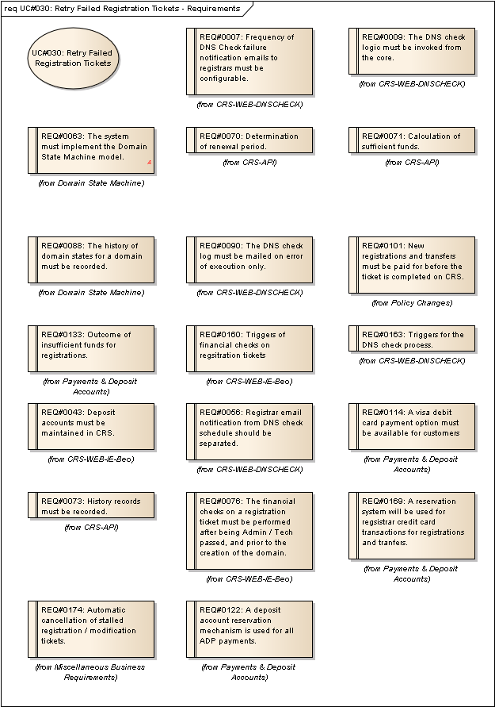
Figure 5 : UC#030: Retry Failed Registration Tickets - Requirements

UC#003: Approve GIBO-Registered Domain
Type: public UseCase
Status: Proposed. Version 1.0. Phase 1.0.
Package: Registration Process: Use Cases
Details: Created on 05/01/2012 16:02:37. Modified on 24/01/2012 15:13:10. Author: Paul Delany

The actor reviews a GIBO-registered domain which has not yet been Admin-reviewed.
If the review is successful, then the financial payment is processed with respect to the domain.
If the review is not successful, then the domain is scheduled for immediate deletion.
If the review is successful but payment processing is not initially successful, then the payment processing will be automatically retried for a defined period. If not successful within that period, then the domain is scheduled for deletion.

Scenarios
SC01: Happy Path {Basic Path}. Detail
Payment Method: ADP
Admin Review: Success
Financial Processing: Success
WIPO Disputed: N
1. The actor reviews the details of the domain for compliance with IEDR policy, and confirms all is correct.
2. The actor sets the domain status to Active [Note: this is the interface label - not the DSM NRP status. Only DSM events can trigger DSM state change.].
3. The system processes financials:
4. The system obtains the cost of the transaction from the associated reservation and determines that the ADP method is to be used.
5. The system verifies that there is sufficient available funds in the deposit account.
6. The system updates the reservation and flags it as placed against the ADP account, ready for invoicing. At the same time, the actual balance of the deposit account is reduced by the total cost of the reservation.
7. DSM EVENT: GIBOAuthorisation. This will set the DSM status of the domain to Active.

SC02: Financials Fail {Exception}. Detail
Payment Method: ADP
Admin Review: Success
Financial Processing: Fail
WIPO Disputed: N
1. The actor reviews the details of the domain for compliance with IEDR policy, and confirms all is correct.
2. The actor sets the domain status to Active.
3. The system processes financials:
4. The system obtains the cost of the transaction from the associated reservation determines that the ADP method is to be used.
5. The system verifies that there is sufficient available funds in the deposit account, but finds that there are insufficient funds.
6. DSM EVENT: GIBOPaymentFailure. This will set the DSM status of the domain to Transaction Failed, for financial processing retry after a period of time. The retry period timeout deadline is also set as a result of this.

SC03: Admin-Review Fail {Exception}. Detail
Payment Method: ADP
Admin Review: Fail
Financial Processing: n/a
WIPO Disputed: N
1. The actor reviews the details of the domain for compliance with IEDR policy, but determines that the registration details are not valid.
2. The actor sets the domain status to Delete [Note: this is the interface label - not the DSM NRP status. Only DSM events can trigger DSM state change.].
3. DSM EVENT: GIBOAdminFailure. This will flag the domain for deletion.

SC04: WIPO Disputed {Exception}. Detail
Payment Method: ADP
Admin Review: n/a
Financial Processing: n/a
WIPO Disputed: Y
1. The actor can review the domain details, but can neither Admin-PASS the domain nor schedule it for deletion, as it is in WIPO dispute.

SC05: Credit Card {Basic Path}. Detail
Payment Method: Credit Card
Admin Review: Success
Financial Processing: Success
WIPO Disputed: N
1. The actor reviews the details of the domain for compliance with IEDR policy, and confirms all is correct.
2. The actor sets the domain status to Active [Note: this is the interface label - not the DSM NRP status. Only DSM events can trigger DSM state change.].
3. The system processes financials:
4. The system references the reservation associated with the domain and determines that a credit card payment method is intended.
5. The system obtains the RealEx authorisation code from the reservation.
6. The system requests settlement via RealEx of the transaction using the authorisation code. RealEx responds with the success response.
7. The system updates the reservation in the system as having been settled and ready for invoicing.
8. DSM EVENT: GIBOAuthorisation. This will set the DSM status of the domain to active.

SC06: Debit Card Failure {Exception}. Detail
Payment Method: Debit Card
Admin Review: Success
Financial Processing: Fail
WIPO Disputed: Y
1. The actor reviews the details of the domain for compliance with IEDR policy, and confirms all is correct.
2. The actor sets the domain status to Active [Note: this is the interface label - not the DSM NRP status. Only DSM events can trigger DSM state change.].
3. The system processes financials:
4. The system references the reservation associated with the domain and determines that a debit card payment method is intended.
5. The system obtains the RealEx authorisation code from the reservation.
6. The system requests settlement via RealEx of the transaction using the authorisation code. RealEx responds with a fail response.
7. DSM EVENT: GIBOPaymentFailure. This will set the DSM status of the domain to Transaction Failed, for periodic retry. The retry period timeout deadline is also set as a result.

Tagged Values
- API = N.

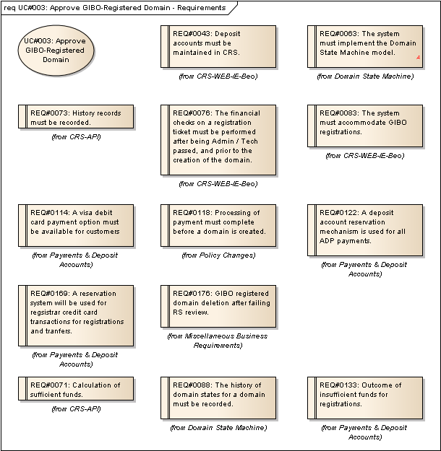
Figure 6 : UC#003: Approve GIBO-Registered Domain - Requirements

UC#026: Update Financially Failed GIBO Domains
Type: public UseCase
Status: Proposed. Version 1.0. Phase 1.0.
Package: Registration Process: Use Cases
Details: Created on 16/01/2012 17:09:24. Modified on 24/01/2012 15:26:09. Author: Paul Delany

The actor checks to see if there are any GIBO domains which have previously failed financial checks and either triggers their deletion (if the retry period has expired) or retries the payment transaction.

Scenarios
SC01: Retry Succeeds {Basic Path}. Details
Payment Method: ADP
WIPO Dispute: N
Retry Period Expired: N
Retry Succeeds: Y
1. The actor confirms that the payment retry period has not yet expired.
2. The actor determines the payment method (ADP) and the total transaction cost from the reservation associated with the domain.
3. The actor checks the available balance of the associated deposit account and confirms there is sufficient available balance to cover the transaction cost.
4. The actor updates the reservation as being settled, ready for invoicing. At the same time, the actual balance on the deposit account is reduced by the total cost of the transaction.
5. DSM EVENT: Payment. This sets the NRP DSM status of the domain to Active.

SC02: Retry Succeeds - Credit Card {Basic Path}. Details
Payment Method: Credit Card
WIPO Dispute: N
Retry Period Expired: N
Retry Succeeds: Y
1. The actor confirms that the payment retry period has not yet expired.
2. The actor determines the payment method (CC), the RealEx authorisation code, and the total transaction cost from the reservation associated with the domain.
3. The actor attempts to settle the RealEx transaction via the RealEx API. The RealEx API returns the success response.
4. The actor updates the reservation as being settled, ready for invoicing.
5. DSM EVENT: Payment. This sets the NRP DSM status of the domain to Active.

SC03: Retry Period Expired {Basic Path}. Details
Payment Method: ADP
WIPO Dispute: N
Retry Period Expired: Y
Retry Succeeds: N
1. The actor confirms that the payment retry period has expired.
2. DSM EVENT: GIBOPaymentRetryTimeout. This flags the domain for deletion.

SC04: Retry Fails {Basic Path}. Details
Payment Method: ADP
WIPO Dispute: N
Retry Period Expired: N
Retry Succeeds: N
1. The actor confirms that the payment retry period has not yet expired.
2. The actor determines the payment method (ADP) and the total transaction cost from the reservation associated with the domain.
3. The actor checks the available balance of the associated deposit account and confirms there is insufficient available balance to cover the transaction cost.

SC05: WIPO Disputed {Exception}. Details
Payment Method: ADP
WIPO Dispute: Y
Retry Period Expired: N
Retry Succeeds: N
1. As the domain is in WIPO dispute no action is taken by the actor.
[Note: This will have the effect that any such domain will in fact be published to the zone file for the duration of the WIPO dispute - despite not having been charged. This may be a very unlikely situation, but clarification is required as to whether GIBO registered domains can ever be put into WIPO dispute prior to full authorisation and payment, or should it be mandated that in order for a domain to be placed into WIPO dispute the RS review / payment taken must happen first.]

Tagged Values
- API = N.

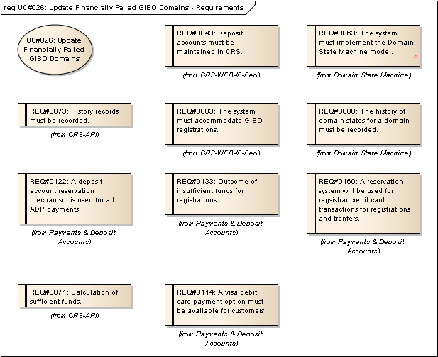
Figure 7 : UC#026: Update Financially Failed GIBO Domains - Requirements

Registration Process: Logical Entities

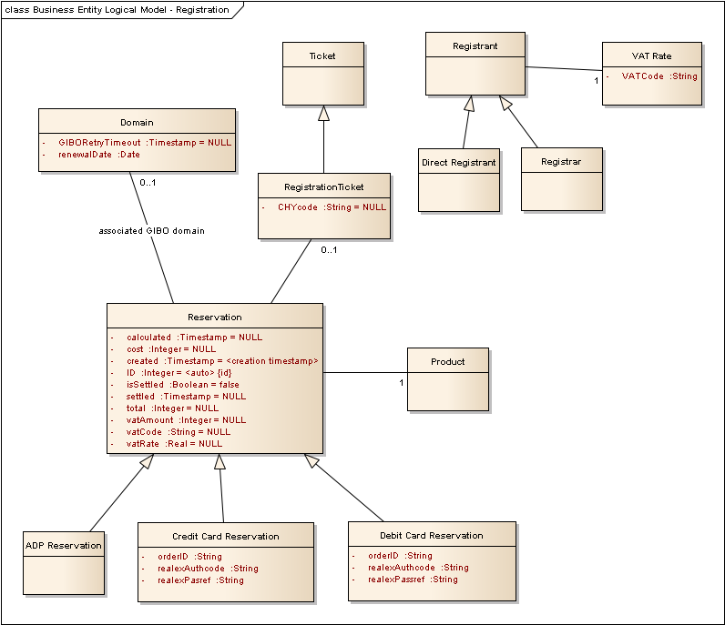
Figure 8 : Business Entity Logical Model - Registration

Registration Process: DSM Aspects

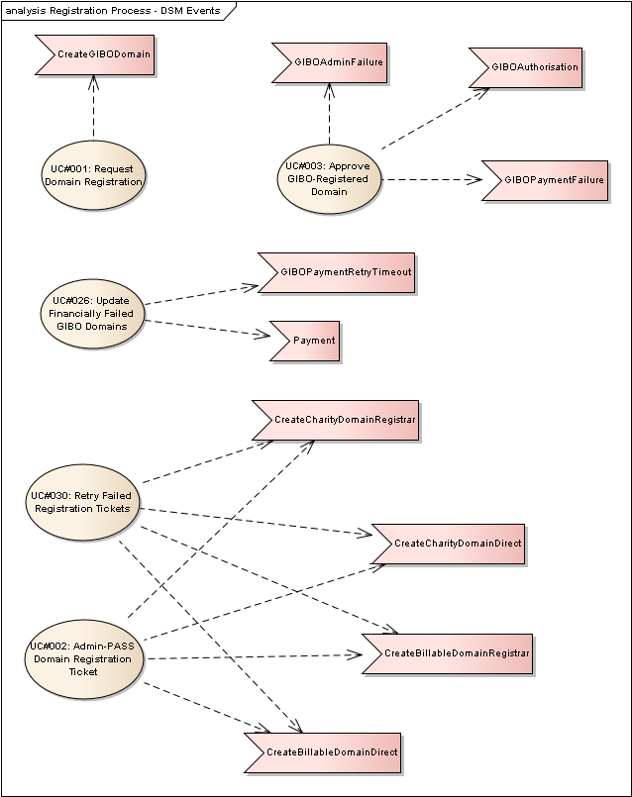
Figure 9 : Registration Process - DSM Events

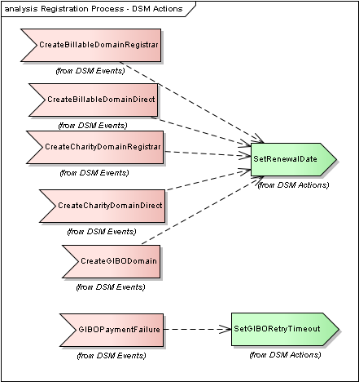
Figure 10 : Registration Process - DSM Actions

