DRAFT FOR ASD REVIEW – 6th FEB

Renewal Process

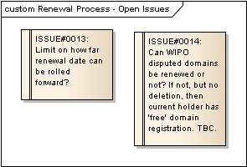
Figure 1 : Renewal Process - Open Issues

ISSUE#0013: Limit on how far renewal date can be rolled forward?
Type: «Functional» Issue
Status: Proposed. Version 1.0. Phase 1.0.; Priority: Medium; Difficulty: Medium
Package: Renewal Process
Details: Created on 06/02/2012 11:55:32. Modified on 06/02/2012 11:56:01. Author: Paul Delany

Suppose a domain's renewal date is in the future at some point, and the customer makes a renewal payment in advance - this rolls the renewal date forward by the appropriate period (single/multi-year renewal).
The customer makes subsequent renewal payments and the same occurs. In theory, then, is there any issue with a customer purchasing, say 30 years' of time at today's price, given that we may increase product rates in future?
Should there be some limit on how far in the future a domain can be renewed for?

Renewal Process Use Cases

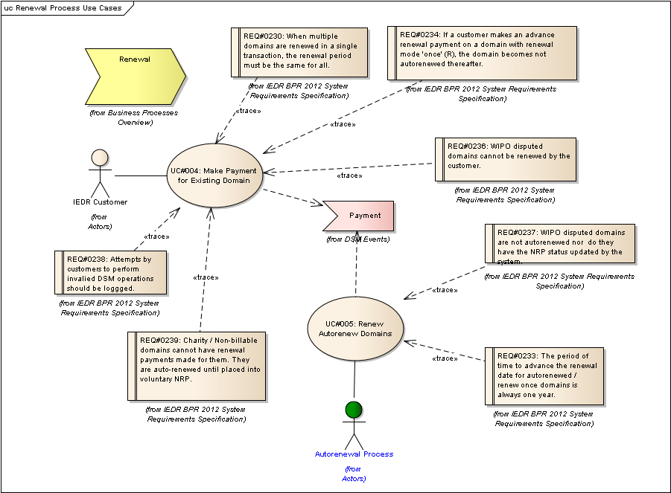
Figure 2 : Renewal Process Use Cases

UC#004: Make Payment for Existing Domain
Type: public UseCase
Status: Proposed. Version 1.0. Phase 1.0.
Package: Renewal Process Use Cases
Details: Created on 03/01/2012 14:11:57. Modified on 06/02/2012 18:16:08. Author: Paul Delany

The actor makes a payment against an existing registered domain for renewal / transfer.

Scenarios
SC01: Registrar Happy Path {Basic Path}. Detail
Reg / Dir: Registrar
ADP / CC / DEB: ADP
NRC / API: API
Payment Success / Fail: Success
Period: 2 years
Domain: A
Holder: B
NRP Status: A
WIPO Dispute: N
Renewal Mode: N
Domain: B
Holder: B
NRP Status: A
WIPO Dispute: N
Renewal Mode: A
Domain: C
Holder: B
NRP Status: IM
WIPO Dispute: N
Renewal Mode: N
1. Registrar issues the account:pay command, indicating ADP payment, via the API for three domains. [See EX20].
2. The system checks that all domains are currently registered by the registrar.
3. The system calculates the cost, inclusive of VAT, for each domain and the total for all 3 domains (for the transaction). [See EX21].
4. The system confirms that there is sufficient available ADP balance for all 3 domains in the transaction.
5. The system creates the single transaction record and the three associated ADP reservations which are initially flagged as unsettled.
6. The system settles the reservation w.r.t. Domain A and reduces the ADP account's actual balance by the reservation amount.
7. DSM EVENT: Payment(Period=2). This results in the renewal date being rolled forward by 2 years from its current value.
8. The system settles the reservation w.r.t. Domain B and reduces the ADP account's actual balance by the reservation amount.
9. DSM EVENT: Payment(Period=2). This results in the renewal date being rolled forward by 2 years from its current value.
10. The system settles the reservation w.r.t. Domain C and reduces the ADP account's actual balance by the reservation amount.
11. DSM EVENT: Payment(Period=2). This results in the renewal date being rolled forward by 2 years from its current value. The NRP Status of the domain is also updated to Active (A).
12. The system responds with the details of the successful transaction. [See EX22 ].

SC02: Registrar Debit Card Payment {Basic Path}. Detail
Payment Success / Fail : Success
Reg / Dir: Registrar
ADP / CC / DEB: DEB
NRC / API: API
Period: 2 years
Domain: A
Holder: B
NRP Status: A
WIPO Dispute: N
Renewal Mode: N
Domain: B
Holder: B
NRP Status: A
WIPO Dispute: N
Renewal Mode: R
Domain: C
Holder: B
NRP Status: IS
WIPO Dispute: N
Renewal Mode: N
1. Registrar issues the account:pay command, indicating debit card payment and details, via the API for three domains. [See EX23].
2. The system confirms that all domains are currently registered by the registrar.
3. The system calculates the cost for each domain, inclusive of VAT, and the total for all 3 domains (for the transaction). [See EX21 ].
4. The system requests authorisation and settlement of the total transaction value from RealEx. [See ]. RealEx responds with the success indication.
5. The system creates the single transaction record and the three associated debit card reservations which are initially flagged as unsettled.
6. The system flags the reservation w.r.t. Domain A as settled.
7. DSM EVENT: Payment(Period=2). This results in the renewal date being rolled forward by 2 years from its current value.
8. The system flags the reservation w.r.t. Domain B as settled.
9. DSM EVENT: Payment(Period=2). This results in the renewal date being rolled forward by 2 years from its current value. The autorenew mode of the domain is changed from renew once (R) to not autorenewed (N).
10. The system flags the reservation w.r.t. Domain C as settled.
11. DSM EVENT: Payment(Period=2). This results in the renewal date being rolled forward by 2 years from its current value. The NRP Status is also updated to Active (A).
12. The system responds with the details of the successful debit card transaction. [See EX22].

SC03: Direct Happy Path {Basic Path}. Detail
Payment Success / Fail : Success
Reg / Dir: Direct
ADP / CC / DEB: CC
NRC / API: NRC
Period: 2 years
Domain: A
Holder: B
NRP Status: A
WIPO Dispute: N
Renewal Mode: N
Domain: B
Holder: B
NRP Status: IS
WIPO Dispute: N
Renewal Mode: N
1. Direct selects two domains, already registered, for renewal, indicating credit card payment and details, and a 2 year renewal period, via the NRC.
2. The system calculates the cost for each domain, inclusive of VAT, and the total for all 2 domains (for the transaction).
3. The system requests authorisation and settlement of the total transaction value from RealEx. [See ]. RealEx responds with the success indication.
4. The system creates the single transaction record and the two associated credit card reservations which are initially flagged as unsettled.
5. The system flags the reservation w.r.t. Domain A as settled.
6. DSM EVENT: Payment(Period=2). This results in the renewal date being rolled forward by 2 years from its current value.
7. The system flags the reservation w.r.t. Domain B as settled.
8. DSM EVENT: Payment(Period=2). This results in the renewal date being rolled forward by 2 years from its current value. The NRP Status is also updated to Active (A).
9. The system responds with the details of the successful transaction. [See ].

SC04: Direct using Debit Card {Basic Path}. Detail
Payment Success / Fail : Success
Reg / Dir: Direct
ADP / CC / DEB: DEB
NRC / API: NRC
Period: 2 years
Domain: A
Holder: B
NRP Status: A
WIPO Dispute: N
Renewal Mode: N
Domain: B
Holder: B
NRP Status: IS
WIPO Dispute: N
Renewal Mode: N
1. Direct selects two domains, already registered, for renewal, indicating debit card payment and details, and a 2 year renewal period, via the NRC.
2. The system calculates the cost for each domain, inclusive of VAT, and the total for all 2 domains (for the transaction).
3. The system requests authorisation and settlement of the total transaction value from RealEx. [See ]. RealEx responds with the success indication.
4. The system creates the single transaction record and the two associated debit card reservations which are initially flagged as unsettled.
5. The system flags the reservation w.r.t. Domain A as settled.
6. DSM EVENT: Payment(Period=2). This results in the renewal date being rolled forward by 2 years from its current value.
7. The system flags the reservation w.r.t. Domain B as settled.
8. DSM EVENT: Payment(Period=2). This results in the renewal date being rolled forward by 2 years from its current value. The NRP Status is also updated to Active (A).
9. The system responds with the details of the successful transaction. [See ].

SC05: Involuntary Mailed Domain {Basic Path}. Detail
Payment Success / Fail : Success
Reg / Dir: Registrar
ADP / CC / DEB: ADP
NRC / API: API
Period: 2 years
Domain: C
Holder: B
NRP Status: IM
WIPO Dispute: N
Renewal Mode: N
- Covered by SC01.

SC06: Involuntary Suspended Domain {Basic Path}. Detail
Payment Success / Fail : Success
Reg / Dir: Registrar
ADP / CC / DEB: ADP
NRC / API: API
Period: 1 year
Domain: A
Holder: B
NRP Status: IS
WIPO Dispute: N
Renewal Mode: N
- Covered by SC02.

SC07: ADP Payment failure - insufficient funds for all domains {Exception}. Detail
Reg / Dir: Registrar
ADP / CC / DEB: ADP
NRC / API: NRC
Payment Success / Fail : Fail
Period: 1 year
Domain: A
Holder: B
NRP Status: A
WIPO Dispute : N
Renewal Mode : N
Domain: B
Holder: B
NRP Status: A
WIPO Dispute : N
Renewal Mode : N
1. Registrar selects two domains already registered, via NRC and requests 1 year renewal payment to be made via ADP.
2. The system calculates the cost, inclusive of VAT, for each domain and the total for all 2 domains (for the transaction). [See EX25].
3. The system confirms that there is insufficient available ADP balance for all 3 domains in the transaction and responds with a notification to the registrar of insufficient available ADP balance.

SC08: Registrar via NRC with some non-billable domains {Exception}. Detail
Payment Success / Fail : Success
Reg / Dir: Registrar
ADP / CC / DEB: CC
NRC / API: NRC
Period: 1 year
Domain: A
Holder: Billable
NRP Status: A
WIPO Dispute : N
Renewal Mode : N
Domain: B
Holder: Non-billable
NRP Status: A
WIPO Dispute : N
Renewal Mode : N
Domain: C
Holder: Charity
NRP Status: A
WIPO Dispute : N
Renewal Mode : N
1. Registrar selects three domains already registered, via NRC, and selects 1 year renewal payment to be made via credit card, supplying the credit card details.
2. The system determines that at least one of the selected domains is either non-billable or a charity, and so not eligible for a renewal payment. The system does not allow the process to continue and notifies the user as to the reason. [See ].

SC09: No billable domain {Exception}. Detail
Payment Success / Fail : Success
Reg / Dir: Registrar
ADP / CC / DEB: CC
NRC / API: API
Period: 1 year
Domain: A
Holder: C
NRP Status: A
WIPO Dispute: N
Renewal Mode: N
1. Registrar issues the account:pay command, indicating credit card payment and details, and a 1 year renewal period, via the API for a single domain. [See EX26].
2. The system confirms that all domains are currently registered by the registrar.
3. The system confirms that at least one specified domain is non-billable or charity and responds with the appropriate failure response. [See EX27].

SC10: Credit Card payment failure {Exception}. Detail
Reg / Dir: Registrar
ADP / CC / DEB: CC
NRC / API: API
Payment Success / Fail : Fail
Period: 1 year
Domain: A
Holder: B
NRP Status: A
WIPO Dispute: N
Renewal Mode: N
1. Registrar issues the account:pay command, indicating credit card payment and details, 1 year period, via the API for a single domain. [See EX26].
2. The system confirms that the domain is currently registered by the registrar.
3. The system calculates the cost for each domain, inclusive of VAT, and the total for the transaction (for the transaction). [See ].
4. The system requests authorisation and settlement of the total transaction value from RealEx. [See ]. RealEx responds with an authorisation failure indication [See ].
5. The system responds with the details of the failed transaction. [See EX29].

SC11: Debit Card payment failure {Exception}. Detail
Payment Success / Fail : Fail
Reg / Dir: Direct
ADP / CC / DEB: DEB
NRC / API: NRC
Period: 1 year
Domain: A
Holder: B
NRP Status: A
WIPO Dispute: N
Renewal Mode: N
1. Direct selects a domain, already registered, for renewal, indicating debit card payment and details, and a 1 year renewal period, via the NRC.
2. The system calculates the cost for each domain, inclusive of VAT, and the total for the transaction (for the transaction).
3. The system requests authorisation and settlement of the total transaction value from RealEx. [See ]. RealEx responds with the failure indication.
4. The system responds with the details of the failed transaction.

SC12: GIBO Post-registration Audit {Exception}. Detail
Payment Success / Fail : Fail
Reg / Dir: Registrar
ADP / CC / DEB: ADP
NRC / API: API
Period: 1 year
Domain: A
Holder: B
NRP Status: P
WIPO Dispute: N
Renewal Mode: N
1. Registrar issues the account:pay command, indicating ADP payment, 1 year period, via the API for a single domain. [See EX37].
2. The system checks that all domains are currently registered by the registrar.
3. The system confirms that at least one domain in the request is not renewable (it has NRP status of P - which cannot be renewed).
4. The system returns a response which indicates that the domain(s) at issue and the reason for the failure of the transaction. [See EX31].

SC13: GIBO Transaction Failed status {Exception}. Detail
Payment Success / Fail : Fail
Reg / Dir: Registrar
ADP / CC / DEB: ADP
NRC / API: API
Period: 1 year
Domain: A
Holder: B
NRP Status: T
WIPO Dispute: N
Renewal Mode: N
1. Registrar issues the account:pay command, indicating ADP payment, 1 year period, via the API for a single domain. [See EX30].
2. The system checks that all domains are currently registered by the registrar.
3. The system confirms that at least one domain in the request is not renewable (it has NRP status of T - which cannot be renewed).
4. The system returns a response which indicates that the domain(s) at issue and the reason for the failure of the transaction. [See EX32].

SC14: Voluntary Mailed {Exception}. Detail
Payment Success / Fail : Success
Reg / Dir: Registrar
ADP / CC / DEB: ADP
NRC / API: API
Period: 1 year
Domain: A
Holder: B
NRP Status : VM
WIPO Dispute : N
Renewal Mode : N
Domain: B
Holder: B
NRP Status: VS
WIPO Dispute : N
Renewal Mode : N
1. Registrar issues the account:pay command, indicating ADP payment, via the API for two domains. [See EX33].
2. The system checks that all domains are currently registered by the registrar.
3. The system confirms that at least one domain is not renewable (it is in Voluntary NRP) and so the transaction cannot proceed.
4. The system responds with the details of the failed transaction. [See EX34].

SC15: Voluntary Suspended {Exception}. Detail
- catered for in SC14.

SC16: Autorenewed {Exception}. Detail
Payment Success / Fail : Success
Reg / Dir: Registrar
ADP / CC / DEB: ADP
NRC / API: NRC
Period: 1 year
Domain: A
Holder: B
NRP Status: A
WIPO Dispute: N
Renewal Mode: A
- Covered by SC01

SC17: WIPO Disputed {Exception}. Detail
Payment Success / Fail : Success
Reg / Dir: Registrar
ADP / CC / DEB: ADP
NRC / API: NRC
Period: 1 year
Domain: A
Holder: B
NRP Status: A
WIPO Dispute: Y
Renewal Mode: N
1. Registrar selects a domain already registered, via NRC, and selects 1 year renewal payment to be made via deposit account.
2. The system calculates the cost for each domain, inclusive of VAT, and the total for all domains (for the transaction).
3. The system confirms that there is sufficient available ADP balance for all domains in the transaction.
4. The system creates the single transaction record and the associated ADP reservation which is initially flagged as unsettled.
5. The system settles the reservation w.r.t. Domain A and reduces the ADP account's actual balance by the reservation amount.
6. DSM EVENT: Payment(Period=2). This results in the renewal date being rolled forward by 2 years from its current value.
7. The system responds with the details of the successful transaction. [See ].

SC18: WIPO Disupted - Autorenew {Exception}. Detail
Payment Success / Fail: Success
Reg / Dir: Registrar
ADP / CC / DEB: ADP
NRC / API: NRC
Period: 1 year
Domain: A
Holder: B
NRP Status: A
WIPO Dispute: Y
Renewal Mode: A
1. Registrar selects a domain already registered, via NRC, and selects 1 year renewal payment to be made via deposit account.
2. The system calculates the cost for each domain, inclusive of VAT, and the total for all domains (for the transaction).
3. The system confirms that there is sufficient available ADP balance for all domains in the transaction.
4. The system creates the single transaction record and the associated ADP reservation which is initially flagged as unsettled.
5. The system settles the reservation w.r.t. Domain A and reduces the ADP account's actual balance by the reservation amount.
6. DSM EVENT: Payment(Period=2). This results in the renewal date being rolled forward by 2 years from its current value.
7. The system responds with the details of the successful transaction. [See ].

SC19: Registrar via API with some non-billable domains {Exception}. Detail
Payment Success / Fail : Success
Reg / Dir: Registrar
ADP / CC / DEB: ADP
NRC / API: API
Period: 1 year
Domain: A
Holder: B
NRP Status: A
WIPO Dispute: N
Renewal Mode: N
Domain: B
Holder: N
NRP Status: A
WIPO Dispute: N
Renewal Mode: N
Domain: C
Holder: C
NRP Status: A
WIPO Dispute: N
Renewal Mode: N
1. Registrar issues the account:pay command, indicating ADP payment, via the API for three domains. [See EX20].
2. The system checks that all domains are currently registered by the registrar.
3. The system confirms that at least one specified domain is non-billable or charity and responds with the appropriate failure response. [See EX35]

Tagged Values
- API = Y.

<ieapi xsi:schemaLocation="http://www.domainregistry.ie/ieapi-1.3 ieapi-1.3.xsd">
<command>
<pay>
<account:pay xsi:schemaLocation="http://www.domainregistry.ie/ieapi-account-1.3 ieapi-account1.3.xsd" test="false">
<account:domain>exampleA.ie</account:domain>
<account:method>
<deposit/>
</account:method>
<period>2</period>
</account:pay>
</pay>
</command>
</ieapi>

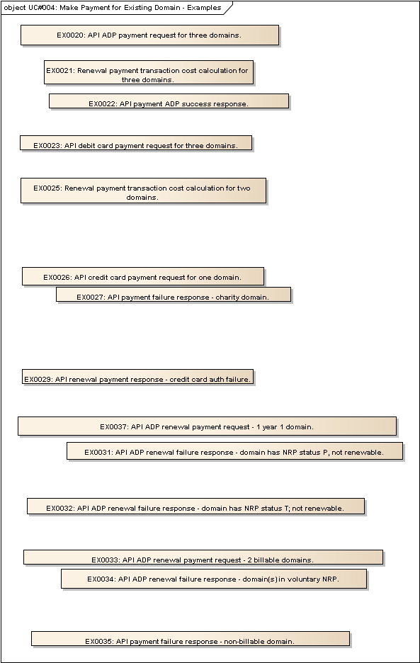
Figure 3 : UC#004: Make Payment for Existing Domain - Examples

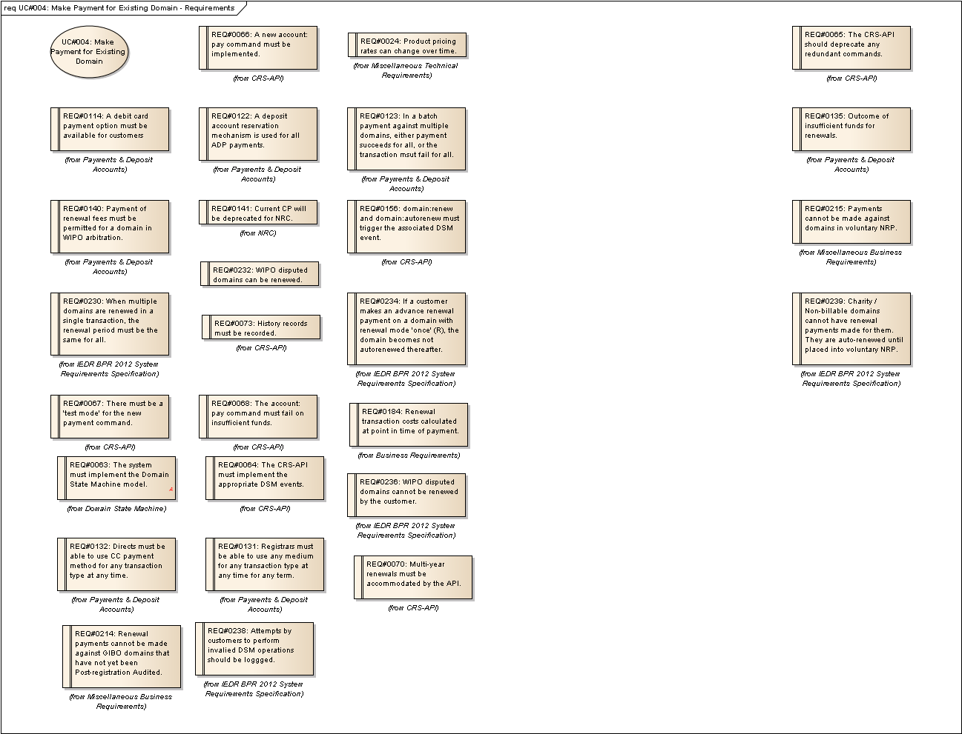
Figure 4 : UC#004: Make Payment for Existing Domain - Requirements

EX0020: API ADP payment request for three domains.
Type: public Entity
Status: Proposed. Version 1.0. Phase 1.0.
Package: Renewal Process Use Cases
Details: Created on 06/02/2012 10:36:41. Modified on 06/02/2012 11:38:53. Author: Paul Delany

<ieapi xsi:schemaLocation="http://www.domainregistry.ie/ieapi-1.3 ieapi-1.3.xsd">
<command>
<pay>
<account:pay xsi:schemaLocation="http://www.domainregistry.ie/ieapi-account-1.3 ieapi-account1.3.xsd" test="false">
<account:domain>exampleA.ie</account:domain>
<account:domain>exampleB.ie</account:domain>
<account:domain>exampleC.ie</account:domain>
<account:method>
<deposit/>
</account:method>
<period>2</period>
</account:pay>
</pay>
</command>
</ieapi>

EX0021: Renewal payment transaction cost calculation for three domains.
Type: public Entity
Status: Proposed. Version 1.0. Phase 1.0.
Package: Renewal Process Use Cases
Details: Created on 06/02/2012 10:37:44. Modified on 06/02/2012 11:45:03. Author: Paul Delany

Customer VAT Code: A
Current VAT Code A Rate: 0.23
Current 2 year domain cost: 20.00 EUR
Domain A cost = 20.00 + (20.00 * 0.23) = 24.60
Domain B cost = 20.00 + (20.00 * 0.23) = 24.60
Domain C cost = 20.00 + (20.00 * 0.23) = 24.60
Transaction Cost = 24.60 + 24.60 + 24.60 = 73.80

EX0022: API payment ADP success response.
Type: public Entity
Status: Proposed. Version 1.0. Phase 1.0.
Package: Renewal Process Use Cases
Details: Created on 06/02/2012 10:38:54. Modified on 06/02/2012 14:22:24. Author: Paul Delany

<?xml version="1.0" encoding="UTF-8" standalone="no"?>
<ieapi xmlns="http://www.domainregistry.ie/ieapi-1.2" xmlns:xsi="http://www.w3.org/2001/XMLSchema-instance" xsi:schemaLocation="http://www.domainregistry.ie/ieapi-1.2 ieapi-1.2.xsd">
<response>
<result code="1000">
<msg>Command completed successfully</msg>
</result>
<resData>
<account:pay xmlns:account="http://www.domainregistry.ie/ieapi-account-1.2" xsi:schemaLocation="http://www.domainregistry.ie/ieapi-account-1.2 ieapi-account-1.2.xsd">
<account:fee>60.00</account:fee>
<account:vat>13.80</account:vat>
<account:total>73.80</account:total>
</account:pay>
</resData>
</response>
</ieapi>

EX0023: API debit card payment request for three domains.
Type: public Entity
Status: Proposed. Version 1.0. Phase 1.0.
Package: Renewal Process Use Cases
Details: Created on 06/02/2012 10:40:06. Modified on 06/02/2012 14:20:04. Author: Paul Delany

<ieapi xsi:schemaLocation="http://www.domainregistry.ie/ieapi-1.3 ieapi-1.3.xsd">
<command>
<pay>
<account:pay xsi:schemaLocation="http://www.domainregistry.ie/ieapi-account-1.3 ieapi-account1.3.xsd" test="false">
<account:domain>exampleA.ie</account:domain>
<account:domain>exampleB.ie</account:domain>
<account:domain>exampleC.ie</account:domain>
<account:method>
<account:card>
<account:cardHolderName>John Doe</account:cardHolderName>
<account:cardNumber>12341234123412</account:cardNumber>
<account:expiryDate>2013-01</account:expiryDate>
<account:cardType>VISA</account:cardType>
<account:cvv>123</account:cvv>
</account:card>
</account:method>
<period>2</period>
</account:pay>
</pay>
</command>
</ieapi>

EX0025: Renewal payment transaction cost calculation for two domains.
Type: public Entity
Status: Proposed. Version 1.0. Phase 1.0.
Package: Renewal Process Use Cases
Details: Created on 06/02/2012 10:46:40. Modified on 06/02/2012 14:24:38. Author: Paul Delany

Customer VAT Code: A
Current VAT Code A Rate: 0.23
Current 1 year domain cost: 10.00 EUR
Domain A cost = 10.00 + (10.00 * 0.23) = 12.30
Domain B cost = 10.00 + (10.00 * 0.23) = 12.30
Transaction Cost = 12.30 + 12.30 = 24.60

EX0026: API credit card payment request for one domain.
Type: public Entity
Status: Proposed. Version 1.0. Phase 1.0.
Package: Renewal Process Use Cases
Details: Created on 06/02/2012 10:47:28. Modified on 06/02/2012 14:47:16. Author: Paul Delany

<ieapi xsi:schemaLocation="http://www.domainregistry.ie/ieapi-1.3 ieapi-1.3.xsd">
<command>
<pay>
<account:pay xsi:schemaLocation="http://www.domainregistry.ie/ieapi-account-1.3 ieapi-account1.3.xsd" test="false">
<account:domain>exampleA.ie</account:domain>
<account:method>
<account:card>
<account:cardHolderName>John Doe</account:cardHolderName>
<account:cardNumber>12341234123412</account:cardNumber>
<account:expiryDate>2013-01</account:expiryDate>
<account:cardType>VISA</account:cardType>
<account:cvv>123</account:cvv>
</account:card>
</account:method>
<period>1</period>
</account:pay>
</pay>
</command>
</ieapi>

EX0027: API payment failure response - charity domain.
Type: public Entity
Status: Proposed. Version 1.0. Phase 1.0.
Package: Renewal Process Use Cases
Details: Created on 06/02/2012 11:05:51. Modified on 06/02/2012 15:00:55. Author: Paul Delany

<?xml version="1.0" encoding="UTF-8" standalone="no"?>
<ieapi xmlns="http://www.domainregistry.ie/ieapi-1.2" xmlns:xsi="http://www.w3.org/2001/XMLSchema-instance" xsi:schemaLocation="http://www.domainregistry.ie/ieapi-1.2 ieapi-1.2.xsd">
<response>
<result code="TBC">
<msg>Transaction unsuccessful. No payment for non-billable domain.</msg>
<value>exampleA.ie</value>
</result>
</response>
</ieapi>

EX0029: API renewal payment response - credit card auth failure.
Type: public Entity
Status: Proposed. Version 1.0. Phase 1.0.
Package: Renewal Process Use Cases
Details: Created on 06/02/2012 11:08:27. Modified on 06/02/2012 14:54:08. Author: Paul Delany

<?xml version="1.0" encoding="UTF-8" standalone="no"?>
<ieapi xmlns="http://www.domainregistry.ie/ieapi-1.2" xmlns:xsi="http://www.w3.org/2001/XMLSchema-instance" xsi:schemaLocation="http://www.domainregistry.ie/ieapi-1.2 ieapi-1.2.xsd">
<response>
<result code="809">
<msg>{Realex authorisation failure message}</msg>
</result>
</response>
</ieapi>

EX0031: API ADP renewal failure response - domain has NRP status P, not renewable.
Type: public Entity
Status: Proposed. Version 1.0. Phase 1.0.
Package: Renewal Process Use Cases
Details: Created on 06/02/2012 11:16:27. Modified on 06/02/2012 14:57:16. Author: Paul Delany

<?xml version="1.0" encoding="UTF-8" standalone="no"?>
<ieapi xmlns="http://www.domainregistry.ie/ieapi-1.2" xmlns:xsi="http://www.w3.org/2001/XMLSchema-instance" xsi:schemaLocation="http://www.domainregistry.ie/ieapi-1.2 ieapi-1.2.xsd">
<response>
<result code="TBC">
<msg>Transaction unsuccessful. Post-registration approval pending for domain.</msg>
<value>exampleA.ie</value>
</result>
</response>
</ieapi>

EX0032: API ADP renewal failure response - domain has NRP status T; not renewable.
Type: public Entity
Status: Proposed. Version 1.0. Phase 1.0.
Package: Renewal Process Use Cases
Details: Created on 06/02/2012 11:18:28. Modified on 06/02/2012 14:58:09. Author: Paul Delany

<?xml version="1.0" encoding="UTF-8" standalone="no"?>
<ieapi xmlns="http://www.domainregistry.ie/ieapi-1.2" xmlns:xsi="http://www.w3.org/2001/XMLSchema-instance" xsi:schemaLocation="http://www.domainregistry.ie/ieapi-1.2 ieapi-1.2.xsd">
<response>
<result code="TBC">
<msg>Transaction unsuccessful. Registration payment pending.</msg>
<value>exampleA.ie</value>
</result>
</response>
</ieapi>

EX0033: API ADP renewal payment request - 2 billable domains.
Type: public Entity
Status: Proposed. Version 1.0. Phase 1.0.
Package: Renewal Process Use Cases
Details: Created on 06/02/2012 11:19:28. Modified on 06/02/2012 14:59:22. Author: Paul Delany

<ieapi xsi:schemaLocation="http://www.domainregistry.ie/ieapi-1.3 ieapi-1.3.xsd">
<command>
<pay>
<account:pay xsi:schemaLocation="http://www.domainregistry.ie/ieapi-account-1.3 ieapi-account1.3.xsd" test="false">
<account:domain>exampleA.ie</account:domain>
<account:domain>exampleB.ie</account:domain>
<account:method>
<deposit/>
</account:method>
<period>1</period>
</account:pay>
</pay>
</command>
</ieapi>

EX0034: API ADP renewal failure response - domain(s) in voluntary NRP.
Type: public Entity
Status: Proposed. Version 1.0. Phase 1.0.
Package: Renewal Process Use Cases
Details: Created on 06/02/2012 11:21:07. Modified on 06/02/2012 14:59:57. Author: Paul Delany

<?xml version="1.0" encoding="UTF-8" standalone="no"?>
<ieapi xmlns="http://www.domainregistry.ie/ieapi-1.2" xmlns:xsi="http://www.w3.org/2001/XMLSchema-instance" xsi:schemaLocation="http://www.domainregistry.ie/ieapi-1.2 ieapi-1.2.xsd">
<response>
<result code="TBC">
<msg>Transaction unsuccessful. Domain in voluntary NRP.</msg>
<value>exampleA.ie</value>
<value>exampleB.ie</value>
</result>
</response>
</ieapi>

EX0035: API payment failure response - non-billable domain.
Type: public Entity
Status: Proposed. Version 1.0. Phase 1.0.
Package: Renewal Process Use Cases
Details: Created on 06/02/2012 11:29:16. Modified on 06/02/2012 15:02:10. Author: Paul Delany

<?xml version="1.0" encoding="UTF-8" standalone="no"?>
<ieapi xmlns="http://www.domainregistry.ie/ieapi-1.2" xmlns:xsi="http://www.w3.org/2001/XMLSchema-instance" xsi:schemaLocation="http://www.domainregistry.ie/ieapi-1.2 ieapi-1.2.xsd">
<response>
<result code="TBC">
<msg>Transaction unsuccessful. No payment for non-billable domain.</msg>
<value>exampleB.ie</value>
<value>exampleC.ie</value>
</result>
</response>
</ieapi>

EX0037: API ADP renewal payment request - 1 year 1 domain.
Type: public Entity
Status: Proposed. Version 1.0. Phase 1.0.
Package: Renewal Process Use Cases
Details: Created on 06/02/2012 14:49:26. Modified on 06/02/2012 14:56:02. Author: Paul Delany

<ieapi xsi:schemaLocation="http://www.domainregistry.ie/ieapi-1.3 ieapi-1.3.xsd">
<command>
<pay>
<account:pay xsi:schemaLocation="http://www.domainregistry.ie/ieapi-account-1.3 ieapi-account1.3.xsd" test="false">
<account:domain>exampleA.ie</account:domain>
<account:method>
<deposit/>
</account:method>
<period>1</period>
</account:pay>
</pay>
</command>
</ieapi>

UC#005: Renew Autorenew Domains
Type: public UseCase
Status: Proposed. Version 1.0. Phase 1.0.
Package: Renewal Process Use Cases
Details: Created on 09/01/2012 14:52:06. Modified on 06/02/2012 18:17:04. Author: Paul Delany

The actor performs the automatic renewal of auto-renewed domains.
In general, the actor will select all domains
- due for automatic renewal (where the domain's renewal mode is either renew once or autorenew),
- and the renewal date <= current date
- which are not in voluntary NRP (NRP status = A | IM | IS.
Each scenario describes the steps for a single such selected domain.

Scenarios
SC01: Renew Once Happy Path {Basic Path}. Details
Payment Succeeds? : Success
NRP Status: A
WIPO Dispute: N
Renewal Mode: R
1. The actor selects a domain with a renewal date <= current date, not WIPO disputed and with renewal mode R (renew once) initiates a one year renewal payment by ADP for the domain.
2. The system checks that the domain is currently registered by the registrar.
3. The system calculates the cost, inclusive of VAT, for the domain (and hence for the transaction). [See EX36].
4. The system confirms that there is sufficient available ADP account balance for the transaction.
5. The system creates the single transaction record and the associated ADP reservation which are initially flagged as unsettled.
6. The system settles the reservation and reduces the ADP account's actual balance by the reservation amount.
7. DSM EVENT: Payment(Period=1). This results in the renewal date being rolled forward by 1 year from its current value and the domain's autorenew status set to N (Not autorenewed).

SC02: Autorenew Happy Path {Basic Path}. Details
Payment Succeeds? : Success
NRP Status: A
WIPO Dispute: N
Renewal Mode: A
1. The actor selects a domain with a renewal date <= current date, not WIPO disputed and with renewal mode A (autorenew) initiates a one year renewal payment by ADP for the domain.
2. The system checks that the domain is currently registered by the registrar.
3. The system calculates the cost, inclusive of VAT, for the domain (and hence for the transaction). [See EX36]].
4. The system confirms that there is sufficient available ADP balance for the transaction.
5. The system creates the single transaction record and the associated ADP reservation which is initially flagged as unsettled.
6. The system settles the reservation and reduces the ADP account's actual balance by the reservation amount.
7. DSM EVENT: Payment(Period=1). This results in the renewal date being rolled forward by 1 year from its current value.

SC03: Renew Once Involuntary Mailed {Alternate}. Details
Payment Succeeds? : Success
NRP Status: IM
WIPO Dispute: N
Renewal Mode: R
1. The actor selects a domain with a renewal date <= current date, not WIPO disputed and with renewal mode R (renew once) initiates a one year renewal payment by ADP for the domain.
2. The system checks that the domain is currently registered by the registrar.
3. The system calculates the cost, inclusive of VAT, for the domain (and hence for the transaction). [See EX36]].
4. The system confirms that there is sufficient available ADP balance for the transaction.
5. The system creates the single transaction record and the associated ADP reservation which are initially flagged as unsettled.
6. The system settles the reservation and reduces the ADP account's actual balance by the reservation amount.
7. DSM EVENT: Payment(Period=1). This results in the renewal date being rolled forward by 1 year from its current value, the domain's autorenew status set to N (Not autorenewed), and the NRP status of the domain is changed from IM to A.

SC04: Autorenew Involuntary Mailed {Alternate}. Details
Payment Succeeds? : Success
NRP Status: IM
WIPO Dispute: N
Renewal Mode: A
1. The actor selects a domain with a renewal date <= current date, not WIPO disputed and with renewal mode A (autorenew) initiates a one year renewal payment by ADP for the domain.
2. The system checks that the domain is currently registered by the registrar.
3. The system calculates the cost, inclusive of VAT, for the domain (and hence for the transaction). [See EX36]].
4. The system confirms that there is sufficient available ADP balance for the transaction.
5. The system creates the single transaction record and the associated ADP reservation which is initially flagged as unsettled.
6. The system settles the reservation and reduces the ADP account's actual balance by the reservation amount.
7. DSM EVENT: Payment(Period=1). This results in the renewal date being rolled forward by 1 year from its current value and the domain's NRP status changed from IM to A.

SC05: Autorenew Involuntary Suspended {Alternate}. Details
Payment Succeeds? : Success
NRP Status: IS
WIPO Dispute: N
Renewal Mode: A
1. The actor selects a domain with a renewal date <= current date, not WIPO disputed and with renewal mode A (autorenew) initiates a one year renewal payment by ADP for the domain.
2. The system checks that the domain is currently registered by the registrar.
3. The system calculates the cost, inclusive of VAT, for the domain (and hence for the transaction). [See EX36]].
4. The system confirms that there is sufficient available ADP balance for the transaction.
5. The system creates the single transaction record and the associated ADP reservation which is initially flagged as unsettled.
6. The system settles the reservation and reduces the ADP account's actual balance by the reservation amount.
7. DSM EVENT: Payment(Period=1). This results in the renewal date being rolled forward by 1 year from its current value and the domain's NRP status changed from IS to A.

SC06: WIPO Dispute {Alternate}. Details
Payment Succeeds? : Success
NRP Status: A
WIPO Dispute: Y
Renewal Mode: R
1. The actor selects a domain with a renewal date <= current date, not WIPO disputed and with renewal mode R (renew once) initiates a one year renewal payment by ADP for the domain.
2. The system checks that the domain is currently registered by the registrar.
3. The system calculates the cost, inclusive of VAT, for the domain (and hence for the transaction). [See EX36] ].
4. The system confirms that there is sufficient available ADP account balance for the transaction.
5. The system creates the single transaction record and the associated ADP reservation which are initially flagged as unsettled.
6. The system settles the reservation and reduces the ADP account's actual balance by the reservation amount.
7. DSM EVENT: Payment(Period=1). This results in the renewal date being rolled forward by 1 year from its current value and the domain's autorenew status set to N (Not autorenewed).

SC07: Renew Once Voluntary Mailed {Alternate}. Details
Payment Succeeds? : Success
NRP Status: VM
WIPO Dispute: N
Renewal Mode: R
Assumption is that domains in voluntary NRP (NRP status = VM | VS) are not autorenewed. Nothing to be done.

SC08: Autorenew Voluntary Suspended {Alternate}. Details
Payment Succeeds? : Success
NRP Status : VS
WIPO Dispute : N
Renewal Mode : A
Assumption is that domains in voluntary NRP (NRP status = VM | VS) are not autorenewed. Nothing to be done.

SC09: Payment Fails {Alternate}. Details
Payment Succeeds? : Fail
NRP Status : A
WIPO Dispute : N
Renewal Mode : R
1. The actor selects a domain with a renewal date <= current date, not WIPO disputed and with renewal mode R (renew once) initiates a one year renewal payment by ADP for the domain.
2. The system checks that the domain is currently registered by the registrar.
3. The system calculates the cost, inclusive of VAT, for the domain (and hence for the transaction). [See EX36]].
4. The system confirms that there is insufficient available ADP account balance for the transaction. The renewal does not take place.

SC10: Payment Fails - Involuntary Mailed {Alternate}. Details
Payment Succeeds? : Fail
NRP Status : IM
WIPO Dispute : N
Renewal Mode : R
1. The actor selects a domain with a renewal date <= current date, not WIPO disputed and with renewal mode R (renew once) initiates a one year renewal payment by ADP for the domain.
2. The system checks that the domain is currently registered by the registrar.
3. The system calculates the cost, inclusive of VAT, for the domain (and hence for the transaction). [See EX36]].
4. The system confirms that there is insufficient available ADP account balance for the transaction. The renewal does not take place.

Tagged Values
- API = N.

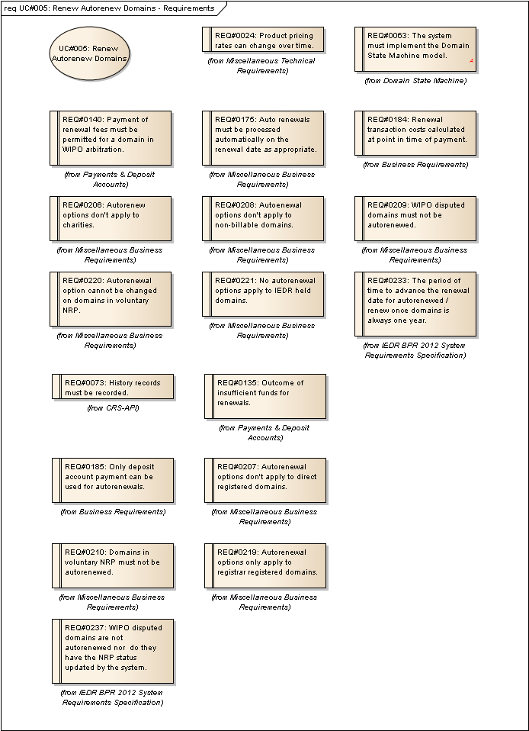
Figure 5 : UC#005: Renew Autorenew Domains - Requirements

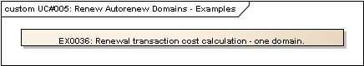
Figure 6 : UC#005: Renew Autorenew Domains - Examples

EX0036: Renewal transaction cost calculation - one domain.
Type: public Entity
Status: Proposed. Version 1.0. Phase 1.0.
Package: Renewal Process Use Cases
Details: Created on 06/02/2012 11:30:35. Modified on 06/02/2012 15:03:27. Author: Paul Delany

Customer VAT Code: A
Current VAT Code A Rate: 0.23
Current 1 year domain cost: 10.00 EUR
Domain A cost = 10.00 + (10.00 * 0.23) = 12.30
Transaction Cost = 12.30

Renewal Process: Logical Entities

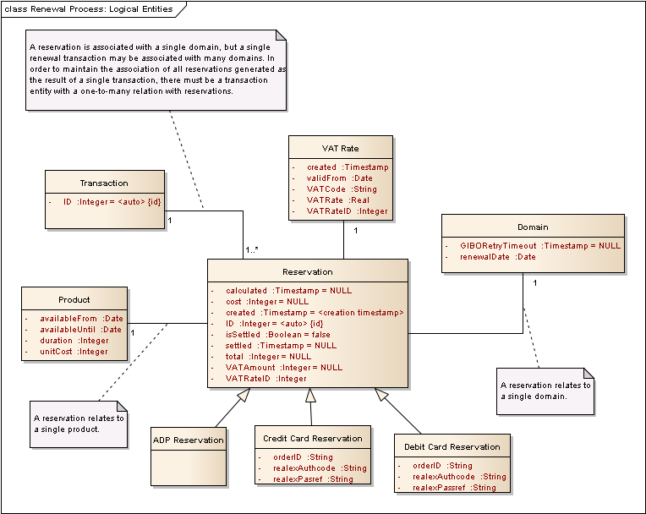
Figure 7 : Renewal Process: Logical Entities

Renewal Process: DSM Aspects

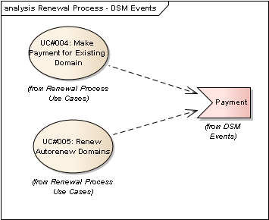
Figure 8 : Renewal Process - DSM Events

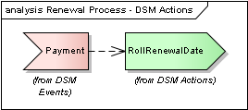
Figure 9 : Renewal Process - DSM Actions

