DRAFT for ASD Review / NASK Preview
V0.1
24 February 2012

Transfer Process

Transfer Process: Activity Diagrams

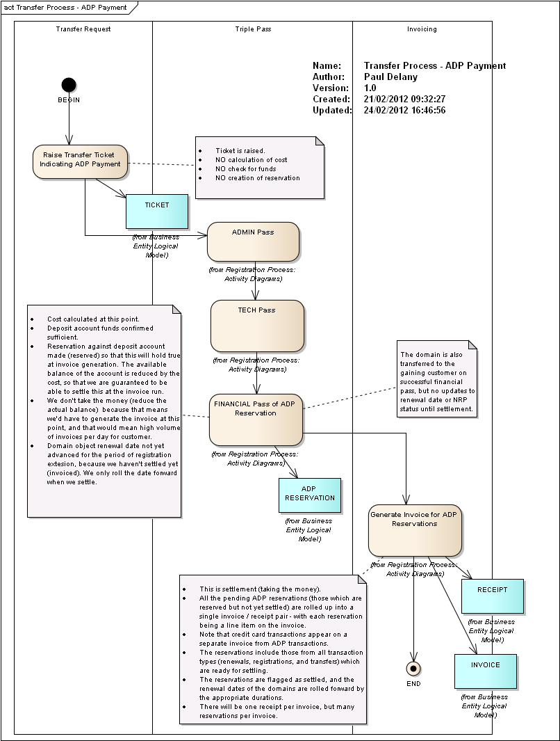
Figure 1 : Transfer Process - ADP Payment

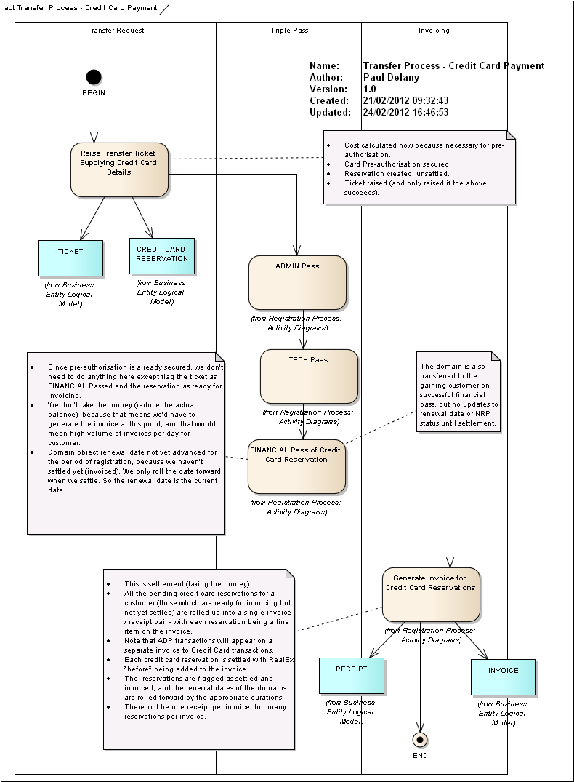
Figure 2 : Transfer Process - Credit Card Payment

Transfer Process: Use Cases

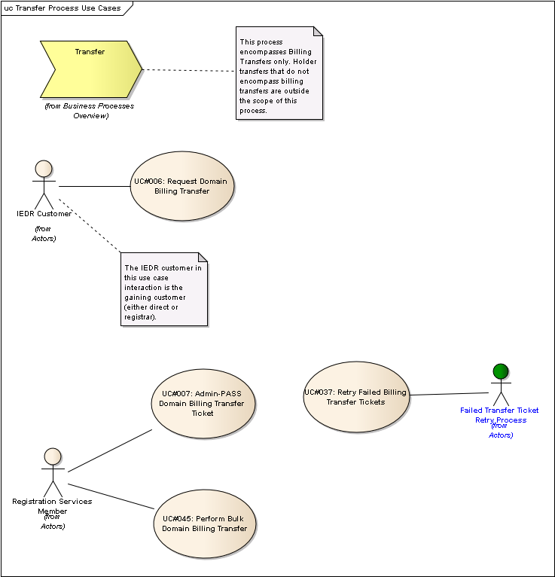
Figure 3 : Transfer Process Use Cases

UC#006: Request Domain Billing Transfer
public UseCase:
The actor raises the modification ticket to request the transfer of an existing domain. The actor seeks to gain the registration of the domain.
In order to raise the ticket, the payment method must be selected and any necessary details supplied, as payment is to be processed prior to completing the transfer.

Scenarios
UC006-SC01: Registrar-Registrar Basic {Basic Path}.
Initial NRP Status: A
Losing Customer: Registrar
Gaining Customer: Registrar
Payment Method: ADP
Channel: API
Payment Authorisation Success: n/a
Holder Type: Billable
Initial Renewal Mode: N
Payment Period: 1
1. The actor issues a domain:transfer command via the API for domain example.ie, specifying a 1 year period to extend the current registration by. [See EX 43]
2. The system validates that no transfer ticket for the domain already exists in the system, and that all mandatory details are supplied and correct.
3. The transfer ticket is created in the system. The expiry date for the ticket is set to be 27 days from the current date.
4. The system responds with success code, the ticket number, the creation date of the ticket, and expiry date of the ticket.

UC006-SC02: Registrar to Direct - Basic {Basic Path}.
Initial NRP Status: A
Losing Customer: Registrar
Gaining Customer: Direct
Payment Method: CC
Channel: NRC
Payment Authorisation Success: Y
Holder Type: Billable
Initial Renewal Mode: N
Payment Period: 1
1. The actor supplies the name of the domain they wish to have transferred to them, supplying credit card details and nameserver details, and specifying a 1 year period to extend the current registration by.
2. The system validates that no transfer ticket for the domain already exists in the system, and that all mandatory details are supplied and correct.
3. The system calculates the cost of the transfer, inclusive of any applicable VAT.
4. The system requests pre-authorisation of the transaction via RealEx. RealEx response with success.
5. The system creates the transaction object and the associated credit card reservation with the duration of the reservation being 12 months.
6. The system creates the transfer ticket. The expiry date for the ticket is set to be 27 days from the current date. The ticket is associated with the transaction.
7. The system responds indicating that the ticket has been created successfully.

UC006-SC03: Direct to Registrar - Basic {Basic Path}.
Initial NRP Status: A
Losing Customer: Direct
Gaining Customer: Registrar
Payment Method: ADP
Channel: API
Payment Authorisation Success: Y
Holder Type: Billable
Initial Renewal Mode: N
Payment Period: 1
1. The actor issues a domain:transfer command via the API for domain example.ie, specifying a 1 year period to extend the current registration by. [See EX 43]
2. The system validates that no transfer ticket for the domain already exists in the system, and that all mandatory details are supplied and correct.
3. The transfer ticket is created in the system. The expiry date for the ticket is set to be 27 days from the current date.
4. The system responds with success code, the ticket number, the creation date of the ticket, and expiry date of the ticket.

UC006-SC04: Voluntary Mailed {Basic Path}.
Initial NRP Status: VM
Losing Customer: Registrar
Gaining Customer: Registrar
Payment Method: ADP
Channel: API
Payment Authorisation Success: Y
Holder Type: Billable
Initial Renewal Mode: N
Payment Period: 2
1. The actor issues a domain:transfer command via the API for domain example.ie, specifying a 2 year period to extend the current registration by.
2. The system validates that no transfer ticket for the domain already exists in the system, and that all mandatory details are supplied and correct.
3. The transfer ticket is created in the system. The expiry date for the ticket is set to be 27 days from the current date.
4. The system responds with success code, the ticket number, the creation date of the ticket, and expiry date of the ticket.

UC006-SC05: Involuntary Suspended {Basic Path}.
Initial NRP Status: IS
Losing Customer: Registrar
Gaining Customer: Registrar
Payment Method: ADP
Channel: API
Payment Authorisation Success: Y
Holder Type: Billable
Initial Renewal Mode: N
Payment Period: 2
1. The actor issues a domain:transfer command via the API for domain example.ie, specifying a 2 year period to extend the current registration by.
2. The system validates that no transfer ticket for the domain already exists in the system, and that all mandatory details are supplied and correct.
3. The transfer ticket is created in the system. The expiry date for the ticket is set to be 27 days from the current date.
4. The system responds with success code, the ticket number, the creation date of the ticket, and expiry date of the ticket.

UC006-SC06: Charity Transfer {Alternate}.
Initial NRP Status: A
Losing Customer: Direct
Gaining Customer: Registrar
Payment Method: n/a
Channel: NRC
Payment Authorisation Success: Y
Holder Type: Charity
Initial Renewal Mode: N
Payment Period: 1
1. The actor supplies the name of the domain they wish to have transferred to them, supplying credit card details and nameserver details. No credit card details or period of registration extension are specified by the actor as it is a charity domain.
2. The system validates that no transfer ticket for the domain already exists in the system, and that all mandatory details are supplied and correct, and that the domain is a charity.
3. The system creates the transfer ticket. The expiry date for the ticket is set to be 27 days from the current date.
4. The system responds indicating that the ticket has been created successfully.

UC006-SC07: Autorenewed Multi-Year {Alternate}.
Initial NRP Status: A
Losing Customer: Registrar
Gaining Customer: Registrar
Payment Method: ADP
Channel: API
Payment Authorisation Success: Y
Holder Type: Billable
Initial Renewal Mode: A
Payment Period: 1
1. The actor issues a domain:transfer command via the API for domain example.ie, specifying a 1 year period to extend the current registration by. [See EX 43]
2. The system validates that no transfer ticket for the domain already exists in the system, and that all mandatory details are supplied and correct.
3. The transfer ticket is created in the system. The expiry date for the ticket is set to be 27 days from the current date.
4. The system responds with success code, the ticket number, the creation date of the ticket, and expiry date of the ticket.

UC006-SC08: Registrar NRC / CC Authorisation Failure multi-year {Alternate}.
Initial NRP Status: A
Losing Registrant: Registrar
Gaining Registrant: Registrar
Payment Method: CC
Channel: NRC
Payment Authorisation Success: N
Holder Type: Billable
Initial Renewal Mode: N
Payment Period: 2
1. The actor supplies the name of the domain they wish to have transferred to them, supplying credit card details and nameserver details, and specifying a 2 year period to extend the current registration by.
2. The system validates that no transfer ticket for the domain already exists in the system, and that all mandatory details are supplied and correct.
3. The system calculates the cost of the transfer, inclusive of any applicable VAT.
4. The system requests pre-authorisation of the transaction via RealEx. RealEx response with failure.
5. The system responds indicating the RealEx failure.

UC006-SC09: Non-billbable Transfer {Alternate}.
Initial NRP Status: A
Losing Customer: Direct
Gaining Customer: Registrar
Payment Method: CC
Channel: NRC
Payment Authorisation Success: Y
Holder Type: Non-billable
Initial Renewal Mode: N
Payment Period: 1
1. The actor supplies the name of the domain they wish to have transferred to them, specifying a 1 year period to extend the current registration by.
2. The system validates that no transfer ticket for the domain already exists in the system, and that all mandatory details are supplied and correct, and that the domain is non-billable and so no credit card / payment details are required.
3. The system creates the transfer ticket. The expiry date for the ticket is set to be 27 days from the current date. The ticket is associated with the transaction.
4. The system responds indicating that the ticket has been created successfully.

UC006-SC10: Direct to Direct {Basic Path}.
Initial NRP Status: A
Losing Customer: Direct
Gaining Customer: Direct
Payment Method: CC
Channel: NRC
Payment Authorisation Success: Y
Holder Type: Billable
Initial Renewal Mode: N
Payment Period: 1
1. The actor supplies the name of the domain they wish to have transferred to them, supplying credit card details and nameserver details, and specifying a 1 year period to extend the current registration by.
2. The system validates that no transfer ticket for the domain already exists in the system, and that all mandatory details are supplied and correct.
3. The system calculates the cost of the transfer, inclusive of any applicable VAT.
4. The system requests pre-authorisation of the transaction via RealEx. RealEx response with success.
5. The system creates the transaction object and the associated credit card reservation with the duration of the reservation being 12 months.
6. The system creates the transfer ticket. The expiry date for the ticket is set to be 27 days from the current date. The ticket is associated with the transaction.
7. The system responds indicating that the ticket has been created successfully.

EX0043: API Domain Transfer Request
public Entity:
<ieapi xsi:schemaLocation="http://www.domainregistry.ie/ieapi-1.2 ieapi-1.2.xsd">
<command>
<modify>
<domain:transfer xsi:schemaLocation="http://www.domainregistry.ie/ieapi-domain-1.2 ieapi-domain-1.2.xsd">
<domain:name>example.ie</domain:name>
<domain:ns>
<domain:nsName>ns11.example.ie</domain:nsName>
<domain:nsAddr>192.1.2.3</domain:nsAddr>
</domain:ns>
<domain:ns><domain:nsName>ns1.blah.ie</domain:nsName></domain:ns>
<domain:contact type="tech">XXX125-IEDR</domain:contact></domain:transfer></modify></command>
</ieapi>

UC#007: Admin-PASS Domain Billing Transfer Ticket
public UseCase:
The actor reviews and approves a domain transfer ticket.

Scenarios
UC007-SC01: Registrar to Registrar Happy Path {Basic Path}. Initial NRP Status: A
Losing Customer: Registrar
Gaining Customer: Registrar
Admin Review: Pass
DNS Check: Pass
Payment Method: ADP
Holder Type: Billable
Initial Renewal Mode: N
Payment Period: 1
1. The actor checks that the transfer ticket request details conform to IEDR policy, and that all necessary supporting documentation has been received. The actor also ensures that the domain's admin contacts are appropriately assigned.
2. The actor sets the admin status of the ticket to PASSED.
3. The system performs the DNS check on the nameserver details supplied with the ticket and confirms they are valid.
4. The system sets the tech-status of the ticket to PASSED.
5. The value of the transfer is calculated and the transaction object and associated reservation created, initially flagged as not ready for settlement (unreserved). The reservation has its duration set to the extension period of the ticket (this is so that when it is settled the renewal date will be rolled forward by the appropriate period).
6. It is confirmed that the registrar's deposit account has sufficient available funds - the reservation is flagged as ready for settlement (reserved). [At this point, the reservation will affect the available deposit account balance.]
7. The system sets the bill-C of the associated domain to be the bill-C of the gaining customer.
8. DSM EVENT: TransferToRegistrar.
9. The financial status of the ticket is PASSED.
10. The registration ticket is closed.

UC007-SC02: Registrar to Direct Happy Path {Basic Path}. Initial NRP Status: A
Losing Customer: Registrar
Gaining Customer: Direct
Admin Review: Pass
DNS Check: Pass
Payment Method: CC
Holder Type: Billable
Initial Renewal Mode: N
Payment Period: 1
1. The actor checks that the transfer ticket request details conform to IEDR policy, and that all necessary supporting documentation has been received. The actor also ensures that the domain's admin contacts are appropriately assigned
2. The actor sets the admin status of the ticket to PASSED.
3. The system performs the DNS check on the nameserver details supplied with the ticket and confirms they are valid.
4. The system sets the tech-status of the ticket to PASSED.
5. The reservation is updated to indicate that it is ready for settlement (at the next invoicing run).
6. The system sets the bill-C of the associated domain to be the bill-C of the gaining customer.
7. DSM EVENT: TransferToDirect. This will change the domain's customer type to 'D' (Direct).
8. The financial status of the ticket is PASSED.
9. The ticket is closed.

UC007-SC03: Direct to Registrar Happy Path {Basic Path}.
Initial NRP Status: A
Losing Customer: Direct
Gaining Customer: Registrar
Admin Review: Pass
DNS Check: Pass
Payment Method: CC
Holder Type: Billable
Initial Renewal Mode: N
Payment Period: 1
1. The actor checks that the transfer ticket request details conform to IEDR policy, and that all necessary supporting documentation has been received. The actor also ensures that the domain's admin contacts are appropriately assigned.
2. The actor sets the admin status of the ticket to PASSED.
3. The system performs the DNS check on the nameserver details supplied with the ticket and confirms they are valid.
4. The system sets the tech-status of the ticket to PASSED.
5. The reservation is updated to indicate that it is ready for settlement (at the next invoicing run).
6. The system sets the bill-C of the associated domain to be the bill-C of the gaining customer.
7. DSM EVENT: TransferToRegistrar. This will change the domain's customer type to R (registrar).
8. The financial status of the ticket is PASSED.
9. The ticket is closed.

UC007-SC04: Charity Transfer {Alternate}.
Initial NRP Status: A
Losing Customer: Registrar
Gaining Customer: Registrar
Admin Review: Pass
DNS Check: Pass
Payment Method: CC
Holder Type: Charity
Initial Renewal Mode: N
Payment Period: 1
1. The actor checks that the transfer ticket request details conform to IEDR policy, and that all necessary supporting documentation has been received. The actor also ensures that the domain's admin contacts are appropriately assigned.
2. The actor sets the admin status of the ticket to PASSED.
3. The system performs the DNS check on the nameserver details supplied with the ticket and confirms they are valid.
4. The system sets the tech-status of the ticket to PASSED.
5. The reservation is updated to indicate that it is ready for settlement (at the next invoicing run).
6. The system sets the bill-C of the associated domain to be the bill-C of the gaining customer.
7. DSM EVENT: TransferToRegistrar.
8. The financial status of the ticket is PASSED.
9. The ticket is closed.

UC007-SC05: Involuntary Mailed {Alternate}.
Initial NRP Status: IM
Losing Customer: Registrar
Gaining Customer: Registrar
Admin Review: Pass
DNS Check: Pass
Payment Method: ADP
Holder Type: Billable
Initial Renewal Mode: N
Payment Period: 1
1. The actor checks that the transfer ticket request details conform to IEDR policy, and that all necessary supporting documentation has been received. The actor also ensures that the domain's admin contacts are appropriately assigned.
2. The actor sets the admin status of the ticket to PASSED.
3. The system performs the DNS check on the nameserver details supplied with the ticket and confirms they are valid.
4. The system sets the tech-status of the ticket to PASSED.
5. The value of the transfer is calculated and the transaction object and associated reservation created, initially flagged as not ready for settlement (unreserved). The reservation has its duration set to the extension period of the ticket (this is so that when it is settled the renewal date will be rolled forward by the appropriate period).
6. It is confirmed that the registrar's deposit account has sufficient available funds - the reservation is flagged as ready for settlement (reserved). [At this point, the reservation will affect the available deposit account balance.]
7. The system sets the bill-C of the associated domain to be the bill-C of the gaining customer.
8. DSM EVENT: TransferToRegistrar.
9. The financial status of the ticket is PASSED.
10. The registration ticket is closed.

UC007-SC06: Involuntary Suspended Multi-year {Alternate}.
Initial NRP Status: IS
Losing Customer: Registrar
Gaining Customer: Registrar
Admin Review: Pass
DNS Check: Pass
Payment Method: ADP
Holder Type: Billable
Initial Renewal Mode: N
Payment Period: 2
1. The actor checks that the transfer ticket request details conform to IEDR policy, and that all necessary supporting documentation has been received. The actor also ensures that the domain's admin contacts are appropriately assigned.
2. The actor sets the admin status of the ticket to PASSED.
3. The system performs the DNS check on the nameserver details supplied with the ticket and confirms they are valid.
4. The system sets the tech-status of the ticket to PASSED.
5. The value of the transfer is calculated and the transaction object and associated reservation created, initially flagged as not ready for settlement (unreserved). The reservation has its duration set to the extension period of the ticket (this is so that when it is settled the renewal date will be rolled forward by the appropriate period).
6. It is confirmed that the registrar's deposit account has sufficient available funds - the reservation is flagged as ready for settlement (reserved). [At this point, the reservation will affect the available deposit account balance.]
7. The system sets the bill-C of the associated domain to be the bill-C of the gaining customer.
8. DSM EVENT: TransferToRegistrar.
9. The financial status of the ticket is PASSED.
The registration ticket is closed.

UC007-SC07: Voluntary Mailed {Alternate}.
Initial NRP Status: VM
Losing Customer: Registrar
Gaining Customer: Registrar
Admin Review: Pass
DNS Check: Pass
Payment Method: ADP
Holder Type: Billable
Initial Renewal Mode: N
Payment Period: 1
1. The actor checks that the transfer ticket request details conform to IEDR policy, and that all necessary supporting documentation has been received. The actor also ensures that the domain's admin contacts are appropriately assigned.
2. The actor sets the admin status of the ticket to PASSED.
3. The system performs the DNS check on the nameserver details supplied with the ticket and confirms they are valid.
4. The system sets the tech-status of the ticket to PASSED.
5. The value of the transfer is calculated and the transaction object and associated reservation created, initially flagged as not ready for settlement (unreserved). The reservation has its duration set to the extension period of the ticket (this is so that when it is settled the renewal date will be rolled forward by the appropriate period).
6. It is confirmed that the registrar's deposit account has sufficient available funds - the reservation is flagged as ready for settlement (reserved). [At this point, the reservation will affect the available deposit account balance.]
7. The system sets the bill-C of the associated domain to be the bill-C of the gaining customer.
8. DSM EVENT: TransferToRegistrar.
9. The financial status of the ticket is PASSED.
10. The registration ticket is closed.

UC007-SC08: Voluntary Suspended Multi-year {Alternate}.
Initial NRP Status: VS
Losing Customer: Registrar
Gaining Customer: Registrar
Admin Review: Pass
DNS Check: Pass
Payment Method: ADP
Holder Type: Billable
Initial Renewal Mode: N
Payment Period: 2
1. The actor checks that the transfer ticket request details conform to IEDR policy, and that all necessary supporting documentation has been received. The actor also ensures that the domain's admin contacts are appropriately assigned.
2. The actor sets the admin status of the ticket to PASSED.
3. The system performs the DNS check on the nameserver details supplied with the ticket and confirms they are valid.
4. The system sets the tech-status of the ticket to PASSED.
5. The value of the transfer is calculated and the transaction object and associated reservation created, initially flagged as not ready for settlement (unreserved). The reservation has its duration set to the extension period of the ticket (this is so that when it is settled the renewal date will be rolled forward by the appropriate period).
6. It is confirmed that the registrar's deposit account has sufficient available funds - the reservation is flagged as ready for settlement (reserved). [At this point, the reservation will affect the available deposit account balance.]
7. The system sets the bill-C of the associated domain to be the bill-C of the gaining customer.
8. DSM EVENT: TransferToRegistrar.
9. The financial status of the ticket is PASSED.
10. The registration ticket is closed.

UC007-SC09: Autorenew Multi-year {Alternate}.
Initial NRP Status: A
Losing Customer: Registrar
Gaining Customer: Registrar
Admin Review: Pass
DNS Check: Pass
Payment Method: ADP
Holder Type: Billable
Initial Renewal Mode: A
Payment Period: 3
1. The actor checks that the transfer ticket request details conform to IEDR policy, and that all necessary supporting documentation has been received. The actor also ensures that the domain's admin contacts are appropriately assigned.
2. The actor sets the admin status of the ticket to PASSED.
3. The system performs the DNS check on the nameserver details supplied with the ticket and confirms they are valid.
4. The system sets the tech-status of the ticket to PASSED.
5. The value of the transfer is calculated and the transaction object and associated reservation created, initially flagged as not ready for settlement (unreserved). The reservation has its duration set to the extension period of the ticket (this is so that when it is settled the renewal date will be rolled forward by the appropriate period).
6. It is confirmed that the registrar's deposit account has sufficient available funds - the reservation is flagged as ready for settlement (reserved). [At this point, the reservation will affect the available deposit account balance.]
7. The system sets the bill-C of the associated domain to be the bill-C of the gaining customer.
8. DSM EVENT: TransferToRegistrar.
9. The financial status of the ticket is PASSED.
10. The registration ticket is closed.

UC007-SC10: Renew Once Multi-year {Alternate}.
Initial NRP Status: A
Losing Customer: Registrar
Gaining Customer: Registrar
Admin Review: Pass
DNS Check: Pass
Payment Method: ADP
Holder Type: Billable
Initial Renewal Mode: R
Payment Period: 1
1. The actor checks that the transfer ticket request details conform to IEDR policy, and that all necessary supporting documentation has been received. The actor also ensures that the domain's admin contacts are appropriately assigned.
2. The actor sets the admin status of the ticket to PASSED.
3. The system performs the DNS check on the nameserver details supplied with the ticket and confirms they are valid.
4. The system sets the tech-status of the ticket to PASSED.
5. The value of the transfer is calculated and the transaction object and associated reservation created, initially flagged as not ready for settlement (unreserved). The reservation has its duration set to the extension period of the ticket (this is so that when it is settled the renewal date will be rolled forward by the appropriate period).
6. It is confirmed that the registrar's deposit account has sufficient available funds - the reservation is flagged as ready for settlement (reserved). [At this point, the reservation will affect the available deposit account balance.]
7. The system sets the bill-C of the associated domain to be the bill-C of the gaining customer.
8. DSM EVENT: TransferToRegistrar.
9. The financial status of the ticket is PASSED.
10. The registration ticket is closed.

UC007-SC11: Card Settlement Failure - REDUNDANT {Exception}.
Initial NRP Status: A
Losing Customer: Registrar
Gaining Customer: Registrar
Admin Review: Pass
DNS Check: Pass
Payment Method: CC
Holder Type: Billable
Initial Renewal Mode: N
Payment Period: 1
Redundant as settlement not performed at triple-pass, but at invoicing.

UC007-SC12: Tech Stall {Exception}.
Initial NRP Status: A
Losing Customer: Registrar
Gaining Customer: Registrar
Admin Review: Pass
DNS Check: Fail
Payment Method: ADP
Holder Type: Billable
Initial Renewal Mode: N
Payment Period: 1
1. The actor checks that the transfer ticket request details conform to IEDR policy, and that all necessary supporting documentation has been received. The actor also ensures that the domain's admin contacts are appropriately assigned.
2. The actor sets the admin status of the ticket to PASSED.
3. The system performs the DNS check on the nameserver details supplied with the ticket, which fails.
4. The system sets the tech-status of the ticket to STALLED.
[The ticket remains in the system as Admin-PASSED but Tech-STALLED, to be retried by the Failed Transfer Ticket Retry Process.]

UC007-SC13: Admin Stall {Exception}.
Initial NRP Status: A
Losing Customer: Registrar
Gaining Customer: Registrar
Admin Review: Fail
DNS Check: Pass
Payment Method: ADP
Holder Type: Billable
Initial Renewal Mode: N
Payment Period: 1
1. The actor checks that the transfer ticket request details conform to IEDR policy, and that all necessary supporting documentation has been received, but finds issue with the request.
2. The actor sets the admin status of the ticket to STALLED.
[The ticket remains in the system as Admin-STALLED.]

UC007-SC14: Direct to Direct Happy Path {Basic Path}.
Initial NRP Status: A
Losing Customer: Direct
Gaining Customer: Direct
Admin Review: Pass
DNS Check: Pass
Payment Method: CC
Holder Type: Billable
Initial Renewal Mode: N
Payment Period: 1
1. The actor checks that the transfer ticket request details conform to IEDR policy, and that all necessary supporting documentation has been received. The actor also ensures that the domain's admin contacts are appropriately assigned.
2. The actor sets the admin status of the ticket to PASSED.
3. The system performs the DNS check on the nameserver details supplied with the ticket and confirms they are valid.
4. The system sets the tech-status of the ticket to PASSED.
5. The reservation is updated to indicate that it is ready for settlement (at the next invoicing run).
6. The system sets the bill-C of the associated domain to be the bill-C of the gaining customer.
7. DSM EVENT: TransferToDirect.
8. The financial status of the ticket is PASSED.
9. The ticket is closed.

UC007-SC15: Insufficient Available ADP Funds {Exception}. Initial NRP Status: A
Losing Customer: Registrar
Gaining Customer: Registrar
Admin Review: Pass
DNS Check: Pass
Payment Method: ADP
Holder Type: Billable
Initial Renewal Mode: N
Payment Period: 1
1. The actor checks that the transfer ticket request details conform to IEDR policy, and that all necessary supporting documentation has been received. The actor also ensures that the domain's admin contacts are appropriately assigned.
2. The actor sets the admin status of the ticket to PASSED.
3. The system performs the DNS check on the nameserver details supplied with the ticket and confirms they are valid.
4. The system sets the tech-status of the ticket to PASSED.
5. The value of the transfer is calculated and the transaction object and associated reservation created, initially flagged as not ready for settlement (unreserved). The reservation has its duration set to the extension period of the ticket (this is so that when it is settled the renewal date will be rolled forward by the appropriate period).
6. It is confirmed that the registrar's deposit account does not have sufficient available funds.
7. The financial status of the ticket is STALLED.
[The ticket remains in the system as Admin-PASSED, Tech-PASSED but financially STALLED, to be retried by the Failed Transfer Ticket Retry Process.]

UC#037: Retry Failed Billing Transfer Tickets
public UseCase:
The actor retries the financial / technical checks on transfer tickets which have previously failed at these points.
The use case involves the actor processing failed transfer tickets, however each scenario relates to a single selected ticket (i.e., a registration ticket that is ADMIN-Passed and either TECH-stalled OR FINANCIAL-stalled.

Scenarios
UC037-SC01: Tech-Stalled Retry Succeeds Fully {Basic Path}. Initial NRP Status: A
Losing Customer: Direct
Gaining Customer: Direct
Payment Method: CC
Holder Type: Billable
Initial Renewal Mode: N
Payment Period: 1
1. The system performs the DNS check on the nameserver details supplied with the ticket and confirms they are valid.
2. The system sets the tech-status of the ticket to PASSED.
3. The reservation is updated to indicate that it is ready for settlement (at the next invoicing run).
4. The system sets the bill-C of the associated domain to be the bill-C of the gaining customer.
5. DSM EVENT: TransferToDirect. This will change the domain's customer type to 'D' (Direct).
6. The financial status of the ticket is PASSED.
7. The ticket is closed.

UC037-SC02: Financial-Stalled - ADP Retry Succeeds Fully {Basic Path}. Initial NRP Status: A
Losing Customer: Registrar.
Gaining Customer: Registrar.
Payment Method: ADP
Holder Type: Billable
Initial Renewal Mode: R
Payment Period: 2
1. The value of the transfer is obtained from the existing transaction and reservation.
2. It is confirmed that the registrar's deposit account has sufficient available funds - the reservation is flagged as ready for settlement (reserved). [At this point, the reservation will affect the available deposit account balance.]
3. The system sets the bill-C of the associated domain to be the bill-C of the gaining customer.
4. DSM EVENT: TransferToRegistrar.
5. The financial status of the ticket is PASSED.
6. The registration ticket is closed.

UC037-SC03: Tech-Stalled Retry Succeeds Financial Fails {Basic Path}. Initial NRP Status: A
Losing Customer: Registrar
Gaining Customer: Registrar
Payment Method: ADP
Holder Type: Billable
Initial Renewal Mode: A
Payment Period: 1
1. The system performs the DNS check on the nameserver details supplied with the ticket and confirms they are valid.
2. The system sets the tech-status of the ticket to PASSED.
3. The value of the transfer is calculated and the transaction object and associated reservation created, initially flagged as not ready for settlement (unreserved). The reservation has its duration set to the extension period of the ticket (this is so that when it is settled the renewal date will be rolled forward by the appropriate period).
4. It is confirmed that the registrar's deposit account does not have sufficient available funds
5. The financial status of the ticket is STALLED.

UC037-SC04: Financial-Stalled - ADP Retry Fails {Basic Path}. Initial NRP Status: A
Losing Customer: Direct
Gaining Customer: Registrar
Payment Method: ADP
Holder Type: Billable
Initial Renewal Mode: N
Payment Period: 2
1. The value of the transfer is obtained from the existing transaction and reservation.
2. It is confirmed that the registrar's deposit account does not have sufficient available funds. The ticket remains financial-STALLED.

UC#045: Perform Bulk Domain Billing Transfer
public UseCase:
A bulk transfer of a set of domains from one customer to another is performed. This can be required as the result of a merger, for example.

Scenarios
UC045-SC01: Basic Path {Basic Path}. This assumes no extension of renewal periods, payments required etc.
Losing Customer: Registrar
Gaining Customer: Registrar
1. The actor selects an existing customer as the losing customer. The system presents the list of domains associated with the customer.
2. The actor selects some of the domains available to be transferred.
3. The actor selects a different existing customer as the gaining customer.
4. The system confirms that each selected domain currently has the losing customer as the bill-c [just a double-check].
5. The system confirms that each selected domain's current admin-c is associated with the same account - that of the losing customer.
6. The system confirms that each domain's current admin-c is not associated with any domain which is not also associated with the losing customer's account.
7. The system confirms that, for each domain, there is no unsettled transaction in the system, for any transaction type.
8. The system confirms that a distinct account exists for the gaining customer.
9. FOR EACH DOMAIN:
10. The system sets the domain's account to be that of the gaining customer.
11. The system sets the domain's bill-c to be that of the gaining customer.
12. DSM EVENT: TransferToRegistrar.
13. The system sets the domain's tech-c to be the bill-C of the gaining customer.
14. The system sets the admin-c's account to be that of the gaining customer.
15. The system sets the domain's creator-c to be the bill-C of the gaining customer.
16. END FOR EACH DOMAIN
17. The system indicates that all domains have been successfully transferred.

UC045-SC02: Issues with Checks {Exception}. This assumes no extension of renewal periods, payments required etc.
Losing Customer: Registrar
Gaining Customer: Registrar
1. The actor selects an existing customer as the losing customer. The system presents the list of domains associated with the customer.
2. The actor selects some of the domains available to be transferred.
3. The actor selects a different existing customer as the gaining customer.
4. The system confirms that each selected domain currently has the losing customer as the bill-c [just a double-check].
5. The system confirms that each selected domain's current admin-c is associated with the same account - that of the losing customer. Some selected domains are at issue in this regard.
6. The system confirms that each domain's current admin-c is not associated with any domain which is not also associated with the losing customer's account. Some selected domains are at issue in this regard.
7. The system confirms that, for each domain, there is no unsettled transaction in the system, for any transaction type. Some selected domains are at issue in this regard.
8. The system indicates, for each domain with one or more issues identified, what the issue is specifically, and does not allow the bulk transfer to proceed with the selected set of domains.
[The actor can retry the above scenario by selecting only the domains not at issue.]

Failed Transfer Ticket Retry Process
public «internal worker» Actor:
Internal system process periodically scheduled to retry the financial processing of transfer tickets that are ADMIN & TECH passed but financially failed.

IEDR Customer
public Actor:
A customer of the IEDR who can register a .ie domain. This can either be a registrar or a direct registrant.

Registration Services Member
public Actor:
A member of the IEDR Registration Services Team.

Transfer Process: Requirements

REQ#0073: History records must be recorded.
«Functional» Requirement:
History must be recorded as per the status quo CRS-API approach.

REQ#0101: New registrations and transfers must be settled before the ticket is completed on CRS.
«Political» Requirement:

REQ#0174: Registration and modification tickets that are either tech or admin stalled are automatically cancelled after a configured (27 days) period of time.
«Functional» Requirement:
Registration / Modification tickets that are either Tech / Admin stalled are automatically cancelled after 27 days.

REQ#0181: Transaction costs and VAT should be calculated at one time only for any transaction.
«Soln. Idea» Requirement:

REQ#0182: Registration transaction costs calculated when the associated reservation is created.
«Legal» Requirement:

REQ#0183: Transfer transaction costs calculated when the associated reservation is created.
«Legal» Requirement:

REQ#0184: Renewal transaction costs calculated at point in time of reservation.
«Legal» Requirement:
For renewals, the transaction costs including VAT if applicable, are calculated when the reservation is made.
This is true regardless of:
Channel (API vs. NRC)
Customer (Direct vs. Registrant)
Payment method (ADP, Credit Card, Debit Card)

REQ#0186: WIPO-disputed domains cannot be transfered.
«Assumption» Requirement:
PD: this is an assumption.

REQ#0196: Only the ADP payment method is available for GIBO registration.
«Constraint» Requirement:

REQ#0198: A DNS check will be performed when a modification ticket to change the ADMIN-C or TECH-C of a domain is ADMIN-PASSED.
«Functional» Requirement:

REQ#0204: Multi-year transfers are required.
«Functional» Requirement:

REQ#0216: Non-billbable domains that are transfered remain non-billable.
«Assumption» Requirement:

REQ#0217: Autorenewed domains that are transferred become non-autorenewed by default.
«Functional» Requirement:

REQ#0240: Debit card payment method only available to Directs for renewals and only via the NRC channel.
«Constraint» Requirement:
Source: AB.

REQ#0241: All card payments not permitted for registration or transfers via the API channel.
«Constraint» Requirement:
This is to minimise the impact on the API.

REQ#0244: ADP payments available to Registrars only, not Directs.
«Functional» Requirement:
This is the status quo.

REQ#0245: Card payments (credit or debit) are not available via the API for registration or transfer transactions.
«Constraint» Requirement:
This is because the impact on the existing API would be too great.

REQ#0246: Debit cards are not available for registration or transfer transactions.
«Functional» Requirement:
This is because pre-authorisation would be required, but not possible with debit cards.

REQ#0247: The API channel is only available to registrars, not directs.
«Constraint» Requirement:

REQ#0249: Financially-stalled domains will be retried by the system in the order of date received when part funds become available.
«Functional» Requirement:

REQ#0251: Credit card payment transactions will have their cost calculated at point of pre-authorisation.
«Functional» Requirement:

REQ#0252: Payment transactions will have their cost calculated at the point of reservation creation.
«Functional» Requirement:

REQ#0255: Available deposit account balance is reduced when an ADP reservation is flagged as reserved. An ADP reservation may be created (cost calculated) but not reserved if the initial Financial-Pass fails.
«Functional» Requirement:

REQ#0256: ADP reservations are created at the first Financial-Pass attempt for registrations and transfers.
«Functional» Requirement:

REQ#0258: Debit card payments will not be permitted via the API channel.
«Constraint» Requirement:

REQ#0259: Debit card payments will not be permitted for registrars via any channel.
«Constraint» Requirement:

REQ#0264: A deposit account with a zero balance should be automatically set up if necessary when a ADP reservation is to be created and no account exists for the registrar.
«Functional» Requirement:

REQ#0266: Charities can only be registered for a one year period.
«Constraint» Requirement:
23 Feb: Raise an error if a multi-year is attempted.

REQ#0267: Charities and other non-billable domains never appear on invoices.
«Constraint» Requirement:

REQ#0268: For registrations, renewals and transfers, the renewal date of a domain is only rolled forward when the invoice is generated, as this is considered settlement.
«Functional» Requirement:

REQ#0270: System will allow for revenue recognition reporting.
«Functional» Requirement:
Need to be able to account for revenue that can be recognised vs. that which has yet to be recognised.

REQ#0272: Every reservation will record the duration in months and the renewal date prior to the transaction taking effect.
«Functional» Requirement:

REQ#0274: All rollforward of renewal dates is supported by an irreversible, settled receipt (whether by credit card, deduction from deposit account, debit card etc).
«Constraint» Requirement:

REQ#0275: Roll-forward of renewal dates must only take place after a settlement.
«Functional» Requirement:
No changes to renewal dates are permitted during a financial *reservation*. If, for any reason, a financially settle transaction is reversed or voided, then the renewal dates MUST be rolled back to the original state.

REQ#0286: All credit card receipts must be routed through Realex.
«Functional» Requirement:
*All* credit card receipts must be routed through Realex.
To ensure that credit card transactions via the API and the NRC are only processed by a reputable processor (currently Realex) and are complete and accurate.

REQ#0287: Transaction IDs or Order IDs must be provided to Realex, in respect of all reservations and settlements - sufficient to allow matching to IEDR transaction IDs (and reconciliation where differences arise).
«Functional» Requirement:
Transaction IDs or Order IDs must be provided to Realex, in respect of all reservations and settlements - sufficient to allow matching to IEDR transaction IDs (and reconciliation where differences arise).
To ensure that credit card transactions via the API and the NRC are only processed by a reputable processor (currently Realex) and are complete and accurate.

REQ#0291: Charity/IEDR owned domains should not be billed. Their renewal dates should be rolled forward by 1 year at a time by an automated process, in advance of the Renewal Date +1 (to avoid entering the NRP process).
«Functional» Requirement:
Charity/IEDR owned domains should not be billed – their renewal dates should be rolled forward by an automated process, in advance of the RenDt +1 (to avoid entering the NRP process).

REQ#0309: The tariff and VAT rate that must be applied for a transaction is that of the day on which the domain was renewed, or the registration / transfer ticket was triple passed. In all cases this is assumed to be the same day as the invoice date.
«Constraint» Requirement:

REQ#0311: The system must support bulk domain billing transfers.
«Functional» Requirement:
See 12-02-24-bulktransferstatements.txt.

REQ#0003: All system changes should progress the architecture of the system towards a coherent MVC design.
«Constraint» Requirement:
At present, the core Phoenix database is accessed via several disparate systems and processes, including batch process cron jobs. This situation is less than ideal as it increases operational risk of data integrity loss or error, and limits the long-term maintainability of the system.
It is an overarching technical consideration to progress the design of the system to a clean MVC design, with the Phoenix database accessed directly by the core alone, with the CRS-WS-API layer alone accessing the core, and all other system components needing to interact with the Phoenix database accessing the CRS-WS-API.
The rationale for this is to mitigate risk to the business of unintended data integrity violation or other disruption to the normal flow of business processes that may result from unnecessarily complex implementations. There may also be reduced long-term maintenance costs associated with the 'clean' architecture.
While it may not be feasible to implement the ideal architecture in any single development project, any development which alters the lines of communication / interaction with the Phoenix database should, at the very least, not move away from this goal. For example, no components should be changed in or added to the system which result in additional direct Phoenix database connections that bypass the CRS-WS-API layer API.

REQ#0009: The DNS check logic must be invoked from the core.
«Constraint» Requirement:
This is in keeping with the MVC architectural principle.
The existing ckdns Perl script which performs the check will be invoked from the core as required.

REQ#0141: Current CP will be deprecated for NRC.
«Functional» Requirement:
Description
The current Guest Control Panel application, used by direct registrants, will be deprecated, and the necessary functionality implemented in NRC.
Rationale
The functionality available to direct registrants is generally a subset of the functionality available to registrars. By including a direct registrant view in NRC economies of de-duplication of development and maintenance effort can be gained in time.

REQ#0122: A deposit account reservation mechanism is used for all ADP payments.
«Soln. Idea» Requirement:
Rationale
If a deposit account reservation mechanism was not used, and:
- an invoice / receipt is generated for each ADP payment, especially for new registrations and transfers
then
- some registrars would receive an unacceptably high volume of invoices in a time period

REQ#0063: The system must implement the Domain State Machine model.
«Constraint» Requirement:

REQ#0169: A reservation mechanism will be used for credit card transactions.
«Functional» Requirement:
The authorisation process for the credit card should "reserve" the payment for the domain, in the same way as the Reservation System for the BPR deposit account is intended to operate. All such authorised/reserved amounts will then be processed on a regular basis, and one invoice will then be generated for that collection of CC authorisations (same methodology as for the deposit account reservations).
The Realex authorisation/reservation ID will need to be recorded at the time of the authorisation, and the XML will need to disclose these.
If the new domain registration ticket is not completed within 27 days, the reserved amount of the credit card will obviously lapse (driven by Realex rules). However, should the ticket be withdrawn or deleted within the 27 day period (by the Registrar staff, or IEDR staff), then the reserved amount will need to be released by CRS (automatically, without manual intervention) and conveyed to the Realex systems.
This modus operandi presupposes that transaction amounts reserved on the Realex system can be selectively released. Specifically, a Registrar could have 20 reserved amounts for 20 individual new registrations, but only say, 4 of those domains might be admin passed by RS staff, and only those 4 specific reserved amounts should be deducted from the credit card at the end of that day, leaving a reservation equivalent to 16 domains (tickets) post-invoicing.
From a Data Protection perspective, Registrars’ credit card details will not be on our systems.
The expectation is that the vast majority of Registrars will opt for the Deposit Account mechanism, only using the credit card to top-up the deposit account (DOA), separately to any individual domain related transaction. The IEDR cannot force Registrars to move away from credit card usage for new registrations and transfers, at this stage.
Credit card transactions are authorised when the reservation is made (prior to RS review), and are settled immediately following Admin / Tech passing.

REQ#0125: VAT amount, if applicable, must be included in reservation amount.
«Functional» Requirement:
With regard to any potential deposit account reservation mechanism, VAT needs to be included in reservation amount, because the reservation is effectively 'taking the money' prior to generating the receipt and invoice.
It also follows, therefore, that the VAT rate to be applied invoicing needs to be known at the time of reservation.
A reference to the VAT rate table can be included in the table storing reservation details.
It can be assumed that any pending invoices against reservations will be run just prior to a VAT rate change. Therefore, the current VAT rate (at time of reservation) is used in reservation calculations.

REQ#0088: The history of domain states for a domain must be recorded.
«Functional» Requirement:
The current status quo of recording the full domain record history is also to be maintained. The recording of domain state could be part of this full record.
This will greatly assist issue diagnosis and resolution, both in terms of system debugging and customer issue resolution.

REQ#0005: The full DNS check batch process will be part of the core.
«Work Scope» Requirement:
DUP#163
The full DNS check currently performed is still required prior to each rebuild, implemented as part of the Core. The existing partial DNS check will no longer be required due to REQ#0004.

REQ#0131: Customers can use any payment method for any transaction at any time for any period with constraints.
«Purpose» Requirement:

REQ#0132: Directs must be able to use CC payment method for any transaction type at any time, via NRC.
«Functional» Requirement:
Directs can use CC payment method for any transaction type at any time for any term.

REQ#0134: Outcome of insufficient funds for transfer transactions is a notification email to the Bill-C, and a 27 day period for successful settlement.
«Functional» Requirement:
When the financial check for domain transfers fail due to insufficient funds then:
- e-mail notification is sent to the Bill-C – just once (no further notifications).
- The ticket will wait in the queue for the customer to pay
- if no payment is received within 27 days, ticket to be deleted (as per current practice)

Transfer Process: Logical Entities

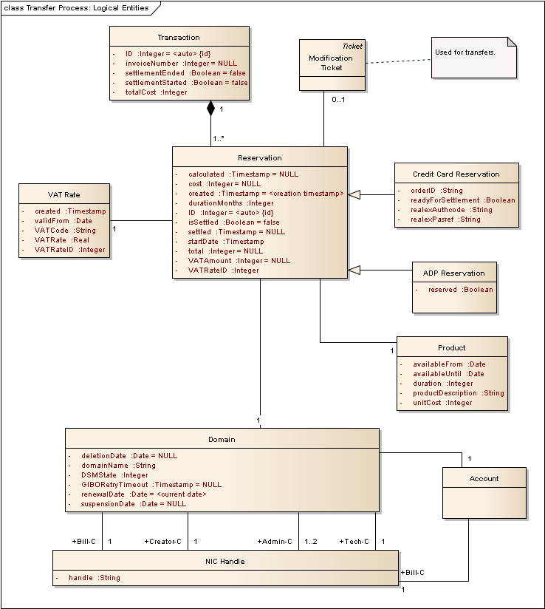
Figure 4 : Transfer Process: Logical Entities

Business Entity Logical Model::Account
public Class:

Custom Properties

Business Entity Logical Model::ADP Reservation
public Class
Extends: Reservation. :
A reservation made against a deposit account.

Custom Properties

Business Entity Logical Model::ADP Reservation Attributes
Attribute | Type | Notes
reserved | private :  Boolean | False if the reservation is not ready to be settled, and has no impact on available ADP balance. If true, and not yet settled, then it is ready to be settled and will have an impact on available balance until that time.

Business Entity Logical Model::Credit Card Reservation
public Class
Extends: Reservation. :
A reservation made using a credit card.

Custom Properties

Business Entity Logical Model::Credit Card Reservation Attributes
Attribute | Type | Notes
orderID | private :  String | See RealEx API documentation.Max. length 40.
readyForSettlement | private :  Boolean | If true, and not yet settled, then this is ready to be included in the next invoice run for settlement.
realexAuthcode | private :  String | See RealEx API documentation.Max. length 10.
realexPasref | private :  String | See RealEx API documentation.Max. length 50.

Business Entity Logical Model::Domain
public Class:
A .ie domain.

Custom Properties

Business Entity Logical Model::Domain Attributes
Attribute | Type | Notes
deletionDate | private :  Date | Initial Value: NULL;
domainName | private :  String
DSMState | private :  Integer | The DSM state of the domain.
GIBORetryTimeout | private :  Timestamp | The timestamp when a financially-failed GIBO registered domain's retry period expires.  Initial Value: NULL;
renewalDate | private :  Date | The renewal date.  Initial Value: <current date>;
suspensionDate | private :  Date | Initial Value: NULL;

Business Entity Logical Model::Modification Ticket
public Class
Extends: Ticket. :

Custom Properties

Business Entity Logical Model::NIC Handle
public Class:

Custom Properties

Business Entity Logical Model::NIC Handle Attributes
Attribute | Type | Notes
handle | private :  String

Business Entity Logical Model::Product
public Class:
A product that customers can purchase (e.g., 1 year domain registration, 2-year domain registration etc.)

Custom Properties

Business Entity Logical Model::Product Attributes
Attribute | Type | Notes
availableFrom | private :  Date | The date that the product becomes available. The product is available to customers from and including this date.
availableUntil | private :  Date | The last date that the product is available. The product is available for purchase until and inclusive of this date.
duration | private :  Integer | Number of years of domain registration for the product.
productDescription | private :  String | Description of the product.
unitCost | private :  Integer | The cost of the product, ex. VAT.

Business Entity Logical Model::Reservation
public Class:
An entity that maintains all necessary information regarding a reservation for a transaction.

Custom Properties

Business Entity Logical Model::Reservation Attributes
Attribute | Type | Notes
calculated | private :  Timestamp | The timestamp at which the vatAmount and total attributes are calculated, based on the cost (derived from the associated product) and the vatRate. This must only occur once in the lifetime of the entity.  Initial Value: NULL;
cost | private :  Integer | The base cost of the reservation, ex VAT, derived from the associated product cost.  Initial Value: NULL;
created | private :  Timestamp | The initial creation timestamp of the reservation.  Initial Value: <creation timestamp>;
durationMonths | private :  Integer | The number of months to roll the renewal date of the domain forward by when the reservation is settled.
ID | private :  Integer | A globally unique ID for the reservation.  Initial Value: <auto>;
isSettled | private :  Boolean | True if the reservation has been settled, false otherwise.  Initial Value: false;
settled | private :  Timestamp | The date and time at which the reservation was settled.  Initial Value: NULL;
startDate | private :  Timestamp | This is the date and time that marks the beginning of the period of time from which the customer derives value for the transaction. Used for revenue recognition accounting purposes.
total | private :  Integer | The total cost inclusive of any applicable VAT.  Initial Value: NULL;
VATAmount | private :  Integer | The amount of applicable VAT.  Initial Value: NULL;
VATRateID | private :  Integer | The ID of the VAT Rate used to perform the calculation of VAT Amount.

Business Entity Logical Model::Transaction
public Class:
Represents a single payment transaction by a customer.

Custom Properties

Business Entity Logical Model::Transaction Attributes
Attribute | Type | Notes
ID | private :  Integer | UID for the transaction.  Initial Value: <auto>;
invoiceNumber | private :  Integer | References the associated invoice on which it appears.  Initial Value: NULL;
settlementEnded | private :  Boolean | This is a flag set when all actions associated with successfully settling the transaction have completed.  Initial Value: false;
settlementStarted | private :  Boolean | A flag set to indicate that settlement of the transaction was started. This is to allow for detection of failed transaction settlement.  Initial Value: false;
totalCost | private :  Integer | The total cost, inclusive of VAT, of all the associated reservations.

Business Entity Logical Model::VAT Rate
public Class:
This represents the valid VAT rate for a particular VAT rate code starting from a particular date in time. It is valid unless and until it is superceded by a VAT rate for the same code at a future point in time.

Custom Properties

Business Entity Logical Model::VAT Rate Attributes
Attribute | Type | Notes
created | private :  Timestamp | The timestamp when the VAT Rate entity was created. This is for data integrity validation. VAT Rates should never be updated or deleted. Only inserted.
validFrom | private :  Date | The date that the VAT rate for the VAT code comes into effect.
VATCode | private :  String | Alphabetic code for the VAT Rate.
VATRate | private :  Real | The VAT rate itself (e.g., 0.23).
VATRateID | private :  Integer | A unique ID for each VAT Rate. This is required to be referenced by other entities for data integrity validation.

Transfer Process: DSM Aspects

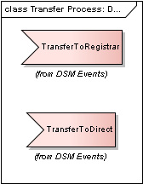
Figure 5 : Transfer Process: DSM Events

TransferToDirect
public Event:
Triggered when a domain is transferred to a direct registrant. It will result in the domain's customer type being updated if necessary.

TransferToRegistrar
public Event:
Triggered when a domain is transferred to a registrar. It will result in the domain's customer type being updated if necessary.

Transfer Process: Open Issues

ISSUE#0015: Should a ticketing system (not the status quo) for transfers be used? Can current modification tickets be used?
«Open Issue» Issue:

ISSUE#0017: Given that the existing API mechanism has never been used to initiate transfers, and the NRC must be altered for this anyway, should we restrict transfer requests to the NRC channel to minimise API impact?
«Open Issue» Issue:

ISSUE#0018: Should AUTH codes be in scope, given high volume of transfer tickets / month?
«Functional» Issue:

ISSUE#0026: What is the volume of billing transfer requests?
«Open Issue» Issue:

ISSUE#0027: How will bulk transfers be handled?
«Open Issue» Issue:

ISSUE#0028: Do holder transfers that do not involve a billing tranfer need to be within BPR scope? Do they affect DSM?
«Open Issue» Issue:

