WYSZUKIWANIE.
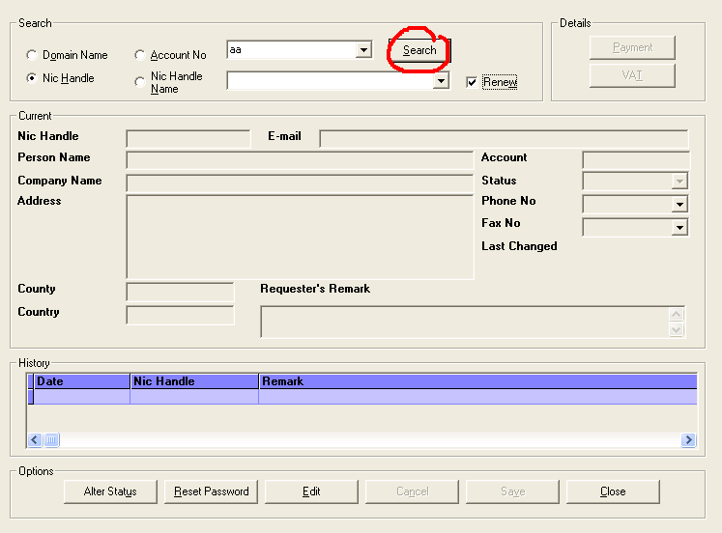
SELECT * FROM NicHandle WHERE Nic_Handle like "aa%"AND NH_Status ="Renew"
SELECT * FROM NicHandle WHERE Nic_Handle = "AAA133-IEDR"
SELECT DATE_FORMAT(Chng_Dt,'%d-%m-%Y') AS 'Date', Chng_NH AS 'Nic Handle', NH_Remark As 'Remark', Chng_Dt as 'TimeStamp' FROM NicHandleHist WHERE Nic_Handle = "AAA133-IEDR"ORDER BY Chng_Dt DESC
SELECT DISTINCT NicHandle.Nic_Handle, NicHandle.NH_Name, NicHandle.A_Number, NicHandle.Co_Name, NicHandle.NH_Address, NicHandle.NH_County, NicHandle.NH_Country, NicHandle.NH_Status, NicHandle.NH_Email, NicHandle.NH_Remark, NicHandle.NH_Status, NicHandle.NH_Status_Dt FROM NicHandle Where Nic_Handle ="AAA133-IEDR"
SELECT * From Telecom WHERE Nic_Handle= "AAA133-IEDR"

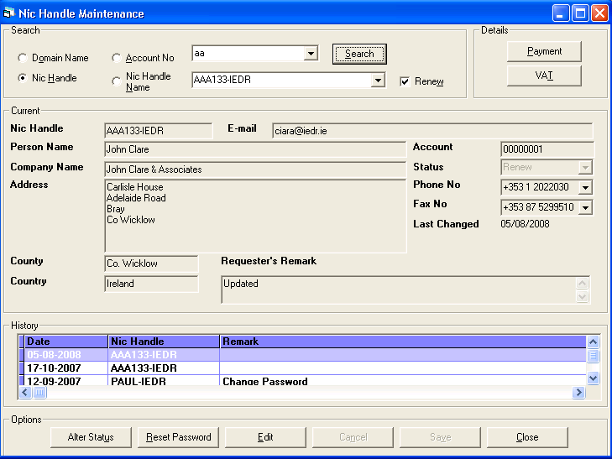

Pole Phoenixa | Kolumna w DB | Wartosc
Nic Handle | NicHandle.Nic_Handle | AAA133-IEDR
Person Name | NicHandle.NH_Name | John Clare
Account | NicHandle.A_Number | 00000001
Company Name | NicHandle.Co_Name | John Clare & Associates
Address | NicHandle.NH_Address | Carlisle House  Adelaide Road  Bray  Co Wicklow
County | NicHandle.NH_County | Co. Wicklow
Country | NicHandle.NH_Country | Ireland
Status | NicHandle.NH_Status | Renew
E-mail | NicHandle.NH_Email | ciara@iedr.ie
Requester’s Remark | NicHandle.NH_Remark | Updated
Last Changed | NicHandle.NH_Status_Dt | 2008-08-05
Phone No | Telecom.Phone (Telecom.Type=’P’) | +353 1 2022030
Fax No | Telecom.Phone (Telecom.Type=’F’) | +353 87 5299510

WYSZUKIWANIE PO:
Nic Handle | SELECT * FROM NicHandle WHERE Nic_Handle like "aa%"
Nic Handle & Renew | SELECT * FROM NicHandle WHERE Nic_Handle like "aa%"AND NH_Status ="Renew"
Domain Name | SELECT DISTINCT Contact_NH FROM Contact WHERE D_Name like "aa%"ORDER BY Contact_NH
Domain Name & Renew | SELECT DISTINCT Contact.Contact_NH, Contact.D_Name, NicHandle.NH_Status, NicHandle.Nic_Handle FROM Contact INNER JOIN NicHandle ON Contact.Contact_NH = NicHandle.Nic_Handle WHERE D_Name like "aa%"AND NH_Status ="Renew" ORDER BY Contact_NH
Account No | SELECT * FROM NicHandle WHERE A_Number = 1 ORDER BY Nic_Handle
Account No & Renew | SELECT * FROM NicHandle WHERE A_Number = 1 AND NH_Status ="Renew" ORDER BY Nic_Handle
Nic Handle Name | SELECT * FROM NicHandle WHERE NH_Name like "%aa%"
Nic Handle Name & Renew | SELECT * FROM NicHandle WHERE NH_Name like "%aa%"AND NH_Status ="Renew"

