Process -> Domains
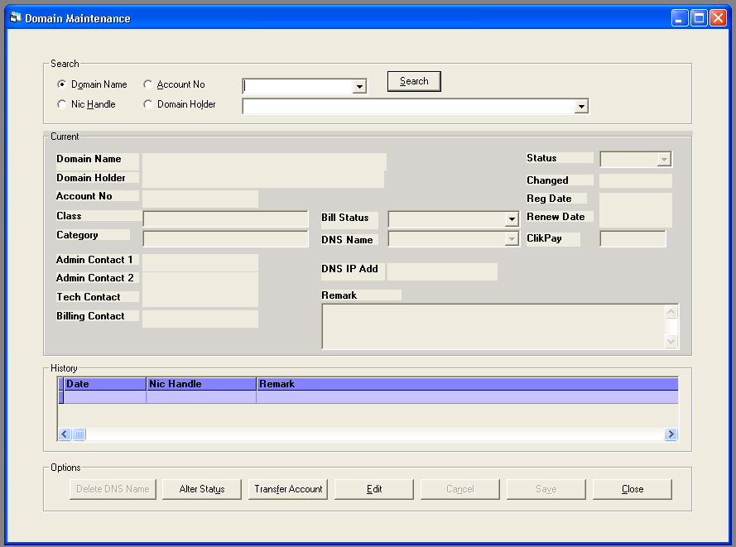

SELECT Description FROM BillStatus
SELECT Status, Description, DetailedDescription, Colour FROM BillStatus
SELECT Description FROM ClikPaid

Domain Maintenance -> Search -> Account No = 1
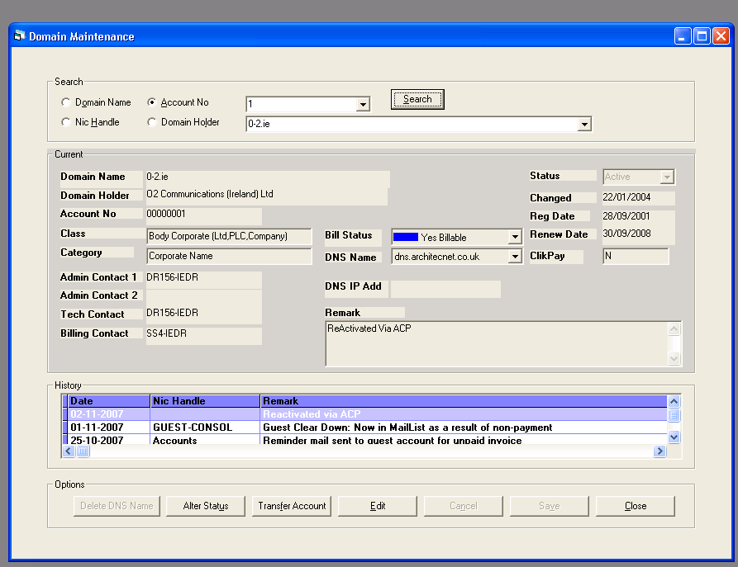
SELECT * FROM Domain
WHERE A_Number = 1 ORDER BY D_Name

SELECT * FROM Ticket
WHERE D_Name like "0-2.ie"ORDER BY D_Name

Select * From Domain
where D_Name = "0-2.ie"

SELECT DATE_FORMAT(Chng_Dt,'%d-%m-%Y') AS 'Date', Chng_NH AS 'Nic Handle', D_Remark As ' Remark', Chng_Dt
FROM DomainHist
WHERE D_Name = "0-2.ie"ORDER BY Chng_Dt DESC

SELECT
Domain.D_Name, Domain.D_Holder, Domain.D_Class, Domain.D_Category, Domain.A_Number, Domain.D_Bill_Status, Domain.D_VAT_Status, Domain.D_ClikPaid, Domain.D_Status, Domain.D_Status_Dt, Domain.D_Reg_Dt, Domain.D_Ren_Dt, Domain.D_Remark, DNS.DNS_Name, DNS.DNS_IpAddr,DNS.DNS_Order FROM DNS INNER JOIN Domain ON Domain.D_Name =DNS.D_Name
WHERE Domain.D_Name = "0-2.ie"

Select * From Domain
where D_Name = "0-2.ie"

SELECT DNS_Name,DNS_Order FROM DNS
WHERE D_Name="0-2.ie" ORDER BY DNS_Order

SELECT DNS_IpAddr,DNS_Name,DNS_Order FROM DNS
WHERE D_Name="0-2.ie" AND DNS_Name
="dns.architecnet.co.uk"

SELECT Contact_NH, Type FROM Contact
WHERE D_Name ="0-2.ie"

SELECT NH_Name FROM NicHandle
WHERE Nic_Handle="DR156-IEDR"

SELECT NH_Name FROM NicHandle
WHERE Nic_Handle="DR156-IEDR"

SELECT NH_Name FROM NicHandle
WHERE Nic_Handle="SS4-IEDR"

SELECT DNS_Name, DNS_IpAddr FROM DNS
WHERE D_Name = "0-2.ie" ORDER BY DNS_Order

select D_Name from D_Locked
where D_Name = "0-2.ie"

Select NH_BillC_Ind FROM NicHandle
WHERE A_Number = 00000001

Transfer Account
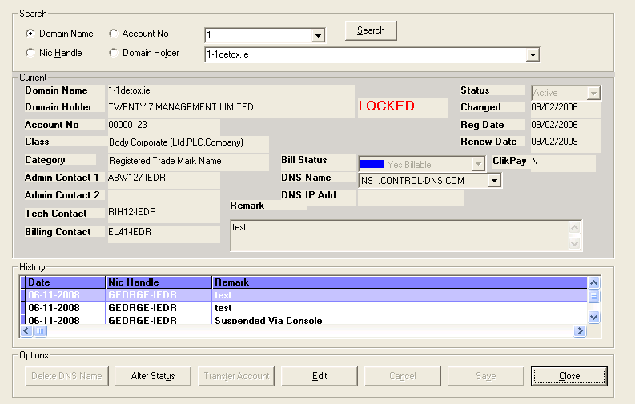
SELECT A_Number, Billing_NH FROM Account WHERE A_Number=123 AND A_Status= "Active"

SELECT Nic_Handle FROM NicHandle WHERE Nic_Handle="ABW127-IEDR"

SELECT Nic_Handle FROM NicHandle WHERE Nic_Handle="RIH12-IEDR"

INSERT INTO
DomainHist(D_Name, D_Holder, D_Class, D_Category, A_Number, D_Status, D_Status_Dt, D_Reg_Dt, D_Ren_Dt, D_TStamp, D_Discount, D_Bill_Status, D_Vat_Status, D_Remark, D_ClikPaid, Chng_NH, Chng_Dt) SELECT DISTINCT D_Name, D_Holder, D_Class, D_Category, A_Number, D_Status, D_Status_Dt, D_Reg_Dt, D_Ren_Dt, D_TStamp, D_Discount,D_Bill_Status, D_Vat_Status, D_Remark, D_ClikPaid, "GEORGE-IEDR", '2008-11-06 07:57:05'
FROM Domain WHERE D_Name ='1-1detox.ie'

INSERT INTO
DNSHist(D_Name, DNS_Name, DNS_IpAddr, DNS_Order, Chng_NH, Chng_Dt) SELECT DISTINCT D_Name, DNS_Name, DNS_IpAddr, DNS_Order, "GEORGE-IEDR", '2008-11-06 07:57:05'
FROM DNS WHERE D_Name = "1-1detox.ie" AND DNS_NAME = "NS1.CONTROL-DNS.COM"

INSERT INTO
DNSHist(D_Name, DNS_Name, DNS_IpAddr, DNS_Order, Chng_NH, Chng_Dt) SELECT DISTINCT D_Name, DNS_Name, DNS_IpAddr, DNS_Order, "GEORGE-IEDR", '2008-11-06 07:57:05'
FROM DNS WHERE D_Name = "1-1detox.ie" AND DNS_NAME = "NS2.CONTROL-DNS.COM"

INSERT INTO
DNSHist(D_Name, DNS_Name, DNS_IpAddr, DNS_Order, Chng_NH, Chng_Dt) SELECT DISTINCT D_Name, DNS_Name, DNS_IpAddr, DNS_Order, "GEORGE-IEDR", '2008-11-06 07:57:05'
FROM DNS WHERE D_Name = "1-1detox.ie" AND DNS_NAME = ""

INSERT INTO
ContactHist(D_Name, Contact_NH, Type, Chng_NH, Chng_Dt) SELECT DISTINCT D_Name, "ABW127-IEDR", "A","GEORGE-IEDR", '2008-11-06 07:57:05'
FROM Contact WHERE D_Name ='1-1detox.ie'

INSERT INTO
ContactHist(D_Name, Contact_NH, Type, Chng_NH, Chng_Dt) SELECT DISTINCT D_Name, "RIH12-IEDR", "T","GEORGE-IEDR", '2008-11-06 07:57:05'
FROM Contact WHERE D_Name ='1-1detox.ie'

INSERT INTO
ContactHist(D_Name, Contact_NH, Type, Chng_NH, Chng_Dt) SELECT DISTINCT D_Name, "", "A","GEORGE-IEDR", '2008-11-06 07:57:05'
FROM Contact WHERE D_Name ='1-1detox.ie'

INSERT INTO
ContactHist(D_Name, Contact_NH, Type, Chng_NH, Chng_Dt) SELECT DISTINCT D_Name, "NTG1-IEDR", "B","GEORGE-IEDR", '2008-11-06 07:57:05'
FROM Contact WHERE D_Name ='1-1detox.ie'

insert into Transfers values("1-1detox.ie",'2008-11-06',"NTG1-IEDR","EL41-IEDR")

replace into D_Locked values("1-1detox.ie", 'Xfer', '20081106075705')

UPDATE
Domain SET A_Number=123, D_Vat_Status="", D_Remark="test" WHERE D_Name="1-1detox.ie" AND D_TStamp = '20081106073949'

UPDATE
Contact SET Contact_NH="EL41-IEDR" Where D_name="1-1detox.ie" AND type="B"

UPDATE
NicHandle SET A_Number="123", NH_Remark="test" WHERE Nic_Handle="ABW127-IEDR"

INSERT INTO
NicHandleHist(Nic_Handle, NH_Name, A_Number, Co_Name, NH_Address, NH_County, NH_Country, NH_Email, NH_Status, NH_Status_Dt, NH_Reg_Dt, NH_TStamp, NH_BillC_Ind, NH_Remark, Chng_NH, Chng_Dt) SELECT DISTINCT Nic_Handle, NH_Name, A_Number, Co_Name, NH_Address, NH_County, NH_Country, NH_Email, NH_Status, NH_Status_Dt, NH_Reg_Dt,NH_TStamp, NH_BillC_Ind, NH_Remark, "GEORGE-IEDR", NOW()
FROM NicHandle WHERE Nic_Handle ='EL41-IEDR'

SELECT Type FROM Contact WHERE D_Name="1-1detox.ie" AND Type= "C"

UPDATE Contact SET Contact_NH="EL41-IEDR" Where D_name="1-1detox.ie" AND Type="C"
151 Query SELECT * from Email WHERE E_Name = 'transferBill'
151 Query SELECT NH_Email FROM NicHandle WHERE Nic_Handle="ABW127-IEDR"
151 Query SELECT NH_Email FROM NicHandle WHERE Nic_Handle=""
151 Query SELECT NH_Email FROM NicHandle WHERE Nic_Handle="EL41-IEDR"
151 Query SELECT NH_Email FROM NicHandle WHERE Nic_Handle="NTG1-IEDR"
151 Query SELECT NH_Email FROM NicHandle WHERE Nic_Handle="RIH12-IEDR"
151 Query SELECT SMTP FROM StaticTableName
151 Query SELECT SMTP_Port FROM StaticTableName
151 Query COMMIT
151 Query Select * From Domain where D_Name = "1-1detox.ie"
151 Query SELECT DATE_FORMAT(Chng_Dt,'%d-%m-%Y') AS 'Date', Chng_NH AS 'Nic Handle', D_Remark As 'Remark', Chng_Dt FROM DomainHist WHERE D_Name = "1-1detox.ie"ORDER BY Chng_Dt DESC
151 Query SELECT Domain.D_Name, Domain.D_Holder, Domain.D_Class, Domain.D_Category, Domain.A_Number, Domain.D_Bill_Status, Domain.D_VAT_Status, Domain.D_ClikPaid, Domain.D_Status, Domain.D_Status_Dt, Domain.D_Reg_Dt, Domain.D_Ren_Dt, Domain.D_Remark, DNS.DNS_Name, DNS.DNS_IpAddr,DNS.DNS_Order FROM DNS INNER JOIN Domain ON Domain.D_Name =DNS.D_Name WHERE Domain.D_Name = "1-1detox.ie"
151 Query Select * From Domain where D_Name = "1-1detox.ie"
151 Query SELECT DNS_Name,DNS_Order FROM DNS WHERE D_Name="1-1detox.ie" ORDER BY DNS_Order
151 Query SELECT DNS_IpAddr,DNS_Name,DNS_Order FROM DNS WHERE D_Name="1-1detox.ie" AND DNS_Name ="NS1.CONTROL-DNS.COM"
151 Query SELECT Contact_NH, Type FROM Contact WHERE D_Name ="1-1detox.ie"
151 Query SELECT NH_Name FROM NicHandle WHERE Nic_Handle="ABW127-IEDR"
151 Query SELECT NH_Name FROM NicHandle WHERE Nic_Handle="EL41-IEDR"
151 Query SELECT NH_Name FROM NicHandle WHERE Nic_Handle="RIH12-IEDR"
151 Query SELECT DNS_Name, DNS_IpAddr FROM DNS WHERE D_Name = "1-1detox.ie" ORDER BY DNS_Order
151 Query select D_Name from D_Locked where D_Name = "1-1detox.ie"
151 Query select D_Name from D_Locked where D_Name = "1-1detox.ie"

Delete DNS Name
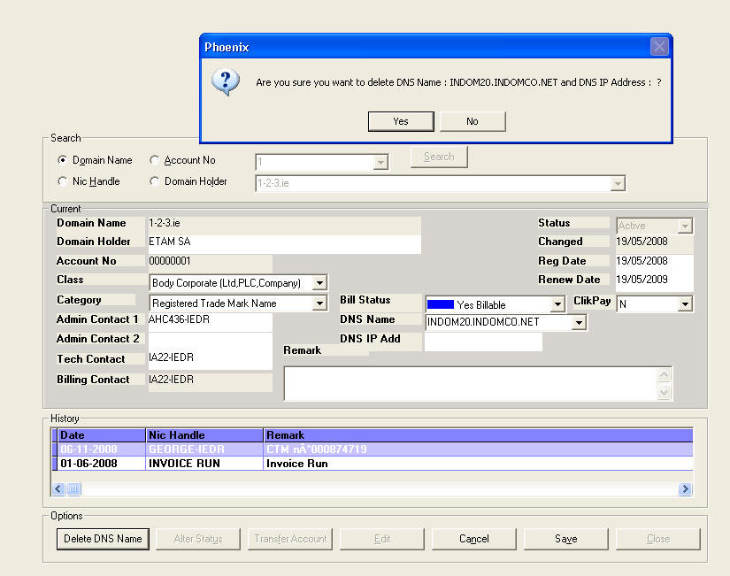
SELECT Nic_Handle FROM NicHandle WHERE Nic_Handle="AHC436-IEDR"
151 Query SELECT Nic_Handle FROM NicHandle WHERE Nic_Handle="IA22-IEDR"
151 Query ROLLBACK
081106 8:16:30 151 Query BEGIN
151 Query SELECT Nic_Handle FROM NicHandle WHERE Nic_Handle="AHC436-IEDR"
151 Query SELECT Nic_Handle FROM NicHandle WHERE Nic_Handle="IA22-IEDR"
151 Query INSERT INTO DomainHist(D_Name, D_Holder, D_Class, D_Category, A_Number, D_Status, D_Status_Dt, D_Reg_Dt, D_Ren_Dt, D_TStamp, D_Discount, D_Bill_Status, D_Vat_Status, D_Remark, D_ClikPaid, Chng_NH, Chng_Dt) SELECT DISTINCT D_Name, D_Holder, D_Class, D_Category, A_Number, D_Status, D_Status_Dt, D_Reg_Dt, D_Ren_Dt, D_TStamp, D_Discount,D_Bill_Status, D_Vat_Status, D_Remark, D_ClikPaid, "GEORGE-IEDR", '2008-11-06 08:16:06' FROM Domain WHERE D_Name ='1-2-3.ie'
151 Query INSERT INTO DNSHist(D_Name, DNS_Name, DNS_IpAddr, DNS_Order, Chng_NH, Chng_Dt) SELECT DISTINCT D_Name, DNS_Name, DNS_IpAddr, DNS_Order, "GEORGE-IEDR", '2008-11-06 08:16:06' FROM DNS WHERE D_Name = "1-2-3.ie" AND DNS_NAME = "INDOM10.INDOMCO.COM"
151 Query INSERT INTO DNSHist(D_Name, DNS_Name, DNS_IpAddr, DNS_Order, Chng_NH, Chng_Dt) SELECT DISTINCT D_Name, DNS_Name, DNS_IpAddr, DNS_Order, "GEORGE-IEDR", '2008-11-06 08:16:06' FROM DNS WHERE D_Name = "1-2-3.ie" AND DNS_NAME = "INDOM20.INDOMCO.NET"
151 Query INSERT INTO DNSHist(D_Name, DNS_Name, DNS_IpAddr, DNS_Order, Chng_NH, Chng_Dt) SELECT DISTINCT D_Name, DNS_Name, DNS_IpAddr, DNS_Order, "GEORGE-IEDR", '2008-11-06 08:16:06' FROM DNS WHERE D_Name = "1-2-3.ie" AND DNS_NAME = "INDOM30.INDOMCO.FR"
151 Query INSERT INTO DNSHist(D_Name, DNS_Name, DNS_IpAddr, DNS_Order, Chng_NH, Chng_Dt) SELECT DISTINCT D_Name, DNS_Name, DNS_IpAddr, DNS_Order, "GEORGE-IEDR", '2008-11-06 08:16:06' FROM DNS WHERE D_Name = "1-2-3.ie" AND DNS_NAME = ""
151 Query INSERT INTO ContactHist(D_Name, Contact_NH, Type, Chng_NH, Chng_Dt) SELECT DISTINCT D_Name, "AHC436-IEDR", "A","GEORGE-IEDR", '2008-11-06 08:16:06' FROM Contact WHERE D_Name ='1-2-3.ie'
151 Query INSERT INTO ContactHist(D_Name, Contact_NH, Type, Chng_NH, Chng_Dt) SELECT DISTINCT D_Name, "IA22-IEDR", "T","GEORGE-IEDR", '2008-11-06 08:16:06' FROM Contact WHERE D_Name ='1-2-3.ie'
151 Query INSERT INTO ContactHist(D_Name, Contact_NH, Type, Chng_NH, Chng_Dt) SELECT DISTINCT D_Name, "", "A","GEORGE-IEDR", '2008-11-06 08:16:06' FROM Contact WHERE D_Name ='1-2-3.ie'
151 Query INSERT INTO ContactHist(D_Name, Contact_NH, Type, Chng_NH, Chng_Dt) SELECT DISTINCT D_Name, "IA22-IEDR", "B","GEORGE-IEDR", '2008-11-06 08:16:06' FROM Contact WHERE D_Name ='1-2-3.ie'
151 Query UPDATE Domain SET D_Name="1-2-3.ie", D_Holder="ETAM SA", A_Number=00000001, D_Class="Body Corporate (Ltd,PLC,Company)" ,D_Category="Registered Trade Mark Name",D_Status="Active" , D_Reg_Dt='2008-05-19',D_Ren_Dt='2009-05-19',D_Bill_Status="Y" , D_Vat_Status="", D_Remark="test", D_ClikPaid="N" WHERE D_Name="1-2-3.ie"AND D_TStamp = '20080805120922'
151 Query DELETE FROM DNS WHERE DNS_Name="INDOM10.INDOMCO.COM" AND D_Name="1-2-3.ie"
151 Query DELETE FROM DNS WHERE DNS_Name="" AND D_Name="1-2-3.ie"
151 Query COMMIT
151 Query Select * From Domain where D_Name = "1-2-3.ie"
151 Query SELECT DATE_FORMAT(Chng_Dt,'%d-%m-%Y') AS 'Date', Chng_NH AS 'Nic Handle', D_Remark As 'Remark', Chng_Dt FROM DomainHist WHERE D_Name = "1-2-3.ie"ORDER BY Chng_Dt DESC
151 Query SELECT Domain.D_Name, Domain.D_Holder, Domain.D_Class, Domain.D_Category, Domain.A_Number, Domain.D_Bill_Status, Domain.D_VAT_Status, Domain.D_ClikPaid, Domain.D_Status, Domain.D_Status_Dt, Domain.D_Reg_Dt, Domain.D_Ren_Dt, Domain.D_Remark, DNS.DNS_Name, DNS.DNS_IpAddr,DNS.DNS_Order FROM DNS INNER JOIN Domain ON Domain.D_Name =DNS.D_Name WHERE Domain.D_Name = "1-2-3.ie"
151 Query Select * From Domain where D_Name = "1-2-3.ie"
151 Query SELECT DNS_Name,DNS_Order FROM DNS WHERE D_Name="1-2-3.ie" ORDER BY DNS_Order
151 Query SELECT DNS_IpAddr,DNS_Name,DNS_Order FROM DNSHist WHERE D_Name ="" AND DNS_Name ="INDOM20.INDOMCO.NET" AND Chng_Dt='2008-11-06 08:16:06'
151 Query SELECT Contact_NH, Type FROM Contact WHERE D_Name ="1-2-3.ie"
151 Query SELECT NH_Name FROM NicHandle WHERE Nic_Handle="AHC436-IEDR"
151 Query SELECT NH_Name FROM NicHandle WHERE Nic_Handle="IA22-IEDR"
151 Query SELECT NH_Name FROM NicHandle WHERE Nic_Handle="IA22-IEDR"
151 Query SELECT DNS_Name, DNS_IpAddr FROM DNS WHERE D_Name = "1-2-3.ie" ORDER BY DNS_Order
151 Query select D_Name from D_Locked where D_Name = "1-2-3.ie"
151 Query select D_Name from D_Locked where D_Name = "1-2-3.ie"

ERRORS
