TICKET EDITION
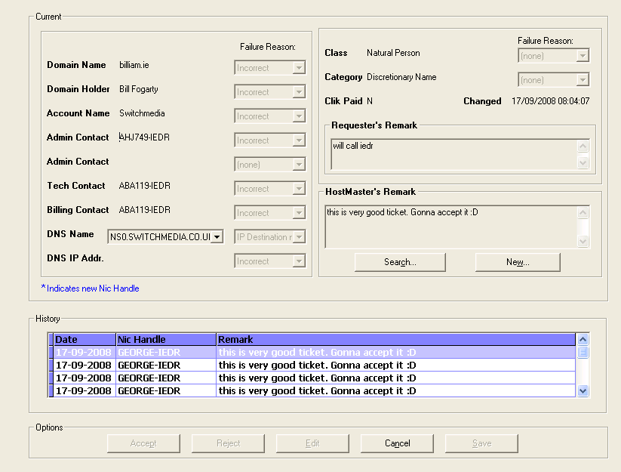

SELECT date FROM faxlog WHERE domain like "billiam.ie" AND date >= DATE_SUB(CURDATE(),INTERVAL 60 DAY)

USE phoenixdb

SELECT
T_Number, D_Name, DN_Fail_Cd, D_Holder, DH_Fail_Cd, A_Name, AC_Fail_Cd, Admin_NH1, NHA1.NH_Status AS nha1_Status,
ANH1_Fail_Cd, Admin_NH2, NHA2.NH_Status AS nha2_Status, ANH2_Fail_Cd, Tech_NH, NHT.NH_Status AS nht_Status,
TNH_Fail_Cd, Bill_NH, NHB.NH_Status AS nhb_Status, BNH_Fail_Cd, DNS_Name1, DNS1_Fail_Cd, DNS_IP1, DNSIP1_Fail_Cd,
DNS_Name2, DNS2_Fail_Cd, DNS_IP2, DNSIP2_Fail_Cd, DNS_Name3, DNS3_Fail_Cd, DNS_IP3, DNSIP3_Fail_Cd, T_Category,
T_Category_Fail_Cd, T_Class, T_Class_Fail_Cd, t_Reg_Dt, T_Remark, H_Remark, T_TStamp, Creator_NH, Admin_Status, T_ClikPaid
FROM
NicHandle AS NHA1, NicHandle AS NHT, NicHandle AS NHB, Account AS a, Ticket AS T LEFT JOIN NicHandle AS NHA2 ON
T.Admin_NH2=NHA2.Nic_Handle
WHERE
T.Admin_NH1=NHA1.Nic_Handle AND T.Tech_NH=NHT.Nic_Handle AND T.Bill_NH=NHB.Nic_Handle
AND a.A_Number=T.A_Number AND T_Number=256625

SELECT FailCd, Description FROM TicketFailCd WHERE Data_Field=10 ORDER BY FailCd ASC
SELECT FailCd, Description FROM TicketFailCd WHERE Data_Field=11 ORDER BY FailCd ASC
SELECT FailCd, Description FROM TicketFailCd WHERE Data_Field=12 ORDER BY FailCd ASC
SELECT FailCd, Description FROM TicketFailCd WHERE Data_Field=13 ORDER BY FailCd ASC
SELECT FailCd, Description FROM TicketFailCd WHERE Data_Field=14 ORDER BY FailCd ASC
SELECT FailCd, Description FROM TicketFailCd WHERE Data_Field=15 ORDER BY FailCd ASC
SELECT FailCd, Description FROM TicketFailCd WHERE Data_Field=16 ORDER BY FailCd ASC
SELECT FailCd, Description FROM TicketFailCd WHERE Data_Field=17 ORDER BY FailCd ASC
SELECT FailCd, Description FROM TicketFailCd WHERE Data_Field=18 ORDER BY FailCd ASC
SELECT FailCd, Description FROM TicketFailCd WHERE Data_Field=19 ORDER BY FailCd ASC
SELECT FailCd, Description FROM TicketFailCd WHERE Data_Field=20 ORDER BY FailCd ASC
SELECT Description FROM ClikPaid
SELECT NH_Name FROM NicHandle WHERE Nic_Handle="AHJ749-IEDR"
SELECT NH_Name FROM NicHandle WHERE Nic_Handle="ABA119-IEDR"
SELECT NH_Name FROM NicHandle WHERE Nic_Handle="ABA119-IEDR"

SELECT DATE_FORMAT(Chng_Dt,'%d-%m-%Y') AS 'Date',Chng_NH AS 'Nic Handle', H_Remark AS Remark, Chng_Dt
FROM TicketHist WHERE T_Number = 256625 ORDER BY Chng_Dt DESC

SELECT
d.D_Name, d.D_Holder, d.D_Category, d.D_Class, d.D_ClikPaid, a.A_Name, c1.Contact_NH as Admin_NH1,
c2.Contact_NH as Admin_NH2, c3.Contact_NH as Tech_NH, c4.Contact_NH as Bill_NH, n1.DNS_Name as DNS_Name1, n1.DNS_IpAddr as DNS_IP1,
n2.DNS_Name as DNS_Name2, n2.DNS_IpAddr as DNS_IP2, n3.DNS_Name as DNS_Name3, n3.DNS_IpAddr as DNS_IP3
FROM
Domain as d
LEFT JOIN Account AS a ON d.A_Number=a.A_Number LEFT JOIN Contact as c1 ON d.D_Name=c1.D_Name AND c1.Type='A'
LEFT JOIN Contact as c2 ON d.D_Name=c2.D_Name AND c2.Type='A' AND c1.Contact_NH<>c2.Contact_NH
LEFT JOIN Contact as c3 ON d.D_Name=c3.D_Name AND c3.Type='T' LEFT JOIN Contact as c4 ON d.D_Name=c4.D_Name AND c4.Type='B'
LEFT JOIN DNS as n1 ON d.D_Name=n1.D_Name AND n1.DNS_Order=1 LEFT JOIN DNS as n2 ON d.D_Name=n2.D_Name AND n2.DNS_Order=2
LEFT JOIN DNS as n3 ON d.D_Name=n3.D_Name AND n3.DNS_Order=3
WHERE
d.D_Name='billiam.ie' LIMIT 0,1

TICKETS

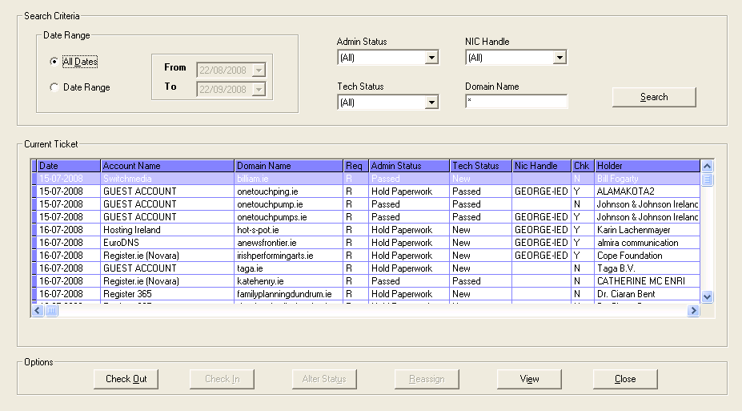

SELECT * FROM TicketAdminStatus ORDER BY Status ASC
SELECT * FROM TicketTechStatus ORDER BY Status ASC
SELECT Nic_Handle FROM Access WHERE (NH_Level & 176) > 0 ORDER BY Nic_Handle

SELECT
T_Number, DATE_FORMAT(T_Created_TS,'%Y%m%d') AS 'SortDate', DATE_FORMAT(T_Created_TS,'%d-%m-%Y') AS 'Date',
a.A_Name AS 'Account Name', D_Name AS 'Domain Name', T_Type AS 'Req', Admin_Status AS 'Admin Code', ax.Description AS 'Admin Status', Tech_Status AS 'Tech Code', ts.Description AS 'Tech Status', CheckedOutTo AS 'Nic Handle', CheckedOut AS 'Chk', D_Holder AS 'Holder'
FROM
TicketAdminStatus AS ax, TicketTechStatus AS ts, Ticket INNER JOIN Account AS a ON a.A_Number = Ticket.A_Number
WHERE
ts.Status = Tech_Status AND ax.Status = Admin_Status ORDER BY T_Created_TS

USE faxlog
SELECT date FROM faxlog WHERE domain like "billiam.ie" AND date >= DATE_SUB(CURDATE(),INTERVAL 60 DAY)
USE phoenixdb

TICKETHISTORY
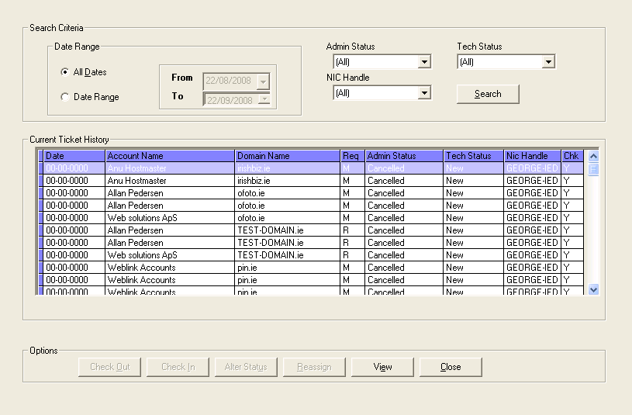

SELECT * FROM TicketAdminStatus ORDER BY Status ASC
SELECT * FROM TicketTechStatus ORDER BY Status ASC

SELECT Nic_Handle FROM Access WHERE (NH_Level & 176) > 0 ORDER BY Nic_Handle

SELECT
T_Number, DATE_FORMAT(T_Created_TS,'%Y%m%d') AS 'SortDate', DATE_FORMAT(T_Created_TS,'%d-%m-%Y') AS 'Date',
a.A_Name AS 'Account Name', D_Name AS 'Domain Name', T_Type AS 'Req', Admin_Status AS 'Admin Code',
ax.Description AS 'Admin Status', Tech_Status AS 'Tech Code', ts.Description AS 'Tech Status',
CheckedOutTo AS 'Nic Handle', CheckedOut AS 'Chk'
FROM
TicketAdminStatus AS ax, TicketTechStatus AS ts,
TicketHist INNER JOIN AccountHist AS a ON a.A_Number = TicketHist.A_Number
WHERE
ts.Status = Tech_Status AND
ax.Status = Admin_Status AND Admin_Status = 9 ORDER BY T_Created_TS

