Table of Contents
1 Home 2
1.1 Simple account summary and Links 2
2 Domain Management 3
2.1 Register domain(s) 4
2.1.1 Register Domain Result 5
2.2 Reports 6
2.2.1 All Domains 6
2.2.2 Newly Registered Domains 6
2.2.3 Search for Domain 7
2.2.3.1 Search with Full Domain Name 7
2.2.3.1.1 Edit DNS 7
2.2.3.2 Partial / select 8
2.2.3.2.1 Edit DNS 8
2.2.3.2.2 Enter MSD (-> confirm) 8
2.2.4 dns server search (A NAME) 8
2.2.5 bulk dns server update (for domain list) 9
2.2.6 NS records (all) 9
2.2.7 Conditionally Accepted Domains 9
2.2.8 Autorenewed Domains 10
2.2.9 Charity Domains 10
3 Contact Management 10
3.1 Admins 10
3.2 Techs 11
3.3 Contact name search 11
3.4 NIC search 11
4 Ticket Management 11
4.1 search (full domain) 12
4.2 view 12
4.3 modify 12
4.3.1 NIC Handle 12
4.3.1.1 view 13
4.3.1.2 search 13
4.3.1.3 new 13
4.3.1.4 edit 13
4.4 delete 14
5 Account Management 14
5.1 Renew and Pay 14
5.1.1 Reports 14
5.1.1.1 Current Renewals and New Reg's 15
5.1.1.1.1 CSV 15
5.1.1.2 Future Renewals - Pay now 15
5.1.1.2.1 CSV 15
5.1.1.3 Transfers - Pay Current Invoice 15
5.1.1.3.1 select 16
5.1.1.3.1.1 Pay online 16
5.1.1.3.1.2 Pay Offline 16
5.1.1.3.1.3 Pay from Deposit 16
5.1.1.3.1.4 Enter MSD process 16
5.1.1.3.1.4.1 Confirm 17
5.1.1.3.2 CSV 17
5.1.1.4 Transfers - Pay in Advance of Invoice 17
5.1.1.4.1 CSV 17
5.1.1.5 Domains with a renewal date 17
5.1.1.6 Modify or Remove Outstanding Payments 18
5.1.1.6.1 remove from batch 18
5.1.1.7 Top Up Deposit Account 18
5.2 Manage MSD 18
5.2.1 Mails / Suspensions / Deletions 18
5.2.1.1 CSV 19
5.2.1.2 The domains which are to be mailed, suspended or deleted 20
5.2.1.3 Domains Available for ReActivation With Payment - PIA 20
5.2.1.3.1 Reactivate 20
5.2.1.3.2 PayFromDeposit 20
5.2.1.3.2.1 cancel 20
5.2.1.3.2.2 continue 21
5.2.1.4 Domains Available for ReActivation Without Payment 21
5.2.1.4.1 Reactivate 21
5.2.2 Deletions over the last year 21
5.3 View Reports 21
5.3.1 Domains Transferred To $NIC over $X days 22
5.3.1.1 CSV 22
5.3.2 Domains Transferred From $NIC over $X days 22
5.3.2.1 CSV 23
5.3.3 Statement of Account - aged balance 23
5.4 View History 23
5.4.1 invoices 23
5.4.1.1 renewal invoice history (year/month) 23
5.4.1.1.1 csv 24
5.4.1.2 transfer invoice history (year/month) 24
5.4.1.2.1 csv 24
5.4.1.3 advance payment invoice history (year/month) 24
5.4.1.3.1 csv 24
5.4.2 payments 25
5.4.2.1 renewal payment history (year/month) 25
5.4.2.1.1 csv 25
5.4.2.2 transfer payment history (year/month) 25
5.4.2.2.1 csv 25
5.4.2.3 advance payment history (year/month) 26
5.4.2.3.1 csv 26
5.4.3 Historical Payment Search (domain) 26
5.4.4 credit notes 26
5.4.4.1 MSD Deletions 26
5.4.4.1.1 CSV 27
5.4.4.2 Transfers Away 27
5.4.4.2.1 CSV 27
5.4.4.3 On Invoices (year/month) 27
5.4.4.3.1 CSV 27
6 Mail List Settings 28
6.1 remove 28
6.2 add 28
7 Resources 29
7.1 Formalisation Drafts 29
7.1.1 Accept T & Cs 29
7.2 Policy Consultations 29
7.3 Policy Guidelines 29
7.4 IEDR Logos and usage guidelines 30
7.5 Statistics 30
7.6 IE API 31

Home

Simple account summary and Links
Text
Url | http://localhost/registrar_console/Console/pageCode/index.php
Description | After login, main menu page has a summary of account details, and links to static content
Screenshot | 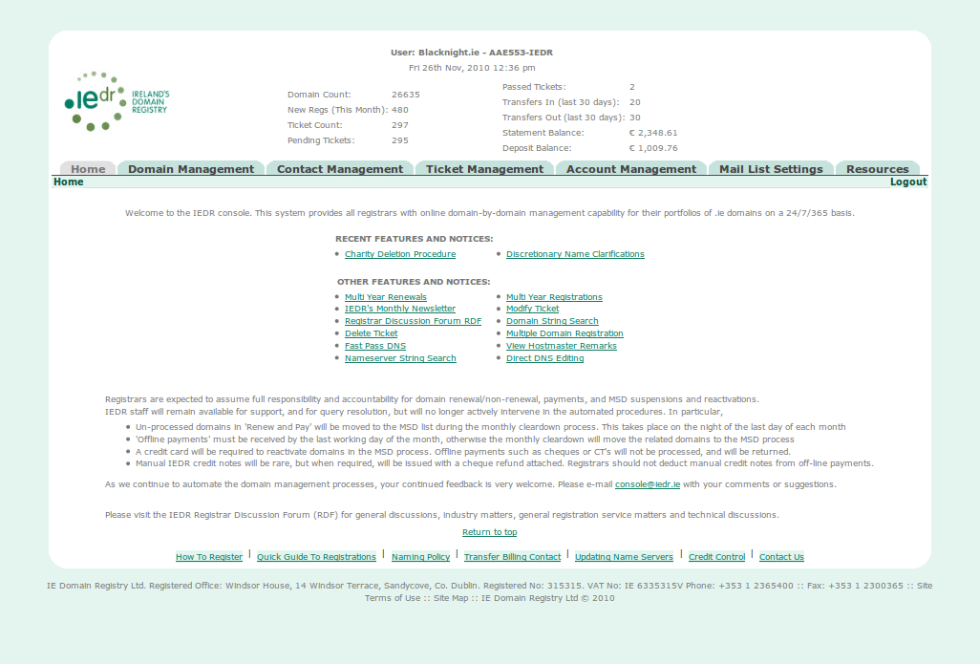
SQL | - Update StaticTable Set Next_Zone_Reload = '17:00:00'  - Select A_Number From Account Where Billing_NH = 'AAE553-IEDR'  - Select Count(D_Name) As DomCount From Domain Where A_Number = 237 And D_Status = 'Active'  - Select A_Name, NH_Email As Email From Account, NicHandle Where Account.A_Number = 237 And Billing_NH = Nic_Handle And A_Status = 'Active'  - Select Count(D_Name) As NewRegs From Domain Where A_Number = 237 And D_Reg_Dt Like DATE_FORMAT(NOW(), '%Y-%m-%')  - Select Count(D_Name) As D_Name From Ticket Where A_Number = 237  - Select Count(D_Name) As D_Name From Ticket Where A_Number = 237 And Tech_Status != 1  - Select Count(D_Name) As D_Name From Ticket Where A_Number = 237 And Admin_Status = 1 And Tech_Status = 1  - Select Case When Total_Bal = '0.00' Then '' Else Total_Bal End As Total_Bal FROM `Statement` Where Nic_Handle = 'AAE553-IEDR' Limit 2,1000  - Select Close_Bal From Deposit where Nic_Handle = 'AAE553-IEDR'  - SELECT Count(D_Name) As D_Name FROM Transfers Where New_Nic_Handle = 'AAE553-IEDR' And Tr_Date >= CURDATE() - INTERVAL 30 DAY  - Select Count(D_Name) As D_Name From Transfers Where Old_Nic_Handle = 'AAE553-IEDR' And Tr_Date >= CURDATE() - INTERVAL 30 DAY UNION Select Count(D_Name) As D_Name From TransfersHist Where Old_Nic_Handle = 'AAE553-IEDR' And Tr_Date >= CURDATE() - INTERVAL 30 DAY  - Select Count(D_Name) As D_Name From Transfers Where New_Nic_Handle = 'AAE553-IEDR' And Tr_Date >= CURDATE() - INTERVAL 30 DAY UNION Select Count(D_Name) As D_Name From TransfersHist Where New_Nic_Handle = 'AAE553-IEDR' And Tr_Date >= CURDATE() - INTERVAL 30 DAY  - Select Close_Bal FROM Deposit WHERE Nic_Handle = 'AAE553-IEDR' limit 1
Text

Domain Management
Text
Url | http://localhost/registrar_console/Console/pageCode/index.php?page=domains_reports
Description
Screenshot | 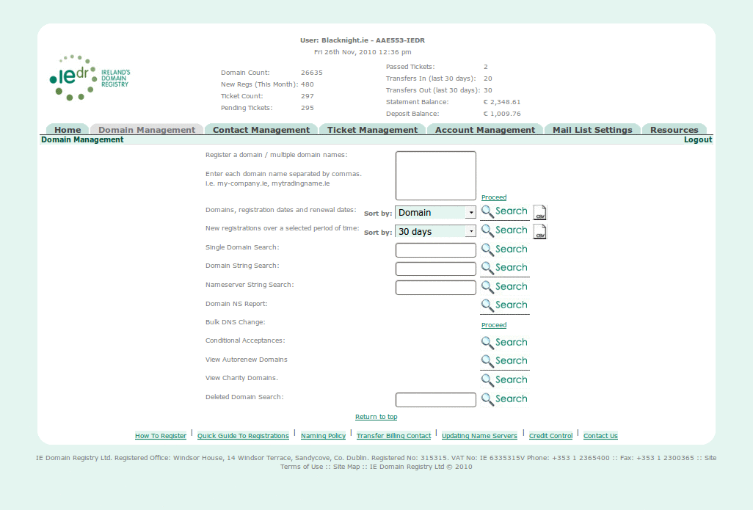
SQL | - Update StaticTable Set Next_Zone_Reload = '17:00:00';  - Select Close_Bal FROM Deposit WHERE Nic_Handle = 'AAE553-IEDR' limit 1;  - Select * From Reseller_Defaults Where Nic_Handle = 'AAE553-IEDR';  - Select VatRate, TradeRate, RetailRate From StaticTableName;  - Select NH_Level From Access Where Nic_Handle = 'AAE553-IEDR';  - Select Country From Account Where Billing_NH = 'AAE553-IEDR';  - Select * From Payment Where Billing_Contact = 'AAE553-IEDR';  - CREATE TEMPORARY TABLE ttable ( Domains varchar(66) NOT NULL DEFAULT '', PRIMARY KEY (Domains));  - SELECT name, id from Class;  - Select Class.name as Class,Category.name as Cat From Class, Category, Class_to_Category where Category.id = Class_to_Category.category_id AND Class.id = Class_to_Category.class_id and Class.id = 1;  - Select Class.name as Class,Category.name as Cat From Class, Category, Class_to_Category where Category.id = Class_to_Category.category_id AND Class.id = Class_to_Category.class_id and Class.id = 2;  - Select Class.name as Class,Category.name as Cat From Class, Category, Class_to_Category where Category.id = Class_to_Category.category_id AND Class.id = Class_to_Category.class_id and Class.id = 3;  - Select Class.name as Class,Category.name as Cat From Class, Category, Class_to_Category where Category.id = Class_to_Category.category_id AND Class.id = Class_to_Category.class_id and Class.id = 4;  - Select Class.name as Class,Category.name as Cat From Class, Category, Class_to_Category where Category.id = Class_to_Category.category_id AND Class.id = Class_to_Category.class_id and Class.id = 5;  - Select Class.name as Class,Category.name as Cat From Class, Category, Class_to_Category where Category.id = Class_to_Category.category_id AND Class.id = Class_to_Category.class_id and Class.id = 6;  - Select Class.name as Class,Category.name as Cat From Class, Category, Class_to_Category where Category.id = Class_to_Category.category_id AND Class.id = Class_to_Category.class_id and Class.id = 7;  - Select Class.name as Class,Category.name as Cat From Class, Category, Class_to_Category where Category.id = Class_to_Category.category_id AND Class.id = Class_to_Category.class_id and Class.id = 8;  - Select CASE WHEN Domain.D_Name != '' Then '<tr><td><font color=red>' When Ticket.D_Name != '' Then '<tr><td><font color=red>' When Ticket.D_Name IS NULL Then '<tr><td><input type=hidden name=dom[] value=' End As OpenHidden, CASE WHEN Domain.D_Name != '' Then '' When Ticket.D_Name != '' Then '' When Ticket.D_Name IS NULL Then ttable.Domains End As doms, CASE WHEN Domain.D_Name != '' Then '' When Ticket.D_Name != '' Then '' When Ticket.D_Name IS NULL Then '>' End As Bit, ttable.Domains As TheDoms, CASE WHEN Domain.D_Name != '' Then '</font></td>' When Ticket.D_Name != '' Then '</font></td>' When Ticket.D_Name IS NULL Then '</td>' End As CloseHidden, CASE WHEN Domain.D_Name != '' Then '<td>already registered</td></tr>' When Ticket.D_Name != '' Then '<td>application pending</td></tr>' When Ticket.D_Name IS NULL Then '<td> is available</td></tr>' End As Type, Case When Ticket.D_Name != '' Then 'yes' End As V From ttable LEFT JOIN Domain ON ttable.Domains=Domain.D_Name LEFT JOIN Ticket ON ttable.Domains=Ticket.D_Name Where ttable.Domains != '1';  - select P_Code, P_Duration, P_Price from Product Where P_Guest = 0 And P_Duration != '1' and CURDATE() BETWEEN P_Valid_From and P_Valid_To and P_Ren='1' ORDER By P_Duration;
Text

Register domain(s)
Text
Url | http://localhost/registrar_console/Console/pageCode/Process.php
Description
Screenshot | 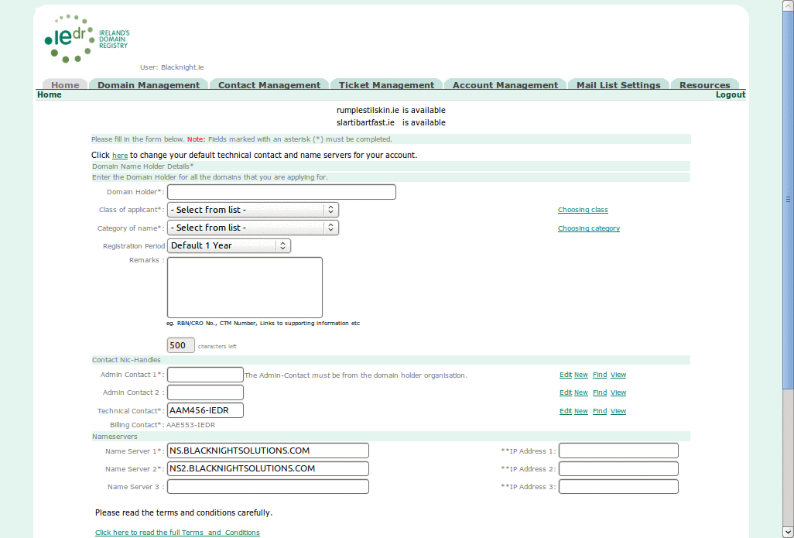
SQL | - Select * From Reseller_Defaults Where Nic_Handle = 'AAE553-IEDR';  - Select VatRate,TradeRate,RetailRate From StaticTableName;  - Select NH_Level From Access Where Nic_Handle = 'AAE553-IEDR';  - Select Country From Account Where Billing_NH = 'AAE553-IEDR';  - Select * From Payment Where Billing_Contact = 'AAE553-IEDR';  - CREATE TEMPORARY TABLE ttable ( Domains varchar(66) NOT NULL DEFAULT '',PRIMARY KEY (Domains));  - Insert Into ttable Values ('humperdink.ie'),('1');  - SELECT name,id from Class;  - Select Class.name as Class,Category.name as Cat From Class,Category,Class_to_Category where Category.id = Class_to_Category.category_id AND Class.id = Class_to_Category.class_id and Class.id = 1;  - Select Class.name as Class,Category.name as Cat From Class,Category,Class_to_Category where Category.id = Class_to_Category.category_id AND Class.id = Class_to_Category.class_id and Class.id = 2;  - Select Class.name as Class,Category.name as Cat From Class,Category,Class_to_Category where Category.id = Class_to_Category.category_id AND Class.id = Class_to_Category.class_id and Class.id = 3;  - Select Class.name as Class,Category.name as Cat From Class,Category,Class_to_Category where Category.id = Class_to_Category.category_id AND Class.id = Class_to_Category.class_id and Class.id = 4;  - Select Class.name as Class,Category.name as Cat From Class,Category,Class_to_Category where Category.id = Class_to_Category.category_id AND Class.id = Class_to_Category.class_id and Class.id = 5;  - Select Class.name as Class,Category.name as Cat From Class,Category,Class_to_Category where Category.id = Class_to_Category.category_id AND Class.id = Class_to_Category.class_id and Class.id = 6;  - Select Class.name as Class,Category.name as Cat From Class,Category,Class_to_Category where Category.id = Class_to_Category.category_id AND Class.id = Class_to_Category.class_id and Class.id = 7;  - Select Class.name as Class,Category.name as Cat From Class,Category,Class_to_Category where Category.id = Class_to_Category.category_id AND Class.id = Class_to_Category.class_id and Class.id = 8;  - Select CASE WHEN Domain.D_Name != '' Then '<tr><td><font color=red>' When Ticket.D_Name != '' Then '<tr><td><font color=red>' When Ticket.D_Name IS NULL Then '<tr><td><input type=hidden name=dom[] value=' End As OpenHidden, CASE WHEN Domain.D_Name != '' Then '' When Ticket.D_Name != '' Then '' When Ticket.D_Name IS NULL Then ttable.Domains End As doms, CASE WHEN Domain.D_Name != '' Then '' When Ticket.D_Name != '' Then '' When Ticket.D_Name IS NULL Then '>' End As Bit, ttable.Domains As TheDoms, CASE WHEN Domain.D_Name != '' Then '</font></td>' When Ticket.D_Name != '' Then '</font></td>' When Ticket.D_Name IS NULL Then '</td>' End As CloseHidden , CASE WHEN Domain.D_Name != '' Then '<td>already registered</td></tr>' When Ticket.D_Name != '' Then '<td>application pending</td></tr>' When Ticket.D_Name IS NULL Then '<td> is available</td></tr>' End As Type, Case When Ticket.D_Name != '' Then 'yes' End As V From ttable LEFT JOIN Domain ON ttable.Domains=Domain.D_Name LEFT JOIN Ticket ON ttable.Domains=Ticket.D_Name Where ttable.Domains != '1';  - select P_Code,P_Duration,P_Price from Product Where P_Guest = 0 And P_Duration != '1' and CURDATE() BETWEEN P_Valid_From and P_Valid_To and P_Ren='1' ORDER By P_Duration;
Text

Register Domain Result
Text
Url
Description
Screenshot | 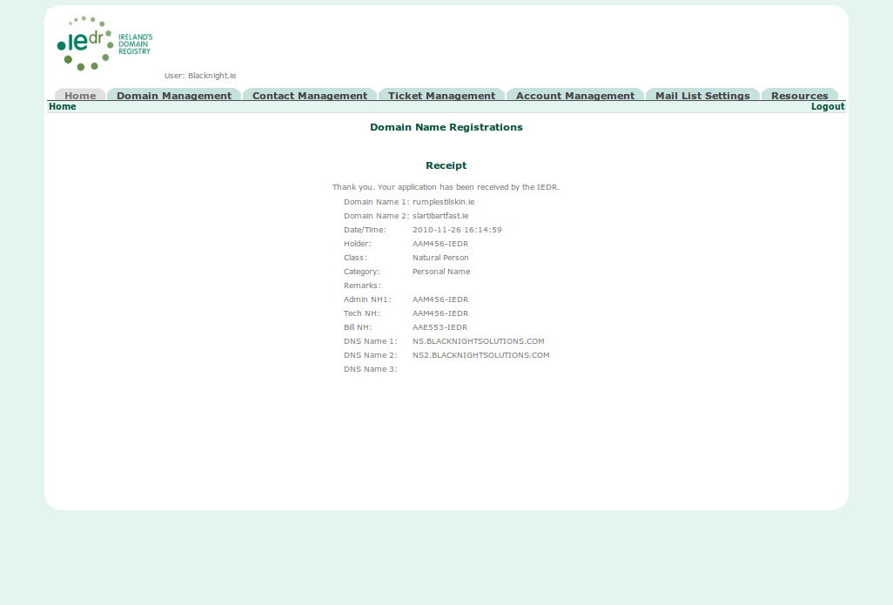
SQL | - Select D_Name from Ticket where D_Name = 'humperdink.ie'  - Select * From NicHandle Where Nic_Handle = 'AAM456-IEDR' And A_Number = 00000237  - Select * From NicHandle Where Nic_Handle = 'AAM456-IEDR' And A_Number = 00000237  - BEGIN  - Select NH_Level From Access Where Nic_Handle = 'AAE553-IEDR'  - BEGIN  - Select Country From Account Where Billing_NH = 'AAE553-IEDR'  - COMMIT  - BEGIN  - Select * From Payment Where Billing_Contact = 'AAE553-IEDR'  - COMMIT  - SET AUTOCOMMIT=0; BEGIN  - Insert Into PendingTicket Values (NULL, 'R', 'humperdink.ie', NULL, 'AAM456-IEDR', NULL, '00000237', NULL, 'Natural Person', 'Personal Name', 'AAM456-IEDR', 'AAM456-IEDR', NULL, '', NULL, 'AAM456-IEDR', NULL, 'AAE553-IEDR', NULL, 'AAE553-IEDR', 'NS.BLACKNIGHTSOLUTIONS.COM', NULL, '', NULL, 'NS2.BLACKNIGHTSOLUTIONS.COM', NULL, '', NULL, '', NULL, '', NULL, 0, '0000-00-00', 0, '0000-00-00', 'N', NULL, NULL, '2011-11-26', now(), NULL, NULL, NULL, now(), 'N', 'N', '', 'N' , '20101126173342-5330' , NULL, NULL, NULL, NULL, NULL, NULL, NULL, NULL, NULL, NULL, NULL), (NULL, 'R', '1', NULL, 'AAM456-IEDR', NULL, '00000237', NULL, 'Natural Person', 'Personal Name', 'AAM456-IEDR', 'AAM456-IEDR', NULL, '', NULL, 'AAM456-IEDR', NULL, 'AAE553-IEDR', NULL, 'AAE553-IEDR', 'NS.BLACKNIGHTSOLUTIONS.COM', NULL, '', NULL, 'NS2.BLACKNIGHTSOLUTIONS.COM', NULL, '', NULL, '', NULL, '', NULL, 0, '0000-00-00', 0, '0000-00-00', 'N', NULL, NULL, '2011-11-26', now(), NULL, NULL, NULL, now(), 'N', 'N', '', 'N' , '20101126173342-5330' , NULL, NULL, NULL, NULL, NULL, NULL, NULL, NULL, NULL, NULL, NULL)  - Delete From PendingTicket Where D_Name = '1'  - COMMIT  - Insert INTO StatsAccessLog (NicHandle,Access_TS,Report,Remote_IP) Values ('AAE553-IEDR',NOW(),'Domain Reg Form','127.0.0.1')  - LOCK IN SHARE MODE TABLES RECEIPTS WRITE; SET AUTOCOMMIT=0; BEGIN  - Insert Into Ticket Select NULL,T_Type,D_Name,DN_Fail_Cd,D_Holder,DH_Fail_Cd,A_Number,AC_Fail_Cd,T_Class,T_Category,T_Remark,Admin_NH1,ANH1_Fail_Cd,Admin_NH2,ANH2_Fail_Cd,Tech_NH,TNH_Fail_Cd,Bill_NH,BNH_Fail_Cd,Creator_NH,DNS_Name1,DNS1_Fail_Cd,DNS_IP1,DNSIP1_Fail_Cd,DNS_Name2,DNS2_Fail_Cd,DNS_IP2,DNSIP2_Fail_Cd,DNS_Name3,DNS3_Fail_Cd,DNS_IP3,DNSIP3_Fail_Cd,Admin_Status,Ad_StatusDt,Tech_Status,T_Status_Dt,CheckedOut,CheckedOutTo,T_Reg_Dt,T_Ren_Dt,T_TStamp,H_Remark,T_Class_Fail_Cd,T_Category_Fail_Cd,T_Created_TS,Opt_Cert,T_ClikPaid,Fee,VAT From PendingTicket Where Session_ID = '20101126173342-5330'  - COMMIT; UNLOCK TABLES  - LOCK IN SHARE MODE TABLES RECEIPTS WRITE; SET AUTOCOMMIT=0; BEGIN  - Delete From PendingTicket Where D_Name = '1'  - LOCK IN SHARE MODE TABLES RECEIPTS WRITE; SET AUTOCOMMIT=0; BEGIN  - Select D_Name From PendingTicket Where Session_ID = '20101126173342-5330'  - LOCK IN SHARE MODE TABLES RECEIPTS WRITE; SET AUTOCOMMIT=0; BEGIN  - Select Distinct D_Holder, T_Class, T_Category, Admin_NH1, Case When Admin_NH2 != '' Then '<tr><td class=value>Admin NH2: </td><td class=value>' End As Admin2Open, Admin_NH2, Tech_NH, Bill_NH, DNS_Name1, Case When DNS_IP1 != '' Then '<tr><td class=value>DNS IP1: </td<td class=value>' End As DNSIP1Open, DNS_IP1, DNS_Name2, Case When DNS_IP2 != '' Then '<tr><td class=value>DNS ip 2: </td><td class=value>' End As DNSIP2Open, DNS_IP2, DNS_Name3, Case When DNS_IP3 != '' Then '<tr><td class=value>DNS IP 3: </td><td class=value>' End As DNSIP3Open, DNS_IP3, Now() As Time, T_Remark From PendingTicket Where Session_ID = '20101126173342-5330'  - LOCK IN SHARE MODE TABLES RECEIPTS WRITE; SET AUTOCOMMIT=0; BEGIN  - Delete From PendingTicket Where Session_ID = '20101126173342-5330'  - COMMIT; UNLOCK TABLES  - Insert INTO StatsAccessLog (NicHandle,Access_TS,Report,Remote_IP) Values ('AAE553-IEDR',NOW(),'Domain(s) Registration','127.0.0.1')
Text

Reports

All Domains
Text
Url | http://localhost/registrar_console/Console/pageCode/index.php?sort=Domain&rpt=AllDoms&page=domains_reports
Description | List domains managed by the logged-in user
Screenshot | 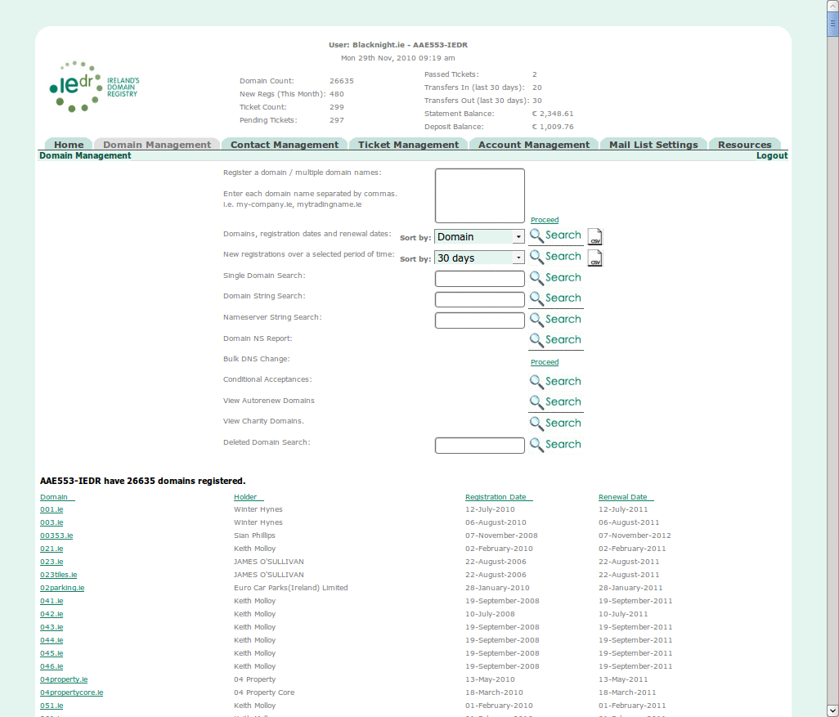
SQL | SELECT DISTINCT Domain.D_Name As Domain, D_Holder As Holder, DATE_FORMAT(D_Reg_Dt, '%d-%M-%Y') As Reg, DATE_FORMAT(D_Ren_Dt, '%d-%M-%Y') As Ren FROM Domain Where D_Status = 'Active' AND A_Number = '00000237' Order By Domain
Text

Newly Registered Domains
Text
Url | http://localhost/registrar_console/Console/pageCode/index.php?days=1&a=&rpt=RegRen&page=domains_reports
Description | Search for domains registered within the last N days
Screenshot | 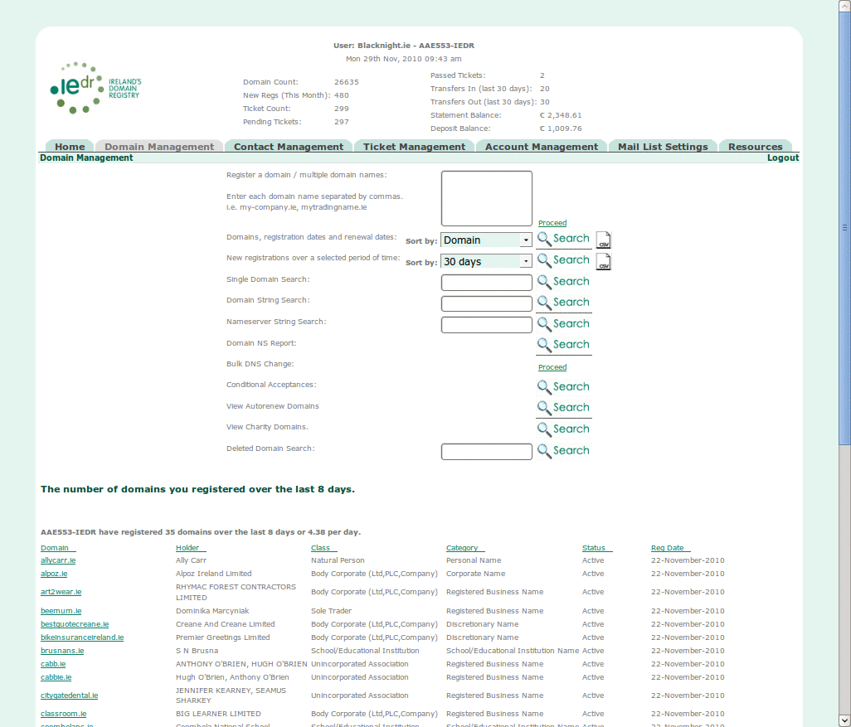
SQL | Select D_Name As Domain, D_Holder As Holder, D_Class As Class, D_Category As Cat, D_Status As Status, DATE_FORMAT(D_Reg_Dt, '%d-%M-%Y') As RegDt From Domain Where A_Number = 00000237 And D_Reg_Dt > CURDATE() - INTERVAL $X DAY And D_Reg_Dt < CURDATE()
Text

Search for Domain

Search with Full Domain Name
Text
Url | http://localhost/registrar_console/Console/pageCode/index.php?domSearch=example&rpt=Single&page=domains_reports&index.php.x=1&index.php.y=1&index.php=Search
Description
Screenshot
SQL
Text

Edit DNS
Text
Url | http://localhost/registrar_console/Console/pageCode/EditDNS.php
Description
Screenshot
SQL
Text

Partial / select
Text
Url | http://localhost/registrar_console/Console/pageCode/index.php?strSearch=example&x=1&y=1&rpt=strSearch&page=domains_reports
Description
Screenshot
SQL
Text

Edit DNS
Text
Url
Description
Screenshot
SQL
Text

Enter MSD (-> confirm)
Text
Url
Description
Screenshot
SQL
Text

dns server search (A NAME)
Text
Url | http://localhost/registrar_console/Console/pageCode/index.php?string=SEARCHPARAM&rpt=DNSString&page=nssearch&index.php.x=52&index.php.y=18&index.php=Search
Description | Search Nameserver entries (Domain.DNS_Name) for a given string
Screenshot | 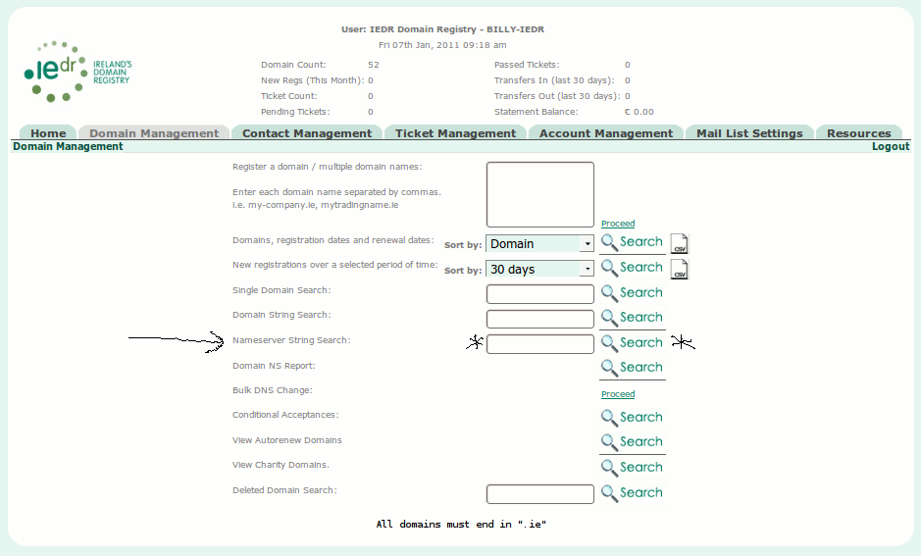  output:  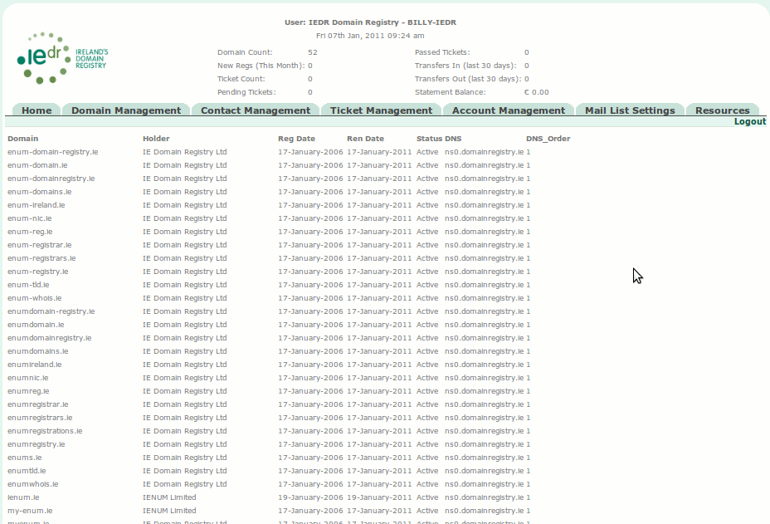
SQL | Select Domain.D_Name as Domain, D_Holder, DATE_FORMAT(D_Reg_Dt, '%d-%M-%Y') as D_Reg_Dt,DATE_FORMAT(D_Ren_Dt, '%d-%M-%Y') as D_Ren_Dt, D_Status, DNS_Name as DNS, DNS_Order as OrderNS from Domain, DNS where Domain.A_Number='' and Domain.D_Name=DNS.D_Name and DNS_Name like '%SEARCHPARAM%'

bulk dns server update (for domain list)
Text
Url
Description
Screenshot
SQL
Text

NS records (all)
Text
Url
Description
Screenshot
SQL
Text

Conditionally Accepted Domains
Text
Url
Description
Screenshot
SQL
Text

Autorenewed Domains
Text
Url
Description
Screenshot
SQL
Text

Charity Domains
Text
Url
Description
Screenshot
SQL
Text

Contact Management
Text
Url | http://localhost/registrar_console/Console/pageCode/index.php?page=contact_reports
Description | List different types of Contacts and Their Details
Screenshot | 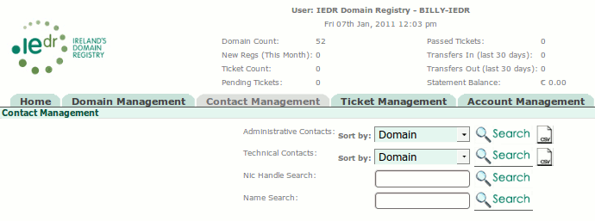
Text

Admins
Text
Url
Description | List domains and NIC Contact details for Admin-Contact NICs
Screenshot | (as bove)
SQL | select Domain.D_Name As Domain, Contact_NH as Nic, REPLACE(REPLACE(REPLACE(REPLACE(NH_Name,CHAR(10),' '),CHAR(13),''),',',' '),'%',' ') AS Name, REPLACE(REPLACE(REPLACE(REPLACE(Co_Name,CHAR(10),' '),CHAR(13),''),',',' '),'%',' ') AS Comp, REPLACE(REPLACE(REPLACE(REPLACE(NH_Address,CHAR(10),' '),CHAR(13),''),',',' '),'%',' ') AS Addr, NH_County AS County, NH_Country AS Country, NH_Email As Email, Phone from Domain LEFT JOIN Contact On Contact.D_Name = Domain.D_Name LEFT JOIN NicHandle On NicHandle.Nic_Handle = Contact.Contact_NH AND NicHandle.A_Number = Domain.A_Number LEFT JOIN Telecom ON Telecom.Nic_Handle = NicHandle.Nic_Handle where Domain.A_Number = $ACC_NO_PARAMETER AND Contact.Type ='A' AND Telecom.Type = 'P' ORDER BY Domain;
Text

Techs
Text
Url
Description | List domains and NIC Contact details for Technical-Contct NICs
Screenshot
SQL | select Domain.D_Name As Domain, Contact_NH as Nic, REPLACE(REPLACE(REPLACE(REPLACE(NH_Name,CHAR(10),' '),CHAR(13),''),',',' '),'%',' ') AS Name, REPLACE(REPLACE(REPLACE(REPLACE(Co_Name,CHAR(10),' '),CHAR(13),''),',',' '),'%',' ') AS Comp, REPLACE(REPLACE(REPLACE(REPLACE(NH_Address,CHAR(10),' '),CHAR(13),''),',',' '),'%',' ') AS Addr, NH_County AS County, NH_Country AS Country, NH_Email As Email, Phone from Domain LEFT JOIN Contact On Contact.D_Name = Domain.D_Name LEFT JOIN NicHandle On NicHandle.Nic_Handle = Contact.Contact_NH AND NicHandle.A_Number = Domain.A_Number LEFT JOIN Telecom ON Telecom.Nic_Handle = NicHandle.Nic_Handle where Domain.A_Number = $ACC_NO_PARAMETER AND Contact.Type ='T' AND Telecom.Type = 'P' ORDER BY Domain
Text

Contact name search
Text
Url
Description
Screenshot
SQL
Text

NIC search
Text
Url
Description
Screenshot
SQL
Text

Ticket Management
Text
Url
Description
Screenshot | 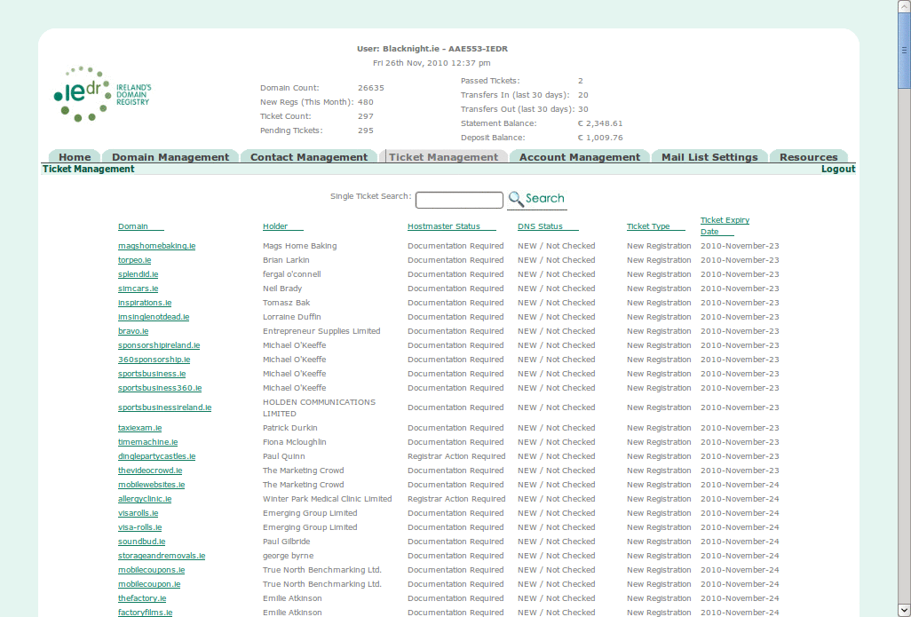
SQL
Text

search (full domain)
Text
Url
Description
Screenshot
SQL
Text

view
Text
Url
Description
Screenshot
SQL
Text

modify
Text
Url
Description
Screenshot
SQL
Text

NIC Handle
Text
Url
Description
Screenshot
SQL
Text

view
Text
Url
Description
Screenshot
SQL
Text

search
Text
Url
Description
Screenshot
SQL
Text

new
Text
Url
Description
Screenshot
SQL
Text

edit
Text
Url
Description
Screenshot
SQL
Text

delete
Text
Url
Description
Screenshot
SQL
Text

Account Management
Text
Url
Description
Screenshot | 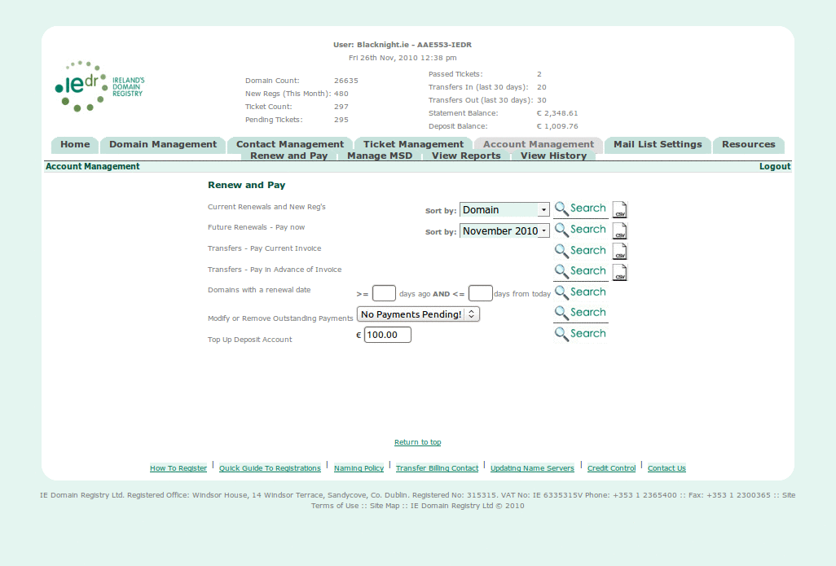
SQL
Text

Renew and Pay
Text
Url
Description
Screenshot
SQL
Text

Reports
Text
Url
Description
Screenshot
SQL
Text

Current Renewals and New Reg's
Text
Url
Description
Screenshot
SQL
Text

CSV
Text
Url
Description
Screenshot
SQL
Text

Future Renewals - Pay now
Text
Url
Description
Screenshot
SQL
Text

CSV
Text
Url
Description
Screenshot
SQL
Text

Transfers - Pay Current Invoice
Text
Url
Description
Screenshot
SQL
Text

select
Text
Url
Description
Screenshot
SQL
Text

Pay online
Text
Url
Description
Screenshot
SQL
Text

Pay Offline
Text
Url
Description
Screenshot
SQL
Text

Pay from Deposit
Text
Url
Description
Screenshot
SQL
Text

Enter MSD process
Text
Url
Description
Screenshot
SQL
Text

Confirm
Text
Url
Description
Screenshot
SQL
Text

CSV
Text
Url
Description
Screenshot
SQL
Text

Transfers - Pay in Advance of Invoice
Text
Url
Description
Screenshot
SQL
Text

CSV
Text
Url
Description
Screenshot
SQL
Text

Domains with a renewal date
Text
Url
Description
Screenshot
SQL
Text

Modify or Remove Outstanding Payments
Text
Url
Description
Screenshot
SQL
Text

remove from batch
Text
Url
Description
Screenshot
SQL
Text

Top Up Deposit Account
Text
Url
Description
Screenshot
SQL
Text

Manage MSD
Text
Url
Description
Screenshot
SQL
Text

Mails / Suspensions / Deletions
Text
Url
Description
Screenshot | 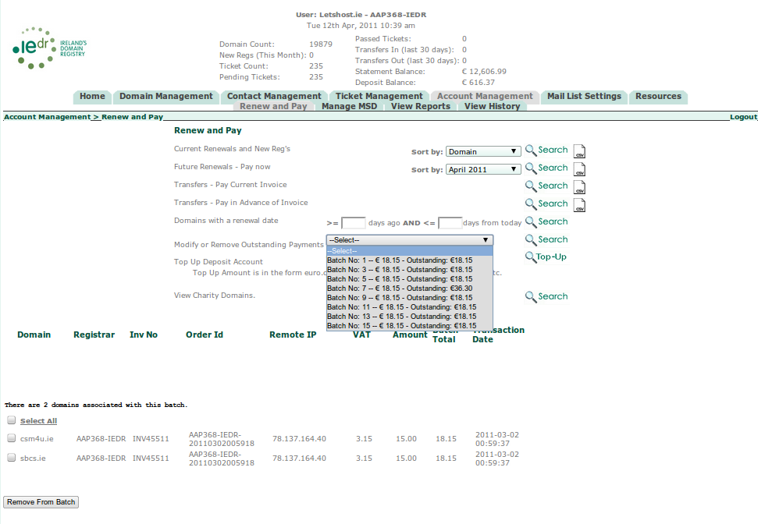
SQL | SELECT Distinct Sess_Id, Nic_Handle, A_Name, Batch_Total, (Sum(VAT) + Sum(Amount)) As Outstanding  FROM PendingPayment, Account  WHERE Trans_Dt <= NOW()  AND Nic_Handle = Billing_NH  AND Nic_Handle = 'AAP368-IEDR'  Group By Sess_Id;  +----------------------------+-------------+-------------+-------------+-------------+  | Sess_Id | Nic_Handle | A_Name | Batch_Total | Outstanding |  +----------------------------+-------------+-------------+-------------+-------------+  | AAP368-IEDR-20110301165416 | AAP368-IEDR | Letshost.ie | 18.15 | 18.15 |  | AAP368-IEDR-20110301165417 | AAP368-IEDR | Letshost.ie | 18.15 | 18.15 |  | AAP368-IEDR-20110301165518 | AAP368-IEDR | Letshost.ie | 18.15 | 18.15 |  | AAP368-IEDR-20110302005918 | AAP368-IEDR | Letshost.ie | 18.15 | 36.30 |  | AAP368-IEDR-20110302113000 | AAP368-IEDR | Letshost.ie | 18.15 | 18.15 |  | AAP368-IEDR-20110302162347 | AAP368-IEDR | Letshost.ie | 18.15 | 18.15 |  | AAP368-IEDR-20110302200822 | AAP368-IEDR | Letshost.ie | 18.15 | 18.15 |  | AAP368-IEDR-20110303005521 | AAP368-IEDR | Letshost.ie | 18.15 | 18.15 |  +----------------------------+-------------+-------------+-------------+-------------+  Select *  FROM PendingPayment  WHERE D_Name != ''  AND Sess_ID = 'AAP368-IEDR-20110303005521'  +-----------+-------------+----------+------------+----------------------------+---------------+------+--------+-------------+  | D_Name | Nic_Handle | Inv_No | Trans_Dt | Sess_ID | Remote_IP | VAT | Amount | Batch_Total |  +-----------+-------------+----------+------------+----------------------------+---------------+------+--------+-------------+  | djhire.ie | AAP368-IEDR | INV45511 | 2011-03-03 | AAP368-IEDR-20110303005521 | 78.137.164.40 | 3.15 | 15.00 | 18.15 |  +-----------+-------------+----------+------------+----------------------------+---------------+------+--------+-------------+  Select PendingPayment.D_Name, Old_Nic_Handle, New_Nic_Handle  FROM Transfers  LEFT JOIN PendingPayment ON  PendingPayment.D_Name = Transfers.D_Name AND  Transfers.Old_Nic_Handle = Nic_Handle  WHERE PendingPayment.D_Name != ''  AND Sess_ID = 'AAP368-IEDR-20110303005521';
Text

CSV
Text
Url
Description
Screenshot
SQL
Text

The domains which are to be mailed, suspended or deleted
Text
Url
Description
Screenshot
SQL
Text

Domains Available for ReActivation With Payment - PIA
Text
Url
Description
Screenshot
SQL
Text

Reactivate
Text
Url
Description
Screenshot
SQL
Text

PayFromDeposit
Text
Url
Description
Screenshot
SQL
Text

cancel
Text
Url
Description
Screenshot
SQL
Text

continue
Text
Url
Description
Screenshot
SQL
Text

Domains Available for ReActivation Without Payment
Text
Url
Description
Screenshot
SQL
Text

Reactivate
Text
Url
Description
Screenshot
SQL
Text

Deletions over the last year
Text
Url
Description
Screenshot
SQL
Text

View Reports
Text
Url
Description
Screenshot
SQL
Text

Domains Transferred To $NIC over $X days
Text
Url
Description
Screenshot
SQL | CREATE TEMPORARY TABLE ttable (  D_Name varchar(66) NOT NULL DEFAULT '' ,  Tr_Date date NOT NULL DEFAULT '0000-00-00' ,  Old_Nic_Handle varchar(15) NOT NULL DEFAULT '' ,  New_Nic_Handle varchar(15) NOT NULL DEFAULT '' ,  PRIMARY KEY (D_Name,Tr_Date,Old_Nic_Handle,New_Nic_Handle));  Insert Into ttable Select * From Transfers;  Insert Into ttable Select * From TransfersHist;  Select  ttable.D_Name As Domain, D_Holder, D_Reg_Dt, D_Ren_Dt, Tr_Date As Moved_Dt  FROM ttable, Domain  Where ttable.D_Name = Domain.D_Name  And New_Nic_Handle = '$NIC_HANDLE'  And Tr_Date >= CURDATE() - INTERVAL $DAYS_PARAM DAY;
Otherwise:

Select
ttable.D_Name As Domain, D_Holder, D_Reg_Dt, D_Ren_Dt, Tr_Date As Moved_Dt
FROM Domain, (select * from (select * from Transfers union select * from TransfersHist) tmpt where Tr_Date >= CURDATE() - INTERVAL 122 DAY AND New_Nic_Handle = '$NIC_HANDLE' ) ttable
Where ttable.D_Name = Domain.D_Name;
Text

CSV
Text
Url
Description
Screenshot
SQL
Text

Domains Transferred From $NIC over $X days
Text
Url
Description
Screenshot
SQL | CREATE TEMPORARY TABLE ttable (  D_Name varchar(66) NOT NULL DEFAULT '',  Tr_Date date NOT NULL DEFAULT '0000-00-00',  Old_Nic_Handle varchar(15) NOT NULL DEFAULT '',  New_Nic_Handle varchar(15) NOT NULL DEFAULT '',  PRIMARY KEY (D_Name,Tr_Date,Old_Nic_Handle,New_Nic_Handle));  Insert Into ttable Select * From Transfers;  Insert Into ttable Select * From TransfersHist;  Select ttable.D_Name As Domain, D_Holder, D_Reg_Dt, D_Ren_Dt, Tr_Date As Moved_Dt  FROM ttable, Domain  Where ttable.D_Name = Domain.D_Name  And Old_Nic_Handle = '$NIC_PARAM'  And Tr_Date >= CURDATE() - INTERVAL $DAYS_PARAM DAY;
Text

CSV
Text
Url
Description
Screenshot
SQL
Text

Statement of Account - aged balance
Text
Url
Description
Screenshot
SQL
Text

View History
Text
Url
Description
Screenshot
SQL
Text

invoices
Text
Url
Description
Screenshot
SQL
Text

renewal invoice history (year/month)
Text
Url
Description
Screenshot
SQL
Text

csv
Text
Url
Description
Screenshot
SQL
Text

transfer invoice history (year/month)
Text
Url
Description
Screenshot
SQL
Text

csv
Text
Url
Description
Screenshot
SQL
Text

advance payment invoice history (year/month)
Text
Url
Description
Screenshot
SQL
Text

csv
Text
Url
Description
Screenshot
SQL
Text

payments
Text
Url
Description
Screenshot
SQL
Text

renewal payment history (year/month)
Text
Url
Description
Screenshot
SQL
Text

csv
Text
Url
Description
Screenshot
SQL
Text

transfer payment history (year/month)
Text
Url
Description
Screenshot
SQL
Text

csv
Text
Url
Description
Screenshot
SQL
Text

advance payment history (year/month)
Text
Url
Description
Screenshot
SQL
Text

csv
Text
Url
Description
Screenshot
SQL
Text

Historical Payment Search (domain)
Text
Url
Description
Screenshot
SQL
Text

credit notes
Text
Url
Description
Screenshot
SQL
Text

MSD Deletions
Text
Url
Description
Screenshot
SQL
Text

CSV
Text
Url
Description
Screenshot
SQL
Text

Transfers Away
Text
Url
Description
Screenshot
SQL
Text

CSV
Text
Url
Description
Screenshot
SQL
Text

On Invoices (year/month)
Text
Url
Description
Screenshot
SQL
Text

CSV
Text
Url
Description
Screenshot
SQL
Text

Mail List Settings
Text
Url
Description
Screenshot | 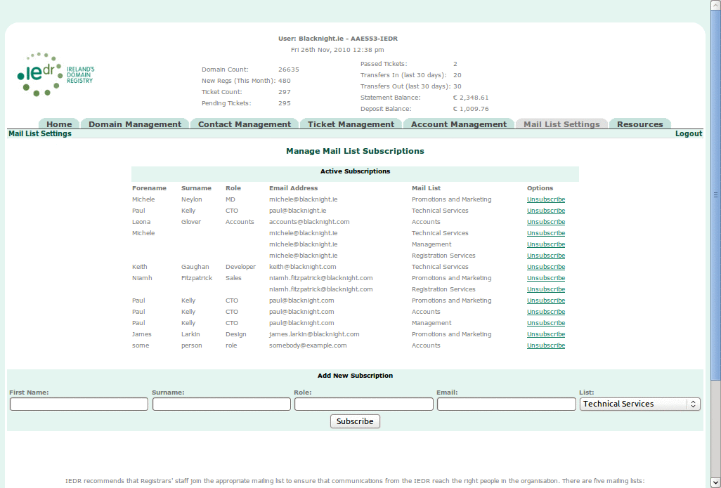
SQL
Text

remove
Text
Url
Description
Screenshot
SQL
Text

add
Text
Url
Description
Screenshot
SQL
Text

Resources
Text
Url
Description
Screenshot | 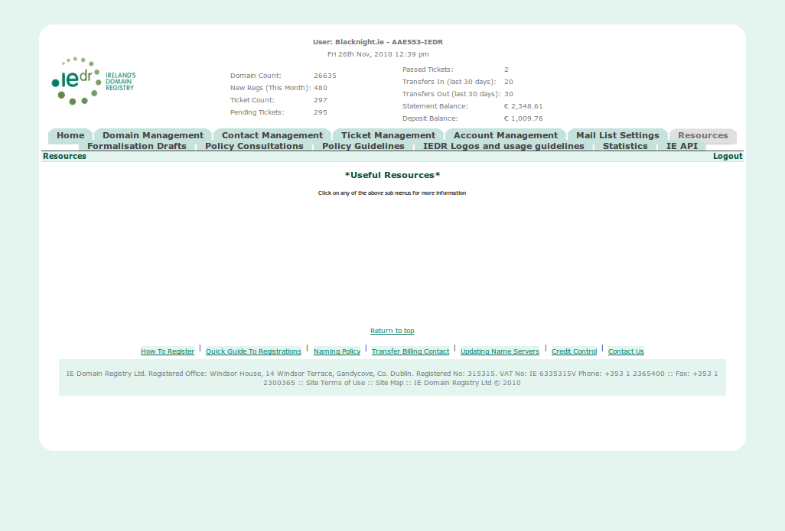
SQL
Text

Formalisation Drafts

Accept T & Cs
Text
Url
Description
Screenshot
SQL
Text

Policy Consultations
Text
Url
Description
Screenshot
SQL
Text

Policy Guidelines
Text
Url
Description
Screenshot
SQL
Text

IEDR Logos and usage guidelines
Text
Url
Description
Screenshot | 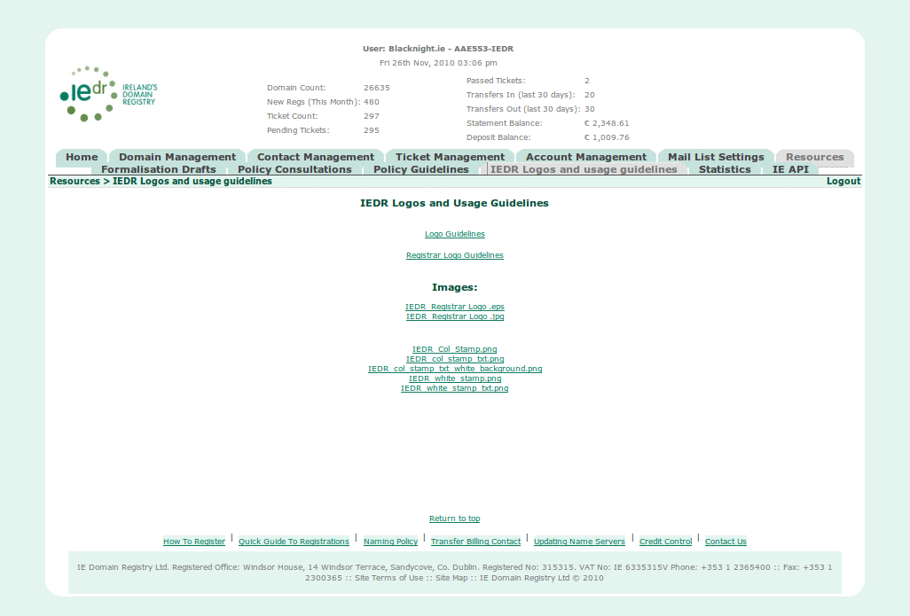
SQL
Text

Statistics
Text
Url
Description
Screenshot | 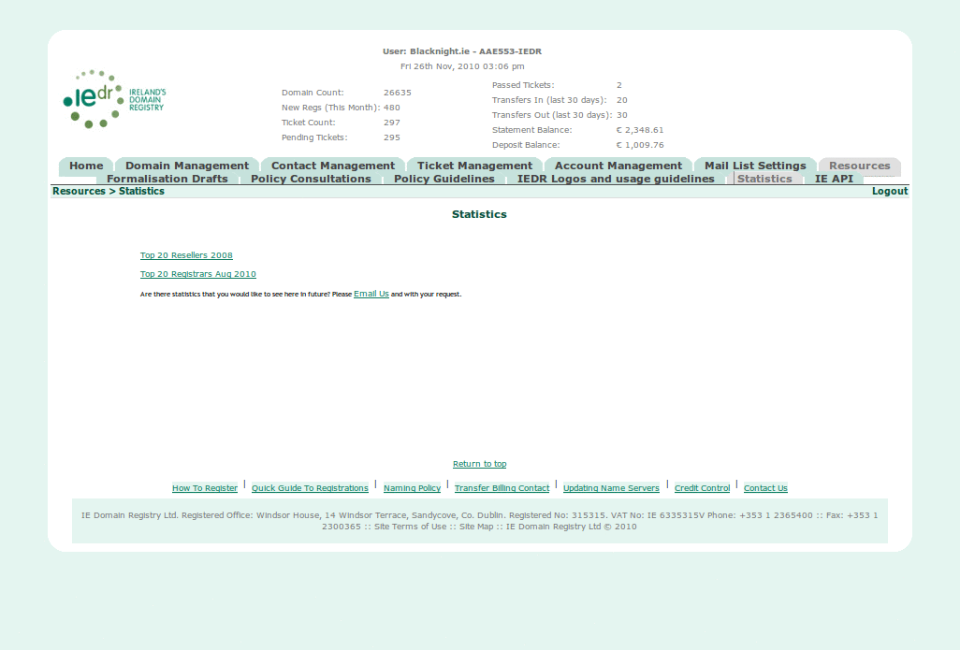
SQL
Text

IE API
Text
Url
Description
Screenshot | 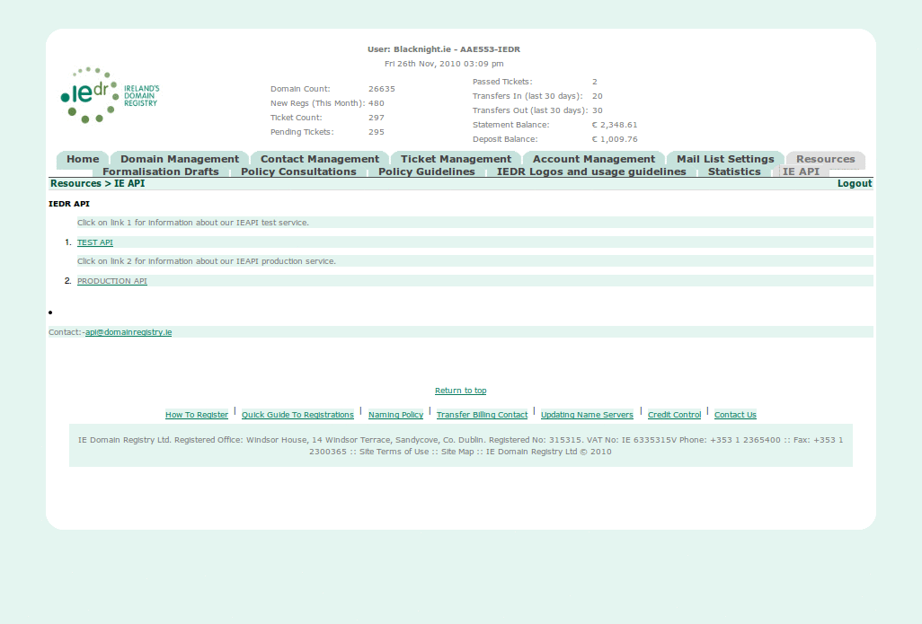
SQL
Text

