WEEK 2 INTERNSHIP TASK
Exploratory Data Analysis of Indian Crop Yield Data
Agribusiness Data Cleaning Project • Week 2

1. Objective
The objective of Week 2 is to perform a detailed Exploratory Data Analysis (EDA) on the cleaned agricultural crop-yield dataset prepared during Week 1. The analysis examines distributions, categorical structure, relationships between variables, statistical characteristics, trends, correlations, and potential anomalies.

2. Dataset Overview
The cleaned dataset contains 19,689 observations and 10 columns covering Indian agricultural production from 1997 to 2020. It includes 55 crop types, 30 states/Union Territories, and 6 cropping seasons. The numerical variables describe cultivated area, production, rainfall, fertilizer usage, pesticide usage, and yield.
Category | Variables | Type | Purpose
Categorical | Crop, Season, State | Categorical | Crop, season and geography
Time | Crop_Year | Integer | Historical year
Agricultural scale | Area, Production | Numeric | Cultivation and output
Environmental | Annual_Rainfall | Numeric | Annual rainfall
Farm inputs | Fertilizer, Pesticide | Numeric | Input usage
Outcome | Yield | Numeric | Production per unit area
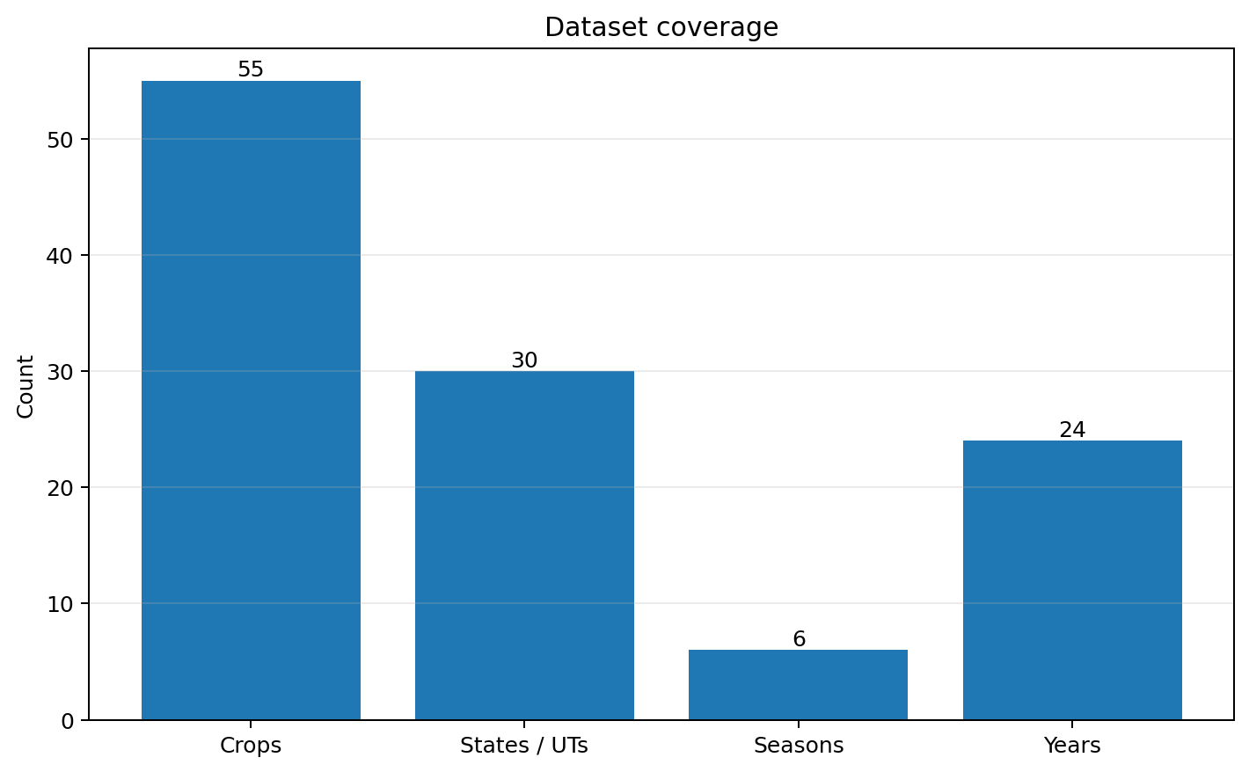
Figure 1. Dataset coverage.

3. Statistical Summary
The table below summarizes the numerical fields. The results show substantial differences between the mean and median for Area, Production, Fertilizer, Pesticide, and Yield, indicating strong right-skewness and the presence of extreme observations.
Variable | Mean | Std. Dev. | Min | Q1 | Median | Q3 | Max
Area | 179,926.600 | 732,828.700 | 0.500 | 1,390.000 | 9,317.000 | 75,112.000 | 50,808,100
Production | 16,435,940 | 263,056,800 | 0.000 | 1,393.000 | 13,804.000 | 122,718.000 | 6,326,000,000
Annual_Rainfall | 1,437.755 | 816.910 | 301.300 | 940.700 | 1,247.600 | 1,643.700 | 6,552.700
Fertilizer | 24,103,310 | 94,946,000 | 54.170 | 188,014.600 | 1,234,957.000 | 10,003,850 | 4,835,407,000
Pesticide | 48,848.350 | 213,287.400 | 0.090 | 356.700 | 2,421.900 | 20,041.700 | 15,750,510
Yield | 79.954 | 878.306 | 0.000 | 0.600 | 1.030 | 2.389 | 21,105.000
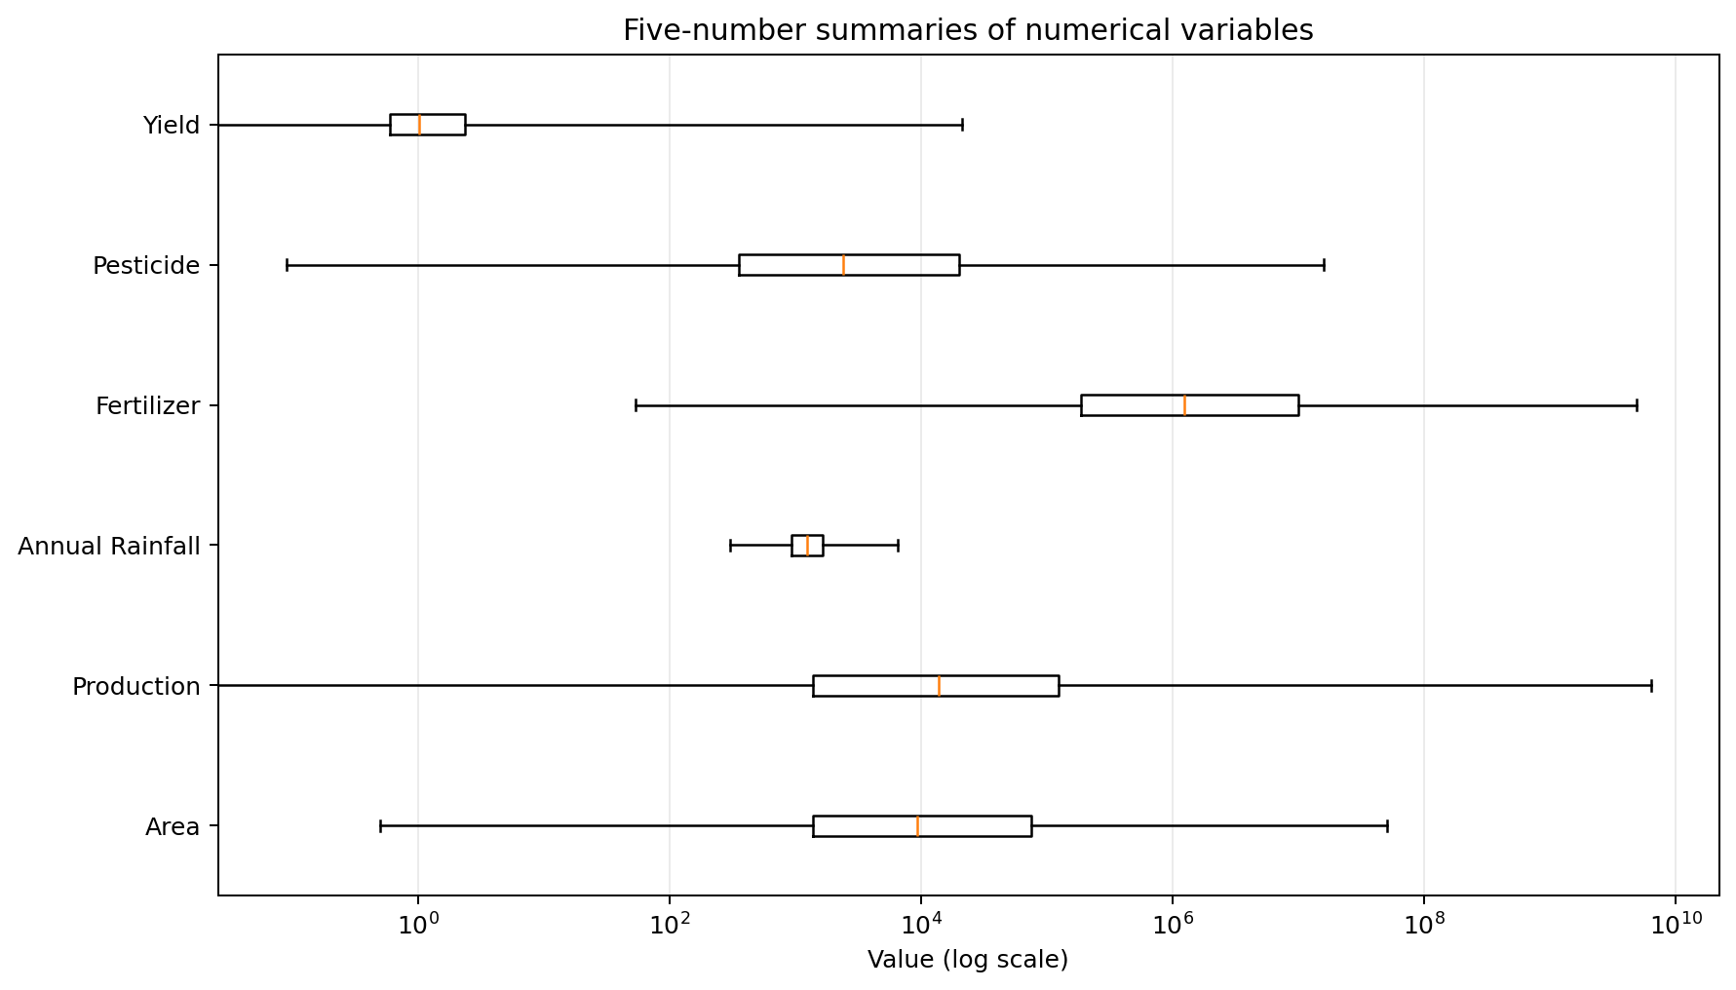
Figure 2. Five-number summaries; log scale is used because the variables span several orders of magnitude.
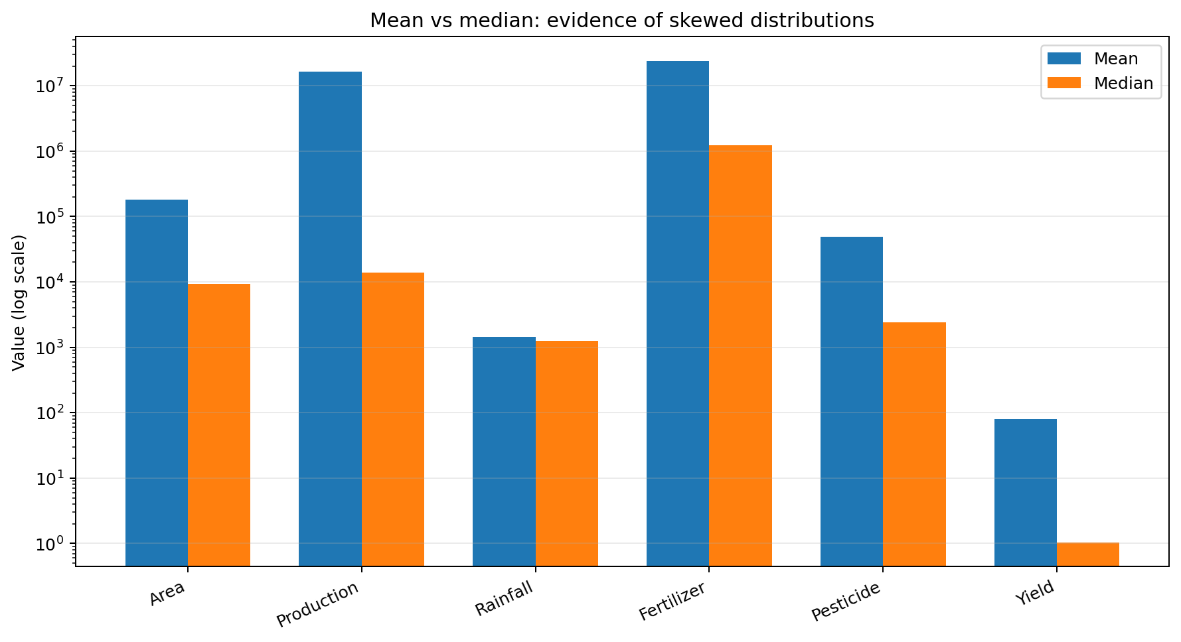
Figure 3. Mean versus median. Large gaps indicate skewness and the influence of high-value observations.

4. Distribution Analysis
The numerical distributions are highly uneven. Area has a median of about 9,317 hectares but a maximum above 50.8 million hectares. Production has a median of 13,804 but reaches 6.326 billion in the maximum observation. Fertilizer and pesticide usage show the same pattern. Yield is especially skewed: the median is only about 1.03 while the maximum is 21,105.
This means that ordinary mean-based summaries can be strongly affected by a small number of very large observations. For further modeling, log transformations, robust scaling, or crop-specific analysis would be appropriate.
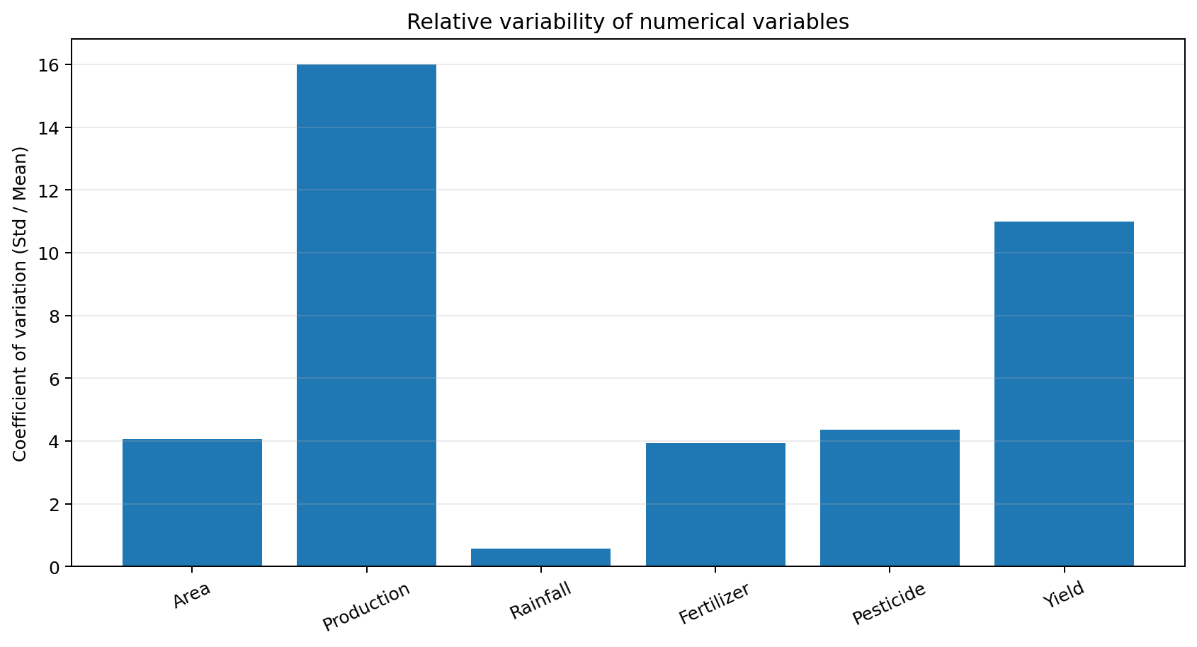
Figure 4. Coefficient of variation. Production and Yield have especially high relative variability.

5. Categorical Analysis
The dataset contains 55 crop categories, 30 states/Union Territories, and 6 seasons. This diversity is important because agricultural conditions differ substantially by crop, geography, and season. Comparing all observations without considering these groups can hide important patterns.
- Crop is a major source of heterogeneity because different crops naturally have very different yield scales.
- State captures geographic and climatic differences, including rainfall patterns and farming practices.
- Season separates agricultural cycles such as Kharif, Rabi, Summer, Autumn, Winter, and Whole Year.
- Group-wise summaries are therefore more informative than relying only on the overall mean.

6. Relationship and Correlation Analysis
The strongest relationship to watch is between Area and Production. Larger cultivated areas generally generate larger total production. Fertilizer and pesticide usage also rise with cultivated area because they are recorded as total quantities rather than per-hectare rates.
A critical analytical point is that Yield is mathematically derived from Production and Area (production per unit area). Consequently, Production should not be treated as an independent predictor of Yield in a predictive model without acknowledging this structural dependency. Using Production to predict Yield can create data leakage or an artificially strong relationship.
Published analyses of this exact dataset also report high correlations among Area, Fertilizer, Pesticide, and Production, which is consistent with the scale effect observed in the descriptive statistics.

7. Trends
The data spans 1997–2020, making it suitable for historical trend analysis. A year-wise inspection should be performed alongside crop and state grouping because the dataset is not a single time series; it is a collection of crop-state-season observations.
One published analysis using the same Kaggle dataset reports that overall production decreases in 2020. This should be interpreted as a dataset-level observation rather than proof of a nationwide agricultural decline, because production is influenced by the crop/state composition represented in each year.

8. Anomaly and Outlier Analysis
The five-number summaries clearly indicate extreme observations. The maximum values of Area, Production, Fertilizer, Pesticide, and Yield are far above their respective medians. Such points should not automatically be deleted: some may represent legitimate large-scale crops or states.
- Coconut and sugarcane are examples of crops with exceptionally high yield values relative to common cereals and pulses.
- Very large production values can be driven by both crop type and cultivated area.
- The wide rainfall range (301.3 to 6,552.7 mm) indicates strong geographic/climatic variation.
- Outlier handling should therefore be performed with domain knowledge and preferably within crop/state groups rather than by blindly deleting all extreme values.

9. Key Insights
- The dataset is large enough for meaningful EDA, with 19,689 observations covering 24 years.
- Agricultural variables are strongly right-skewed, so medians and percentiles are often more representative than means.
- Yield varies enormously across crops; comparing raw yield values across all crops can be misleading.
- Area, Production, Fertilizer, and Pesticide are strongly affected by farm/crop scale and should be normalized when comparing efficiency.
- Production and Yield are structurally linked, so Production must be handled carefully in predictive analysis to avoid leakage.
- Geography and season are important grouping variables because rainfall and farming practices differ across India.
- Extreme observations are not necessarily errors; several can represent legitimate high-output crops such as coconut and sugarcane.

10. Recommendations for Further Analysis
- Create crop-wise and state-wise boxplots to compare yield distributions fairly.
- Calculate per-hectare fertilizer and pesticide usage to remove the effect of farm size.
- Use Spearman correlation in addition to Pearson correlation because several variables are strongly skewed.
- Use log-scaled visualizations for Area, Production, Fertilizer, Pesticide, and Yield.
- For predictive modeling, exclude Production when Yield is the target unless the analytical purpose explicitly allows this derived relationship.
- Investigate year-wise changes within individual crops rather than relying only on total production.

11. Conclusion
The EDA shows that the Indian crop-yield dataset contains substantial agricultural diversity and strong scale effects. The most important findings are the highly skewed numerical distributions, the presence of legitimate but extreme crop-level observations, strong relationships among farm scale and total input/output variables, and the structural dependence of Yield on Production and Area. These findings provide a strong basis for the next stages of analysis and modeling while highlighting the need for robust statistics, appropriate transformations, and careful treatment of data leakage.

12. Sources and Data Provenance
Primary project dataset: Week 1 cleaned file, cleaned_crop_yield.csv, stored in the internship GitHub repository.
The dataset structure and 19,689-row coverage are consistent with the public Agricultural Crop Yield in Indian States dataset covering 1997–2020. Publicly reported descriptive statistics were used to validate the numerical summary reported in this document.
GitHub repository: https://github.com/srirammote/agribusiness-data-cleaning
Public dataset reference: https://www.kaggle.com/datasets/akshatgupta7/crop-yield-in-indian-states-dataset

