README

# Team Members

Akhil Ravichandran 1211257187

Sriram Vellangallor Subramanian 1209270383

# Assumptions

We assume that the code is executed on a Linux/Unix based system with Python2.x

The code can be executed in the following ways–

# 1. Modular:

Please ensure that exec.sh has executable privileges.

* chmod +x exec.sh

exec.sh can be executed with the following options:

arg1: Type of loss (log, hinge)

arg2: Type of momentum (polyak, nag or none)

* ./exec.sh

The above will execute with default parameters– log loss with polyak (classical) momentum

Below are the various combinations that the code can be executed in:

./exec.sh log

./exec hinge

./exec log polyak

./exec hinge polyak

./exec log nag

./exec hinge nag

./exec log none

./exec hinge none

Please note that not providing an argument would let the code execute with default parameters– if no parameters are provided at all, log likelihood loss with Polyak momentum is set. If the wrong loss parameter is passed, again log likelihood is set. If a valid loss parameter is passed and no or incorrect momentum is passed, Polyak momentum is set.

# 2. Modular:

The code is designed as 2 separate files, one for each– log likelihood and hinge loss separately and each python file can be independently executed. If you are using an IDE to execute the python file and the command line argument is not configured in the IDE, the except block at the beginning of the code sets the momentum for the execution.

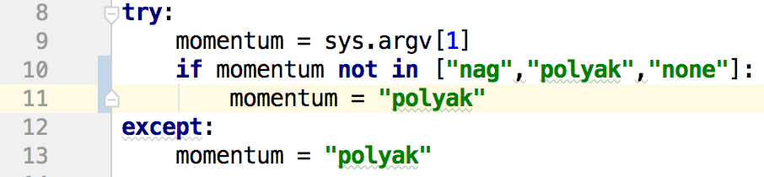

By changing the momentum value in the except block (illustrated above), you can change the momentum choice to one of “polyak”, “nag” or “none”