Design a Data Warehouse for IPL Cricket Tournament.

Business process:

* To identify the performance of players.
* To identify the scores of each team.
* How many tickets are getting booked per each match?
* How many tickets are sold for each team?

Grain:

* To maintain the match details and player individual performance as well as booking_count per each team.

Dimension:

* Match_Date, Stadium_Details, Location, Time, Ticket, Person, Transaction_Details.

Fact:

* Match_details, Team_details, Player_details

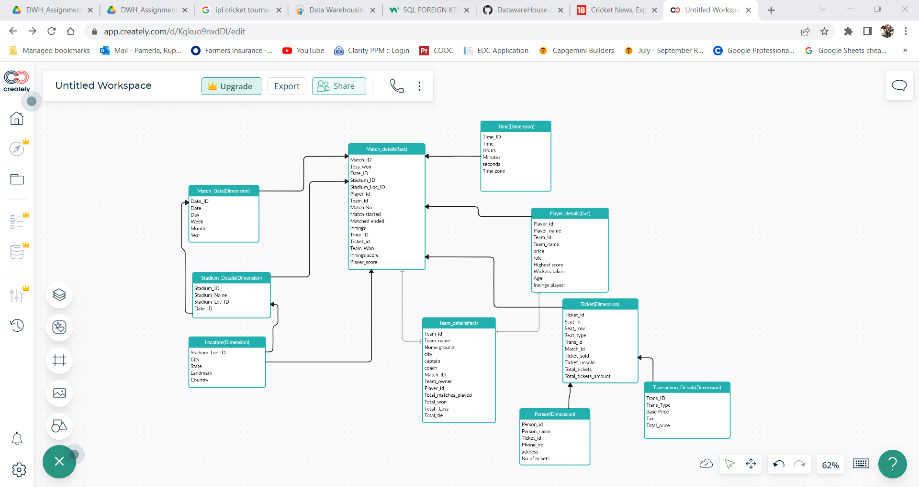

To get the count seats where seat_row =50

Select count(*) from ticket where seat_row=50

Design a Data Warehouse for Food delivery app like Swiggy, Zomato.y

Business process:

* To identity the sales based on location.
* To identity most loving items.
* How many orders are getting booked per each day?
* How many orders are cancelled per each day?
* Sales during peak hours per day

Grain:

* Individual order are getting placed on each day for delivery

Dimension:

* Customer,Delivery_agent,Order_date,location,device,charges,item,restaurant,vehicle,Documents

Fact:

* Order, Transaction_details

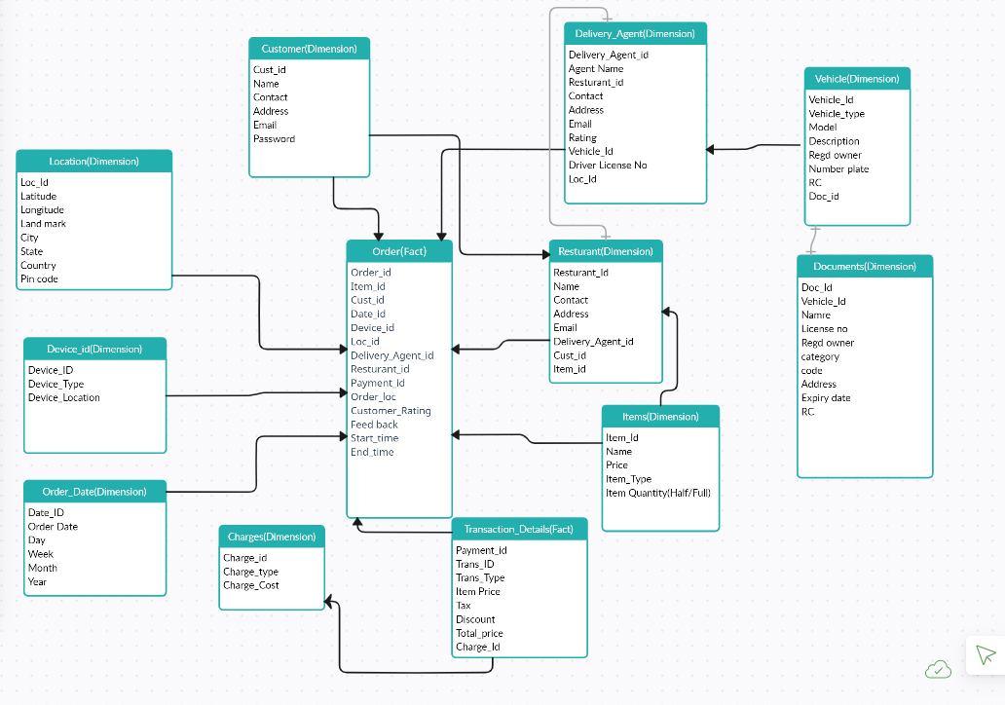

1)Top 5 agents who has rating more than or equal to 4.5

Select Agent_id, Agent_Name, rating from Delivery_agent where rating >=4.5;

2)Get the total price of the order

Select o.order_id, t.total price from order o inner join transaction_details t on o.payment_id= t.payment_id;

3)Get the top restaurant name which has more orders.

Select count(o.order_id),r.name from orders o inner join resturant r on o.resturant_id = r.resturant_id group by r.name desc limit 1;

4)To calculate the sum of payments based on trans_type.

Select payment_id, sum(case when trans_type =cash then total_price else o) as cash_payment,

Sum(case when trans_type=online then total_price else 0) as Online_payment

End

From Transaction_details group by payment_id;

5) Get the license expiry date for delivery_agent

Select da.agent_name,da.driver_license_no,d,expiry date from Delivery_agent da inner join vehicle v on da.vehicle_id=v.vehicle_id join documents d on v.doc_id=d.doc_id;

Design a Data Warehouse for cab ride service like Uber, Lyft (Asked in Google for Data

Engineer role)

Business process:

* Tracks rides done by driver and their performance.
* To identity most rides are happening to which place.
* How many trips are getting booked per each day?
* How many trips are cancelled per each day?
* Avg price during peak hours per day

Grain:

* Individual trip are getting placed on each day on each transaction level

Dimension:

* Customer,Driver,Order_date,location,device,charges,car,Documents

Fact:

* Trip, Transaction_details

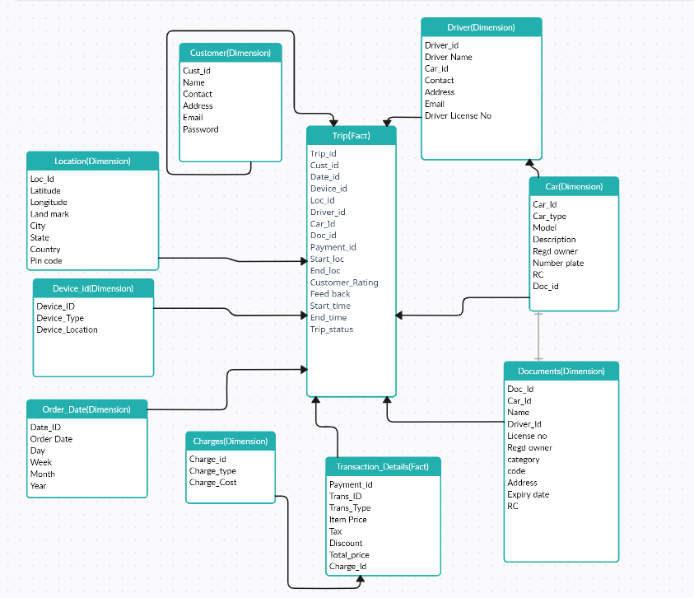

Get the total price for each and every ride

Select t.trip_id,td.total_price from trip t inner join transaction_details td on t.payment_id=ta.payment_id;

Select trip_id,customer_rating,

Case

When customer_rating >=4.5 then ‘Excellent’

When customer_rating >=4 and customer_rating <4.5 then ‘Good’

When customer_rating >=3 and customer_rating <4 then ‘medium’

Else ‘bad’

End as rating from trip;

4. Design a Data Warehouse for Restaurent table booking app like Dineout (Asked in

McKinsey for Consultant Data Engineer role)

Business process:

* To identity on which time most booking took place
* How many tables are getting booked per each day?
* How many bookings are cancelled per each day?
* Avg price during peak hours per day
* Avg Booking during weekends and special occasions

Grain:

* Individual Bookings are getting placed on each day on each transaction level

Dimension:

* Customer,Resturant,Booking_date,location,device,discounts,Table.

Fact:

* Booking, Transaction_details

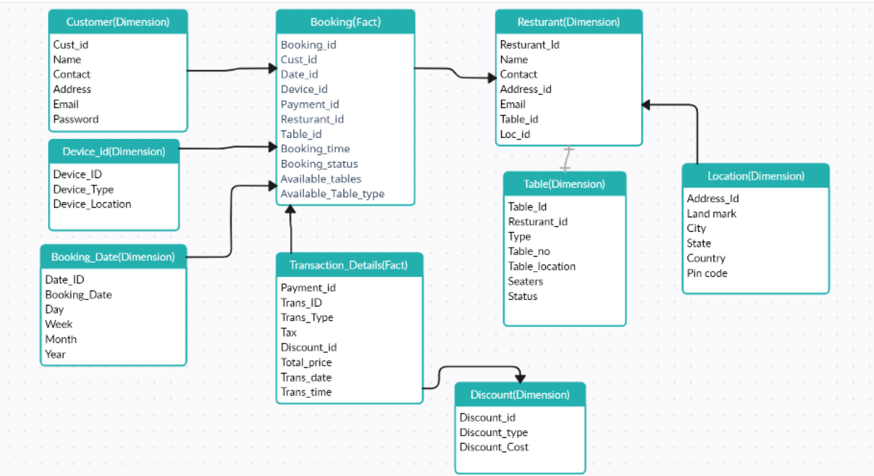

Total no booking on 12/05/2021

Select b.Booking_id, d.booking_date from booking b inner join booking_date d on b.date_id = d.date_id where d.booking date=’12/05/2021’;

Get all the transaction details for booking with name

Select b.booking_id, c.name, t.* from booking b inner join customer c on b.cust_id=c.cust_id inner join transaction_details t on b.payment_id=t.transaction_details;

Total no of tables in a restaurant

Select r.Resturant_id, r.name, count(t.Table_id) from restaurant r inner join table t on r.table_id=t.table_id;

5. Design a Data Warehouse for Covid Vaccination Application (Asked in Livsapce for

Data Engineer role)

Business process:

* To identity how many people are vaccinated?
* Most vaccinated drug name.
* To get the total count of vaccines
* Avg booking on vaccines on each day.

Grain:

* Individual bookings on each day

Dimension:

* Booking_date, vaccine, booster, Vaccine/booster, center, person, room, location, records

Fact:

* Booking

