**Ticket Booking - Testing.**

Application has been hosted in OpenShift (<http://jbossews-rajen.rhcloud.com/Ticketing> ).

I registered it for free, was curious about Open Shift, set up RubyGems for Git, SFTP, SSH, did deployment there for the first time.

Since it is for free, the heap space is very low, often it goes out of memory (Small gear on the free account with heap space 512MB). Please let me know incase the application is not available, will restart it for you.

1. Loading Home page:

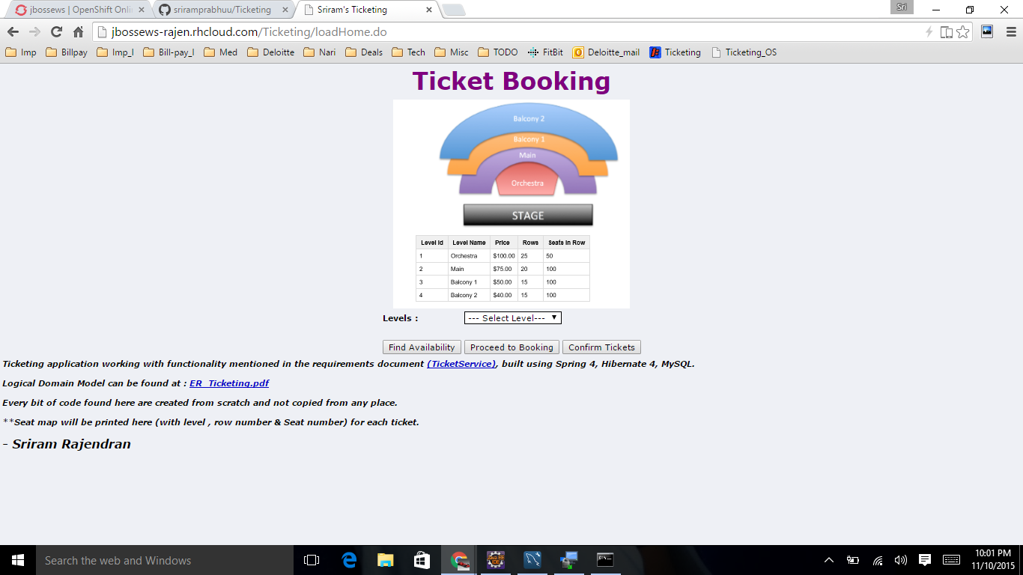

2) Getting Levels (From master tables in Database)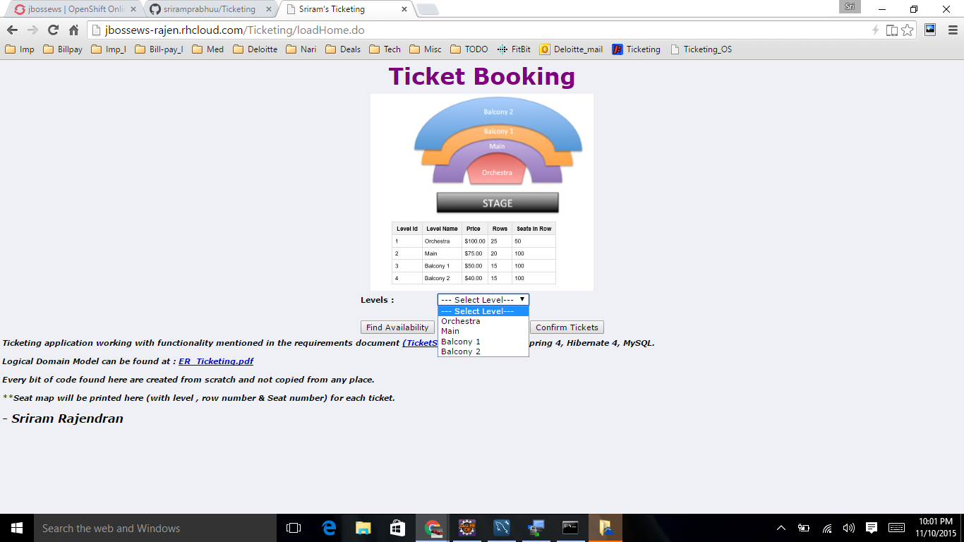

3) Results loaded from Database for selected levels.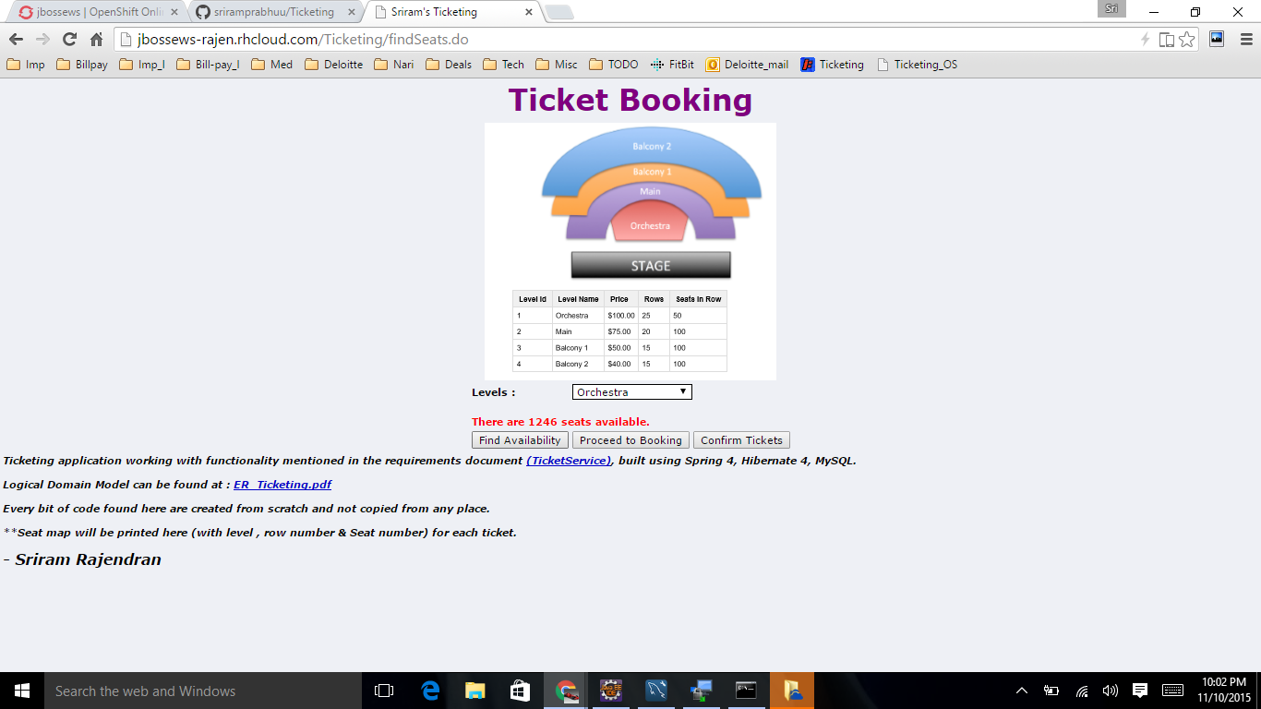4) Proceed to booking, click on “Proceed to booking” 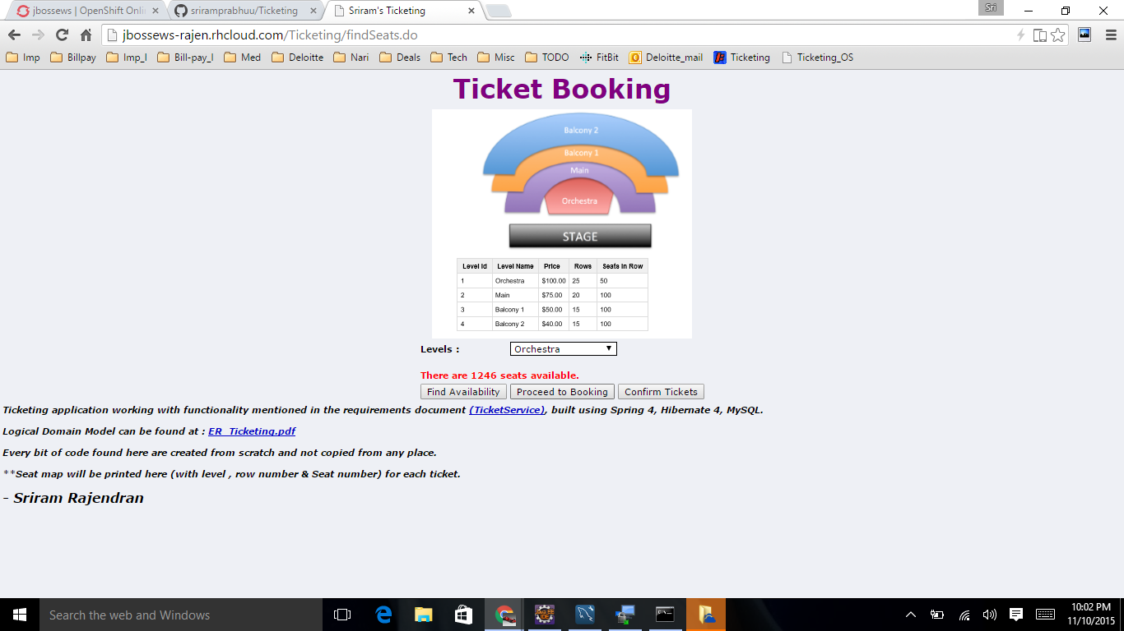

5) Fill the details, test validations 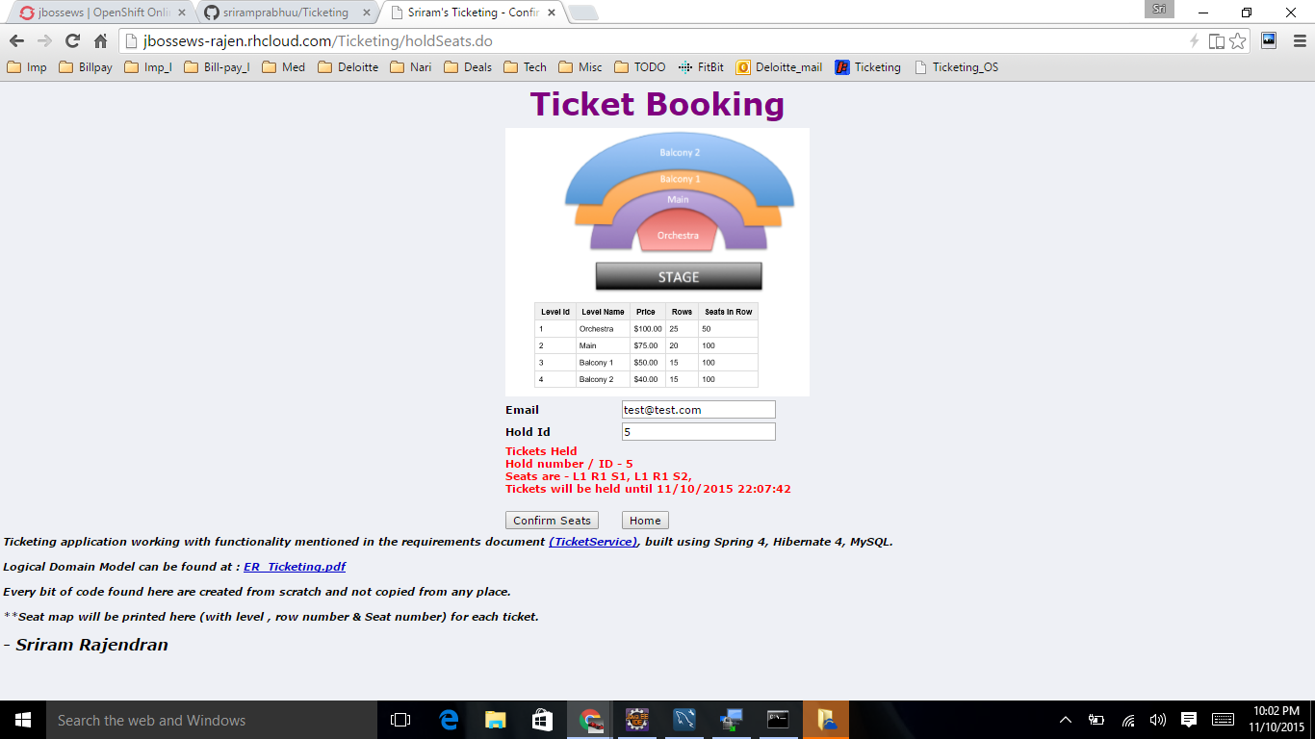6) Tickets held, ticket details (Seat maps with Level, Row number and seat number) printed in the screen. 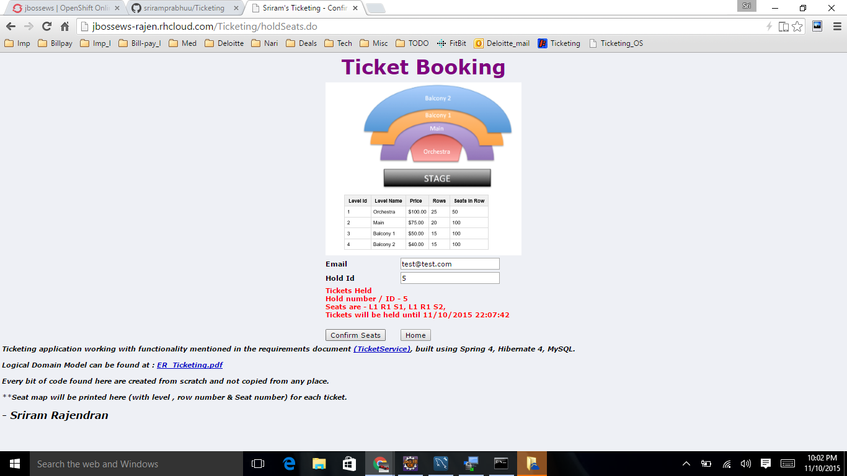

7) Click on confirm to confirm the seats.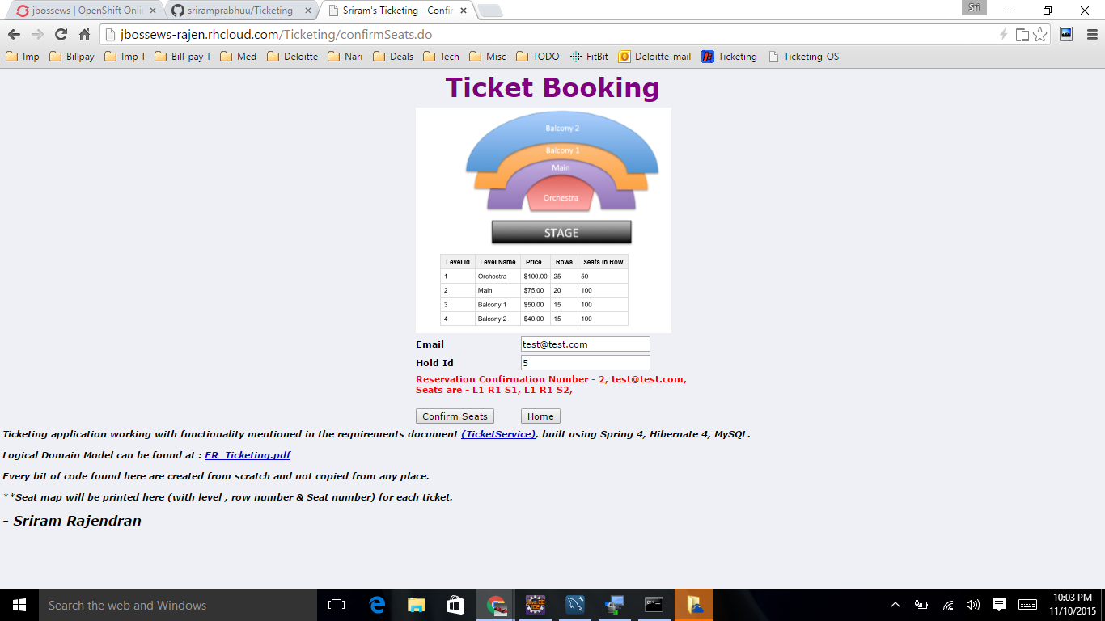8)Tickets confirmed, with confirmation number and seat maps printed in screen. 9) Held tickets, can be pulled and confirmed. Click on the link to view the LDM.