**   **

**AI-DRIVEN EXPLORATION AND PREDICTION OF COMPANY REGISTRATION TRENDS WITH (ROC) – GUIDELLINES**

**PHASE 4 : DEVELOPMENT PART 2**

**SUBMITTED BY :**

|  |  |  |  |
| --- | --- | --- | --- |
| **S.NO** | **NAME** | **REGISTER NUMBER** | **NAAN MUDHALVAN ID** |
| 01. | SRIRAM R | 822421106302 | Aut822421106302 |
| 02. | SARAVANAN B | 822421106058 | Au822421106058 |
| 03. | SURYA P | 822421106073 | Au822421106073 |
| 04. | THULASIRAJAN U | 822421106075 | Au822421106075 |
| 05. | VISHNU PRAKASH P | 822421106082 | Au822421106082 |

STUDENTS III YEAR ECE   
DEPARTMENT OF ELECTRONICS AND COMMUNICATION ENGINEERING,  
MRK INSTITUTE OF TECHNOLOGY,  
KATTUMANNARKOIL , CUDDALORE DISTRICT,  
PIN : 608 301.

**GUIDED BY :**

**Miss. ARULMOZHI R ,** **M.E.,**

ASSISTANT PROFESSOR,

DEPARTMENT OF ELECTRONICS AND COMMUNICATION ENGINEERING,  
MRK INSTITUTE OF TECHNOLOGY,  
KATTUMANNARKOIL , CUDDALORE DISTRICT,  
PIN : 608 301.

**AI-Driven Exploration and Prediction of Company Registration Trends with (RoC) - Guidellines**

**PHASE 4 : DEVELOPMENT PART 2**

**Continue building the AI-driven exploration and prediction project by :**

* Performing exploratory data analysis
* Feature engineering
* Predictive modeling.

Dataset Link :  <https://tn.data.gov.in/resource/company-master-data-tamil-nadu-upto-28th-february-2019>

**ABSTRACT :**

Picking the right company structure for your business is as important as any other business-related activity. The right business structure will allow your enterprise to operate efficiently and meet your required business targets. In India, every [business must register](https://cleartax.in/services/cat_company_registration/c) themselves as part of the mandatory legal compliance. Before we learn how to register a company, let’s try and understand the types of business structures in India.

**PREDICTIVE MODELING :**

Company registration involves a lot of processes. Before registering a company one should decide on the structure of the company.

**REGISTER A COMPANY IN INDIA :**

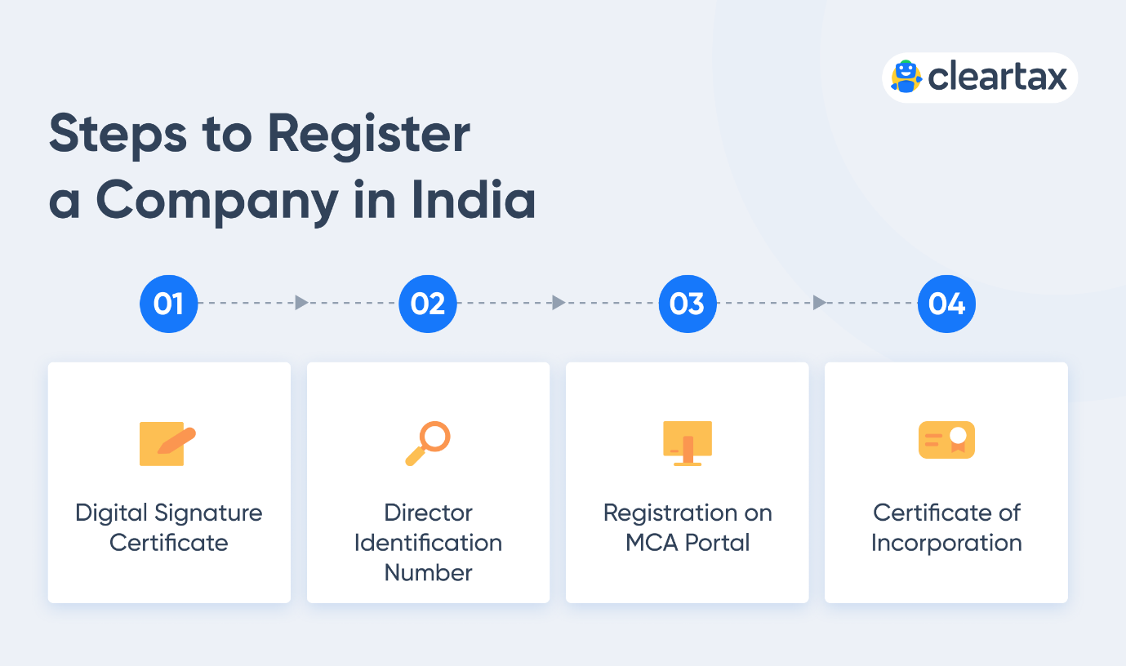

### **Step 1: Digital Signature Certificate (DSC)**

### **Step 2: Director Identification Number (DIN)**

### **Step 3: Registration on the MCA Portal**

### **Step 4: Certificate of Incorporation**

### **Step 1: Digital Signature Certificate (DSC)**

As the registration process of the company is completely online, Digital signatures are required to file the forms on the MCA portal. DSC is mandatory for all the proposed directors and the subscribers of the Memorandum of Association (MoA) and Articles of Association (AoA).

DSC can be obtained from government recognised certifying authorities. The list of such certified authorities can be accessed [here](https://www.mca.gov.in/MinistryV2/certifyingauthorities.html). DSC can also be obtained online in just two days from [here](https://cleartax.in/services/get-digital-signature/p). Class 3 category of DSC must be obtained by the directors and subscribers of MoA and AoA.

### **Step 2: Director Identification Number (DIN)**

The Director Identification Number (DIN) is an identification number for a director and it has to be obtained by anyone who wants to be a director in a company. The DIN of all the proposed directors of the company along with the name and the address proof are to be provided in the company registration form. DIN can be obtained while filing the SPICe+ form, i.e. company registration form.

SPICe+ is a web-based company registration form, through which DIN can be obtained for a maximum of three directors. If there are more directors in the company and they do not have a DIN, the company can be incorporated with three directors and it has to appoint new directors later on after incorporation.

### **Step 3: Registration on the MCA Portal**

To apply for company registration, the SPICe+ form is to be filled out and submitted on the [MCA portal](https://www.mca.gov.in/content/mca/global/en/home.html). To fill out the SPICe+ form and submit documents, the director of the company has to register on the MCA portal. After registration, the director can log in and will obtain access to the MCA portal services which include filing e-forms and viewing public documents.

The company must also reserve its name by submitting two proposed names in the Part-A of the SPICe+ form. The reservation of the name is essential because if the company name is similar to the name of an existing/registered company, LLP, trademark or it contains words prohibited under the Companies (Incorporation Rules) 2014, the SPICe+ form will get rejected.

If the SPICe+ form gets rejected due to non-approval of the company name, the applicant has to re-file another SPICe+ form for the reservation of a new name by paying the prescribed fee. However, after the approval of the name filed in Part-A of the SPICe+ form, it will be reserved for a period of 20 days within which the company must fill Part-B of the SPICe+ form and submit the form online. The applicant must provide the details of the company and directors in the Part-B of the SPICe+ form, attach documents, attach DSC, check the form and submit it.

### **Step 4: Certificate of Incorporation**

Once, the registration application is filled and submitted along with the required documents, the Registrar of Companies will examine the application. Upon verification of the application, he will issue the Certificate of Incorporation of the Company.

The Certificate of Incorporation is issued with PAN and TAN as allotted by the Income Tax Department. An electronic mail with a Certificate of Incorporation as an attachment along with PAN and TAN will also be sent to the applicant.

## ****DOCUMENTS REQUIRED FOR COMPANY REGISTRATION :****

* Proof of identification of all the company’s directors and shareholders (partners in case of LLP). Any one of the below documents can be submitted as proof of identification:
* Pan card
* Aadhar card
* Driving license
* Passport
* Proof of address of all the directors and shareholders (partners in case of LLP). Any one of the below documents can be submitted as address proof:
  + Latest telephone bill (not older than 2 months)
  + Latest electricity bill (not older than 2 months)
  + Bank account statement having address
* DIN (DPIN in case of LLP) and DSC of all the directors (partners in case of LLP)

## BENEFITS OF COMPANY REGISTRATION IN INDIA :

A company registration provides many advantages. A licensed company makes it genuine and enhances the business’ credibility.

* Protects against personal obligation, and defends against other threats and losses.
* Builds goodwill and also supports more customer attraction
* Gives reliable investors bank credits and good investment with ease.
* Provides cover of the responsibility to protect the company’s assets
* Bigger commitment to wealth and greater stability
* Increases the ability to develop and grow large

### **TYPES OF COMPANIES IN INDIA :**

There are six types of companies, each of them taking a different approach to the company registration process in India.

* Private Limited Company
* Public Limited Company
* One Person Company
* Producer Company
* Nidhi Company
* Section 8 Company

### **FEATURES COMMON TO EVERY TYPE OF COMPANY :**

## Types of Company Registration in India

### **ADVANTAGES OF REGISTERING A COMPANY IN INDIA**

## Benefits of Company Registration in India

**FEATURE ENGINEERING :**

The ROCs also ensure that LLPs comply with the statutory requirements under the LLP Act. The office of the ROC maintains a registry of records related to companies registered with them, and permits the general public to access this data on payment of a fee. The Union Government maintains administrative control over ROCs through Regional Directors. There are 7 Regional Directors, and they supervise the functioning of ROCs within their respective regions.

The Registrar of Companies takes care of company registration (also known as incorporation) in India, completes reporting and regulation of companies and their directors and shareholders, and also oversees government reporting of various matters including the annual filling of various documents.

**PERFORMING EXPLORATORY DATA ANALYSIS :**

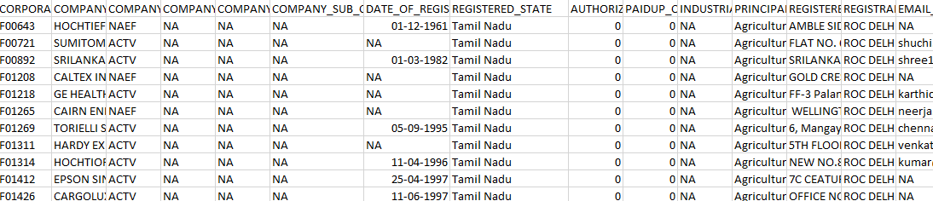

**CONCLUSION :**

if the company is to be registered as an OPC, LLP, PLC or Public Limited Company. After deciding on the structure, the company name must be decided and the directors of the company need to obtain DIN and DSC before applying for company registration.

After choosing the company name and obtaining DIN and DSC, the company registration form must be filed on the MCA portal. The SPICe+ form, i.e., the company registration form, must be filled, and the required documents must be uploaded and submitted online on the MCA portal along with the prescribed fees. After verification of the SPICe+ form, the ROC will issue the company incorporation certificate. The incorporation certificate is proof of registration of the company and the company will come into existence as a separate legal entity.