



ORION 10.4 – User Manual

Budgeting




Table of Contents
INTRODUCTION ............................................................................................................................................ 3
MASTERS......................................................................................................................................................... 6
BUDGET PERIOD MASTER................................................................................................................................ 6
Period Dates................................................................................................................................................ 8
BUDGET LEVEL MASTER............................................................................................................................... 10
Budget Users/Budget Group..................................................................................................................... 11
Level Rules............................................................................................................................................... 12
FORMULA MASTER........................................................................................................................................ 15
BUDGET HIERARCHY MASTER ...................................................................................................................... 17
Level Details............................................................................................................................................. 18
BUDGET CATEGORY MASTER........................................................................................................................ 19

Segment .................................................................................................................................................... 20
Budget Codes............................................................................................................................................ 26
Levels........................................................................................................................................................ 27
FINANCE BUDGET RULES .............................................................................................................................. 28
OPERATIONS BUDGET RULES – PURCHASE REQUISITION .............................................................................. 29
OPERATIONS BUDGET RULES – PO................................................................................................................ 30
Category Priority ...................................................................................................................................... 31

SETUPS........................................................................................................................................................... 32
BUDGET CATEGORY SETUP ........................................................................................................................... 32
BUDGET TRANSACTION SETUP...................................................................................................................... 34
BUDGET CODE SETUP.................................................................................................................................... 35

TRANSACTIONS........................................................................................................................................... 37
BUDGET ENTRY AND APPROVAL - OPERATIONS............................................................................................ 37
Reference.................................................................................................................................................. 39
Budget Details .......................................................................................................................................... 39
Monthly Break-up..................................................................................................................................... 42
BUDGET ENTRY AND APPROVAL - FINANCE.................................................................................................. 44
BUDGET ADDITION/MODIFICATION/DELETION ............................................................................................. 45
BUDGET ADDITION........................................................................................................................................ 45
Budget Modification................................................................................................................................. 45
Budget Deletion........................................................................................................................................ 46
GL TRANSACTION ENTRY ............................................................................................................................. 47
PURCHASE REQUISITION................................................................................................................................ 48
PURCHASE ORDER......................................................................................................................................... 50
BUDGET TRANSFER ....................................................................................................................................... 51
Transfer Details ........................................................................................................................................ 52
Budget Details .......................................................................................................................................... 52
Authorization............................................................................................................................................ 53
Budget Transfer for Operations Budget.................................................................................................... 54
BUDGET CARRY FORWARD ........................................................................................................................... 55

PROCESSING ................................................................................................................................................ 56
TRANSACTION PROCESSING........................................................................................................................... 56

ORION Budget User Manual Version 1.1 1



Table of Figures
FIG. 1 - BUDGET PROCESS FLOW..........................................................................................................................4
FIG. 2 - OVERALL BUDGET MODULE PROCESS FLOW ..........................................................................................5
FIG. 3 - BUDGET PERIOD MASTER........................................................................................................................6
FIG. 4 - PERIOD DATES SCREEN ...........................................................................................................................8
FIG. 5 - GENERATE DATE WINDOW......................................................................................................................8
FIG. 6 - BUDGET LEVEL MASTER.......................................................................................................................10
FIG. 7 - BUDGET USERS/GROUPS TAB................................................................................................................11
FIG. 8 - LEVEL RULES TAB.................................................................................................................................12
FIG. 9 - AUTHORIZATION WINDOW....................................................................................................................13
FIG. 10 - AMENDMENT WINDOW .......................................................................................................................14
FIG. 11 - FORMULA MASTER..............................................................................................................................15
FIG. 12 - FORMULA BUILDER WINDOW..............................................................................................................15
FIG. 13 - BUDGET HIERARCHY MASTER ............................................................................................................17

FIG. 14 - LEVEL DETAILS TAB ...........................................................................................................................18
FIG. 15 - BUDGET CATEGORY MASTER..............................................................................................................19
FIG. 16 - SEGMENT TAB .....................................................................................................................................20
FIG. 17 - BUDGET CODES SCREEN......................................................................................................................26
FIG. 18 - LEVEL TAB..........................................................................................................................................27
FIG. 19 -FINANCE BUDGET RULES MASTER.......................................................................................................28
FIG. 20 - OPERATIONS BUDGET RULES – PO MASTER .......................................................................................30
FIG. 21 - CATEGORY PRIORITY TAB...................................................................................................................31
FIG. 22 - BUDGET CATEGORY SETUP .................................................................................................................32
FIG. 23 - BUDGET TRANSACTION SETUP ............................................................................................................34
FIG. 24 - BUDGET CODE SETUP..........................................................................................................................35
FIG. 25 - BUDGET ENTRY AND APPROVAL TRANSACTION - OPERATIONS ..........................................................37
FIG. 26 - REFERENCE TAB..................................................................................................................................39
FIG. 27 - BUDGET DETAILS TAB.........................................................................................................................40
FIG. 28 - MONTHLY BREAK-UP WINDOW...........................................................................................................42
FIG. 29 - CASH FLOW WINDOW .........................................................................................................................43
FIG. 30 – BUDGET ENTRY AND APPROVAL TRANSACTION.................................................................................44
FIG. 31 - BUDGET ADDITION SCREEN ................................................................................................................45
FIG. 32 - GL TRANSACTION ENTRY SCREEN......................................................................................................47
FIG. 34 - PURCHASE REQUISITION TRANSACTION..............................................................................................48
FIG. 35 - ITEM DETAILS TAB..............................................................................................................................49
FIG. 36 - DOCUMENT BUDGET TAB....................................................................................................................49
FIG. 37 - PO TRANSACTION ...............................................................................................................................50
FIG. 38 – BUDGET TRANSFER TRANSACTION.....................................................................................................51
FIG. 39 – BUDGET DETAILS TAB OF BUDGET TRANSFER ...................................................................................53
FIG. 40 – AUTHORIZATION TAB OF BUDGET TRANSFER.....................................................................................54
FIG. 41 – BUDGET CARRY FORWARD TRANSACTION..........................................................................................55
FIG. 42 – FINANCE BUDGET RULES MASTER .....................................................................................................56
FIG. 43 - TRANSACTION PROCESSING SCREEN ...................................................................................................57

ORION Budget User Manual Version 1.1 2



Introduction
A budget is in simple words a financial plan pertaining to the income and expenses that are estimated for a future period. The budget also proposes a method to meet the expenses while targeting income to meet the expenditure.
Individuals, governments or organizations plan budgets. In the corporate world, the top management of an organization usually performs budgeting.
Budgeting is based on the experience of the organization in handling its accounts. Over a period, the organization establishes a certain pattern of income and expenses, which guides future budgets.

Budgets are generally prepared on an annual basis. However, short- and mid-term budgets such as half-yearly, quarterly, fortnightly, weekly, and daily budgets also exist.
In ORION, the user is able to create both Finance budget and Operations budget. Finance budget is created on the basis of account grouping. Operations budget is prepared at the Item level or as per user grouping. Therefore, it is mandatory to group users and accounts before preparing the budget. The grouping helps for reporting purposes.
There are two approaches to budgeting, Top Down and Bottom Up. The Top Down approach is when the budget is created by the top management and assigned to the lowest level in the organization. The Bottom Up approach implies that budget creation begins at the lowest level of the organization and is further improvised as it progresses through the levels. The intermediary levels play the role of approvers or valuators of the budget. Distribution from higher levels to lower levels is done using the Formula master. This master is not used if the approach is Bottom Up because all values confirmed at lower levels are pulled into the higher levels.
The Budgeting module maintains the budget amounts in Base Currency. For the Finance budget, the user enters the budget amount for the entire budget period. This amount is apportioned into Sub Period and Period. For example, an annual budget is defined with a two-year period in the Period master along with a monthly sub period. The budget amount is entered at the Budget Detail level and further broken down into an annual amount and a monthly amount.
For the Operations budget, users cannot enter quantity/value at the Budget level. This is entered at the Period level and totalled to derive the Budget level values. Thus, the user enters the Sub Period quantity/value and the application validates if the sum at the Sub Period level is equal to the Period level.
The created budget is now displayed in the form of a balance sheet for comparison with the actual amount. Budgeting is done at the Company level or maintained at the Division, Department, and Analysis Codes 1 and 2 levels.

ORION Budget User Manual Version 1.1 3



The process of budgeting using a Bottom Up approach is displayed in the following flow chart:


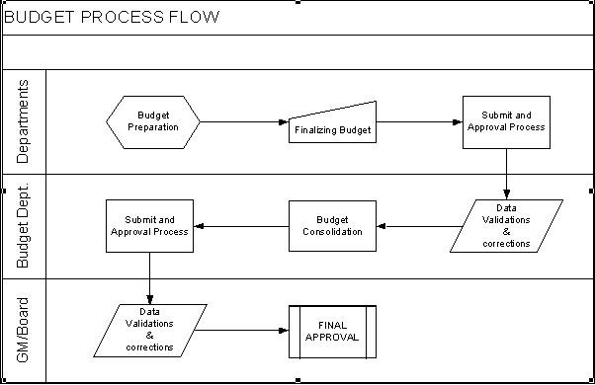
Fig. 1 - Budget Process Flow

ORION Budget User Manual Version 1.1 4



The overall process flow for the Budget module is as shown in the flowchart:


Creating Budget Period and Defining calender for the same

Creating Levels, Pulling Flow, Level Parameters

Approval Required ?
Define Authorised Yes Groups and Users
as per ORION Standards

No

Amendment After Approval?
Define
Yes Amendment Users as per
ORION Standards

No
Defining Budget Hierarchy

Budget Category Creation

Segment Setup, Applicable Hierarchy Setup

Budget Setup (Period Setup, Quantity / Value flags)

1) Document is modified by any user for any level until it is submitted.

2) After Approval, Document is amended if not pulled by the next level. (Based on the Amend After Approval Flag)

3) If Approval is required, only approved document of Child levels is pulled at the next level. If not required, all documents of the child level are pulled.

4) When pulled, a new set of records is created at higher levels.

5) Approver is allowed to add new records.

6)Next Approving Level includes details pulled from Entry level and also details added at lower approving level

7) Once the documents are pulled at higher level, lower level cannot be selected in new documents.

Budget Creation & Approval at Different Levels

No

Last Level of Budget

Submit, Yes Approval
Required

No
Submission and Approval Process as per ORION for the level

Approved Budget

Fig. 2 - Overall Budget Module Process Flow

ORION Budget User Manual Version 1.1 5



Masters The Masters in the Budget module include:
Ç Budget Period Ç Budget Level
Ç Budget Category Ç Budget Hierarchy
NOTE: Freeze check box - if this check box is selected in a screen/field, then that screen/record cannot be used further in the application.
Budget Period Master

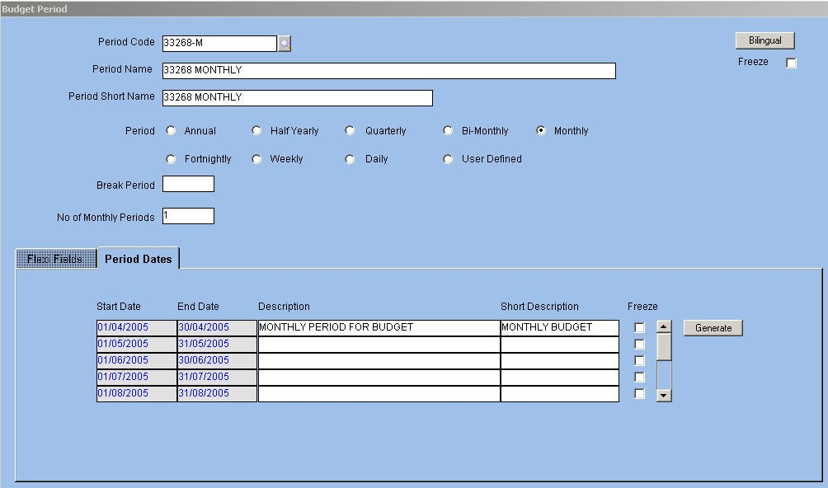
The period for which the budget is prepared is defined in the Budget Period master. The budgeting period is chosen from either system provided or user defined options. The default Budget Period in ORION is annual.
The Budget Period master is displayed below:

Fig. 3 - Budget Period Master VPeriod Code/Name/Short Name
Alphanumeric – 12
Enter or select from LOV a unique budget period code. Next, enter a name for the budget period that identifies it to the user. The application defaults the shorter version of the name for printing reports.
NOTE: Period Code cannot be deleted once Budget Setup is defined for the period or the period is used in a Budget transaction..

ORION Budget User Manual Version 1.1 6



VPeriod
Option Button Select the option button as applicable. The available options are:
Ç Annual
Ç Half yearly Ç Quarterly Ç Bi-monthly Ç Monthly
Ç Fortnightly Ç Weekly
Ç Daily

Ç User defined
The user is allowed to define only one period code for periods other than user-defined ones. VBreak Period
The application displays the default break period. The Break Period field accepts entries when Budget Period is user defined. In this case, Break Period is defined in days. The field is left blank when Budget Period is Annual, Half-yearly, Quarterly, Bi-monthly, or Monthly. When the period is Fortnightly, Weekly, or Daily, the application defaults the values 15, 7, and 1 respectively.
VNumber of Periods
Numeric – 2
When creating the budget, a period is further divided into Sub Period. Budget Category determines Period and Sub Period for the budget.
The total Budget Period is calculated as Budget Period * Number of Periods defined in the Period master.
Based on this definition, the first Break Period of the budget is identified. This field determines the total projection period for the budget. For example, if the first Break Period is fortnightly and the number of periods is 24 then the budget projection is for 24 fortnights or approximately one year.

ORION Budget User Manual Version 1.1 7



Period Dates
This tab displays the start and end dates of Budget Period in the ‘Start Date’ and ‘End Date’ fields. This auto-generation of dates is based on the Calendar created by clicking on the Generate button.


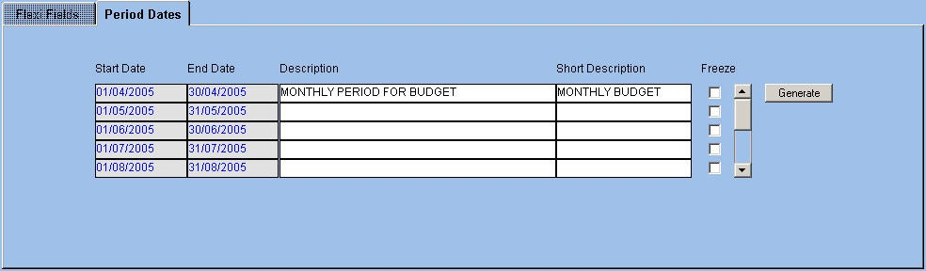
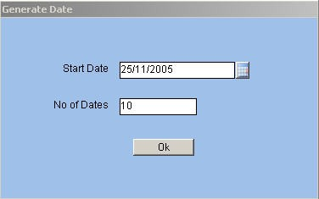
Fig. 4 - Period Dates Screen Description/Short Description
Alphanumeric – 240, 30
Enter a description for the period range in this field. A bilingual option is also provided. The application defaults the first 30 characters of the description in the adjacent field.
Generate
Button Click the button to create a calendar for the budget.
The Generate Date window is displayed as follows.

Fig. 5 - Generate Date Window VStart Date
Date Enter or select from LOV the start date for calendar generation in this field.

ORION Budget User Manual Version 1.1 8




VNumber of Dates
Date
Enter the number of dates for which the application is to display the period. If the period is set as Fortnightly and 5 is the entry for this field, ORION displays five fortnight periods in the Budget Period master.

ORION Budget User Manual Version 1.1 9



Budget Level Master
Each organization follows a pattern of levels for preparation of budgets. In some cases, users at the lower levels prepare the budget and send it to the next level for approval. Users at the next level approve the budget directly or modify the same. The budget then passes to the next higher level till it reaches the highest level for final approval. All these levels are linked to provide a hierarchy for budget approval. Some of the levels are given the authority to validate and correct the budget figures given by various departments. For example, an intermediary level is grouped into a Budgeting department.
The Budget Level master defines all levels involved in the budget process. Each level is then mapped to the ORION User/Group to define users allowed to enter the budget at each level.

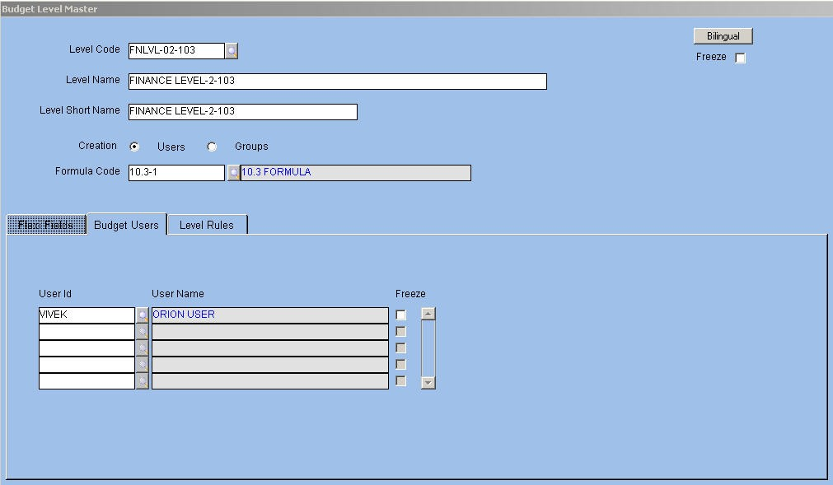
The Budget Level Master is displayed below.

Fig. 6 - Budget Level Master VLevel Code/Name/Short Name

Alphanumeric – 12

Enter or select from LOV a unique Level Code for the level in the hierarchy. This code cannot be duplicated. The code determines the approval and authorization rights for users of the budget document. Next, enter a name that denotes the level in the hierarchy. The application defaults the shorter version of the name for printing reports.
VCreation - Users/Groups
Option Button
Select the option button to assign a level each to an ORION user or group.
This option button is to determine the users applicable for the budget at the attached Level Code.
NOTE: Based on the logged in user or the group to which the logged-in user is assigned, data filter of the budget document occurs. Through data filter, budget creation is facilitated.

ORION Budget User Manual Version 1.1 10



VFormula Code
Alphanumeric – 12 Attach the Formula Code defined in the Formula master.
This code is attached to the topmost level or the parent level in the Budget Level master. In the case of a Top Down approach, the budget details are distributed across the child levels. The code is to determine the value at each child level.
Budget Users/Budget Group
The Budget Users/Budget Group tab label changes dynamically based on the option selected for the ‘Creation’ option button in the header block. This tab allows assigning users or groups to the selected Level Code. At this particular level, only the assigned users or groups are able to create and modify the budget.


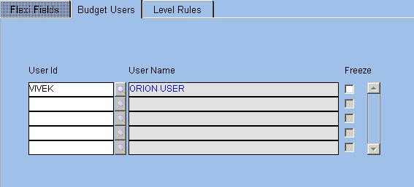
Fig. 7 - Budget Users/Groups Tab VUser Id/Group Code
Alphanumeric – 12
Enter or select from LOV the ID assigned to a particular user or group in this field. On selecting the User ID, the User Name gets automatically defaulted in the adjacent field.

ORION Budget User Manual Version 1.1 11



Level Rules
The tab allows the user to set amendment and authorization rules for transactions applicable to the Level code.
The Level Rules tab is displayed below.


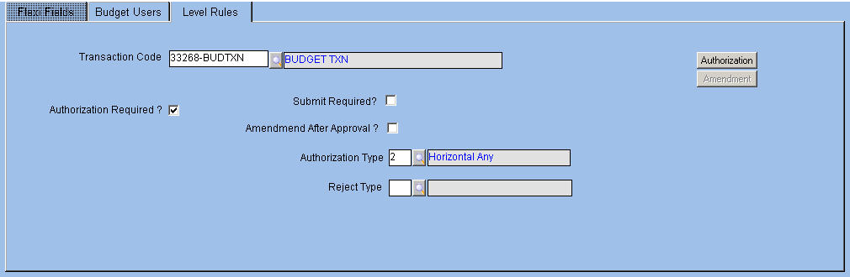
Fig. 8 - Level Rules Tab VTransaction Code
Alphanumeric – 12
Enter or select from LOV the Transaction Codes (defined in Transaction master) applicable for the level code. The application displays the description in the adjacent field.
Authorization Required?
Check box
Select the check box if authorization is required for the budget document against the chosen Transaction Code within the attached Level Code.
Submit Required?
Check box Select the check box if the budget document requires submission.
Amendment After Approval?
Check box Select the check box if the document is amendable after the approval is complete. VAuthorization Type
Numeric
Enter or select from LOV an authorization type. The available options are: Ç Horizontal Any
Ç Horizontal All Ç Vertical All
Ç Vertical Bypass
NOTE: This field is applicable only when the user selects the ‘Authorization Required’ check box.

ORION Budget User Manual Version 1.1 12



VReject Type
Alphanumeric – 12
If the attached Authorization Type is Vertical All or Vertical Bypass, then enter or select from the LOV an appropriate reject type. The available options are:
Ç Reject and Return to Beginning Level Ç Reject and Return to Previous Level.
Authorization
Button
Click the button to enter authorization details. The Transaction Code and its description are automatically displayed on entering this screen.
The Authorization window is displayed below.


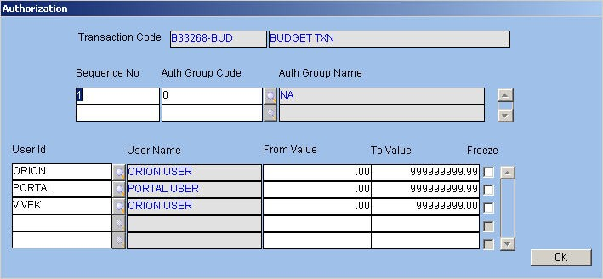
Fig. 9 - Authorization Window VSequence Number
Numeric Enter a sequence number. for the authorization
VAuthorization Group Code/Authorization Group Name Alphanumeric – 12
Enter or select from LOV the Authorization Group Code. Once a code is entered, the application displays the description in the adjacent field.
VUser ID/Name
Alphanumeric – 240
Enter the ID of the user belonging to the attached Authorization Group. Once a name is entered the description pertaining to it gets automatically displayed in the adjacent field.
VFrom and To Value
Numeric Enter the range of amounts of the budget that a particular user is authorized to approve.

ORION Budget User Manual Version 1.1 13



Amendment

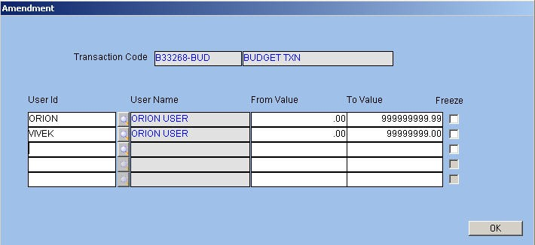
Numeric Click the button to define users who are allowed to amend the document after approval. The Amendment window is displayed below.

Fig. 10 - Amendment Window
For field-level explanation of this window, please refer the Authorization window.

ORION Budget User Manual Version 1.1 14

