


Formula Master
When the Budget Approach is Top Down, the Budget Details entered at the higher levels are distributed to the lower levels. In other words, the budget created at the Parent Levels is de-aggregated down to the child levels. In the Budgeting module, this distribution of Budget Details is done using formula defined in the Formula master. The formula created using the Formula master is attached to the Parent Level and defines the value at Child Level. The Formula Code is attached to a Level code in the Budget Level master.
The Formula master is displayed below.


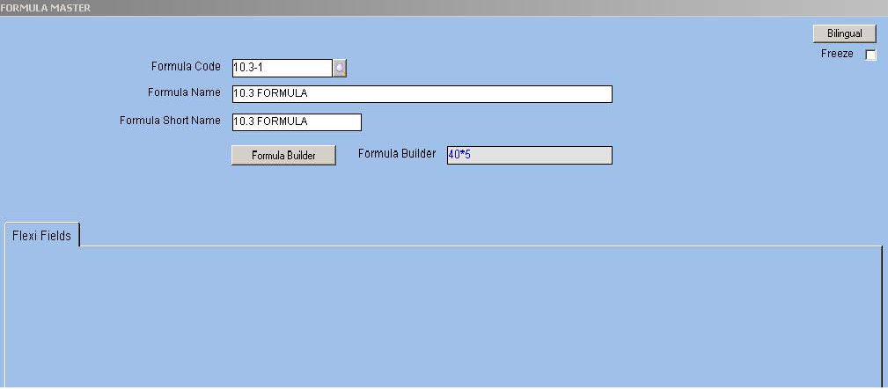
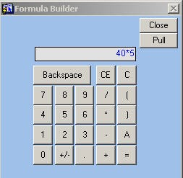
Fig. 11 - Formula Master VFormula Code/Name/Short Name
Alphanumeric – 12 Enter or select from the LOV a unique code to identify the formula in this field.
Formula Builder
Button Click the button to open the calculator window. This calculator builds the formula.

Fig. 12 - Formula Builder Window

ORION Budget User Manual Version 1.1 15



Buttons

Backspace

CE

C

0, 1, 2, 3, 4, 5, 6, 7, 8, 9

.

+/-

+, -, *, /

[,]

A

=

Usage

Deletes only one character at a time, the last entered character.

Clears the formula entered so far

Clears the formula entered so far

Includes the respective numerals in the formula being created

Includes the decimal point in the numerical

Toggles a positive value to a negative value and vice versa

Arithmetic operators to be embedded amongst the operands in the formula

Brackets to highlight precedence

Indicates a variable, the forecast value that is passed on to the lower level

None


Click the ‘Pull’ button to pull the formula into the ‘Formula Display’ field and the ‘Close’ button to close the Formula Builder.

ORION Budget User Manual Version 1.1 16



Budget Hierarchy Master
The Budget Hierarchy master interrelates levels to form a hierarchical structure for budget approval. This relationship is created based on Level Code and Parent Level Code. Further, the hierarchy is the basis to define the authority of the intermediary levels. For example, the intermediary level is given the authority only to pull and consolidate budget data but not add a new budget item or a new budget category at the same level.
The Budget Hierarchy master is displayed below.


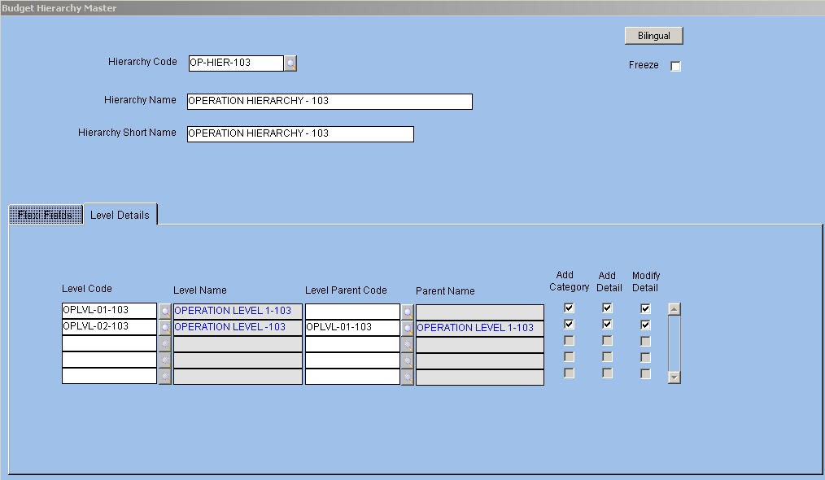
Fig. 13 - Budget Hierarchy Master VHierarchy Code/Name/Short Name
Alphanumeric – 12
Enter or select from the LOV a distinct code to denote the hierarchy. Next, enter a name for the hierarchy. The application defaults the shorter version of the name for printing reports.

ORION Budget User Manual Version 1.1 17



Level Details
This tab allows the user to build the hierarchy between Level Codes and to assign rights including category addition, detail addition and detail modification to each Level.
The Level Details tab is displayed below.


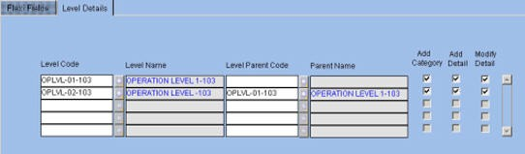
Fig. 14 - Level Details Tab VLevel Code
Alphanumeric – 12
Enter or select from LOV the required Level Code. The options available in the LOV are those defined in the Budget Level Master. The application automatically displays the name in the ‘Level Name’ field.
VLevel Parent Code
Alphanumeric – 12
Enter or select from LOV a code for Level Parent. The application automatically displays the name in the ‘Parent Name’ field.

NOTE:
Ç Each level is a child level to a parent. The level for which no parent code is attached is the top level in the hierarchy. The lowest level is when the level is not defined as parent for any subsequent level. Many such lowest level codes can exist.
Ç There can be only one record in the hierarchy with no parent code. The NULL value is allowed for this record.
Add Category
Check box Select the check box if the user is allowed to add a category at intermediate level.
Add Detail
Check box Select the check box if a user at a particular level is given rights to add details to the budget. Modify Detail
Check box
Select the check box if a user at a level is allowed to modify details entered by users at the child or parent levels. If the user does not have rights to carry out add, modify, or delete actions, then the Intermediate Level is able to only pull the values from lower or higher level and confirm the value. This signifies that changes in value or new addition at intermediate level are not allowed.

ORION Budget User Manual Version 1.1 18



Budget Category Master
Budget Category codes are created for Operations and Finance budgets. The hierarchy approach is also assigned simultaneously. Based on the nature of the Budget, applicable segments are assigned to the Budget category. Applicable segments are predefined for the group. For example, the applicable segments for Operations budget are Item Code, Grade Code, and so on. User-defined grouping for budget creation is also possible. For Finance budget, Main Account, Sub-account, Division, Department, and so on form the basis of grouping. The Finance budget is also user defined.
If Analysis Codes 1 to 20 are defined for Budget Category, then the application displays these in the Analysis Codes tab.
The Budget Category master is displayed as follows.


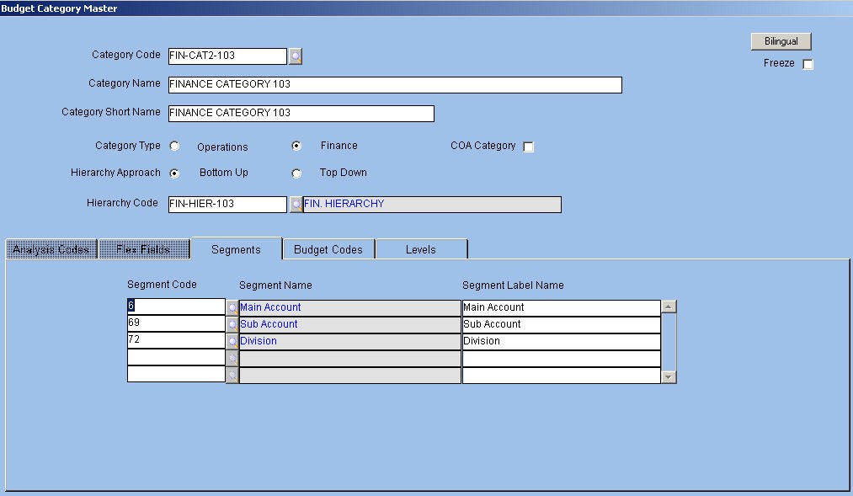
Fig. 15 - Budget Category Master VCategory Code/Name/Short Name
Alphanumeric-12, 240, 30
Enter or select from the LOV the required category code. Next enter a name for the category. The application defaults the shorter version of the name for printing reports
Category Type
Option Button Select the required Category Type from the available options, namely, Operations and Finance. Hierarchy Approach
Option Button
Select the required Hierarchy Approach from the available options, namely, Bottom Up or Top Down for creating budgeting level hierarchies.
NOTE:
Ç In the Bottom Up Approach, users at the lower levels enter the budget first and pass it on to users at the higher levels for consolidation.

ORION Budget User Manual Version 1.1 19



Ç In the Top Down Approach, the budget is created at the highest level.
Ç Users at the lower levels enter values less than or equal to the value entered at the higher level.
VHierarchy Code
Alphanumeric – 12 Enter or select from LOV a Hierarchy Code defined in the ‘Budget Hierarchy’ master. Segment
Click the tab to define segments that form part of Budget Category. The module permits 12 segments in each category. Budget is created for segments defined in the Budget Category setup. Once the category is set up and segments defined, no addition or deletion of the segments is possible if the category is used in the setup or in the Budget transaction. Select the segment as applicable.

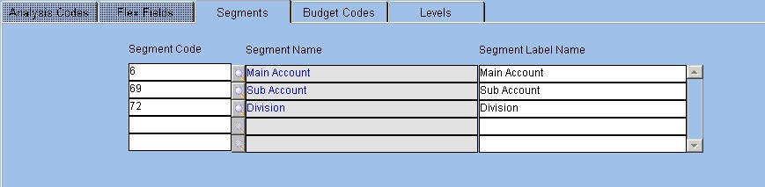
The Segment tab is displayed below.

Fig. 16 - Segment Tab VSegment Code/Name
Alphanumeric – 12
Enter or select from LOV a unique Segment Code defined in the System Value Set. Once a code is entered, the application displays the description in the adjacent field.
VSegment Label Name
Alphanumeric – 240 Enter the label to be displayed in the transaction form in this field.
The Segment values are distinct for the Operations and Finance budgets based on the chosen Category Type. Segments are not interchangeable and are created in the System value set. If a value is frozen in the value set, it is not available for selection.

ORION Budget User Manual Version 1.1 20




The predefined Segment Codes for the Finance category are as follows:

Segment Code

3

6

9

12

15

18

21

24

27

30

33

36

39

42

45

48

51

54

57

60

63

66

69

72

75

78

81

84

87

90

93

96

ORION Budget User Manual
Segment Description

Main Account Category

Main Account

Main Account Classification 01

Main Account Classification 02

Main Account Classification 03

Main Account Classification 04

Main Account Classification 05

Main Account Classification 06

Main Account Classification 07

Main Account Classification 08

Main Account Classification 09

Main Account Classification 10

Main Account Classification 11

Main Account Classification 12

Main Account Classification 13

Main Account Classification 14

Main Account Classification 15

Main Account Classification 16

Main Account Classification 17

Main Account Classification 18

Main Account Classification 19

Main Account Classification 20

Sub Account

Division

Division Classification 01

Division Classification 02

Division Classification 03

Division Classification 04

Division Classification 05

Division Classification 06

Division Classification 07

Division Classification 08

Version 1.1 21




99 Division Classification 09

102 Division Classification 10

105 Division Classification 11

108 Division Classification 12

111 Division Classification 13

114 Division Classification 14

117 Division Classification 15

120 Division Classification 16

123 Division Classification 17

126 Division Classification 18

129 Division Classification 19

132 Division Classification 20

135 Department

138 Analysis - 01

141 Analysis - 02

144 Activity - 01

147 Activity - 02

Similarly, the preset value sets for the Operations category are as follows:

Segment Code

3

6

9

12

15

18

21

24

27

30

33

36

39

42

45

ORION Budget User Manual
Segment Description

Location Type

Location Code

Location Analysis 01

Location Analysis 02

Location Analysis 03

Location Analysis 04

Location Analysis 05

Location Analysis 06

Location Analysis 07

Location Analysis 08

Location Analysis 09

Location Analysis 10

Location Analysis 11

Location Analysis 12

Location Analysis 13

Version 1.1 22




48

51

54

57

60

63

66

69

72

75

78

81

84

87

90

93

96

99

102

105

108

111

114

117

120

123

126

129

132

135

138

141

144

147

ORION Budget User Manual
Location Analysis 14

Location Analysis 15

Location Analysis 16

Location Analysis 17

Location Analysis 18

Location Analysis 19

Location Analysis 20

Supplier Code

Supplier Analysis 01

Supplier Analysis 02

Supplier Analysis 03

Supplier Analysis 04

Supplier Analysis 05

Supplier Analysis 06

Supplier Analysis 07

Supplier Analysis 08

Supplier Analysis 09

Supplier Analysis 10

Supplier Analysis 11

Supplier Analysis 12

Supplier Analysis 13

Supplier Analysis 14

Supplier Analysis 15

Supplier Analysis 16

Supplier Analysis 17

Supplier Analysis 18

Supplier Analysis 19

Supplier Analysis 20

Item Code

Grade Code 1

Grade Code 2

Item GL Code

Job Charge Area

Employee Charge Area

Version 1.1 23




150 Cost Centre Charge Area

153 Supplier Charge Area

156 Location Charge Area

159 Customer Charge Area

162 Charge Code

165 Item Analysis 01

168 Item Analysis 02

171 Item Analysis 03

174 Item Analysis 04

177 Item Analysis 05

180 Item Analysis 06

183 Item Analysis 07

186 Item Analysis 08

189 Item Analysis 09

192 Item Analysis 10

195 Item Analysis 11

198 Item Analysis 12

201 Item Analysis 13

204 Item Analysis 14

207 Item Analysis 15

210 Item Analysis 16

213 Item Analysis 17

216 Item Analysis 18

219 Item Analysis 19

222 Item Analysis 20

225 Country

228 State

231 County

234 City

237 Sector

ORION Budget User Manual Version 1.1 24



The system values are displayed as follows:


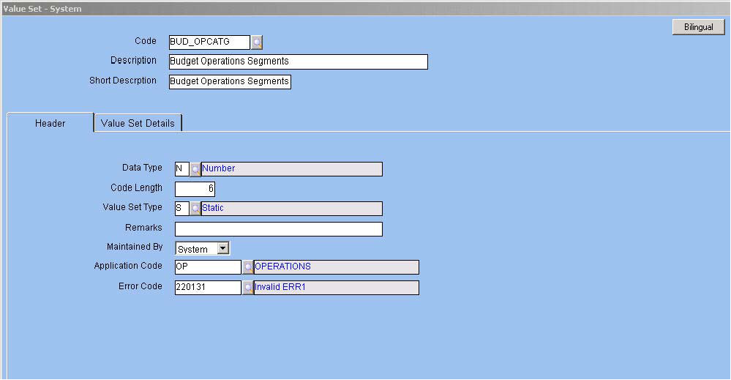
Fig. 17 – Value set System Screen
There are conditions that govern the selection of Segment Codes. They are:
Ç Item GL Code/Item Analysis Code is not selected with Item Code
Ç Location Type/Location Analysis Code is not selected with Location Code Ç Supplier Analysis Code is not selected with Supplier Code
Ç Division Classification Code is not combined with Division Code
Ç Main Account Classification Code is not selected with Main Account Code Ç To select Charge Code, select multiple Charge Area Segments
Ç Main Account is selected if Sub Account and Activity Code are also included
Ç Department Segment Code is selected if Division Segment Code is also selected Ç Main Account Category is not selected with Main Account Code

ORION Budget User Manual Version 1.1 25



Budget Codes
The tab aids in grouping values of each category into Budget Codes. In this tab, the user defines the category-wise Budget Codes and their descriptions.
The Budget Codes Tab is displayed below.


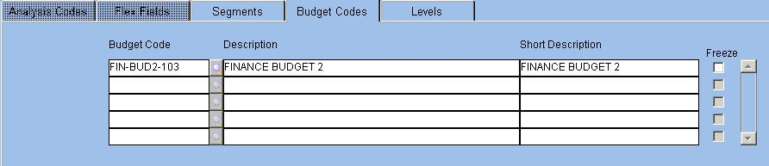
Fig. 17 - Budget Codes Screen VBudget Code/Description
Alphanumeric – 12, 240
Enter or select from the LOV a unique code for the budget as defined in the Budget Code master. Next, enter a description for the budget. The application defaults the shorter version of the description for reporting purposes.

ORION Budget User Manual Version 1.1 26



Levels
Click the tab to view the hierarchy levels at which the budget is entered for the selected category. The hierarchy tree is displayed based on Hierarchy Code attached to the category. The tree starts at the topmost level.
The Level tab is displayed as follows.


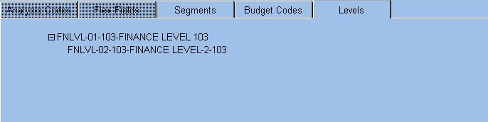
Fig. 18 - Level Tab

ORION Budget User Manual Version 1.1 27



Finance Budget Rules
Budget Rules for Finance Category are applicable for the GL transaction entry and batch processing of transactions.
Points differentiating Finance Budget Rules from Operations Budget Rules include:
Ç The budget is applicable only at the document level in the Applicable at field because each document is considered as a GL entry.
Ç This leads to the allocation of budget in Finance Category through the GL transaction entry. The utilization of the budget is calculated after posting of entries.
Select the ‘Check Budget at Posting’ check box to verify and allocate Finance Budget. The other check boxes are:
Check Budget at Entry – The budget amount is validated when the GL entry is passed using the GL Transaction Entry screen

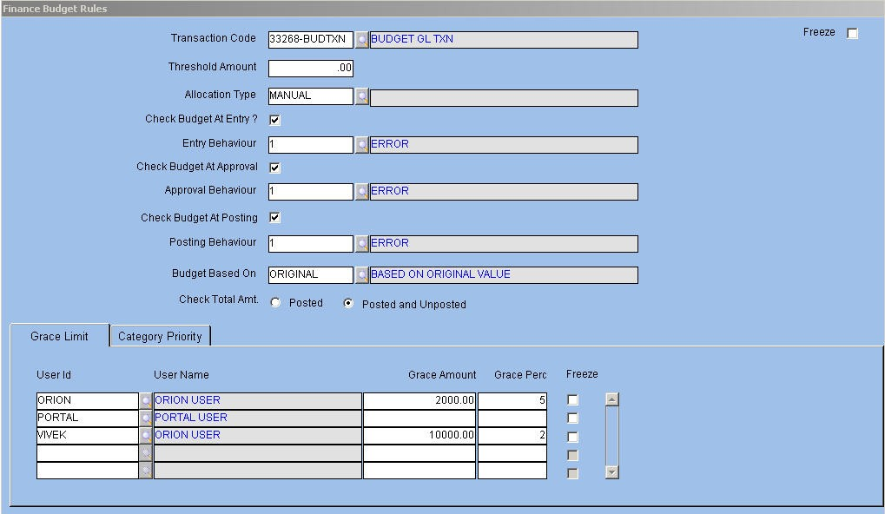
Check Budget at Approval –Allows budget allocation and control at the time of approval The Finance Budget Rules master is displayed as follows.

Fig. 19 -Finance Budget Rules Master
For field level explanation of this master, please refer the Budget Rules Setup in General Ledger module.

ORION Budget User Manual Version 1.1 28



Operations Budget Rules – Purchase Requisition
Operations Budget Rules for purchase requisition are defined in ORION company wise and transaction wise. Once the budget is approved, utilization of the budget amount and control of the same occurs through the Purchase Requisition transaction.
The Operations Budget Rules master is displayed as follows.


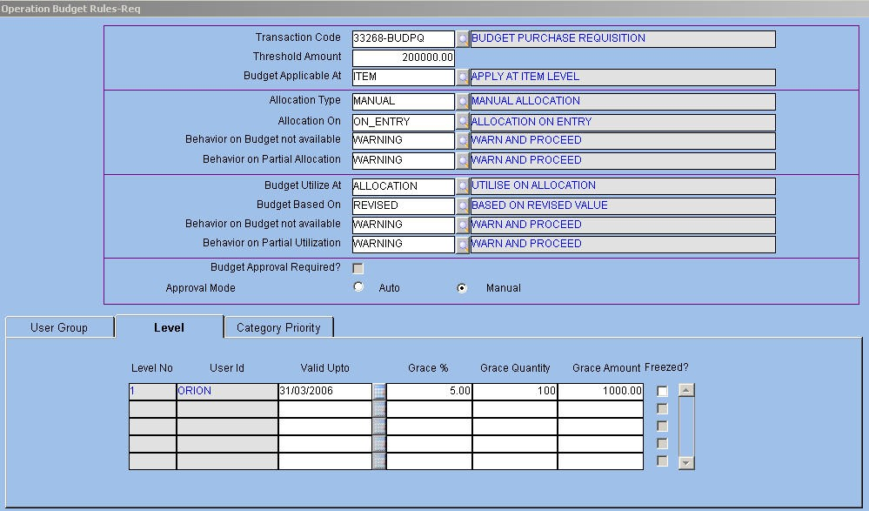
For field level explanation of Category Priority Tab, please refer the Operation Budget Rules PO master in Budget module and Budget Rules master in Procurement module

ORION Budget User Manual Version 1.1 29

