


Operations Budget Rules – PO
Operations Budget Rules for Purchase Order (PO) are defined company wise and transaction wise. Once the budget is approved, utilization of the budget amount and control of the same occurs through the PO transaction.
The parameters defined for Operations Budget Rules, which are pulled when the transaction form is loaded, are displayed in the following screenshot:


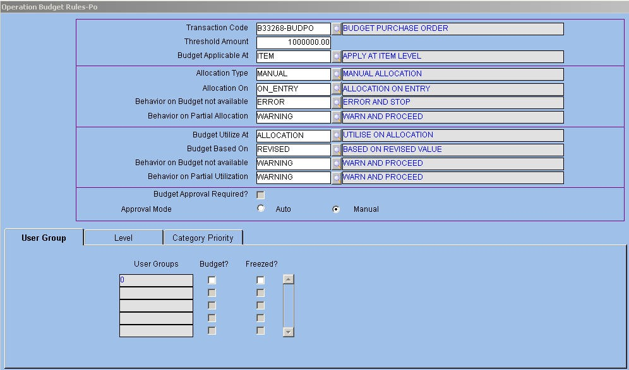
Fig. 20 - Operations Budget Rules – PO Master VTransaction Code
Alphanumeric – 12 Enter or select from LOV the transaction code for PO transition.
VThreshold Amount
Numeric
Enter the threshold amount for the budget. The transaction permits allocation, utilization and control of budget only when the document amount is above the threshold amount.
V Budget Applicable At
Alphanumeric – 12 Enter or select from LOV the level at which the budget is applicable. The valid values are:
Ç Item or Detail level – budget information is entered for each item
Ç Document level – budget information is entered only at the Document level and not at the Item level.
VAllocation Type
Alphanumeric – 12
Enter or select from the LOV the allocation type applicable to the budget in this field. The valid values are:
ORION Budget User Manual Version 1.1 30



Ç Not Required - does not allocate the budget to any item or document. Therefore, utilization does not take place.
Ç Automatic - automatically allocates the budget at the Item or Document level. The prioritization of the budget categories is required for ORION to do the allocation. When the transaction needs budget allocation, ORION chooses the first category where budget is allocated.
Ç Manual - Budget Category Code is entered in the header and Budget Details in the Details block when Allocation Type is manual. Next, based on Setup, click the Allocate button to allocate the budget.
Based on Category Code entered in the header block, select the PO details, Budget Description, Budget Code, applicable segments for the selected category, and the available Quantity or Value of the item.
Category Priority

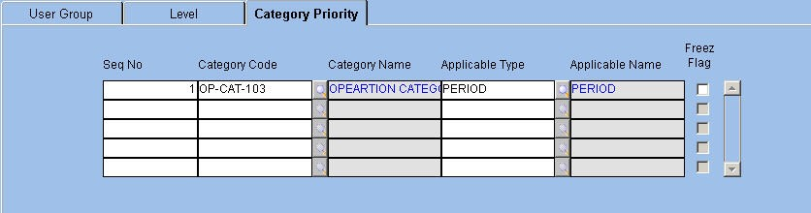
Budget Rules are attached to Budget Categories in a sequential manner. Click the Category Priority tab to define categories applicable for PO. In case allocation is automatic, the application verifies the priority assigned to categories by sequence number so as to identify the category against which budget allocation is required.
Based on the applicable type defined for the category, budget control is done at the Detail, Period, or Sub Period levels.
The Category Priority Tab is displayed as follows.

Fig. 21 - Category Priority Tab
For further information on Operations Budget Rules – PO, please refer the Budget Rules master in Procurement module.

ORION Budget User Manual Version 1.1 31



Setups Budget Category Setup
This Setup screen links Period, Sub Period, and Category Segment Values defined in the Budget Category master. These Periods and Sub-periods are defined using Period Codes that take up the application-defined period type values such as Annual, Half Yearly, Quarterly, Monthly, Fortnightly, Weekly and Daily.
The application validates Period and Sub-period on the basis of these values. For user-defined periods and Daily, Weekly and Fortnightly periods, the break period in days is used. For Annual and user-defined combination, the Annual period is broken up into days based on the Standard Number of Days company parameter.

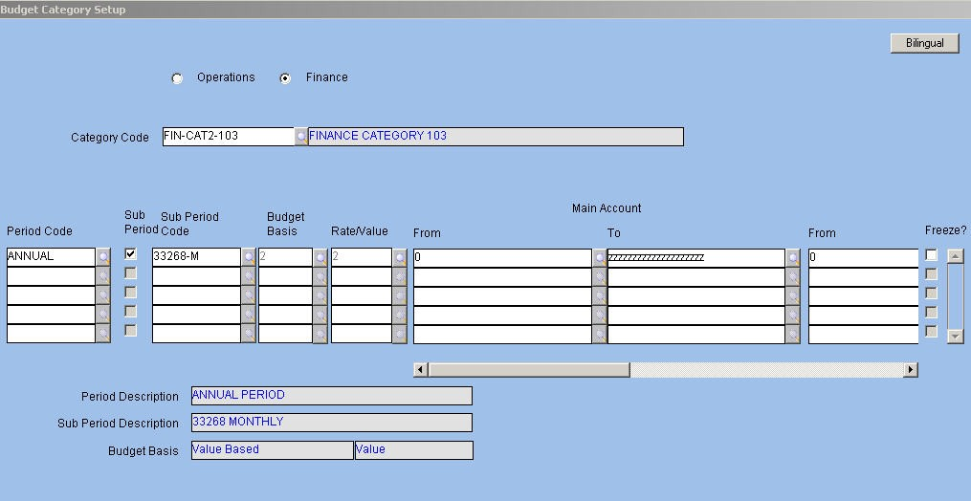
Moreover, for each of the defined Segment Values, the Budget Category setup determines if the budget for segments is quantity based, value based or Both. This is defined by specifying budget basis. When Budget Basis is Both, the Rate or Value flag determines whether the users enter Rate or Value. If the user enters Rate, the value is computed and the reverse is also true. The user sets the applicable values for the segments corresponding to the Category code from LOV and assigns to the Category code, period wise.
NOTE: Category is to be previously defined in the Category master.

Fig. 22 - Budget Category Setup VCategory Type
Option Button Select the Category Type option button as Operations or Finance.
VCategory Code
Alphanumeric – 12
Enter or select from LOV the category code as defined in the Category master. Once a code is entered the Description pertaining to it gets defaulted in the adjacent field.

ORION Budget User Manual Version 1.1 32



VPeriod Code
Alphanumeric – 12
Enter or select from LOV the period code as defined in the Budget Period master. The application displays the name in the ‘Period Description’ field.
VSub Period
Alphanumeric – 1 Select the check box to enable entry of Sub Period Code. Sub Period is optional.
VSub Period Code
Alphanumeric – 12
Enter or select from LOV the sub period as defined in the Budget Period master. Once a code is entered, the application displays the description in the ‘Sub Period Description’ field.

NOTE: The sub period entered should be less than the Period. If the period is fortnightly, Sub-period is to be Weekly or Daily.
VBudget Basis
Numeric
Enter or select from LOV the basis for budget as defined in the Category master. The available options are:
Ç Quantity – only Quantity is entered Ç Value – Only Value is entered
Ç Both – Budget is based on both Quantity and Value. Whether you enter rate to obtain value or enter value to obtain rate is determined by defining the Rate or Value flag.
NOTE: Budget Basis is modifiable to Quantity and Both only when Item Code is defined as a segment. Otherwise, Value is the default entry.
Once the basis is entered, the application displays the description in the ‘Budget Basis’ field. ‘VRate/Value
Numeric
Fields related to Rate or Value get enabled or disabled based on choice of the Rate/Value Flag when the Budget Basis is Both.
VLocation Code From/To
Alphanumeric – 12 Enter or select from LOV a range of locations defined for the Category Code.
NOTE: Depending on segments defined in the Category master for the selected Category Code, the segment field labels are displayed.

ORION Budget User Manual Version 1.1 33



Budget Transaction Setup
The Budget Transaction setup consists of transaction parameters pertaining to the Budget module.
In this module, the approval and amendment rules are derived from the Budget Level master. Therefore, generic parameters related to approval and amendment are inapplicable to this module. Likewise, only two values; namely, C and M are applicable for document generation in the Budget module.
The Budget Transaction Setup screen is displayed below.


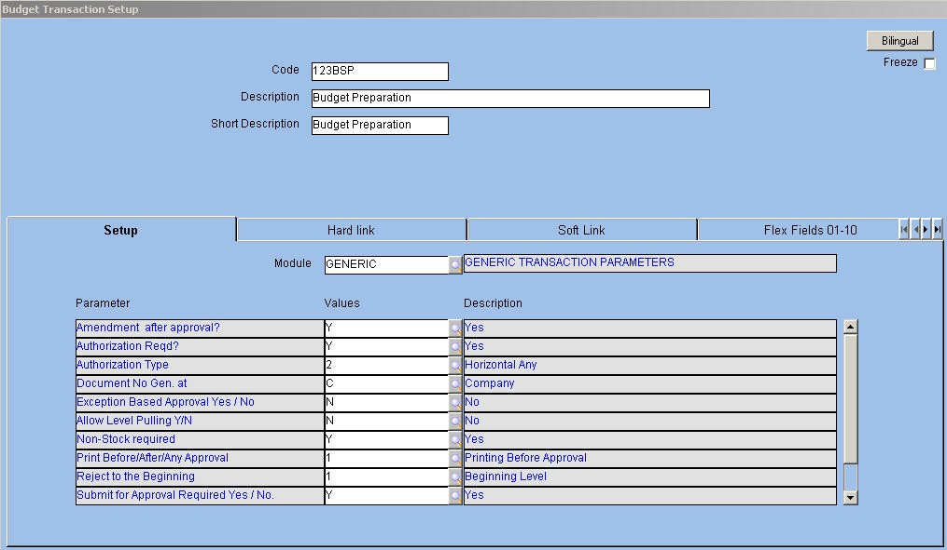
Fig. 23 - Budget Transaction Setup VAllow Level Pulling Y/N
Alphanumeric – 1
When this parameter is set to Y, the higher levels are allowed to pull budgets entered by the child levels and the intermediary levels pull budgets entered by both the higher and lower levels.
NOTE: This is set to Y for the Budget Addition, Modification and Deletion transactions.
VTransaction Operation
Alphanumeric – 1 The value of this parameter differs according to the transaction. Values are as follows:
Ç P - for budget creation or preparation transaction Ç A - for budget addition
Ç D - for budget deletion
Ç M - for budget modification

ORION Budget User Manual Version 1.1 34



Budget Code Setup
Budget Code setup enables the grouping of budget details. A set of Segment Values defined for a category is assigned to a Budget Code. When creating the budget, enter Budget Code and click the ‘Pull’ button to pull all segments defined in the Budget Code setup into the Budget Creation form. This process reduces data entry.
The Budget code setup is displayed as follows.


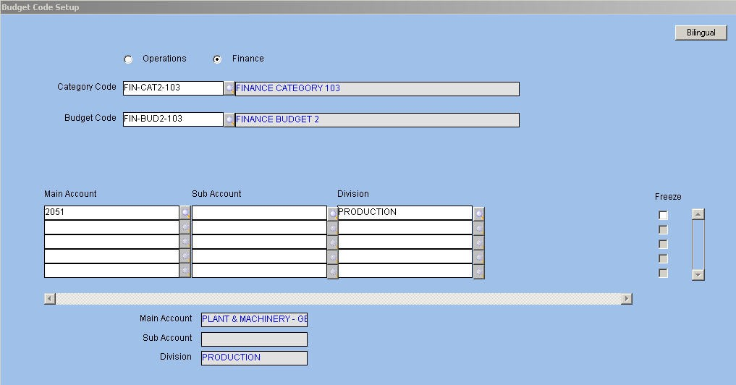
Fig. 24 - Budget Code Setup VCategory Type
Option Button Select the Category Type option button as Operations or Finance.
VCategory Code
Alphanumeric – 12
Enter or select from the LOV the required category code. The application displays the description in the adjacent field.
VBudget Code
Alphanumeric – 12
Enter or select from the LOV the Budget Code associated with the selected Category Code in this field. The application displays the description in the adjacent field.
NOTE: Once Category Code and Budget Code are selected; the application displays segments with appropriate labels based on segments defined in the Category master. For example, Location Code, Item Code, Grade Code 1 and Grade Code 2 being segments of the category, the form displays these segments.

ORION Budget User Manual Version 1.1 35



VLocation Code
Alphanumeric – 20 Enter or select from the LOV the code of the location.
VItem Code
Alphanumeric – 20 Enter or choose from the LOV the item code.
VGrade Code 1 and 2
Alphanumeric – 20 Enter or select from the LOV the Grade Code 1 and 2 values in their respective fields.
VJob Charge Area

Alphanumeric – 20 Enter or select from the LOV the charge area to which the job is assigned.
Once a code is entered in each of these fields the description pertaining to them get automatically displayed in their respective Description fields.
The following transactions relate to a budget: Ç Budget Entry and Approval
Ç Budget Deletion Ç Budget Addition
Ç Budget Modification

ORION Budget User Manual Version 1.1 36



Transactions Budget Entry and Approval - Operations
The entry and approval of budget is dependent on the approach defined in the Category master. Budget Entry is based on levels where users at each level have different rights to enter or approve the budget depending on the selected Budget Category Code and Level Code. Further entry and approval is allowed when a budget entry exists for the immediate child or the level is permitted to include categories in the budget starting at the intermediary level.
Segments on which the budget is defined are determined once Budget Category is selected. Labels for the Detail fields are determined based on segments selected for the category and the label defined for each of the segments.

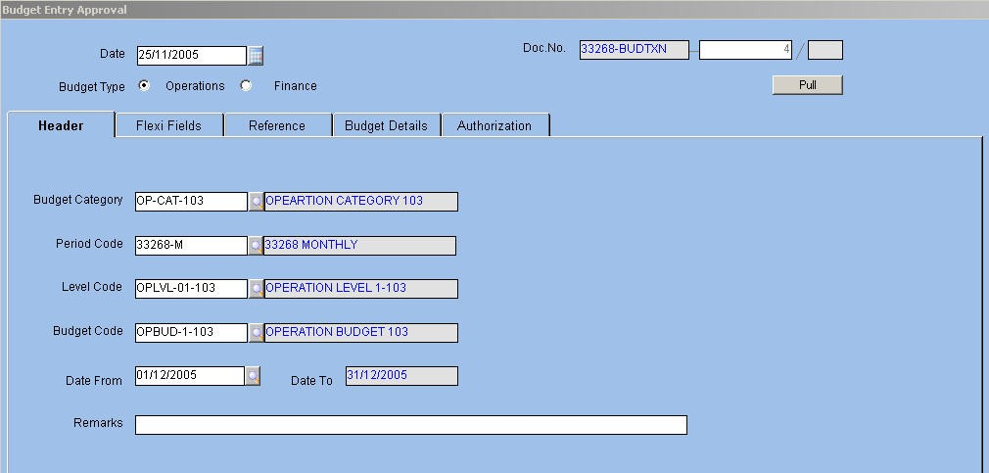
NOTE: Budget Category is not modified once set-up is complete and budget entry for a category is created. Segments once defined are not altered. Additionally, changes in Level Codes are not possible.
The Budget Entry and Approval transaction screen is displayed as follows.

Fig. 25 - Budget Entry and Approval Transaction - Operations The system date is defaulted as the Budget Document Date in the Date field.
The document number is system generated and displayed in the Document Number field. VBudget Type
Option Button Select the required Budget Type from the available options – Operations and Finance. VBudget Category
Alphanumeric – 12
Enter or select from the LOV the code of Budget Category defined in the Category master. Once a code is entered the description pertaining to it gets displayed in the adjacent field.
NOTE: Categories appearing in LOV depend on the Budget Type. If Operations is selected as Budget Type, the application permits only those categories with Category Type as Operations.

ORION Budget User Manual Version 1.1 37



VPeriod Code
Alphanumeric – 12
Enter or choose from LOV the code of the Budget Period. The options available in the LOV are related to the budget category selected in the previous field.
VDate From and To
Date
Enter or select from the Calendar help the budget commencement date related to the selected Period Code. The applicable dates are created or auto generated in the Period master for the selected period using Calendar. Based on the date entered in this field and the Period Code, the budget completion date gets auto generated. The number of periods defined in the Budget Category setup is used to calculate the ending date of the budget.

For example, the budget projection is until 31/1/07 for a half-yearly budget period if the beginning date is 1/1/05 and the number of periods is 3.
NOTE: The Budget Category, Period Code, Date From, and Level Code combination needs to be unique.
VLevel Code
Alphanumeric – 12
Enter or select from the LOV the required hierarchy code defined in the Budget Hierarchy master. Level Codes are related to the attached Budget Category. Select only those levels that are defined for Hierarchy Code attached to the selected category. Each level is linked to a set of users or groups. ORION displays in LOV only those Level Codes that are applicable to the logged-in user. The rights of the users are defined in the Budget Level master.
Moreover, depending on the Top Down or Bottom Up approach selected in the Category master, the Budget Entry level is the lowest or the highest.
VBudget Code
Alphanumeric – 12
Enter or select from the LOV the Budget Code in this field. Next, click the ‘Pull’ button to pull Segment Values related to Budget Code defined in the Budget Code Setup.
VRemarks
Alphanumeric – 2000 Enter remarks related to fields.
NOTE: The Detail Flex button is enabled when the Budget Details Flex fields is set up.

ORION Budget User Manual Version 1.1 38



Reference
Click the tab to view Budget Codes duplicated from the header block. Modify these if required. The Reference Tab is displayed as follows.


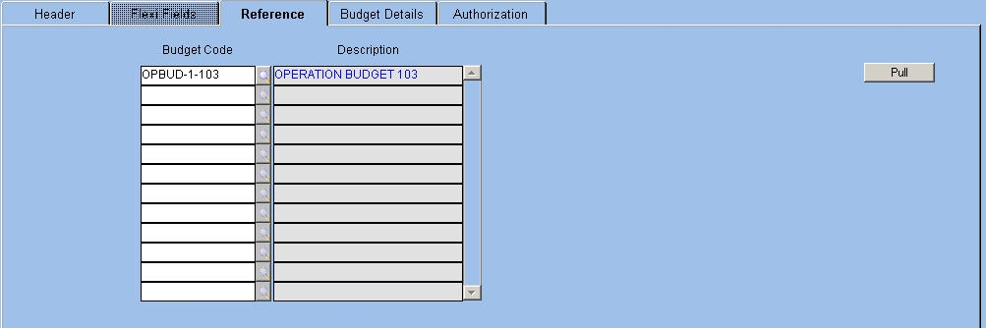
Fig. 26 - Reference Tab VBudget Code
Alphanumeric – 12
When the user pulls the budget details from the Budget Code setup by entering Budget Code in the header, the record is copied in the Reference block and segments are pulled into the Budget Details tab.
If more records need to be pulled for other Budget Codes, enter Budget Code in the Reference block and click the ‘Pull’ button in this block.
Budget Details
Click the tab to enter details based on Budget Category and Level Code. If the approach defined in the category is Bottom Up then pull Segments for the lowest level from the Budget Code setup or enter them manually. For higher-level codes, the application pulls details along with quantity/value based on the selected category and level. Additionally, the fields are displayed and labeled as defined in the Budget Category Setup. Therefore, these fields are dynamic.
For example, Budget Category has Item Code, Grade Code 1, and Grade Code 2 as segments in the Budget Category setup. These fields are then displayed with the default values of Grade Code 1 and 2, which in turn are enabled or disabled depending on the Grade Code 1 and Grade Code 2 Required transaction parameter in the Item master

ORION Budget User Manual Version 1.1 39



The Budget Details tab is displayed as follows.


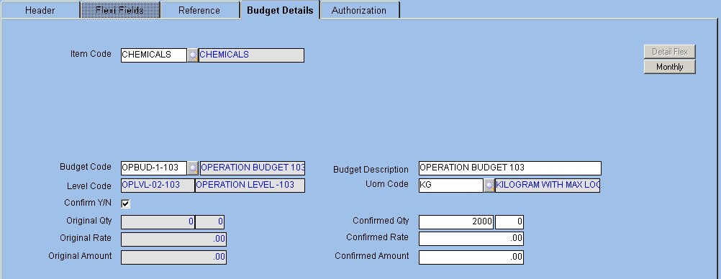
Fig. 27 - Budget Details Tab VBudget Code
Alphanumeric – 12
The Budget Code specified in the header block gets defaulted in this field, which can be modified if required. The description of this code gets defaulted in the adjacent field. The field is left blank if Budget Reports are not required.
VBudget Description
Alphanumeric -– 240
Enter the description for each budget in this field. If budget details are pulled from the Budget Code Setup then the application displays the description in the ‘Budget Code Description’ field.
VLevel Code
The application displays the child levels of the selected Parent Level Code in the header block. VUOM Code
Alphanumeric-12
Enter or select from LOV the currency code. The application displays the description in the adjacent field. The UOM Code field is visible only when Item Code is one of the segments defined in the Category and the Budget Category Setup is Quantity-based or BOTH. This field is enabled or disabled based on the UOM Can Be Modified Y/N transaction parameter.

ORION Budget User Manual Version 1.1 40



The valid values for a budget are:
Quantity-based - Limiting the quantity for the Operations item controls budget. A value cannot be entered when Quantity is the basis. This is applicable in the Operations budget if Item Code is one of the segments.
Value-based - Controlling the value controls the budget. Quantity cannot be entered when value is selected as basis.
BOTH - Both quantity and value are used for control purposes. This is applicable in the Operations budget if Item Code is one of the segments.
Confirm Y/N
Check box

Select the check box to confirm the original quantity, rate and value entered by users at the child levels. If the record is entered by any of the other levels, the check box is to be selected. If pulled from higher or lower level, it is to be cleared. The current level validates the Confirm block to determine whether the details are accepted at the current level or not.
VOriginal Quantity
The application displays the quantity entered by users. If the Top Down approach is the basis, the parent level users enter this field and if the approach is Bottom Up, the child levels enter this field.
Original Rate
The application displays the rate entered by users. The child level users enter the rate in case of Bottom Up approach and parent level users enter the rate for Top Down approach.
Original Amount
The application displays the original amount as entered by users at the child levels for Bottom Up approach and parent level users for Top Down approach.
Confirmed Quantity
The consolidated quantity that appears on clicking the ‘Monthly’ button is pulled. The quantity is set to 0.00 by default.
Confirmed Rate
The confirmed rate that appears on clicking the ‘Monthly’ button is pulled. Users at the parent level or child levels depending on the Top Down or Bottom Up approach confirm the rate. The rate is set to 0.00 by default.
Confirmed Amount
The amount confirmed by the users at the parent or child levels depending on the Top Down or Bottom Up approach is pulled. The amount is set to 0.00 by default.
Period
Button
Click the button to enter Sub Period and the budget basis defined in the Budget Period setup. It is optional to enter the Sub Period details. The label of the Period button changes as per the chosen Budget Period to Weekly, Fortnightly, and so on.
If the Sub Period breakup is required, the value entered as Confirmed Amount in the period level is equally disbursed among Sub Periods. For example, if Confirmed Amount is INR 60,000 then each Sub Period is given INR 20,000.

ORION Budget User Manual Version 1.1 41



Monthly Break-up
Click the Period button to view the breakup in the Monthly Breakup pop-up window. This breakup depends on the chosen Budget Period. The Original Quantity, Rate and Amount fields are displayed along with the Confirmed Quantity, Rate and Amount fields, which are amendable.
The Monthly Break-up Window is displayed below.


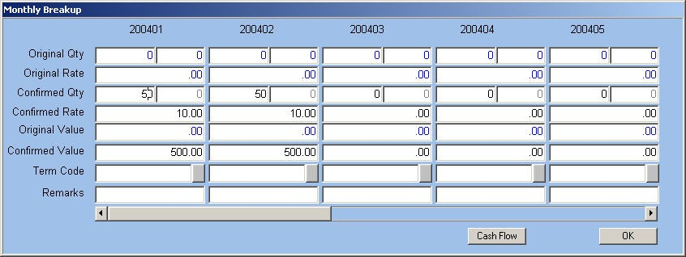
Fig. 28 - Monthly Break-up Window VTerm Code
Alphanumeric – 12
Enter or select from LOV the term code as attached to Budget Period. This is used to determine the cash flow for Budget Period.

ORION Budget User Manual Version 1.1 42



Cash Flow
Button
Click the button to project the cash flow for a future period based on the input values during budget creation. The input values are the budgeted expenses and credit term in the form of term code for these expenses.
The Cash Flow Window is displayed below.


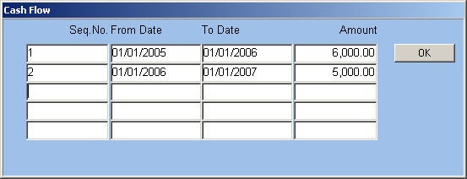
Fig. 29 - Cash Flow Window
NOTE: Term Code and Cash Flow are enabled only when Budget Basis is Value or Both.
When Term Code is attached at the Period level, the application generates the information required for cash flow. When Term Code is not used, enter values in fields. The cash flow is determined for each record and needs to match with the overall cash flow.
VSequence Number
Numeric Enter the sequence number of the record.
VFrom Date/To
Date Enter the date range for which cash flow is to be determined.
VAmount
Numeric Enter the amount that is projected as expenses for the specified period.

ORION Budget User Manual Version 1.1 43



Budget Entry and Approval - Finance
The Finance Budget is created when the Budget Category is chosen as Finance and the Category Code is applicable to the Finance Budget. The Categories related to the Finance budget and the defined segments are filtered. The segments that are applicable for the Finance budget category codes are Main Account, Sub Account, Division and Department. The Finance budget is also user-defined and includes segments as per user needs.
Budget Entry and Approval for the Finance budget is as follows:
Main Account Type determines values entered in the Main Account Code field. The valid values for Account Types are:
Ç A – Asset Ç L – Liability

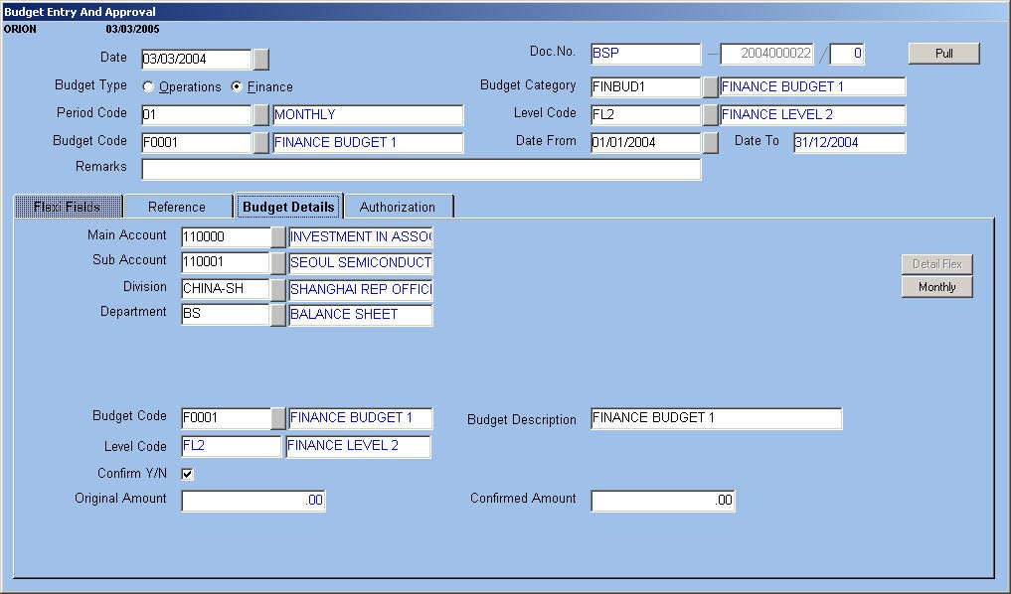
Ç E – Expense Ç I – Income
The Expense and Asset Account types are debited while the Income and Liability Account types are credited in financial entry.
The Budget Entry and Approval Transaction for Finance is displayed below.

Fig. 30 – Budget Entry and Approval Transaction
For the Finance budget, enter Confirmed Amount in the Budget Details tab. Similar to the Operations Budget entry, this Confirmed Amount is apportioned to Periods and Sub Periods. In case you pull the budget details from the child levels, the application pulls the Period and Sub Period amounts or values. Changes in Confirmed Amount or Value in the budget details are reflected as new values in Periods and Sub Periods.

ORION Budget User Manual Version 1.1 44

