


Budget Addition/Modification/Deletion
It is possible to add, modify and delete budget details after final approval of the budget by the users at the highest level. These actions are controlled by various transaction parameters.
Budget Allocation displays all existing categories in the budget for modification and deletion. The new category option enables users to make additions.
The Level Rules Setup is the basis to pull levels. Enter Level Code only when you require to pull levels. In such a case, rights applicable to a concerned level determine the details and authorization of the performed action.
When this authorization of the budget is mandatory without the need for level pulling, use authorization parameters such as Authorization Required Y/N, Amend after Approval Y/N and Authorization and Amendment Groups/Users from Transaction Setup.

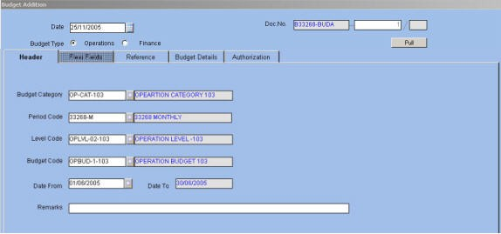
The end result of budget addition, modification and deletion is an approved budget document. Budget Addition
New categories and details related to the category and for a specific period are added through the Budget Addition window. Click the ‘Monthly’ button to view the monthly breakup details of the budget. Similarly, to view the details of cash flow for a particular period, click ‘Cash Flow’ button.
The Budget Addition Transaction screen is displayed below.

Fig. 31 - Budget Addition Screen
The application verifies if these details already exist. If existing, it displays an error message and does not allow the user to make entries.
Budget Modification
Budget modification is based on the Budget Category, Budget Period, and the Date (From) fields. When all the above fields are entered, ORION displays budget details such as Segment Values, Budget Detail Flexi fields, Budget Code and Budget Description.
Select the budget details to be modified. These details are displayed with the available quantity and value. Modify the Quantity and Value fields using the Quantity/Value Flag option. Enter a value greater than or equal to zero. This value is either negative or positive.
The Cash Flow details are also amendable if available. Modification of cash flow ensures that this amount tallies with the revised budget amount.

ORION Budget User Manual Version 1.1 45




Budget Deletion
For Budget Deletion, the revised Quantity or Value fields are defaulted to zero after deletion. A negative sign is placed next to the available quantity. For example, available quantity of 1000 when revised to –1000 implies zero budget. Similarly, the Cash Flow amount is also set to zero.

ORION Budget User Manual Version 1.1 46



GL Transaction Entry
The allocation of budget is done in Finance through the GL transaction entry. Finance Budget Rules are applicable to this entry.


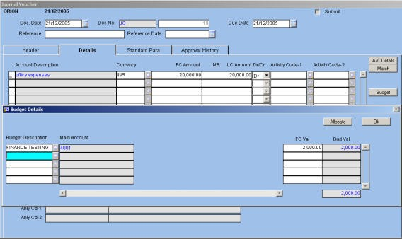
Fig. 32 - GL Transaction Entry Screen
Enter the account, amount, and debit or credit details in the Details tab. Based on the selected Budget Category Code and values specified in the Details tab, enter the budget details.
If the allocation type is manual, click the ‘Budget’ button to enter budget allocation details. Enter or select from LOV the Budget Description, Budget Code and segments. Click LOV to view the available budget details.
Next, enter the amount to be allocated and click ‘Allocate’ button. Repeat the process for all lines in the Details tab. Completed entries in a GL transaction are displayed in the main GL Transaction screen.

ORION Budget User Manual Version 1.1 47



Purchase Requisition
Once the budget is approved, the consumption of the budget is done in Operations through the PRQ transaction. Budget Rules set in ‘Operations Budget Rules for PRQ’ are applied to the transaction.
In the Budget module when the ‘Applicable At’ field is selected at the Item level and Allocation Type is Manual, Budget Category Code is entered in the header. Additionally, enter the Budget Quantity and Budget Value fields depending on Budget Basis for the selected Budget Segments. Click the ‘Item Budget’ button to enter the budget details. Once fields in the ‘Item Details’ tab are entered, the budget details are captured in the ‘Document Budget’ field with the Segment Codes appearing as per the selected Category Code.
The Purchase Requisition transaction screen is displayed below.


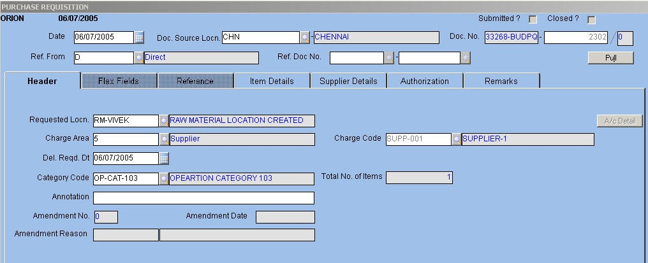
Fig. 34 - Purchase Requisition Transaction
When the ‘Applicable At’ field is set to the Item level and Allocation Type is Automatic, the application defaults the Budget Description, Budget Code, Quantity and Value fields and segments such as Location Code and Item Code depending on the code entered in the Transaction Code field in the header block. This way, the budget is automatically allocated when the requisition is saved.
NOTE:
Ç If the basis is Quantity, only the Quantity field is entered. Ç If the basis is Value, only the budget value is entered.
Ç If the budget basis is Both, both quantity and value are selected for budget availability.

ORION Budget User Manual Version 1.1 48



In the ‘Item Details’ tab, enter the quantity to be purchased and the loose quantity as per UOM defined at Item level.


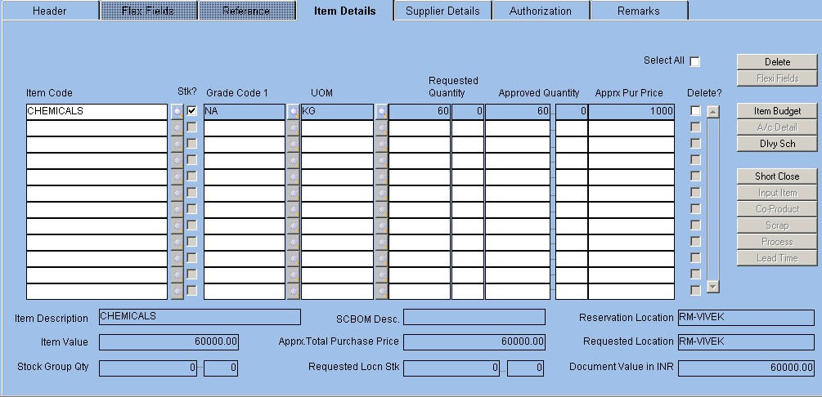
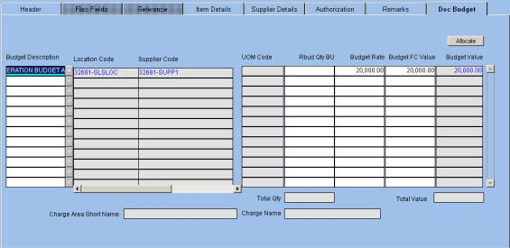
Fig. 35 - Item Details Tab
When the ‘Applicable At’ field is selected at the Document level, Budget Category Code is entered at the header and the budget details are displayed in the Document Budget tab. Additionally, you view Base UOM. The quantity to be purchased is entered only in Base UOM.
Click the ‘Allocate’ button for the application to allocate the quantity and value based on the budget details and Budget Basis.
The Document Budget tab is displayed below.

Fig. 36 - Document Budget Tab Related Topics: Purchase Requisition Transaction in Purchase module.

ORION Budget User Manual Version 1.1 49



Purchase Order
Purchase Order (PO) is prepared based on quotations received from vendors offering the requisite supplies. PO is sent to the Inventory department as well as the Accounts department for verification. The latter makes use of PO to process the purchase transactions and allocate the budget amount for a purchase.
The allocation of budget for PO transactions is similar to the purchase requisition transactions. The user enters the Budget Category Code in the header block and the budget details in the Item Budget window when options are at the Item level and allocation is of type Manual.
The PO transaction screen is displayed below.


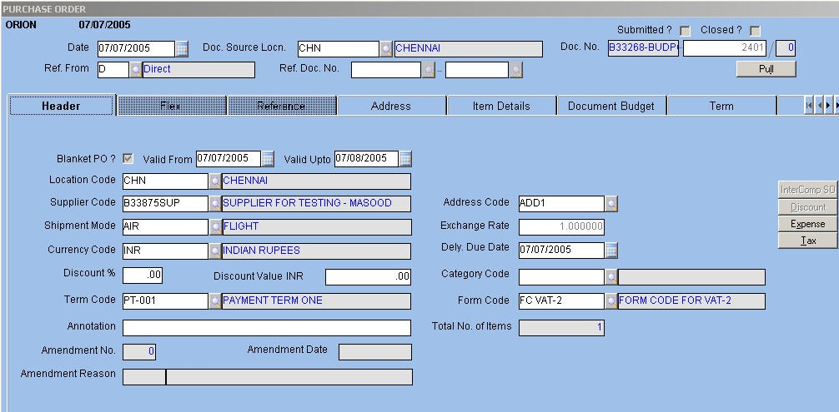
Fig. 37 - PO Transaction
For field-level explanation of the purchase requisition and PO screens, please refer the Purchase module.

ORION Budget User Manual Version 1.1 50



Budget Transfer Pre-requisite:
Ç For the Budget Transfer transaction to be enabled, set the Carry Forward / Transfer? Transaction parameter to ‘1’, denoting transfer.
Ç For negative balance to be transferred, set the Transfer Negative Balance Y/N transfer parameter to ‘Y’.
The transfer transactions allows the user to transfer budget quantity or amount to another record, period or sub period once the budget is prepared and approved,
Budget Transfer is possible on the following levels:
Ç One to One – One budget detail to the other

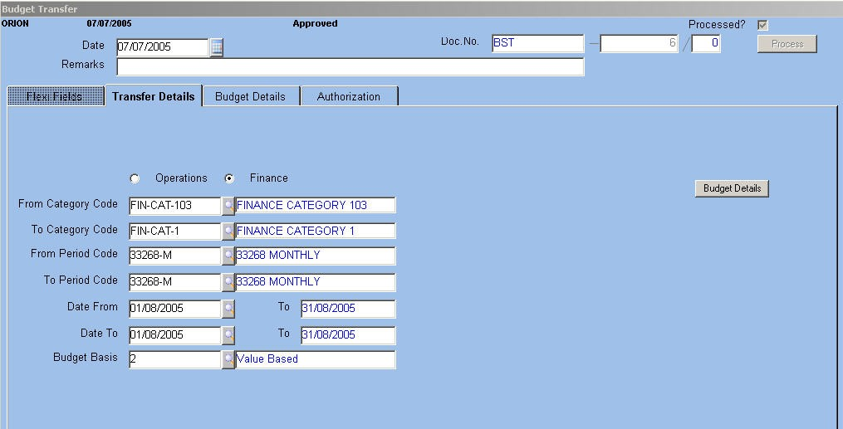
Ç One to Many – One Budget detail to more than one Budget detail Ç Many to One – Multiple Budget details into a single budget detail Ç Many to Many
The screen allows a single transaction to handle One to One, One to Many and Many to One transfers. However, for the Many to Many transfer, a contra entry is necessary.
The contra entry is where a dummy budget is created for facilitating the transfer. The multiple values to be transferred are first to a single budget (many to one) and then the dummy budget is transferred to multiple budgets (one to many).
For example, item Values A, B, C, D need to be transferred to E, F, G, H.
Instead of transferring directly, transfer the Values of A, B, C, D into Z item (dummy entry) and then transfer the value from Z (-) to E, F, G, H.
The Budget Transfer transaction screen is displayed below.

Fig. 38 – Budget Transfer Transaction Date
The application defaults the system date. To modify, enter the date of budget transfer.

ORION Budget User Manual Version 1.1 51



Document Number
The application displays the document number with the amendment counter, if any.

Remarks

Enter remarks pertaining to the transfer if any. Transfer Details
Budget Type

Select the option button as per the applicable budget type. From and To Category Codes

Alphanumeric – 12

Option Button

Alphanumeric-12


Enter the range of category codes to be transferred. The LOV is populated with the codes applicable to the chosen budget type.
NOTE: If the From and To category codes are the same, it is mandatory that the Period Codes are different.
From and To Period Code
Numeric
The application defaults the Period To field if only one period is defined for the selected category code.
Date From and To
Dates
Enter or select from LOV the starting and ending dates within the selected periods for transferring the budget amounts.
NOTE: Transfer from Current Period to Past Period is not possible. The module supports transfers from current period to current period, current to future, future to current, future to future, past to future.
Budget Basis
Numeric
Enter or select from LOV the basis of the budget. The applicable values are: Ç 1 – quantity based
Ç 2 – Value Based Ç 3 – Both
NOTE: When saving the transfer details, the applicable displays an error message if the Value based budget is transferred to a quantity based or BOTH budget. The converse too is not allowed.
Budget Details
Click the Budget Details button once you fill in all the fields. This tab comprises two parts – Transfer From and Transfer To. The Transfer From part is populated with the following details:
Ä Budget Code and description

ORION Budget User Manual Version 1.1 52



Ä Segments applicable to the chosen budget category – in the screenshot, the Main Account Segment and its description are displayed
Ä The total budget amount available for transfer

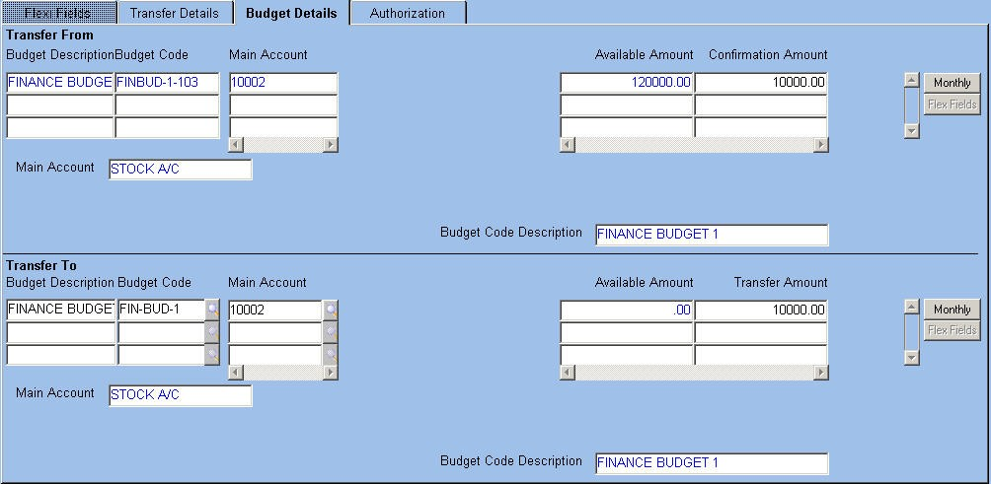
Ä The user is allowed to do full or partial transfer of the available budget amount. The Details tab is displayed below.

Fig. 39 – Budget Details Tab of Budget Transfer Confirmation Amount
Numeric
Enter the actual amount to be transferred from one budget to another. Of the available amount, the user is allowed to transfer completely or partially.
Monthly
Button
Click the button to view the break-up details of the transferable amount. The user is able to see the allocation of the entire amount across months.
NOTE: The Button label is dynamic and changes as per the chosen Period Code.
In the Transfer To part, the application defaults the details from the previous tab. The user is allowed to modify any of the defaulted fields. For example, the budget code to which the amount is to be transferred is modifiable.
The application defaults the following details: Ä Budget Code and description
Ä Segments applicable to the category code
Ä The transfer amount (defaulted from the Transfer To part) Click the Process button to complete the transfer process. Authorization
The tab displays details of the users who authorized the transfer. The Authorization tab is displayed below:

ORION Budget User Manual Version 1.1 53



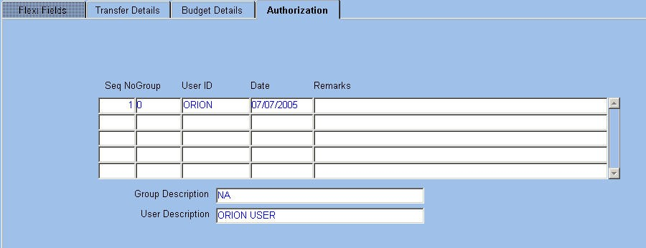

Fig. 40 – Authorization Tab of Budget Transfer The application displays the following details:
Ä Sequence number
Ä Group to which the authorized users belong and its description Ä ID of the authorized user and description
Ä Date of authorization
The user is allowed to enter any remarks pertaining to the transfer. Budget Transfer for Operations Budget
The transfer mechanism for Operations budget is similar to the Finance budget. A few variances are listed below:
In case Item Code, Grade Code 1 and Grade Code 2 are segments of the category, the application defaults the Grade Code 1 and 2 values based on the Item Code.
NOTE: The Grade Code 1 and Grade Code 2 Required transaction parameter setting determines the enabling/ disabling of the fields.
When Item Code is one of the segments, the UOM and Budget Basis are defaulted. The user is able to enter the UOM only if Budget is Quantity based or Both
When the budget transfer is saved, the budget summary is updated. In case document approval is required, the adjustment amount in budget summary is updated when the document is approved.

ORION Budget User Manual Version 1.1 54



Budget Carry Forward Prerequisite:
Set the Carry Forward/Transfer transaction parameter to C
The application allows carrying forward of available budget amounts and other details from one period to another. The user is allowed to transfer only positive budget balance.
The Budget Carry Forward transaction screen is displayed as follows.


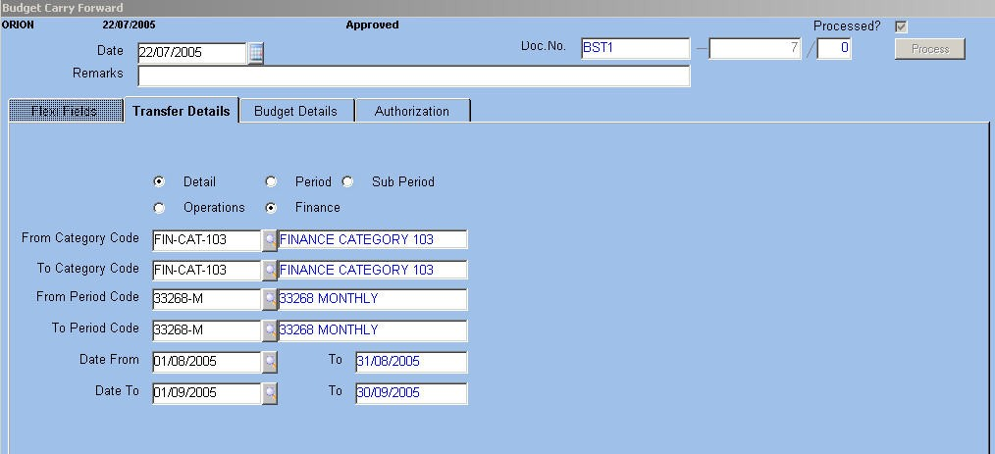
Fig. 41 – Budget Carry Forward transaction The application allows carry forward of budgets at the following levels
Ä Budget Detail Level – all budget details are carried forward including entries in the Period, Sub Period and Cash Flow blocks
Ä Period Level – amount/quantity is carried forward from one period to the other along with the Sub Period and Cash Flow details
Ä Sub Period Level –amount/quantity is carried forward from one Sub Period to another provided Sub Period is defined.
The Category From and Category To fields need to be the same. The application defaults the Category To field based on data entered in the Category From field.. It is the same for the Period Code To field.
Date To
Date
Enter a future date compared to the Date From field.
NOTE: Partial carry forward of budget quantity/amount is not possible. The segments and budget basis are automatically defaulted
For field level explanation of the Budget Details and Authorization tabs, please refer the Budget Transfer transaction.

ORION Budget User Manual Version 1.1 55



Processing Transaction Processing
Transaction processing or posting is done for both single and batch transactions. During batch processing, all the unprocessed transactions are submitted for processing. Once processed, these cannot be modified except by introduction of additional vouchers to effect changes.
Select the ‘Check Budget on Posting’ check box for the application to validate the budget at the time of posting. This validation is either in GL or in the Batch Posting screen.
The Finance Budget Rules screen is displayed below.


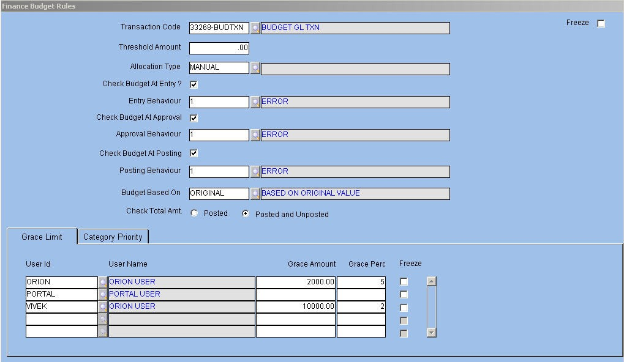
Fig. 42 – Finance Budget Rules Master
Processing of transactions impacts balances of accounts, and the transaction is visible in various reports pertaining to Trial Balance, Balance Sheet, Profit and Loss Statement, GL and Daybook.
The Transaction Processing screen is displayed below.

ORION Budget User Manual Version 1.1 56




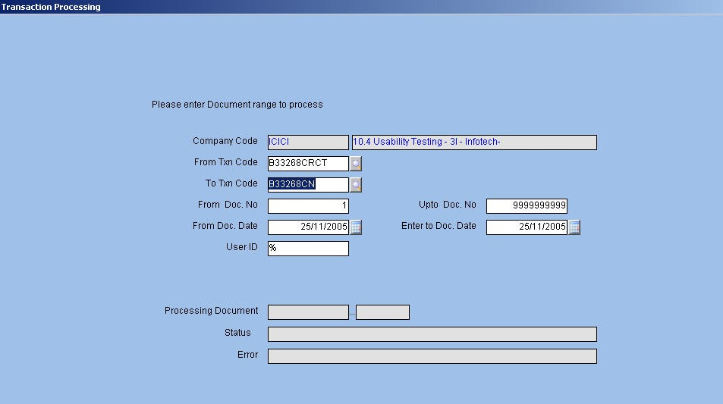
Fig. 43 - Transaction Processing Screen
The code of the logged in company and its description get defaulted in the Company Code field on entering this screen.
VTransaction Code From/To
Alphanumeric – 2 Enter or select from the LOV the codes of the range of transaction that is to be processed. VDocument Number From/To
Alphanumeric – 10 Enter the range of document numbers for which the transaction is to be processed.
V Document Date From/To
Date Enter or select from LOV the start and end document dates of transactions. VUser ID
Alphanumeric – 12
Enter the Id of the user whose documents need to be processed. To process the documents of all applicable users of the logged-in company, enter a percentage symbol, which is the default value.
The following fields are populated with details on processing a transaction: Ç The document code and number of the processed transaction
Ç The status of the transaction
Ç Errors, if occurred during transaction processing

ORION Budget User Manual Version 1.1 57

