NOVAC Technology Solutions



Business Requirement Document

For

System Parameter

Definition

Revision History

Version No. | Date | Reason For Changes | Author | Reviewer | Approver
0.1 | 26-02-2026 | System Parameter | J.S. Loganathan | S Ram Prasad | S Ram Prasad
0.1.1 | 02-03-2026 | +Add Parameter Removed and Mapping icon in Figma Changed  P-2 | J.S. Loganathan | S Ram Prasad | S Ram Prasad

Table of Contents
1. Introduction 2
2. Functional Requirements 2
2.1 System Parameter Listing 2
2.2 System Parameter Mapping 3
3. Interface Requirements 5
Internal Interfaces 5
3.1.1 Hardware Interface 5
3.1.2 Software Interface 5
3.1.3 Communication Interface 5
3.1.4 External Interfaces 5
3.1.4.1 Hardware Interface 5
3.1.4.2 Software Interface 5
3.1.4.3 Communication Interface 5
Operating Environment Requirement 6
3.1.5 Hardware Requirements 6
3.1.6 Software Requirements 6
3.1.7 Network Requirements 6
3.1.8 Operational scenarios: 6
Non Functional Requirements (NFR) 6
3.1.9 Reliability 6
3.1.10 Performance 6
3.1.11 Security 6
3.1.12 Usability 6
3.1.13 Other Requirements 6
Open Issues 6
Acceptance Criteria 6
4. Appendix A 7

Introduction
A system parameter is a configurable control value defined within the application that governs system behavior, operational rules, or processing logic at runtime without requiring code modification or redeployment. System parameters enable controlled configuration, flexibility, and environment-specific adjustments while maintaining application stability and integrity.
System Parameter Figma:
https://www.figma.com/proto/vHwccSheU4Hdad6iVrmcuw/Master-Part-4?page-id=375%3A8392&node-id=36526-7426&viewport=614%2C255%2C0.04&t=Z8aA5hlqO8J9yALH-8&scaling=scale-down&content-scaling=fixed&hide-ui=1

Functional Requirements
The System Parameter will provide:
- Enable dynamic configuration of system behavior.
- Reduce dependency on technical deployments for configuration changes.
- Improve governance and auditability of configuration changes.
- Minimize operational risk due to manual or undocumented changes.

2.1 System Parameter Listing
The System Parameter menu shall provide a centralized interface for viewing, editing and mapping all configurable system parameters.
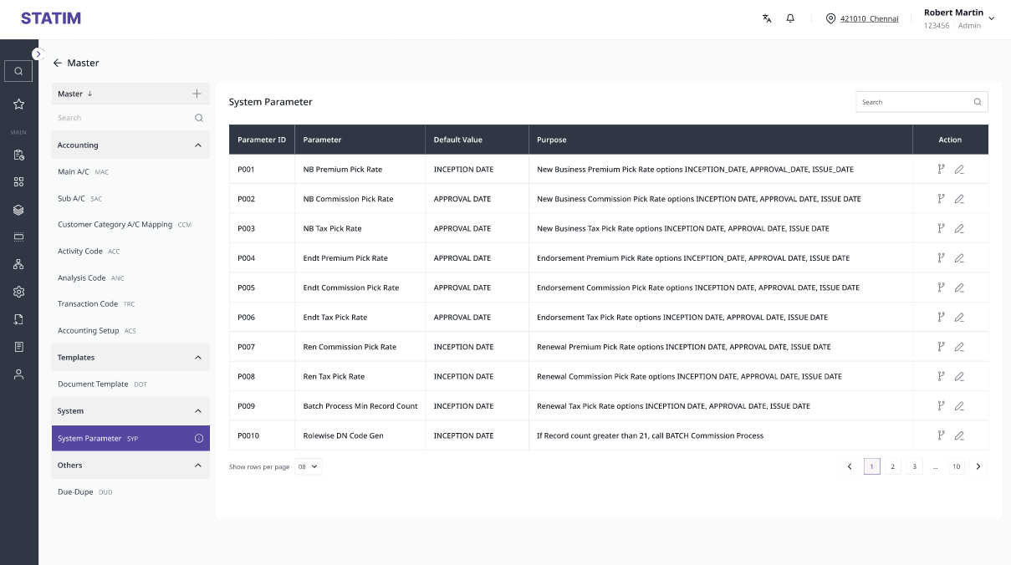
System Parameter - Listing

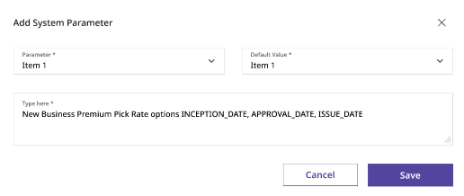 System Parameter - Edit

The System Parameter screen shall provide a search feature that enables users to filter and display parameter records based on user-entered search criteria (e.g., Parameter, Default value, or Purpose).
Provide inline editing in the System Paramter.
S. No. | Field Name | Field Type | Field Source | Validations/Remarks
1 | Param ID (Hidden in the Edit popup) | Default (Backend) | System Generated through backend | Auto Generated system ID once the record is Saved and will be listed only in the Listing and Label in the mapping.
2 | Parameter* | Default (Backend) | Entry will be created through backend | Mandatory field.  Non-Modifiable via edit option
3 | Default Value* | Default (Backend) | Entry will be created through backend | Mandatory field.  Modifiable via edit option
4 | Purpose* | Default (Backend) | Entry will be created through backend | Mandatory field.  Modifiable via edit option
5 | Map | Icon |  | To map the Parameter with the combinations of Company, COB, LOB, Channel, Product and parameter value.
6 | Edit | Icon |  | To Edit the Default Value and/or Purpose

**Please note that, in Edit mode only Default Value and Pupose will be allowed to modify. Parameter should not be allowed to be changed once it is created.

2.2 System Parameter Mapping
Users can associate a system parameter with a combinations of below:
- Company
- COB
- LOB
- Channel
- Product Code
- Parameter Value

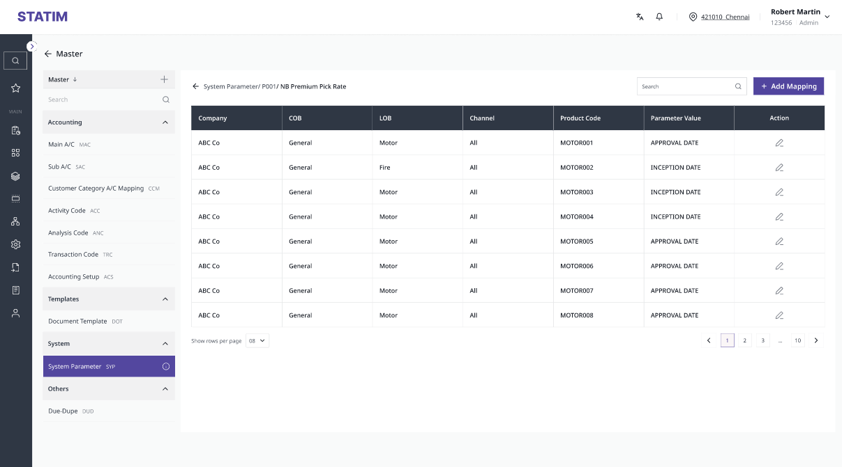 Mapping Listing

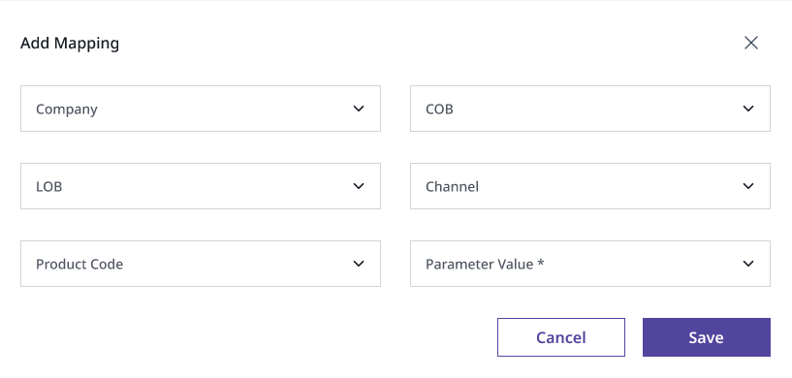
System Parameter + Add Mapping

S. No. | Field Name | Field Type | Field Source | Validations/Remarks
1 | Company | Dropdown | Values fetched from Company Master | Non-Mandatory field
2 | COB | Dropdown | Values fetched from COB Master | Non-Mandatory field
3 | LOB | Dropdown | Values fetched from LOB Master | Non-Mandatory field
4 | Channel | Dropdown | Values fetched from the Common Codes – Channel (Multi-Select) | Non-Mandatory field
5 | Product Code | Dropdown | Values fetched from the Product Configurator  (Multi-Select) | Non-Mandatory field.  List of approved products in the Product Configurator as per Company, COB, LOB and Channel combinations to be shown.  When multiple values selected in the Add popup window, records should be created individually.
8 | Parameter Value* | Dropdown | Values shown from the backend | Mandatory field.
9 | Cancel | Button |  | Cancel the changes made
10 | Save | Button |  | Save the details with auto generated Param ID

Please note that, in Edit mode only Parameter Value will be allowed to modify. Any other column should not be allowed to be changed once it is created.
When we choose multi-select, each and every combination should be created as an individual row in the mapping.
**Audit Log to be maintained at the back end for the creation, modification of Parameter and its mapping at the Header and Mapping level.

Assumptions:
The System Parameter Master shall function as a centralized configuration repository applicable to all system modules. Business logic and module-specific functionalities shall be controlled and driven by the parameter values defined within this master. Any change in an applicable system parameter value shall influence system behavior in accordance with the defined configuration rules.

Interface Requirements

Internal Interfaces

Hardware Interface
<Not Applicable>

Software Interface
<Not Applicable>

Communication Interface
<Not Applicable>

External Interfaces

Hardware Interface
<Not Applicable>

Software Interface
<Not Applicable>

Communication Interface
<Not Applicable>

Operating Environment Requirement
<Not Applicable>

Hardware Requirements
<Not Applicable>

Software Requirements
<Not Applicable>

Network Requirements
<Not Applicable>

Operational scenarios:
<Not Applicable>

Non Functional Requirements (NFR)

Reliability
<Not Applicable>

Performance
<Not Applicable>

Security
<Not Applicable>

Usability
<Not Applicable>

Other Requirements
<Not Applicable>

Open Issues
<Not Applicable>

Acceptance Criteria
- Functional testing will be executed by internal testing team, and the same will be delivered to client for UAT.

Appendix A
Find the attached Parameter and its applicable Parameter values for reference so far.
Please note that new paramaters and values will be provided by Product team, in case if it is required for any new functionality/modifications to the existing functionality.

