

STATIM 2.0
UAT Process Standard
Client: YAS Takaful
Version 0.1 (Draft)
Prepared by: Novac Technology Solutions
Strictly Confidential

Document Control

Revision History
Version | Date | Prepared By | Reviewed By | Approved By | Description of Changes
0.1 | 03-Jul-2026 | Sriram Ramkumar (QA Manager) |  |  | Initial Draft for review

Review & Approval
Role | Name | Organization
QA Manager (Author) | Sriram Ramkumar | Novac
Delivery Manager (Reviewer) | Sudarsanam Krishnan | Novac
Vertical Head (Approver) | Senthil Viswanathan | Novac
Business Analyst | Ramprasad | Novac
Business Analyst | Padmanabhan | Novac
Business Owner / BA Sign-off | TBD | YAS Takaful

Table of Contents
Document Control 1
Revision History 1
Review & Approval 1
1. Introduction 3
1.1 Purpose 3
1.2 Scope 3
In Scope 3
Out of Scope 3
1.3 Objectives 3
1.4 Intended Audience 3
2. Definitions & Acronyms 4
3. UAT Delivery Approach 4
3.1 Delivery Principles 4
3.2 Relationship to SIT and Shift-Left Testing 4
3.3 Testing Approach 5
4. UAT Governance 5
4.1 Governance Principles 5
4.2 Governance Meetings 5
4.3 Entry Approval 5
5. Roles & Responsibilities 5
5.1 Project Roles 5
5.2 Activity Ownership 6
6. UAT Lifecycle 6
7. UAT Planning & Readiness 7
7.1 Planning Activities 7
7.2 Environment Readiness 7
UAT Environment 7
7.3 Test Data 7
8. Manual UAT Process 7
8.1 Coverage 8
8.2 Process 8
8.3 Evidence 8
9. Automation Support During UAT 8
9.1 Current Automation Coverage 8
9.2 Scope 9
9.3 Process 9
9.4 Deliverables 9
10. Defect Management 9
10.1 Defect Lifecycle 9
10.2 Severity Classification 9
10.3 Priority Classification 10
10.4 Defect Triage 10
10.5 Defect Closure 10
11. Test Evidence & Deliverables 10
11.1 Manual UAT 11
11.2 Automation 11
12. Reporting & Communication 11
12.1 Reporting Matrix 11
12.2 Key Metrics 11
13. Entry & Exit Criteria 12
13.1 Entry Criteria 12
13.2 Exit Criteria 12
14. UAT Sign-off Process 12
14.1 Sign-off Deliverables 13
14.2 Go / No-Go Decision 13
15. Risk & Issue Management 13
16. Change Management 13
17. Assumptions, Dependencies, and Constraints 14
18. References 14
19. Document Sign-off 15

1. Introduction

1.1 Purpose
This document defines the standard User Acceptance Testing (UAT) process followed by Novac Technology Solutions for the STATIM 2.0 engagement with YAS Takaful. It establishes a consistent approach for UAT planning, execution, governance, defect management, and formal business acceptance.

1.2 Scope

In Scope
- Manual UAT execution across all release-scoped modules.
- Automation support during UAT using NAFPro (Novac Automation Framework Pro), for “selected” end-to-end positive business journeys.
- Business validation of functional, negative, and boundary scenarios.
- Defect management during the UAT window, including triage and closure.
- Test evidence capture and reporting.
- Entry, exit, and formal sign-off governance.

Out of Scope
- Mobile Testing, Security Testing, and Performance Testing are not part of the current UAT scope, consistent with the STATIM 2.0 Test Plan.
- SIT-level defect management and QA-side Shift-Left validation are governed separately and are not repeated in this document (see Section 18, References).
- Detailed NAFPro framework architecture is not reproduced here; it is governed by the NAFPro framework documentation.

1.3 Objectives
- Standardize the UAT process for the STATIM 2.0 engagement.
- Define clear responsibilities between Novac and YAS Takaful.
- Validate business requirements prior to production release.
- Standardize UAT reporting, evidence, and metrics.
- Reduce production risk through formal, traceable business acceptance.

1.4 Intended Audience
This document is intended for the following stakeholders:
Stakeholder Group | Organization
Business Owners | Novac
Business Analysts | Novac / YAS Takaful
Subject Matter Experts (SMEs) | Novac / YAS Takaful
QA Manager | Novac
Test Lead | Novac
QA Team | Novac
Delivery Manager | Novac
Development Team | Novac

2. Definitions & Acronyms
Term | Description
UAT | User Acceptance Testing
SIT | System Integration Testing
QA | Quality Assurance
TL | Test Lead
QAM | QA Manager
DM | Delivery Manager
BA | Business Analyst
NAFPro | Novac Automation Framework Pro (Selenium-Cucumber BDD, Java)
RTM | Requirement Traceability Matrix
P1 / P2 | Priority 1 (Critical) / Priority 2 (High) defect classification

3. UAT Delivery Approach
Novac follows a hybrid delivery model with predominantly Waterfall-based UAT execution for STATIM 2.0.

3.1 Delivery Principles
- Business-driven validation.
- Risk-based testing, prioritizing high-impact business flows.
- Requirements traceability maintained via the RTM.
- Manual-first testing, with automation support for selected positive journeys.
- Controlled defect management with defined triage and closure steps.
- Evidence-based validation for every executed scenario.
- Formal, documented business sign-off before Go-Live.

3.2 Relationship to SIT and Shift-Left Testing
UAT begins only after System Integration Testing (SIT) is complete. Developer-side Shift-Left validation is a pre-SIT activity governed by the STATIM 2.0 Project Delivery Process and is not repeated in this document. UAT entry assumes both SIT and Shift-Left validation are complete (see Section 13, Entry Criteria).

3.3 Testing Approach
Manual testing covers positive, negative, boundary, and business rule validation. Automation supports selected end-to-end positive flows using NAFPro. Automation is executed for every UAT release and re-executed before final UAT sign-off.
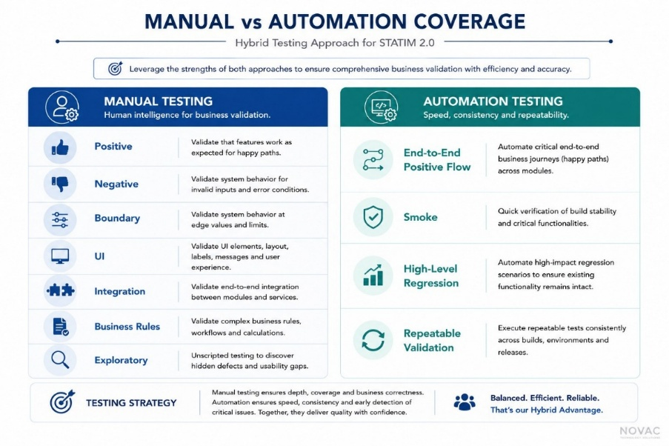

4. UAT Governance

4.1 Governance Principles
- Clear ownership across Novac and YAS Takaful.
- Regular, structured stakeholder communication.
- Timely defect triage aligned to test cycle boundaries.
- Transparent reporting to all stakeholder levels.
- Controlled approvals at each governance gate.
- Business-led final acceptance.

4.2 Governance Meetings
Meeting | Frequency | Participants
Internal QA Status | Daily | QA Team, Test Lead, QA Manager
Client Status | Weekly | Novac Delivery Team, YAS Takaful Stakeholders
Defect Triage | End of each test cycle / as required | QA, BA, Development Team
Go / No-Go | End of UAT | Test Lead, QA Manager, Delivery Manager, Client BA

4.3 Entry Approval
UAT readiness is approved by the QA Manager after verification of all defined entry criteria (Section 13).

5. Roles & Responsibilities

5.1 Project Roles
Role | Novac | YAS Takaful
Delivery Manager | Sudarsanam Krishnan | TBD
QA Manager | Sriram Ramkumar | TBD
Test Lead | Praveen Kumar B | TBD
QA Team | Novac QA Team | —
Business Analyst | Ramprasad, Padmanabhan | TBD
Development Team | Novac Dev Team | —
Business Users | Support | TBD
Subject Matter Experts | Support | TBD

5.2 Activity Ownership
The table below reflects primary ownership of each UAT activity. ‘Support’ indicates a secondary or advisory role.
Activity | Novac | YAS Takaful
UAT Planning | Owner | Review
Test Scenario Design | Owner | Review
Test Case Preparation | Owner | Review
Test Case Approval | Support | Owner
Test Data Preparation | Owner | Support
SIT Environment | Owner | —
UAT Environment | Support | Owner
Manual UAT Execution | Owner | Participate
Automation Execution | Owner | View Results
Defect Triage | Owner | Owner
Defect Closure | Owner | Review
Business Sign-off | Support | Owner

6. UAT Lifecycle
The diagram below illustrates the end-to-end UAT lifecycle, from requirements approval through business sign-off.
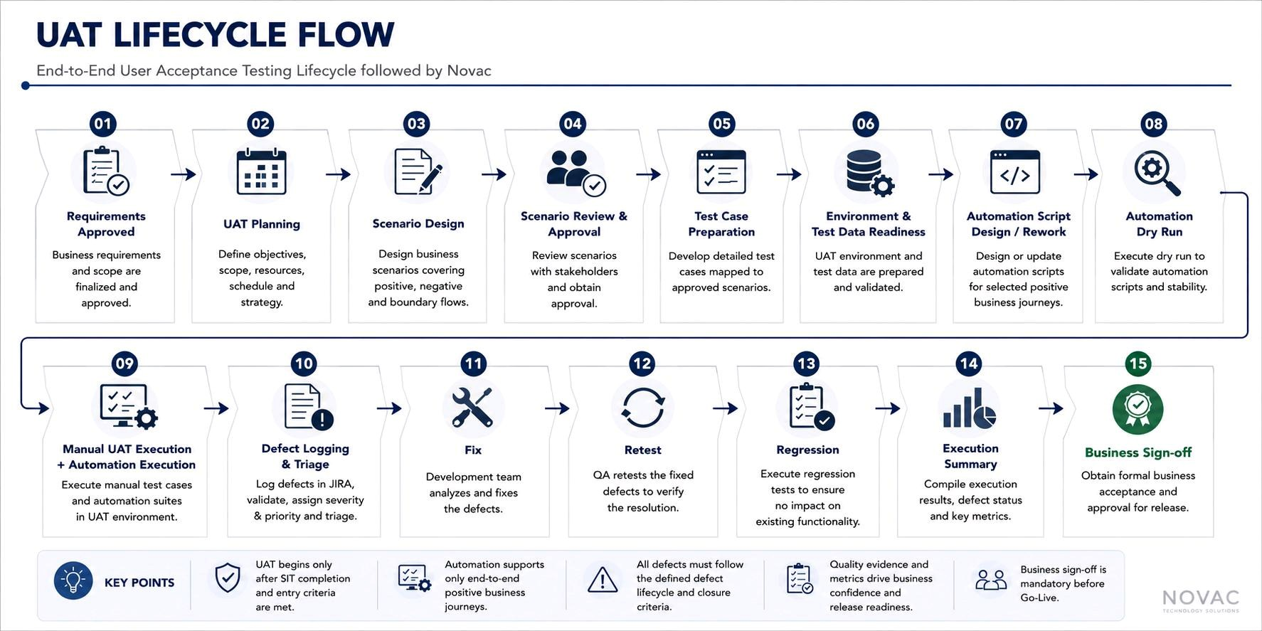

7. UAT Planning & Readiness

7.1 Planning Activities
- Confirm UAT scope with YAS Takaful stakeholders.
- Identify business processes and priority scenarios.
- Prepare the execution schedule.
- Allocate QA and business resources.
- Finalize entry and exit criteria.
- Confirm reporting cadence.
- Identify risks and dependencies (Section 15).

7.2 Environment Readiness
- Stable UAT build deployed.
- Required integrations available.
- User access configured for both Novac and YAS Takaful users.
- Test data loaded.
- Sensitive data masked.
- Environment validation completed prior to UAT start.

UAT Environment
https://statim20.novactech.net/CoreApp_UAT (placeholder).

7.3 Test Data
- Prepared by the Novac QA Team.
- Sensitive information masked prior to use.
- Refreshed before every UAT release, subject to project agreement.

8. Manual UAT Process
Manual UAT is the primary validation approach and covers complete business validation.

8.1 Coverage
- Positive scenarios
- Negative scenarios
- Boundary validations
- Business rules
- Functional validations
- UI validations
- Integration validations

8.2 Process
- Prepare test scenarios.
- Review scenarios with Novac BA and Client BA, following the Novac QA Review Process (see Section 18).
- Prepare detailed test cases in QMetry.
- Execute approved test cases.
- Capture execution evidence in QMetry.
- Log defects in JIRA.
- Retest resolved defects.
- Perform high-level positive regression, scoped to modules impacted by fixes in the current cycle.
- Publish the execution summary.

8.3 Evidence
- QMetry Test Cycle
- Screenshots, where applicable
- Execution Summary

9. Automation Support during UAT
Automation supports manual UAT by validating selected end-to-end positive business journeys using NAFPro (Novac Automation Framework Pro — Selenium-Cucumber BDD, Java). It complements manual testing and is not a replacement for business validation. Detailed framework architecture is governed separately by the NAFPro framework documentation and is not reproduced here.

9.1 Current Automation Coverage
Automation coverage during UAT currently spans the following modules. This list is updated as coverage expands across releases.
- Product Configurator
- New Business
- Rating
- Rules
- Accounting Setup
- System Parameters
- Claims

9.2 Scope
- End-to-end positive business flows only.
- Smoke and regression validation of selected journeys.

9.3 Process
- Review automation scope for the release.
- Design or update NAFPro scripts.
- Execute an automation dry run.
- Execute scripts for every UAT release.
- Re-execute before final UAT sign-off.
- Review failures and raise defects where required.
- Generate automation reports.

9.4 Deliverables
- HTML Execution Report
- Excel Execution Report
- Screenshots
- Execution Logs

10. Defect Management
This section defines the structured process to identify, assess, resolve, and close defects raised during UAT.

10.1 Defect Lifecycle
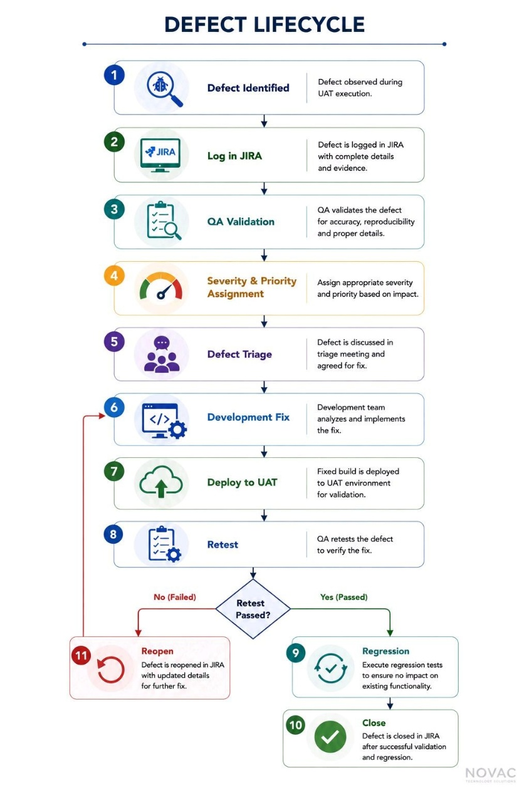

10.2 Severity Classification
Severity | Description
Critical | System unavailable, data loss, or core business process blocked.
High | Major business functionality unavailable, workaround not viable.
Medium | Functionality impacted; a workaround exists.
Low | Minor issue with limited business impact.
Resolution timelines are agreed jointly at Defect Triage for each cycle, consistent with the STATIM 2.0 Test Plan (v1.1) triage process, rather than fixed per-severity SLAs.

10.3 Priority Classification
Priority | Description
High | Immediate attention required.
Medium | Resolve during the current UAT cycle.
Low | Can be scheduled for a later release.

10.4 Defect Triage
Aligned with the STATIM 2.0 Test Plan (v1.1), a dedicated triage meeting is held at the end of every module execution for all P1 (Critical) and P2 (High) defects. Additional triage sessions may be called as required.
Participants:
- Novac QA Team
- Test Lead
- Business Analyst
- Development Team
- YAS Takaful Business Representative, as required
All triage outcomes are recorded in JIRA against the respective defect. Deferred defects are jointly reviewed by the Novac BA, Development Team, and Client BA before a final decision is made.

10.5 Defect Closure
A defect may be closed only after:
- Fix verification is completed.
- Required regression is completed.
- Evidence is captured.
- Closure is validated by the Novac QA Team.
- Review is completed by the Test Lead and QA Manager.

11. Test Evidence & Deliverables

11.1 Manual UAT
Deliverable | Tool
Test Cycle Execution | QMetry
Test Evidence | QMetry Attachments
Execution Summary | QMetry

11.2 Automation
Deliverable | Format
Automation Report | HTML
Automation Summary | Excel
Screenshots | Automated capture
Execution Logs | NAFPro framework output

12. Reporting & Communication

12.1 Reporting Matrix
Report | Audience | Frequency
Internal QA Status | Novac QA Team | Daily
Weekly Project Status | Novac & YAS Takaful Stakeholders | Weekly
Test Execution Summary | Project Team | Every UAT Cycle
Defect Summary | Project Team | Daily / Weekly
Automation Execution Report | Project Team | Every Automation Run
UAT Closure Report | Management | End of UAT
Go / No-Go Report | Leadership | Prior to Production

12.2 Key Metrics
- Planned vs. Executed Test Cases
- Pass Percentage
- Failed Test Cases
- Open Defects by Severity
- Defect Aging
- Automation Execution Status
- Business Readiness

13. Entry & Exit Criteria

13.1 Entry Criteria
- SIT and developer-side Shift-Left validation completed successfully.
- UAT build deployed.
- No open Critical SIT defects.
- UAT environment validated.
- Required integrations available.
- Test data prepared and masked.
- Business scenarios approved.
- Test cases reviewed and approved.
- User access available for Novac and YAS Takaful teams.
- UAT schedule approved.
- QA Manager approval obtained.

13.2 Exit Criteria
- 100% of planned scenarios executed.
- Mandatory business processes validated.
- No open Critical defects.
- High severity defects resolved or formally accepted by YAS Takaful.
- Regression completed.
- Automation execution completed for applicable modules.
- Test evidence available and archived.
- UAT report completed.
- Client BA sign-off received.

14. UAT Sign-off Process
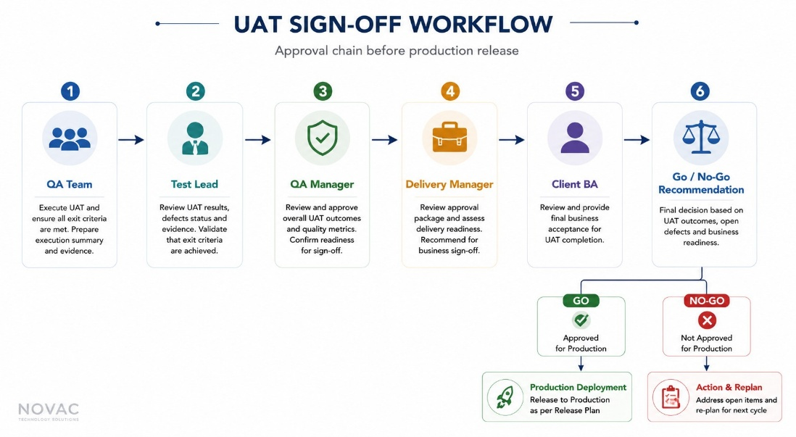

14.1 Sign-off Deliverables
- UAT Execution Summary
- Defect Summary
- Automation Results
- Outstanding Risk Register
- UAT Closure Report
- Go / No-Go Recommendation

14.2 Go / No-Go Decision
The final production recommendation considers:
- Completion of the agreed UAT scope.
- Exit criteria compliance.
- Outstanding defect assessment.
- Business readiness.
- Client approval.

15. Risk & Issue Management
Risks and issues identified during UAT planning or execution are logged, owned, and tracked to closure. The QA Manager maintains the risk register and reviews it at each governance meeting (Section 4.2).
Risk Category | Escalation Owner | Trigger
Schedule Risk | Test Lead | Delay to build availability, environment readiness, or business review turnaround.
Quality Risk | QA Manager | High defect density, repeated regression failures, or unresolved Critical defects.
Resource Risk | Delivery Manager | Unavailability of QA, business, or SME resources during planned execution windows.
Scope Risk | QA Manager / Client BA | Late-stage scope changes affecting agreed UAT coverage.
Unresolved risks are escalated in the sequence: QA Team → Test Lead → QA Manager → Delivery Manager → Vertical Head / Client BA, as needed.

16. Change Management
Changes to UAT scope, requirements, or test cases are managed through an updated Requirement Traceability Matrix (RTM). Changes must be incorporated into the affected test cases and the RTM immediately, and communicated to YAS Takaful stakeholders at the next scheduled status update.

17. Assumptions, Dependencies, and Constraints
Assumptions | Dependencies | Constraints
SIT and Shift-Left validation are completed prior to UAT entry. | Timely availability of YAS Takaful business users for scenario review and sign-off. | Fixed UAT window as per the agreed project schedule.
BRD documents and Figma designs are available for scenario and test case design. | Stable builds provided after unit testing and Novac Dev Team sign-off. | Limited access to production-like data during early UAT cycles.

18. References
The following Novac standards govern related processes and are not duplicated in this document:
Document | Version | Relevance
STATIM 2.0 Test Plan | v1.1 | Overall test strategy, cycle definitions, defect triage cadence.
STATIM 2.0 Testing Cycle Process | v1.1 | SIT-level test cycle process and entry/exit criteria.
STATIM 2.0 QA Review Process | v1.0 | Peer, Lead, and Business review workflow for test cases and scripts.
STATIM 2.0 Cross-Browser Testing Process | v1.0 | Browser and resolution compatibility testing methodology.
STATIM 2.0 Project Delivery Process | v0.1 | End-to-end SDLC, including QA-side Shift-Left Testing (Phase 9).
NAFPro Framework Documentation | — | Automation framework architecture and usage.

19. Document Sign-off
By signing below, the undersigned confirm review and acceptance of this UAT Process Standard for the STATIM 2.0 – YAS Takaful engagement.
Role | Name | Organization | Signature | Date
QA Manager | Sriram Ramkumar | Novac
Delivery Manager | Sudarsanam Krishnan | Novac
Vertical Head | Senthil V | Novac
Client Manager | TBD | YAS Takaful

End of Document.

