Sriram Ramesh

08/12/2019

Assignment 5: Data manipulation in dictionaries and lists, reading and writing to a .txt file

GitHub: <https://github.com/sriramramesh18/IntroToProg-Python.git>

**Assignment 5: Data manipulation in dictionaries and lists, reading and writing to a .txt file**

**Introduction**

The goal of this assignment is to get introduced to dictionaries and lists, reading and writing to a text file, gathering options from the user and saving the inputs into a list/dictionary and then storing the values in a text file. The input here is the user’s choice of tasks and their priorities. I read the text file values into a dictionary, save it to a list, manipulate the list, save the items and their values to a text file based on user input.

**The Script**

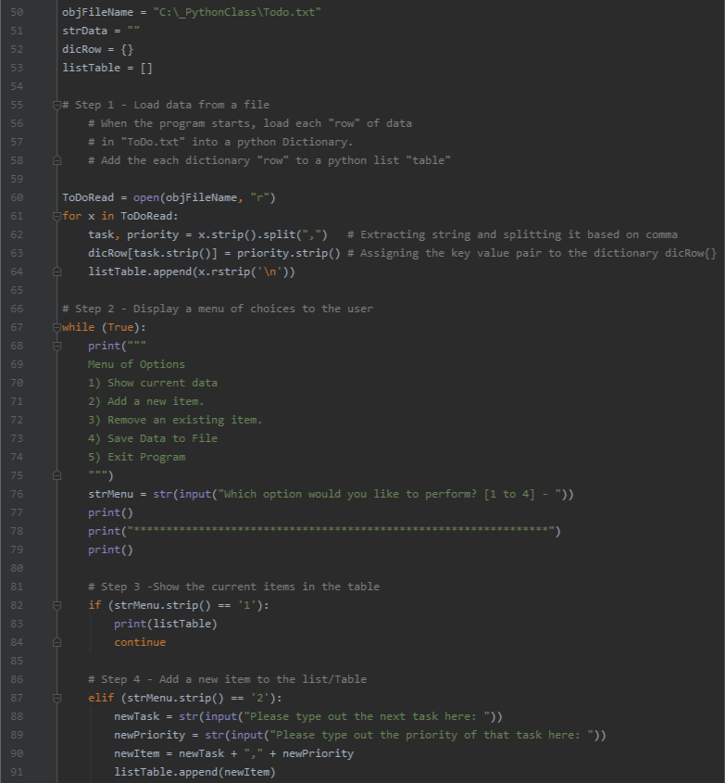

FIG 1

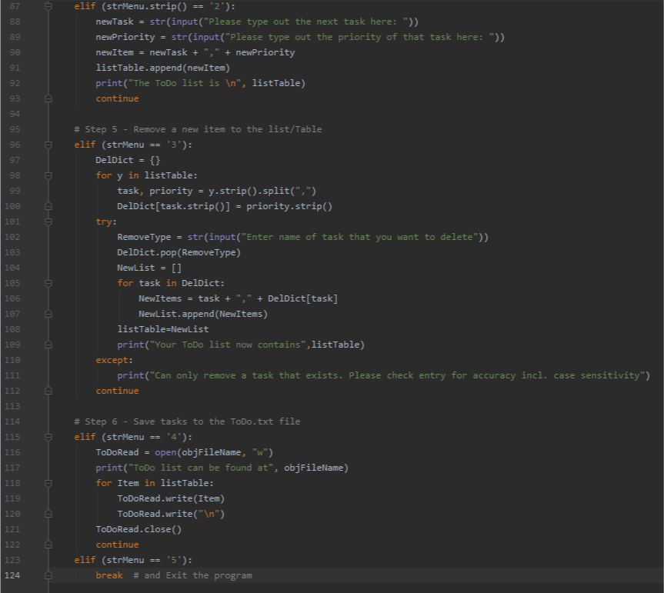

FIG 2

As shown in FIG 1 and 2, I used 6 steps to do the following:

* Load data from a file
* Display a menu of choices to the user
* Show the current items in the table
* Add a new item to the list/table
* Remove a new item from the list/table
* Save tasks to the ToDo.txt file

I learnt several things during this assignment including the difference between using dictionaries vs lists, how the key-value pairs in a dictionary can be effectively manipulated. I ran into multi-dimensional lists while doing the data manipulation exercise and finally found my way out. The error handling I have been doing in my previous assignments was efficiently replaced by the try-except functionality in python which was another new lesson learnt.

**Sample Output**

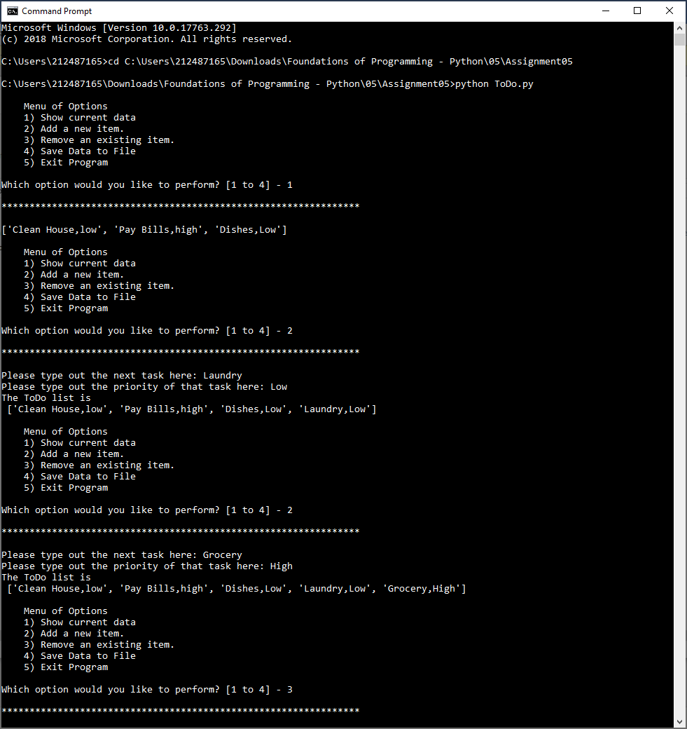

FIG 3

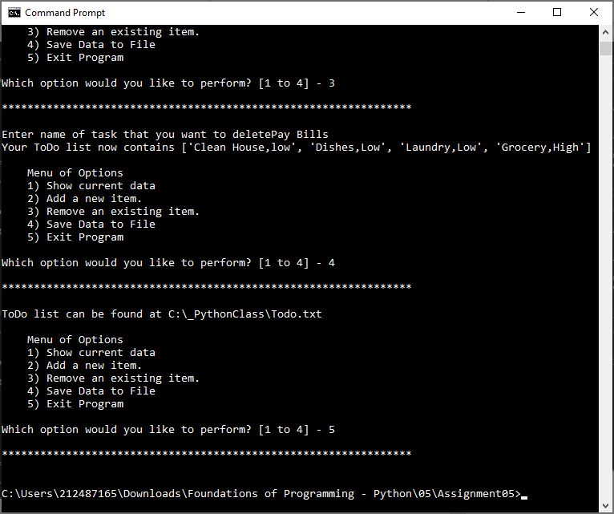

FIG 4

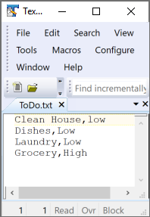

FIG 4

**Summary**

This was a good exercise to get familiar with tuples. The assignment helped me start thinking about different types of data manipulation/presentation and analyze user inputs at every stage in order to handle error better.