Sriram Ramesh

08/19/2019

Assignment 6: Using Functions and Class to create a ToDo list

GitHub: <https://github.com/sriramramesh18/IntroToProg-Python.git>

**Assignment 6: Using Functions and Class to create a ToDo list**

**Introduction**

The goal of this assignment is to get introduced to functions, classes and how to effectively use them. The input here is the user’s choice of tasks and their priorities. I define a class to instantiate the variables and read the text file values into a dictionary, save it to a list, use functions to manipulate the list by adding or removing items, save the items and their values to a text file based on user input.

**The Script**

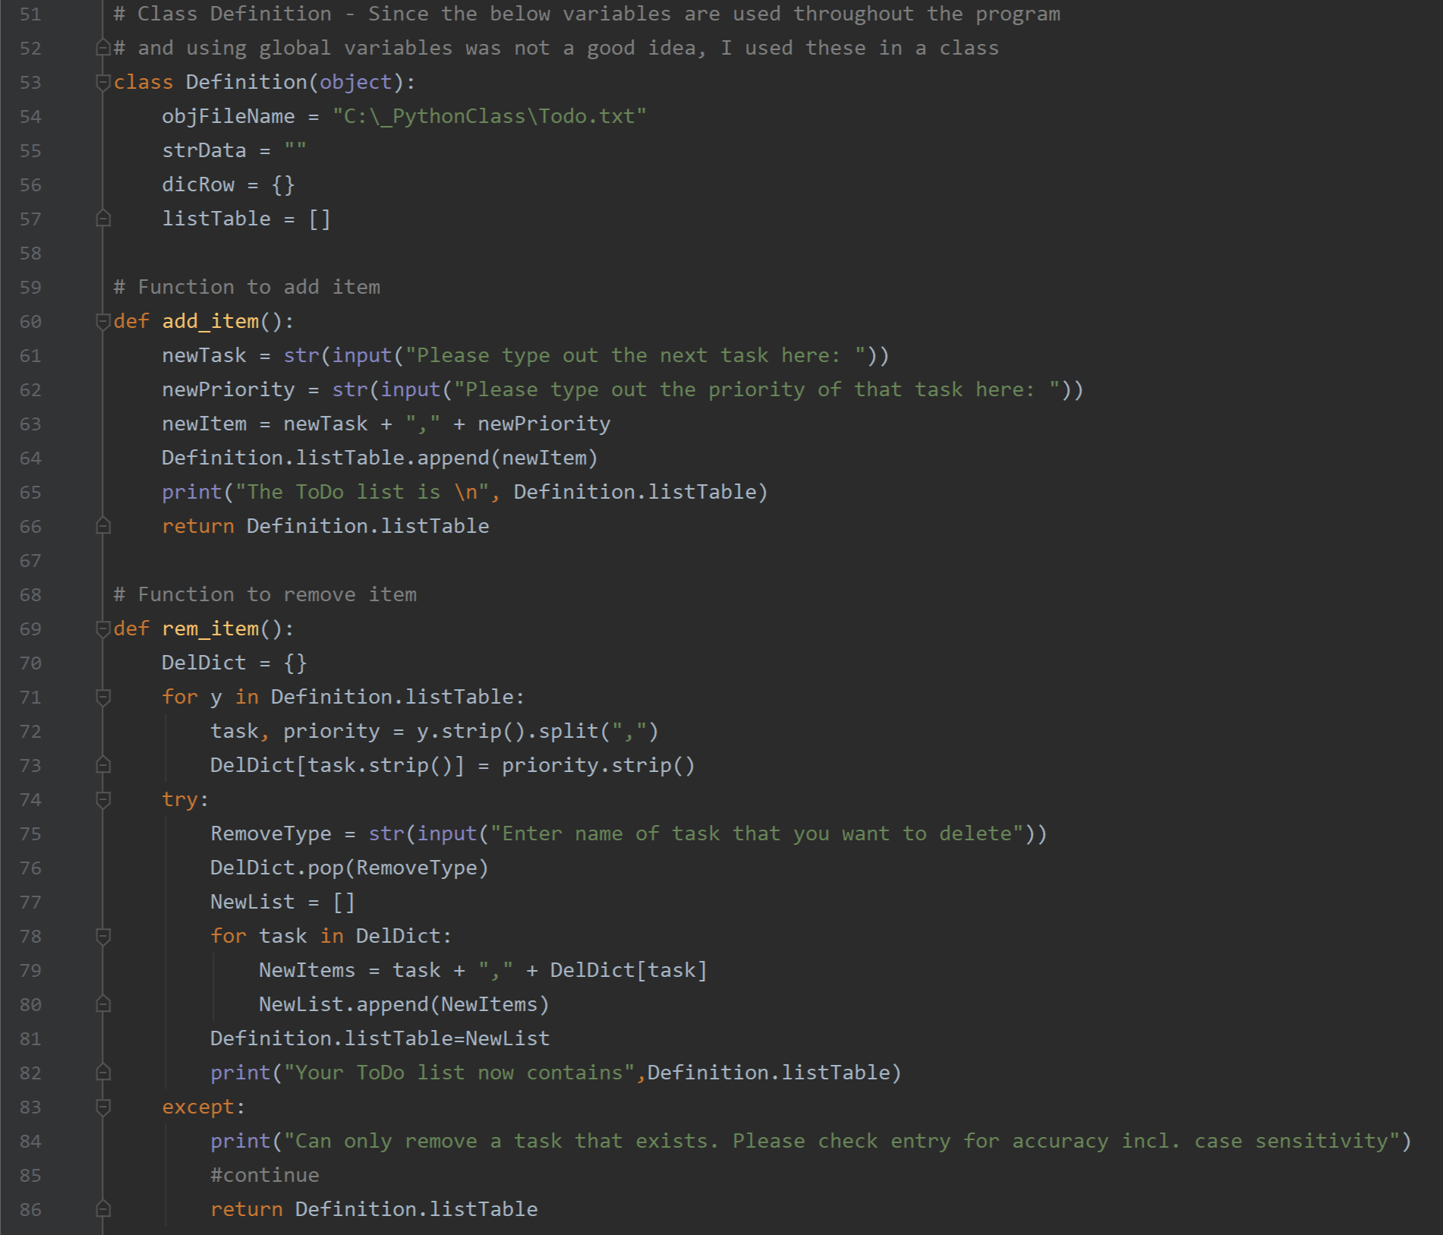

FIG 1

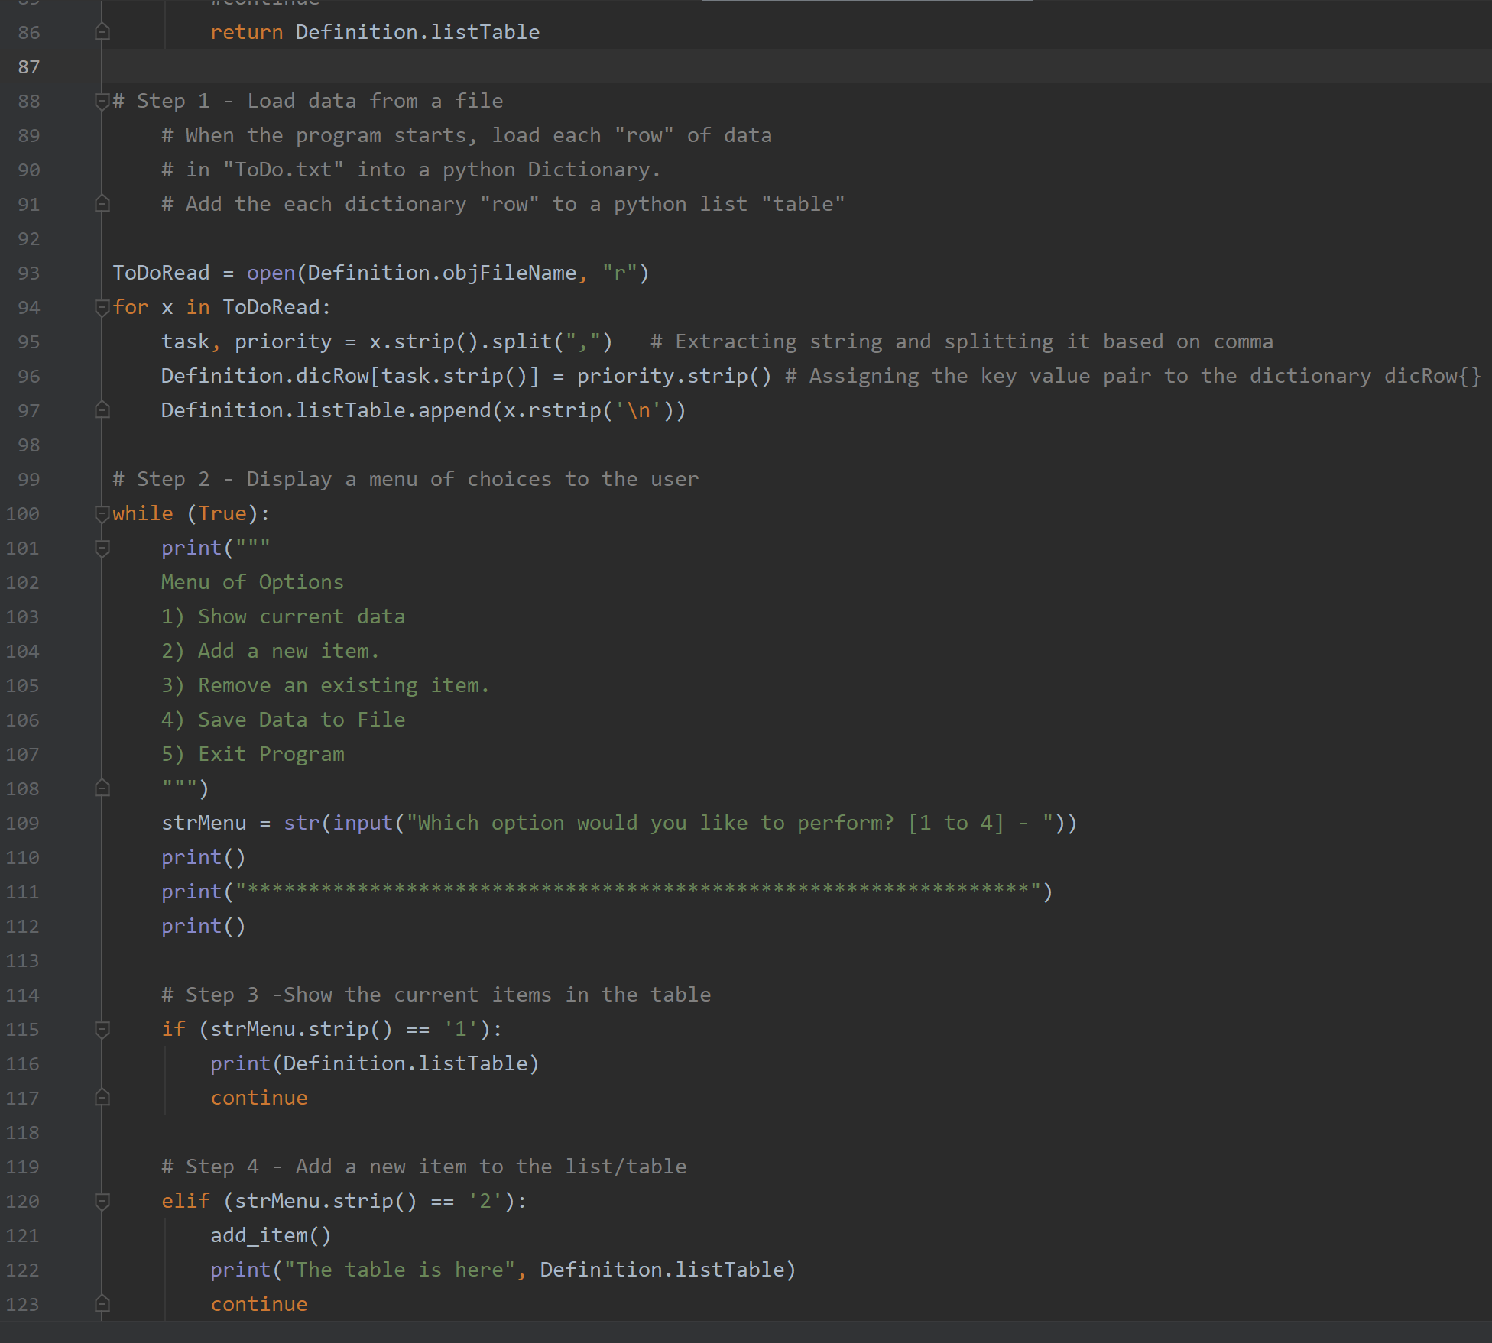

FIG 2

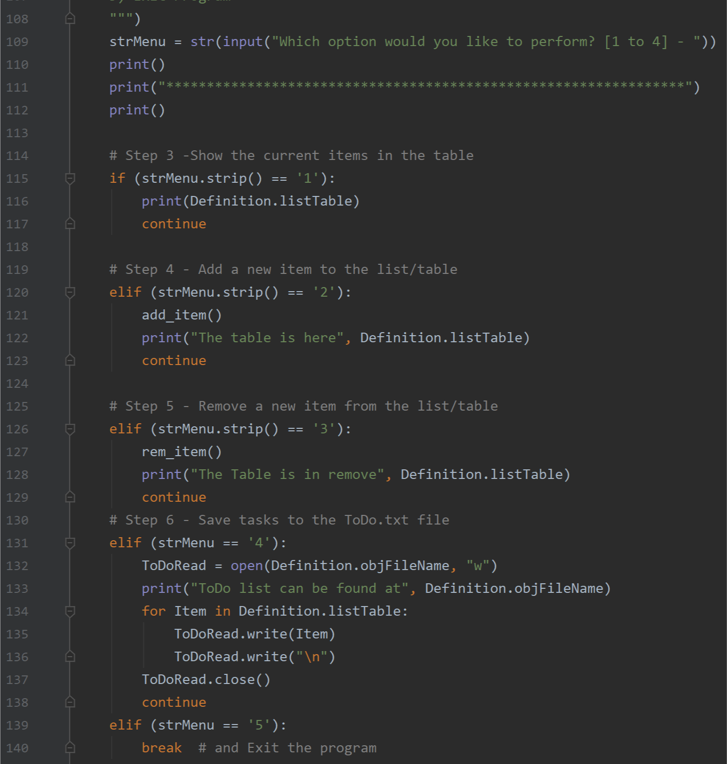

FIG 3

As shown in FIG 1, 2 and 3, I used 6 steps to do the following:

* Load data from a file
* Display a menu of choices to the user
* Show the current items in the table
* Add a new item to the list/table
* Remove a new item from the list/table
* Save tasks to the ToDo.txt file

First, I defined a class that includes:

* objFileName = "C:\_PythonClass\Todo.txt"
* listTable = []

This helped me use objFileName and listTable throughout the program without having to use the global variable functionality. I used it in conjecture with the name of the class – Definition.

I learnt several things during this assignment including the functions and classes, defining functions can make a program cleaner. I look forward to learning more about classes and their capabilities in the coming sessions.

**Sample Output**

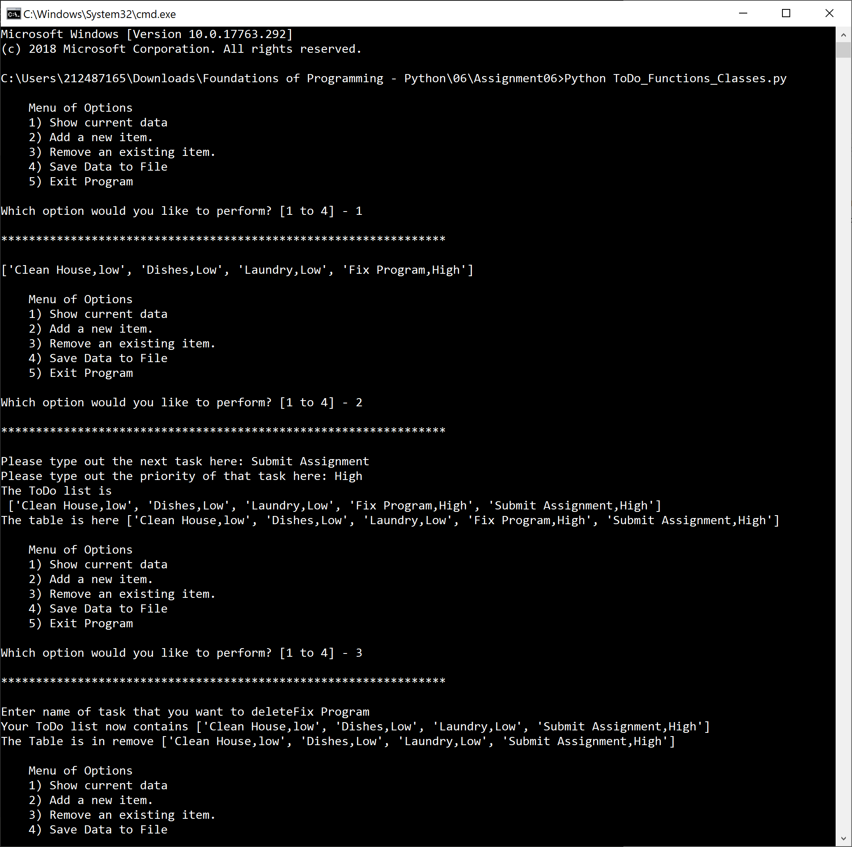

FIG 4

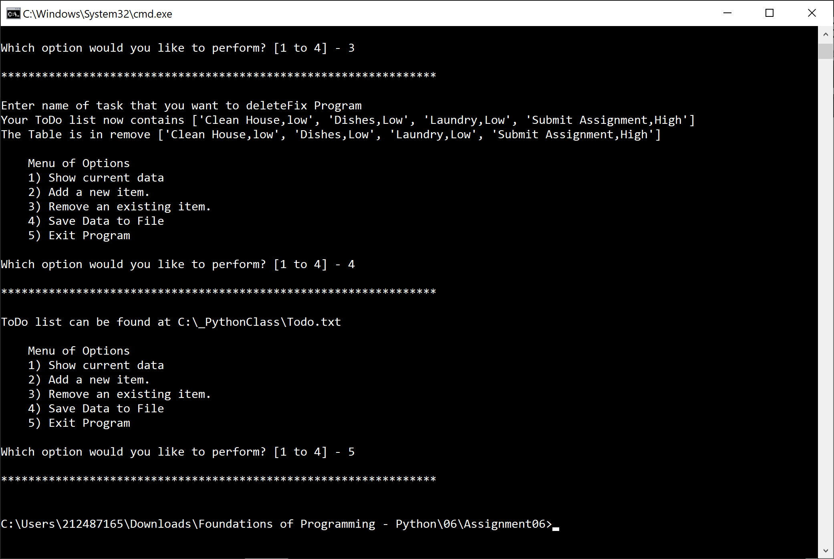

FIG 5

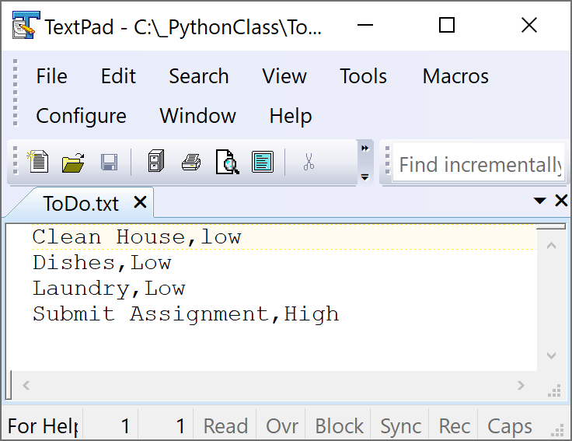

FIG 6

**Summary**

This was a good exercise to get familiar with functions and classes. The assignment helped me start thinking about how to organize my program efficiently using classes and functions.