Sriram Ramesh

09/02/2019

Assignment 7: Using Functions and Class to create a ToDo list

GitHub: <https://github.com/sriramramesh18/IntroToProg-Python.git>

Blog: <https://pythonnoviceassignment.blogspot.com/2019/09/sriram-ramesh-09022019-assignment-7.html?_sm_au_=iWHHT7Pj7M07ntSP>

**Assignment 7: Error Handling and Pickling**

**Introduction**

The goal of this assignment is to get introduced to the different types of error handling options and pickling. I have used my past assignment in which the script performed basic mathematical operations on 2 user input numbers. I have attempted to use the error handling options while getting both the user input numbers and while dividing by 0.

**The Script**

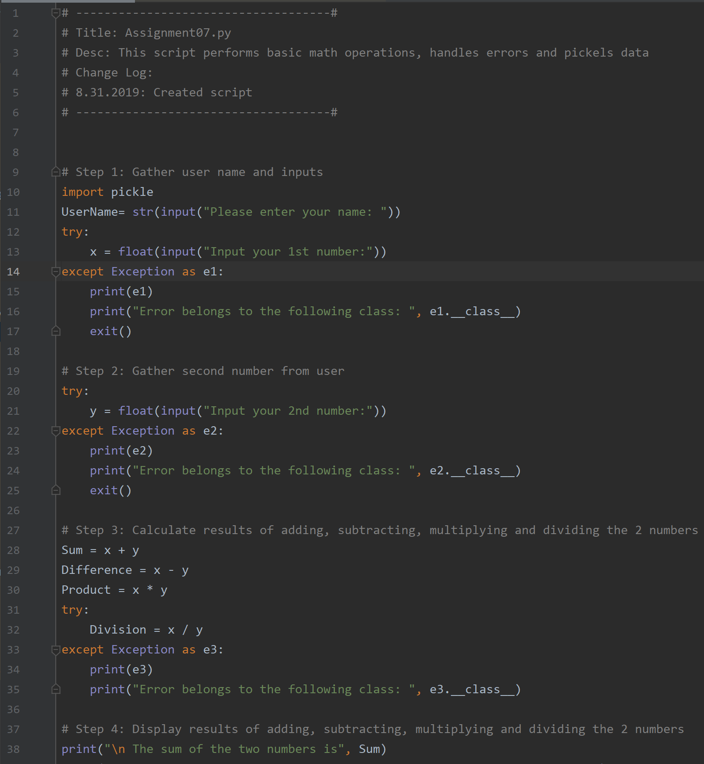

FIG 1

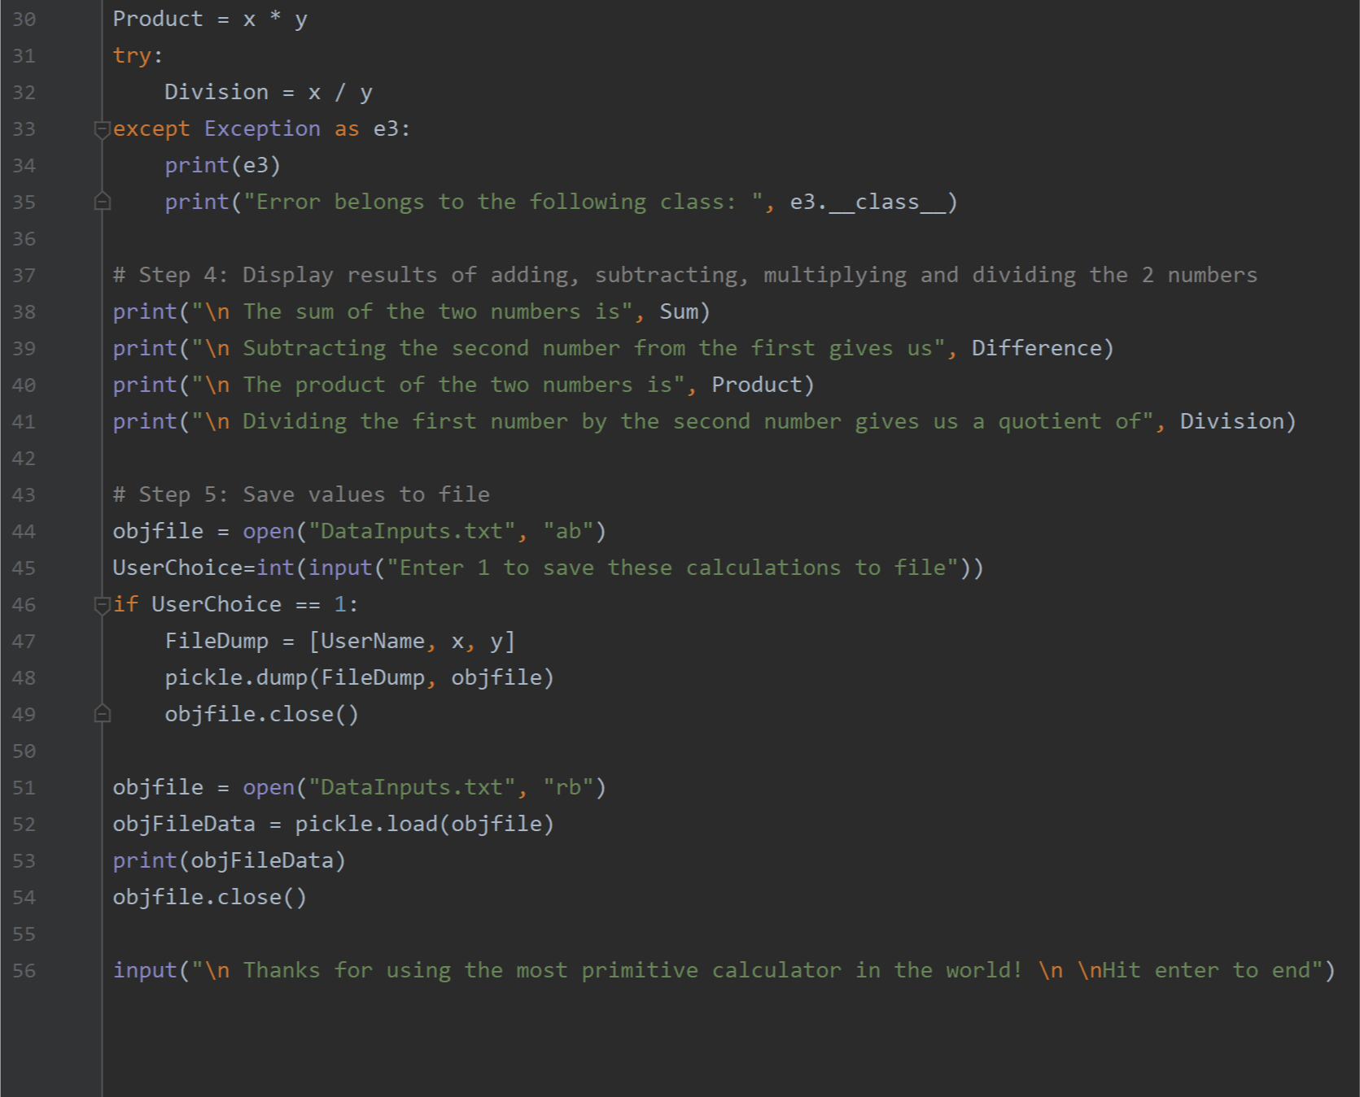

FIG 2

As shown in FIG 1 and 2, I used 5 steps to do the following:

* Gather user name and first number
* Gather second number from user
* Calculate the results of sum, difference, product and division
* Display the results
* Save Values to File

First, I defined exceptions while gathering input numbers. Second, I defined another exception class to handle division by 0. I added the pickling function to hide the user inputs with the intention of data privacy.

I learnt several things during this assignment including the different exception handling options and how pickling works.

**Sample Output**

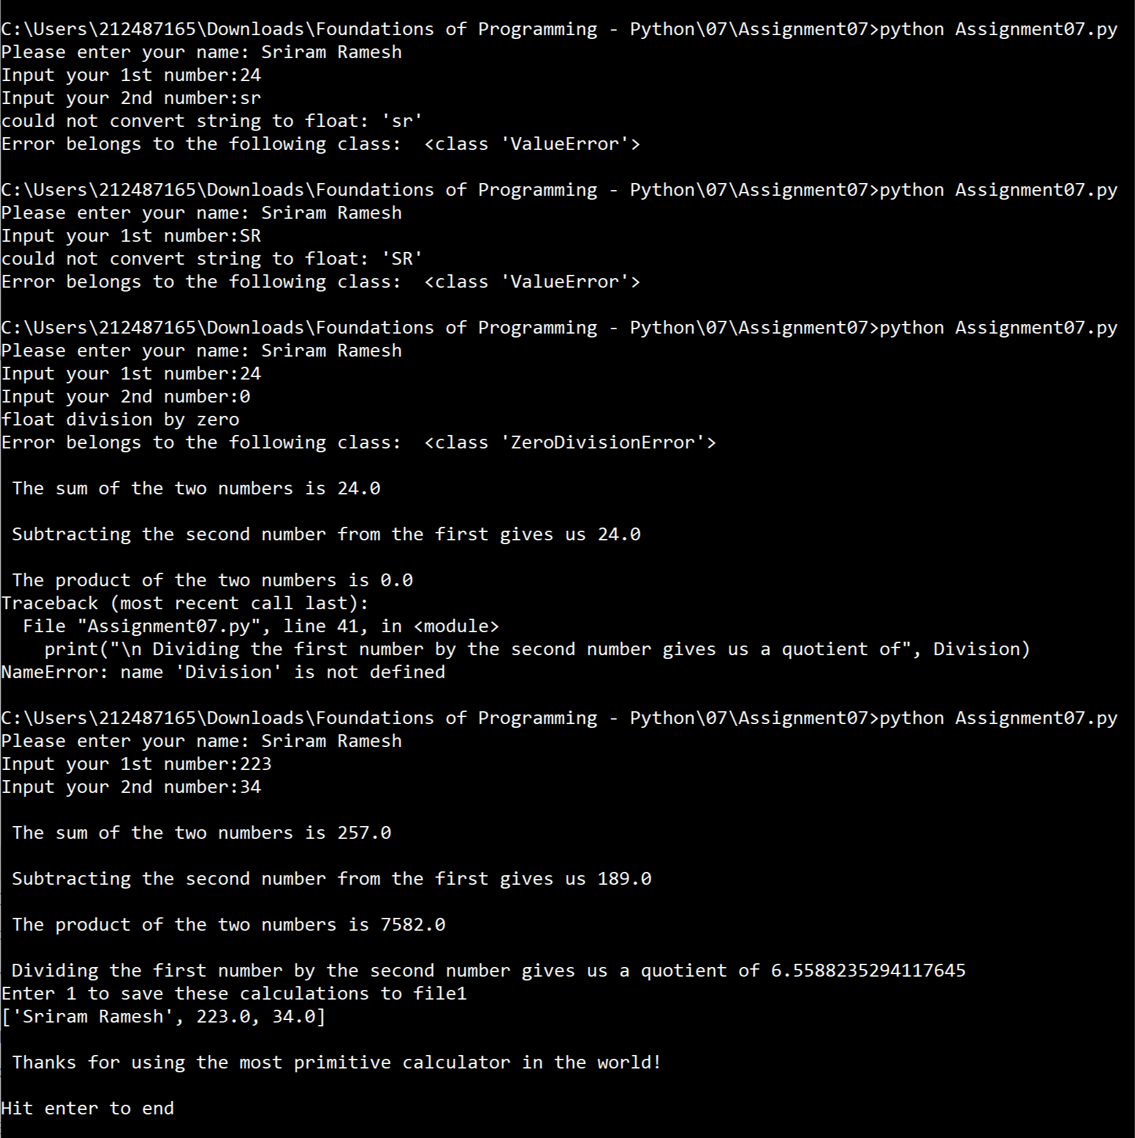

FIG 4

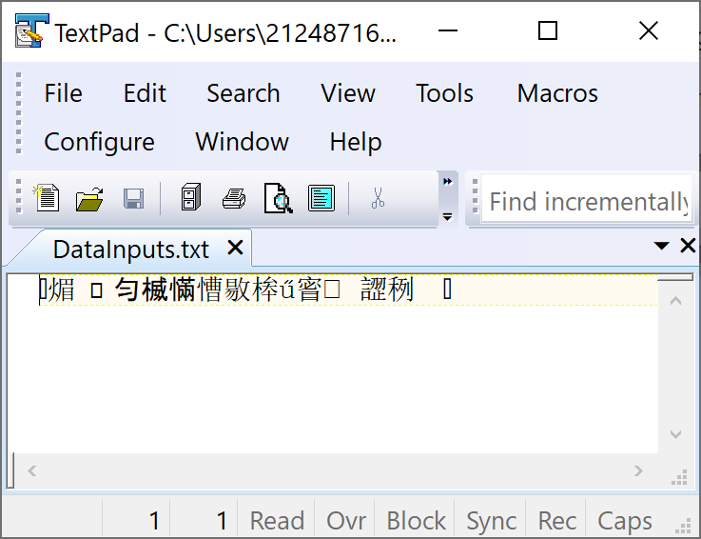

FIG 5

**Summary**

This was a good exercise to get familiar with exception handling and pickling. The assignment helped me see how all the error handling I did in my previous assignments could have been easily handled using some of Python’s in-built functionality.