Module 3: IBM Python Assignment

1. Consider a list(list=[]) and perform insertion, print, remove, append, sort, pop, reverse.

**Solution:**

class Lister:

def __init__(self, list, **kwargs):

self.list = list

self.insert_func(list, 2, 10)

def insert_func(self, list, pos, element, *args):

list.insert(pos, element)

print(list)

print(self.remove_list(list, pos))

self.function(list, 22, 1)

def remove_list(self, list, pos, *args):

list.remove(pos)

return list

def function(self, list, add, rem, *args):

list.append(add)

print(list)

list.sort()

print(list)

list.pop(rem)

print(list)

list.reverse()

print(list)

if __name__ == “__main__”:

list = [1, 2, 3, 4, 5, 6]

lister = Lister(list)

**Output:**

[1, 2, 10, 3, 4, 5, 6]

[1, 10, 3, 4, 5, 6]

[1, 10, 3, 4, 5, 6, 22]

[1, 3, 4, 5, 6, 10, 22]

[1, 4, 5, 6, 10, 22]

[22, 10, 6, 5, 4, 1]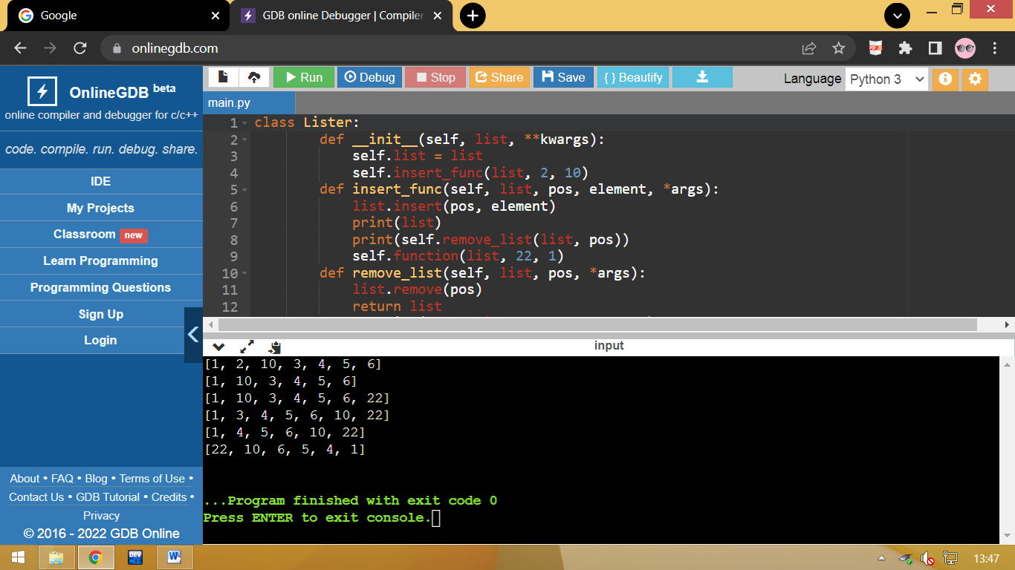

1. Write a calculator program in python.

**Solution:**

class Calculator:

def __init__(self, **kwargs):

print(“Calculator is ready to use…”)

while True:

print(“1. Addition \n 2. Subtraction \n 3. Multiplication \n 4. Division ”)

option = int(input(“Enter your option: ”))

num1 = int(input(“Enter number 1: “))

num2 = int(input(“Enter number 2: ”))

if option == 1:

print(f”{num1} + {num2} = ”, self.add(num1, num2))

elif option == 2:

print(f”{num1} - {num2} = ”, self.subtract(num1, num2))

elif option == 3:

print(f”{num1} x {num2} = ”, self.multiple(num1, num2))

elif option == 4:

print(f”{num1} / {num2} = ”, self.divide(num1, num2))

else:

print(“Invalid option…”)

def add(self, num1, num2):

return num1 + num2

def subtract(self, num1, num2):

return num1 - num2

def multiple(self, num1, num2):

return num1 * num2

def divide(self, num1, num2):

return num1 / num2

if __name__ == “__main__”:

calculator = Calculator()

**Output:**

1.Addition

2.Subtraction

3.Multiplication

4.Division

Enter your option: 1

Enter number 1 : 3

Enter number 2 : 2

3 + 2 = 5

1.Addition

2.Subtraction

3.Multiplication

4.Division

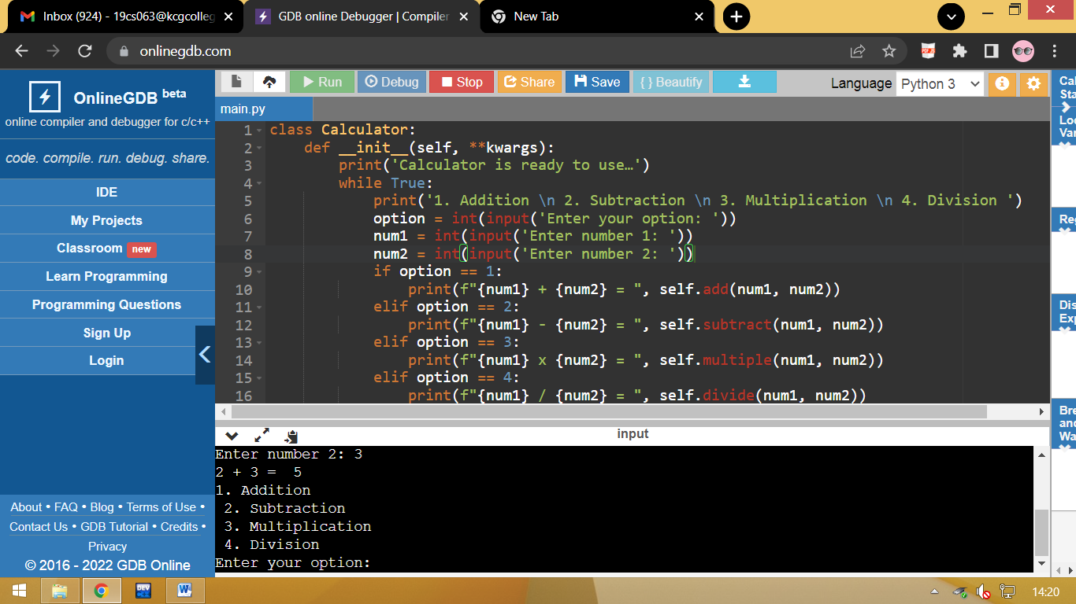

1. Write a program to concatenate, reverse and slice a string.

**Solution:**

var1 = "Hello "

var2 = "World"

var3 = var1 + var2

print(var3)

txt = "Hello World"[::-1]

print(txt)

b = "Hello, World!"

print(b[2:5])

**Output:**

Hello World

dlroW olleH

llo

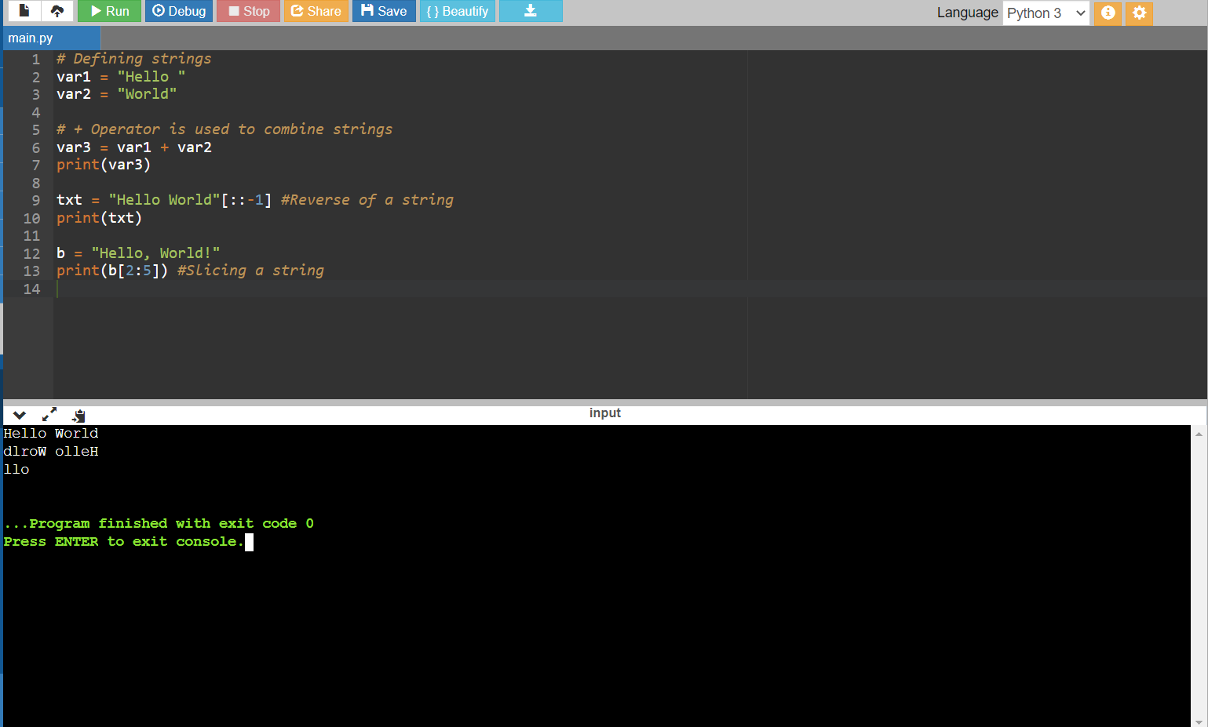

1. Why is a python a popular programming language?

**Solution:**

* Python is an interpreted, object-oriented, high-level programming language with dynamic semantics.
* Its high-level built-in data structures, combined with dynamic typing and dynamic binding, make it very attractive for Rapid Application Development, as well as for use as a scripting or glue language to connect existing components together.
* Python's simple, easy to learn syntax emphasizes readability and therefore reduces the cost of program maintenance.
* Python supports modules and packages, which encourages program modularity and code reuse. The Python interpreter and the extensive standard library are available in source or binary form without charge for all major platforms, and can be freely distributed.

1. What are the other frameworks that can be used with Python?

**Solution:**

* Django
* Flask
* Kivy
* PySimpleGUI
* PyQt5
* BeautifulSoup
* tensorflow
* OpenCV

1. Full Form of WSGI?

**Solution:**

* WSGI Stands for Web Server Gateway Interface
* **WSGI**is a specification that describes the communication between **web servers and Python web applications or frameworks**.
* It explains how a web server communicates with python web applications/frameworks and how web applications/frameworks can be chained for processing a request.