**Public Transport Optimization**

|  |
| --- |
| **Submitted By:**  **Sriram V**  **(au80421205070)** |

**Introduction:**

Public transport optimization in the context of the Internet of Things (IoT) refers to the use of IoT technologies and data analytics to improve the efficiency, safety, and overall quality of public transportation systems.

**Project Objective:**

Public transport optimization in the context of the Internet of Things (IoT) refers to the use of IoT technologies and data analytics to improve the efficiency, arrival prediction, and overall quality of public transportation.

1. **IoT Devices and Data Collection:**

IoT devices play a pivotal role in enhancing public transport optimization through efficient data collection. According to Phase - 3

1. **Data Processing and Analysis:**

Data processing and analysis in the context of public transport optimization is a critical component of improving transit systems. The collected data from IoT devices, such as GPS trackers and sensors on public transport vehicles, are processed to extract valuable insights. This process involves real-time monitoring of vehicle locations, passenger loads, and traffic conditions. Use the Analysis algorithm to get correct results.

1. **Web Development:**

Web development can be a powerful tool in the realm of public transport optimization, as it provides a user-friendly interface for both transit authorities and commuters. Through well-designed websites and mobile apps, passengers can access real-time information on bus or train schedules, route changes, and delays, making their daily commute more predictable and efficient.

**Front-end:**

**HTML, CSS,** and **JavaScript** will be used for the front-end development to create the user interface.

1. **HTML/CSS**: Create the structure and style of the platform, including maps, tables, charts, and real-time updates.

**Code**:

**index.html**

<!DOCTYPE html>

<html>

<head>

<meta charset="UTF-8">

<title>Public Transport Dashboard</title>

<link rel="stylesheet" type="text/css" href="styles.css">

</head>

<body>

<div class="header">

<h1>Public Transport Dashboard</h1>

</div>

<div class="container">

<div class="map">

<div id="map"></div>

</div>

<div class="data">

<div class="data-item">

<h2>Real-time Location</h2>

<p id="location">Loading...</p>

</div>

<div class="data-item">

<h2>Ridership</h2>

<p id="ridership">Loading...</p>

</div>

<div class="data-item">

<h2>Arrival Time</h2>

<p id="arrival-time">Loading...</p>

</div>

</div>

</div>

<script src="script.js"></script>

</body>

</html>

**styles.css:**

body {

font-family: Arial, sans-serif;

margin: 0;

padding: 0;

}

.header {

background-color: #333;

color: #fff;

text-align: center;

padding: 15px;

}

.container {

display: flex;

margin: 20px;

}

.map {

flex: 2;

height: 400px;

border: 1px solid #ccc;

}

.data {

flex: 1;

padding: 20px;

}

.data-item {

margin-bottom: 20px;

}

h2 {

margin: 0;

}

#map {

width: 100%;

height: 100%;

}

1. **JavaScript:** Use JavaScript to make the platform interactive and to handle real-time updates. You'll need to use libraries or frameworks like Leaflet for mapping and Chart.js for data visualization.

**Code:**

**script.js**

const staticData = {

location: "City Center",

ridership: 120,

arrivalTime: "10 minutes",

};

document.getElementById("location").textContent = staticData.location;

document.getElementById("ridership").textContent = staticData.ridership;

document.getElementById("arrival-time").textContent = staticData.arrivalTime;

**Back-end:**

For the back-end, you'll need a server to manage data from IoT sensors, perform data processing, and serve this data to the front-end. You can use Python Script.

**1. Data Ingestion:** Set up a system to receive data from IoT sensors. IoT devices should send location, ridership, and arrival time data to your server through APIs.

**2. Data Processing:** Process and clean the data as needed. This may include data validation, transformation, and storage in a database.

**3. Database:** Use a database like MongoDB, PostgreSQL, or MySQL to store and manage historical and real-time transit data.

**4. APIs:** Create APIs that allow the front-end to request real-time data from the server. These APIs should be used to retrieve data from the database and send it to the client in JSON format.

**5. Real-Time Updates:** Implement websockets or Server-Sent Events (SSE) to provide real-time updates to the front-end. When new data is received from the IoT sensors, push it to connected clients.

1. **Data Visualization:**

Data visualization is a key element in harnessing the potential of public transport optimization. Through compelling visual representations, such as interactive maps, graphs, and dashboards, transportation authorities and commuters can gain valuable insights into the performance and efficiency of public transit systems. Real-time data on vehicle locations, passenger loads, and service status can be displayed in an intuitive manner, allowing passengers to make informed travel decisions. For transit authorities, data visualization tools provide a means to track performance metrics, identify bottlenecks, and make data-driven decisions for route adjustments and service improvements. These visualizations are integral to creating a more transparent, user-friendly, and data-informed public transport ecosystem, ultimately benefiting both passengers and urban mobility as a whole.

1. **Alerts and Notifications:**

Alerts and notifications are indispensable components of public transport optimization, ensuring that both passengers and transit authorities stay informed and responsive. Commuters can receive real-time updates on service disruptions, delays, or route changes. Such notifications serve as early warning mechanisms, mitigating potential problems and enhancing the reliability and convenience of public transport. This real-time communication not only fosters a better travel experience for passengers but also plays a vital role in optimizing transit services and improving overall urban mobility.

1. **User Authentication and Security:**

User authentication and security in public transport optimization is paramount for ensuring safe and efficient transit systems. Implementing robust user authentication methods, such as contactless smart cards or mobile apps with secure authentication protocols, not only helps in preventing fare evasion but also enhances passenger safety

1. **Database Management:**

Database management plays a vital role in public transport optimization by efficiently storing, retrieving, and managing vast amounts of data critical for the functioning of the transit system. This includes passenger information, route schedules, vehicle maintenance records, and real-time tracking data. A well-designed database system enables operators to make informed decisions, such as optimizing routes, improving maintenance schedules, and enhancing the overall passenger experience. Additionally, it allows for data analysis, enabling the identification of trends and areas for improvement in public transport services. Effective database management not only ensures the smooth operation of transit systems but also contributes to better service quality and cost-effectiveness, ultimately benefiting and operators alike.

1. **User Interface:**

Design a user-friendly interface that displays real-time transit information. The interface can include:

1. **Maps:** Display the current locations of public transport vehicles on a map using a library like Leaflet or Google Maps.
2. **Tables:** Show a list of vehicles with details such as vehicle number, current location, and estimated arrival time at key stops.
3. **Real-Time Updates**: Continuously update the information on the platform as new data from IoT sensors becomes available.

**Circuit Diagram for Public Transport Optimization:**

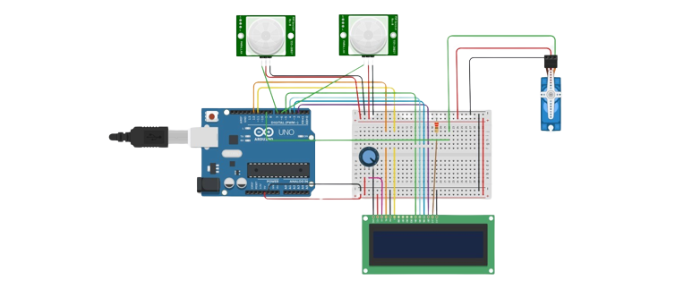

**3-D Representation for Public Transport Optimization:**



