Case Study 2 – Azure API Management

GitHub Link : <https://github.com/sriramsurendhran/surge-api-case-study-2.git>

Author : Sriram SURENDHRAN

ArchitectureDesign :

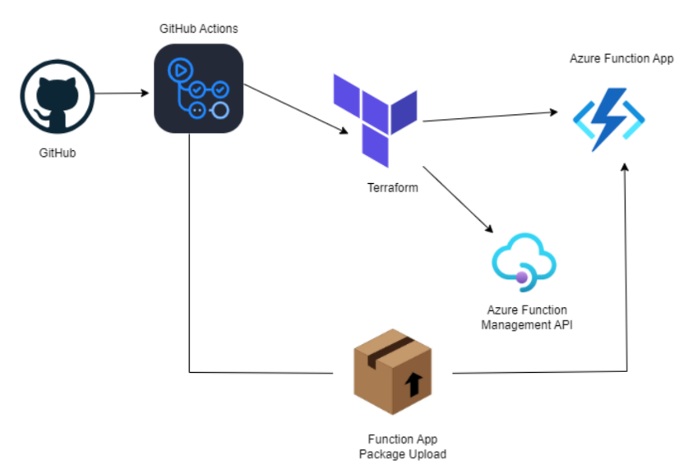

Task Solution:

Azure API Management (APIM):

• APIM Instance:

An APIM instance named my-apim is created, acting as a gateway to manage APIs,

including versioning, security, and scaling.

• Terraform Integration:

o Terraform is used to create and manage the APIM instance.

o A main.tf file in the Terraform directory contains the Resource Manager and

APIM configurations.

o Using the Terraform client, resources are provisioned in Azure by executing

the Terraform files.

• API Registration:

o An API named AzureApimAPI is registered within the APIM instance and

exposed at the path /azureapim.

o Secure communication is ensured via HTTPS.

o The backend is configured to route requests to a Function App using its

hostname.

• API Gateway:

o The APIM instance enforces security policies, transforms API requests, and

routes them to backend services like Azure Functions.

o Application Insights is integrated to track usage, errors, and performance

metrics for the Function App.

• Resource Group and Outputs:

o The created resource group, named apim-function-rg, is exposed as an output.

o Application Insights (azurerm_application_insights) is configured for telemetry

and performance monitoring.

• Administration:

o Publisher details (email and name) are configured for APIM administration.

Function App:

• Migrates the logic to a serverless model to handle incoming API requests from APIM.

• Monitors API health and infrastructure.

• The connection string is passed to the Function App via an environment variable.

Terraform Automation:

• Automates the provisioning of resources such as APIM, Azure Functions, storage,

monitoring, and security settings.

• Provides flexibility to create or delete resources by applying Terraform instructions.

• Careful execution is required during resource deletion.

Security:

• Authentication and Authorization:

o APIM enforces authentication using methods like OAuth 2.0 and API keys.

o Policies enforce JWT validation, including OpenID Connect integration with

Azure Active Directory (AAD).

o API requests must include an Authorization header with a valid token (JWT).

o Unauthorized requests return a 401 Unauthorized response.

• Security Enhancements:

o A policy ensures the aud (audience) claim matches the API client ID.

o An additional security header (X-Frame-Options) prevents clickjacking.

Monitoring:

• Integrated Monitoring:

o Azure Monitor, Log Analytics, and Application Insights are configured to track

usage and diagnose performance issues.

Azure APIM Configuration:

• Resource Group:

o A resource group named apim-function-rg is created in the India South location,

serving as a container for Azure resources.

• Storage Account:

o A storage account named azueapimfunctionapp is created within the resource

group for storing runtime data and package files.

o It uses the Standard performance tier and LRS (Locally Redundant Storage)

replication.

• App Service Plan:

o An App Service Plan named function-app-plan is created with the Dynamic SKU

(Y1 size) for Azure Functions.

o The reserved flag is enabled for specific configurations.

This setup ensures a secure, scalable, and well-monitored API management and Function

App environment using Azure and Terraform.