Problem Chosen: Smart Road Damage Reporting & Rapid Response System for Solapur Municipal Corporation.

Problem context
The urban roads are affected by potholes, cracks, humps and surface damage due to heavy rains, heavy traffic, weather conditions, poor drainage maintenance and inadequate maintenance. This issue leads to accidents, vehicle breakdowns, heavy traffic and discomfort for commuters. Currently, road inspection is done manually or when the citizens’ complaints to the municipal corporation authorities, but this this reactive approach results in delay in identification and repairing damaged roads. This will cause much delay and road will be remains in poor condition for extended periods. The lack of real time monitoring, severity assessment, and automated escalation mechanism. Because of all these reasons Solapur Municipal Corporation requires an intelligent system that continuously monitor the road condition and quick response to prevent the accidents and infrastructure deterioration.

Objectives
- The develop an IOT -based real- time road damage detecting system.
- It will automatically detect the potholes, cracks, and irregularities.
- Ultrasonic sensor measures the road surface depth.
- Accelerometer (MPU6050) detects the vibration.
- Pi camera module captures the images of damaged roads.
- GPS module shares the location of damaged roads.
- The collected data is processed by Raspberry Pi.
- Raspberry pi collects the data and analyses it.
- The damaged roads are classified as low, medium, high severity.
- The collected data displays on the municipal dashboard.
- Then the processed data is sent to the respected departments, and to implement an escalation mechanism if action is delayed.
- To reduce road accidents, vehicle damage.
- To improve response time of municipal authorities, to enable continuous monitoring using municipal vehicles.
- To contribute to safer and sustainable urban road development.

Constraints
- Sensor accuracy may decrease in extreme weather conditions (rain, dust, heat).
- Low visibility during night time may impact image quality.
- Network connectivity problems may cause delays in transmitting real-time data.
- Limited power supply for continuous use in vehicles.
- Budget constraints for mass implementation.
- Data storage and cloud maintenance costs.
- Hardware damage.
- GPS signal may loss in dense urban area.
- Over heating of raspberry pi .
- Delay in the data synchronization in the offline area .

Functions
- The Continuous monitoring of road surface conditions.

- Detection of depth variation and vibration levels.

- Image capture of damaged road areas.

- GPS location tagging.

- Severity analysis using processing algorithm.

- The Data transmission to cloud server.

- Dashboard visualization for authorities.

- Automatic department assignment and escalation.

Early-Stage Solution Architecture
Problem Chosen: Smart Road Damage Reporting & Rapid Response System for Solapur Municipal Corporation
List of subsystems
S.No | Subsystem Name | Functionality
1. | Sensing Subsystem | Detect road damage using Ultrasonic Sensor & MPU6050
2. | Image Capture Subsystem | Capture road damage images using Camera Module
3. | Location Tracking Subsystem | Provide real-time GPS coordinates
4. | Processing Subsystem | Raspberry Pi processes data & calculates severity
5. | Communication Subsystem | GSM/Wi-Fi sends data to cloud
6. | Cloud & Storage Subsystem | Store road damage data securely
7. | Dashboard Subsystem | Display damage location & severity to authorities
8. | Escalation & Alert Subsystem | departments & Forward issue to relevant Commissioner if delayed

The proposed IoT-based Road Damage Detection and Severity Mapping System is broken down into several subsystems to ensure a modular design and effective interaction among the various components. Each subsystem has a particular function that interacts with other subsystems in terms of energy, information, material, or space.
Subsystems Interaction matrix
- Sensing → Processing: Sensor data (depth, vibration signals).
- Camera Processing: Road damage image data.
- GPS Processing: Latitude & Longitude coordinates.
- Communication: Processed severity Processing data.
- Communication Cloud: Data upload via GSM/Wi-Fi.
- Cloud → Dashboard: Display information to municipal officers.
- Dashboard → Departments: Issue assignment.
- Dashboard Commissioner: Escalation in case of delay.

From / To | Ultrasonic | Accelerometer | Camera | GPS | Cloud | Processing | Dashboard | Mechanical
Ultrasonic | - | - | - | - |  | Distance data (pothole depth in cm) | - | Spatial: Mounted facing road
Accelerometer | - | - | - | - | - | Info: Vibration data (XYZ acceleration m/s²) | - | Spatial: Fixed to chassis
Camera | - | - | - | - | - | Info: Road image frames (JPEG/video) | - | Spatial: Forward/downward orientation
GPS | - | - | - | - | - | Info: Latitude, Longitude, Timestamp | - | Requires sky visibility
Cloud | - | - | - | - | - | - | Info: Dashboard data (maps, severity alerts) | Virtual subsystem
Processing | Control signals | Control/config | Camera trigger | Data parsing |  | - | - | Mounted inside housing
Dashboard | - | - | - | - | User queries, issue assignment | - | - | Used in municipal office
Mechanical | Sensor alignment | Vibration coupling | Camera angle fixing | GPS mounting | - | Enclosure & cooling | - | _

Architecture Diagram
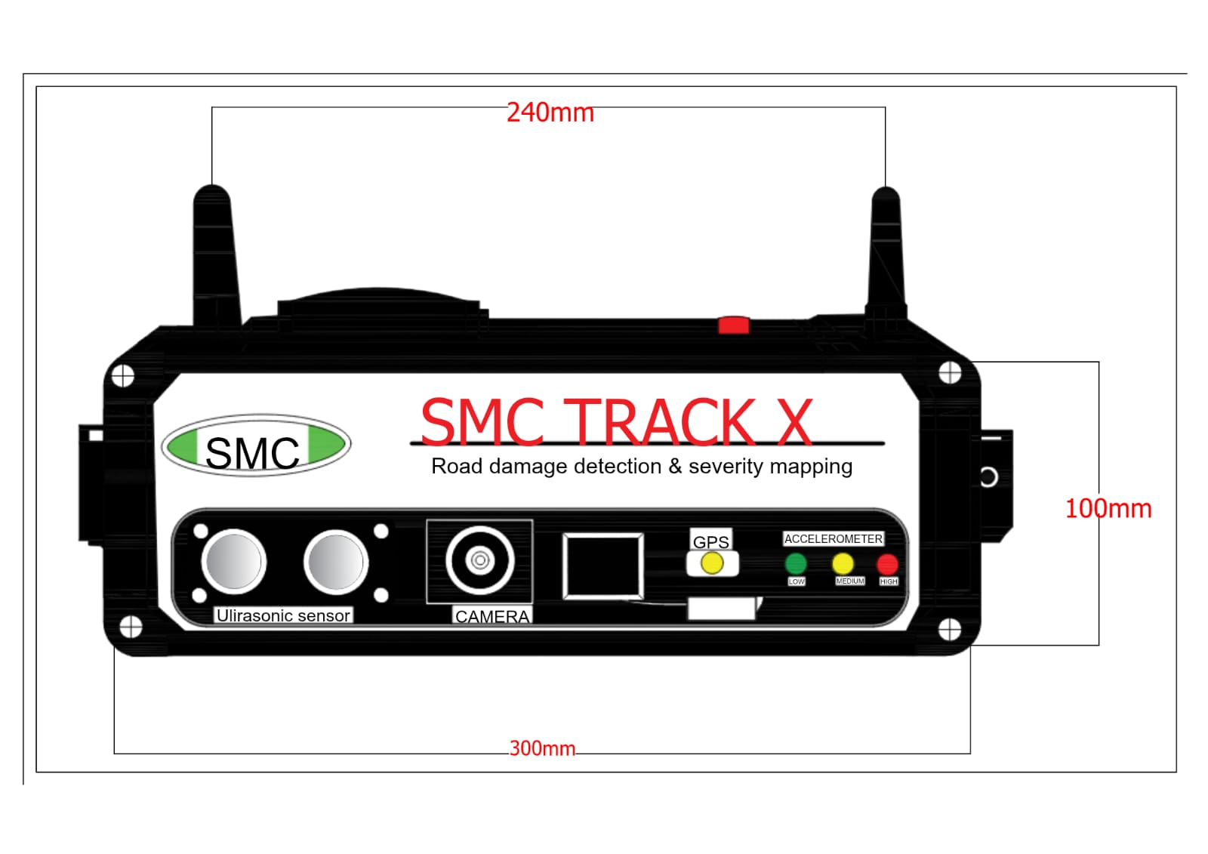
SMC Track X is an IoT edge-to-cloud solution that aims to identify road damage in real-time through sensors mounted on vehicles. It is a multi-layered system that combines sensing, processing, communication, cloud analysis, and dash-boarding.

Architectural Characteristics
- Modular design.
- Scalable (multiple vehicles supported).
- Real-time detection.
- Fault-tolerant communication.
- Cloud-based analytics.
- Clear subsystem boundaries
- Easy maintenance & upgrade

Team Information
Team name: TrackX |  |  | Institute code: QM
Institute name: KG REDDY College of Engineering & technology
City: Hyderabad |  |  | State: Telangana
Mentor Details
Mentor name: Vijaya Bhasker
Contact number: 9640818559 |  |  | Email: vijayabhasker@kgr.ac.in
Participant Details
S.No | Participant name | Program | Sem | Contact number | Email
1 | Sriramula Monika | Electronics and Communication Engineering (ECE) | 2-2 | 8978031743 | sriramulamonika24@gmail.com
2 | Muddana.Charan Sai | Electronics and Communication Engineering (ECE) | 2-2 | 87122 26370 | muddanacharansai@gmail.com
3 | Suddula.Jeevan | Electronics and Communication Engineering (ECE) | 2-2 | 75695 99153 | jeevansuddula42@gmail.com
4 | Golli. Nandhini | Electronics and Communication Engineering (ECE) | 2-2 | 70325 94936 | nandinigolli0@gmail.com
5 | Kurupudi. Raja Rajeswari | Electronics and Communication Engineering (ECE) | 2-2 | 90149 79673 | kurupudivenkatyasvanth@gmail.com

Note: The above details will be used for certificate generation. Please ensure accuracy.

Declaration
We hereby declare that the work titled “Smart Road Damage Reporting & Rapid Response System for Solapur Municipal Corporation” submitted for SAMVED-2026 is the original outcome of our team’s efforts.
The work has been carried out by us under the guidance of the undersigned mentor and is neither copied from any source nor generated using artificial intelligence (AI) tools.

Place: Hyderabad
Date: 20/02/2026.
Team Leader Name: Sriramula Monika
Mentor Name: Vijaya Bhasker

