Version of SQL used

Type: Microsoft SQL Server

Version: 13.00.1601

If the database is not compatible with the current instance of SQL Server. Please follow the below mentioned steps:

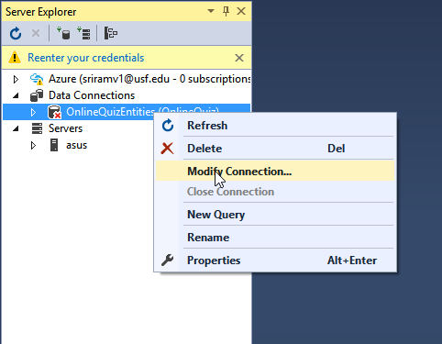

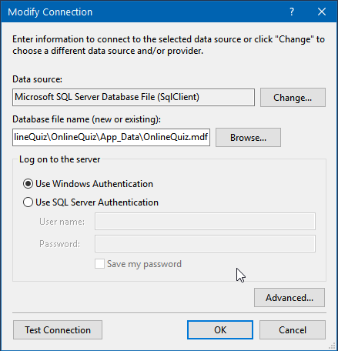

Click “OK”

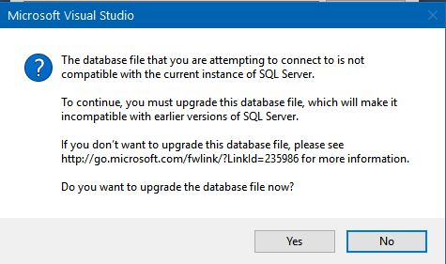

Click “Yes”

