Understanding document

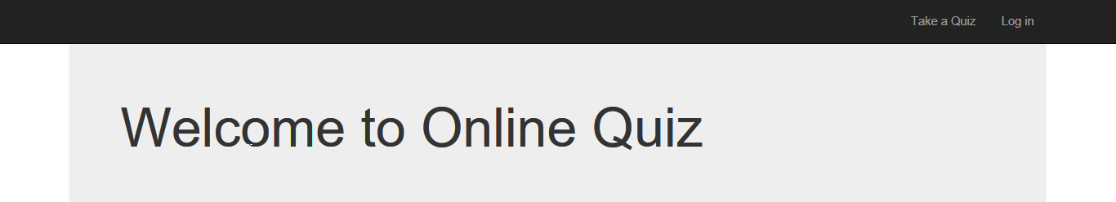

There will be 2 options:

Admin users will be able to **Log in** and create a new quiz or edit existing quizzes.

Every user can **“Take a Quiz”.** Upon clicking “Take a Quiz”

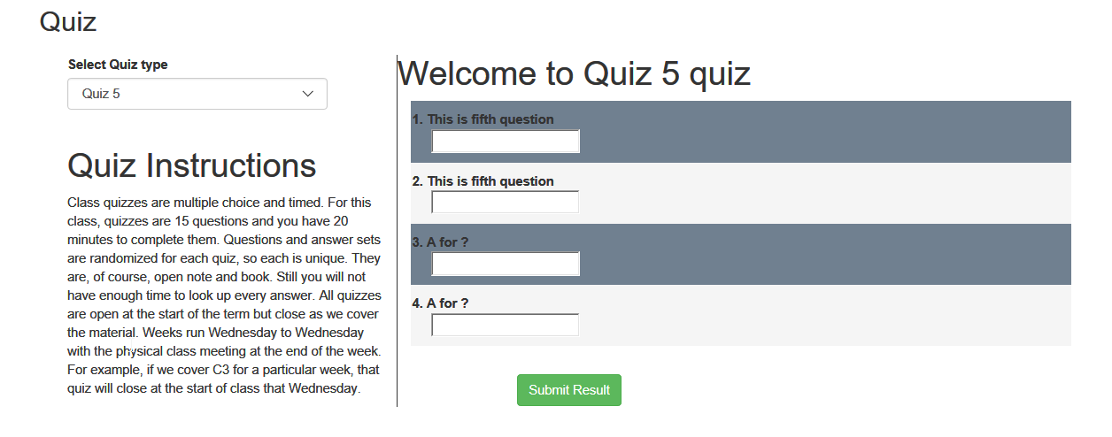

All the quizzes will be listed in the drop-down and on selecting a quiz, their respective questions will be listed in the page.

After Answering the questions and on clicking the “Submit Result” button.

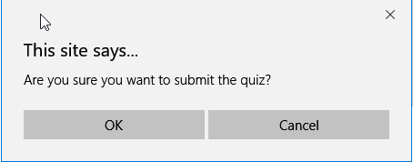

A confirmation pop-up appears.

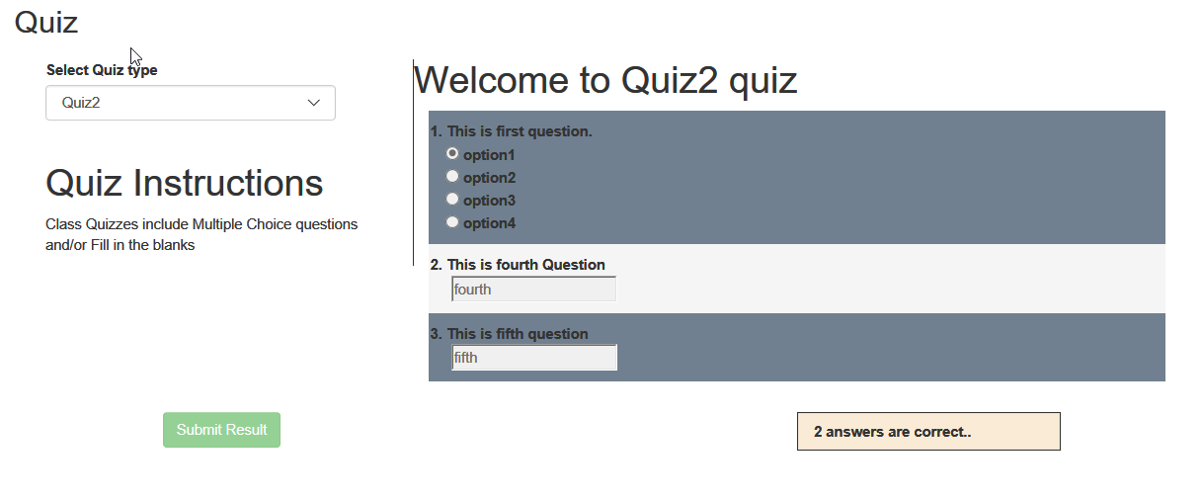

Now Login to create new quizzes/Questions

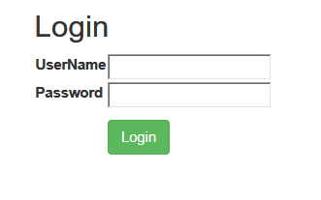

User name: admin

Password: admin

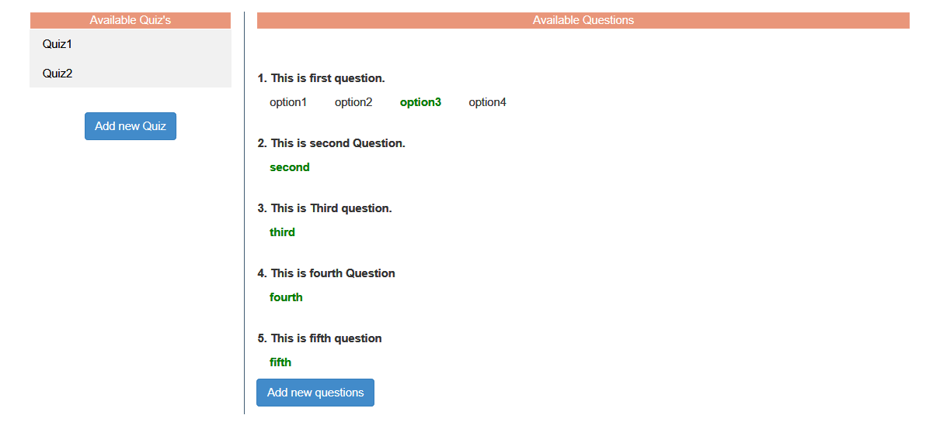

On the left, all the available Quizzes are available. While on the right all the available questions are displayed.

**Add new Questions:**

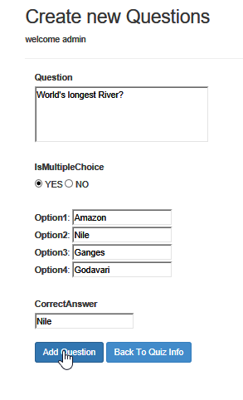 

It is a multiple choice question and upon adding the question a message will be displayed.

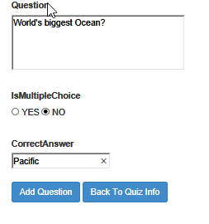

This is not a multiple-choice question. It is a fill in the blanks question.



Click on “Add Question” to complete adding the question.

Upon clicking “Back to Quiz Info”. These new questions will be listed in the page

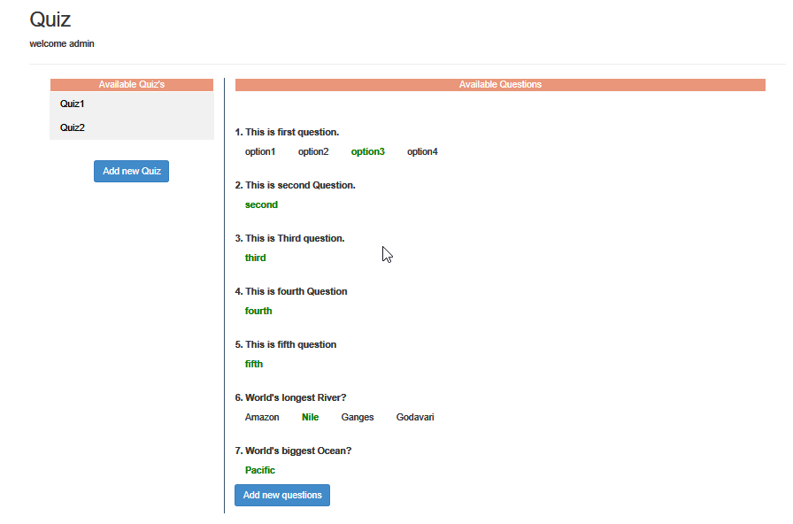

**Add new Quiz:**

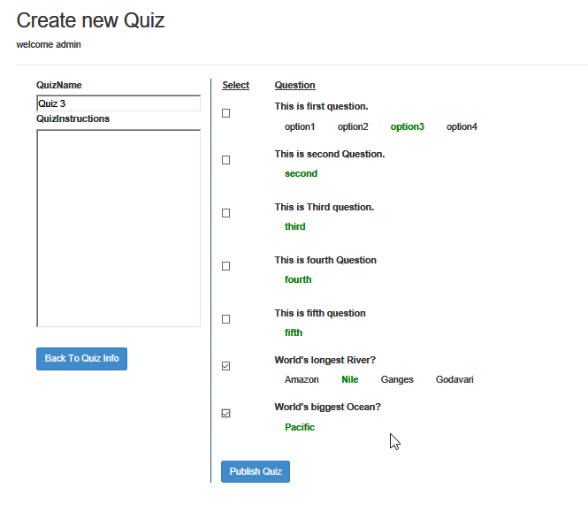

We can select the questions for the Quiz and upon clicking “Publish Quiz”. The quiz will be listed in the list.



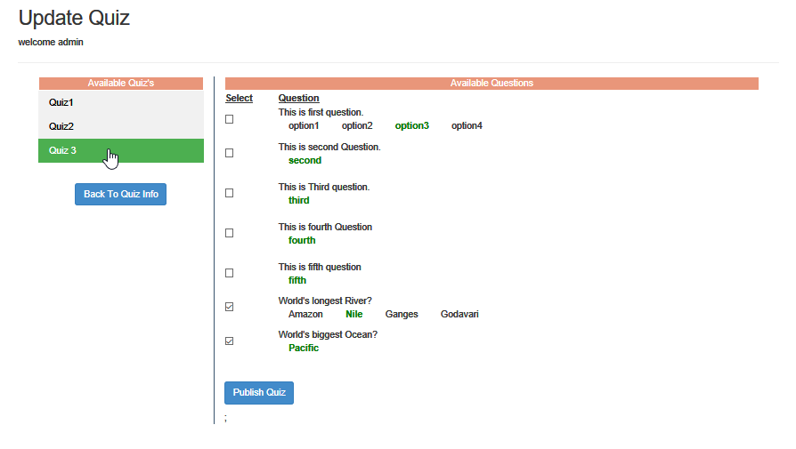

We can add/remove questions from a quiz by checking /unchecking the check box next to the questions. Upon clicking “Publish Quiz” the data will be saved in the data base.

I have included database (OnlineQuiz.mdf) file in the project.