**CHAPTER 1**

**INTRODUCTION**

**1.1 PURPOSE**

WHO (World Health Organization) estimates that in 2012 there were 285 million visually impaired people in the world, of which 246 million had low vision and 39 million are totally blind. Of those who are blind 90% live in developing world.

The Purpose of ultrasonic blind stick is to help the visually impaired people to detect the obstacles around them and give the feedback to that person in the form of voice, Which add an advantage by not depending on others.

**1.2 SCOPE**

This project is to provide a way of path to the blind persons by replacing manual blinds sticks with these electronic blind sticks which helps the visually impaired people in travel purposes. It is also useful in indoor purposes as well. This stick is also fitted with RF transmitter and receiver which helps the impaired persons to find the stick by simply pressing the remote.

**1.3 OVERVIEW**

The aim of the overall system is to provide a low cost and efficient navigation aid for a visually impaired person who gets a sense of artificial vision by providing information about the environmental scenario of static and dynamic objects around them. Ultrasonic sensors are used to calculate distance of the obstacles around the blind person to guide the user towards the available path, In addition we do added water, LDR sensors and RF remote module. Output is in the form of sequence of voice sound which the blind person can hear.

**1.4 EXISTING SYSTEM**

Existing Sticks has many faults like cannot detect the objects accurately. Thus we were motivated to develop a smart white cane to overcome these limitations.

**1.5 DISADVANTAGES**

* By using a normal blind stick we cannot detect far away object.
* Sensitive objects can be damaged when hit by the stick.
* Ground undulations cannot be detected.
* It is difficult to find the stick when it was kept away at different place than usual pic up spot.

**1.6 PROPOSED SYSTEM**

* Proposed system helps visually challenged people to navigate with ease using advanced technology.
* Our proposed project first uses ultrasonic sensors to detect obstacles ahead using ultrasonic waves and in addition we do also added water sensor, LDR and RF remote.
* On sensing obstacles the sensor passes this data to the microcontroller.
* The microcontroller then processes this data and calculates if the obstacle is close enough.
* If the obstacle is close the microcontroller sends a signal to sound a voice playback module.
* It also detects and sounds a different voice commands if it detects water and alerts the blind.
* One more feature is that it allows the blind to detect if there is light or darkness in the room.

**1.7ADVANTAGES**

* The aim of the overall system is to provide a low cost and efficient navigation aid for a visually impaired person who gets a sense of artificial vision by providing information about the obstacle.
* Thus this system allows for obstacle detection as well as finding stick if misplaced by visually disabled people.

**CHAPTER 2**

**REQUIREMENT ANALYSIS**

**2.1 FUNCTIONAL REQUIREMENTS**

**2.1.1 Embedded c**

In this project blind stick is used by the visually impaired people by using different sensors for detecting object, water and light detection. For all these processes we should have to calibrate all the sensors by using connecting wires and sending voice output if there is an object. This process is done using Aurdino IDE.

* Embedded C is a generic term given to a programming language written in C, which is associated with particular hardware architecture.
* Each processor is associated with embedded software. The first and foremost thing is the embedded software that decides functioning of the embedded system. Embedded C language is most frequently used to program the microcontroller. Earlier, many embedded applications were developed using assembly level programming.
* Embedded C is an extension to the C language with some additional header files. These header files may change from controller to controller.

These programs play prominent role in monitoring and controlling external devices. They also directly operate and use the internal architecture of the microcontroller, such as interrupt handling, timers, serial communication and other available features.

Comments: In embedded C programming language, we can place comments in our code which helps the reader to understand the code easily.  
C=a+b; /* add two variables whose value is stored in another variable C*/

Preprocessor directives: All the functions of the embedded C software are included in the preprocessor library like “#includes<reg51.h>, #defines”. These functions are executed at the time of running the program.

Advantages of embedded C program

* Its takes less time to develop application program.
* It reduces complexity of the program.
* It is easy to verify and understand.
* It is portable in nature from one controller to another.

void setup()

{

// put your setup code here, to run once:

}

void loop()

{

// put your main code here, to run repeatedly:

}

**2.1.2 Arduino tool kit:**

The Arduino tool kit is having five sensors that are attached to it and there is also Ethernet that is attatched with the aurdino board.

**2.2 NON FUNCTIONAL REQUIREMENTS**

A Non-Functional requirement is a requirement that specifies criteria that can be used to judge the operation of a system, rather than specific behaviors. Non-Functional requirements are often called qualities of a system and these are as followers.

**2.2.1 Usability**

The device gives the status messages regularly based on the user actions performed. Thus the access to this system is very easy. .

**2.2.2 Performance**

This system is developed in the high level languages and using the advanced front-end technology it will give response to the end user on client system with in very less time with accuracy.

**2.2.3 Security**

Security and confidentiality are the top most concerns of the User. The system should be flexible so that only the authorized persons can do any further modifications.

**2.2.4 Reliability**

The system should be available for 24 hours a day , 7 days a week i.e.., There should be continuous availability of the system.

**2.2.5 Documentation**

Everything that is done for designing the system is documented in an understandablemanner.

**2.2.6 System Modifications**

The system should be flexible so that only the authorized persons can do any further modifications.

**2.2.7 Error Handling**

The system should be error free i.e., the system should display a meaningful high-level components in proposed system should handle exceptions that occur while connecting to IO Exceptions.

* 1. **SYSTEM REQUIREMENTS:**

The user is expected to ensure that the minimum requirements for running the product are satisfied. The hardware and software environment in which this product was developed is specified. It is necessary to make sure that the hardware and software the consumer uses is compatible to the specification given below.

**2.3.1** **Hardware requirements:**

* System : Pentium Dual Core or above.
* Hard Disk : 20 GB.
* RAM : 4GB.
* Sensors : Arduino UNO, Ultrasonic Sensor, LDR, moisture sensor,RF module

**2.3.2 Software requirements**

* Operating system : Windows XP or Higher
* Coding Language : MC Programming Language: C
* Tool : Arduino IDE

**CHAPTER 3**

**DESIGN**

**3.1 SYSTEM ARCHITECTURE:**

A system architecture or systems architecture is the [conceptual model](https://en.wikipedia.org/wiki/Conceptual_model) that defines the [structure](https://en.wikipedia.org/wiki/Structure), [behavior](https://en.wikipedia.org/wiki/Behavior), and more [views](https://en.wikipedia.org/wiki/View_model) of a [system](https://en.wikipedia.org/wiki/System). An architecture description is a formal description and representation of a system, organized in a way that supports reasoning about the [structures](https://en.wikipedia.org/wiki/Structure) and [behaviors](https://en.wikipedia.org/wiki/Behavior) of the system.

A system architecture can comprise system [components](https://en.wikipedia.org/wiki/System), the expand systems developed, that will work together to implement the overall system. There have been efforts to formalize languages to describe system architecture; collectively these are called [architecture description languages](https://en.wikipedia.org/wiki/Architecture_description_languages) (ADLs).

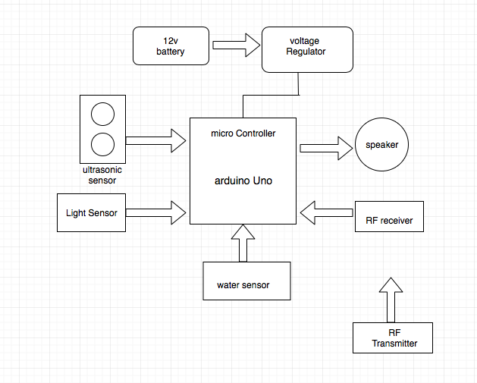

Fig 3.1: Work flow and system architecture

The architecture involves sensors that are connected to the Aurdino board which gathers the input and the output is in the form of the voices.

**3.2 SYSTEM DESIGN**

From a project management point of view, software design is conducted in two steps; Preliminary design is concerned with transformation of requirements into data and software architecture. Detailed design focuses on refinements to the architectural representation that leads to detailed data structure and algorithmic representations of software.

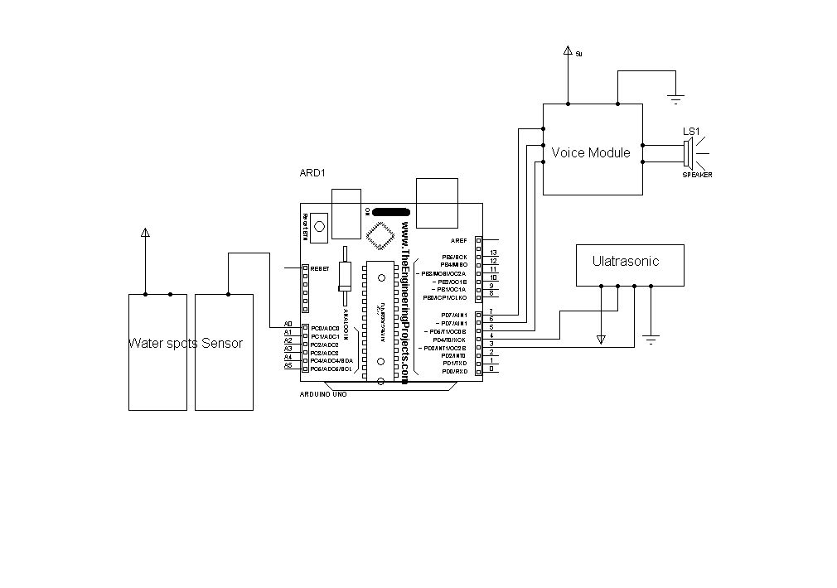

Fig 3.2: System Architecture

**3.2.1 Fundamental design concepts**

Data abstraction

Information hiding Modularity

Concurrency

Verification

**3.3 DETAILED DESIGN**

Detailed design focuses on refinements to the architectural representation that leads to detailed data structure and algorithmic representation of software.

**3.3.1 Logical Design**

The logical design of an information system is analogous to an engineering blue print or conceptual view of an automobile, it shows the major features and how they are related to one another.

**3.3.2 Input Design**

The input design is the bridge between users and the information system. It specifies the manner in which data enters the system for processing. It can ensure the reliability of the system and produce reports from accurate data or it may result in output of error information.

**3.3.3 Output Design**

Each and every activity in this work is result oriented. The most important feature of information system for users is the output. Thus the following points are considered during output design.

What information to be present?

Whether to display or print the information?

How to arrange the information in an acceptable format?

How the status has to be maintained each and every time?

How to distribute outputs to the recipients?

**3.3.4 Data Design**

Data design is the first of the three design activities that are conducted during software engineering. The impact of data structure on program structure and procedural complexity causes data design to have a profound influence on software quality.

**3.4 DATA FLOW DIAGRAMS:**

A data flow diagram (DFD) maps out the flow of information for any process or system. It uses defined symbols like rectangles, circles and arrows, plus short text labels, to show data inputs, outputs, storage points and the routes between each destination. Data flowcharts can range from simple, even hand-drawn process overviews, to in-depth, multi-level DFDs that dig progressively deeper into how the data is handled. They can be used to analyze an existing system or model a new one. Like all the best diagrams and charts, a DFD can often visually “say” things that would be hard to explain in words, and they work for both technical and nontechnical audiences, from developer to CEO. That’s why DFDs remain so popular after all these years. While they work well for data flow software and systems, they are less applicable nowadays to visualizing interactive, real-time or database-oriented software or systems.

To Construct a Data Flow Diagrams, we use:

* Arrows-Identifies data flow data in motion. It is a pipeline through which information flows.
* Circles - Like the rectangle in flowcharts, Circles stand for a process that converts incoming data to information.
* Open-Ended Boxes or Parallel Lines - An Open-Ended box represents a data/store-data at rest, or a temporary repository.
* Squares - A Square defines a source or destination of system data.

**3.4.1 DFD LEVELS AND LAYERS:**

A data flow diagram can dive into progressively more detail by using levels and layers, zeroing in on a particular piece.  DFD levels are numbered 0, 1 or 2, and occasionally go to even Level 3 or beyond.

**3.4.1.1 Level 0 DFD:**

DFD Level 0 is also called a Context Diagram. It’s a basic overview of the whole system or process being analyzed or modeled. It’s designed to be an at-a-glance view, showing the system as a single high-level process, with its relationship to external entities. It should be easily understood by a wide audience, including stakeholders, business analysts, data analysts and developers.

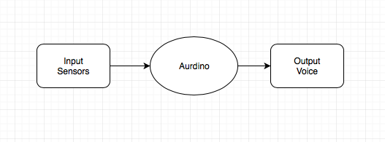

Fig 3.3: Level Zero DFD

**3.4.1.2 Level 1 DFD:**

* DFD Level 1 provides a more detailed breakout of pieces of the Context Level Diagram. You will highlight the main functions carried out by the system, as you break down the high-level process of the Context Diagram into its sub processes.

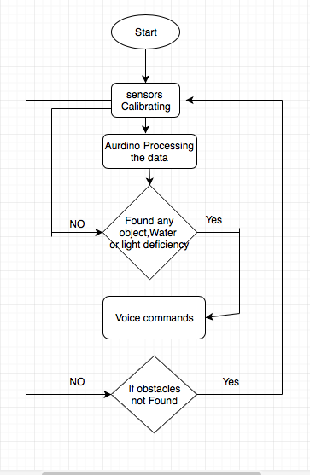

Fig 3.4:Level 1 DFD

**CHAPTER 4**

**IMPLEMENTATION**

**4.1 HARDWARE REQUIREMENTS**

**4.1.1 Ultrasonic sensor**

An Ultrasonic sensor is a device that can measure the distance to an object by using sound waves. It measures distance by sending out a sound wave at a specific frequency and listening each processor is associated with embedded software. The first and foremost thing is the embedded software that decides functioning of the embedded system. Embedded C language is most frequently used to program the microcontroller. Earlier, many embedded applications were developed using assembly level programming.for that sound wave to bounce back.By recording the elapsed time between the sound wave being generated and the sound wave bouncing back,it is possible to calculate the distance between the sensor and the object.

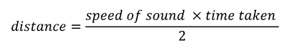

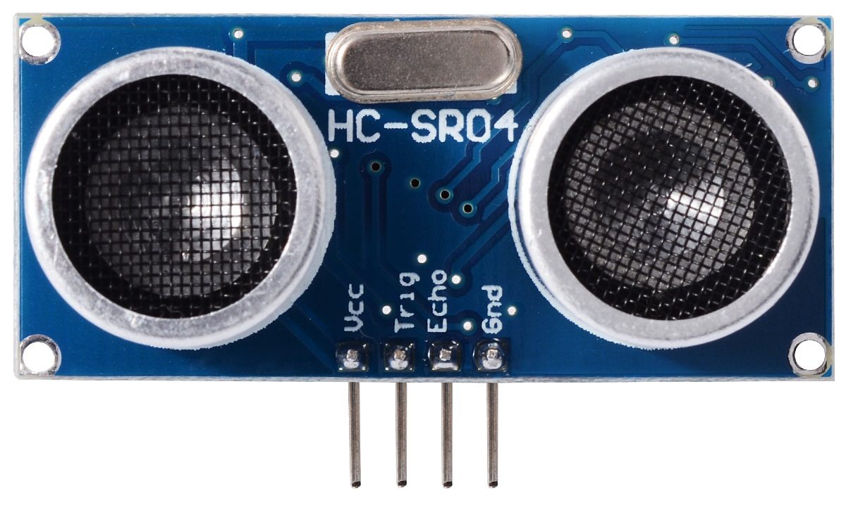

Fig 4.1: UltrasonicSensor

**4.1.2 Connecting wires:**

A wire is a single, usually [cylindrical](https://en.wikipedia.org/wiki/Cylinder_(geometry)), flexible strand or rod of metal. Wires are used to bear mechanical [loads](https://en.wikipedia.org/wiki/Structural_load) or [electricity](https://en.wikipedia.org/wiki/Electricity) and [telecommunications signals](https://en.wikipedia.org/wiki/Signal_(electronics)). Wire is commonly formed by [drawing](https://en.wikipedia.org/wiki/Drawing_(manufacturing)) the metal through a hole in a [die](https://en.wikipedia.org/wiki/Die_(manufacturing)) or [draw plate](https://en.wikipedia.org/wiki/Draw_plate). [Wire gauges](https://en.wikipedia.org/wiki/Wire_gauge) come in various [standard](https://en.wikipedia.org/wiki/Standardisation) sizes, as expressed in terms of a [gauge number](https://en.wikipedia.org/wiki/American_wire_gauge). The term *wire* is also used more loosely to refer to a bundle of such strands, as in "multistranded wire", which is more correctly termed a [wire rope](https://en.wikipedia.org/wiki/Wire_rope) in mechanics, or a [cable](https://en.wikipedia.org/wiki/Electrical_cable) in electricity. These are mainly used in coonectin sensors.

**4.1.3 Arduino UNO:**

Arduino is an open-source prototyping platform based on easy-to-use hardware and software. Arduino boards are able to read inputs, light on a sensor, a finger on a button, or a Twitter message and turn it into an output, activating a motor, turning on an LED, publishing something online. You can tell your board what to do by sending a set of instructions to the microcontroller on the board. To do so you use the Arduino programming language (based on Wiring), and the Arduino Software (IDE), based on Processing.

We will be using Arduino UNO board during this workshop. The UNO is the best board to get started with electronics and coding. It is the most robust board you can start playing with. It is the most used and documented board of the whole Arduino family.

4.1.3.1 Pin out Configuration:

The Arduino Uno is a microcontroller board based on the ATmega328p microcontroller. It has following pin out:

* 14 digital input/output pins (6 can be used as Pulse Width Modulation (PWM) outputs)
* 6 analog inputs
* Crystal oscillator
* USB connection
* Power jack
* In-Circuit Serial Programming ICSP header
* Reset button

It contains everything needed to support the microcontroller; simply connect it to a computer with a USB cable or power it with an AC-to-DC adapter or battery to get started. It makes easy to build and debug projects.



Fig. 4.2: Arduino UNO board pin description

* Digital pins:

These pins are used with digitalRead(), digitalWrite(), and analogWrite(), analogWrite() works only on the pins with the PWM symbol as shown in Fig4.2.

* Pin 13 LED:

This pin includes only actuator built-in to your board. Besides being a handy target for your first blink sketch, this LED is very useful for debugging.

* Power LED:

This pin indicates that your Arduino is receiving power. It is very useful for debugging.

* ATmega microcontroller:

The microcontroller is the heart of your board.

* Analog in:

These pins are use with analogRead().

* GND and 5V:

These pins are used to provide +5V power and ground to your circuits.

* Power connector:

This is used to power your Arduino when it’s not plugged into a USB port for power. It can accept voltages between 7-12V.

* TX and RX LEDs:

These LEDs indicate communication between your Arduino and your computer. They also flicker rapidly during sketch upload as well as during serial communication. These are also useful for debugging.

* USB port:

This port is used for powering your Arduino Uno, uploading your sketches to your Arduino, and for communicating with your Arduino.

* Reset button:

This button is used to resets the ATmega microcontroller.

4.1.4 LDR

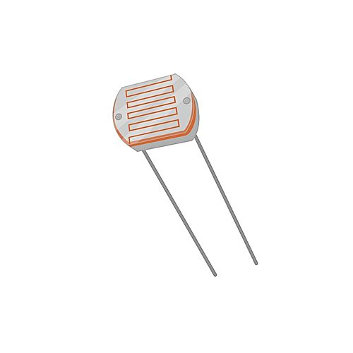

Fig 4.3: LDR

LDR :An LDR is a component that has a ( variable) resistance that changes with the light intensity that falls upon it.

4.1.5 Water sensor:

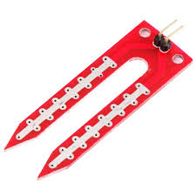

Fig 4.4:Water sensor

Water sensor: Water sensor is used to detect the water or any type of liquids present on the floor.

4.1.6 APR33Avoice processor

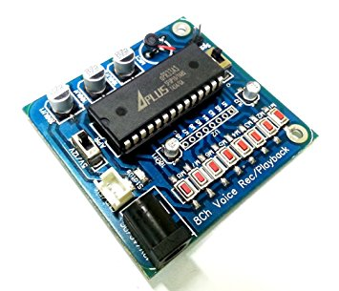

Fig 4.5: APR33Avoice processor

The APR33A series are powerful audio processor along with high performance audio analog-to-digital converters (ADCs) and digital-to- analog converters (DACs).

4.1.7 RF Module

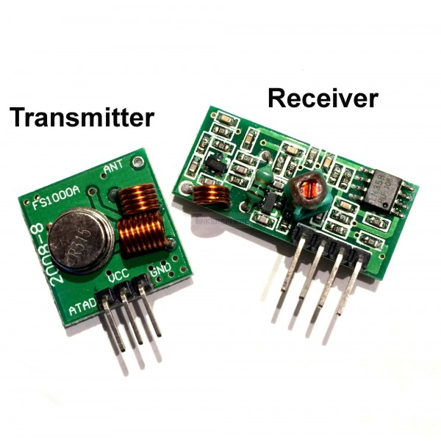

Fig 4.6: RF 433 MHz

An RF module (radio frequency module) is a (usually) small electronic circuit used to transmit and/or receive radio signals on one of a number of carrier frequencies.

**4.2 SOFTWARE REQUIREMENTS:**

**4.2.1 Arduino Software (IDE):**

The Arduino Integrated Development Environment (IDE) contains a text editor for writing code, a message area, a text console, a toolbar with buttons for common functions and a series of menus. It connects to the Arduino hardware to upload programs and to carry out communication between them. The software and step-by-step directions for its installation is available at <http://arduino.cc/en/Main/Software>

**4.2.2 Install the Drivers for Windows:**

After successfully installing Arduino IDE the next step is to install the supported drivers for the cable that has been used for connecting the Arduino board to Computer. Following steps need to be followed for successful installation of the drivers.

1) Plug in board via USB and wait for Windows to begin its driver installation process. After a few moments, the process will fail i.e., this is not unexpected.

2) Click on the “Start Menu”, and open up the “Control Panel”.

3) While in the “Control Panel”, navigate to “System and Security”. Next, click on “System”. Once the System window is up, open the “Device Manager”.

4) Look under Ports (COM & LPT). There must be an open port named "Arduino UNO (COMxx)".

5) Right click on the "Arduino UNO (COMxx)" port and choose the "Update Driver Software" option.

6) Next, choose the "Browse my computer for Driver software" option.

7) Finally, navigate to and select the Uno’s driver file, named "ArduinoUNO.inf", located in the "Drivers" folder of the Arduino Software download.

8) Windows will finish up the driver installation from there.

**4.2.3 Integrated Development Environment (IDE):**

Different menus with variety of options are available in Arduino IDE which makes it easy to use. Few important and most frequently used icons are discussed as under.



Fig. 4.7: IDE Window

* Compile:

Before program “code” can be sent to the board, it first needs to be converted into instructions that the board understands. This process is called compiling.

* Stop:

This stops the compilation process.

* Create new Sketch:

This opens a new window to create a new sketch.

* Open Existing Sketch:

This loads a sketch from a file on computer.

* Save Sketch:

This saves the changes to the working sketch.

* Upload to Board:

This compiles the code and then transmits it over the USB cable to board.

* Serial Monitor:

This is used to receive data from external devices through USB cable /DB9 connector.

* Tab Button:

This lets you to create multiple files in sketch. This is for more advanced programming that is not a part of this course.

* Sketch Editor:

This is where the sketches are written.

* Text Console:

This shows what the IDE is currently doing and error messages are also displayed here.

**4.2.4 How to Upload a Sketch:**

The Arduino IDE consists of few example sketches which can be uploaded to Arduino board by using following steps:

1. Double-click the Arduino application.

2. Open the LED blink example sketch: File > Examples > 1.Basics > Blink

3. Select Arduino Uno under the Tools > Board menu.

4. Select serial port (if not aware of exact port, disconnect the UNO and the entry that disappears is the right one.)

5. Click the Upload button.

6. After the message “Done uploading” appears, the LED on Arduino will start blinking once a second.

Each sketch of Arduino IDE must contain at least two functions.

* setup ():

This function is called once when the program starts.

* loop ():

This function is called repetitively over and over again.



Fig. 4.8: Function of setup and loop

**4.2.5 Digital Pins:**

Digital pins are much easy to understand as there are only two states, either ON or OFF. In Arduino sketch terms, an ON state is known as HIGH (5V) and OFF state is known as LOW (0V).

4.2.5.1 pinMode ():

This command configures the specified pin to behave either as an input or an output.

Syntax*:* pinMode(pin, mode)

4.2.5.2 digitalWirte ():

This command writes a HIGH or a LOW value to a digital pin.

* If the pin has been configured as an OUTPUT with pinMode(), its voltage will be set to the corresponding value: 5V (or 3.3V on 3.3V boards) for HIGH, 0V (ground) for LOW.
* If the pin is configured as an INPUT, digitalWrite() will enable (HIGH) or disable (LOW) the internal pull up on the input pin. It is recommended to set the pinMode() to INPUT_PULLUP to enable the internal pull-up resistor

Syntax*:* digitalWrite(pin, value)

4.2.5.3 digitalRead():

This command reads the value from a specified digital pin, either HIGH or LOW .

Syntax*:* digitalRead(pin)

Sample Program:

int val = 0; // variable to store the read value

void setup()

{

pinMode(13, OUTPUT); // sets the digital pin 13 as output

pinMode(7, INPUT); // sets the digital pin 7 as input

pinMode(8, OUTPUT);

Serial.begin(9600);

}

void loop()

{

digitalWrite(8, HIGH);

val = digitalRead(7); // read the input pin

Serial.print(val);

}

**4.2.6 Serial Monitor:**

The Arduino IDE has a feature that can be of a great help in debugging sketches or controlling Arduino from your computer's keyboard. It displays serial data being sent from Arduino UNO (USB or serial board).

**4.2.6.1 Configuration of Serial Monitor:**

1. Connect Arduino UNO board by USB to your computer to activate the Serial Monitor.

2. To get familiar with using the Serial Monitor, Write the following Sketch into a blank

Arduino IDE window.

3. Then verify it and if it's OK, Upload it.

4. Click on Serial Monitor icon at right corner

5. A pop up in a new window

6. Look at the Serial Monitor window.

* The small upper box is where you can type in characters (hit or click "Send")
* The larger area (Corner can be dragged to enlarge) is where characters sent From Arduino will be displayed.
* At the bottom are two pull-downs:
* One sets the "line ending" that will be sent to Arduino when you or click Send
* The other sets the Baud Rate (9600) for communications. (If this does not match the value set up in your sketch in Setup, characters will be unreadable).
* SETUP:

In Setup you need to begin Serial Communications and set the Baud Rate (speed) that data will be transferred at. That looks like this:

Serial.begin(9600); // set up Serial library at 9600 bps

* LOOP:

Here we can use following commands to send data serially & configure it to the Serial Monitor.

Examples:

* serial.availabe():

This command is use to get the number of bytes (characters) available for reading from the serial port.

* serial.flush() :

This command is used to wait for the transmission of outgoing serialdata to complete.serial.print(data).This command is used to print data to the serial port as human-readable ASCII text.

* serial.read():

This command is used to reads incoming serial data.

Sample sketch:

/*

* Hello World!

*

* This is the Hello World! For Arduino.

* It shows how to send data to the computer

*/

void setup() // run once, when the sketch starts

{

Serial.begin(9600); // set up Serial library at 9600 bps

}

void loop() // run over and over again

{

Serial.println("Hello world!"); // prints hello continuously

delay(1000); }

Output:



Fig. 4.9: Serial monitor

**4.3. STEPS FOR EXECUTION:**

The various steps involved in the execution of the Smart Bins are:-

1. Connecting the circuit.
2. Importing the code into the Arduino software.
3. Calculating the distance of objects in front using Ultrasonic sensor.
4. Comparing with the distance limit
5. Triggering the voice module
6. Sending voice message to the voice module about distance of objects.
   1. **OVERVIEW OF SOFTWARE USED:**

**4.4.1 ARDUINO SOFTWARE:**

Arduino is an open-source electronics platform based on easy-to-use hardware and software. Arduino boards are able to read inputs - light on a sensor, a finger on a button, or a Twitter message - and turn it into an output - activating a motor, turning on an LED, publishing something online. You can tell your board what to do by sending a set of instructions to the microcontroller on the board. To do so you use the [Arduino programming language](https://www.arduino.cc/en/Reference/HomePage) (based on [Wiring](http://wiring.org.co/)), and [the Arduino Software (IDE)](https://www.arduino.cc/en/Main/Software), based on [Processing](https://processing.org/).

* Why arduino:

Arduino has been used in thousands of different projects and applications. The Arduino software is easy-to-use for beginners, yet flexible enough for advanced users. It runs on Mac, Windows, and Linux. Teachers and students use it to build low cost scientific instruments, to prove chemistry and physics principles, or to get started with programming and robotics.

* Advantages of using arduino:
* **Inexpensive** - Arduino boards are relatively inexpensive compared to other microcontroller platforms. The least expensive version of the Arduino module can be assembled by hand, and even the pre-assembled Arduino modules cost less than $50.
* **Cross-platform** - The Arduino Software (IDE) runs on Windows, Macintosh OSX, and Linux operating systems. Most microcontroller systems are limited to Windows.
* **Simple, clear programming environment** - The Arduino Software (IDE) is easy-to-use for beginners, yet flexible enough for advanced users to take advantage of as well. For teachers, it's conveniently based on the Processing programming environment, so students learning to program in that environment will be familiar with how the Arduino IDE works.
* **Open source and extensible software** - The Arduino software is published as open source tools, available for extension by experienced programmers. The language can be expanded through C++ libraries, and people wanting to understand the technical details can make the leap from Arduino to the AVR C programming language on which it's based. Similarly, you can add AVR-C code directly into your Arduino programs if you want to.
* **Open source and extensible hardware** - The plans of the Arduino boards are published under a Creative Commons license, so experienced circuit designers can make their own version of the module, extending it and improving it.
* Even relatively inexperienced users can build the [breadboard version of the module](https://www.arduino.cc/en/Main/Standalone) in order to understand how it works and save money.

4.4.2 Arduino UNO:

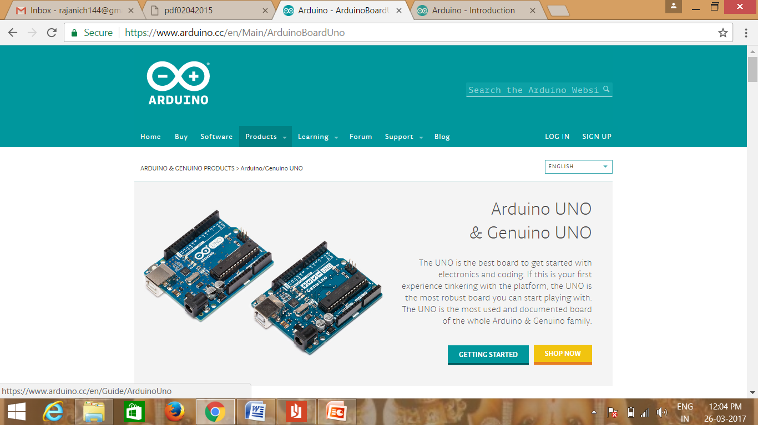

* Connect your Uno board with an A B USB cable; sometimes this cable is called a USB printer cable.
* Install the board drivers.
* Open your first sketch:

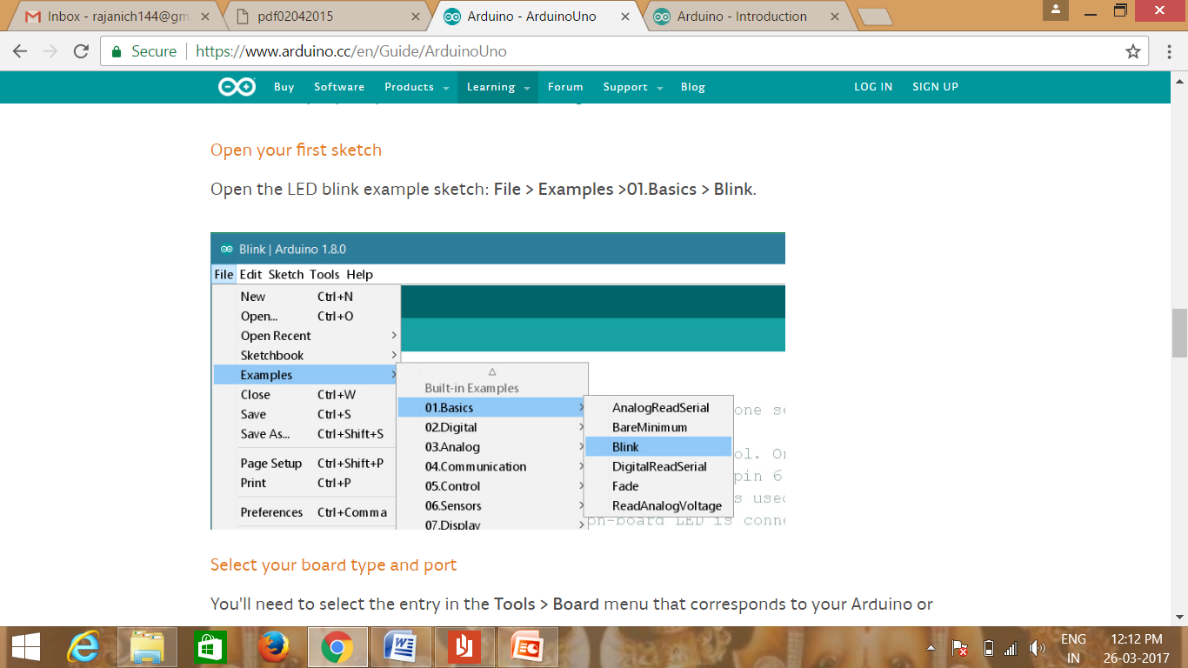

Fig 4.10 Opening sketch examples

* Select your board type and port:

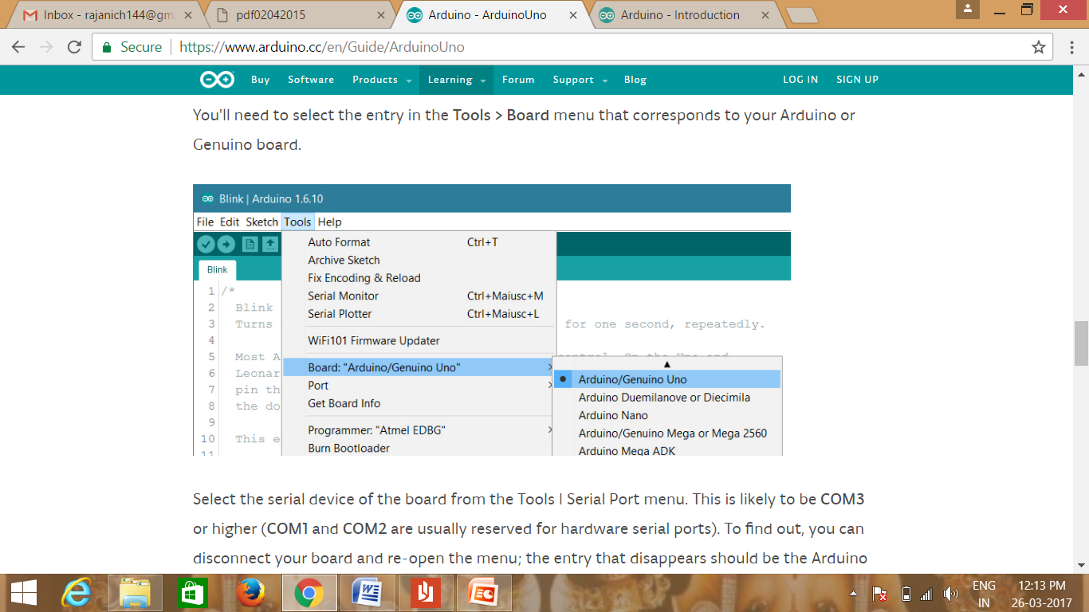

Fig 4.11: selecting board type and port

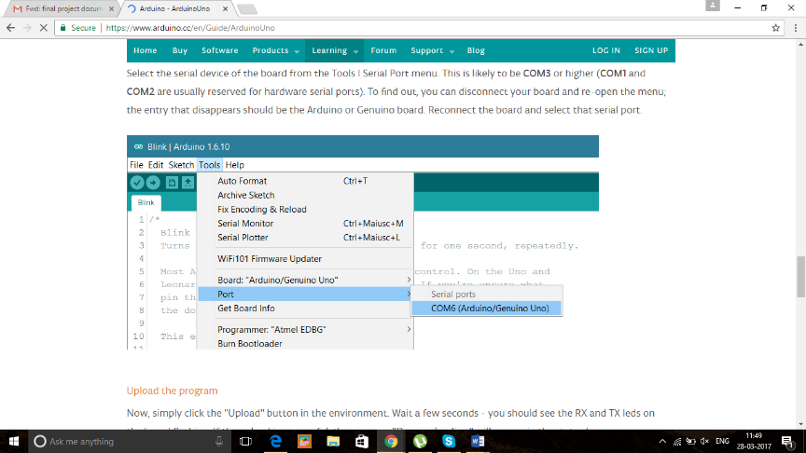

Fig 4.12: Port COM6 implementation

* Upload the program:

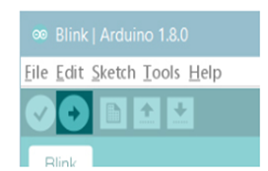

Fig 4.13: Uploading the program

**CHAPTER 5**

**TESTING**

**5.1 INTRODUCTION**

After finishing the development of any computer based system the next complicated time consuming process is system testing. During the time of testing only the development company can know that, how far the user requirements have been met out and so on.

**5.2 TESTING TECHNIQUES**

Software testing is a critical element software quality assurance. This testing also called a Glass Box Testing. In this testing ,by knowing the specified function that a product can be designed to perform that the task can be conducted that demonstrates each function is fully operation at the same time searching for errors in each function. It is a test case design that uses control structure of the procedural design to derive test case. Basis path testing is a white box testing. Basis Path Testing.

Flow Graph Notation

Cyclomatic Complexity Deriving Test Cases

Graph Matrices

Control Structure Testing

Condition Testing

Data Flow Testing

Loop Testing

**5.2.1 TEST CASE DESIGN**

|  |  |
| --- | --- |
| Any engineering product can be tested in one of two ways. |  |

5.2.1.1 White Box testing

This test focuses on the program control structure. Test are derived to ensure that all the statements in the program have been executed at least once during testing and that the all logical conditions have been exercised.

5.2.1.2 Black Box testing

In this testing by knowing the internal operation of a product, tests can be conducted to ensure that "all gears mesh" that is the internal operation performs according to specification and all internal components have been adequately exercised .It fundamentally focuses on the functional requirements of the software. The steps involved in the black box testing case designs are:

Graph Based testing methods:

Cause and effect graphs are generated and cyclometric complexity considered in using the test cases. Boundary values of the Equivalence classes are considered and tested as they generally fail in Equivalence class testing. Test inputs are classified into Equivalence classes such that one input check validates all the input values in that class.

Equivalence portioning:

Equivalence partitioning or equivalence class partitioning (ECP) is a software testing technique that divides the input data of software unit into partitions of equivalent data from which test cases can be derived. In principle, test cases are designed to cover each partition at least once.

Boundary value Analysis:

Boundary value analysis is a software testing technique in which tests are designed to include representatives of boundary values in a range. The idea comes from the boundary. Given that we have a set of test vectors to test the system, a topology can be defined on set.

**5.2.2 TEST CASES**

A test case, in software engineering, is a set of conditions under which a tester will determine whether an application, software system or one of its features is working as it was originally intended. The mechanism for determining whether a software program or system has passed or failed such a test is known as a test oracle. In some settings, an oracle could be a requirement or use case, while in others it could be a heuristic. It may take many test cases to determine that a software program or system is considered sufficiently scrutinized to be released. Test cases are often referred to as test scripts, particularly when written - when they are usually collected into test suites.

|  |  |  |  |  |
| --- | --- | --- | --- | --- |
| Serial No | Module Name | Test Case name | Test Case | Test Result |
| 1 | Uploading code | Uploading Code for execution | Code uploaded | Pass |
| 2 | Distance Measuring | Calculating the distance to the object | Distance measured | Pass |
| 3 | Distance Comparison limit | Verifying distance with given Depth limit | Verified successfully | Pass |
| 4 | Water Detection | Calibrating the sensor for detecting water | Water detected | Pass |
| 5 | Light efficiency detection | Verifying light sensitivity | Light efficiency detected | Pass |
| 6 | RF module | Sending signal to the receiver | Buzzer activated | Pass |
| 7 | Voice output | Voice calibration | Voice delivered sucessfully | Pass |

Table 5.1: Study of test cases

There are various test cases performed for the assurance that the project is executed successfully. First it is tested if the code is uploaded successfully. If the code is uploaded then it is verified if it is executed correctly. Depth of the bin is then calculated and is measured manually. If the both values are matched it is said that the module is correct. It is then compared with the depth limit given and if it is crossed, then message should be sent to the officers. If the message is sent, once the bin is filled then the GSM module is said to be working exactly. The message includes the location of the bin. If the location shows the exact position then the GPS module is said to be performed correctly.

**CHAPTER 6**

**SCREEN SHOTS**

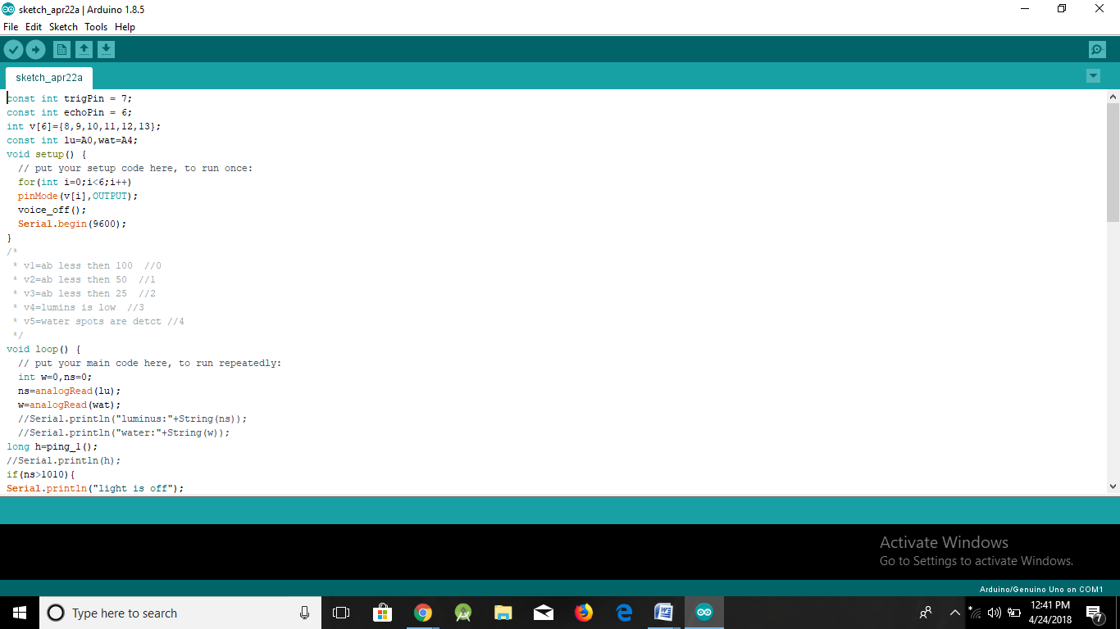

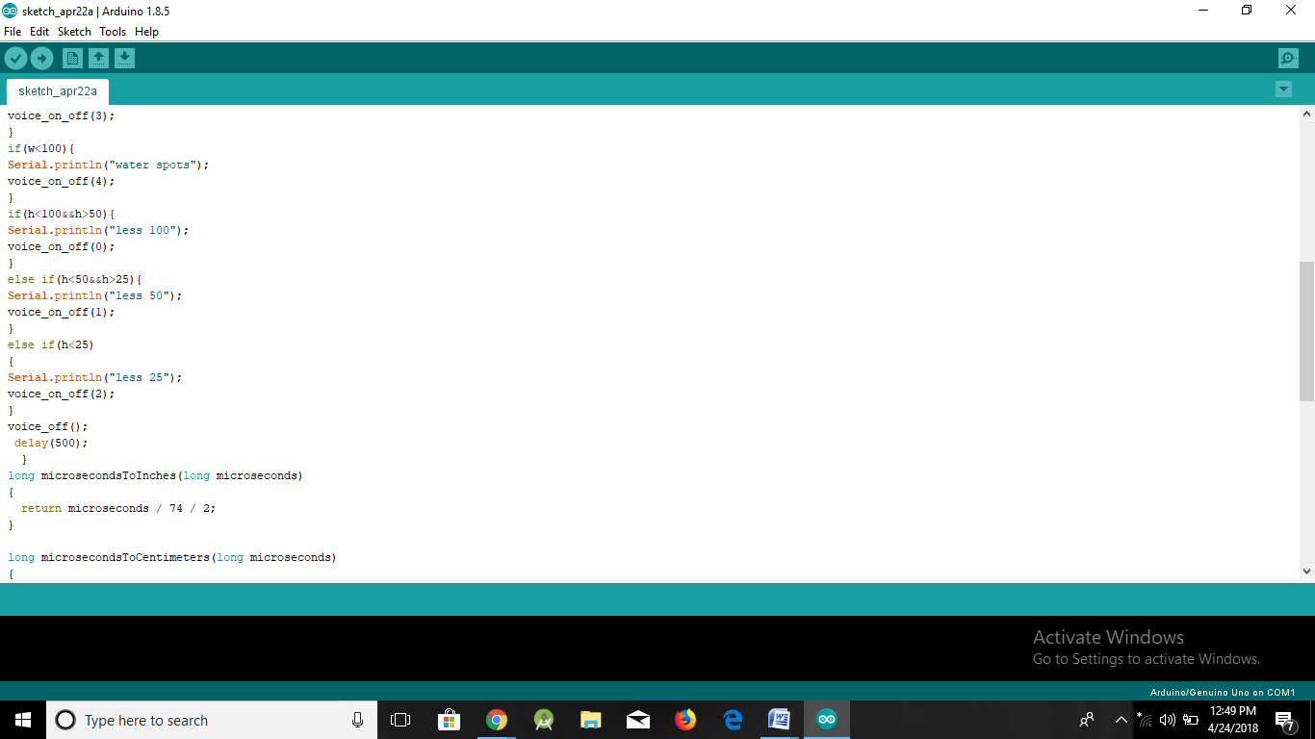

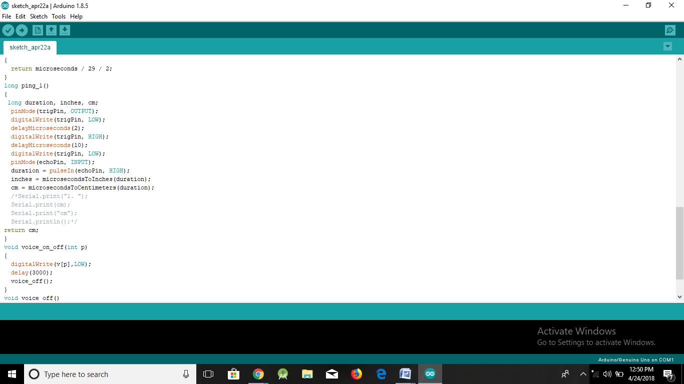

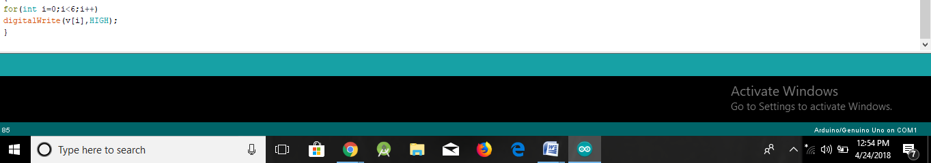

**Description:**The above screenshots describes the structural code which is written in the arduino uno and the environment in which the code run.

As you can see from the screenshots the code has two structural parts:

void setup()

{

// put your setup code here, to run once:

}

void loop()

{

// put your main code here, to run repeatedly}

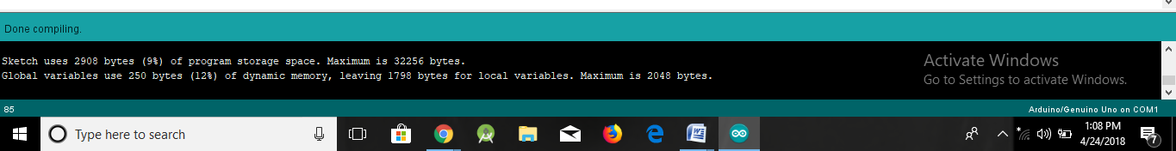

Description; After compiling the code succesfully it prints the above message.

**CHAPTER 7**

**CONCLUSION AND FUTURE SCOPE**

**7.1 CONCLUSION**

Smart Sensors are not just a fad, they are the wave of the future. As more people realize the value of these inventions the field will grow without bounds. This can be demonstrated by the design specified. It’s practical, cost efficient and extremely useful. If all of these characteristics weren’t enough to warrant investigation into this field of study, these inventions will also make the inventor very wealthy. This project is application based as it has an application for blind people. It can be further improved to have more decision taking capabilities by employing varied types of sensors and thus could be used for different applications. It aims to solve the problems faced by the blind people in their daily life. The system also takes measures to ensure their safety

**7.2 FUTURE SCOPE:**

It can be further enhanced by using VLSI technology to design the PCB unit. This makes the system further more compact. Also, use of active RFID tags will transmit the location information automatically to the PCB unit, when the intelligent stick is in its range. The RFID sensor doesn’t have to read it explicitly. A variety of future scopes are available that can be used of with the stick such as the usage of a GSM module helping to find the tick with the help of mobile phones, usage of GPS system incorporating the entire assembly into belt of people. The global position of' the user is obtained using the global positioning system (GPS), and their current position and guidance to their destination will be given to the user by voice. It can also contain special arrangement to connect the walking stick to the aadhar card of blinds, helping the government serve the physically disabled even better.

**BIBLIOGRAPHY**

[1] Anon, n.d. Electronic Walking Stick for the Blind, s.l.: s.n..

[2] Osama Bader AL-Barrm International Journal of Latest Trends in Engineering and Technology (IJLTET)

[3] Kang, S. J., Ho, Y., K. & Moon, I. H., 2001. Development of an Intelligent Guide-Stick for the Blind. Seoul, Korea, IEEE March 2013].

[4] Koley, S. & Mishra, R., 2012. VOICE OPERATED OUTDOOR NAVIGATION SYSTEM FOR VISUALLY IMPAIRED PERSONS. International Journal of Engineering Trends and Technology. 3(2).

[5] Sakhardande, J., Pattanayak, P. & Bhowmick, M., 2012. Smart Cane Assisted Mobility for the Visually Impaired. Engineering and Technology, Issue 70.May2013].

[6] REIS, R. A., 1997. Ultrasonic Motion Detector, U.S: POP tronix.

[7] http://www.mid-day.com/articles/iit-delhi-creates affordable-smart-cane-for-the blind/15506173#sthash.oI4Pa9Vm.dpuf

**REFERENCE PAPER**

Ultrasonic Blind Walking Stick

Abhishek Bhokare#1 Amruta Amberkar#2 Anvesh Gawde#3Pratham Kale#4 Abhijeet Pasi*5 #Department of Information Technology

*Lecturer, Department of Information Technology Engineering Shah & Anchor Kutchhi Polytechnic

abhi1497@gmail.com#1, amrutamberkar@gmail.com#2, dalvijay686@gmail.com#3, kalepratham10@gmail.com#4, abhijeetpasi@sakp.ac.in*5

Abstract: God gifted sense of vision to the human being is an important aspect of our life. But there are some unfortunate people who lack the ability of visualizing things. The visually impaired have to face many challenges in their daily life. The problem gets worse when there is an obstacle in front of them. Blind stick is an innovative stick designed for visually disabled people for improved navigation. The paper presents a theoretical system concept to provide a smart ultrasonic aid for blind people. The system is intended to provide overall measures – Artificial vision and object detection. The aim of the overall

system is to provide a low cost and efficient navigation aid for a visually impaired person who gets a sense of artificial vision by providing information about the environmental scenario of static and dynamic objects around them. Ultrasonic sensors are used to calculate distance of the obstacles around the blind person to guide the user towards the available path. Output is in the form of sequence of beep sound which the blind person can hear.

Keywords: Ultrasonic sensors, visually impaired person, Microcontroller. __________________________________________________*****_________________________________________________

the walking cane (also called white cane or stick) and guide dogs. The most important drawbacks of these aids are necessary skills and training phase, range of motion and very little information conveyed. With the rapid advances of modern technology, both in hardware and software front have brought potential to provide intelligent navigation capabilities. Recently there has been a lot of Electronic Travel Aids (ETA) designed and devised to help the blind navigate independently and safely. Also high-end technological solutions have been introduced recently to help blind persons to navigate independently. Many blind guidance systems use ultrasound because of its immunity to the environmental noise. Another reason why ultrasonic is popular is that the technology is relatively inexpensive, and also ultrasound emitters and detectors are small enough to be carried without the need for complex circuit. Blind people have used canes as mobility tools for centuries, but it was not until after World War I that the white cane was introduced.

III. LITERATURE SURVEYNumerous attempts have been made in the society to help the blind. “Project Prakash” is a humanitarian mission to help the blind children especially by training them to utilize their brains to learn a set of objects around them [3]. The stick has a ping sonar sensor to sense the distant objects. It also has a wet detector to detect the water. The micro-controller used is PIC microcontroller. The microcontroller circuit is on the outside of the stick but is protected with a code so its security cannot be breached. The only feedback given to the user is through the vibration motor [4]. Three sensors are used viz. ultrasonic, pit sensor and the water sensor. Even this is a PIC based system. The feedback given is through the vibration as well as the speaker/headphones. There is a GPS system where-in the user has to feed his location. No information on how a blind man would do that. Also they haven’t mentioned anything about the size and shape of their cane and neither

62 ______________________________________________________________________________________________________

I. INTRODUCTION:There are approximately 37 million people across the globe who are blind, over 15 million are from India [1]. Even for the non-visually impaired the congestion of obstacles is sometimes problematic, it’s even worse for the visually impaired. People with visual disabilities are often dependent on external assistance which can be provided by humans, trained dogs, or special electronic devices as support systems for decision making. Existing devices are able to detect and recognize objects that emerge on the floor, but a considerable risk is also includes the objects that are at a sudden depth, or obstacles above waist level or stairs. Thus we were motivated to develop a smart white cane to overcome these limitations. The most common tool that the blind currently use to navigate is the standard white cane. We decided to modify and enhance the walking cane, since blind are only able to detect objects by touch or by cane. The user sweeps the cane back and forth in front of them. When the cane hits an object or falls off of the edge of a stair, the user then becomes aware of the obstacle – sometimes too late [1]. We accomplished this goal by adding ultrasonic sensors at specific positions to the cane that provided information about the environment to the user through audio feedback. The main component of this system is the Radio-Frequency module which is used to find the

stick if it is misplaced around. .

II. BACKGROUND Vision is the most important part of human physiology as 83% of information human being gets from the environment is via sight. The 2011 statistics by the World Health Organization (WHO) estimates that there are 285 million people in world with visual impairment, 39 billion of which are blind and 246 with low vision [2]. The traditional and oldest mobility aids for persons with visual impairments are

IJRITCC | January 2016, Available @ http://www.ijritcc.org



|  |
| --- |
| International Journal on Recent and Innovation Trends in Computing and Communication ISSN: 2321-8169 |
| Volume: 4 Issue: 1 62 - 65 |

_______________________________________________________________________________________________________

about the placement of their circuitry [5]. The author has made a detachable unit consisting of an ultrasonic sensor and a vibration motor. It can be fit on any stick. It detects obstacles up to 3m. The vibration feedback varies in the intensity as the obstacles come nearer. Many different approaches have been taken with the primary purpose of creating a technology to aid the visually impaired. The priorities set by different authors are different leaving a scope of improvement in every application [6].

IV. DESCRIPTION

Figure 1. Block Diagram of System

In this system the ultrasonic sensor are used to sense the obstacle (if there is any). The signal is then send to microcontroller to operate a buzzer. There is one more advantage of this system. Sometimes when the blind loose there sticks or forgot where have they put it, they can find it by using the wireless remote.

V. COMPONENT DETAILS

1.1 Major components names 1. Ultrasonic sensor2. Microcontroller3. RF module

4.Micro-switch1.2Components description

1.2.1 Ultrasonic Sensor

Ultrasonic sensors (also known as transceivers when they both send and receive) work on a principle similar to radar or sonar which evaluate attributes of a target by interpreting the echoes from radio or sound waves respectively. Ultrasonic sensors generate high frequency sound waves and evaluate the echo which is received back by the sensor. Sensors calculate the time interval between sending the signal and receiving the echo to determine the distance to an object. This technology can be used for measuring: wind speed and direction (anemometer), fullness of a tank and speed through air or

63 ______________________________________________________________________________________________________

IJRITCC | January 2016, Available @ http://www.ijritcc.org

water. For measuring speed or direction a device uses multiple detectors and calculates the speed from the relative distances to particulates in the air or water. To measure the amount of liquid in a tank, the sensor measures the distance to the surface of the fluid. Further applications include: humidifiers, sonar, medical ultra sonography, burglar alarms and non-destructive testing. Systems typically use a transducer which generates sound waves in the ultrasonic range, above 18,000 hertz, by turning electrical energy into sound, then upon receiving the echo turn the sound waves into electrical energy which can be measured and displayed. The technology is limited by the shapes of surfaces and the density or consistency of the material. For example foam on the surface of a fluid in a tank could distort a reading.

1.2.2 Microcontroller

A microcontroller is a small computer (SoC) on a single integrated circuit containing a processor core, memory, and programmable input/output peripherals. Program memory in the form of Ferroelectric RAM, NOR flash or OTP ROM is also often included on chip, as well as a typically small amount of RAM. Microcontrollers are designed for embedded applications, in contrast to the microprocessors used in personal computers or other general purpose applications. Microcontrollers are used in automatically controlled products and devices, such as automobile engine control systems, implantable medical devices, remote controls, office machines, appliances, power tools, toys and other embedded systems. By reducing the size and cost compared to a design that uses a separate microprocessor, memory, and input/output devices, microcontrollers make it economical to digitally control even more devices and processes. Mixed signal microcontrollers are common, integrating analog components needed to control non-digital electronic systems.

1.2.3 RF Module

An RF module (radio frequency module) is a small electronic device used to transmit and/or receive radio signals between two devices. In an embedded system it is often desirable to communicate with another device wirelessly. This wireless communication may be accomplished through optical communication or through radio frequency (RF) communication. For many applications the medium of choice is RF since it does not require line of sight. RF communications incorporate a transmitter and/or receiver.

1.2.4 Micro switch

A micro switch, also known as snap-action switch, is a generic term used to refer to an electric switch that is actuated by very little physical force, through the use of a tipping-point mechanism. They are very common due to their low cost and durability, greater than 1million cycles and up to 10 million cycles for heavy duty models. This durability is a natural consequence of the design. Internally a stiff metal strip must be bent to activate the switch. This produces a very distinctive clicking sound and a very crisp feel. When pressure is removed the metal strip springs back to its original state. Common applications of micro switches include the door inter lock on a microwave oven, leveling and safety switches in

|  |
| --- |
|  |
| International Journal on Recent and Innovation Trends in Computing and Communication ISSN: 2321-8169 |
| Volume: 4 Issue: 1 62 - 65 |

_______________________________________________________________________________________________________

elevators, vending machines, and to detect paper jams or other faults in photocopiers. Micro switches are commonly used in tamper switches on gate valves on fire sprinkler systems and other water pipe systems, where it is necessary to know if a valve has been opened or shut. The defining feature of micro switches is that a relatively small movement at the actuator button produces a relative large movement at the electrical contacts, which occurs at high speed (regardless of the speed of actuation).

VI. LIST OF REQUIREMENTS

1.3 HARDWARE REQUIREMENT: 1. Microcontroller2. Ultrasonic module3. RF module 4. LDR5. LED6. Buzzer7. Push button 8. GPS module

photons.

1.10 Buzzer:A buzzer or beeper is an audio signaling device, which may be mechanical, electromechanical, or piezoelectric. Typical uses of buzzers and beepers include alarm devices, timers and confirmation of user input such as a mouse click or keystroke.

1.11 Resistors:A resistor is a two-terminal electronic component designed to oppose an electric current by producing a voltage drop between its terminals in proportion to the current, that is, in accordance with Ohm's law: V = IR.

1.12 Push Buttons:A push-button (also spelled pushbutton) or simply button is a simple switch mechanism for controlling some aspect of a machine or a process. Buttons are typically made out of hard material, usually plastic or metal. The surface is usually flat or shaped to accommodate the human finger or hand, so as to be easily depressed or pushed.

1.13 GPS Module:New improved GPS Module with built-in antenna and memory back-up for OEM and hobbyists projects. This unit features low power consumption, high sensitivity. The unit is ideal for navigation systems, distance measurements, vehicle monitoring and recording, boating direction and location, together with hiking and cross country exploring.

1.14 GSM Modem:A GSM modem is a specialized type of modem which accepts a SIM card, and operates over a subscription to a mobile operator, just like a mobile phone. From the mobile operator perspective, a GSM modem looks just like a mobile phone. When a GSM modem is connected to a computer, this allows the computer to use the GSM modem to communicate over the mobile network. While these GSM modems are most frequently used to provide mobile internet connectivity, many of them can also be used for sending and receiving SMS and MMS messages.

1.15 Keil Micro Vision (IDE) Keil an ARM Company makes C compilers, macro assemblers, real-time kernels, debuggers, simulators, integrated environments, evaluation boards, and emulator’s for ARM7/ARM9/Cortex-M3, XC16x/C16x/ST10, 251, and 8051 MCU families. Keil development tools for the 8051 Microcontroller Architecture support every level of software developer from the professional applications engineer to the student just learning about embedded software development. When starting a new system, simply select the microcontroller you use from the Device Database and the μVision IDE sets all compiler, assembler, linker, and memory options for you.

1.16 COMPILER:Compilers are programs used to convert a High Level Language to object code. Desktop compilers produce an output object code for the underlying microprocessor, but not for other microprocessors.

64 ______________________________________________________________________________________________________

9. 1.4

GSM modem

SOFTWARE REQUIREMENTS 1. Keil micro vision (IDE) 2. Compiler

VII. DEFINITION & ABBREVIATION

1.5A microcontroller (sometimes abbreviated μC, uC or MCU) is a small computer on a single integrated circuit containing a processor core, memory, and programmable input/output peripherals.

1.6 Ultrasonic Sensor Ultrasonic sensor provides a very low-cost and easy method of distance measurement. This sensor is perfect for any number of applications that require you to perform measurements between moving or stationary objects. Naturally, robotics applications are very popular but you'll also find this product to be useful in security systems or as an infrared replacement if so desired.

1.7 RF Module :An RF Module is a small electronic circuit which is used to receive, transmit or transceiver radio waves on one of a number of carrier frequencies.

1.8 LDR:A photo resistor or light-dependent resistor (LDR) or photocell is a light-controlled variable resistor. The resistance of a photo resistor decreases with increasing incident light intensity; in other words, it exhibits photo conductivity.

1.9 LED:A light-emitting diode (LED) is a semiconductor light source. LEDs are used as indicator lamps in many devices, and are increasingly used for lighting. When a light-emitting diode is forward biased (switched on), electrons are able to recombine with holes within the device, releasing energy in the form of

Microcontroller (ATMEGA328)

IJRITCC | January 2016, Available @ http://www.ijritcc.org

|  |
| --- |
|  |
| International Journal on Recent and Innovation Trends and Communication ISSN: 2321-8169 |
| Volume: 4 Issue: 1 62 - 65 |

[1]

[2] [3] [4]

[5] [6]

[7]

REFERENCES:Rohit Sheth “Smart White Cane- an Elegant and Economic

Walking Aid” www.who.int/mediacentre/factsheets/fs282/en/“Project Prakash” http://web.mit.edu/bcs/sinha/prakash.html

Mohammad Hazzaz Mahmud, “Smart walking stick - an electronic approach to assist visually disabled persons” “http://www.ijser.org/researchpaper%5CSmart-walking-stick- an-electronic-approach-to-assist- visually-disabled- persons.pdf”.

G.Gayathri, “Smart Walking Stick for visually impaired” “http://ijecs.in/issue/v3-i3/8%20ijecs.pdf”Singh Vaibhav, “ 'SMART’ CANE FOR THE VISUALLY IMPAIRED: DESIGN AND CONTROLLED FIELD TESTING OF AN AFFORDABLE OBSTACLE DETECTION SYSTEM” http://assistech.iitd.ernet.in/doc/Transed2010_Smar t_Cane.pdf

http://www.atmel.com/devices/atmega328.aspx