DRAINAGE MONITORING SYSTEM USING IOT

1 Sriram Venkata sai Bharath 2 K Sravani 3 T sidhartha 4 B Bhuvaneswari

1 B.E Student ,Dept of ECE , Saveetha School of Engineering, Chennai, India.

2 B.E Student ,Dept of ECE , Saveetha School of Engineering, Chennai, India.

3 B.E Student ,Dept of ECE , Saveetha School of Engineering, Chennai, India.

4 B.E Student ,Dept of ECE , Saveetha School of Engineering, Chennai, India.

ABSTRACT:

The Internet of Things (IOT) consists of real life objects, communication devices attached to sensor networks in order to provide communication and automated actions between real world and information world. IOT came into existence because, without human interaction computers were able to access data from objects and devices, but it was aimed at, to overcome the limiting factors of human entered data, and to achieve cost, accuracy and generality factors. Sensor Network is a key enabler for IOT paradigm. This paper represents the implementation and design function of an Drainage Monitoring System (UDMS) for IoT applications using Ultrasonic sensor. The vital considerations of this design are low cost, low maintenance, fast deployment, and high number of sensors, long life-time and high quality of service. The proposed model provides a system of monitoring the water level and the location of the blockage.

INTRODUCTION:

The greater part of the urban areas received the underground seepage framework and it is the obligation of Municipal Corporation to look after cleanliness, solid and wellbeing of urban areas. On the off chance that the waste framework is not legitimately overseen then unadulterated water gets pollute with seepage water and irresistible ailments may get spread. The waste gets hindered amid blustery season and it will make the issues to routine life like activity may get stuck, condition will wind up plainly filthy and absolutely it will disturbs general society.

In many cases blocked drains can cause sewage and waste water to back up and potentially come up onto your property. Suppose if there is a facility that officials or concerned persons come to know immediately the blockage or clogging inside the drainage channels in which area and exact place where it gets blocked. So our main focus is to monitor the manholes using sensors. If drainage gets blocked or water overflows, the sensor senses the activity and sends the information via transmitter to the concern persons.

Manhole maintenance by human is very difficult because environment is very poor and it is difficult to go inside of manhole for inspecting the states of manholes all the time. Immediately it is not possible to confirm if the person intrudes the manhole or an accident happens inside of the manhole.

The drainage system is essential for the people who live in urban areas as this system reduces flood effect by carrying water away (a facility to dispose liquid waste).Improper maintenance of existing drainage system leaving many people suffer. The major areas effecting in many urban areas because of faulty, improper drainage monitoring system are roads. Roads are built up to support human and vehicular traffic. Currently urbanization has negative impact on drainage system in many cities and towns across the globe.

In this paper, we propose smart drainage, called drainage monitoring system using IOT .The present existing drainage system has to integrate with technology to wipe out the problems us facing. The smart drainage system has the intelligence of sensors and predictive system identifies the drain clogged spot and gives us the details for further actions to take. If there is any clogging in any area sensors will gives us the necessary details about the location. The sensors are communicated through communication modules to share information.

**PROPOSED METHOD**:

In this we propose the Drainage monitoring system using IOT

**BLOCK DIAGRAM:**

sensor

controller

cloud

mobile

Design of drainage monitoring system System governing the flow of sewage from pipes. To detect variations in the drainage flow. Collection of data. Obtain prior alerts regarding blocks and locate them using IOT The above block diagram is explained with the different modules:

**BLOCK DIAGRAM**

Transmitter module

Receiver module

Galileo

Ultrasonic sensor

Ultrasonic Sensor

Sensor Module Transmitter Module processing Module

As the name indicates, ultrasonic sensors measure distance by using ultrasonic waves. The sensor head emits an ultrasonic wave and receive the wave reflected back from the target. Ultrasonic sensors measure the distance to the target by measuring the time between the emission and reception. sensors at different locations will collect information of sewage flow through that node and send it to the central system which will generate alerts prior to complete blockage.

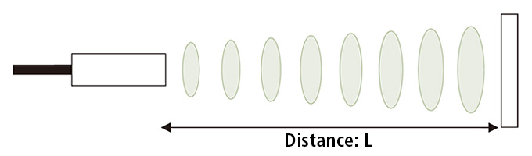

**INTEL GALIEO**

Intel's Galileo Gen 2 Board is the first in a family of Arduino-certified development boards based on Intel® architecture and specifically designed for makers, students, educators, and DIY electronics enthusiasts. Based on the Intel Quark™ SOC X1000, a 32-bit Intel Pentium® processor-class system on a chip (SOC), the genuine Intel processor and native I/O capabilities of the Intel Galileo board (Gen 2) provide a full-featured offering for a wide range of applications. Arduino-Certified and designed to be hardware-, software-, and pin-compatible with a wide range of Arduino Uno R3 shields. Additionally it allows users to incorporate Linux firmware calls in their Arduino sketch programming.

**Programming**

Galileo can be programmed with the Arduino software (download). When you are ready to upload the sketch to the board, program Galileo through the USB Client port by selecting "Intel Galileo" as your board in the Arduino IDE. Connect Galileo's port labeled USB Client (the one closest to the Ethernet) to your computer. For details, see the reference, tutorials and Intel Galileo Getting Started Guide. Rather than requiring a physical press of the reset button before an upload, Galileo is designed to be reset by software running on a connected computer.

When the board boots up two scenarios are possible:

If a sketch is present in persistent storage, it is executed

If no sketch present, the board waits for upload commands from the IDE

If a sketch is executing, you can upload from the IDE without having to press the reset button on the board. The sketch is stopped; the IDE waits for the upload state, and then starts the newly uploaded sketch.

Pressing the reset button on the board restarts a sketch if it is executing and resets any attached shields.

**BLOCK DIAGRAM**

cloud

Data import

**Data base management system**

Contains general data obtained from various time instances with which the data received from the circuits will be compared and generate the alerts**.**

In the context of IOT, data management should act as a layer between the objects and devices generating the data and the applications accessing the data for analysis purposes and services. The devices themselves can be arranged into subsystems or subspaces with autonomous governance and internal hierarchical management. The functionality and data provided by these subsystems is to be made available to the IoT network, depending on the level of privacy desired by the subsystem owners.

Alerts will be generated when the blockage starts developing Time available to repair the blockage will be enough to prevent the drainage line from completely shutting down.

This technology can be used for all fluid carrying systems. (e.g. Water pipes, gas pipelines)

**AURDUINO**

The Arduino Integrated Development Environment - or Arduino Software (IDE) - contains a text editor for writing code, a message area, a text console, a toolbar with buttons for common functions and a series of menus. It connects to the Arduino and Genuino hardware to upload programs and communicate with them.

Arduino board designs use a variety of microprocessors and controllers. The boards are equipped with sets of digital and analog [input/output](https://en.wikipedia.org/wiki/Input/output) (I/O) pins that may be interfaced to various expansion boards (*shields*) and other circuits. The boards feature serial communications interfaces, including [Universal Serial Bus](https://en.wikipedia.org/wiki/Universal_Serial_Bus) (USB) on some models, which are also used for loading programs from personal computers. The microcontrollers are typically programmed using a dialect of features from the programming languages [C](https://en.wikipedia.org/wiki/C_(programming_language)) and [C++](https://en.wikipedia.org/wiki/C%2B%2B). In addition to using traditional compiler tool chains, the Arduino project provides an [integrated development environment](https://en.wikipedia.org/wiki/Integrated_development_environment)(IDE) based on the [Processing](https://en.wikipedia.org/wiki/Processing_(programming_language)) language project

**Software development:**

A program for Aurdino may be written in any programming language for a compiler that produces binary machine code for the target processor. Atmel provides a development environment for their microcontrollers, AVR Studio and the newer Atmel Studio

The Arduino IDE supports the languages [C](https://en.wikipedia.org/wiki/C_(programming_language)) and [C++](https://en.wikipedia.org/wiki/C%2B%2B) using special rules of code structuring. The Arduino IDE supplies a [software library](https://en.wikipedia.org/wiki/Software_library) from the [Wiring](https://en.wikipedia.org/wiki/Wiring_(development_platform)) project, which provides many common input and output procedures. User-written code only requires two basic functions, for starting the sketch and the main program loop, that are compiled and linked with a program stub *main()* into an executable [cyclic executive](https://en.wikipedia.org/wiki/Cyclic_executive) program with the [GNU tool chain](https://en.wikipedia.org/wiki/GNU_toolchain), also included with the IDE distribution. The Arduino IDE employs the program to convert the executable code into a text file in hexadecimal encoding that is loaded into the Arduino board by a loader program in the board's firmware.

**RESULT**

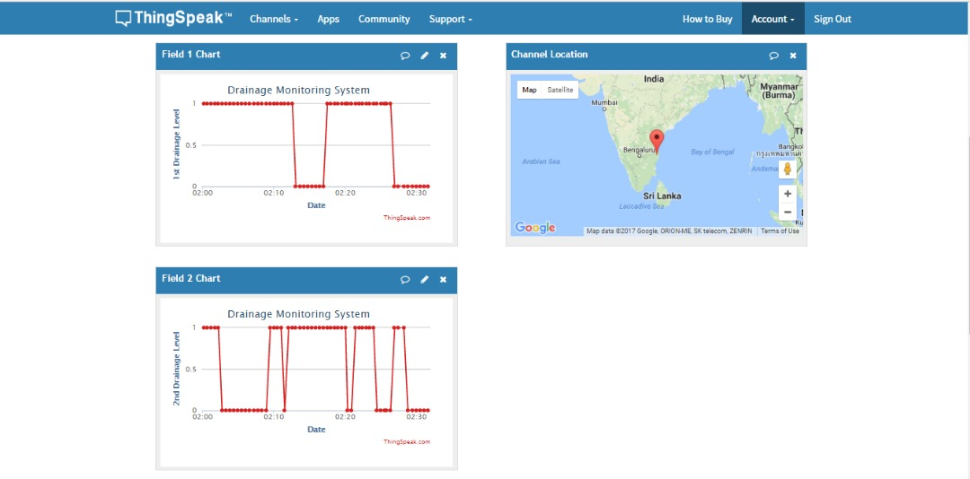

* The result of the above drainage monitoring system shown are shown in fig
* The date and the drainage level graphs are shown the drainage monitoring system using IOT.
* The level of water before blockage and after blockage are provided.
* And the blockage area can be identified.
* Thus the clogs in the drainage gets identified using these circuit. And the concerned authorities notified from the cloud and GSM.

**CONCLUSION:**

Many cities across the world are facing drainage system problems. Heavy Rain falls causing damaged roads and loss of valuable human hours affecting in one or other ways the country economy. There is a concern situation coming to scene frequently these days.. Smart drainage system development and testing of emphasis (sensory drains) is currently carried out and expected to go on a trail in the real drains in coming next years.

The drainage monitoring system using Internet of Things was proposed in this paper is to collect data from circuits and transmits the collected data to the processor and to analyse the drainage monitoring system through cloud and sends an alert to the corresponding municipal authorities..This technique enables us to detect information of sewage flow through that node at different locations and send it to the central system which will generate alerts prior to complete blockage.

The Theme of this project is to design a Drainage monitoring System to reduce the effect caused by water logging during floods.

**References**

1. Lazarescu, M.T., "Design of a WSN Platform for Long-Term Environmental Monitoring for IoT Applications," Emerging and Selected Topics in Circuits and Systems, IEEE Journal on , vol.3, no.1, pp.45,54, March 2013.
2. Manhole cover type sensor node apparatus US 20120206270A1 publication date 16 Aug 2012
3. Kelly, S.D.T.; Suryadevara, N.K.; Mukhopadhyay, S.C., "Towards the Implementation of IoT for Environmental Condition Monitoring in Homes," Sensors Journal, IEEE, vol.13, no.10, pp.3846,3853, Oct. 2013.
4. Romer, K.; Mattern, F., "The design space of wireless sensor networks," Wireless Communications, IEEE , vol.11, no.6, pp.54,61, Dec. 2004
5. ] M. Kuorilehto, M. Kohvakka, J. Suhonen, P. Hmlinen, M. Hnnikinen, and T. D. Hmlinen, Ultra-Low Energy Wireless Sensor Networks in Practice. New York: Wiley, 2007.
6. K. Romer and F. Mattern, “The design space of wireless sensor networks,” IEEE Wireless Comm., vol. 11, no. 6, pp. 54–61, Dec. 2004.
7. “Manhole explosions causes and case studies”, by W.Z.Black Georgia Institute of Technology, Atlanta GA June2013
8. Yan Xijun., Lu Limei., and XuLizhong., “The Application of Wireless Sensor Network In the Irrigation Area Automatic System”, International Conference on Networks Security, Wireless Communications and Trusted Computing, Vol.1, pp.21-24, 2009
9. K. Romer and F. Mattern, “The design space of wireless sensor networks,” IEEE Wireless Comm., vol. 11, no. 6, pp. 54–61, Dec. 2004
10. P. Harrop and R. Das, “Wireless Sensor Networks 2010–2020,” IDTechEx Ltd, Downing Park, Swaffham Bulbeck, Cambridge, CB25 0NW, United Kingdom, Report, 2010.
11. N. Burri, P. von Rickenbach, and R. Wattenhofer, “Dozer: Ultra-Low Power Data Gathering in Sensor Networks,” in Information Processing in Sensor Networks, Apr. 2007, pp. 450–459.
12. I. Dietrich and F. Dressler, “On the lifetime of wireless sensor networks,” ACM Trans. Sen. Netw., vol. 5, no. 1, pp. 5:1–5:39, Feb. 2009.
13. C. Jardak, K. Rerkrai, A. Kovacevic, and J. Riihijarvi, “Design of largescale agricultural wireless sensor networks: email from the vineyard,” International Journal of Sensor Networks, vol. 8, no. 2, pp. 77–88, 2010.
14. P. I. Fierens, “Number of wireless sensors needed to detect a wildﬁre,” International Journal of Wildland Fire, no. 18(7), pp. 625–629, 2009
15. LiuJinHuaGaoGongLiang.Based on G S M of groundwater level and rainfall on-line monitoring system [J].Automation technology and application, 2007, 6 (I) • 28-29
16. S. M. Khaled Reza., Shah Ahsanuzzaman Md. Tariq., and S.M. Mohsin Reza., “Microcontroller Based Automated Water Level Sensing and Controlling: Design and Implementation Issue”, Proceedings of the World Congress on Engineering and Computer Science, Vol 1, pp.1-7, 2010.