LPG Gas Cylinder Monitoring Based On IOT

MINI PROJECT REPORT 2016

Submitted By

K.C.Mohan Kumar (191312129)
V.Venu Gopal Reddy (191312154)
K.Venkata Teja (191312124)

in partial fulfillment for the award of the degree
of
BACHELOR OF ENGINEERING
IN
ELECTRONICS AND COMMUNICATION ENGINEERING
at

SAVEETHA SCHOOL OF ENGINEERING

SAVEETHA UNIVERSITY
CHENNAI 602 105
SAVEETHA SCHOOL OF ENGINEERING
SAVEETHA UNIVERSITY
CHENNAI 602 105
DEPARTMENT OF ELECTRONICS AND COMMUNICATION ENGINEERING

BONAFIDE CERTIFICATE
Certified that this project report “LPG Gas Cylinder Monitoring Based On IOT” is the bonafide work of “K.C. Mohan Kumar, V .Venu Gopal Reddy, K.Venkata Teja” who carried out project work under my supervision.

PROJECT COORDINATOR H.O.D
Ms.Christeena Joseph M.E,( Ph.D. ) Dr. P. C. Kishore Raja M.E, Ph.D
Assistant professor (S.G) Professor and Head
Department of ECE Department of ECE
Saveetha School of Engineering Saveetha School of Engineering
Saveetha University Saveetha University
Chennai – 602 105 Chennai – 602 105

UNIVERSITY EXAM DATE:

INTERNAL EXAMINER EXTERNAL EXAMINER

CERTIFICATION BY GUIDE

The project entitled “LPG Gas Cylinder Monitoring Based On IOT” submitted for the B.E degree is an original work of L.Rajiv, S.Priyanka, P.Manikanta Naidu under the guidance of Mr.M.Reji.

Signature of the guide
Mr.M.REJI M.E,(Ph.D)
Assistant professor
Department of ECE
Saveetha School of Engineering
Saveetha University
Chennai – 602 105

DECLARATION

I here by declare that the project entitled “LPG Gas Cylinder Monitoring Based On IOT” submitted for the B.E degree is our original work and the project has not formed the basis for the award of any degree, associate ship, fellow ship or any other similar titles.

Signature of the student:
Student Name: K.C.Mohan Kumar
Date:

ACKNOWLEDGEMENT

I thankful to Our Almighty for His blessings and also for giving us good knowledge and strength in enabling us to finish our project.
At the outset, I wish to express our gratitude to our honorable Chancellor, Dr. N. M. Veeraiyan for providing us with the facilities for the completion of our project. I oblige to our Vice Chancellor, Dr.Mythili Baskaran for her continual support.
With profound gratitude and respect, I express my sincere thanks to our director, Ms. Ramya Deepak, for her continual support.
I thank our Principal, Dr. P. Shankar for his encouragement in carrying out our project work.
It is our bounded duty to acknowledge with gratitude for the generous help that I have received from our Head of the Department, Dr. P.C. Kishoreraja, who has been furnishing a wealth of information regarding our project and has been instrumental in the successful completion of our project.
I mention my special thanks to our Project Coordinator Ms.Christeena Joseph
for her guidance and support.
I deeply indebted to our project guide Mr.M.Reji for her motivation, guidance and valuable suggestions to carry out project and her consistent encouragement throughout the course of our project work.
I take the opportunity to acknowledge the efforts with gratitude to our staff members at Electronics and Communication Department for their sincere co-operation and generous help. Finally specially I thank to my parents and friends for their moral support and care extended during difficult times.

TABLE OF CONTENTS

BONAFIDE CERTIFICATE 2
CERTIFICATION BY GUIDE 2
DECLARATION 2
ACKNOWLEDGEMENT 2
ORGANIZATION OF REPORT 28
LIST OF FIGURES 29
ABSTRACT 10
  - INTERNET OF THINGS …………..……………………………………….…………………...........12
1.2 THINKSPEAK 13
1.3 GSM-SYSTEM OVERVIEW
1.3.1 GSM SERVICES……………………………………………………………………………………………….
1.3.2 GSM BASICS……………………………………………………………………………………………………
1.4 APPLICATIONS AND ADVANTAGES
2.LITERATURE SURVEY 15
2.1 1Automatic Lpg Booking, Leakage Detection And A Real Time Lpg Measurement Monitoring System 16
2.2 Embedded control system for LPG leakage detection and prevention 16
2.3. Smart Gas Cylinder Using Embedded System 17
2.4.Lpg Detection, Measurement And Booking System…………………………………………………………….
3. PROJECT OVERVIEW…………………………………………………………………………………………...18
3.1 GENERAL 19
4. IMPLEMENTATION 20
4.1 REQUIREMENT ANALYSIS 21
4.2 HARDWARE REQUIREMENTS 21
4.3 SOFTWARE REQUIREMENTS 21
5. BLOCK DIAGRAM AND HARDWARE 22
5.1 BLOCK DIAGRAM 23
5.1.1 Load Cell 23
5.1.2 LOADCELL HISTORY 24
5.1.3 hydraulic load cell 24
5.1.4 PNEUMATIC LOAD CELLS 25
5.1.5 STRAIN GUAGE LOAD CELLS 26
5.2 INTEL GALILIEO ZEN2 27
5.3 GSM MODULE 30
5.4 SIM……………………………………………………………………..………………………………………………………………………….………..31
6.SENSOR INTERFACE DESCRIPTION 42
7. PROGRAM DESCRIPTION 48
7.1 PROGRAM…………………………………………………………………………………………………………………………………………………..
8. RESULT ANANYSIS 51
9. CONCLUSION………………………………………………………………………………………………………………………………………………………

ORGANIZATION OF REPORT

- Chapter I contains the introduction of our project. It also lists out the advantages of this device.

- Chapter II consists of Literature survey for the project.

- Chapter III contains the general overview of the project with module explanations.

- Chapter IV explains the requirements of the project.

- Chapter V has the circuit description and the components used.

- Chapter VI contains interfacing of sensor.

- Chapter VII contains the program of the project

- Chapter VIII contains results and outputs

- Chapter VIII contains the conclusion .

LIST OF FIGURES

FIG.NO | CONTENT | PAGE.NO
1 | Specification summary for GSM cellular system | 19
2 | Block Diagram | 23
3 | Load cell circuit diagram | 32
4 | Intel Galilieo zen 2 Architecture | 35
5 | GSM block diagram | 40
6 | SIM
7 | Load cell interface

ABSTRACT

A cost-effective, automatic Liquefied Petroleum Gas (LPG) real time gas monitoring In this system, the LPG Quantity is monitored through the sensor and information is sent to the user by Short Message Service (SMS) using GSM module,and its staistics can be viewed using thinkspeak through Iot concept. The main advantage of the system is the advance intimation of cylinder quantity so that the user can book cylinder in advance.

CHAPTER I

INTRODUCTION

1. Introduction

GSM based LPG weight and LPG leakage detection System has application in Home, Hotels, restaurants, as well as in Industries. This project is used to monitor the weight of LPG gas cylinder. In our home we observe whenever LPG Gas cylinder is empty, we give request for new cylinder at the office of Gas cylinder provider. Many times it happens that because of the Rush or due to the shortage of cylinder, there is a delay in providing the gas cylinder. Main reason behind this is delay in informing to the gas provider or we inform the gas provider at the last moment when the gas is empty. One more example in hotels or sometimes in industry also the LPG gas is also used. In home or in hotels the main purpose of LPG gas is for cooking. But in industry sometimes, LPG gas or some other combustible gas is used for some other purposes like welding or cutting or for some other use. In these places if the LPG gas inside gas cylinder is finished at that time request for new gas cylinder is sent to the storage department but if there is shortage in stock then there is delay in providing new gas cylinder.

To avoid all such situations, we have implemented a project called LPG Gas Cylinder Monitoring Based On IOT. In this project we have used a loadcell as weight sensor. This sensor will be placed below the LPG gas cylinder. Output of weight sensor is given to microcontroller. Microcontroller will continuously monitor the weight of LPG gas. This is calculated by total weight received by weight sensor minus the weight of empty gas cylinder. Because the gas cylinder is made up of metal and it has some weight. The actual weight of the gas is:

LPG weight = Actual weight received by weight sensor – actual weight of empty gas cylinder

Whenever LPG gas weight is 20% remaining, system sends a low priority or low warning message to the owner of the house or owner of hotel or industry. So the owner will get SMS. Contents of SMS will be “Weight of LPG gas is below 20% threshold value. The actual weight is XYZ kilogram.” The value of XYZ will be replaced by the value received by the formula given above.

So first a low warning messages is sent when there is 20% gas remaining in the cylinder. The second message is sent which has high priority or we can say that it is a critical message when the gas cylinder is just 5% remaining.

So use of first low priority SMS is that user gets intimation about the weight of the gas. So he/she can immediately place the order / book a new LPG gas cylinder or gas refilling. In some cases user can ignore the first SMS because it has low priority but still there is a 20% gas remaining inside the cylinder. 20% means still there are some days for which user can use the gas and whenever the user receives the second SMS then he/she can immediately give order for the gas. Now days LPG Gas cylinder booking in some cities is done by sending SMS. We have to send SMS from a registered number to the gas booking agency. Then our request is taken down which means we don’t have to dial a call or we don’t have to visit the agency personally. This project helps in implementing this method by sending SMS whenever the gas is empty. We can send SMS to the gas provider agency whenever gas is 5% or empty

  - Internet of Things (IOT)
The Internet of Things refers to uniquely identifiable objects and their virtual representations in an Internet-like structure. The term Internet of Things was proposed by Kevin Ashton in 1999. The concept of the Internet of Things first became popular through the Auto-ID Center at MIT and related market analysts publications. If all objects and people in daily life were equipped with identifiers, they could be managed and inventoried by computers. Tagging of things may be achieved through such technologies as near field communication, barcodes, Quasi Redundancy (QR) codes and digital watermarking. According to ABI Research more than 30 billion devices will be wirelessly connected to the Internet of Things (Internet of Everything) by 2020. Cisco created a dynamic "connections counter" to track the estimated number of connected things from July 2013 until July 2020.
The Internet of Things (IoT), sometimes referred to as the Internet of Objects, will change everything including ourselves. This may seem like a bold statement, but consider the impact the Internet already has had on education, communication, business, science, government, and humanity. Clearly, the Internet is one of the most important and powerful creations in all of human history.IoT represents the next evolution of the Internet, taking a huge leap in its ability to gather, analyze, and distribute data that we can turn into information, knowledge, and, ultimately, wisdom. In this context, IoT becomes immensely important. IoT projects are under way that promise to improve distribution of the world’s resources to those who need them most, and help us understand our planet so we can be more proactive and less reactive. Even so, several barriers exist that threaten to slow IoT development, including the transition to IPv6, having a common set of standards, and developing energy sources for millions, even billions of minute sensors.
Currently, IoT is made up of a loose collection of different, purpose-built networks. Today’s cars, for example, have multiple networks to control engine function, safety features, communications systems, and so on. Commercial and residential buildings also have various control systems for heating, venting, and air conditioning, telephone service, security and lighting. As IoT evolves, these networks, and many others, will be connected with added security, analytics, and management capabilities. This will allow IoT to become even more powerful in what it can help people achieve. IoT Can Be Viewed as a Network of Networks Interestingly, this situation mirrors what the technology industry experienced in the early days of networking. In the late 1980s and early 1990s, Cisco, for example, established itself by bringing disparate networks together with multiprotocol routing, eventually leading to IP as the common networking standard. With IoT, history is repeating itself, although on a much grander scale.
The next revolution will be the interconnection between objects to create a smart environment. Only in 2011, the number of interconnected devices on the planet overtook the actual number of people. Currently there are 9 billion interconnected devices and it is expected to reach 24 billion devices by 2020. The creation of the Internet has marked a foremost milestone towards achieving ubicomp‘s vision which enables individual devices to communicate with any other device in the world. The inter-networking reveals the potential of a seemingly endless amount of distributed computing resources and storage owned by various owners.
1.2 ThinkSpeak
The Internet of Things provides access to a broad range of embedded devices and web services. ThingSpeak is an open data platform and API for the Internet of Things that enables you to collect, store, analyze, visualize, and act on data from sensors or actuators, such as Arduino, Raspberry Pi, BeagleBone Black, and other hardware. For example, with ThingSpeak you can create sensor-logging applications, location-tracking applications, and a social network of things with status updates, so that you could have your home thermostat control itself based on your current location.
The primary element of ThingSpeak activity is the channel, which contains data fields, location fields, and a status field. After you create a ThingSpeak channel, you can write data to the channel, process and view the data with MATLAB code, and react to the data with tweets and other alerts. The typical ThingSpeak workflow lets you:
Create a Channel and collect data
Analyze and Visualize the data
Act on the data using any of several Apps
The ThingSpeak API is available on GitHub and includes the complete ThingSpeak API for processing HTTP requests, storing numeric and alphanumeric data, numeric data processing, location tracking, and status update.

1.3 GSM - system overview
The GSM system was designed as a second generation (2G) cellular phone technology. One of the basic aims was to provide a system that would enable greater capacity to be achieved than the previous first generation analogue systems. GSM achieved this by using a digital TDMA (time division multiple access approach). By adopting this technique more users could be accommodated within the available bandwidth. In addition to this, ciphering of the digitally encoded speech was adopted to retain privacy. Using the earlier analogue cellular technologies it was possible for anyone with a scanner receiver to listen to calls and a number of famous personalities had been "eavesdropped" with embarrassing consequences.



1.3.1 GSM services
Speech or voice calls are obviously the primary function for the GSM cellular system. To achieve this the speech is digitally encoded and later decoded using a vocoder. A variety of vocoders are available for use, being aimed at different scenarios.
In addition to the voice services, GSM cellular technology supports a variety of other data services. Although their performance is nowhere near the level of those provided by 3G, they are nevertheless still important and useful. A variety of data services are supported with user data rates up to 9.6 kbps. Services including Group 3 facsimile, videotext and teletex can be supported.
One service that has grown enormously is the short message service. Developed as part of the GSM specification, it has also been incorporated into other cellular technologies. It can be thought of as being similar to the paging service but is far more comprehensive allowing bi-directional messaging, store and forward delivery, and it also allows alphanumeric messages of a reasonable length. This service has become particularly popular, initially with the young as it provided a simple, low fixed cost

1.3.2 GSM basics
The GSM cellular technology had a number of design aims when the development started:
- It should offer good subjective speech quality
- It should have a low phone or terminal cost
- Terminals should be able to be handheld
- The system should support international roaming
- It should offer good spectral efficiency
- The system should offer ISDN compatibility
The resulting GSM cellular technology that was developed provided for all of these. The overall system definition for GSM describes not only the air interface but also the network or infrastructure technology. By adopting this approach it is possible to define the operation of the whole network to enable international roaming as well as enabling network elements from different manufacturers to operate alongside each other, although this last feature is not completely true, especially with older items.
GSM cellular technology uses 200 kHz RF channels. These are time division multiplexed to enable up to eight users to access each carrier. In this way it is a TDMA / FDMA system.
The base transceiver stations (BTS) are organised into small groups, controlled by a base station controller (BSC) which is typically co-located with one of the BTSs. The BSC with its associated BTSs is termed the base station subsystem (BSS).
Further into the core network is the main switching area. This is known as the mobile switching centre (MSC). Associated with it is the location registers, namely the home location register (HLR) and the visitor location register (VLR) which track the location of mobiles and enable calls to be routed to them. Additionally there is the Authentication Centre (AuC), and the Equipment Identify Register (EIR) that are used in authenticating the mobile before it is allowed onto the network and for billing. The operation of these are explained in the following pages.
Last but not least is the mobile itself. Often termed the ME or mobile equipment, this is the item that the end user sees. One important feature that was first implemented on GSM was the use of a Subscriber Identity Module. This card carried with it the users identity and other information to allow the user to upgrade a phone very easily, while retaining the same identity on the network. It was also used to store other information such as "phone book" and other items. This item alone has allowed people to change phones very easily, and this has fuelled the phone manufacturing industry and enabled new phones with additional features to be launched. This has allowed mobile operators to increase their average revenue per user (ARPU) by ensuring that users are able to access any new features that may be launched on the network requiring more sophisticated phones.

1.3.3 GSM system overview
The table below summarises the main points of the GSM system specification, showing some of the highlight features of technical interest.
SPECIFICATION SUMMARY FOR GSM CELLULAR SYSTEM
Multiple access technology | FDMA / TDMA
Duplex technique | FDD
Uplink frequency band | 890 - 915 MHz  (basic 900 MHz band only)
Downlink frequency band | 933 -960 MHz  (basic 900 MHz band only)
Channel spacing | 200 kHz
Modulation | GMSK
Speech coding | Various - original was RPE-LTP/13
Speech channels per RF channel | 8
Channel data rate | 270.833 kbps
Frame duration | 4.615 ms

Fig:1 Specification summary for GSM cellular system

Applications and Advantages:
Applications of GSM based LPG weight detection System:
This project can be used any where for real time monitoring the cylinder quantity.

1) Domestic purpose: In our home, in our day to day basis we use LPG gas cylinder. Mainly we use it for cooking purpose and for various other purposes like boiling the water and some other functions. So this project can be used for domestic use where daily usage statistics can be viewed
.
2) Hotels: Hotels are one of the largest areas where LPG gas is used. Mainly for cooking food.
Hotels and restaurant use large number of LPG gas cylinders. So this is the area where our project finds its most suitable application
.
3) Industry: In industries, LPG gas is used or some other gas cylinders are used mainly for welding purposes or cutting purposes or hitting purposes. With the use of this project, the industry owner can be intimated about the gas weight or the gas availability.
Advantages of GSM based LPG weight
- This project is easy to use. And this project is fully automated so no human attention is required.
- It avoids the problematic situation or the trouble caused due to unavailability of gas cylinder. Generally unavailability is caused by late intimation or late booking of gas cylinder.
- This project helps to know the statistics of the cylinder quantity

CHAPTER-2
LITERATURE SURVEY

2.1Automatic Lpg Booking, Leakage Detection And A Real Time Lpg Measurement Monitoring System

A cost-effective, automatic Liquefied Petroleum Gas (LPG) booking, leakage detection and real time LPG measurement monitoring system is proposed in this paper. In this system, the LPG leakage is detected through the sensor and information is sent to the user by Short Message Service (SMS) and simultaneously alerts the customer using a GSM module, while activating the alarm . The additional advantage of the system is that it continuously monitors the level of the LPG present in the cylinder using weight sensor and automatically books the cylinder using a GSM module.
The prescribed system gives a fully automated approach towards the gas booking. Real time weight measurement of the gas and its display on LCD makes it an efficient home security system and also can be used in industries and other places to detect gas leaks. The cost involved in developing the system is significantly low and is much less than the cost of gas detectors commercially available in the market.

2.2 Embedded control system for LPG leakage detection and prevention

The design of a wireless LPG leakage monitoring system is proposed for home safety. The system detects the leakage of the LPG and alerts the consumer about the leak and as an emergency measure the system will switch on the exhaust fan and also checks the leakage. An added feature of the system is that the approximate consumption is indicated in terms of the total weight. The proposed system makes use of GSM module in order to alert about the gas leakage via an SMS.Whenever the system detects the increase in the concentration of the LPG it immediately alerts by activating an alarm and simultaneously sending message to the specified mobile phones. The exhaust fan is switched on and an LPG safe solenoid valve fitted to the cylinder is given a signal to close avoiding further leakage. The device ensures safety and prevents suffocation and explosion due to gas leakage.

2.3 SMART GAS CYLINDER USING EMBEDDED SYSTEM

The design of a wireless LPG leakage monitoring system is proposed for home safety. This system detects the leakage of the LPG and alerts the consumer about the leak by SMS and as an emergency measure the system will turnoff the power supply, while activating the alarm. The additional advantage of the system is that it continuously monitors the level of the LPG present in the cylinder using load sensor and if the gas level reaches below the threshold limit of gas around 2kg so that the user can replace the old cylinder with new in time and automatically books the cylinder using a GSM module .The device ensures safety and prevents suffocation and explosion due to gas leakage. This project is implemented using ARM 7 processor and simulated using keil software.

2.4 LPG Detection, Measurement and Booking System

This paper we present how to detect the leakage using a gas sensor and book a new cylinder automatically by sending a message to agency. The gas sensor MQ-6 is very sensitive to methane and propane which are main constituents of LPG. A load cell is used to measure the weight of cylinder continuously. The weight of cylinder is displayed continuously and some 4-5 MQ-6 sensors will be placed in different place of room, output of sensor will become high when there is LPG leakage is present. When the sensor output is high buzzer will be switched on and a message will be sent to customer and nearest gas agency via GSM. When the weight of cylinder equal to threshold value a message will be sent to agency to book new cylinder. The same system is implemented using LabVIEW, and a statistical analysis of gas sensor and load cell is done.

CHAPTER-3
PROJECT OVERVIEW

PROJECT OVERVIEW

3.1 GENERAL

A system is proposed for monitoring quantity of the Lpg used in homes, industries and hotels based on the quantity range the user us noticed in advance so that he can book or refill the Lpg
This project is used to monitor the weight of LPG gas cylinder. In our home we observe whenever LPG Gas cylinder is empty, we give request for new cylinder at the office of Gas cylinder provider. Many times it happens that because of the Rush or due to the shortage of cylinder, there is a delay in providing the gas cylinder. Main reason behind this is delay in informing to the gas provider or we inform the gas provider at the last moment when the gas is empty. One more example in hotels or sometimes in industry also the LPG gas is also used. In home or in hotels the main purpose of LPG gas is for cooking. But in industry sometimes, LPG gas or some other combustible gas is used for some other purposes like welding or cutting or for some other use. In these places if the LPG gas inside gas cylinder is finished at that time request for new gas cylinder is sent to the storage department but if there is shortage in stock then there is delay in providing new gas cylinder.
To avoid all the problems due we developed an automatic intimation system which intimates the user in advance using as warning message using gsm technology and the statistics of the quantity of the cylinder and be seen though an Iot concept uing thinkSpeak.

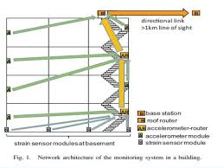

CHAPTER-4
IMPLEMENTATION

IMPLEMENTATION

This chapter describes about the requirement analysis in accordance with the resources used. It also describes the implementation of the project with the tool used.
4.1 REQUIREMENT ANALYSIS
It determines the requirements of a new system and analyze on product and resource requirement, which is required for the successful system. The product requirement includes input and output requirements it gives the wants in term of input to produce the required output. The resource requirements define in brief about the software and hardware that are needed to achieve the required functionality.

4.2 HARDWARE REQUIREMENTS

- Intel Galileo zen 2
- Power Supply
- Gsm shield
- sim
- Usb Cable
- Load cell sensor

4.3 SOFTWARE REQUIREMENTS

Intel Ardino

CHAPTER-5

BLOCK DIAGRAM
AND HARDWARE
DESCRIPTION

CIRCUIT DESCRIPTION

5.1 BLOCK DIAGRAM

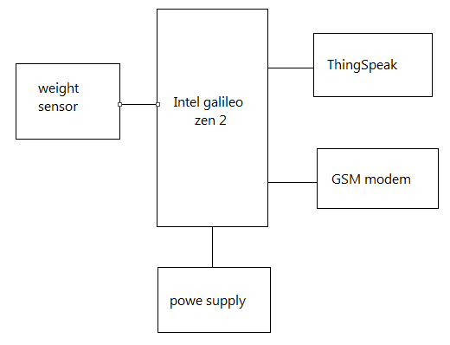
Fig:2 Block diagram

5.1.1 LOAD CELL
A load cell is a transducer which converts force into a measurable electrical output. Although there are many varieties of load cells, strain gage based load cells are the most commonly used type.
Except for certain laboratories where precision mechanical balances are still used, strain gage load cells dominate the weighing industry. Pneumatic load cells are sometimes used where intrinsic safety and hygiene are desired, and hydraulic load cells are considered in remote locations, as they do not require a power supply. Strain gage load cells offer accuracies from within 0.03% to 0.25% full scale and are suitable for almost all industrial applications.

5.1.2 Load Cell History
Before strain gage-based load cells became the method of choice for industrial weighing applications, mechanical lever scales were widely used. Mechanical scales can weigh everything from pills to railroad cars and can do so accurately and reliably if they are properly calibrated and maintained. The method of operation can involve either the use of a weight balancing mechanism or the detection of the force developed by mechanical levers. The earliest, pre-strain gage force sensors included hydraulic and pneumatic designs. In 1843, English physicist Sir Charles Wheatstone devised a bridge circuit that could measure electrical resistances. The Wheatstone bridge circuit is ideal for measuring the resistance changes that occur in strain gages. Although the first bonded resistance wire strain gage was developed in the 1940s, it was not until modern electronics caught up that the new technology became technically and economically feasible. Since that time, however, strain gages have proliferated both as mechanical scale components and in stand-alone load cells.
5.1.3 Hydraulic load cells
They are force -balance devices, measuring weight as a change in pressure of the internal filling fluid. In a rolling diaphragm type hydraulic load cell, a load or force acting on a loading head is transferred to a piston that in turn compresses a filling fluid confined within an elastomeric diaphragm chamber. As force increases, the pressure of the hydraulic fluid rises. This pressure can be locally indicated or transmitted for 2remote indication or control. Output is linear and relatively unaffected by the amount of the filling fluid or by its temperature. If the load cells have been properly installed and calibrated, accuracy can be within 0.25% full scale or better, acceptable for most process weighing applications. Because this sensor has no electric components, it is ideal for use in hazardous areas. Typical hydraulic load cell applications include tank, bin, and hopper weighing. For maximum accuracy, the weight of the tank should be obtained by locating one load cell at each point of support and summing their outputs.
5.1.4 Pneumatic load cells
They also operate on the force-balance principle. These devices use multiple dampener chambers to provide higher accuracy than can a hydraulic device. In some designs, the first dampener chamber is used as a tare weight chamber. Pneumatic load cells are often used to measure relatively small weights in industries where cleanliness and safety are of prime concern. The advantages of this type of load cell include their being inherently explosion proof and insensitive to temperature variations. Additionally, they contain no fluids that might contaminate the process if the diaphragm ruptures. Disadvantages include relatively slow speed of response and the need for clean, dry, regulated air or nitrogen
5.1.5 Strain-gage load cells
convert the load acting on them into electrical signals. The gauges themselves are bonded onto a beam or structural member that deforms when weight is applied. In most cases, four strain gages are used to obtain maximum sensitivity and temperature compensation. Two of the gauges are usually in tension, and two in compression, and are wired with compensation adjustments as shown in Figure 7-2. When weight is applied, the strain changes the electrical resistance of the gauges in proportion to the load. Other load cells are fading into obscurity, as strain gage load cells continue to increase their accuracy and lower their unit costs.
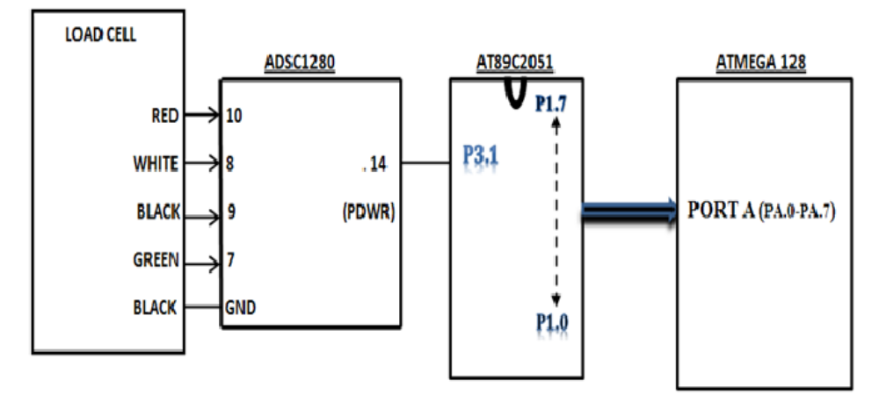
Fig:3 Load cell circuit
5.2 Intel Galilieo zen2
The Intel Galileo Gen 2 development board is a microcontroller board based on the Intel Quark™SoC X1000 application processor, a 32-bit Intel Pentium brand system on a chip (SoC). It is the first board based on Intel® architecture designed to be hardware and software pin-compatible with shields designed for the Arduino Uno* R3.
This platform provides the ease of Intel architecture development through support for the Microsoft Windows, Mac OS, and Linux host operating systems. It also brings the simplicity of the Arduino integrated development environment (IDE) software.
The Intel Galileo Gen 2 board is also software-compatible with the Arduino software development environment, which makes usability and introduction a snap. In addition to Arduino hardware and software compatibility, the Intel Galileo Gen 2 board has several PC industry standard I/O ports and features to expand native usage and capabilities beyond the Arduino shield ecosystem. A full-sized mini-PCI Express* slot, 100 Mb Ethernet port, Micro-SD slot, 6-pin 3.3V USB TTL UART header, USB host port, USB client port, and 8 Mbyte NOR Flash* come standard on the board.
Intel Galileo Gen 2 improves on Gen 1 by replacing the RS-232 console port with a 6-pin 3.3V USB TTL UART header. New additions to the Intel Galileo Gen 2 board include 12-bit pulse-width modulation (PWM), console UART1 redirection to Arduino* headers, 12V Power-over-Ethernet (PoE) capability, and a power regulation system that accepts power supplies from 7V to 15V.
The genuine Intel® processor and surrounding native I/O capabilities of the SoC provides for a fully featured offering for both the maker community and students alike. It will also be useful to professional developers who are looking for a simple and cost effective development environment to the more complex Intel® Atom™ processor and Intel® Core™ processor-based designs.
BLOCK DIAGRAM
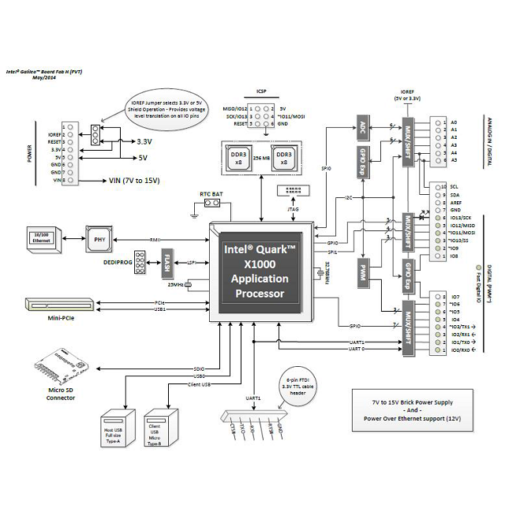
Fig:4 Intel Galilieo zen 2 Architecture

Physical Characteristics
- 10 cm long and 7 cm wide with the USB connectors, UART jack, Ethernet connector, and power jack extending beyond the former dimension
- Four screw holes allow the board to be attached to a surface or case00
- Reset button to reset the sketch and any attached shields

Processor Features
- Instruction set architecture (ISA)-compatible 32-bit Intel® Pentium® processor
- 16 Kbytes L1 cache
- 512 Kbytes of on-die embedded SRAM
- Simple to program: single thread, single core, constant speed
- ACPI-compatible CPU sleep states supported
- Integrated real-time clock (RTC) with optional 3V “coin cell” battery for operation between turn on cycles
- 400 MHz clock speed

Storage Options
- 8 Mbyte Legacy SPI Flash to store firmware (bootloader) and the latest sketch
- Between 256 Kbytes and 512 Kbytes dedicated for sketch storage
- 512 Kbytes embedded SRAM
- 256 Mbytes DRAM
- Optional micro SD card offers up to 32 Gbytes of storage
- USB storage works with any USB 2.0 compatible drive
- 11 Kbytes EEPROM programmed via the EEPROM library

5.3 GSM Module
Gas sensor detects the presence of gas, weight sensor gives the gas level in cylinder, and microcontroller will take corrective or necessary actions. The status of all these happening has to be conveyed to the owner of system or housemates. The technology making it very easy to send and receive messages using GSM module works on simple AT commands which can be implemented by interfacing it to the microcontroller Rx and Tx pins. The GSM module used is SIMCOM 300 which uses SIM memory to store the number of system owner or housemates and distributor or to whoever the messages have to be forwarded. It requires very less memory to send and receive text messages and operates on simple 12 Volt adapter
This is one of the important blocks in our pr1oject. GSM modem is used for sending SMS so that user can get remote indication. GSM modem is used to send SMS to user about the situation of gas cylinder like threshold is cross or gas level is 20%, gas level is below 5%. Microcontroller communicates with GSM modem and sends commands to GSM modem. Thus a text SMS is sent to the owner of the gas cylinder
Fig:5 GSM Block Diagram
BLOCK DIAGRAM
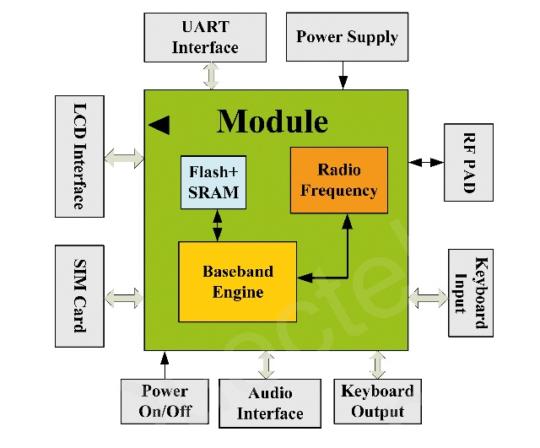
Model | Function | Interface
USR-GM3 | SMT GPRS Module | UART
USR-GPRS232-7S3 (New) | Pin Type GPRS/GSM Module | UART
USR-GPRS232-730 (New) | GPRS DTU | RS232/RS485
USR-GM1 | SMT GPRS Module | UART
USR-GPRS232-7S2 | Pin Type GPRS Module | UART
USR-GPRS232-701-PCBA | GPRS DTU Module | RS232/RS485
USR-GPRS232-701 | GPRS DTU | RS232/RS485
USR-GPRS232-710 | GPRS DTU | RS232/RS485
USR-GPRS232-720 | GPRS DTU | RS232

Global System for Mobile communications (GSM: originally from Group Special Mobile) is the most popular standard for mobile phone in the world. GSM/GPRS Smart Modem is a multi-functional, ready to use, rugged and versatile modem that can be embedded or plugged into any application. The Smart Modem can be customized to various applications by using the standard AT commands. The modem is fully type-approved and can directly be integrated into our project with any or all the features of Voice, Data, Fax, SMS, and Internet etc.
GSM provides recommendations, not requirements. The GSM specifications define the functions and interface requirements in detail but do not address the hardware. The reason for this is to limit the designers as little as possible but still to make it possible for the operators to buy equipment from different suppliers. The GSM network is divided into three major sysems: the switching system(SS), the base station system (BSS) and the operation and support system (OSS).
WORKING PRINCIPLE OF GSM
GSM uses a combination of TDMA (Time division multiple access) and FDMA (Frequency division multiple access). There are 125 up link channel and 125 downlink. Uplink channel means from mobile to base station and downlink means from base station to the mobile. 124 channels reserved for communication and is 1 is used for safe guard (100 Hz in each) which provides a separation bands width the channel
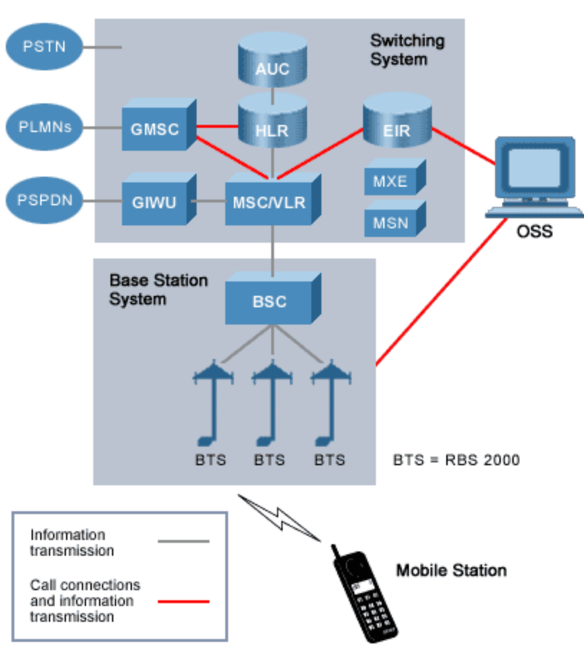
5.4 SIM
A subscriber identity module or subscriber identification module (SIM) is an integrated circuit chip that is intended to securely store the international mobile subscriber identity (IMSI) number and its related key, which are used to identify and authenticate subscribers onmobile telephony devices (such as mobile phones and computers). It is also possible to store contacts on many SIM cards. SIM cards are always used on GSM phones; for CDMA phones, they are only needed for newer LTE-capable handsets. SIM cards can also be used insatellite phones.The SIM circuit is part of the function of a Universal Integrated Circuit Card (UICC) physical smart card, which is usually made of PVC with embedded contacts and semiconductors. "SIM cards" are designed to be transferable between different mobile devices. The first UICC smart cards were the size of credit and bank cards; the development of physically smaller mobile devices has prompted the development of smaller SIM cards, where the size of the plastic carrier is reduced while keeping electrical contacts the same.
A SIM card contains its unique serial number (ICCID), international mobile subscriber identity (IMSI) number, security authentication and ciphering information, temporary information related to the local network, a list of the services the user has access to, and two passwords: a personal identification number (PIN) for ordinary use, and a personal unblocking code (PUK) for PIN unlocking.Fig:6 SIM
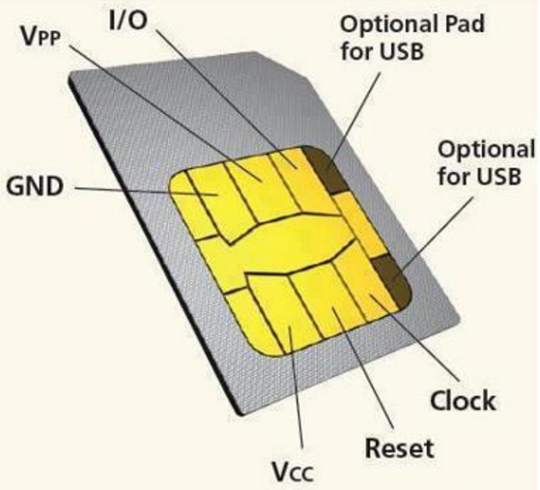

CHAPTER-6

SENSOR INTERFACE
DESCRIPTION

Interfacing a Load Cell With an Intel Galileo zen 2 Board

Setup and Wiring
A load cell usually has 4 wires, but it’s important to check the wiring for the unit you have:
- Red Wire: Excitation +
- Black Wire: Excitation –
- Green Wire: Signal +
- White Wire: Signal –
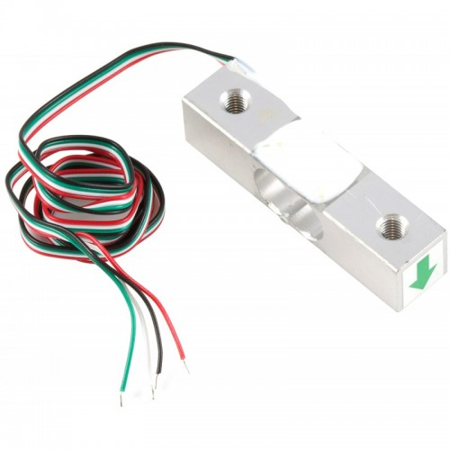
5 kg Micro Load Cell

The parts needed for connecting the load cell to the shield :
- Load Cell Amplifier Shield
- Load Cell
- Arduino Board
- 4 x 0.1″ Spaced F/F Jumper Wires (Stripped at one end)
- Heat shrink (Optional)
- Soldering Iron

Solder the F/F jumper wires to the Load Cell wires. To avoid mixing the wires when connecting the load cell, you can choose the same color wires as those of the load cell :
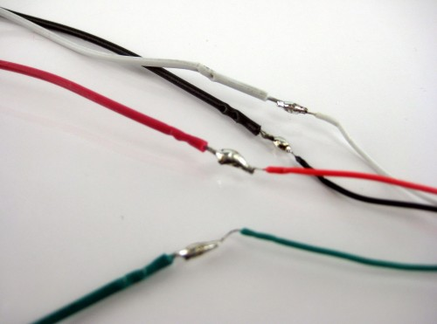
Soldering

Add heat shrink over the soldered areas:
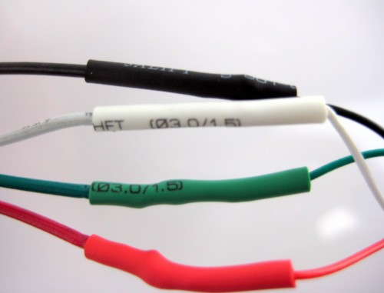
Heat Shrink
Connect the load cell to the Load Cell Amplifier Shield:
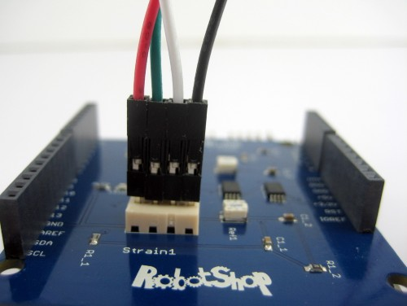
Connecting the Load cell
The Load Cell Shield uses analog pins A0 and A1 for Strain 1 and Strain 2 inputs respectively. The white connectors on the board are 4 pin Molex connectors with 0.1″ spacing. There are two modifications per channel that can be done to adjust the output voltage of the shield described below:

Gain
The gain of the amplification per channel is dependent on the Gain1 / Gain2 resistors. The AD8426 default gain is 1 without a gain resistor. The standard gain resistor value of the shield is 100 Ohm (for each channel) for a gain of 495. These resistors can be replaced depending on the user’s application with the appropriate ones. The gain can be calculated by using the following gain equation (from AD8426 datasheet) : Rgain= 49400/(Gain-1)

Reference voltage
The reference voltage feature is used to offset the output signal to a mid-supply voltage to be used with a single power supply ADC. The reference voltage can be set using the onboard potentiometers associated with each channel.
CIRCUIT CONNECTION:
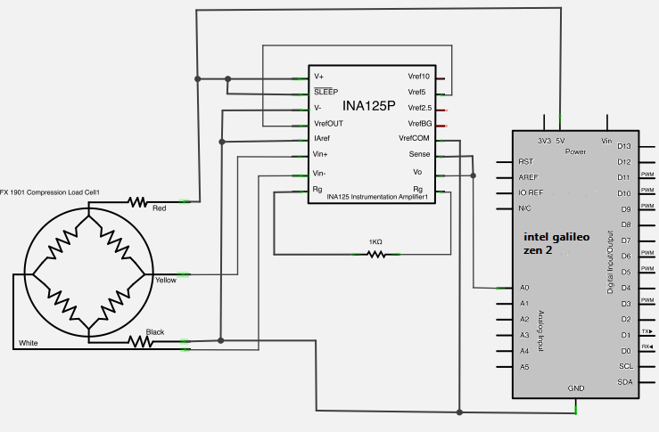
Fig:7 Load cell interface

CHAPTER-7

PROGRAM
DESCRIPTION

PROGRAM:
---------------------------------------------------------------------------------------------------------------------------------------------------------------------------------------------------------- LPG GAS CYLINDER MONITRORING USING IOT
----------------------------------------------------------------------------------------------------------------------------------------------------------------------------------------------------------
#include<String.h>
const int sensepin= A0;
const int threshold=50;//threshold Weight for Gas cylinder
int reading;
void setup() {
// put your setup code here, to run once:
Serial.begin(9600);//initialisation for client communication
Serial1.begin(115200);//initialisation serial communication with GSM shield
delay(100);

}
void loop()
{
// put your main code here, to run repeatedly:
reading = analogRead(sensepin);//to read the value from the sensor
Serial.println(reading);//to print the values from sensor
if (reading > threshold)
{
Serial1.println("AT+CMGF=1"); //Sets the GSM Module in Text Mode
delay(1000); // Delay of 1000 milli seconds or 1 second
Serial1.println("AT+CMGS=\"+919789950995\"\r"); // Replace x with mobile number
delay(1000);
Serial1.println(" Cylinder status\nYour Gas is under treshold Limit\n Please Book for Cylinder\nThank you..Intel Galelio Gen 2");// The SMS text you want to send
delay(100);
Serial1.println((char)26);// ASCII code of CTRL+Z
delay(1000);
}
/*if(Serial1.available())
{
Serial.write(Serial1.read());
delay(10000);
}*/

}

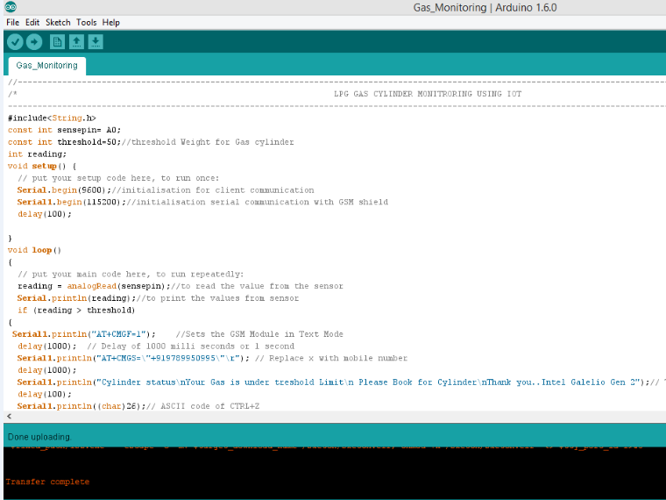

CHAPTER-8
RESULT ANALYSIS

RESULT AND ANALYSIS

This chapter shows the final output scenario of the project. The working of the project is shown in this chapter.

1.SENSOR TEST OUTPUT ON SERIAL MONITOR
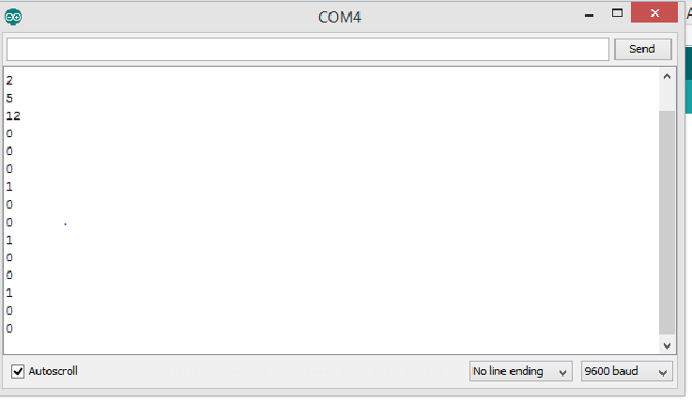

2.PROGRAM OUTPUT ON SERIAL MONITOR
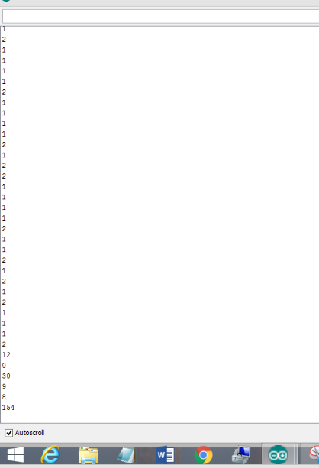

3.MESSAGE OUTPUT :1
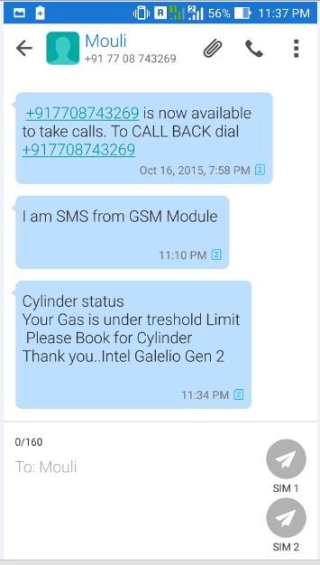

4.MESSAGE OUTPUT:2
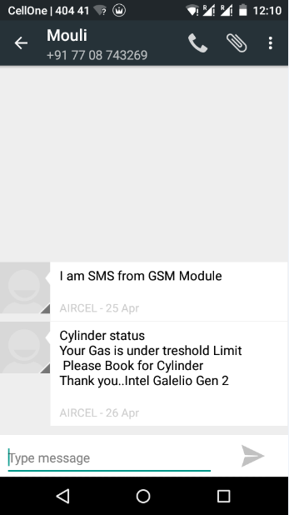

CHAPTER-7
CONCLUSION

CONCLUSION:
An effective gas monitoring is proposed and developed using intel galilieo zen 2 and GSM shield where the quantity of gas in measured using load cell and when the level is below the threshold limit the LPG user is intimated in advance so the he can book the cylinder in advance

CHAPTER-8
REFERENCE

REFERENCE:
[1] Sunithaa.Js, Sushmitha.D, “Embedded control system for LPG leakage detection and prevention” International Conference on Computing and Control Engineering (ICCCE 2012), 12 & 13 April, 2012
[2] V.Ramya, B. Palaniappan,“Embedded system for hazardous gas detection and alerting” International Journal of Distributed and Parallel Systems (IJDPS) Vol.3, No.3, May 2012
[3]S. Rajitha, T. Swapna,“Security alert system using GSM for gas leakage”International Journal of VLSI and Embedded Systems-IJVES
[4] Taufiq Noor Machmuda, “LPG Gas Detector and leak prevention based microcontroller”
[5] Fraiwan, L.; Lweesy, K.; Bani-Salma, A. Mani, N, “A wireless home safety gas leakage detection system”, Proc. of 1st Middle East, Conference on Biomedical Engineering, pp.11-14, 2011.
[6]Mr.SagarShinde,Mr.S.B.Patil,Dr.A.J.Patil,“Development of movable gas tanker leakage detection using wireless sensor network based on embedded system”,International Journal of Engineering Research and Applications (IJERA) ISSN: 2248-9622 www.ijera.com Vol. 2, Issue 6, November- December 2012, pp.1180-1183
[7] A. Mahalingam, R. T. Naayagi, N. E. Mastorakis, “Design and Implementation of an Economic Gas Leakage Detector”, Recent Researches in Applications of Electrical and Computer Engineering.
[8] M. B. Fish, R.T. Wainer, “Standoff Gas Leakage detectors based on tunable diodes laser absorption spectroscopy”
[9] A. CheSoh, M.Sc.; M.K. Hassan, M.Eng.; and A.J. Ishak, M.Sc. “ Vehicle gas leakage detector”

