SRH Hochschule Heidelberg

SRH University Heidelberg

Smart Cycle Docking Station

Author: Hulugundi Venatesha, Sriram

Matriculation Number: 11010343

Address: Lessingstrasse, 38  
69214 Eppelheim  
Germany

Supervisor: Prof. Dr. Achim Gottscheber

Begin: 18. June 2018

End: 20. July 2018

# Abstract

This project’s aim is to create a cycle docking station which is smart, cost effective, reliable and energy efficient. RFID technology is used to identify and track any cycle near a docking station which has the authorized RFID tag. UHF RFID tags and readers are used to achieve better detecting range for the station with the use of compatible UHF RFID antennas. Each cycle that needs to be detected is attached a tag whose credentials are stored in the database. Whenever a cycle is detected, it is identified by its tag and the data is transferred to the cloud and finally made available to the user through an application on mobile or a personal computer.

Contents

Abstract 2

Chapter 1: Introduction to Radio Frequency 4

Electromagnetic Spectrum 4

Radio Frequency 4

Types of Radio Frequencies 5

Chapter 2: Radio Frequency Identification 6

Types of RFID technology 6

Chapter 3: Overview of the system 7

Arduino Uno 7

M6E Nano 9

UHF RFID Antenna 11

UHF RFID tag 12

EPC Radio-Frequency Identity Protocols Generation-2 UHF RFID 13

High range view of the final system 15

Overview of Docking station 16

Working of Docking station 17

Explanation of the algorithm used for the controller 17

Chapter 4: Conclusion and Future scope 18

Chapter 5: Sensor Based Control 19

REFERENCES 19

Figure 1: Arduino Uno 10

Figure 2: SparkFun Simultaneous RFID Reader - M6E Nano 11

Figure 3: UHF RFID Antenna 13

Figure 4: UHF RFID Tag 14

# Chapter 1: Introduction to Radio Frequency

Radio frequency identification abbreviated as RFID is one of the major technologies used in the world today in the field of security. Even though the technology itself is much older the recent developments in the chip manufacturing are making RFID practical for new applications and settings, particularly consumer item level tagging. These advancements have the potential to revolutionize supply-chain management, inventory control, and logistics.

## Electromagnetic Spectrum

The electromagnetic spectrum is the range of frequencies (the spectrum) of electromagnetic radiation and their respective wavelengths and photon energies.

This frequency range is divided into separate bands, and the electromagnetic waves within each frequency band are called by different names; beginning at the low frequency (long wavelength) end of the spectrum these are: radio waves, microwaves, terahertz waves, infrared, visible light, ultraviolet, X-rays, and gamma rays at the high-frequency (short wavelength) end.

## Radio Frequency

RF is the lowest portion in the electromagnetic spectrum familiar as a medium of analog and modern digital wireless communication system. It spreads in the range between 3 KHz and 300 GHz. All known transmission systems work in the RF spectrum range including analog radio, aircraft navigation, marine radio, amateur radio, TV broadcasting, mobile networks and satellite systems.

Radio frequencies are generated and processed within very many functional units such as transmitters, receivers, computers, and televisions to name a few. Radio frequencies are also applied in carrier current systems including telephony and control circuits.

Electric currents that oscillate at radio frequencies have special properties not shared by direct current or alternating current of lower frequencies.

* Energy from RF currents in conductors can radiate into space as electromagnetic waves (radio waves). This is the basis of radio technology.
* RF current does not penetrate deeply into electrical conductors but tends to flow along their surfaces; this is known as the skin effect.

## Types of Radio Frequencies

Different types of Radio frequencies are as follows:

* Extremely low frequency which ranges from 3Hz to 3KHz and is used in seismic studies
* Very low frequency which ranges from 3KHz to 30KHz and is used in submarines
* Low frequency ranges from 30KHz to 300KHz and one important feature of this range is that it gets reflected by earth’s ionosphere and thus it is useful for long distance communication
* Medium frequency was one of the most popular ranges since the beginning of the wireless radio technology. It operates in the range 300KHz to 3MHz. It is used in many applications including AM radio transmission
* High frequency operates between 3MHz and 30MHz and is mostly used by the aviation industry
* Very high frequency is one of the most commonly used bands which has an operating range from 30 MHz to 300Mhz. It is mostly used in TV broadcasting, medical equipment, amateur radio and military application
* Ultra high frequency is the most important frequency bands for modern wireless communication systems. It ranges from 300 MHz to 3 GHz and is mainly used in GPS navigation systems, satellites, pagers, Wi-Fi, Bluetooth, television broadcasting, and most importantly GSM, CDMA and LTE mobile transmission
* Super high frequency is in the range of 3 GHz to 30 GHz. It can only operate in line of sight path since any obstruction in between the transmitter and receiving station will break the communication. It is commonly used in 5GHz Wifi channel
* Extremely high frequency band is the highest in RF frequency spectrum which range between 30 GHz and 300 GHz. EHF is only used in advanced communication systems due to its complex nature and line of sight requirement. EHF is used in radio astronomy and remote sensing (weather analysis)

# Chapter 2: Radio Frequency Identification

Radio frequency identification abbreviated as RFID is one of the major technologies used in the field of security. Even though the technology is a bit old it is getting popular due to the innovations in the field of chip manufacturing technology.

An RFID system mainly consists of three main components: a scanning antenna, a transceiver and a transponder or also called as an RFID tag. An RFID tag consists of a microchip, memory to store some information and an antenna.

The RFID reader is a network-connected device that can be permanently attached or portable. It uses radio frequency waves to transmit signals that activate the tag. Once activated, the tag sends a wave back to the antenna, where it is translated into data.

## Types of RFID technology

There are two main types of RFID tags: active RFID and passive RFID. An active RFID tag has its own power source, often a battery. A passive RFID tag, on the other hand, does not require batteries; rather it receives its power from the reading antenna, whose electromagnetic wave induces a current in the RFID tag's antenna. There are also semi-passive RFID tags, meaning a battery runs the circuitry while communication is powered by the RFID reader.

RFID tags are used in many industries, for example, an RFID tag attached to an automobile during production can be used to track its progress through the assembly line; RFID-tagged pharmaceuticals can be tracked through warehouses; and implanting RFID microchips in livestock and pets allows for positive identification of animals.

Since RFID tags can be attached to cash, clothing, and possessions, or implanted in animals and people, the possibility of reading personally-linked information without consent has raised serious privacy concerns. These concerns resulted in standard specifications development addressing privacy and security issues. ISO/IEC 18000 and ISO/IEC 29167 use on-chip cryptography methods for untraceability, tag and reader authentication, and over-the-air privacy. ISO/IEC 20248 specifies a digital signature data structure for RFID and barcodes providing data, source and read method authenticity. This work is done within ISO/IEC JTC 1/SC 31 Automatic identification and data capture techniques. Tags can also be used in shops to expedite checkout, and to prevent theft by customers and employees.

# Chapter 3: Overview of the system

The current system uses UHF RFID readers which are manufactured by Things magic. The tags which are used also works in the UHF range and are passive tags, meaning they do not need any external power to operate. The system also uses an antenna for a better range of communication. The specifications of the antenna are described in the table below. To control and coordinate all the processes a microcontroller board Arduino Uno board is used.

## Arduino Uno

Arduino Uno is a microcontroller board based on the ATmega328P. It has 14 digital input/output pins (of which 6 can be used as PWM outputs), 6 analog inputs, a 16 MHz quartz crystal, a USB connection, a power jack, an ICSP header and a reset button. It contains everything needed to support the microcontroller; simply connect it to a computer with a USB cable or power it with a AC-to-DC adapter or battery to get started.

"Uno" means one in Italian and was chosen to mark the release of Arduino Software (IDE) 1.0. The Uno board and version 1.0 of Arduino Software (IDE) were the reference versions of Arduino, now evolved to newer releases. The Uno board is the first in a series of USB Arduino boards, and the reference model for the Arduino platform; for an extensive list of current, past or outdated boards see the Arduino index of boards.

The Arduino Uno can be programmed with the (Arduino Software (IDE)). The ATmega328 on the Arduino Uno comes preprogrammed with a bootloader that allows you to upload new code to it without the use of an external hardware programmer. It communicates using the original STK500 protocol.

The Arduino Uno board can be powered via the USB connection or with an external power supply. The power source is selected automatically.

External (non-USB) power can come either from an AC-to-DC adapter (wall-wart) or battery. The adapter can be connected by plugging a 2.1mm center-positive plug into the board's power jack. Leads from a battery can be inserted in the GND and Vin pin headers of the POWER connector.

The board can operate on an external supply from 6 to 20 volts. If supplied with less than 7V, however, the 5V pin may supply less than five volts and the board may become unstable. If using more than 12V, the voltage regulator may overheat and damage the board. The recommended range is 7 to 12 volts.

|  |  |
| --- | --- |
| Microcontroller | ATmega328P |
| Operating Voltage | 5V |
| Input Voltage (recommended) | 7-12V |
| Input Voltage (limit) | 6-20V |
| Digital I/O Pins | 14 (of which 6 provide PWM output) |
| PWM Digital I/O Pins | 6 |
| Analog Input Pins | 6 |
| DC Current per I/O Pin | 20 mA |
| DC Current for 3.3V Pin | 50 mA |
| Flash Memory | 32 KB (ATmega328P) of which 0.5 KB used by bootloader |
| SRAM | 2 KB (ATmega328P) |
| EEPROM | 1 KB (ATmega328P) |
| Clock Speed | 16 MHz |
| LED_BUILTIN | 13 |
| Length | 68.6 mm |
| Width | 53.4 mm |
| Weight | 25 g |

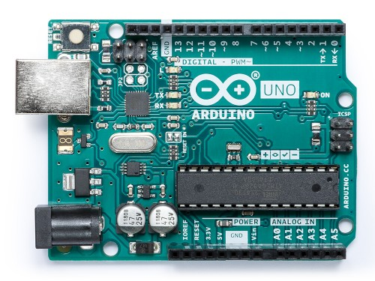

Figure 1: Arduino Uno (source: https://arduino.cc)

## 

## M6E Nano

Embedded UHF RFID Module

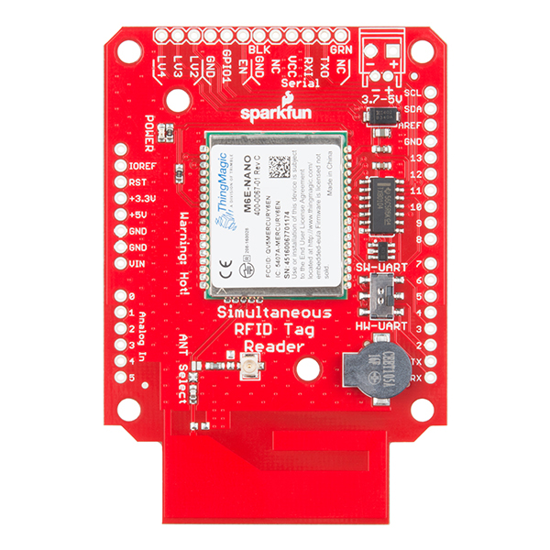ThingMagic Nano delivers the smallest form factor for a Mercury Series embedded UHF RFID module with very low power consumption and is ideal for battery operated, low cost, small form-factor portable readers. ThingMagic Nano’s wide RF output range (0 dBm to +27 dBm) is important for the read/write requirements for RFID-enabled printers and tag commissioning stations. It features a surface mount package designed for the efficiency of SMT manufacturing, driving down the total cost for embedding RFID in volume applications, including handheld devices, consumables authentication, device configuration and access control.

Figure 2: SparkFun Simultaneous RFID Reader - M6E Nano (source: http://www.sparkfun.com)

|  |  |
| --- | --- |
| RFID Protocol support | EPCglobal Den 2v2 (ISO 18000-63) |
| Antenna Connector | Single 50 Ohm connection |
| RF Power output | Separate read and write levels, command-adjustable from 0 dBm to +27 dBm in 0.01 dB steps |
| Control/Data Interfaces | UART; 3.3V logic levels 9.6 to 921.6 kbps |
| GPIO Sensors and Indicators | Four 3.3V bidirectional ports configurable as input (sensor) ports or output (indicator) ports |
| DC Power Required | DC Voltage: 3.3 to 5.5 V for +25 dBm out; 3.7 to 5.5 V for +27 dBm out |
| DC power consumption @ RF level | 3.2 W @ 5 VDC for +27 dBm out |
| Certification | EU (ETSI EN 302 208 v3.1.1, RED 2014/53/EU) |
| Max Read Rate | Up to 200 tags/second |
| Max Tag Read Distance | Over 4.5 meters (15 feet) with 6 dBi antenna (33 dBm EIRP) |
| Operating Temperature | -40°C to +60°C (case temperature) |

*Source : https://www.jadaktech.com/wp-content/uploads/2018/09/Nano-Product-Spec-Sheet-09052018.pdf*

## UHF RFID Antenna

The ultra-high-frequency (UHF) RFID Antenna boasts a frequency range of 860-960 MHz with a gain of 6dBi. Each UHF RFID Antenna is terminated with a 30cm long TNC Female RP cable.

Features

* Frequency Range: 860-960 MHz
* Gain: 6 dBi
* VSWR: < 1.6: 1
* Impedance: 50Ω
* Polarization: Linear Vertical
* Antenna Connector: TNC Female RP
* Max Power: 100W
* 223mm x 200mm x 60mm

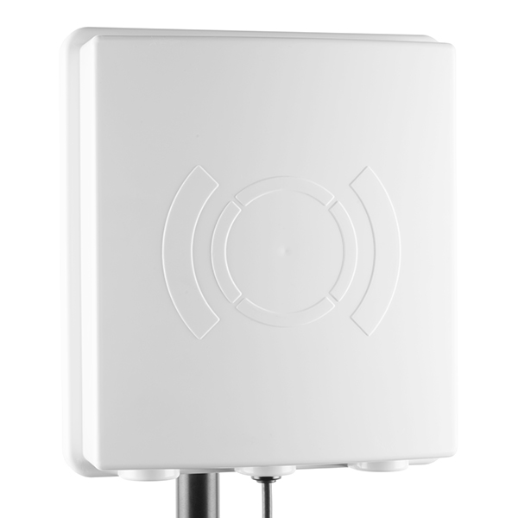

Figure 3: UHF RFID Antenna (TNC) (source: https://www.sparkfun.com)

## UHF RFID tag

The current system uses gen 2 RFID tags. These tags are attached to the cycle using the adhesive provided with the tags. These are passive and inexpensive tags.

Some main features of the tags are:

* EPCglobal Gen2 and ISO/IEC 18000-6c
* 800 Bits of Memory
* 512 User Bits
* 64-Bit Unique TID (unalterable serial number)
* 32-Bit Access and 32-Bit Kill Passwords* Width: 1cm
* Length: 7cm

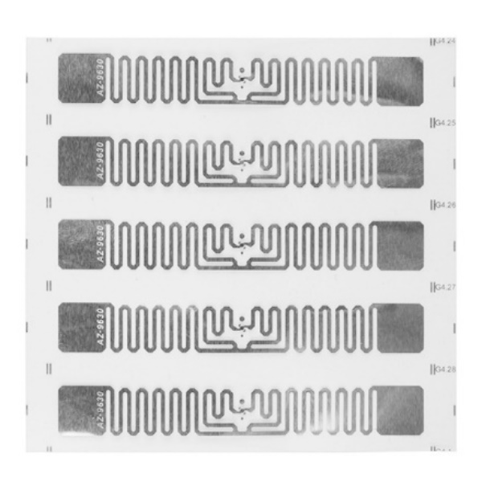

Figure 4: UHF RFID Tag (source: https://www.sparkfun.com)

## EPC Radio-Frequency Identity Protocols Generation-2 UHF RFID

This protocol defines the physical and logical requirements for a passive-backscatter, Interrogator-talks-first (ITF), radio-frequency identification (RFID) system operating in the 860 MHz – 960 MHz frequency range. The system comprises Interrogators, also known as Readers, and Tags, also known as Labels or Transponders. An Interrogator transmits information to a Tag by modulating an RF signal in the 860 MHz – 960 MHz frequency range. The Tag receives both information and operating energy from this RF signal. Tags are passive, meaning that they receive all their operating energy from the Interrogator’s RF signal. An Interrogator receives information from a Tag by transmitting a continuous-wave (CW) RF signal to the Tag; the Tag responds by modulating the reflection coefficient of its antenna, thereby backscattering an information signal to the Interrogator. The system is ITF, meaning that a Tag modulates its antenna reflection coefficient with an information signal only after being directed to do so by an Interrogator. Interrogators and Tags are not required to talk simultaneously; rather, communications are half-duplex, meaning that Interrogators talk, and Tags listen, or vice versa.

This protocol specifies:

* Physical interactions (the signaling layer of the communication link) between Interrogators and Tags, and
* Logical operating procedures and commands between Interrogators and Tags.

## High range view of the final system

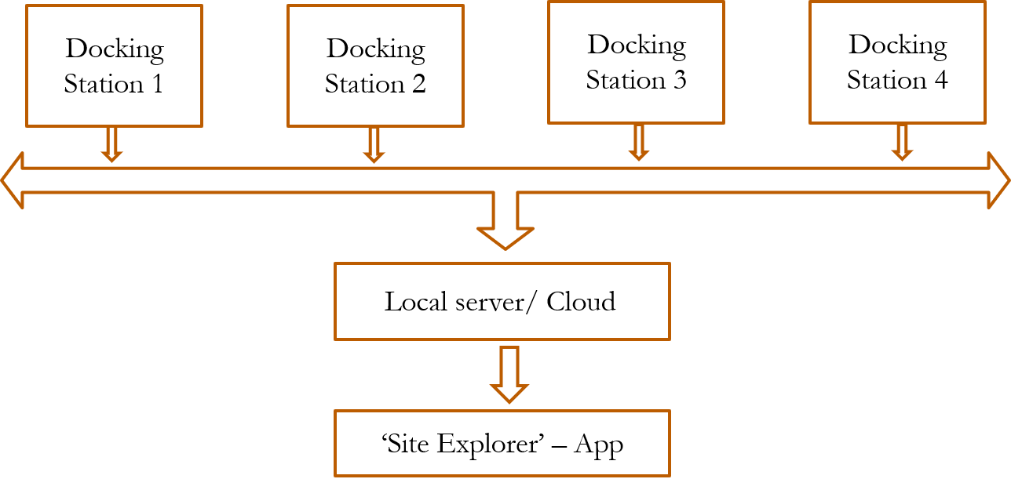

Figure 5: The above diagram depicts the overall architecture of the smart docking station

The final system consists of a finite number of docking stations. These docking stations have their individual RFID receivers, antennas and control modules to transmit the data to the local server/Cloud.

A local server consists of a computer which is used to collect data from all the different docking stations. The data collected is then interpreted and processed according some predefined algorithm and then sent to a remote app to the user.

## Overview of Docking station

Arduino Controller

UHF RFID Trans receiver

Local Network

ANTENNA

6

5

4

3

2

1

13

12

11

10

8

9

7

17

16

15

14

Figure 6: Figure shows the overview of a single docking station, the squares that are numbered are to indicate cycles that are parked

Every docking station consists of a controller unit and a trans-receiver which is used to detect the RFID tags present in the cycles.

Every cycle has a UHF RFID tag attached to it. When these cycles come into the range of the antenna at any station the tag gets detected by the trans-receiver and exchanges the data which is stored inside the tag.

The tags or the cycles are only detected when they are present in the range of the RFID antenna. Those cycles which are in the vicinity but not in the range of the antenna will not be detected by the antenna and hence will not be visible to the application which is used by the user at the end.

For example, the cycles numbered 1 to 13 are the only ones which are in the range of the antenna. Hence these are detected without any problem and the same is updated in the application. But even though cycles 14 till 17 are near the antenna, they are out of its range and hence they are not detected and the user using the application cannot see those cycles.

## Working of Docking station

Each docking as shown in figure x has a controller and a trans-receiver to communicate with the tags which are present in cycles. Antenna is used to improve the range of communication between the tags and the trans receiver.

The trans-receiver can be controlled in two ways,

1. Using ThingMagic’s windows application call Universal Reader Assistant
2. Using some microcontroller and programming it to communicate using the API given by ThingMagic.

Advantages of using a microcontroller over Universal Reader Assistant.

* A microcontroller which can control the trans-receiver does not need a windows-based system to read the data unlike the Universal Reader Assistant
* Microcontroller based system outputs the data in various formats so that the user can choose the suitable format
* As the data is available in many forms, it becomes very easy to process the data using different logics at the same time
* The system is connected to internet using the onboard wifi, so it can be used to push the data to cloud-based services for later use
* Since this kind of system only uses a small microcontroller with minimal peripheral circuitry, the overall system costs a fraction of an actual windows-based computer

## Explanation of the algorithm used for the controller

The code for the Arduino microcontroller is written in Arduino C using Arduino IDE. Inbuilt libraries are used to get the APIs which are required to operate the trans-receiver.

* An array is initiated to store the information about the tags that are going to be read
* The size of each array is set to 12 which is equal to the size of data stored in the tags
* The receiver is initialized to scan for tags in every predefined interval
* This interval is made short so that the receiver does not get overheated
* When this predefined interval is reached the receiver sends out a signal to scan for the available tags in the vicinity
* If a new tag is detected, then the array is updated with a new tags information

# Chapter 4: Conclusion and Future scope

The project is tested in a practical environment using tags which are made for nonmetallic applications. The next phase of the project is to experiment with different types of tags to get as better range as possible. Tags are one of the main factors which decide the range of the system, hence choosing a right tag will be a major deciding factor for the project to succeed.

Out of all the many possibilities to improve the project these are the major developments that can be done:

1. Using right tags for the application, like tags which are made to be used on metallic surface
2. Antenna which can give required power so that the detected range can be improved
3. A microcontroller system which has capabilities to communicate wirelessly. For example, a controller like ESP8266 which has onboard microcontroller along with Wifi module for wireless communication
4. A local server to communicate with all the controllers in the docking station. By this the individual controllers are only required to communicate with the local sever. This can improve the performance of the application used by the end user since the application then is only required to communicate with the local server rather than the whole system.

# REFERENCES