Software Architecture and Design Document (SAD)
Document Details
Project | Automated Meeting Minutes Generator (AMMG)
Version | 1.0
Authors | Sriranga Bharadwaj (PES1UG24AM286)  Srijan Akshit (PES1UG24AM284)  Swasthik Pamadi (PES1UG24AM298)  Siddhanth Khurdiya (PES1UG24AM275)
Date | 06-10-2026
Status | Draft

Table of Contents
1. Introduction 3
1.1 Purpose 3
1.2 Scope 3
1.3 Audience 3
1.4 Definitions 3
2. Document Overview 3
2.1 How to Use This Document 3
2.2 Related Documents 3
3. Architecture 3
3.1 Goals & Constraints 3
3.2 Stakeholders & Concerns 4
3.3 Component (UML) Diagram 5
3.4 Component Descriptions 5
3.5 Chosen Architecture Pattern and Rationale 6
3.6 Technology Stack & Data Stores 7
Data Model (main entities) 7
3.7 Risks & Mitigations 8
3.8 Traceability to Requirements 8
3.9 Security Architecture 8
4. Design 9
4.1 Design Overview 9
4.2 UML Sequence Diagrams 10
4.3 API Design 11
Internal Component Interface (Worker Pipeline) 12
4.4 Error Handling, Logging & Monitoring 12
4.5 UX Design 12
4.6 Open Issues & Next Steps 12
5. Appendices 13
5.1 Glossary 13
5.2 References 13
5.3 Tools 13

Note: This Table of Contents is generated via field codes. To ensure page-number accuracy after editing, right-click the TOC and select "Update Field".

1. Introduction

1.1 Purpose
This document specifies the architecture and design of the Automated Meeting Minutes Generator (AMMG), which converts meeting audio into text and produces editable structured minutes with key discussions, decisions, action items, responsible people and deadlines. It records the major architectural decisions, the security architecture, the API design and the behavioural models needed to implement and review the system.

1.2 Scope
Covers user and meeting management, audio ingestion, speech-to-text with speaker identification, NLP extraction, minutes generation/editing, export and sharing, action tracking and administration. Real-time captioning and meeting-platform bots are out of scope.

1.3 Audience
Developers, QA engineers, security reviewers, project guide / evaluators and system administrators.

1.4 Definitions
ASR (Automatic Speech Recognition), NLP, ADR (Architecture Decision Record), JWT, RBAC, STRIDE, TLS, API, MoM (Minutes of Meeting). Full definitions are given in the SRS section 1.4.

2. Document Overview

2.1 How to Use This Document
This document provides the architectural views of AMMG: component diagram, layered structure, architecture decision records, STRIDE threat model, sequence diagrams, data model and API design. Readers evaluating the design should start with section 3 (architecture) and use section 4 (design) for implementation-level detail.

2.2 Related Documents
- Software Requirements Specification (SRS v1.0)
- Software Test Plan (STP v1.0)
- Requirements Traceability Matrix (SRS section 8)

3. Architecture

3.1 Goals & Constraints
Goals: accurate and fast minutes generation (<= 0.5x audio length), editable results, confidentiality of recordings, 99% availability, and modular code that can swap ASR/NLP models.
Constraints: open-source components, self-hosted models for privacy, 500 MB / 3 h upload limit, academic timeline and limited GPU resources, and ASR accuracy limited by audio quality.

3.2 Stakeholders & Concerns
Stakeholder | Concerns
Organizer | Accuracy, speed, ease of editing, export formats
Participant / Owner | Clear action items, deadlines, reminders
Admin / Operations | Monitoring, retention, failures, maintainability
Security / Privacy | Confidentiality of recordings, access control, deletion
Developers | Modularity, testability, replaceable models
Evaluators | Traceability to requirements, quality of design

3.3 Component (UML) Diagram
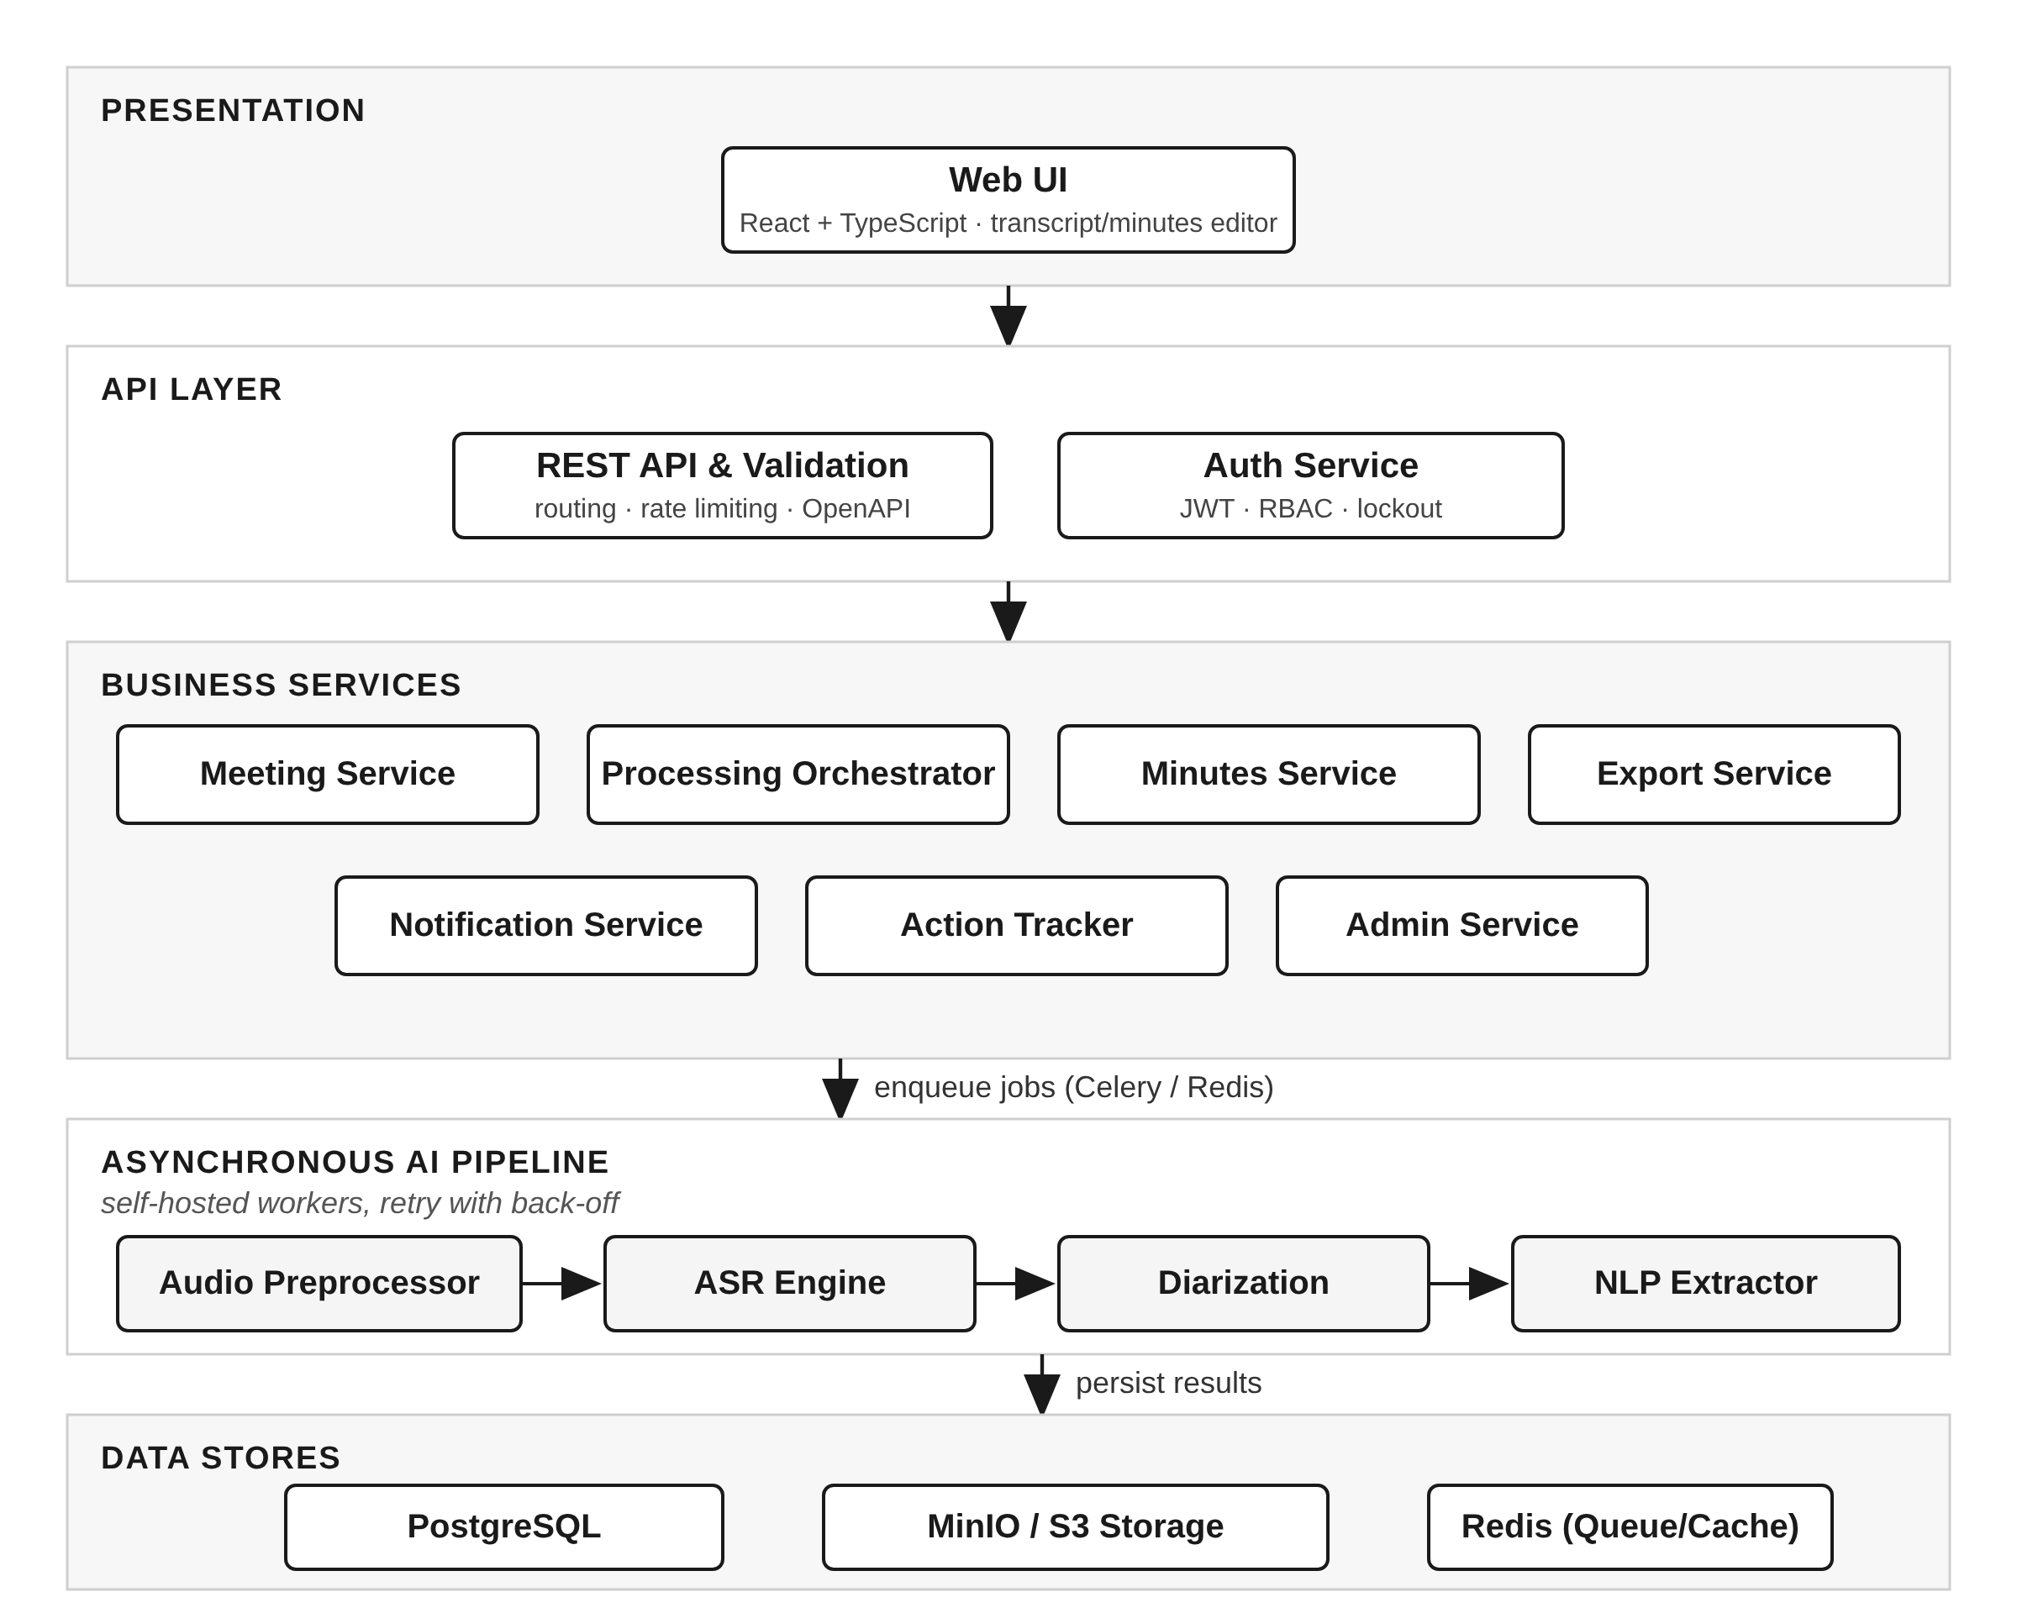
Figure 3.1: Component diagram - layered architecture with asynchronous AI workers

3.4 Component Descriptions
Component | Responsibility | Reqs
Web UI | Upload/record, status, transcript viewer with audio sync, minutes editor, dashboard, admin console | F-011, 012, 022, 041, 050
REST API & Validation | Single entry point; input validation, rate limiting, routing, OpenAPI docs | SR-005, 006, 007
Auth Service | Registration, login, JWT issue/refresh, RBAC, lockout | F-001..003, SR-003, 004
Meeting Service | Meeting & attendee CRUD, audio upload, status, deletion/retention | F-010, 011, 014, 061
Processing Orchestrator | Creates the job pipeline and enqueues tasks, handles retry | F-014, NF-005
Audio Preprocessor | Validates audio, converts to 16 kHz mono WAV (FFmpeg) | F-013
ASR Engine | Whisper-class transcription with segment timestamps; English/Hindi | F-020, F-023
Diarization | Speaker segmentation and labelling (pyannote-class) | F-021
NLP Extractor | Topic segmentation + summaries; decision and action-item detection; owner resolution; date normalisation; confidence scores | F-030..035
Minutes Service | Builds structured minutes, editing, autosave, versions, source links | F-040..043
Export Service | Renders minutes to DOCX, PDF, Markdown | F-044
Notification Service | Email sharing and deadline reminders (scheduler) | F-045, F-051
Action Tracker | Cross-meeting action list, filters, status updates | F-050, F-051
Admin Service | Job monitoring/restart, retention policy, audit log view | F-060, F-061, SR-008

3.5 Chosen Architecture Pattern and Rationale
A layered architecture (Presentation -> API -> Business -> Data) is combined with an asynchronous pipeline (queue + workers; pipes-and-filters style) for the heavy audio/AI processing. Layering gives separation of concerns and testability; the queue prevents long-running ASR from blocking web requests and lets processing scale independently.
ADR | Decision | Alternatives rejected & reason
ADR-1 | Modular monolith back end (FastAPI) + separate worker processes | Microservices: operational overhead too high for team size and project scale
ADR-2 | Asynchronous job queue (Celery + Redis) for processing | Synchronous processing: request time-outs for long audio
ADR-3 | Self-hosted open-source ASR/diarization/NLP models | Cloud speech APIs: privacy risk and cost; kept behind an interface so a cloud engine can be plugged in with opt-in
ADR-4 | PostgreSQL for structured data; object storage for audio/exports | Storing audio in DB: poor performance; NoSQL: data is relational
ADR-5 | Every AI result is editable and carries a confidence score | Fully automatic output: errors would be unrecoverable and reduce trust

3.6 Technology Stack & Data Stores
Area | Technology
Front end | React + TypeScript, Material UI, wavesurfer.js (audio), TipTap (rich editor)
Back end | Python 3.11, FastAPI, SQLAlchemy, Pydantic
Async processing | Celery, Redis
Speech/AI | faster-whisper (ASR), pyannote.audio (diarization), spaCy, dateparser, local instruction-tuned LLM for extraction/summaries
Audio | FFmpeg
Data stores | PostgreSQL (metadata, transcripts, minutes), MinIO/S3 (audio, exports), Redis (queue/cache)
Export | python-docx, WeasyPrint/ReportLab, Markdown generator
Security | TLS (reverse proxy Nginx), Argon2id, JWT, ClamAV
DevOps | Docker Compose, GitHub Actions CI, pytest, Postman, JMeter

Data Model (main entities)
Entity | Key attributes | Relationships
User | id, name, email, password_hash, role, locked_until | 1 - * Meeting (owner)
Meeting | id, title, datetime, agenda, language, status, owner_id | 1 - * Attendee, AudioFile, MinutesVersion
Attendee | id, meeting_id, name, email, speaker_label | * - 1 Meeting
AudioFile | id, meeting_id, storage_key, duration, format, purge_date | 1 - 1 Transcript
TranscriptSegment | id, transcript_id, start, end, speaker_label, text | * - 1 Transcript
Topic / Decision | id, meeting_id, title/statement, summary, start-end, confidence | * - 1 Meeting
ActionItem | id, meeting_id, task, owner_attendee_id, due_date, status, confidence, segment_id | * - 1 Meeting, 0..1 Attendee
MinutesVersion | id, meeting_id, version_no, content_json, created_by, created_at | * - 1 Meeting
AuditLog | id, user_id, event, timestamp, details | * - 1 User

3.7 Risks & Mitigations
Risk | Mitigation
Poor ASR accuracy (noise, accents, overlap) | Audio normalisation; choose larger model; editable transcript; language selection
Wrong owner/deadline extraction | Confidence scores; highlight < 0.6; rule-based date parser; user review before sharing
Long processing time / GPU shortage | Queue with limits; model size configurable; CPU fallback; progress status
Sensitive data leakage | Self-hosted models, AES-256 at rest, TLS, RBAC, retention purge
LLM hallucination in summaries | Ground every item to a transcript segment (source link); constrained prompts; review step
Worker crash mid-job | Idempotent tasks, automatic retry, Admin restart

3.8 Traceability to Requirements
Requirement | Design element
F-001..003 Authentication, RBAC | Auth Service
F-010..014 Meeting/audio input | Meeting Service, Audio Preprocessor, Orchestrator
F-020..023 Transcription | ASR Engine, Diarization, Web UI transcript viewer
F-030..035 Content analysis | NLP Extractor
F-040..045 Minutes, export, share | Minutes Service, Export Service, Notification Service
F-050..051 Action tracking | Action Tracker, Notification Service
F-060..061 Admin | Admin Service, retention scheduler
NF-001, NF-005 Performance/scalability | Queue + workers, model sizing
SR-001..010 Security | API layer, Auth Service, storage encryption, audit log (see 3.9)

3.9 Security Architecture
Threat modelling (STRIDE) is used to derive the security architecture. Each threat category below is mapped to a concrete example in AMMG and its mitigation, which in turn references the security requirements AMG-SR-001..010 of the SRS.
Threat | Example in AMMG | Mitigation
Spoofing | Stolen credentials / token | Argon2id, lockout, short-lived JWT, refresh rotation (SR-003, 004)
Tampering | Altering minutes or audit log | RBAC, versioned minutes, tamper-evident audit log (SR-005, 008)
Repudiation | User denies sharing/deleting | Audit events with user and time (SR-008)
Information disclosure | Accessing another user's recording; sniffing | TLS 1.2+, AES-256 at rest, ownership checks, self-hosted models (SR-001, 002, 005, 009)
Denial of service | Huge uploads, login floods | Size limits, rate limiting, queue (SR-006, 007)
Elevation of privilege | Participant acts as Admin; malicious file | Server-side RBAC, upload validation + virus scan, input sanitisation (SR-005, 006, 010)

4. Design

4.1 Design Overview
The back end is split into business modules behind a REST API. Uploading a recording creates a processing job: Audio Preprocessor -> ASR -> Diarization -> NLP Extractor -> Minutes generation. Each stage writes its result to the database and updates the meeting status (QUEUED -> TRANSCRIBING -> ANALYSING -> READY / FAILED).
The Extractor works in steps: (1) segment the transcript into topics and summarise each; (2) detect decision and action-item sentences; (3) resolve the owner from a named person, speaker label or pronoun against the attendee list; (4) find deadline phrases and convert them to absolute dates relative to the meeting date; and (5) attach confidence scores and source segment IDs.

4.2 UML Sequence Diagrams
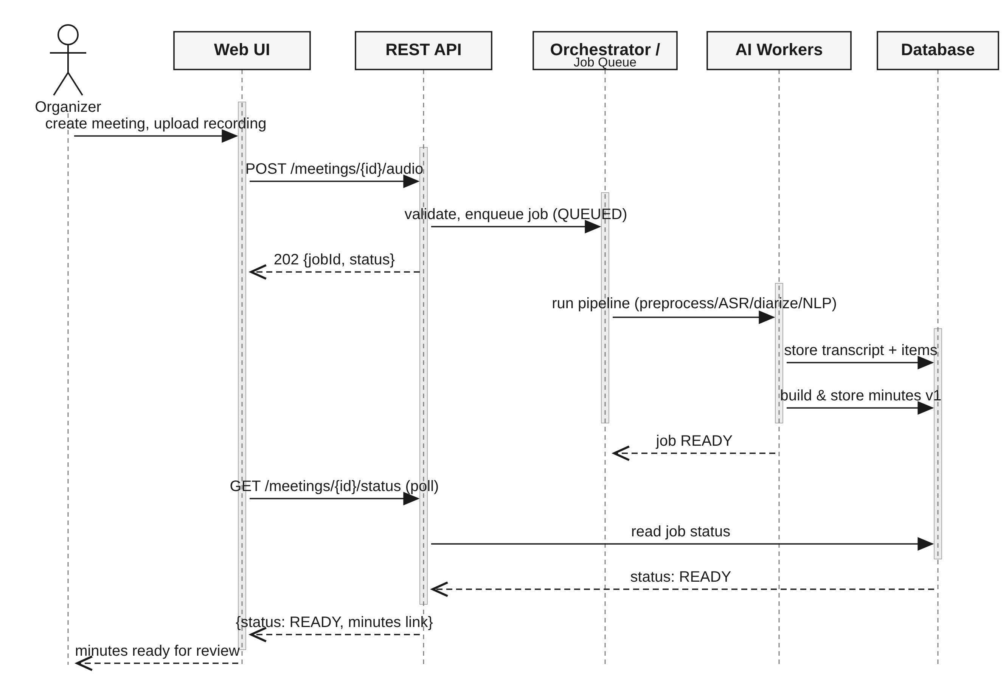
Figure 4.1: Upload recording and generate minutes
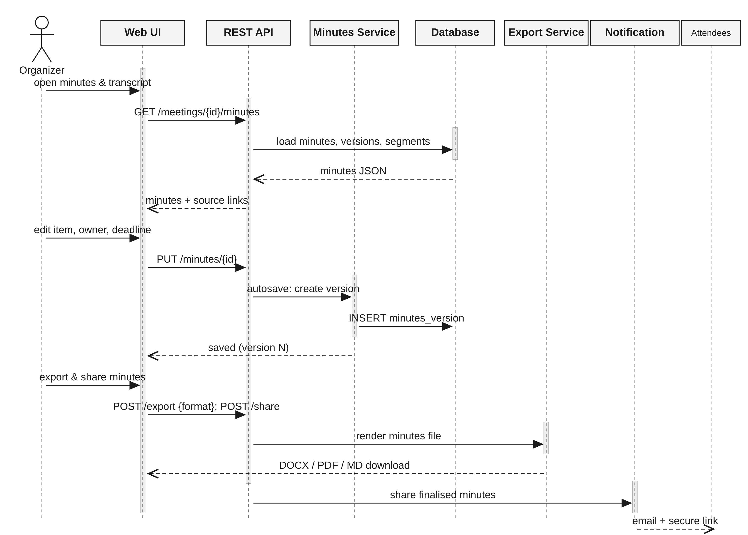
Figure 4.2: Review, edit, export and share minutes

4.3 API Design
All endpoints are under /api/v1, JSON over HTTPS, JWT bearer authentication. The full OpenAPI (Swagger) specification is generated by FastAPI.
Endpoint | Method | Request | Response | Errors
/auth/login | POST | {email, password} | {accessToken, refreshToken} | 401 Invalid credentials, 423 Account locked, 429 Too many requests
/meetings | POST | {title, datetime, agenda, language, attendees[{name,email}]} | 201 {meetingId} | 400 Validation error, 401
/meetings/{id}/audio | POST | multipart file (mp3/wav/m4a/mp4) | 202 {jobId, status: QUEUED} | 401, 403 Not owner, 413 File too large, 415 Unsupported type
/meetings/{id}/status | GET | - | {status, stage, progress} | 404 Not found, 403
/meetings/{id}/transcript | GET / PUT | PUT: {segments[{id,text,speaker}]} | {segments[{start,end,speaker,text}]} | 403, 404
/meetings/{id}/minutes | GET | - | {version, topics[], decisions[], actionItems[{task,owner,due,confidence,sourceSegment}]} | 403, 404
/minutes/{id} | PUT | {content} | {version} | 400, 403, 409 Version conflict
/minutes/{id}/export | POST | {format: docx|pdf|md} | File stream | 400 Bad format, 403, 404
/minutes/{id}/share | POST | {recipients[] optional} | {sent[], failed[]} | 403, 502 Mail server error
/actions | GET | ?owner&status&dueBefore | {items[]} | 401
/admin/jobs/{id}/retry | POST | - | 202 | 403 Not admin, 404

Internal Component Interface (Worker Pipeline)
Interface | Input | Output
ASRService.transcribe(audioPath, language) | 16 kHz WAV, language code | list of {start, end, text}
DiarizationService.label(audioPath, segments) | audio, segments | segments with speaker_label
NLPAnalyzer.analyze(segments, attendees, meetingDate) | labelled transcript, attendee list, date | {topics[], decisions[], actionItems[]} each with confidence and sourceSegmentId

4.4 Error Handling, Logging & Monitoring
- Standard error body {code, message, requestId}; no stack traces or file paths to clients.
- Failed pipeline stages set status FAILED with reason; automatic retry up to 3 times with back-off; Admin/Organizer can retry.
- Logs are structured JSON; no passwords, tokens, or transcript text in logs; security events go to the audit log.
- Monitoring: queue length, job duration, failure rate, API latency, uptime (health endpoint + dashboard).

4.5 UX Design
Simple three-step flow: Create meeting -> Upload/Record -> Review minutes. The transcript view highlights the current spoken segment while audio plays; clicking any action item jumps to its source. Low-confidence items are marked with a warning colour. Accessible fonts, high contrast, keyboard shortcuts, responsive layout, and a progress indicator during processing complete the experience.

4.6 Open Issues & Next Steps
- Final selection of model sizes after benchmarking on the evaluation set.
- Handling overlapping speech and strong accents.
- Future enhancements: live transcription, Zoom/Teams/Google Meet integration, more languages, calendar integration, task-tool export (Jira/Trello).

5. Appendices

5.1 Glossary
ASR, WER, Diarization, NLP, ADR, RBAC, JWT, STRIDE, TLS, MoM - see SRS section 1.4.

5.2 References
- IEEE 830 / ISO 29148 (requirements)
- IEEE 42010 (architecture description)
- OWASP Top 10 / ASVS
- NIST SP 800-160
- OpenAI Whisper, pyannote.audio documentation
- FastAPI documentation

5.3 Tools
Graphviz and Matplotlib are used for diagrams (may be redrawn in PlantUML/draw.io), Swagger/OpenAPI for API documentation, Postman for API testing, and Git/GitHub for version control.

