LAB 1
1. Implement Tic –Tac –Toe Game
Implement "Tic-tac-Toe" in general without using any standard algorithm.
OUTPUT:
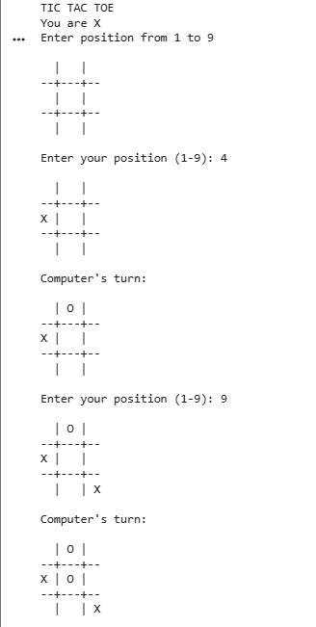
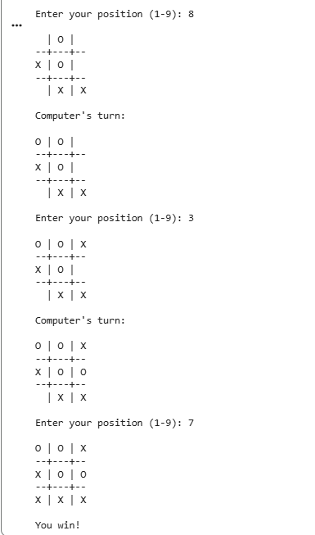

2. Implement vacuum cleaner agent
Implement "Vacuum Cleaner Agent" using the concept of "Simple Reflex agent and Goal based" architecture.
OUTPUT:
