LAB 3
For 8-puzzle A* implementation, to calculate, f(n), consider two cases,
1. g(n): Depth of the node, h(n): Number of Misplaced tiles
Output:
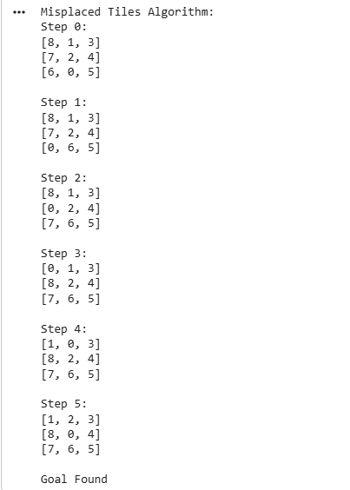
2. g(n): Depth of the node, h(n): Manhattan Distance
Output:
